SENTINELOPS-LITE
Sample Application
Deployed in Multi-Cloud
with AI-Agent Observability

Project type | Flask sample application with AI-agent release gates
Deployment targets | AWS Elastic Beanstalk ECS and Azure App Service
Observability | Prometheus, Grafana, Node Exporter, Flask metrics
Document scope | Architecture, workflow, technology stack, configuration, results and learning outcomes

- Prepared for project review and deployment documentation.
- Contents include
- Project Overview
- Project Objectives and Scope
- Project Architecture
- Project Workflow
- Technology Stack
- Project File Structure and Responsibilities
- Variables and Secrets Required
- Background Processes and Runtime Behavior
- Monitoring, Metrics and Dashboards
- Deployment Model
- Result
- Learning Outcomes
- Limitations and Future Enhancements
- Conclusion

- PROJECT OVERVIEW:
SentinelOps-Lite is a Flask-based sample application designed for multi-cloud deployment and monitoring. It uses AI agents for pre-deployment validation, deployment-error diagnosis, and post-deployment verification. The application is containerized with Docker and deployable to AWS Elastic Beanstalk ECS or Azure App Service through GitHub Actions. Prometheus collects application, system, and AI-agent metrics, while Grafana provides real-time dashboards for tokens, requests, agent status, and service health.

- Sentinel Ops-Lite is not an official AWS, Azure, or open-source product.
- It is a project name commonly used for a lightweight DevOps monitoring and observability platform.
- In your previous project discussions, it referred to the application you were building.
- A typical SentinelOps-Lite project includes:
  - CI/CD: GitHub Actions or Azure DevOps pipelines
  - Cloud Platforms: AWS Elastic Beanstalk and Azure App Service
  - Containerization: Docker
  - Monitoring: Prometheus
  - Visualization: Grafana
  - AI Monitoring: AI agents that monitor deployments, infrastructure, and application health

- These tools also can be used as it is sample application it is built simply, if you want you can take the project to next advanced level by using this tech stalk :
  - Infrastructure as Code: Terraform
  - Security Scanning: Tools such as Trivy and SonarQube
  - Notifications: Slack, Microsoft Teams, Email, or other alerting systems

- PROJECT OBJECTIVES AND SCOPE
  - Objectives:
- Provide a small, observable Flask web application with health, API, monitoring and metrics endpoints.
- Automate quality checks before deployment using a test/review agent.
- Deploy a consistent container image using GitHub Actions and Docker Hub.
- Support a selectable AWS, Azure or both-cloud deployment path.
- Expose Prometheus metrics for application health, system health and AI-agent activity.
- Provide Grafana dashboards for application, infrastructure, deployment and AI-agent views.

  - Scope :
The project scope includes source code, Docker packaging, Elastic Beanstalk ECS configuration, Azure multi-container configuration, GitHub Actions orchestration, Prometheus scrape/rule configuration, Grafana provisioning, and AI-agent reporting. It is a demonstration and learning project; production environments should add stronger identity management, durable metrics storage, alert routing and formal change controls.

- PROJECT ARCHITECTURE
  - Logical architecture
The system is organized into five layers: application, delivery agents, metrics, monitoring services and cloud deployment. The application layer serves the user interface and APIs. The agent layer reports delivery decisions. The metrics layer converts application and agent events into Prometheus series. Prometheus stores and queries time-series data, while Grafana visualizes it.

Component | Responsibility
User / Browser | Requests `/`, `/health`, `/monitor/status`, `/grafana/` and `/prometheus/` through Nginx.
Nginx reverse proxy | Public entry point on port 80; routes application, Prometheus, Grafana and Node Exporter paths.
Flask application | `app.py` imports the Flask `application` object from `agent_monitor.py`.
AI-agent services | `test_agent.py`, `errors.py` and `final_agent.py` send status and usage data.
Prometheus | Scrapes `app:5000/metrics`, Prometheus itself and `node-exporter:9100/metrics`.
Grafana | Uses the Prometheus datasource and provisions dashboard JSON files.
Cloud platform | AWS Elastic Beanstalk ECS or Azure App Service multi-container deployment.

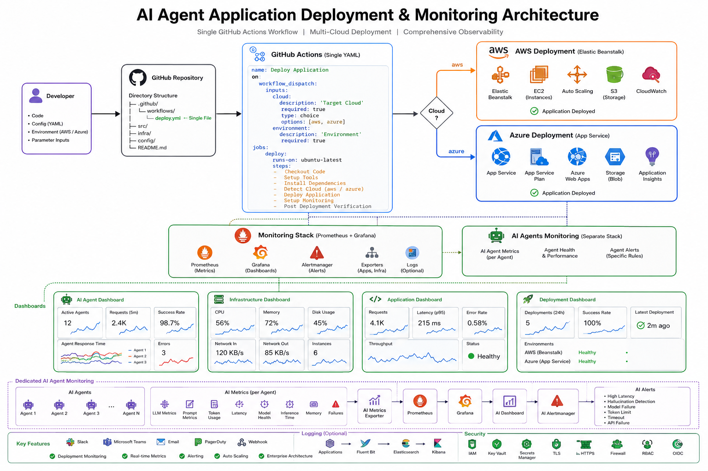

  - Data flow
- A CI agent starts and performs its assigned stage.
- The agent calculates provider/model, prompt tokens, completion tokens, total tokens, request count and execution time.
- The agent sends a JSON status event to `POST /monitor/status` using `X-Monitor-Token` authentication.
- `agent_monitor.py` updates Prometheus metrics and persists the latest agent state to `logs/agent_stats.json`.
- Prometheus scrapes the Flask `/metrics` endpoint at the configured interval.
- Grafana queries Prometheus and displays the dashboards.

- PROJECT WORKFLOW

Developer
│
▼
GitHub Repository
│
▼
GitHub Actions
(Single deploy.yml)
│
├── Checkout Code
├── Install Dependencies
├── Run Unit Tests
├── Security Scan
├── Build Docker Image
├── Push Docker Image
├── Read Inputs
│ ├── Cloud
│ ├── Environment
│ └── Monitoring
│
▼
Cloud Selection
│
├──────────────────────────────┐
│ │
▼ ▼
AWS Azure
Elastic Beanstalk App Service
EC2 App Service Plan
Auto Scaling Application Insights
CloudWatch Azure Monitor
│ │
└──────────────┬───────────────┘
▼
Monitoring Stack
│
┌──────────┴──────────┐
│ │
Prometheus Alertmanager
│
Node Exporter
cAdvisor
Blackbox Exporter
│
▼
Grafana
│
├── AI Dashboard
├── Infrastructure Dashboard
├── Application Dashboard
└── Deployment Dashboard

────────────────────────────────────

Dedicated AI Monitoring

AI Agent 1
AI Agent 2
AI Agent 3
AI Agent N
│
▼
AI Metrics Exporter
│
▼
Prometheus
│
▼
Grafana

  - GitHub Actions workflow
Stage | Description
Manual selection | The workflow is started from GitHub Actions with `cloud=aws`, `cloud=azure` or `cloud=both`.
Pre-check | The pre-deployment agent compiles Python files, validates requirements, checks Docker/deployment files and runs pytest.
Build | Docker Buildx builds the application image and pushes an immutable Git SHA tag to Docker Hub.
Deployment | The selected cloud job renders its deployment configuration and deploys the image.
Failure diagnosis | If a deployment fails, the error agent collects logs and writes a diagnosis report.
Post-check | The final agent verifies the deployed health endpoint and produces an upgrade report.
Monitoring | Agent reports and application metrics are scraped by Prometheus and visualized by Grafana.

  - Agent lifecycle
Agent | Stage | Purpose | Typical result
test_agent | Pre-deploy | Quality gate before build/deployment | Approved or rejected
errors_agent | Deploy failure | Diagnosis when AWS/Azure deployment fails | Failed diagnosis report
final_agent | Post-deploy | Health verification and improvement advice | Approved/report

- TECHNOLOGY STACK
Area | Technology | Use in project
Language | Python 3.11 | Application, agents and tooling
Web framework | Flask 3.0.3 | Routes, APIs, health and monitor receiver
WSGI server | Gunicorn 22.0.0 | Production application process
Metrics | prometheus-client 0.20.0 | Application and AI-agent Prometheus metrics
Monitoring | Prometheus 2.53.0 | Scraping, time-series storage and PromQL
Visualization | Grafana 11.1.0 | Dashboards and Prometheus visualization
Infrastructure metrics | Node Exporter 1.8.0 | Host-level metrics
Containerization | Docker and Docker Buildx | Reproducible application packaging
Registry | Docker Hub | Stores deployable immutable images
Cloud 1 | AWS Elastic Beanstalk ECS | Multi-container AWS deployment
Cloud 2 | Azure App Service | Optional multi-container Azure deployment
Automation | GitHub Actions | Pre-check, build, deploy and verification
AI provider | Google Gemini via `google-genai` | Optional AI summaries and analysis
System collection | psutil | Process and system metrics

- PROJECT FILE STRUCTURE AND RESPONSIBILITIES

Project Link : https://github.com/Saibaba-22/Sentinelops-lite-monitoring-progra-awsbs-git.git

  - FILE STRUCTURE.
- File structure of a project

IMPORTANT NOTE : This is a plain-text project file structure reference. Save each project file using its filename and file extension. Do not save Python, YAML, JSON, Dockerfile, shell-script, Markdown, HTML, CSS, JavaScript, or configuration files as .txt files.

D:.
│ .dockerignore
│ .ebignore
│ .env.example
│ .gitignore
│ agent.py
│ agent_monitor.py
│ app.py
│ docker-compose.yml
│ Dockerrun.aws.json
│ error.docx
│ errors_report.txt
│ Filestructure.txt
│ final_agent.py
│ generate_docx.py
│ requirements.txt
│ review_agent.py
│ Sentinelops-AI-Progra.rar
│ test_app.py
│ variables_secrets.txt
│
├───.ebextensions
│ 01-nginx.config
│ 02-logging.config
│
├───.github
│ └───workflows
│ awsbs.yml
│ azappser.yml
│ pipeline.yml
│
├───.platform
│ └───hooks
│ └───predeploy
│ 10-inject-private-ip.sh
│
├───.pytest_cache
│ │ .gitignore
│ │ CACHEDIR.TAG
│ │ README.md
│ │
│ └───v
│ └───cache
│ lastfailed
│ nodeids
│ stepwise
│
├───agent
│ │ errors.py
│ │ final_agent.py
│ │ monitor_client.py
│ │ single_agent.py
│ │ test_agent.py
│ │
│ └───__pycache__
│ errors.cpython-311.pyc
│ final_agent.cpython-311.pyc
│ monitor_client.cpython-311.pyc
│ single_agent.cpython-311.pyc
│ test_agent.cpython-311-pytest-8.2.0.pyc
│ test_agent.cpython-311.pyc
│
├───deployment
│ deploy-aws.sh
│ deploy-azure.sh
│ Procfile
│
├───docker
│ │ docker-compose.azure.yml
│ │ docker-compose.yml
│ │ Dockerfile
│ │
│ └───nginx
│ nginx-aws.conf
│ nginx-azure.conf
│ nginx.conf
│
├───docs
│ architecture.svg
│ DEPLOYMENT.md
│ monitoring-flow.svg
│ README.md
│ TROUBLESHOOTING.md
│
├───logs
│ agent_stats.json
│
├───monitoring
│ │ agent_state.py
│ │ collectors.py
│ │ metrics.py
│ │ __init__.py
│ │
│ ├───exporters
│ │ └───node-exporter
│ ├───grafana
│ │ ├───dashboards
│ │ │ ai-agent-dashboard.json
│ │ │ application-dashboard.json
│ │ │ deployment-dashboard.json
│ │ │ system-dashboard.json
│ │ │
│ │ └───provisioning
│ │ ├───dashboards
│ │ │ dashboard.yml
│ │ │ dashboards.json
│ │ │
│ │ └───datasources
│ │ datasource.yml
│ │
│ ├───prometheus
│ │ alert.rules.yml
│ │ prometheus.yml
│ │ recording.rules.yml
│ │
│ └───__pycache__
│ agent_state.cpython-311.pyc
│ collectors.cpython-311.pyc
│ metrics.cpython-311.pyc
│ __init__.cpython-311.pyc
│
├───reports
│ deploy_error_diagnosis.txt
│ pre_deploy_ai_review.txt
│ pre_deploy_report.txt
│
├───static
│ ├───css
│ │ dashboard.css
│ │
│ ├───images
│ └───js
│ dashboard.js
│
├───templates
│ dashboard.html
│ index.html
│
└───__pycache__
agent.cpython-311.pyc
agent_monitor.cpython-311.pyc
app.cpython-311.pyc
final_agent.cpython-311.pyc
generate_docx.cpython-311.pyc
review_agent.cpython-311.pyc
test_app.cpython-311-pytest-8.2.0.pyc
test_app.cpython-311.pyc

  - FILES AND PURPOSE
- The files used commonly in both

File Name | Purpose
app.py | Main Flask application that serves the web application, exposes APIs, health checks, metrics, and integrates monitoring components.
agent_monitor.py | Runs the AI monitoring dashboard, displays AI agent status, system health, deployment status, and monitoring pages.
requirements.txt | Lists all Python packages and dependencies required to run the application.
test_app.py | Contains unit and integration tests for the Flask application endpoints and functionality.
.dockerignore | Specifies files and folders to exclude from the Docker build context, reducing image size and build time.
.env.example | Sample environment variables file used as a template for configuring application secrets and settings.
agent/errors.py | Defines custom exception classes and error handling utilities for the AI agent.
agent/final_agent.py | Core AI agent responsible for monitoring metrics, analysing system health, generating recommendations, and automation logic.
agent/monitor_client.py | Client module that communicates with monitoring services such as Prometheus or application APIs to collect data.
agent/test_agent.py | Unit tests for validating AI agent functionality and monitoring logic.
monitoring/init.py | Initializes the monitoring package and enables module imports.
monitoring/agent_state.py | Stores and manages the current state of the AI monitoring agent, including alerts and health information.
monitoring/collectors.py | Collects infrastructure, application, deployment, and system metrics from various sources.
monitoring/metrics.py | Defines Prometheus metrics, counters, gauges, histograms, and helper functions used throughout the application.
monitoring/prometheus/prometheus.yml | Main Prometheus configuration file defining scrape targets, scrape intervals, and monitoring jobs.
monitoring/prometheus/alert.rules.yml | Defines Prometheus alerting rules for application failures, high resource usage, deployment issues, and AI agent alerts.
monitoring/prometheus/recording.rules.yml | Contains recording rules that precompute commonly used Prometheus queries to improve dashboard performance.
monitoring/grafana/dashboards/ai-agent-dashboard.json | Grafana dashboard displaying AI agent status, recommendations, alerts, and monitoring analytics.
monitoring/grafana/dashboards/application-dashboard.json | Grafana dashboard visualising application performance, requests, latency, errors, and uptime.
monitoring/grafana/dashboards/deployment-dashboard.json | Grafana dashboard showing deployment history, pipeline status, deployment duration, and release metrics.
monitoring/grafana/dashboards/system-dashboard.json | Grafana dashboard monitoring CPU, memory, disk, network, and overall infrastructure health.
monitoring/grafana/provisioning/datasources/datasource.yml | Automatically provisions Prometheus as the Grafana data source during startup.
monitoring/grafana/provisioning/dashboards/dashboard.yml | Automatically imports and provisions Grafana dashboards from the dashboards directory.
docker/Dockerfile | Defines the Docker image build process, including dependencies, application setup, and startup commands.
templates/index.html | Flask homepage template providing the application's main user interface.
templates/dashboard.html | HTML template displaying monitoring dashboards, metrics, AI insights, and system information.
.github/workflows/pipeline.yml | GitHub Actions CI/CD workflow that builds, tests, scans, and deploys the application to AWS Elastic Beanstalk or Azure App Service based on workflow inputs.

  - FILES USED ONLY IN AWS

Examples:
app.py -> save as Python file (.py)
pipeline.yml -> save as YAML workflow (.yml)
ai-agent-dashboard.json -> save as JSON file (.json)
Dockerfile -> save exactly as Dockerfile, with no .txt extension
10-inject-private-ip.sh -> save as shell script (.sh)
index.html -> save as HTML file (.html)

This reference file itself is intentionally saved as:
SentinelOps-Lite-File-Structure.txt

SENTINELOPS-LITE - RECOMMENDED ACTIVE PROJECT STRUCTURE
========================================================
.
|-- app.py # Flask public entry point
|-- agent_monitor.py # Flask app, /metrics and /monitor/status
|-- agent_monitoring.py # Optional local monitoring launcher
|-- requirements.txt # Python dependencies
|-- test_app.py # Flask and endpoint tests
|-- Dockerrun.aws.json # AWS ECS Elastic Beanstalk task definition
|-- .dockerignore # Docker build exclusions
|-- .ebignore # Elastic Beanstalk bundle exclusions
|-- .env.example # Safe configuration-name reference
|
|-- agent/
| |-- test_agent.py # Pre-deployment quality/test agent
| |-- errors.py # Deployment-failure diagnosis agent
| |-- final_agent.py # Post-deployment verification agent
| `-- monitor_client.py # Sends agent status to Flask
|
|-- monitoring/
| |-- __init__.py # Python package marker
| |-- metrics.py # Prometheus metric definitions
| |-- collectors.py # Application/system status snapshots
| |-- agent_state.py # Persisted agent-state store
| |
| |-- prometheus/
| | |-- prometheus.yml # Prometheus scrape configuration
| | |-- alert.rules.yml # Alerting rules
| | `-- recording.rules.yml # Recording rules
| |
| `-- grafana/
| |-- dashboards/
| | |-- ai-agent-dashboard.json # AI-agent dashboard
| | |-- application-dashboard.json # Application dashboard
| | |-- system-dashboard.json # System dashboard
| | `-- deployment-dashboard.json # Deployment dashboard
| |
| `-- provisioning/
| |-- datasources/
| | `-- datasource.yml # Prometheus datasource
| `-- dashboards/
| `-- dashboard.yml # Dashboard provider
|
|-- docker/
| |-- Dockerfile # Flask application image
| |-- nginx/
| | `-- nginx-aws.conf # AWS reverse-proxy configuration
| |-- docker-compose.azure.yml # Optional Azure Compose configuration
| |-- prometheus/Dockerfile # Optional Prometheus image
| `-- grafana/Dockerfile # Optional Grafana image
|
|-- templates/
| |-- index.html # Main application page
| `-- dashboard.html # Optional dashboard template
|
|-- .ebextensions/
| |-- 01-nginx.config # Elastic Beanstalk Nginx settings
| `-- 02-logging.config # Elastic Beanstalk logging settings
|
|-- .platform/hooks/predeploy/
| `-- 10-inject-private-ip.sh # AWS pre-deploy hook
|
|-- .github/workflows/
| `-- pipeline.yml # Main multi-cloud GitHub Actions workflow
|
|-- logs/ # Runtime state; do not commit secrets
|-- reports/ # CI reports and diagnostics
`-- docs/ # Project documentation

FILES TO USE FOR THE CURRENT AWS ECS PIPELINE
==============================================
app.py
agent_monitor.py
requirements.txt
test_app.py
Dockerrun.aws.json
.dockerignore
.ebignore
docker/Dockerfile
docker/nginx/nginx-aws.conf
agent/test_agent.py
agent/errors.py
agent/final_agent.py
agent/monitor_client.py
monitoring/__init__.py
monitoring/metrics.py
monitoring/collectors.py
monitoring/agent_state.py
monitoring/prometheus/prometheus.yml
monitoring/prometheus/alert.rules.yml
monitoring/prometheus/recording.rules.yml
monitoring/grafana/dashboards/ai-agent-dashboard.json
monitoring/grafana/dashboards/application-dashboard.json
monitoring/grafana/dashboards/system-dashboard.json
monitoring/grafana/dashboards/deployment-dashboard.json
monitoring/grafana/provisioning/datasources/datasource.yml
monitoring/grafana/provisioning/dashboards/dashboard.yml
templates/index.html
.github/workflows/pipeline.yml

OPTIONAL OR LEGACY FILES
========================
These can be archived if they are not called by another workflow or manual command:

agent.py
final_agent.py
review_agent.py
generate_docx.py
error.docx
Sentinelops-AI-Progra.rar
docker-compose.yml
docker/docker-compose.yml
deployment/deploy-aws.sh
deployment/deploy-azure.sh
deployment/Procfile
.github/workflows/awsbs.yml
.github/workflows/azappser.yml

GENERATED/CACHE FILES NOT TO COMMIT
===================================
__pycache__/
.pytest_cache/
*.pyc
logs/agent_stats.json
reports/*.txt
errors_report.txt

SECRET FILES NEVER TO COMMIT
============================
.env
variables_secrets.txt
AWS credentials
Docker Hub tokens
Gemini API keys
Monitor tokens
Grafana passwords

File or directory | Purpose
`app.py` | Public Flask entry point; imports `application` from `agent_monitor.py` and adds `/` and `/api`.
`agent_monitor.py` | Core Flask app, metrics endpoint, status receiver, modern monitoring page and agent-metrics API.
`agent_monitoring.py` | Optional local-only monitoring launcher/dashboard; not the AWS Flask entry point.
`agent/` | Active pre-check, error and post-deployment agents plus the monitor client.
`monitoring/` | Prometheus metric definitions, state persistence and status collectors.
`monitoring/prometheus/` | Prometheus scrape configuration and rule files.
`monitoring/grafana/` | Dashboard JSON and provisioning files.
`docker/Dockerfile` | Application image build and Gunicorn command.
`Dockerrun.aws.json` | AWS ECS task definition with Nginx, app, Prometheus, Grafana and Node Exporter.
`.github/workflows/pipeline.yml` | Main multi-cloud GitHub Actions pipeline.
`templates/` | HTML templates used by the Flask application.

Important distinction
`agent_monitor.py` is the Flask monitoring application. `agent_monitoring.py` is an optional local monitoring helper. They should not be renamed over each other.

File Path | Purpose
requirements.txt | Python dependencies
agent/test_agent.py | Pre-check agent script
agent/errors.py | Failure diagnosis agent script
agent/final_agent.py | Post-deploy verification agent
docker/Dockerfile | Main application Docker image
docker/nginx/nginx.conf | Nginx config
docker/nginx/nginx-aws.conf | Nginx config for AWS (optional, falls back to nginx.conf)
docker/docker-compose.azure.yml | Azure compose file
docker-compose.yml | AWS compose file
Dockerrun.aws.json | AWS ECS deployment manifest
monitoring/prometheus/prometheus.yml | Prometheus config
monitoring/prometheus/alert.rules.yml | Prometheus alert rules
monitoring/prometheus/recording.rules.yml | Prometheus recording rules
monitoring/grafana/provisioning/datasources/datasource.yml | Grafana datasource config
monitoring/grafana/provisioning/dashboards/dashboard.yml | Grafana dashboard provisioning
monitoring/grafana/dashboards/ai-agent-dashboard.json | Grafana dashboard JSON

7. Variables and Secrets Required

7.1 Repository variables
Variable | Sample value | Purpose
`PYTHON_VERSION` | `3.11` | Python version used by CI.
`AI_PROVIDER` | `gemini` | AI provider label.
`AI_MODEL` | `gemini-3.1-flash-lite` or `gemini-2.5-flash` | Gemini model used by agents.
`DOCKERHUB_USERNAME` | `saibaba22` | Docker Hub account name.
`DOCKERHUB_REPOSITORY` | `sentinelops-lite-monitoring-progra-awsbs-git` | Docker Hub repository.
`AWS_APP_NAME` | `agent` | Elastic Beanstalk application.
`AWS_ENV_NAME` | `agent` | Elastic Beanstalk environment.
`AWS_REGION` | `us-east-1` | AWS region.
`AZURE_WEBAPP_NAME` | `sentinelops-lite-prod` | Required only for Azure.
`AZURE_RESOURCE_GROUP` | `sentinelops-rg` | Required only for Azure.
`APP_HEALTH_PATH` | `/health` | Post-deployment health path.
`AI_RPM_LIMIT` | `15` | Display quota: requests per minute.
`AI_TPM_LIMIT` | `250000` | Display quota: tokens per minute.
`AI_RPD_LIMIT` | `500` | Display quota: requests per day.

7.2 Repository secrets
Secret | Sample format | Purpose
`DOCKERHUB_TOKEN` | `dckr_pat_...` | Push and pull Docker images.
`AWS_ACCESS_KEY_ID` | `AKIA...` | AWS authentication; OIDC is recommended for production.
`AWS_SECRET_ACCESS_KEY` | `***` | AWS authentication.
`GEMINI_API_KEY` | `***` | Optional Gemini calls and AI summaries.
`MONITOR_TOKEN_AWS` | `***` | Protects AWS `/monitor/status` POST.
`MONITOR_TOKEN_AZURE` | `***` | Protects Azure `/monitor/status` POST.
`GRAFANA_ADMIN_PASSWORD` | `***` | Grafana administrator password.
`AZURE_CREDENTIALS` | Service-principal JSON | Azure login for GitHub Actions.
`MONITOR_API_URL_AWS` | Plain monitor URL | Optional pre-check reporting URL.
`MONITOR_API_URL_AZURE` | Plain monitor URL | Optional Azure pre-check reporting URL.

Security rule
Never commit real values in `.env`, `variables_secrets.txt`, deployment manifests, logs or reports. If a real credential was previously committed, revoke and rotate it.

8. Background Processes and Runtime Behavior

8.1 Flask startup
- Gunicorn imports `app:application`.
- `app.py` imports the Flask object from `agent_monitor.py`.
- `agent_monitor.py` registers routes and initializes Prometheus metrics.
- A daemon metrics updater refreshes process and system gauges at the configured interval.
- The app listens on `0.0.0.0:5000` inside the container.

8.2 Prometheus background process
Prometheus runs as a separate container and scrapes the Flask application through the internal service name `app:5000`. It also scrapes itself and Node Exporter. The public Nginx path is `/prometheus/`, while internal service-to-service access uses the Prometheus container address.

8.3 Grafana background process
Grafana runs on port 3000 and is exposed publicly through `/grafana/`. At startup, provisioning creates or updates the Prometheus datasource and loads dashboard JSON files from the configured dashboard directory.

8.4 Agent status persistence
Each accepted agent report updates in-memory Prometheus metrics and persists the latest state in `logs/agent_stats.json`. The persisted JSON supports the HTML monitor and provides continuity for latest status information, while historical charts require Prometheus samples over time.

9. Monitoring, Metrics and Dashboards

9.1 Application endpoints
Endpoint | Purpose
`/` | Main application page
`/api` | Version and build information
`/health` | Load balancer and deployment health probe
`/metrics` | Prometheus exposition endpoint
`/api/status` | Aggregated application/system/deployment snapshot
`/agent/status` | Latest agent status JSON
`/api/agent-metrics` | Real Prometheus-based agent totals and quotas
`/monitor/status` GET | Modern browser monitoring page
`/monitor/status` POST | Authenticated CI-agent status receiver
`/prometheus/` | Public Prometheus UI/API through Nginx
`/grafana/` | Public Grafana UI through Nginx

9.2 AI-agent metrics
Metric | Meaning
`agent_state` | Current state by agent, stage, cloud and state label.
`agent_last_decision` | Latest decision by agent.
`agent_model_info` | Provider and model identity.
`agent_prompt_tokens_total` | Cumulative prompt tokens.
`agent_completion_tokens_total` | Cumulative completion tokens.
`agent_token_usage_total` | Cumulative total tokens.
`agent_api_calls_total` | Cumulative API requests by status.
`agent_tasks_total` | Completed agent tasks by result.
`agent_last_run_timestamp_seconds` | Timestamp of the most recent report.
`agent_execution_time_seconds` | Latest execution duration.

9.3 Quota presentation
The modern monitor displays quota-style values such as `RPM 3 / 15`, `TPM 1.07K / 250K` and `RPD 30 / 500`. The current values are derived from Prometheus counters and recent-window calculations. The limits are display configuration values and should be aligned with the provider quota assigned to the project.

10. Deployment Model

10.1 AWS Elastic Beanstalk ECS
The current AWS environment uses the ECS-based Elastic Beanstalk platform. `Dockerrun.aws.json` defines the application, Nginx, Prometheus, Grafana and Node Exporter containers. Nginx exposes port 80, while the other services communicate within the ECS task and are routed through Nginx paths.

10.2 Azure App Service
The Azure path uses a multi-container Compose configuration. Azure exposes the web-facing Nginx service publicly and routes monitoring paths internally. Azure and AWS require separate cloud variables and monitor tokens.

10.3 Registry and image strategy
The pipeline builds the application image using the GitHub SHA as an immutable image tag. Docker Hub stores the image, and the selected cloud deployment references the same build tag. This prevents a deployment from accidentally using a different image than the one tested by CI.

11. Result
The completed SentinelOps-Lite sample demonstrates a working multi-cloud application delivery pattern with a Flask service, Prometheus instrumentation, Grafana visualization, infrastructure metrics and AI-agent release stages.
- The application exposes health, API and metrics endpoints.
- Prometheus can scrape application and infrastructure metrics.
- Grafana can use the provisioned Prometheus datasource and dashboards.
- The pipeline supports manual selection of AWS, Azure or both targets.
- AI-agent status can be associated with an agent name, model, stage, cloud, token usage and API request counts.
- Deployment failures can be diagnosed using uploaded reports and cloud logs.
Operational interpretation
An agent card marked “not reported” is not a fabricated zero. It means that agent has not sent an accepted report in the current metrics history. For a successful deployment, `test_agent` and `final_agent` are normally active; `errors_agent` runs when a deployment failure occurs.

12. Learning Outcomes
Learning area | Outcome
Cloud deployment | Understand how one containerized application can be prepared for AWS and Azure.
CI/CD design | Build a staged pipeline with pre-check, build, deploy, diagnosis and post-check phases.
Prometheus instrumentation | Define counters, gauges, histograms and labels for application and AI activity.
Grafana visualization | Connect a datasource, provision dashboards and write PromQL queries.
AI-agent observability | Track which agent ran, which model was used, how many tokens were consumed and how many calls were made.
Incident diagnosis | Read ECS, Elastic Beanstalk, Docker and application logs to identify startup failures.
Configuration management | Separate source templates, environment variables and secrets.
Security awareness | Avoid committing API keys, cloud credentials, monitor tokens and passwords.
Debugging methodology | Trace data through the complete path: agent → Flask → Prometheus → Grafana.

13. Limitations and Future Enhancements
- Use GitHub OIDC instead of long-lived AWS access keys.
- Store Prometheus data on durable storage or use a managed metrics service.
- Use a durable shared state store if multiple application replicas must share agent state.
- Add a dedicated Alertmanager and notification channels.
- Add integration tests that verify the complete agent-report-to-Grafana path.
- Use a secrets manager for Grafana, monitor tokens and AI credentials.
- Add deployment rollback automation after failed health verification.
- Separate development, staging and production cloud environments.

14. Conclusion
SentinelOps-Lite provides a practical sample of a cloud-ready application with AI-assisted delivery and integrated monitoring. Its main value is the end-to-end connection between deployment automation and operational evidence: the project validates code before release, diagnoses failures during release, verifies the service after release, and exposes measurable application and agent behavior through Prometheus and Grafana.
The project is also designed as a learning foundation. The architecture is intentionally understandable: Flask serves the application, AI agents report events, Prometheus stores metrics, Grafana visualizes them, and GitHub Actions coordinates the lifecycle across cloud targets.

Appendix A: Quick verification checklist
- `python -m py_compile app.py agent_monitor.py` passes.
- `pytest -q` passes.
- Docker image builds successfully.
- `/health` returns HTTP 200.
- `/metrics` returns Prometheus exposition text.
- Prometheus target `flask-app` is UP.
- Grafana datasource Save & Test succeeds.
- AI-agent dashboard is visible.
- Agent reports appear in `/monitor/status` and `/api/agent-metrics`.
- No real secrets are present in Git history or deployment files.

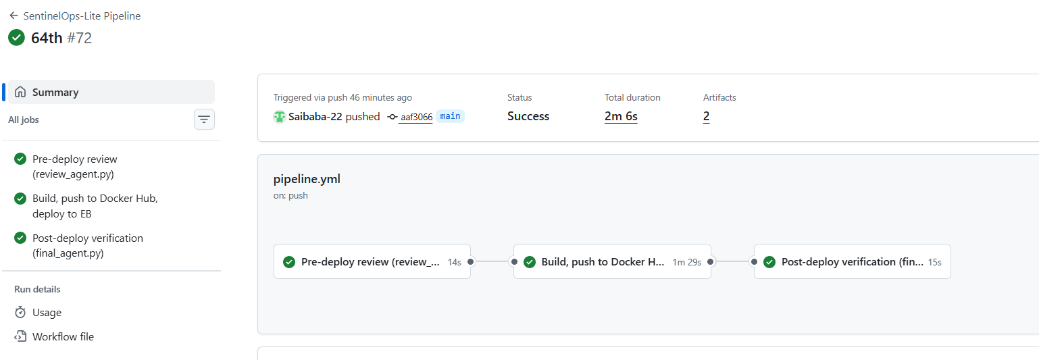

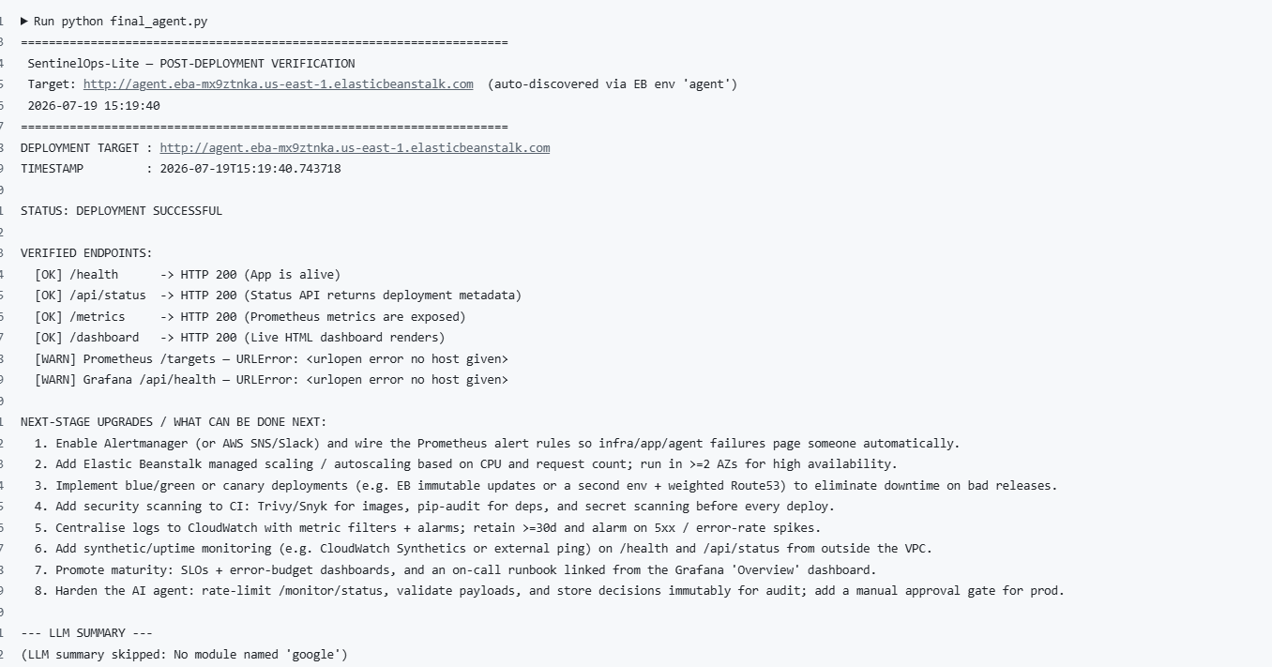

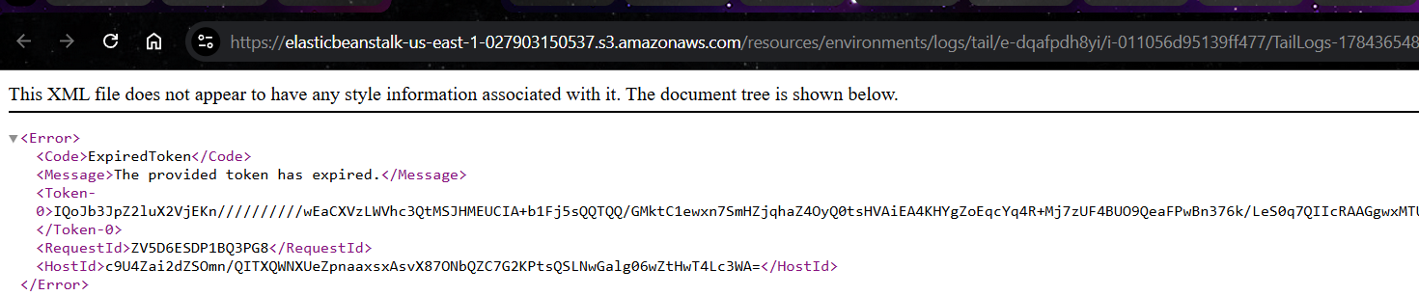

I found the problem.
It is not Docker Hub, not Elastic Beanstalk, and not GitHub Actions.
The problem is your deployment/deploy.sh.

Your script is doing too many things
It:
- builds Docker
- pushes Docker
- edits Dockerrun.aws.json
- edits docker-compose.yml
- creates deploy.zip twice
- runs envsubst
- runs eb init
- runs eb status
- runs eb printenv
- creates another ZIP
- finally runs eb deploy
It is over 260 lines and mixes deployment with debugging.

If host.docker.internal is not known yet, that’s expected until you redeploy with extra_hosts.

If host-gateway is not supported on your platform
Then the backup alternative is to map:
YAML
extra_hosts:
- "host.docker.internal:172.17.0.1"
because the Docker bridge host is often 172.17.0.1.
But try host-gateway first.

PROM=$(docker ps -q --filter ancestor=prom/prometheus:v2.53.0)
docker inspect -f '{{range .NetworkSettings.Networks}}{{.Gateway}}{{end}}' "$PROM"

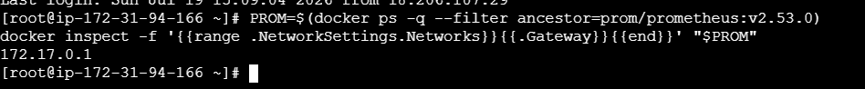

Queries for ai agent
Current Agent State
Running
Agent State Timeline
Task Outcomes
Token Usage (tokens/sec)
API Calls (success/failed)
API Response Time (s)
Queue Size
Agent Accuracy
Execution Time (last / avg)

Recommended Prometheus metrics + Grafana queries
Use these metric names in your app, then use these queries.

1) Current Agent State

Best metric
text
agent_running
Gauge:
- 1 = running
- 0 = not running

Query
promql
agent_running

Grafana
Use a Stat panel with value mapping:
- 1 -> Running
- 0 -> Stopped

2) Agent State Timeline

Best metric
text
agent_state{state="idle|running|waiting|error"}
Gauge, one-hot style:
- running = 1, others = 0
Example:
text
agent_state{state="idle"} 0
agent_state{state="running"} 1
agent_state{state="waiting"} 0
agent_state{state="error"} 0

Query
promql
agent_state

Grafana
Use State timeline panel.

3) Task Outcomes

Best metric
text
agent_tasks_total{outcome="success|failed|timeout|cancelled"}
Counter

Query
promql
sum by (outcome) (increase(agent_tasks_total[$__range]))

Grafana
Use Pie chart, Bar chart, or Time series.

4) Token Usage (tokens/sec)

Best metric
text
agent_tokens_total{type="input|output"}
Counter

Query
Total:
promql
sum(rate(agent_tokens_total[$__rate_interval]))
Split by input/output:
promql
sum by (type) (rate(agent_tokens_total[$__rate_interval]))

5) API Calls (success/failed)

Best metric
text
agent_api_calls_total{status="success|failed"}
Counter

Query
promql
sum by (status) (increase(agent_api_calls_total[$__range]))
If you want per-second:
promql
sum by (status) (rate(agent_api_calls_total[$__rate_interval]))

6) API Response Time (s)

Best metric
Histogram:
text
agent_api_response_seconds_bucket
agent_api_response_seconds_sum
agent_api_response_seconds_count

Avg response time
promql
sum(rate(agent_api_response_seconds_sum[$__rate_interval]))
/
sum(rate(agent_api_response_seconds_count[$__rate_interval]))

P95 response time
promql
histogram_quantile(0.95, sum by (le) (rate(agent_api_response_seconds_bucket[$__rate_interval])))

P99 response time
promql
histogram_quantile(0.99, sum by (le) (rate(agent_api_response_seconds_bucket[$__rate_interval])))

7) Queue Size

Best metric
text
agent_queue_size
Gauge

Query
promql
agent_queue_size

8) Agent Accuracy

Best metric option A
text
agent_predictions_correct_total
agent_predictions_total
Counters

Query
promql
100 *
sum(rate(agent_predictions_correct_total[$__rate_interval]))
/
sum(rate(agent_predictions_total[$__rate_interval]))

Best metric option B
If you expose direct gauge:
text
agent_accuracy_ratio

Query
promql
agent_accuracy_ratio * 100

9) Execution Time (last / avg)

Best metric
Histogram or summary:
text
agent_execution_seconds_bucket
agent_execution_seconds_sum
agent_execution_seconds_count

Average execution time
promql
sum(rate(agent_execution_seconds_sum[$__rate_interval]))
/
sum(rate(agent_execution_seconds_count[$__rate_interval]))

Last execution time
Best if you expose a direct gauge:
text
agent_last_execution_seconds

Query
promql
agent_last_execution_seconds
If you do not expose that gauge, Prometheus cannot reliably show “last execution time” from only a histogram.

Best full metric set for your app
If you want this dashboard to work cleanly, expose these metrics:
text
agent_running
agent_state{state="idle|running|waiting|error"}
agent_tasks_total{outcome="success|failed|timeout|cancelled"}
agent_tokens_total{type="input|output"}
agent_api_calls_total{status="success|failed"}
agent_api_response_seconds_bucket
agent_queue_size
agent_predictions_correct_total
agent_predictions_total
agent_execution_seconds_bucket
agent_last_execution_seconds

q. REASON: The test command exited with a non-zero code, indicating failures where the /agent/status endpoint returned a JSON object lacking the expected top-level 'status' key.
a.
@application.route("/agent/status")
def agent_status():
"""
Return backward-compatible top-level agent status plus all three agents.

Top-level fields keep existing tests/dashboard clients working.
The `agents` field contains detailed per-agent monitoring state.
"""

state_data = agent_state_store.load()
agents = state_data.get("agents", {})

# Select the agent with the newest last_run value as the summary agent.
latest_agent = {}

for agent_data in agents.values():
if not latest_agent:
latest_agent = agent_data
continue

if str(agent_data.get("last_run") or "") > str(
latest_agent.get("last_run") or ""
):
latest_agent = agent_data

# Fallback values preserve old /agent/status response behavior.
response = {
"status": latest_agent.get("status", state_data.get("status", "Idle")),
"decision": latest_agent.get(
"decision",
state_data.get("decision", "none"),
),
"provider": latest_agent.get(
"provider",
state_data.get("provider", "gemini"),
),
"model": latest_agent.get(
"model",
state_data.get("model", "gemini-2.5-flash"),
),
"prompt_tokens": latest_agent.get(
"prompt_tokens",
state_data.get("prompt_tokens", 0),
),
"completion_tokens": latest_agent.get(
"completion_tokens",
state_data.get("completion_tokens", 0),
),
"total_tokens": latest_agent.get(
"total_tokens",
state_data.get("total_tokens", 0),
),
"tokens": latest_agent.get(
"total_tokens",
state_data.get("tokens", 0),
),
"requests": latest_agent.get(
"requests",
state_data.get("requests", 0),
),
"api_key_count": latest_agent.get(
"api_key_count",
state_data.get("api_key_count", 0),
),
"api_keys": latest_agent.get(
"api_key_count",
state_data.get("api_keys", 0),
),
"last_run": latest_agent.get(
"last_run",
state_data.get("last_run"),
),
"execution_time_seconds": latest_agent.get(
"execution_time_seconds",
state_data.get("execution_time_seconds", 0),
),

# New detailed data for all three CI agents.
"agents": agents,
}

return jsonify(response)

q. REASON: The test failed because the agent status returned from '/agent/status' was 'approved' (lowercase) instead of the expected 'Approved' (title case)

a. change approved to Approved

q. REASON: The test failed due to a case-sensitivity mismatch where the stored agent status 'approved' did not match the expected 'Approved'.

q.
in agent_monitor.py
"status": latest_agent.get("status", state_data.get("status", "Idle")),

Change to
"status": str(
latest_agent.get("status", state_data.get("status", "Idle"))
).capitalize(),

- Search as “Elastic Bean Stalk”
- Select “environment” from side bar
- Now if you get Upgrade to new version at top right click on it and move to new version
- Else leave it
- Environment details
- Application name : agent
- Environment name : agent
- Platform details :
  - Platform : Docker
  - Platform branch : ECS running on 64bit Amazon Linux 2023
- Infrastructure : ( it is shown optional but we need to use to change cpu and memory increase)
  - Compute
  - Instance type : c7i-flex-large ( 2 CPU 4 GB RAM)
  - Instance type : m7i-flex-large ( 2 CPU 8GB RAM)
- Click on “Create”

QUESTIONS AND ANSWERS

Q. does this dockerrun.aws.json is used by azure also or only aws

A. Dockerrun.aws.json — AWS Only ❌ Azure Cannot Use It

App used by cloud

What You Need for Each Platform

AWS Elastic Beanstalk
text
your-project/
├── Dockerrun.aws.json ← AWS reads this
├── docker/
│ └── nginx-ecs/
│ └── default.conf
└── monitoring/
└── prometheus/
└── prometheus.yml

Azure App Service
text
your-project/
├── docker-compose.yml ← Azure reads this
├── docker/
│ └── nginx/
│ └── default.conf
└── monitoring/
└── prometheus/
└── prometheus.yml

AWS Beanstalk expects:
1. File MUST be named "application.py" (not app.py)
2. Variable MUST be named "application" (not app)
3. WSGIPath must point to "application:application"
4. requirements.txt MUST exist (even if empty)
5. Flask routes must handle Beanstalk health check at "/"

File structure

your-project/
├── application.py ← MUST be this name
├── requirements.txt ← MUST exist
├── Procfile ← Tells Beanstalk how to run
└── .ebextensions/
└── 01_flask.config ← Beanstalk configuration

Common Beanstalk Errors and Fixes
Error | Cause | Fix
Not Found | Wrong filename | File MUST be application.py
Method Not Allowed | No WSGI app | Use Flask, not HTTPServer
502 Bad Gateway | gunicorn crash | Check requirements.txt has flask
Health check fail | No / route | @application.route("/") returns 200
Module not found | Missing deps | requirements.txt must list flask
Import error | Wrong variable | Must be application = Flask(...)

✅ AI Scanner loaded → /scanner
✅ app.py loads correctly
Routes:
GET /
GET /health
GET /api
GET /api/status
GET /agent/status
GET /metrics
POST /monitor/status
GET /scanner ← scanner working
GET /scanner/api/scan
GET /scanner/api/rescan

Common error faced

Error 1

Deploying new version to instance(s).
2026-07-30 16:07:18 ERROR ECS task stopped due to: Task failed to start. (grafana: prometheus: nginx: app: node-exporter: )
2026-07-30 16:07:29 ERROR Failed to start ECS task: arn:aws:ecs:us-east-1:027903150537:task/awseb-agent-kgjm9snfkv/44466e2c222e46dd8e2ca2c4cfec1dd0 is STOPPED.
2026-07-30 16:07:29 ERROR ECS task stopped due to: Task failed to start. (node-exporter: prometheus: grafana: app: nginx: )
2026-07-30 16:07:33 ERROR Instance deployment failed. For details, see 'eb-engine.log'.
2026-07-30 16:07:34 ERROR [Instance: i-036b7b9ec81821674] Command failed on instance. Return code: 1 Output: Engine execution has encountered an error..
2026-07-30 16:07:34 INFO Command execution completed on all instances. Summary: [Successful: 0, Failed: 1].
2026-07-30 16:07:34 ERROR Unsuccessful command execution on instance id(s) 'i-036b7b9ec81821674'. Aborting the operation.
2026-07-30 16:07:34 ERROR Failed to deploy application.
ERROR: ServiceError - Failed to deploy application.
Error: Process completed with exit code 4.

Nginx conf issue

What to change in awsbs.yml:
Just these 3 lines in the "Render AWS ECS Dockerrun manifest" step:
1. Python section — change the sourcePath:
Python
# FIND:
volume.setdefault("host", {})["sourcePath"] = "/var/app/current/docker"

# REPLACE WITH:
volume["host"]["sourcePath"] = "/var/app/current/docker/nginx-ecs"
2. Bash section — change the target directory:
Bash
# FIND:
mkdir -p docker/nginx
cp "$source" docker/nginx/default.conf

# REPLACE WITH:
mkdir -p docker/nginx-ecs
cp "$source" docker/nginx-ecs/default.conf
3. Git add line:
Bash
# FIND:
git add Dockerrun.aws.json docker/nginx/default.conf .ebignore

# REPLACE WITH:
git add Dockerrun.aws.json docker/nginx-ecs/default.conf .ebignore
That's it — just 3 small line changes. Commit and redeploy!

Error

@application.post("/monitor/status", methods=["GET", "POST"])

This is invalid! @application.post() doesn't accept a methods parameter. It's a shortcut that ONLY allows POST. You're mixing two different decorator styles.
This causes Flask to crash on startup → app container dies → ECS task fails.

Fix — change this ONE line:
Find:
Python
@application.post("/monitor/status", methods=["GET", "POST"])
Replace with:
Python
@application.route("/monitor/status", methods=["GET", "POST"])

