- AZURE VPN

- AZURE WITH AWS VPN AND PING AZURE FROM AWS
- Infrastructure in Azure
- Create Resource Group : SaiVPN

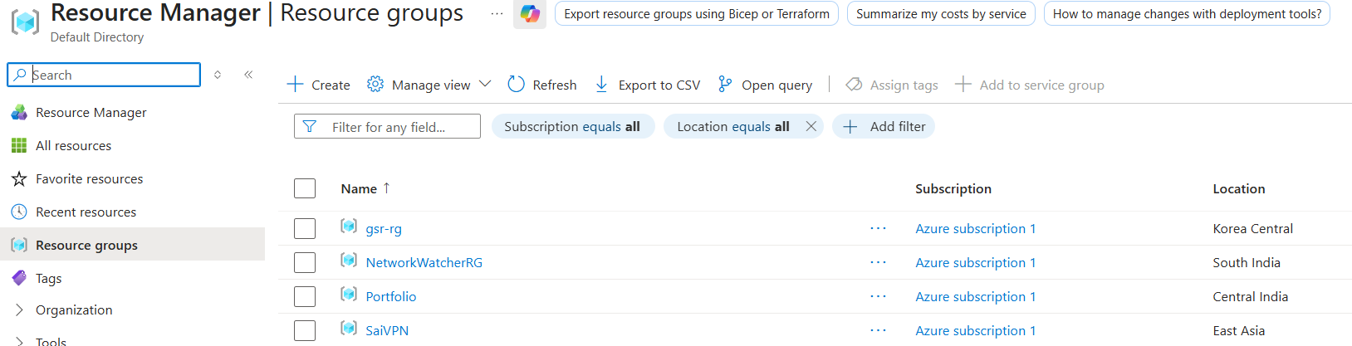

- Create Vnet : SaiVPNVnet

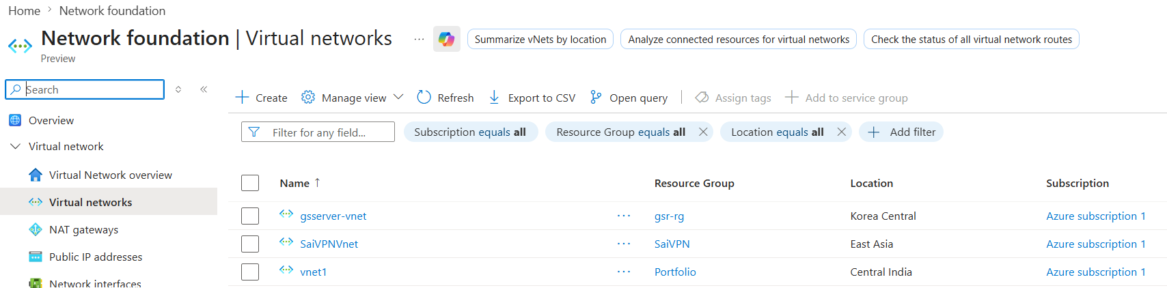

- Create Subnet in Vnet and while select subnet type as Dedicated gateway : GatewaySubnet and serversai

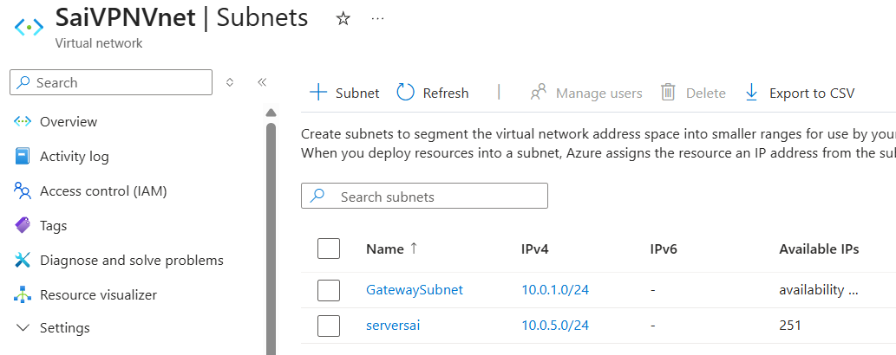

- Create a Virtual Machine : vpnserver

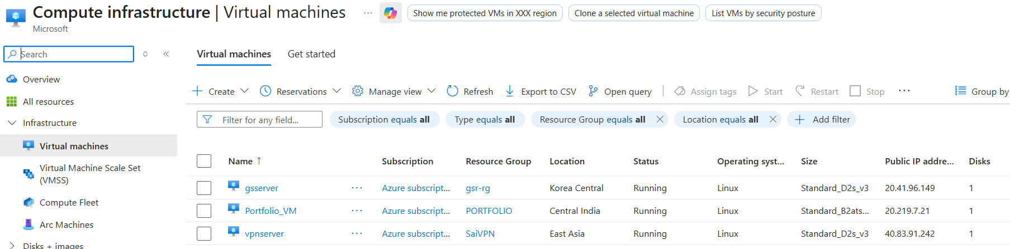

- Building Infrastructure in Azure Done

- Build infrastructure in AWS
- Create VPC :

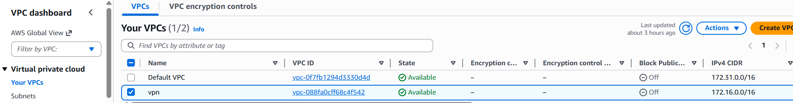

- Create subnet :

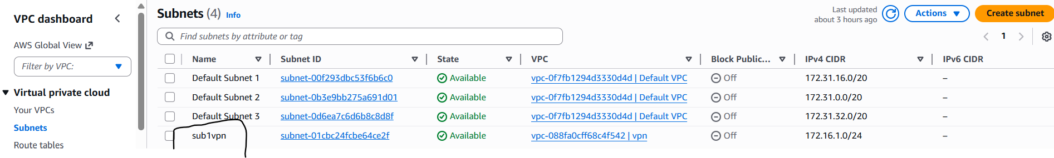

- Create Internet Gateway and attach to VPC

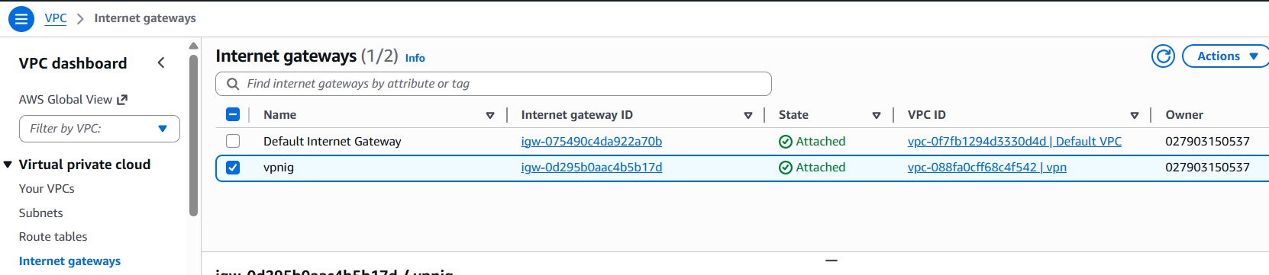

- Rename Route Table and edit Routes :

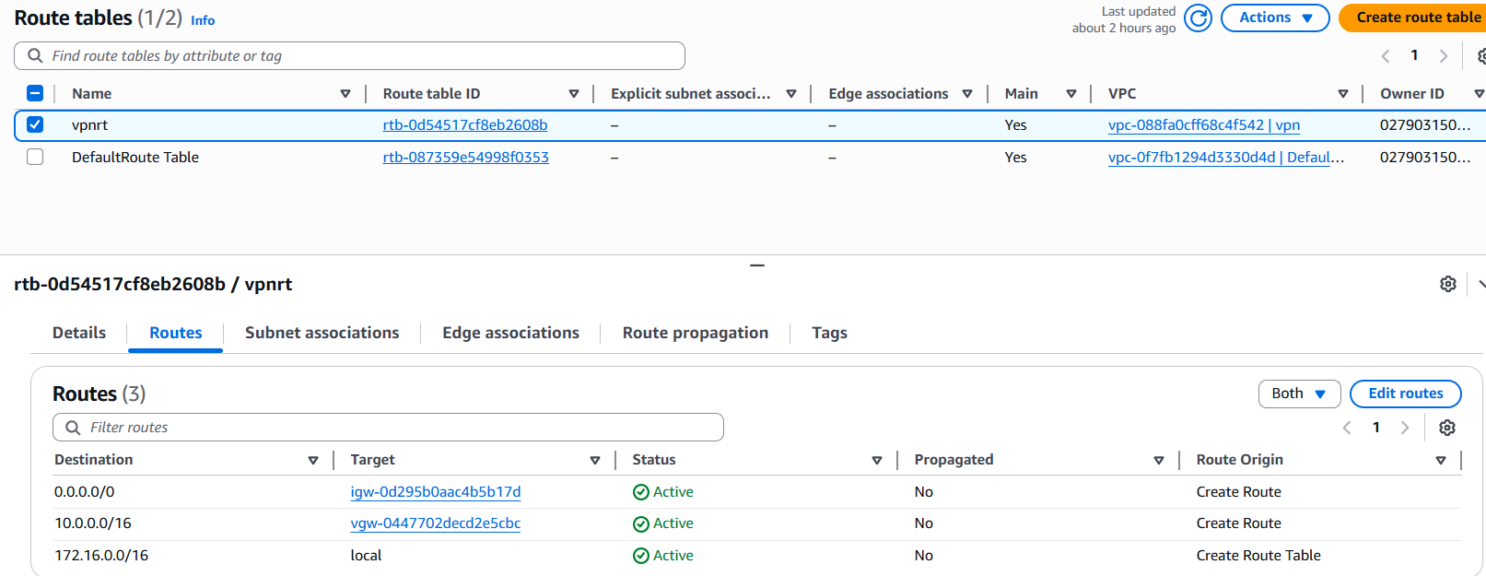

- Rename Security Group and edit Rules :

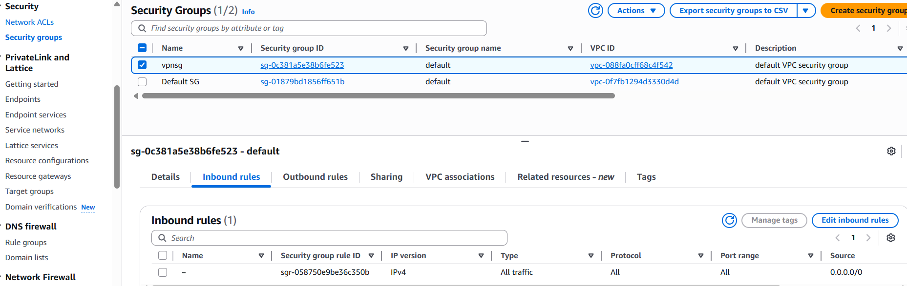

- Create EC2 :

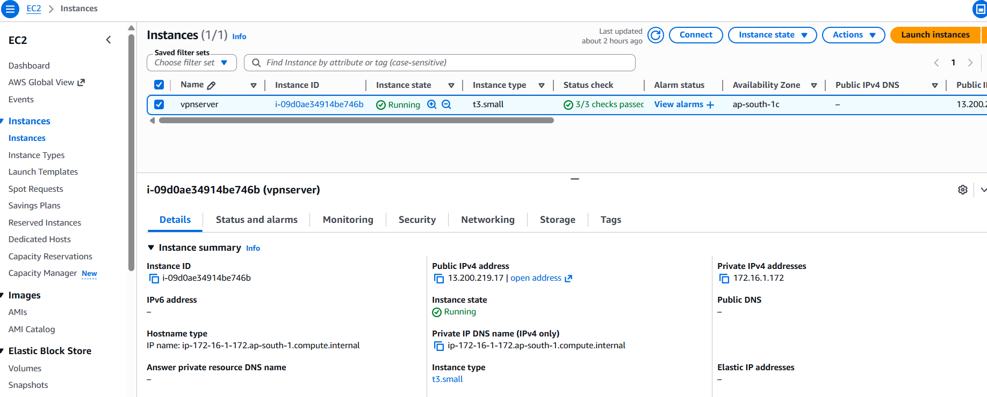

- VPN SETUP
- Start Building VPN setup in Azure Virtual Network – VPN Gateway
- As it is used in AWS VPN setup
- In Azure, Type in search bar Virtual Private gateway complete else it won’t show

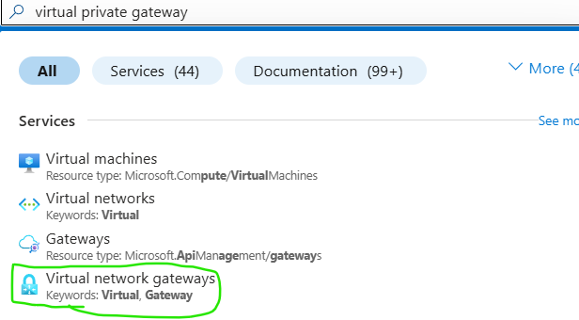

- Select Virtual Network Gateways

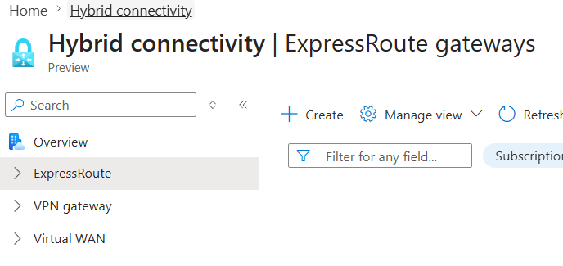

- From left bar select VPN gateway -> VPN gateway

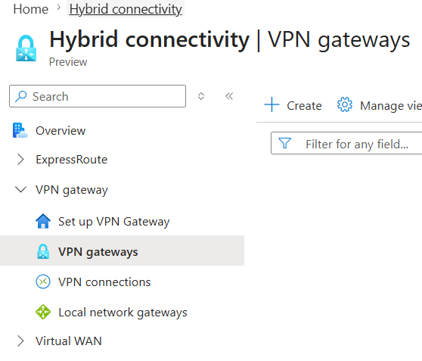

- Click on create
- Basic
  - Name : any
  - Region : East Asia
- Gateway Configuration :
  - Gateway Type : VPN
  - SKU : VpnGw1AZ
  - Virtual Network : select yours
  - Subnet : Default selected
- If Gatewaysubnet is not created before it shows error

- Public IP :
  - Public IP : Create new
  - Public ip address name : any
  - Enable active-active mode : Disabled
  - Configure BGP : Disabled
- Review and Create -> create

- Takes time to create 10 to 15 minutes

- AWS VPN Setup
- From VPC left bar
- Under Virtual Private network (VPN)
- You can find Virtual Private Gateways need for VPN

- Name : any
- Create

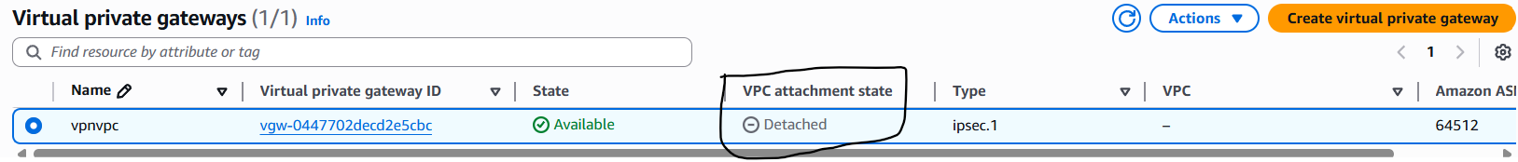

- Its clarly not attached to vpc

- Click on actions and attach vpc

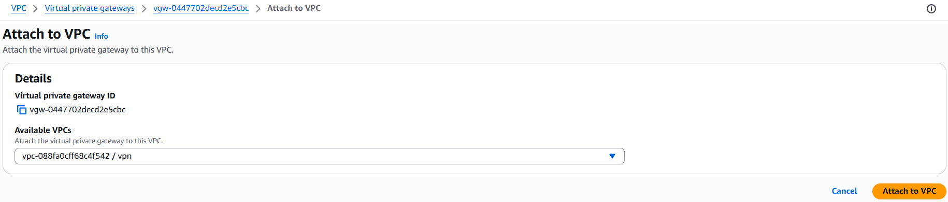

- Now vpc attached

- Customer Gateway
- From Left bar Under Virtual Private Network,
- Select Customer gateway

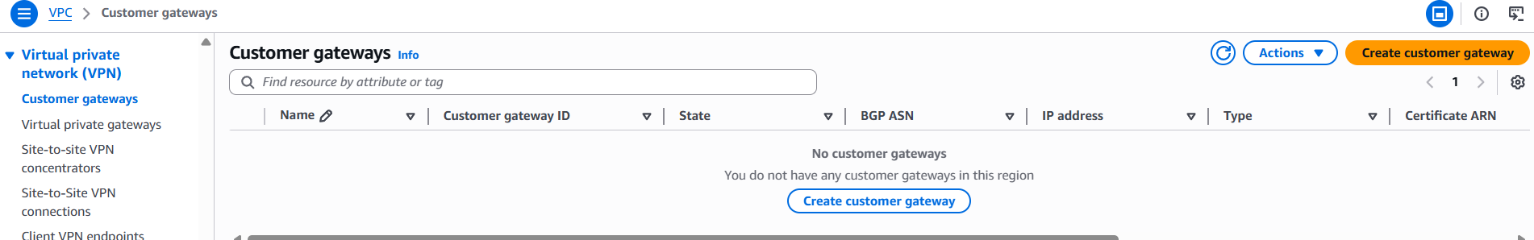

- Click on Create Customer Gateway
- Fill Details :
  - Name tag : azurevpn
  - BGP ASN : 65000 (default )
  - Ip address : provide azure vpn public ip
  - Certificate ARN : leave it
  - Device optional : choice
  - Create gateway

- After creating Customer Gateway

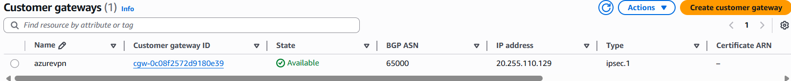

- Now SITE TO SITE VPN CONNECTIONS
- From left bar under Virtual Private Network (VPN)
- Select site to site VPN connections

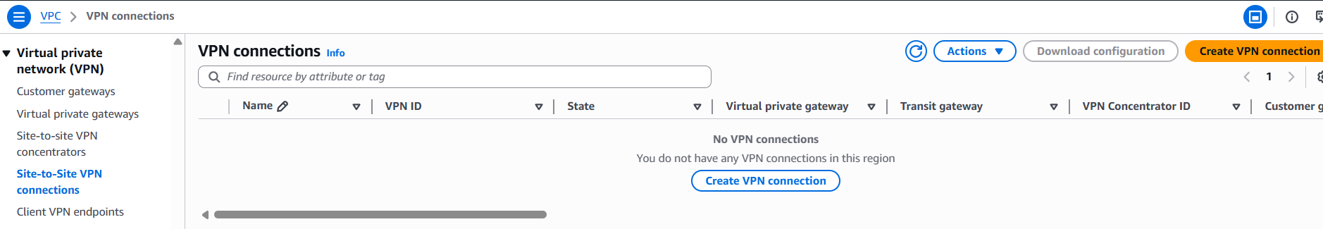

- Create VPN connection
- Fill details :
  - Name tag : any
  - Target gateway type : select virtual private gateway
  - Virtual private gateway : select id
  - Customer gateway : existing
  - Customer gateway id : select created id
  - Routing Options : static
  - Routing IP prefix : Azure VM’s Vnet range

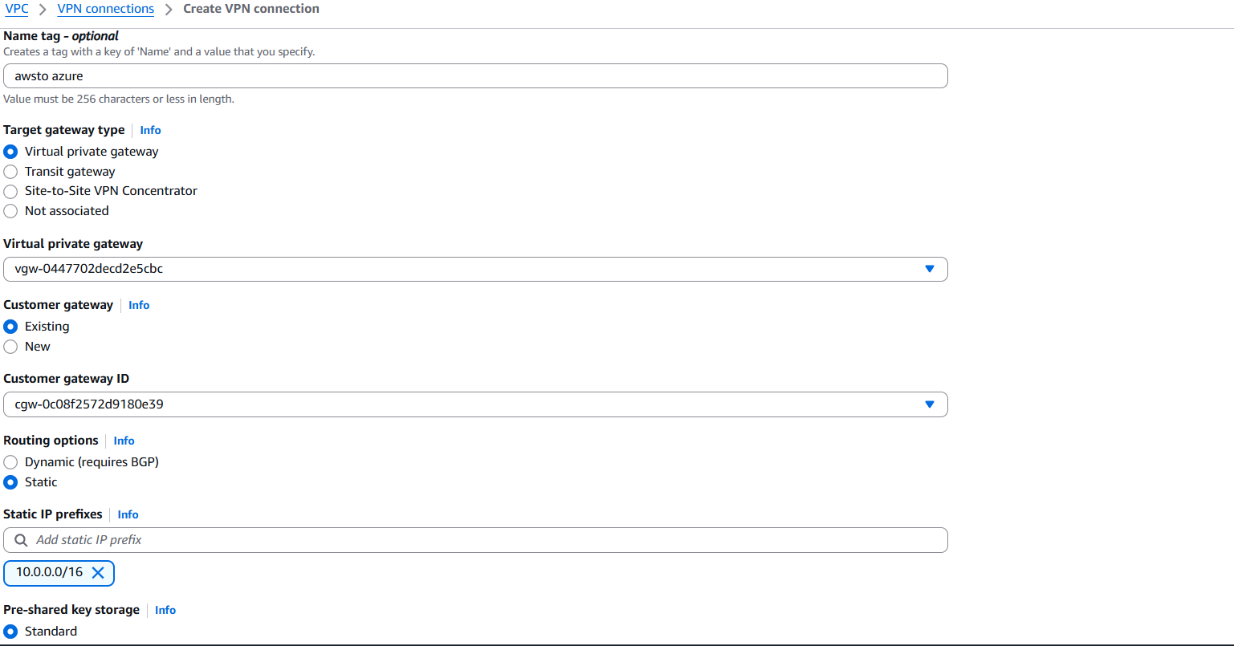

- After creating VPN connection

- Go to Route table and write rules
  - Destination : 10.0.0.0/16 | Target : Virtual Private Gateway | Tag : VPGid

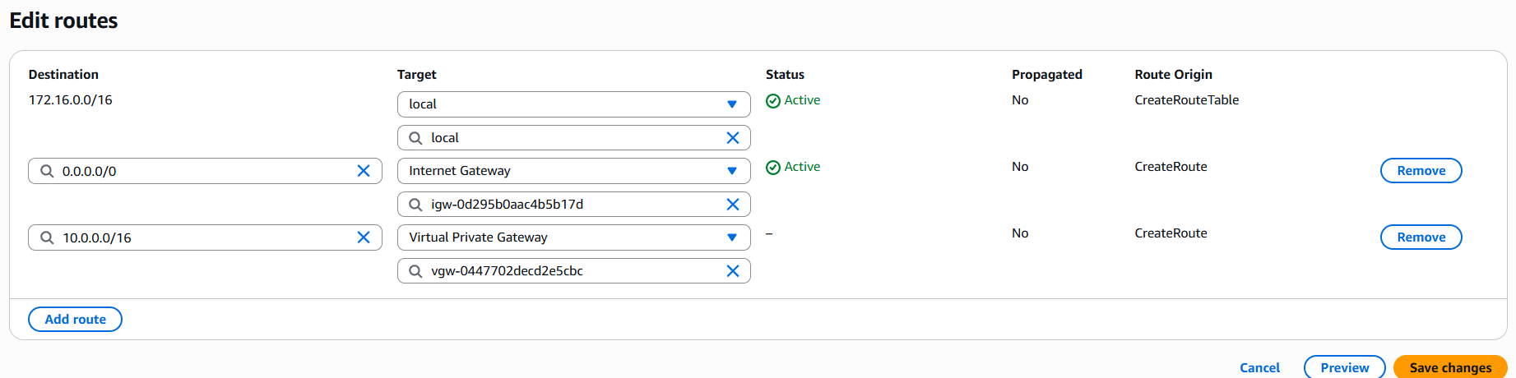

- Click on site to site connections and select connection
- Download configuration gets active, select it

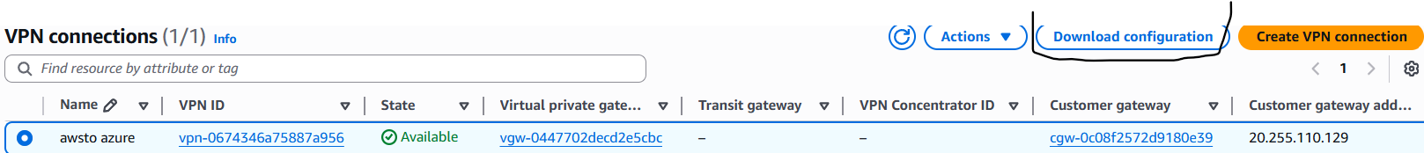

- Select details and download
  - Vendor : Cisco Systems, inc
  - Platform : ASA 5500 Series
  - ASA : 8.2+
  - IKE version : ike1
- Select download, a notepad is downloaded



- From Azure Setup Open VPN gateway and create connection
- Search Local Network Gateway and select it

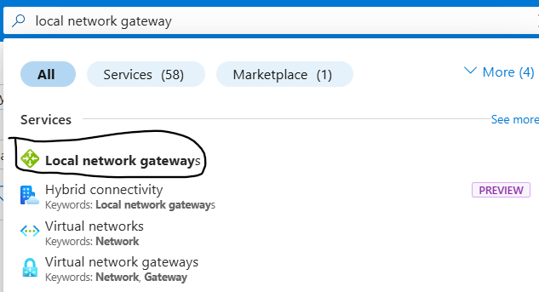

- Click on create
- Fill details :
  - Resource Group : SaiVPN ( select your resource group)
  - Region : east asia
  - Name : any
  - Public IP address : AWS VPN public ip

- Open downloaded Note pad and search tunnel-group xx.xx.xx.xx type ipsec-l2l
- The ip address is aws vpn ip

  - Address Space : AWS VPC private address range
- From AWS select VPC -> details -> copy IPv4 ICDR range

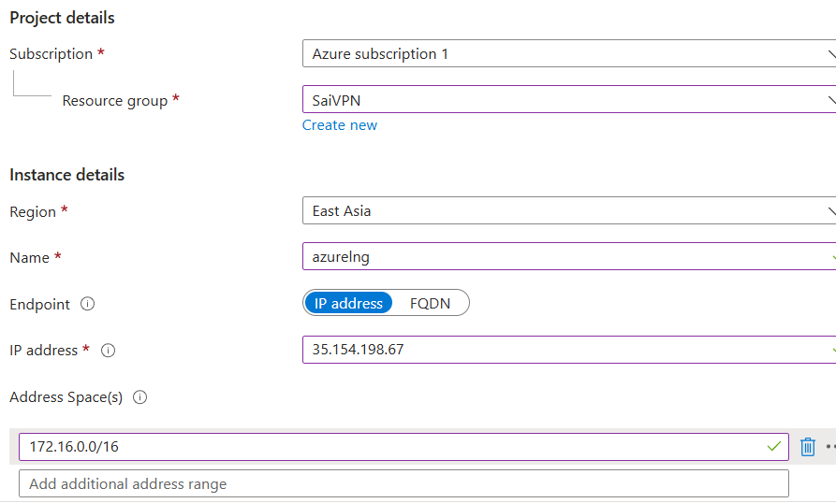

- Review and create -> create

- Now open VPN gateway from Azure
- Select VPN -> settings -> Connections

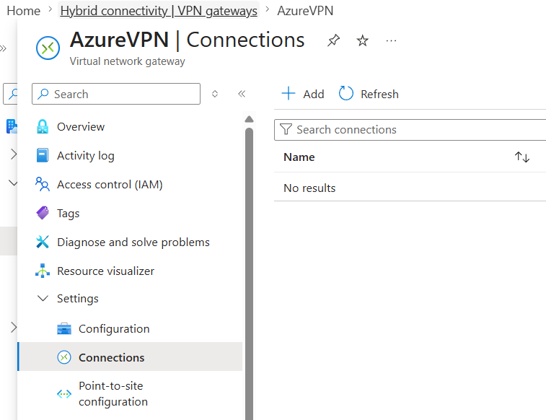

- Select add
- Basic :
  - Resource Group : SaiVpn ( select yours )
  - VPN Type : Site to site
  - Name : any
  - Region : east Asia
- Settings :
  - Virtual Network Gateway : select existing gateway
  - Local Network Gateway : select existing gateway
  - Authentication Method : shared key
  - Shared Key :
Find in notepad : search pre-shared-key that is key
  - Next
  - Review and Create -> Create
- Connection created but status is pending

- Now try to connect vm to ec2 and reverse Before status success
- From Azure to AWS

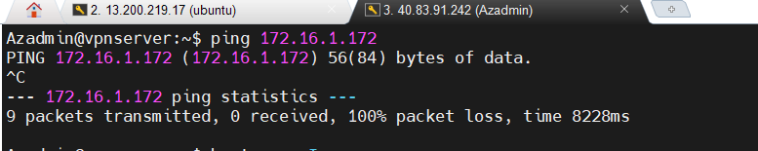

- From AWS to Azure

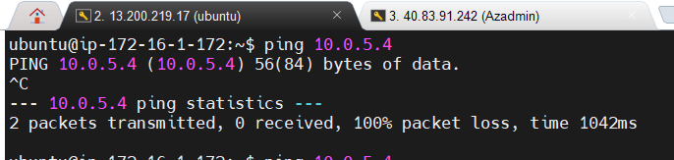

- Wait until the status becomes connected
- Now status is connected

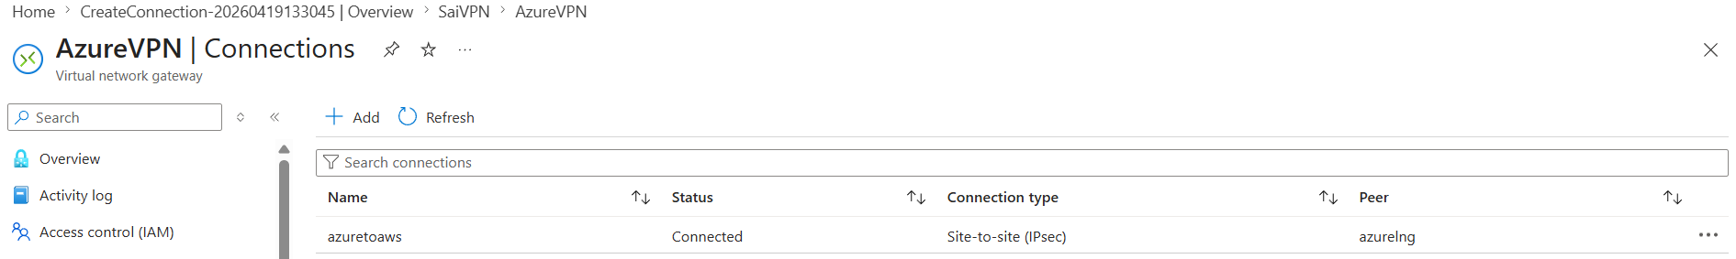

- After Success Now try to connect from Aws to azure and reverse
- From azure to AWS

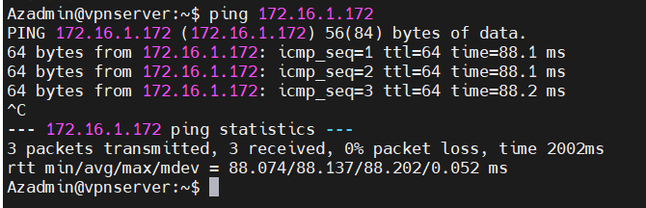

- From AWS to Azure

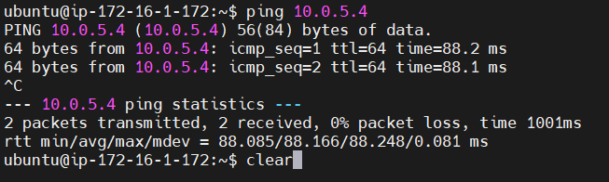

- TASK Create one more VPC and and ec2 ping from Azure vm to AWS ec2 2

