# **Exercise 1: Implementing the Singleton Pattern**

**Singleton Pattern Code:**

package Singleton;

public class Logger {

private static Logger instance = new Logger();

private Logger() {

System.*out*.println("Logger instance created");

}

public static Logger getInstance() {

return instance;

}

public void log(String message) {

System.*out*.println("LOG: " + message);

}

}

**Test the Singleton Implementation:**

package Singleton;

public class LoggerTest {

public static void main(String[] args) {

Logger logger1 = Logger.*getInstance*();

Logger logger2 = Logger.*getInstance*();

logger1.log("This is the first log message.");

logger2.log("This is the second log message.");

if (logger1 == logger2) {

System.*out*.println("Both logger instances are the same. Singleton works!");

} else {

System.*out*.println("Logger instances are different. Singleton failed.");

}

}

}

**Output:**

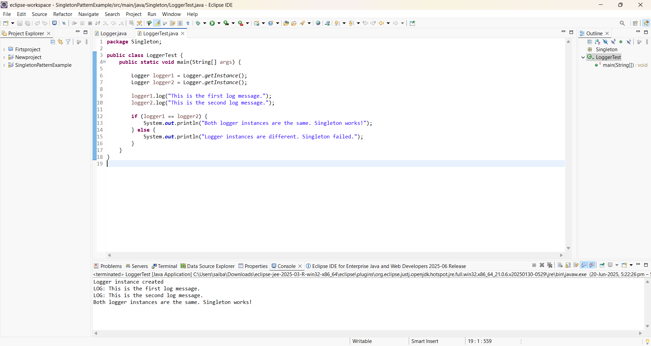

# **Exercise 2: Implementing the Factory Method Pattern**

**Code:**

1. Define Document Interface

package com.factory;

public interface Document {

void open();

}

1. Create Concrete Document Classes

**WordDocument.java**

package com.factory;

public class WordDocument implements Document {

public void open() {

System.out.println("Opening a Word document.");

}

}

**PdfDocument.java**

package com.factory;

public class PdfDocument implements Document {

public void open() {

System.out.println("Opening a pdf document.");

}

}

**ExcelDocument.java**

package com.factory;

public class ExcelDocument implements Document {

public void open() {

System.out.println("Opening a Excel document.");

}

}

1. Implement the Factory Method

**DocumentFactory**

package com.factory;

public abstract class DocumentFactory {

public abstract Document createDocument();

}

**WordDocumentFactory**

package com.factory;

public class WordDocumentFactory extends DocumentFactory {

public Document createDocument() {

return new WordDocument();

}

}

**PdfDocumentFactory**

package com.factory;

public class PdfDocumentFactory extends DocumentFactory {

public Document createDocument() {

return new PdfDocument();

}

}

**ExcelDocumentFactory**

package com.factory;

public class ExcelDocumentFactory extends DocumentFactory {

public Document createDocument() {

return new ExcelDocument();

}

}

1. Test the Factory Method Implementation:

**Main Class:**

package com.factory;

public class Main {

public static void main(String[] args) {

DocumentFactory wordFactory = new WordDocumentFactory();

Document word = wordFactory.createDocument();

word.open();

DocumentFactory pdfFactory = new PdfDocumentFactory();

Document pdf = pdfFactory.createDocument();

pdf.open();

DocumentFactory excelFactory = new ExcelDocumentFactory();

Document excel = excelFactory.createDocument();

excel.open();

}

}

**Output:**

