Experiment 1 : Create Table with Constraints

NOT NULL
Ensures a column cannot have NULL (empty) values.

UNIQUE
Ensures all values in a column are different.

PRIMARY KEY
Uniquely identifies each record in a table (NOT NULL + UNIQUE)

FOREIGN KEY
Links one table to another using a referenced key.

CHECK
Ensures that all values in a column satisfy a specific condition.

DEFAULT
Assigns a default value to a column if no value is provided.

CREATE INDEX
Improves the speed of data retrieval from a table.

Experiments:

NOT NULL
Code:
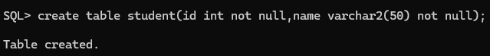
create table student(id int not null,name varchar2(50) not null);

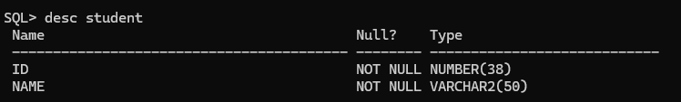
Output:

UNIQUE
Code:
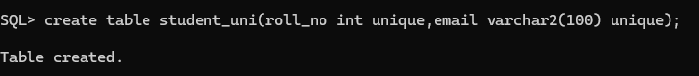
create table student_uni(roll_no int unique,email varchar2(100) unique);
Output:

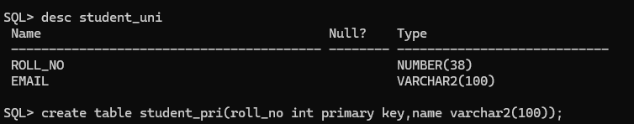

PRIMARY KEY
Code:
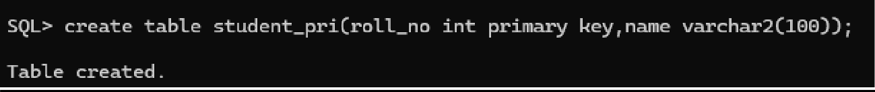
create table student_pri(roll_no int primary key,name varchar2(100));

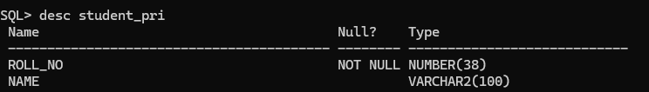
Output:

FOREIGN KEY
Code:
create table dept(dept_id int primary key,dept_name varchar2(100));
create table student_fore(roll_no int primary key,dept_id int,foreign key (dept_id) references dept(dept_id));
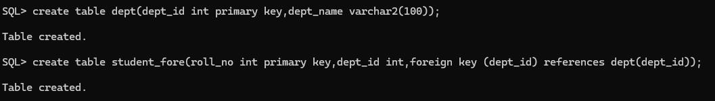

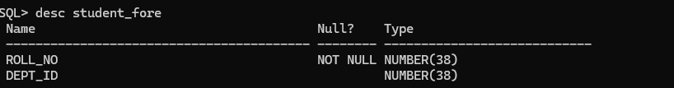
Output:

CHECK
Code:
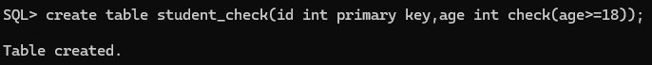
create table student_check(id int primary key,age int check(age>=18));

Output:

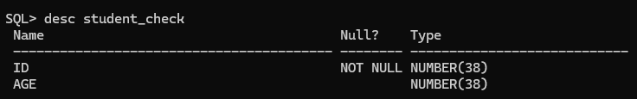

DEFAULT
Code:
create table student_default(id int primary key,city varchar2(50) default 'kadiri');

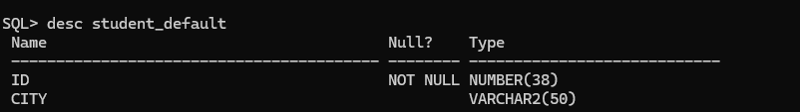
Output:

CREATE INDEX
Code:
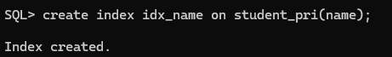
create index idx_name on student_pri(name);

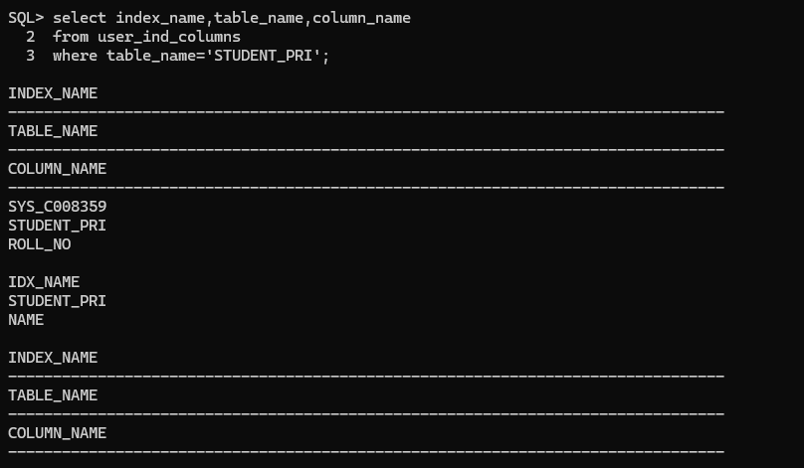
Output:

Experiment 2 : INSERT Command
  - Insert values with single entry

  - Insert values with multiple entires

  - ALTER Table Structure

  - VIEW Table structure

  - UPDATE table

  - DELETE Rows in table

Source Code:

-- =========================================
-- EXPERIMENT 2: INSERT COMMAND
-- =========================================

-- Step 1: Create and use database
CREATE DATABASE IF NOT EXISTS DBMS_Experiments;
USE DBMS_Experiments;

-- Step 2: Create necessary tables (so INSERT has targets) CREATE TABLE IF NOT EXISTS Students (
StudentID INT PRIMARY KEY, FirstName VARCHAR(50) NOT NULL, LastName VARCHAR(50),
Email VARCHAR(100) UNIQUE, Age INT CHECK (Age >= 18),
City VARCHAR(50) DEFAULT 'Unknown'
);

CREATE TABLE IF NOT EXISTS Courses ( CourseID INT PRIMARY KEY, CourseName VARCHAR(100) NOT NULL
);

CREATE TABLE IF NOT EXISTS Enrollments (
EnrollmentID INT PRIMARY KEY, StudentID INT,
CourseID INT,
FOREIGN KEY (StudentID) REFERENCES Students(StudentID), FOREIGN KEY (CourseID) REFERENCES Courses(CourseID)
);

-- =========================================
-- INSERT COMMANDS
-- =========================================

-- ¹⬛⬛ Insert values with single entry
INSERT INTO Students (StudentID, FirstName, LastName, Email, Age, City) VALUES (1, 'John', 'Doe', 'john.doe@example.com', 20, 'New York');

-- ⬛2 Insert values with multiple entries
INSERT INTO Students (StudentID, FirstName, LastName, Email, Age, City) VALUES
(2, 'Alice', 'Smith', 'alice.smith@example.com', 22, 'Boston'),
(3, 'Bob', 'Brown', 'bob.brown@example.com', 21, 'Chicago'),
(4, 'Mary', 'Johnson', 'mary.johnson@example.com', 19, DEFAULT);

-- ⬛3 Insert into Courses table
INSERT INTO Courses (CourseID, CourseName) VALUES
(101, 'Database Systems'),
(102, 'Operating Systems'),
(103, 'Computer Networks');

-- ⬛4 Insert into Enrollments table
INSERT INTO Enrollments (EnrollmentID, StudentID, CourseID) VALUES
(1, 1, 101),
(2, 2, 102),
(3, 3, 103),
(4, 4, 101);

-- =========================================
-- VIEW INSERTED DATA
-- =========================================
SELECT * FROM Students; SELECT * FROM Courses; SELECT * FROM Enrollments;

Program:

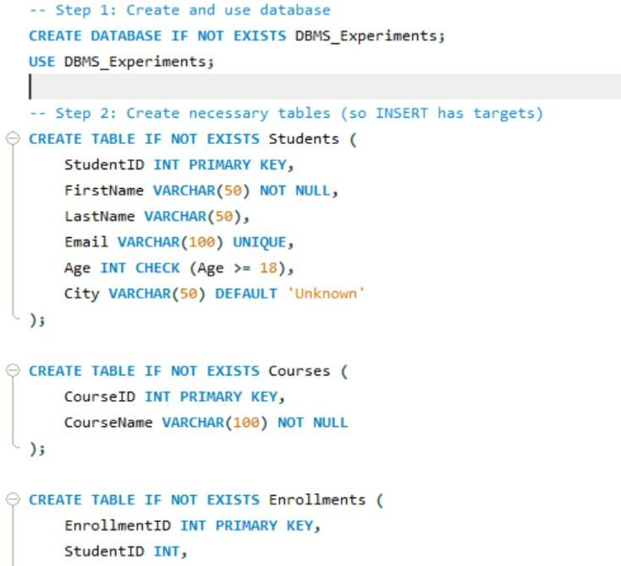

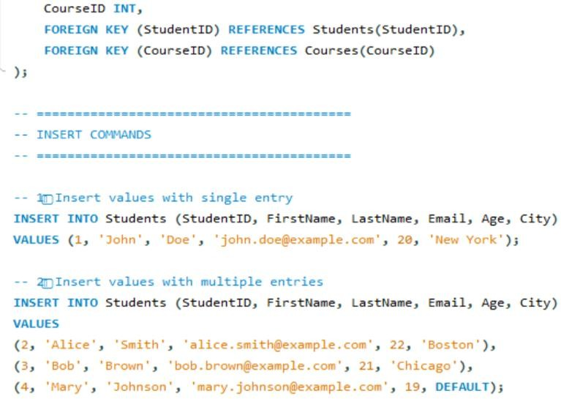

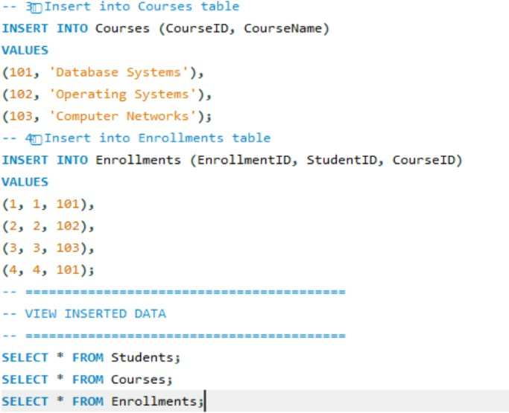

Output:
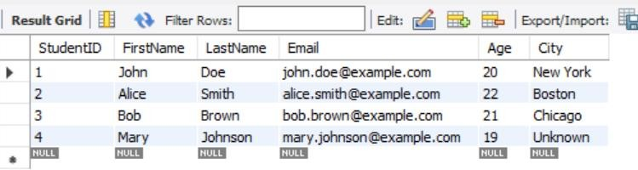

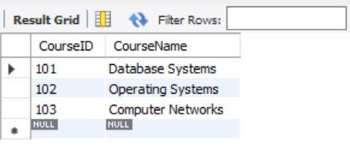
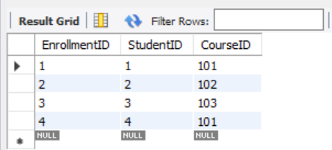

Experiment 3 :Aggregate Functions
Source Code:

DROP DATABASE IF EXISTS college;
CREATE DATABASE college; USE college;

-- Create table
CREATE TABLE marks (
student_name VARCHAR(50), subject VARCHAR(50),
score INT
);

-- Insert sample data
INSERT INTO marks VALUES ('Manasa', 'DBMS', 90),
('Ravi', 'DBMS', 80),
('Priya', 'Math', 95),
('Kiran', 'Math', 65),
('Meena', 'Math', 60);

-- Display all records SELECT * FROM marks;

-- Aggregate functions demonstration SELECT
MIN(score) AS min_score, MAX(score) AS max_score, COUNT(*) AS total_students, SUM(score) AS total_score, AVG(score) AS avg_score
FROM marks;

Program:
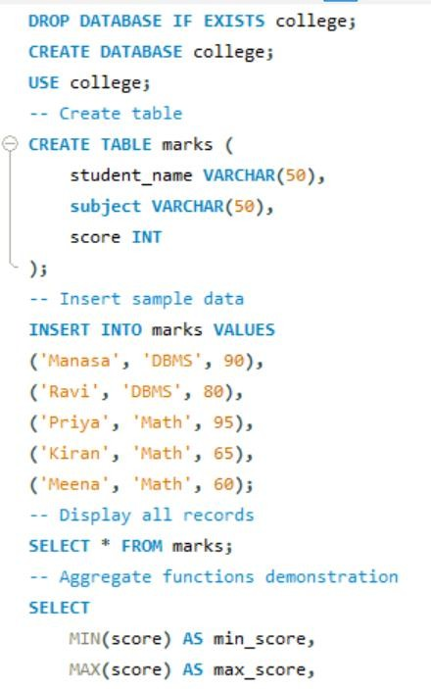
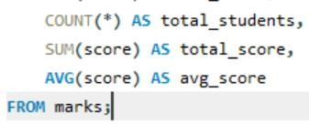

Output:
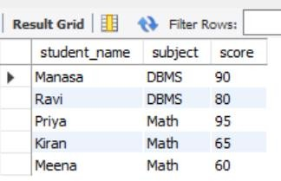

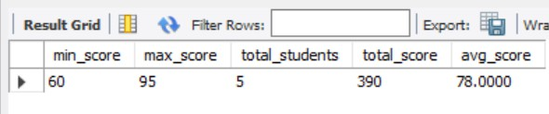

Experiment 4 :Group By and Order By
Source Code:

DROP DATABASE IF EXISTS college;
CREATE DATABASE college; USE college;
CREATE TABLE marks (
student_name VARCHAR(50), subject VARCHAR(50),
score INT
);
INSERT INTO marks VALUES ('Manasa', 'DBMS', 90),
('Ravi', 'DBMS', 80),
('Priya', 'Math', 95),
('Kiran', 'Math', 65),
('Meena', 'Math', 60);
-- Average score per subject
SELECT subject, AVG(score) AS avg_score FROM marks
GROUP BY subject;
-- Order students by score descending SELECT student_name, score
FROM marks
ORDER BY score DESC;

Program:
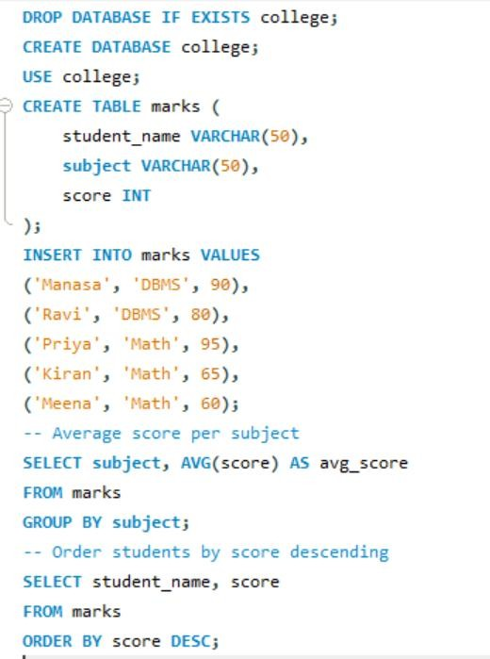

Output:
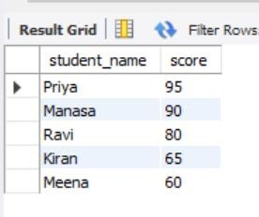
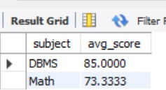

Experiment 5 : Ascending, Descending
Source Code:

-- Create database
CREATE DATABASE IF NOT EXISTS college;
USE college;

-- Create table
DROP TABLE IF EXISTS student;
CREATE TABLE student ( id INT PRIMARY KEY, name VARCHAR(30),
age INT,
branch VARCHAR(10)
);

-- Insert sample data
INSERT INTO student VALUES (1, 'Manasa', 20, 'CSE'),
(2, 'Ravi', 22, 'ECE'),
(3, 'Kiran', 21, 'CSE'),
(4, 'Priya', 19, 'EEE'),
(5, 'Arjun', 23, 'MECH');

-- View all records SELECT * FROM student;

-- Ascending order by name SELECT * FROM student ORDER BY name ASC;

-- Descending order by age SELECT * FROM student ORDER BY age DESC;

Program:

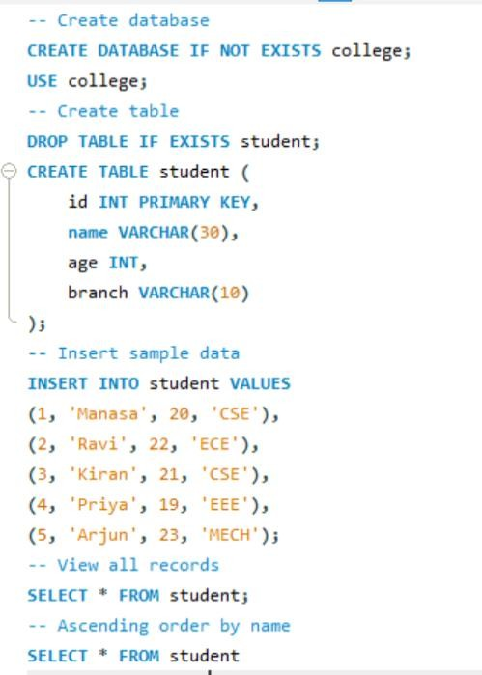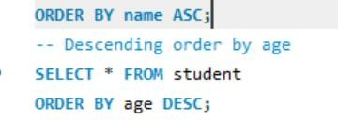

Output:
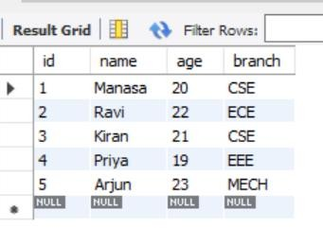
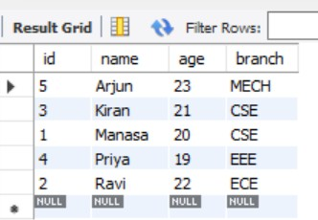
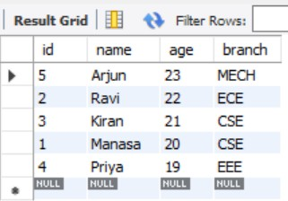

Experiment 6 :SQL Operators
- Like operator (%,-)

- Between & or Source Code:
DROP DATABASE IF EXISTS college;
CREATE DATABASE college; USE college;
CREATE TABLE student ( student_id INT PRIMARY KEY, name VARCHAR(50),
age INT, dept_id INT
);
INSERT INTO student VALUES (101, 'Manasa', 20, 1),
(102, 'Ravi', 21, 2),
(103, 'Priya', 19, 1),
(104, 'Kiran', 22, 1),
(105, 'Meena', 20, 3);
-- LIKE operator
SELECT * FROM student WHERE name LIKE 'M%'; SELECT * FROM student WHERE name LIKE '%an%';
-- BETWEEN operator
SELECT * FROM student WHERE age BETWEEN 19 AND 21;
-- IN operator
SELECT * FROM student WHERE dept_id IN (1, 3);

Program:

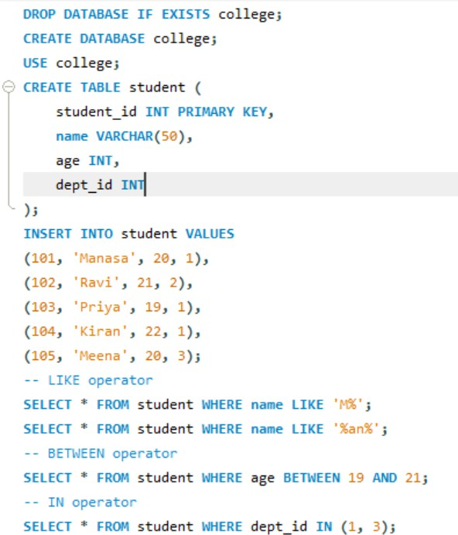

Output:
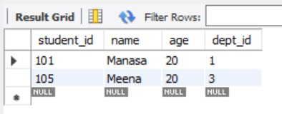
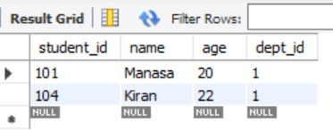

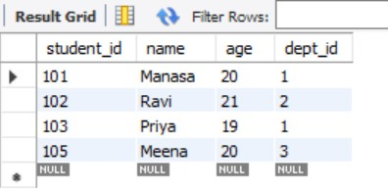
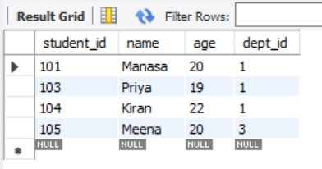

Experiment 7 : SQL Joins

- Inner Join

- Left Join

- Right Join

- Outer Join

- Left Join exclude Inner Join

- Right Join exclude Inner Join

- Outer Join exclude Inner Jain Source Code:
-- Create tables
DROP TABLE IF EXISTS Students; DROP TABLE IF EXISTS Courses;
CREATE TABLE Students ( StudentID INT,
Name VARCHAR(50),
CourseID INT
);

CREATE TABLE Courses ( CourseID INT,
CourseName VARCHAR(50)
);

-- Insert data
INSERT INTO Students VALUES (1, 'John', 101),
(2, 'Emma', 102),
(3, 'Raj', 103),
(4, 'Sara', NULL);

INSERT INTO Courses VALUES (101, 'Math'),
(102, 'Science'),
(104, 'History');

-- 1. INNER JOIN
SELECT s.Name, c.CourseName FROM Students s
INNER JOIN Courses c ON s.CourseID = c.CourseID;

-- 2. LEFT JOIN
SELECT s.Name, c.CourseName FROM Students s
LEFT JOIN Courses c ON s.CourseID = c.CourseID;

-- 3. RIGHT JOIN
SELECT s.Name, c.CourseName FROM Students s
RIGHT JOIN Courses c ON s.CourseID = c.CourseID;

-- 4. FULL OUTER JOIN (some databases: use UNION of LEFT + RIGHT) SELECT s.Name, c.CourseName
FROM Students s
LEFT JOIN Courses c ON s.CourseID = c.CourseID UNION
SELECT s.Name, c.CourseName FROM Students s
RIGHT JOIN Courses c ON s.CourseID = c.CourseID;

-- 5. LEFT JOIN EXCLUDING INNER JOIN
SELECT s.Name, c.CourseName FROM Students s
LEFT JOIN Courses c ON s.CourseID = c.CourseID WHERE c.CourseID IS NULL;

-- 6. RIGHT JOIN EXCLUDING INNER JOIN
SELECT s.Name, c.CourseName FROM Students s
RIGHT JOIN Courses c ON s.CourseID = c.CourseID WHERE s.CourseID IS NULL;

Program:

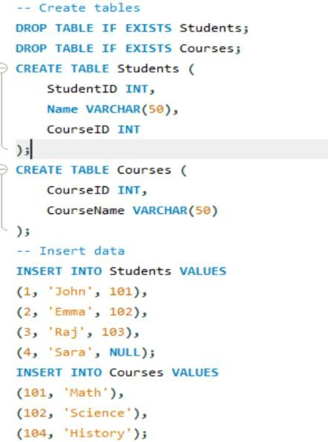
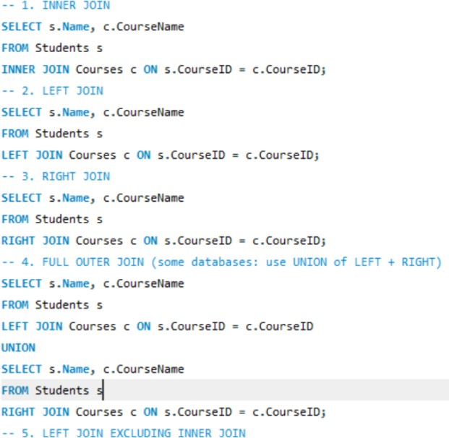
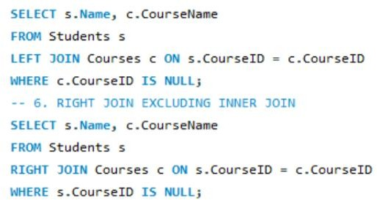

Output:

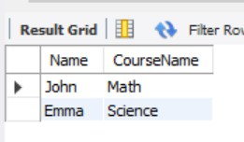
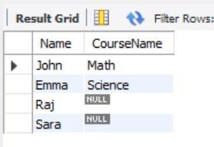
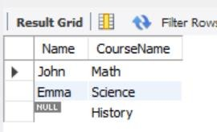
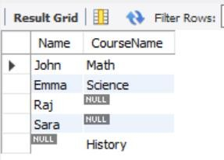

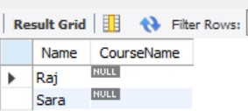
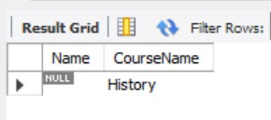

Experiment 8 : Normal Forms

- INF

Source Code:

DROP DATABASE IF EXISTS normalforms; CREATE DATABASE normalforms;
USE normalforms;

CREATE TABLE orders_1nf ( order_id INT,
customer_name VARCHAR(30), product VARCHAR(30),
quantity INT

);

INSERT INTO orders_1nf VALUES (1, 'Manasa', 'Pen', 10),
(1, 'Manasa', 'Book', 2),

(2, 'Ravi', 'Pencil', 5); SELECT * FROM orders_1nf;

Program:

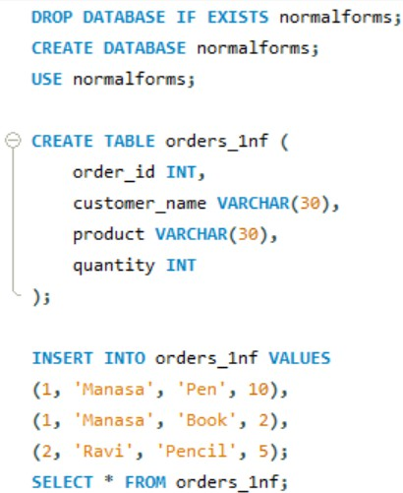

Output:
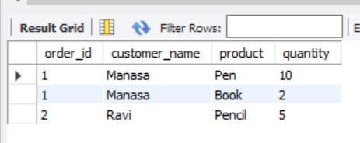

- 2NF

Source Code:

-- Clean safely (drop children first) DROP TABLE IF EXISTS items;
DROP TABLE IF EXISTS orders_2nf; DROP TABLE IF EXISTS customer;
-- Recreate tables

CREATE TABLE customer ( cust_id INT PRIMARY KEY, cust_name VARCHAR(30)
);

CREATE TABLE orders_2nf ( order_id INT PRIMARY KEY, cust_id INT,
FOREIGN KEY (cust_id) REFERENCES customer(cust_id)

);

CREATE TABLE items (

item_id INT PRIMARY KEY, order_id INT,
product VARCHAR(30), quantity INT,
FOREIGN KEY (order_id) REFERENCES orders_2nf(order_id)

);

-- Insert data

INSERT INTO customer VALUES (1, 'Manasa'), (2, 'Ravi'); INSERT INTO orders_2nf VALUES (101, 1), (102, 2);
INSERT INTO items VALUES (1, 101, 'Pen', 10),
(2, 101, 'Book', 2),

(3, 102, 'Pencil', 5);

-- Verify

SELECT o.order_id, c.cust_name, i.product, i.quantity FROM orders_2nf o
JOIN customer c ON o.cust_id = c.cust_id JOIN items i ON o.order_id = i.order_id; Program:

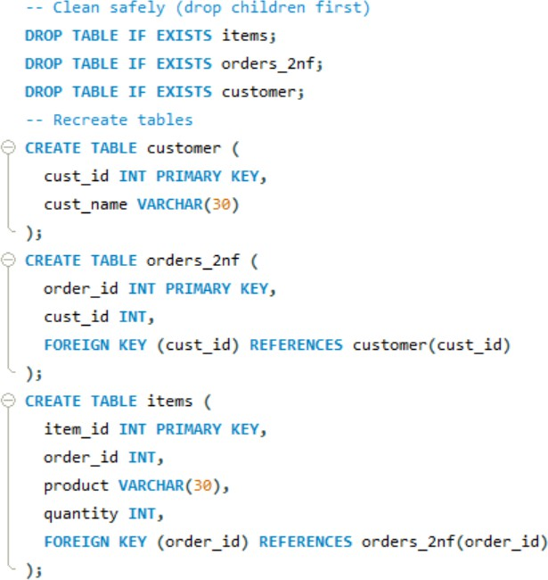
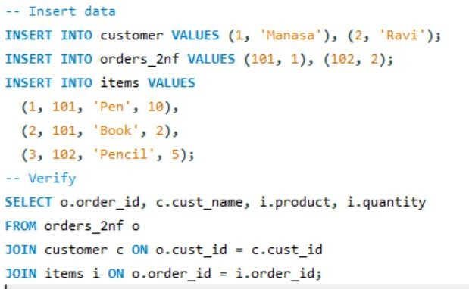

Output:
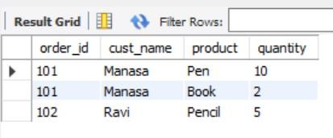

- 3NF

Source Code:

-- Create database
CREATE DATABASE normalforms3; USE normalforms3;
-- Tables for 3NF CREATE TABLE city (
city_name VARCHAR(30) PRIMARY KEY,
state VARCHAR(30)

);
CREATE TABLE customer ( cust_id INT PRIMARY KEY, cust_name VARCHAR(30), city_name VARCHAR(30),
FOREIGN KEY (city_name) REFERENCES city(city_name)
);
CREATE TABLE orders ( order_id INT PRIMARY KEY, cust_id INT,
product VARCHAR(30), quantity INT,
FOREIGN KEY (cust_id) REFERENCES customer(cust_id)
);
-- Insert data
INSERT INTO city VALUES
('Vijayawada', 'Andhra Pradesh'), ('Hyderabad', 'Telangana'); INSERT INTO customer VALUES (1, 'Manasa', 'Vijayawada'),
(2, 'Ravi', 'Hyderabad'); INSERT INTO orders VALUES (101, 1, 'Pen', 10),
(102, 1, 'Book', 5),
(103, 2, 'Pencil', 6);
-- Display result
SELECT o.order_id, c.cust_name, c.city_name, ci.state, o.product, o.quantity FROM orders o
JOIN customer c ON o.cust_id = c.cust_id JOIN city ci ON c.city_name = ci.city_name;

Program:
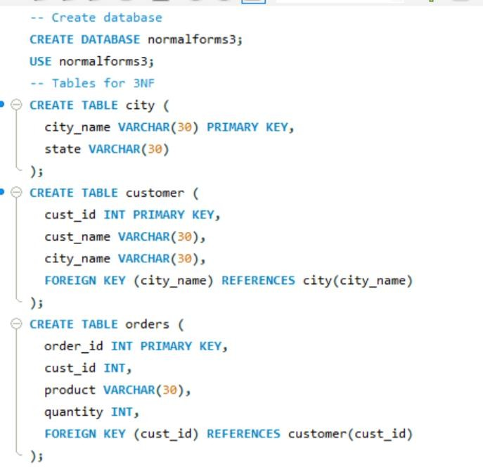

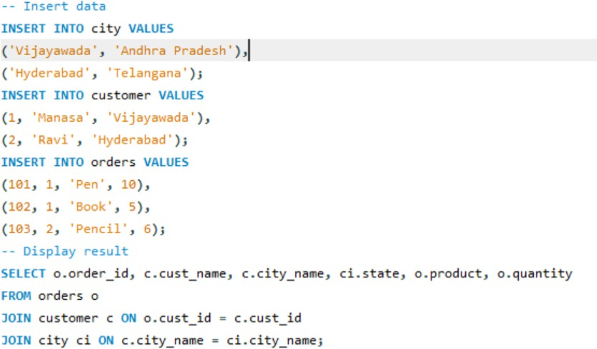

Output:
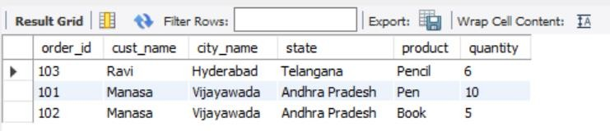

Experiment 9 :Nested Queries Using select across two tables
Source Code:

CREATE TABLE department ( dept_id INT PRIMARY KEY, dept_name VARCHAR(20)
);
CREATE TABLE student ( stu_id INT PRIMARY KEY, stu_name VARCHAR(20), dept_id INT,
FOREIGN KEY (dept_id) REFERENCES department(dept_id)
);
INSERT INTO department VALUES (1, 'CSE'), (2, 'ECE');
INSERT INTO student VALUES (101, 'Manasa', 1),

(102, 'Ravi', 2),
(103, 'Priya', 1);
SELECT stu_name FROM student
WHERE dept_id = (SELECT dept_id FROM department WHERE dept_name = 'CSE');

Program:
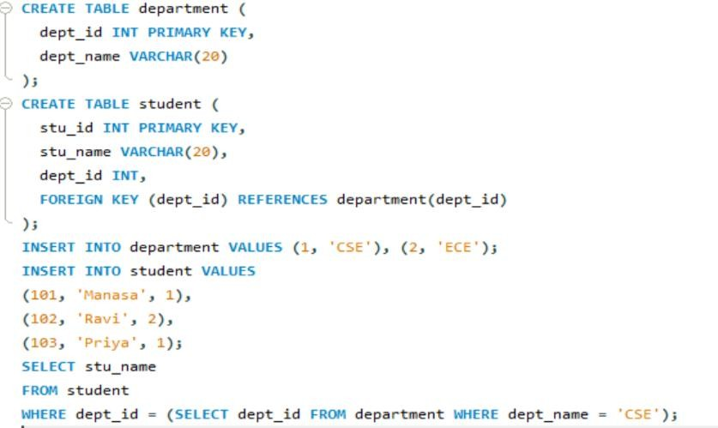

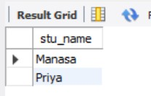
Output:

Experiment 10 :SQL wild card characters
Source Code:

DROP TABLE IF EXISTS student;

CREATE TABLE student ( id INT,
name VARCHAR(30)

);

INSERT INTO student (id, name) VALUES (1, 'Manasa'),

(2, 'Ravi'),

(3, 'Manoj'),

(4, 'Priya'),

(5, 'Kiran');

-- Names starting with 'Ma' SELECT name
FROM student

WHERE name LIKE 'Ma%';

-- Names containing 'ri' (case-insensitive) SELECT name
FROM student

WHERE LOWER(name) LIKE '%ri%';

Program:
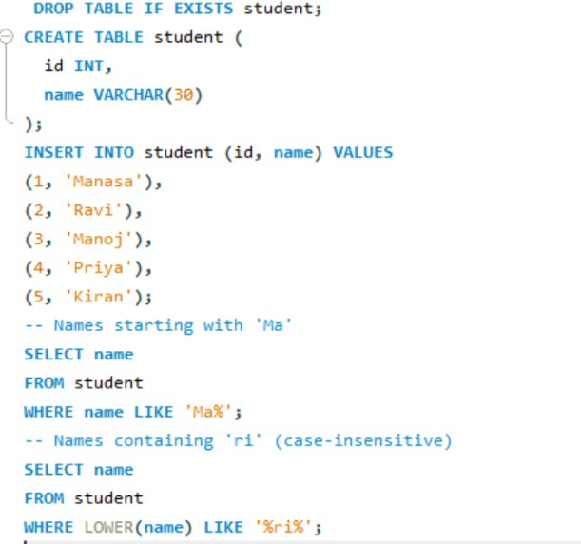

Output:

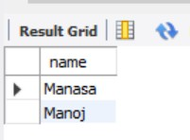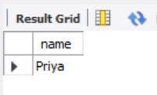

Experiment 11 :Retrieve Database using SELECT with Comparison operator ( = , > . <. >= , <= )
Source Code:

DROP TABLE IF EXISTS student;

CREATE TABLE student ( id INT,
name VARCHAR(30),

marks INT

);

INSERT INTO student (id, name, marks) VALUES (1, 'Manasa', 85),
(2, 'Ravi', 72),

(3, 'Manoj', 90),

(4, 'Priya', 78),

(5, 'Kiran', 60);

-- Single query showing all comparison operators SELECT
name, marks, CASE
WHEN marks = 78 THEN 'Equal to 78' WHEN marks > 80 THEN 'Greater than 80' WHEN marks < 75 THEN 'Less than 75'
WHEN marks >= 78 THEN 'Greater than or equal to 78' WHEN marks <= 72 THEN 'Less than or equal to 72' ELSE 'Other'
END AS `Condition` FROM student;

Program:

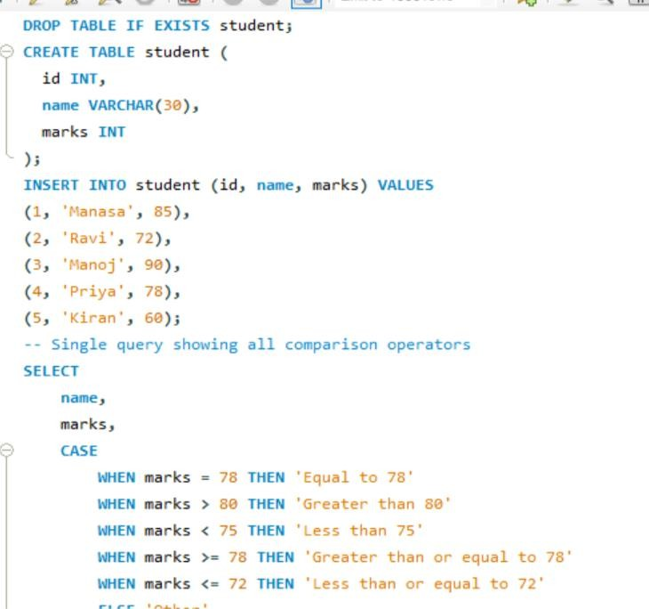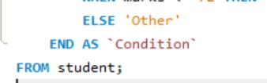

Output:
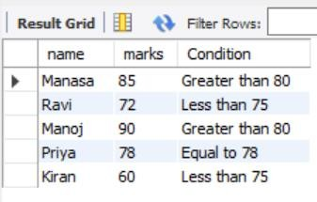

Experiment 12 : Working on Local Host XAMPP Server
- Exploring Server Variables.( Servername. User, pwd, DBname) Source Code:
-- Get the current MySQL user

SELECT USER();

-- Get the current selected database SELECT DATABASE();

-- Get the hostname (server name) SHOW VARIABLES LIKE 'hostname';

-- Get the MySQL version SELECT VERSION();

Program:
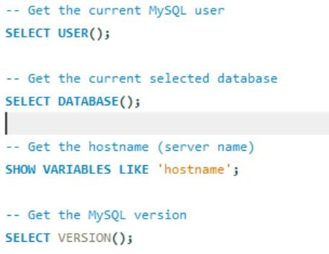

Output:
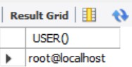
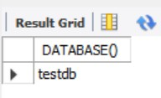

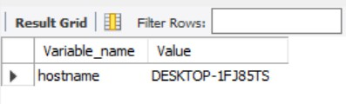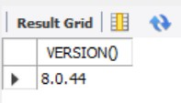

- Exploring Create hierarchical user access with privileges Source Code:
-- Check if the database exists and then drop it DROP DATABASE IF EXISTS testdb; CREATE DATABASE testdb;
USE testdb;

CREATE TABLE students (id INT PRIMARY KEY, name VARCHAR(50), age INT);

Program:
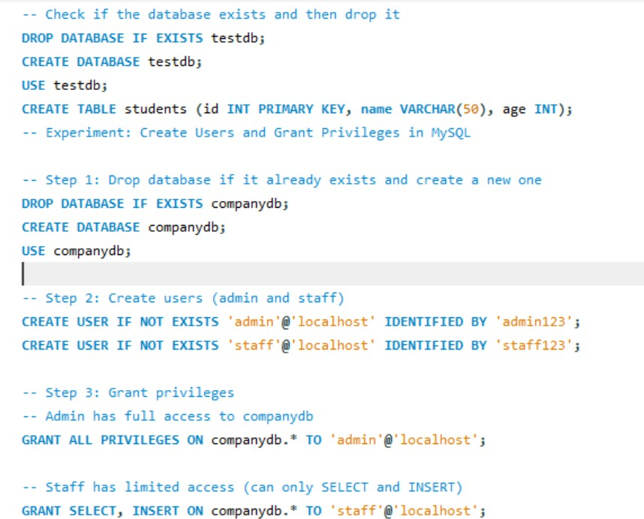

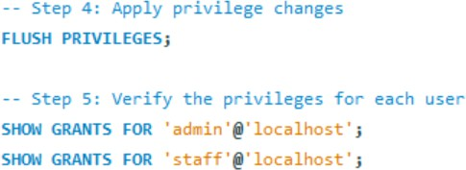

Output:

