**Test Case 1**: User enters a valid email and password, clicks "Sign Up"

Expected Output:- Account created successfully

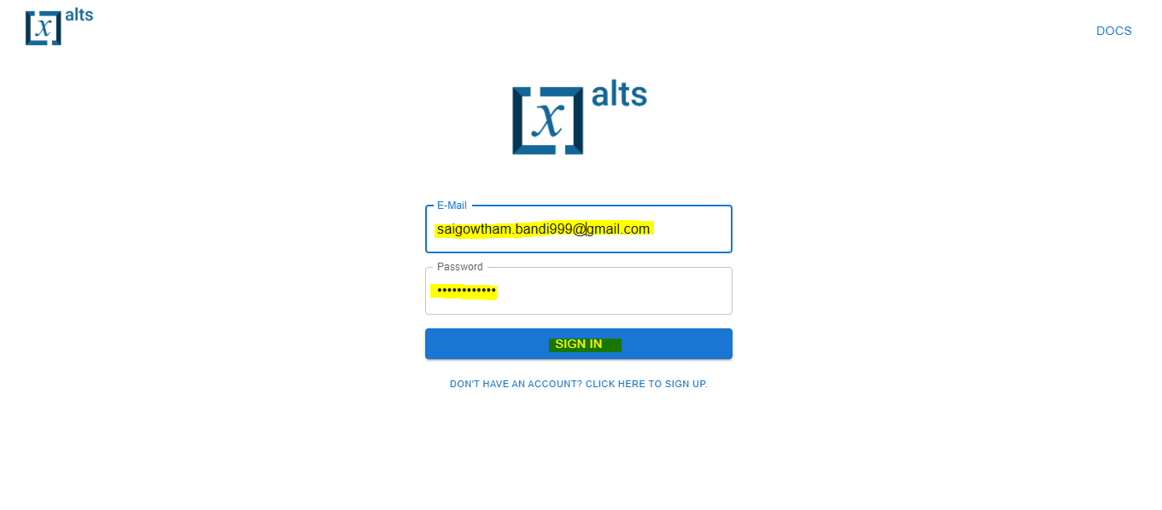

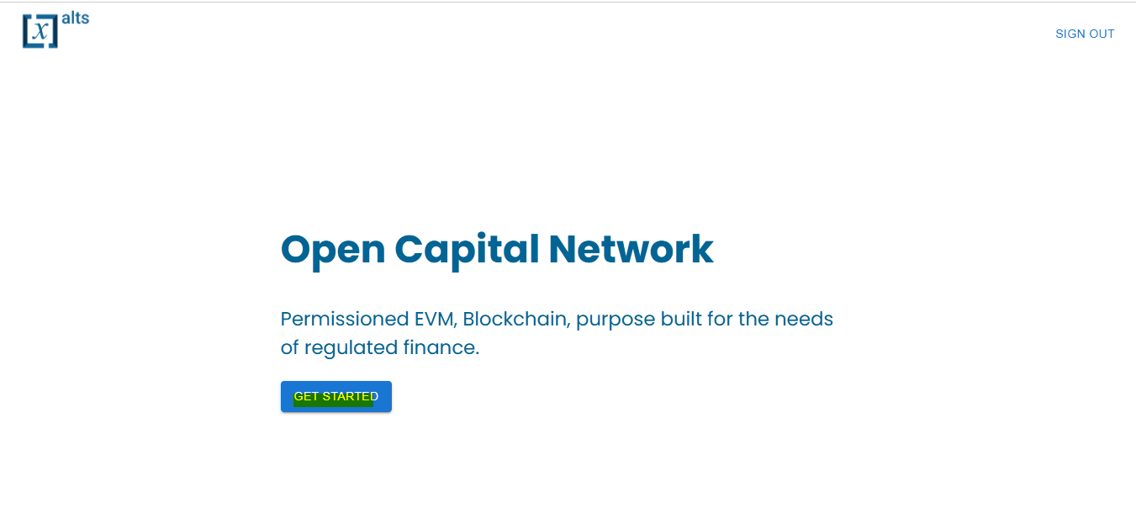

**Test Case 2**: User enters an invalid email (e.g., missing "@" symbol).

**Expected Result**: Error message: "Invalid email format.

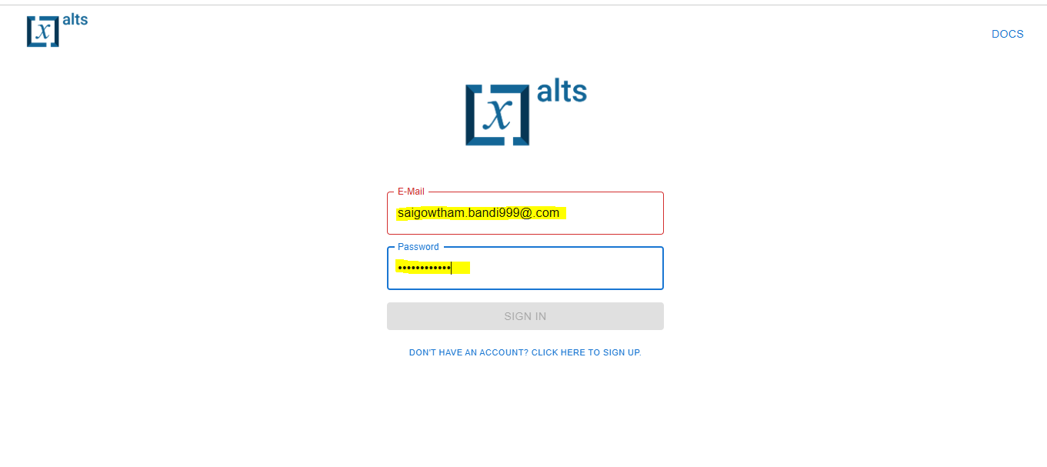

But SIGN IN button is not enabled

**Test Case 3**: User enters a password that doesn't meet security requirements (e.g., less than 8 characters).

**Expected Result**: Error message: "One Uppercase letter or lower case letter should be present."

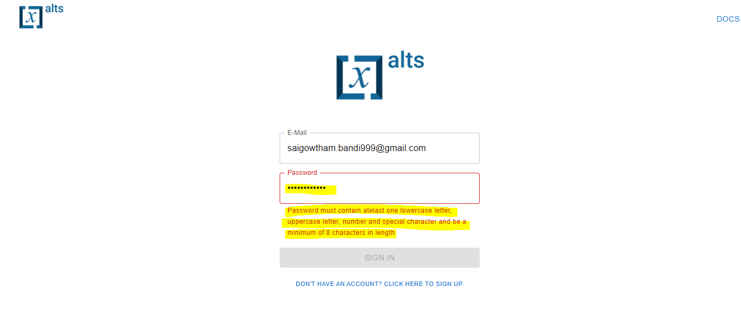

**Test Case 4**: User leaves the email or password field blank and tries to sign up.

**Expected Result**: Error message: "This field is required."

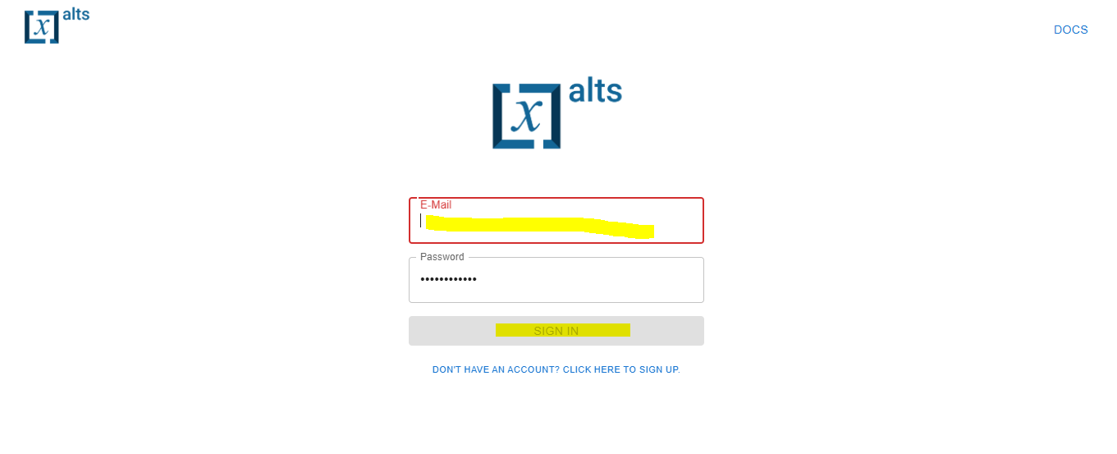

**Test Case 5**: User enters a registered email and correct password.

**Expected Result**: User is logged in and redirected to the homepage.

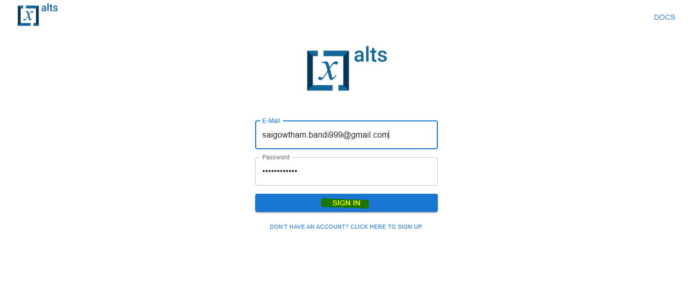

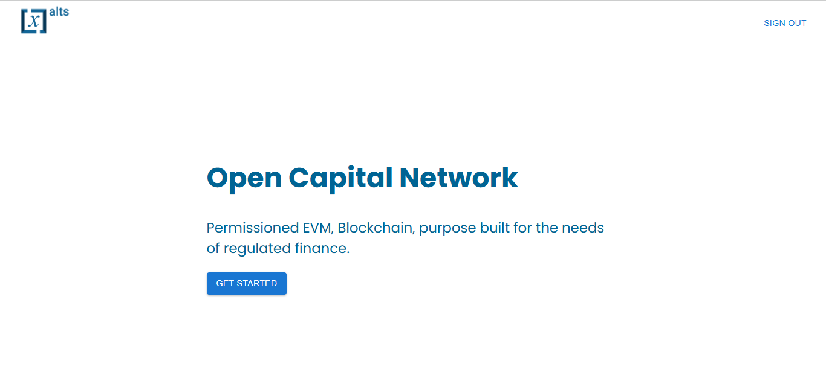

**Test Case 6**: User enters an incorrect email.

**Expected Result**: Error message: "User Not Found."

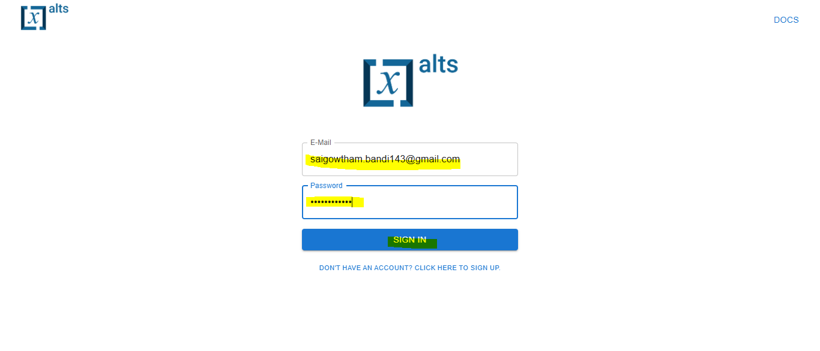

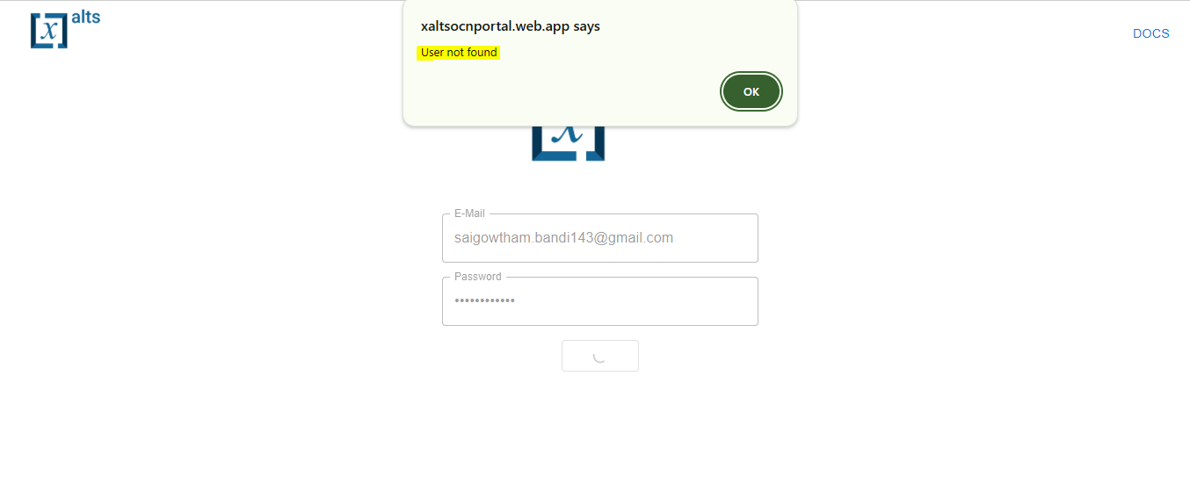

**Test Case 7**: User enters the wrong password for a valid email.

**Expected Result**: Error message: "Incorrect Email or Password."

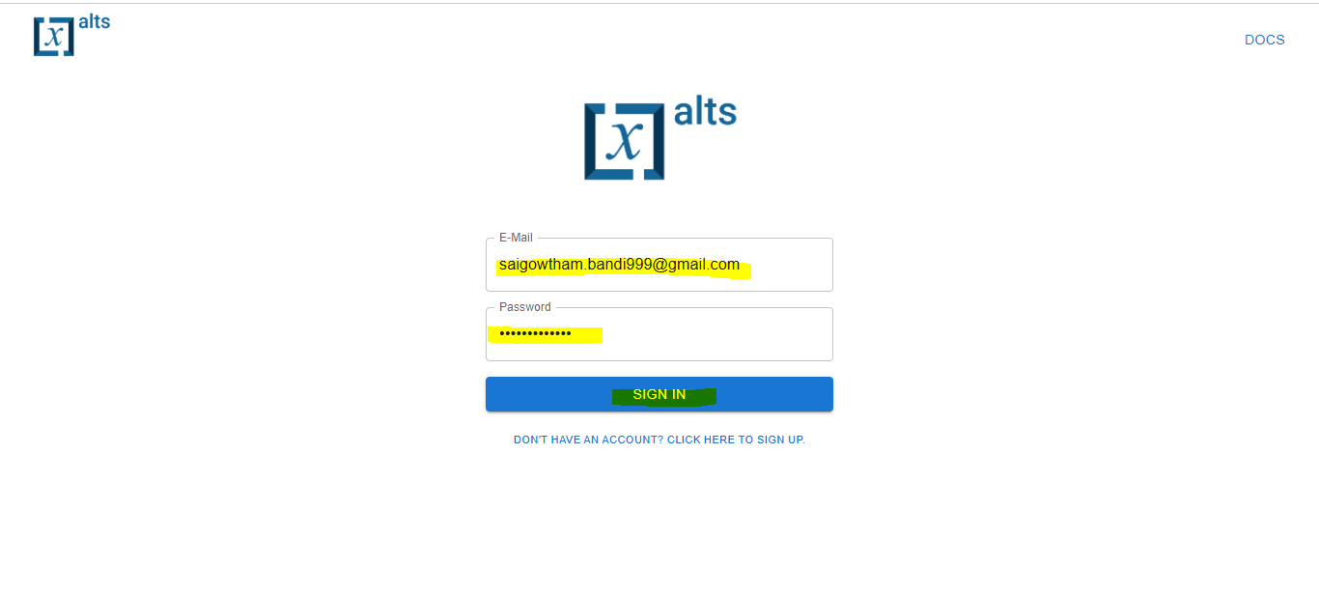

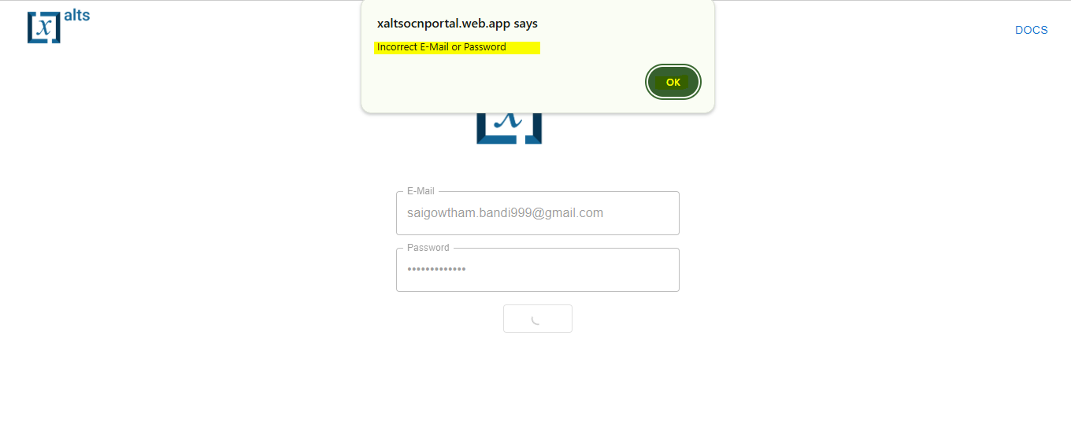

**Test Case 8**: User clicks the "Sign Out" button.

**Expected Result**: User is logged out, and redirected to the Sign In page.

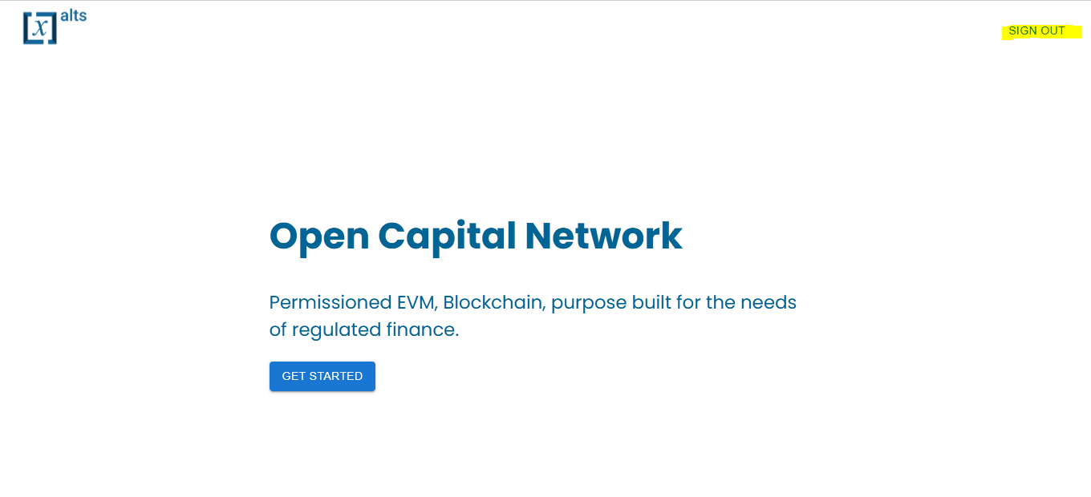

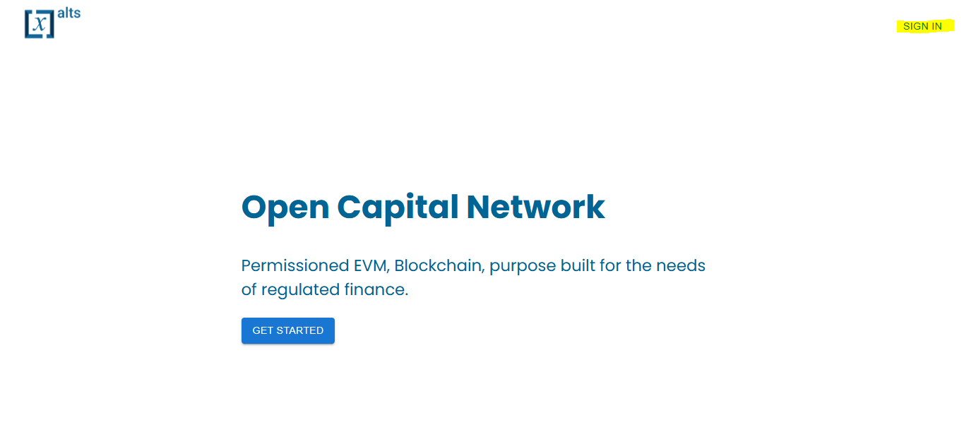

**Node Onboarding to Existing Blockchain**

**Test Case 1**: User enters valid Node ID and IP address, clicks "Add Node."

**Expected Result**: Node is added to the list of nodes.

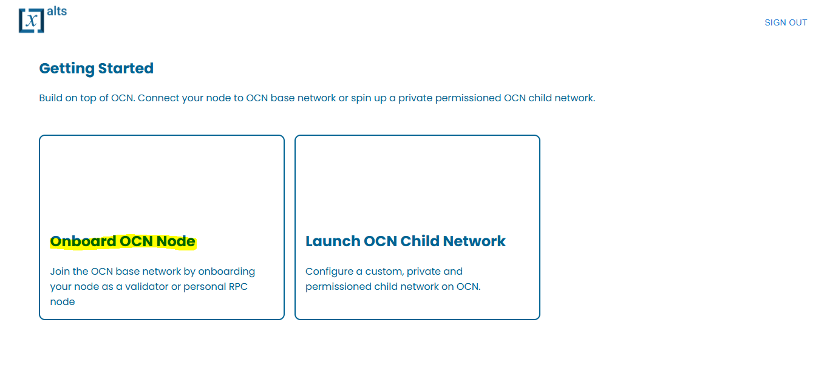

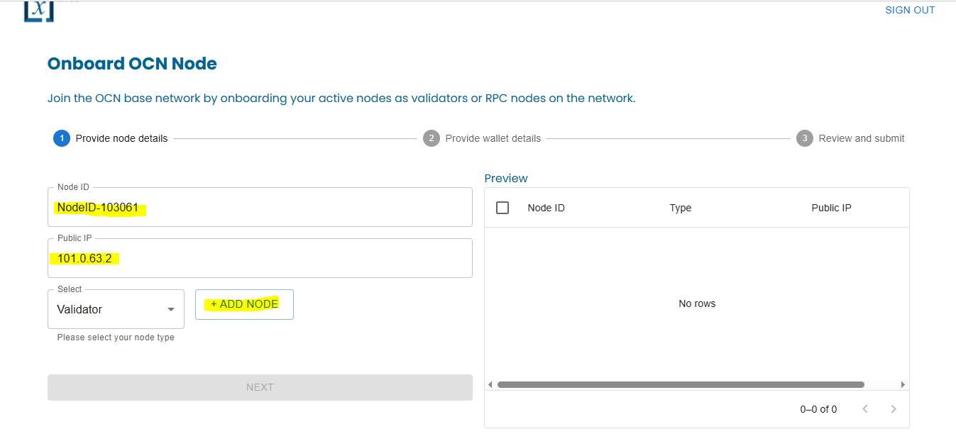

**Test Case 2**: User successfully adds nodes and clicks "Next."

**Expected Result**:- lands on provide wallet details page.

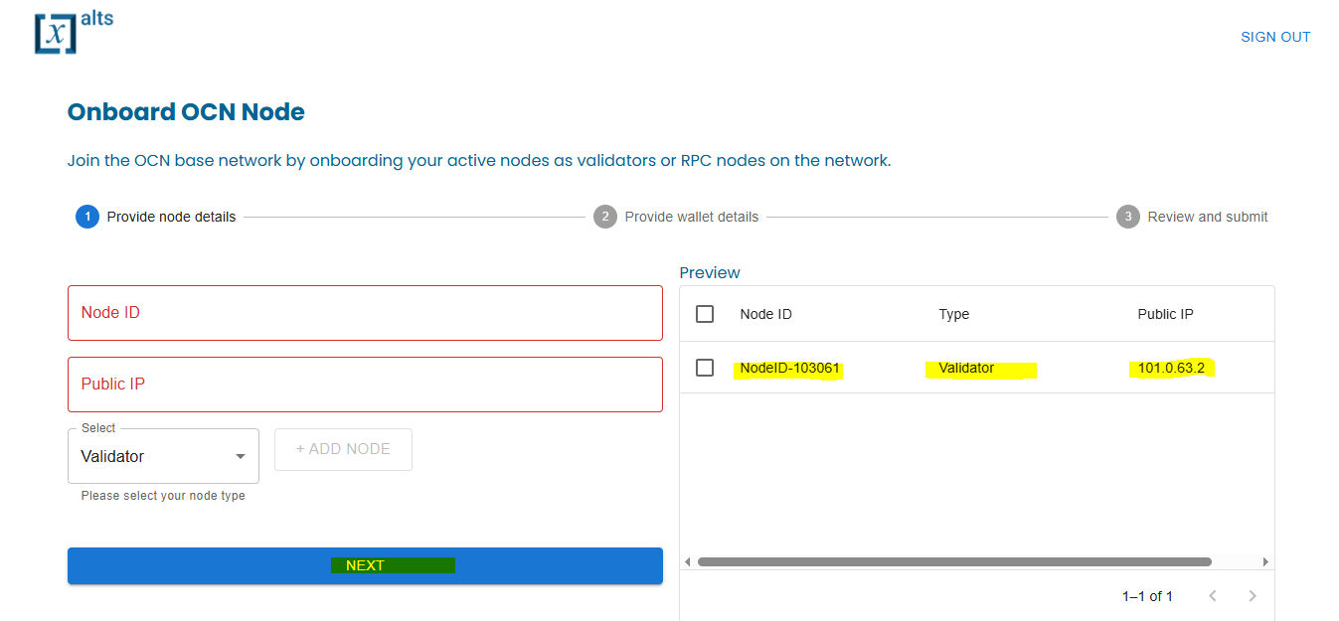

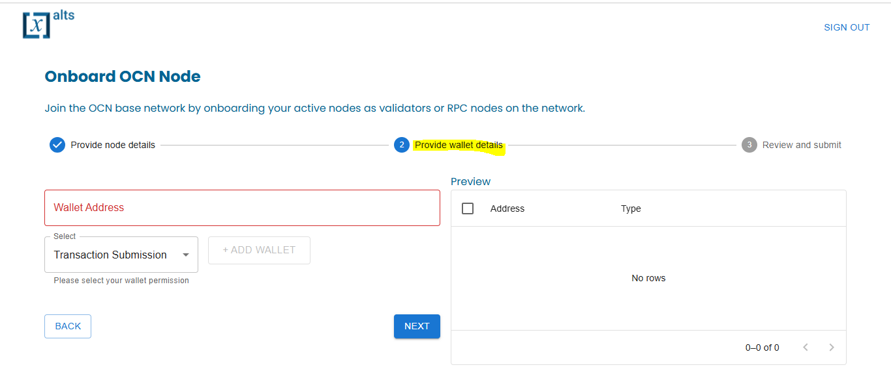

**Test Case 3**: User successfully provide wallet details and clicks on Add wallet button

**Expected Result :-**  wallet details should add successfully

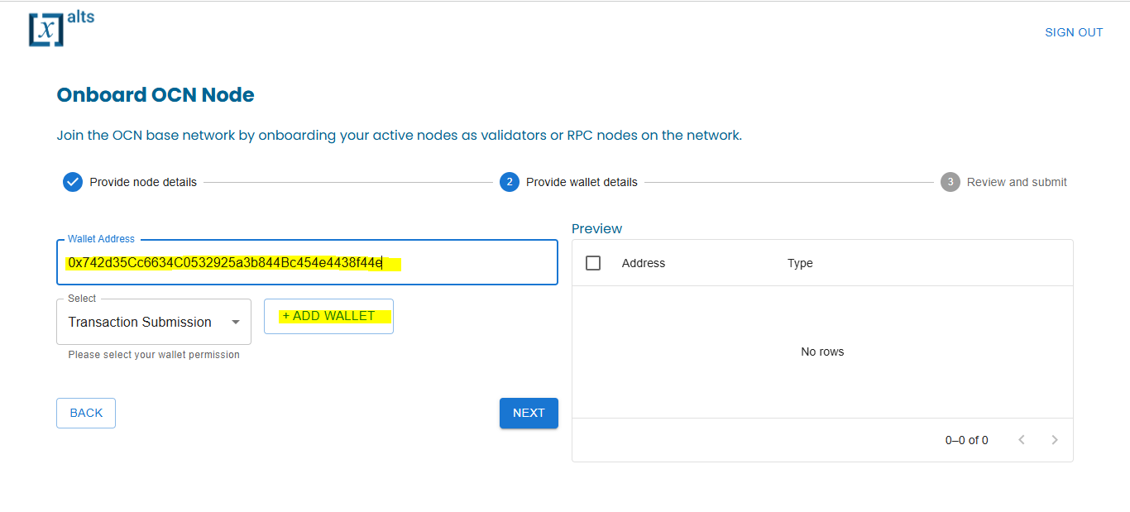

Test Case:- 4: When user clicks on NEXT button

Expected Output:- User should land Review and Submit Page

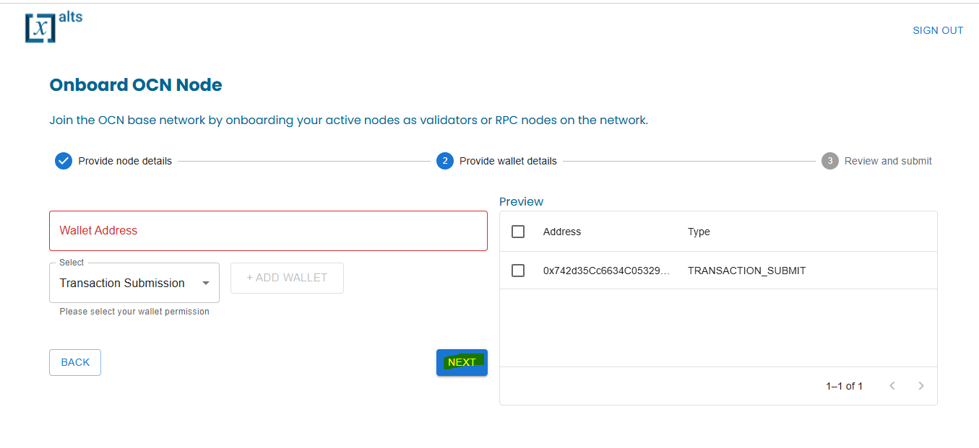

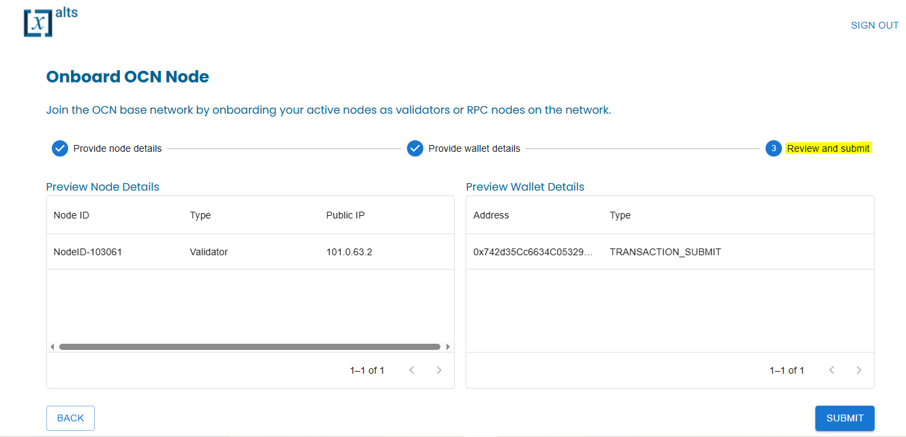

Test Case-5:- When User clicks on Submit Button and should select Preview Node Details , Preview Wallet Details and clicks on Submit Button

Expected Output:-

