ECG Monitoring System using AD8232 and Arduino UNO

1. Abstract
This project presents the design and implementa on of a low-cost ECG monitoring system using the AD8232 sensor and Arduino UNO. The system captures electrical signals from the human heart, processes them using digital filtering techniques, and displays the waveform using the Arduino Serial Plo er. The aim is to develop a simple and efficient real- me ECG monitoring solu on.

2. Introduc on
Electrocardiography (ECG) is a technique used to measure the electrical ac vity of the heart. It is widely used for detec ng heart condi ons and monitoring cardiac health. This project focuses on building a cost-effec ve ECG monitoring system using AD8232 and Arduino UNO for real- me signal acquisi on and visualiza on.
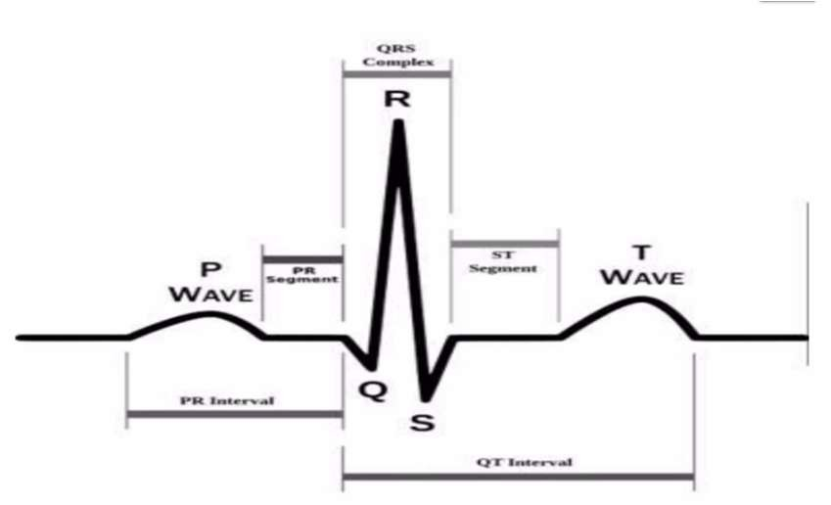
Fig 1: ECG Waveform(P-QRS-T Complex)

3. Objec ves
- To design a low-cost ECG monitoring system
- To acquire real- me ECG signals using AD8232
- To process ECG signals using filtering techniques
- To display ECG waveform using Arduino Serial Plo er
- To ensure proper electrode detec on using lead-off mechanism

4. Block Diagram
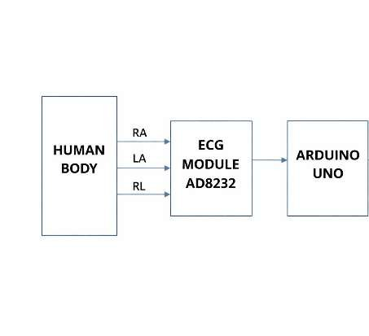
Explana on of Block Diagram
The ECG signal is collected from the human body using electrodes (RA, LA, RL).
The AD8232 module amplifies and filters the weak ECG signals.
The Arduino UNO reads the analog signal and converts it into digital form. The processed signal is then displayed using Serial Plo er.

5. Working model diagram:
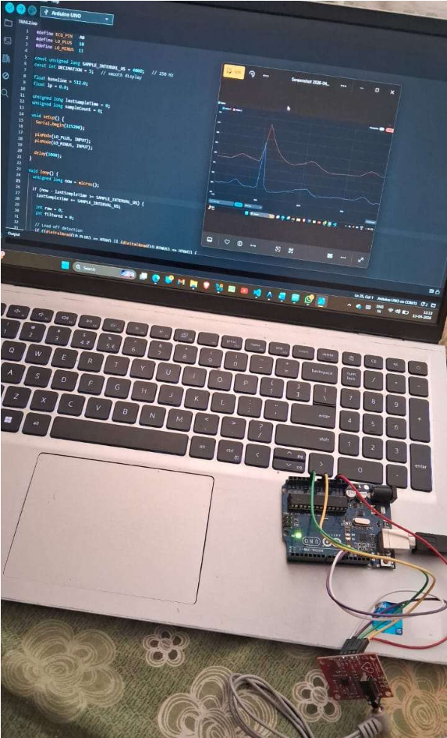
Fig 2: Working Model of ECG System

6. Components Used
- Arduino UNO
- AD8232 ECG Sensor
- Electrodes (RA, LA, RL)
- Jumper wires
- Computer with Arduino IDE

7.Prototype Design:
The prototype shows the connec on of electrodes to the AD8232 ECG module and Arduino UNO.
The electrodes (RA, LA, RL) capture heart signals, which are amplified by the AD8232 module.
The processed signal is then sent to Arduino for further processing and display.
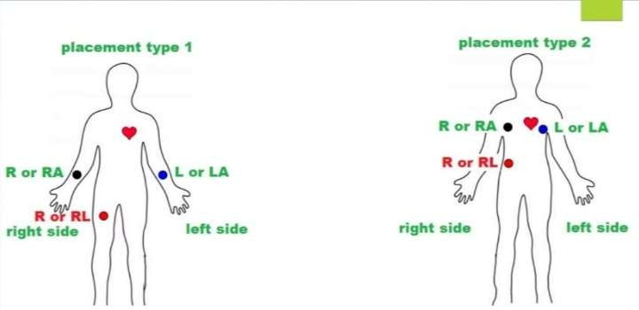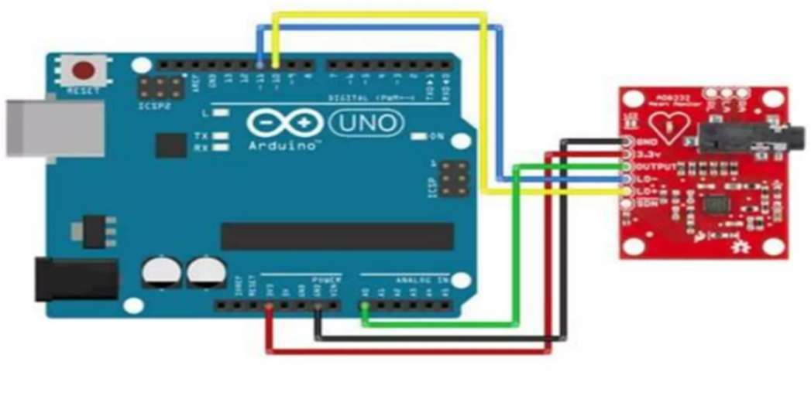
Fig 3: Prototype Design of ECG Monitoring System

8. Working Principle
The Electrocardiogram (ECG) monitoring system works by capturing the electrical ac vity of the human heart using surface electrodes placed on the body. These electrodes (RA, LA, RL) detect very small bioelectric signals generated during cardiac ac vity.
The detected signals are extremely weak (in millivolts) and are therefore amplified using the AD8232 ECG module. This module also performs ini al analog filtering to remove mo on ar facts and unwanted noise.
The condi oned analog signal is then fed into the Arduino Uno through an analog input pin (A0). The Arduino converts this analog signal into digital form using its built-in Analog-to-Digital Converter (ADC).
Once digi zed, the signal undergoes further processing using so ware-based filtering techniques such as baseline correc on and low-pass filtering to improve signal quality. The processed ECG waveform is then transmi ed via serial communica on and displayed using the Arduino Serial Plo er for visualiza on of heart ac vity (P, QRS, T waves).

9. Code Explana on
The implemented code performs real- me acquisi on and processing of ECG signals using the Arduino pla orm.
Sampling
The ECG signal is sampled at a rate of 250 Hz, which is suitable for accurately capturing cardiac signals without losing important waveform details.
Lead-Off Detec on
The system con nuously checks the status of electrode connec ons using LO+ and LO− pins. If electrodes are disconnected, the system outputs zero values to avoid displaying incorrect data.
Baseline Removal
To eliminate baseline dri caused by breathing and body movement, an exponen al moving average method is used. This ensures that the ECG waveform remains centered and stable.
Low-Pass Filtering
A digital low-pass filter is applied to remove high-frequency noise such as power line interference and muscle ar facts. This helps in preserving the essen al features of the ECG signal, especially the QRS complex.
Signal Amplifica on and Offset
The filtered signal is amplified to enhance visibility and shi ed to fit within the ADC range (0–1023), making it suitable for plo ng.
Decima on (Data Reduc on)
To ensure smooth visualiza on and reduce data overload, the system outputs only every nth sample. This improves readability in the Serial Plo er.
Output Visualiza on
Finally, both raw and filtered ECG signals are transmi ed via serial communica on and displayed graphically using the Arduino Serial Plo er

10. Results
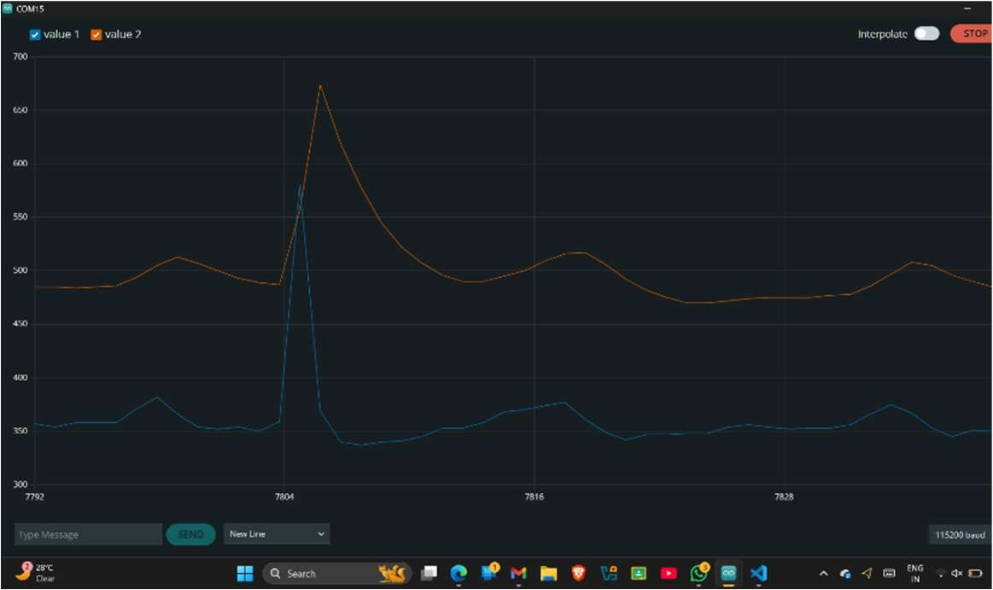
The system successfully displays ECG waveform including P, QRS, and T waves. The filtered signal is smoother and clearer compared to raw signal.

11. Conclusion
The ECG monitoring system successfully captures and displays real- me heart signals.
Digital filtering improves signal quality by reducing noise and baseline dri .
This system provides a low-cost solu on for basic ECG monitoring and can be further enhanced for advanced applica ons.

