**ANDROID CODE:**

**GUACAMOLE RECIPE:**

**MainActivity.java:**

**package** com.example.mkrishna254.healthyrecipe;  
  
**import** android.support.v7.app.ActionBarActivity;  
**import** android.os.Bundle;  
**import** android.view.Menu;  
**import** android.view.MenuItem;  
**import** android.view.View;  
**import** android.widget.Button;  
**import** android.content.Intent;  
  
**public class** MainActivity **extends** ActionBarActivity {  
  
 @Override  
 **protected void** onCreate(Bundle savedInstanceState) {  
 **super**.onCreate(savedInstanceState);  
 setContentView(R.layout.***activity_main***);  
 *//create a button object* Button recipeButton = (Button) findViewById(R.id.***btnRecipe***);  
 *//create a click listener* recipeButton.setOnClickListener(**new** View.OnClickListener() {  
 @Override  
 **public void** onClick(View v) {  
 startActivity(**new** Intent (MainActivity.**this**,RecipeActivity.**class**));  
 }  
 }  
 );  
 }  
  
  
 @Override  
 **public boolean** onCreateOptionsMenu(Menu menu) {  
 *// Inflate the menu; this adds items to the action bar if it is present.* getMenuInflater().inflate(R.menu.***menu_main***, menu);  
 **return true**;  
 }  
  
 @Override  
 **public boolean** onOptionsItemSelected(MenuItem item) {  
 *// Handle action bar item clicks here. The action bar will  
 // automatically handle clicks on the Home/Up button, so long  
 // as you specify a parent activity in AndroidManifest.xml.* **int** id = item.getItemId();  
  
 *//noinspection SimplifiableIfStatement* **if** (id == R.id.***action_settings***) {  
 **return true**;  
 }  
  
 **return super**.onOptionsItemSelected(item);  
 }  
}

**activity_main.xml:**

<**RelativeLayout xmlns:android="http://schemas.android.com/apk/res/android"  
 xmlns:tools="http://schemas.android.com/tools" android:layout_width="match_parent"  
 android:layout_height="match_parent" android:paddingLeft="@dimen/activity_horizontal_margin"  
 android:paddingRight="@dimen/activity_horizontal_margin"  
 android:paddingTop="@dimen/activity_vertical_margin"  
 android:paddingBottom="@dimen/activity_vertical_margin" tools:context=".MainActivity"  
 android:background="#ff2dffdb"  
 android:id="@+id/txt"**>  
  
 <**TextView  
 android:layout_width="wrap_content"  
 android:layout_height="wrap_content"  
 android:textAppearance="?android:attr/textAppearanceLarge"  
 android:text="HEALTHY RECIPES"  
 android:id="@+id/txtTitle"  
 android:layout_marginTop="33dp"  
 android:layout_alignParentTop="true"  
 android:layout_centerHorizontal="true"  
 android:textSize="36sp"** />  
  
 <**ImageView  
 android:layout_width="wrap_content"  
 android:layout_height="wrap_content"  
 android:id="@+id/imgGuac"  
 android:src="@drawable/guac"  
 android:layout_centerVertical="true"  
 android:layout_centerHorizontal="true"** />  
  
 <**TextView  
 android:layout_width="wrap_content"  
 android:layout_height="wrap_content"  
 android:textAppearance="?android:attr/textAppearanceMedium"  
 android:text="Guacamole"  
 android:id="@+id/txtGuac"  
 android:layout_above="@+id/imgGuac"  
 android:layout_centerHorizontal="true"  
 android:layout_marginBottom="35dp"  
 android:textSize="28sp"  
 android:textColor="#ff440eff"** />  
  
 <**Button  
 android:layout_width="wrap_content"  
 android:layout_height="wrap_content"  
 android:text="View Recipe"  
 android:id="@+id/btnRecipe"  
 android:layout_below="@+id/imgGuac"  
 android:layout_centerHorizontal="true"  
 android:layout_marginTop="73dp"  
 android:textColor="#ff1350ff"** />  
  
</**RelativeLayout**>

**RecipeActivity.java:**

**package** com.example.mkrishna254.healthyrecipe;  
  
**import** android.support.v7.app.ActionBarActivity;  
**import** android.os.Bundle;  
**import** android.view.Menu;  
**import** android.view.MenuItem;  
  
  
**public class** RecipeActivity **extends** ActionBarActivity {  
  
 @Override  
 **protected void** onCreate(Bundle savedInstanceState) {  
 **super**.onCreate(savedInstanceState);  
 setContentView(R.layout.***activity_recipe***);  
 }  
  
  
 @Override  
 **public boolean** onCreateOptionsMenu(Menu menu) {  
 *// Inflate the menu; this adds items to the action bar if it is present.* getMenuInflater().inflate(R.menu.***menu_recipe***, menu);  
 **return true**;  
 }  
  
 @Override  
 **public boolean** onOptionsItemSelected(MenuItem item) {  
 *// Handle action bar item clicks here. The action bar will  
 // automatically handle clicks on the Home/Up button, so long  
 // as you specify a parent activity in AndroidManifest.xml.* **int** id = item.getItemId();  
  
 *//noinspection SimplifiableIfStatement* **if** (id == R.id.***action_settings***) {  
 **return true**;  
 }  
  
 **return super**.onOptionsItemSelected(item);  
 }  
}

**activity_recipe.xml:**

<**RelativeLayout xmlns:android="http://schemas.android.com/apk/res/android"  
 xmlns:tools="http://schemas.android.com/tools" android:layout_width="match_parent"  
 android:layout_height="match_parent" android:paddingLeft="@dimen/activity_horizontal_margin"  
 android:paddingRight="@dimen/activity_horizontal_margin"  
 android:paddingTop="@dimen/activity_vertical_margin"  
 android:paddingBottom="@dimen/activity_vertical_margin"  
 tools:context="com.example.mkrishna254.healthyrecipe.RecipeActivity"  
 android:background="#ffbaff68"  
 android:id="@+id/txt1"**>  
  
 <**TextView  
 android:layout_width="wrap_content"  
 android:layout_height="wrap_content"  
 android:textAppearance="?android:attr/textAppearanceLarge"  
 android:text="Guacamole Recipe"  
 android:id="@+id/txtGuacRecipe"  
 android:layout_alignParentTop="true"  
 android:layout_centerHorizontal="true"  
 android:textSize="30sp"** />  
  
 <**TextView  
 android:layout_width="wrap_content"  
 android:layout_height="wrap_content"  
 android:textAppearance="?android:attr/textAppearanceMedium"  
 android:text="Ingredients"  
 android:id="@+id/textView"  
 android:layout_below="@+id/txtGuacRecipe"  
 android:layout_alignParentLeft="true"  
 android:layout_alignParentStart="true"  
 android:layout_marginTop="40dp"  
 android:textColor="#ffff4414"  
 android:textSize="28sp"** />  
  
 <**TextView  
 android:layout_width="wrap_content"  
 android:layout_height="wrap_content"  
 android:textAppearance="?android:attr/textAppearanceMedium"  
 android:text="3 chopped avacados"  
 android:id="@+id/textView2"  
 android:layout_below="@+id/textView"  
 android:layout_centerHorizontal="true"  
 android:layout_marginTop="38dp"  
 android:textSize="24sp"** />  
  
 <**TextView  
 android:layout_width="wrap_content"  
 android:layout_height="wrap_content"  
 android:textAppearance="?android:attr/textAppearanceMedium"  
 android:text="1 juice lime"  
 android:id="@+id/textView3"  
 android:textSize="24sp"  
 android:layout_below="@+id/textView2"  
 android:layout_alignLeft="@+id/textView2"  
 android:layout_alignStart="@+id/textView2"** />  
  
 <**TextView  
 android:layout_width="wrap_content"  
 android:layout_height="wrap_content"  
 android:textAppearance="?android:attr/textAppearanceMedium"  
 android:text="1/2 chopped onion"  
 android:id="@+id/textView4"  
 android:textSize="24sp"  
 android:layout_below="@+id/textView3"  
 android:layout_centerHorizontal="true"** />  
  
 <**TextView  
 android:layout_width="wrap_content"  
 android:layout_height="wrap_content"  
 android:textAppearance="?android:attr/textAppearanceMedium"  
 android:text="2 chopped tomatoes"  
 android:id="@+id/textView5"  
 android:textSize="24sp"  
 android:layout_below="@+id/textView4"  
 android:layout_alignLeft="@+id/textView4"  
 android:layout_alignStart="@+id/textView4"** />  
  
 <**TextView  
 android:layout_width="wrap_content"  
 android:layout_height="wrap_content"  
 android:textAppearance="?android:attr/textAppearanceMedium"  
 android:text="1 T chopped cilantro"  
 android:id="@+id/textView6"  
 android:textSize="24sp"  
 android:layout_below="@+id/textView5"  
 android:layout_alignLeft="@+id/textView5"  
 android:layout_alignStart="@+id/textView5"** />  
  
 <**TextView  
 android:layout_width="wrap_content"  
 android:layout_height="wrap_content"  
 android:textAppearance="?android:attr/textAppearanceMedium"  
 android:text="Directions"  
 android:id="@+id/txtDirec"  
 android:layout_below="@+id/textView6"  
 android:layout_alignParentLeft="true"  
 android:layout_alignParentStart="true"  
 android:layout_marginTop="40dp"  
 android:textSize="28sp"  
 android:textColor="#ffff411d"** />  
  
 <**TextView  
 android:layout_width="wrap_content"  
 android:layout_height="wrap_content"  
 android:textAppearance="?android:attr/textAppearanceMedium"  
 android:text="Mash the ingredients. Add salt, cumin, garlic and cayenne to taste."  
 android:id="@+id/textView7"  
 android:layout_below="@+id/txtDirec"  
 android:layout_alignParentLeft="true"  
 android:layout_alignParentStart="true"  
 android:textSize="24sp"** />  
  
</**RelativeLayout**>

**SCREEN_SHOTS:**

* **Design view of the HealthyRecipe app:**

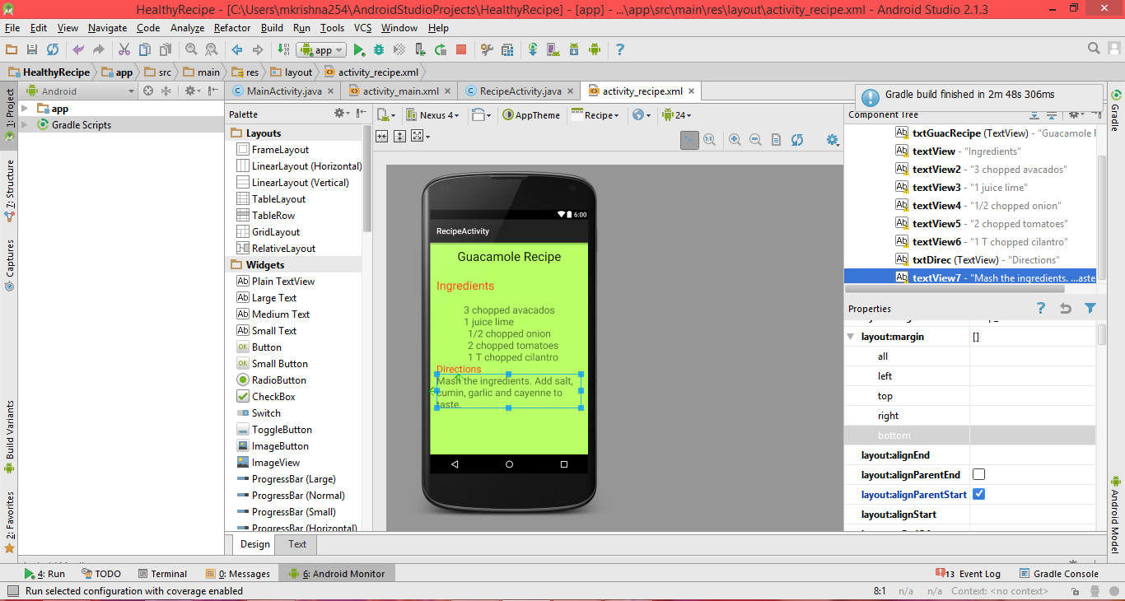

* **Text view of the HealthyRecipe app:**

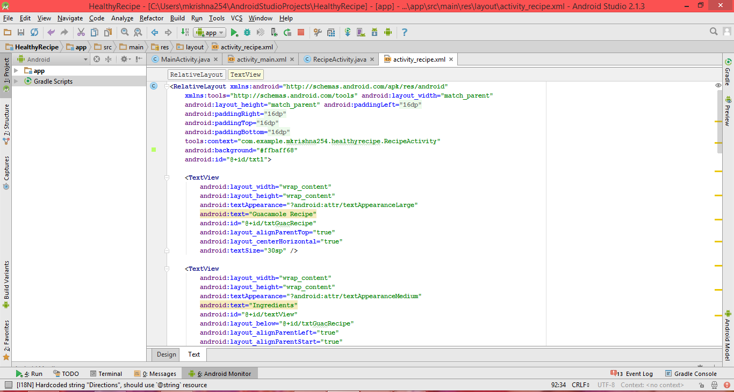

* **Console view of the HealthyRecipe app.**

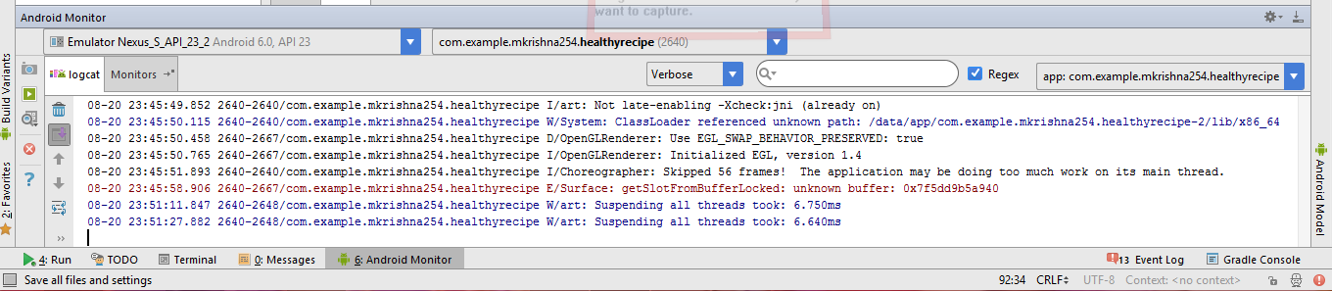

1. When you run the application below window appears.

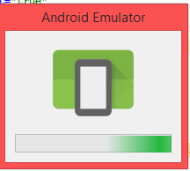

1. When the app is launching.

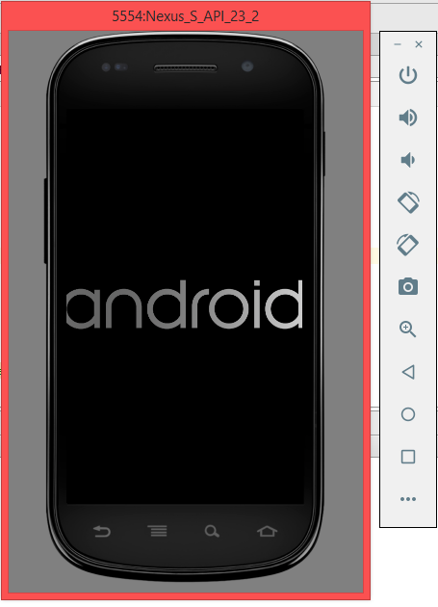

1. After the app launches.

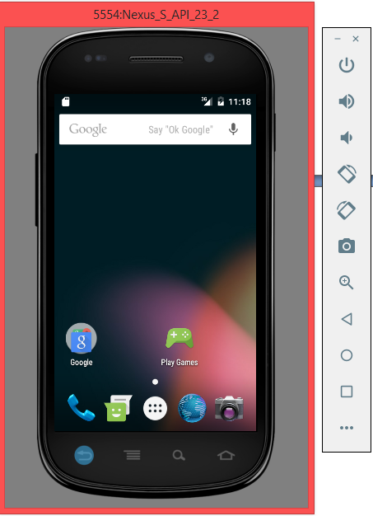

1. When you click on the more app’s button.

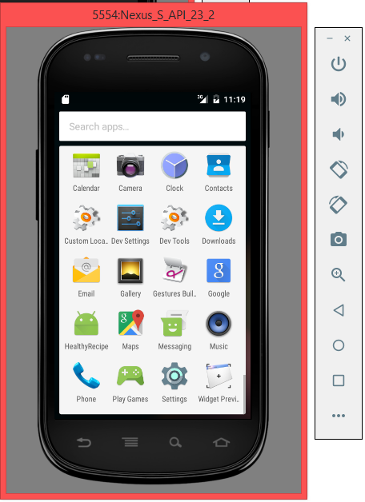

1. Double click on the HealthyRecipe app.

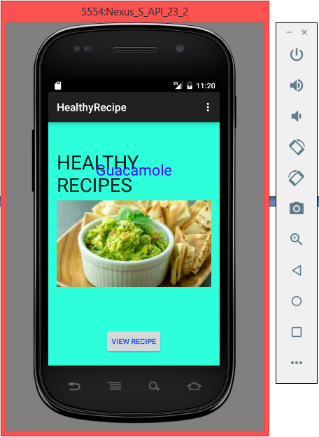

1. After clicking on the VIEW RECIPE button.

