C# Code

1. Sample code for sorting a string using predefined function

using System;

class linSearch

{

public static void Main()

{

Console.WriteLine("Enter Number of Elements you Want to Hold in the Array ? ");

string s = Console.ReadLine();

int x = Int32.Parse(s);

int[] a = new int[x];

Console.WriteLine("Enter Array Elements :");

for (int i = 0; i < x; i++)

{

string s1 = Console.ReadLine();

a[i] = Int32.Parse(s1);

}

Array.Sort(a);

Console.WriteLine("Sorted Array : ");

for (int i = 0; i < x; i++)

{

Console.WriteLine("{0}", a[i]);

}

Console.Read();

}

}

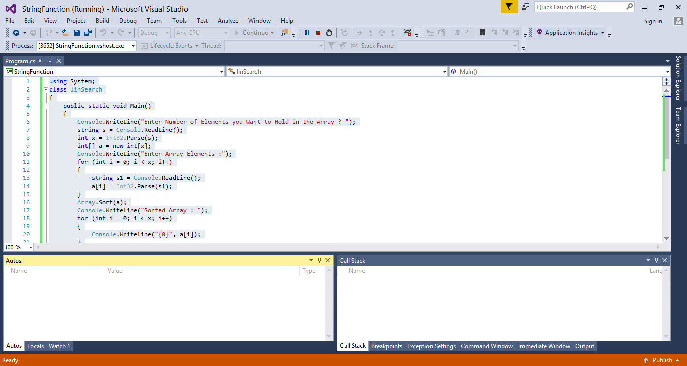

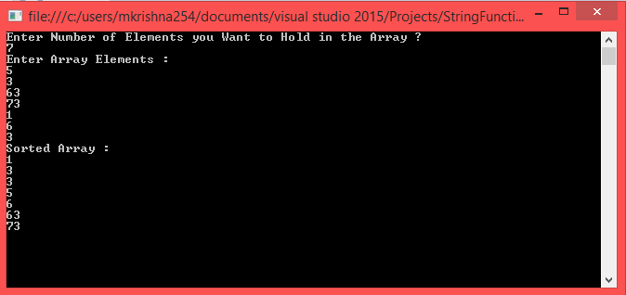

1. Sample code for finding product if two numbers using recursion

using System;

class program

{

public static void Main()

{

int a, b, result;

Console.WriteLine("Enter two numbers to find their product: ");

a = int.Parse(Console.ReadLine());

b = int.Parse(Console.ReadLine());

prog pg = new prog();

result = pg.product(a, b);

Console.WriteLine("Product of {0} and {1} is {2}", a, b, result);

Console.ReadLine();

}

}

class prog

{

public int product(int a, int b)

{

if (a < b)

{

return product(b, a);

}

else if (b != 0)

{

return (a + product(a, b - 1));

}

else

{

return 0;

}

}

}



