**Basic code for C# language:**

**Arithmetic Operators:**

int myNum = 9;

int otherNum = 12;

int result = myNum + otherNum;

Console.WriteLine(result);

int myNum = 9;

int otherNum = 12;

int result = myNum * otherNum;

Console.WriteLine(result);

int myNum = 9;

int otherNum = 12;

int result = myNum / otherNum;

Console.WriteLine(result);

string name = "Grant";

string lastName = "Klim";

string fullName = name + lastName;

Console.WriteLine(fullName);

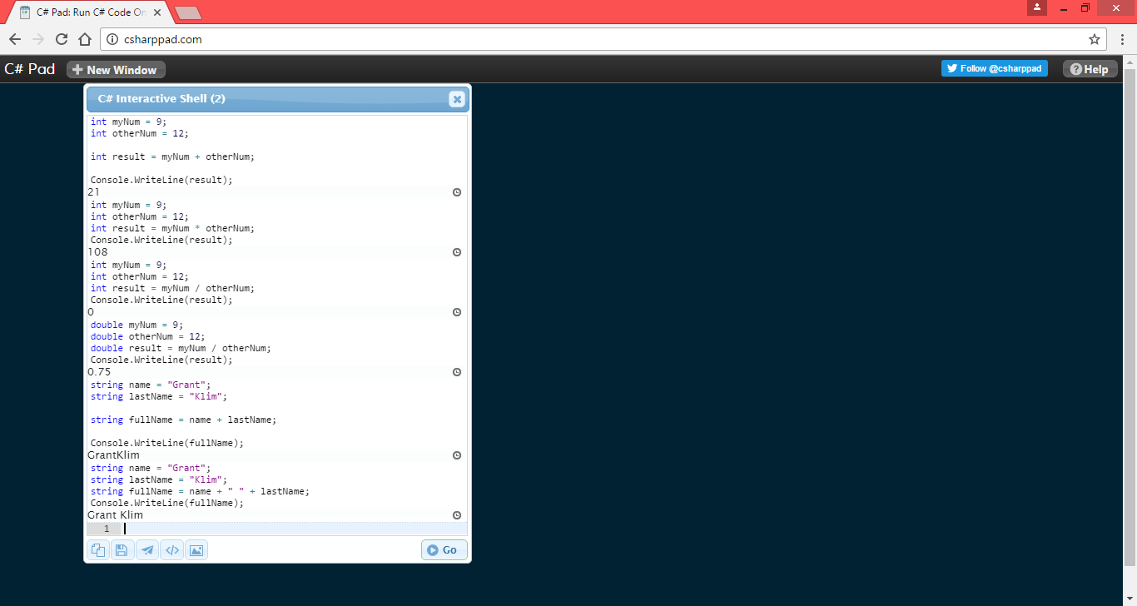

int myNum= 9;

string alsoNum= "0";

var result = myNum + Convert.ToInt16(alsoNum);

Console.WriteLine(result);

int myNum= 9;

string alsoNum= "grant";

var result = myNum + Convert.ToInt16(alsoNum);

Console.WriteLine(result);

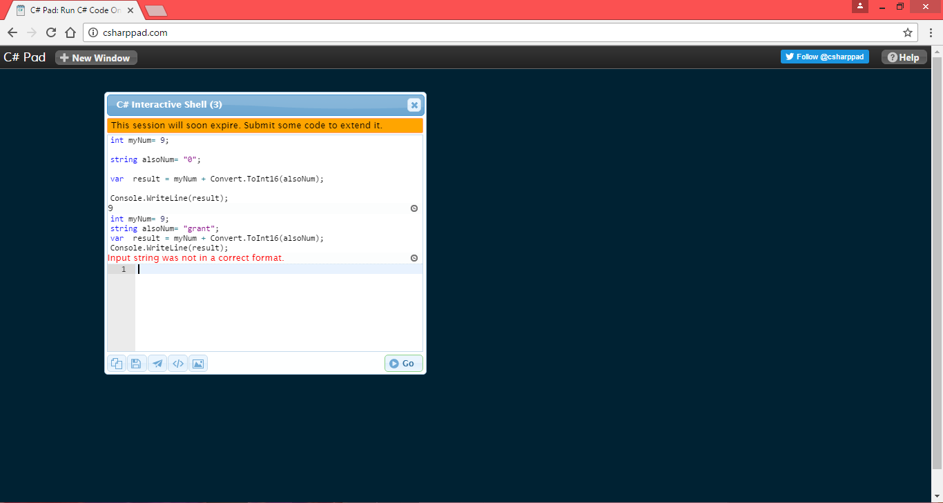

double myNum=786;

string sentence="My number is: "+ myNum.ToString();

Console.WriteLine(sentence);

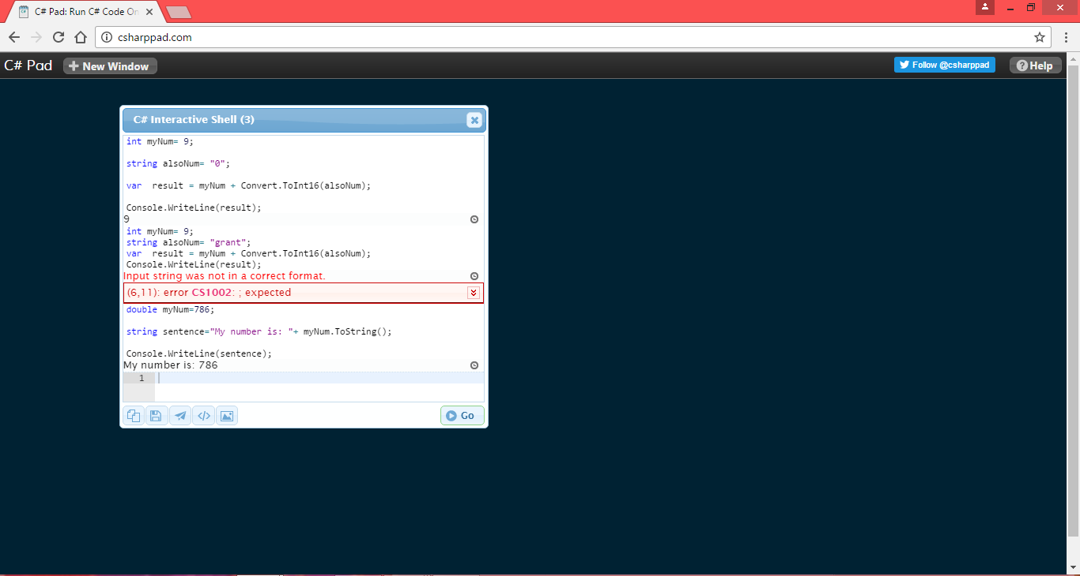

int myNum =1;

switch (myNum)

{

case 1:

Console.WriteLine("num is 1");

break;

case 2:

Console.WriteLine("num is 2");

break;

default:

Console.WriteLine("default case");

break;

}

int myNum =10;

switch (myNum)

{

case 1:

Console.WriteLine("num is 1");

break;

case 2:

Console.WriteLine("num is 2");

break;

default:

Console.WriteLine("default case");

break;

}

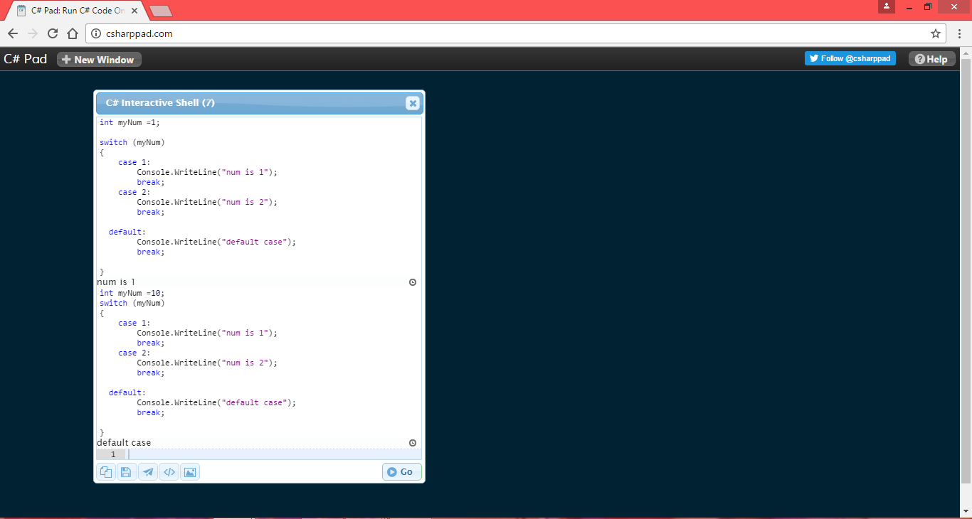

int i = 0;

while(i<100){

Console.WriteLine("Value of i= " + i.ToString());

i++;

}

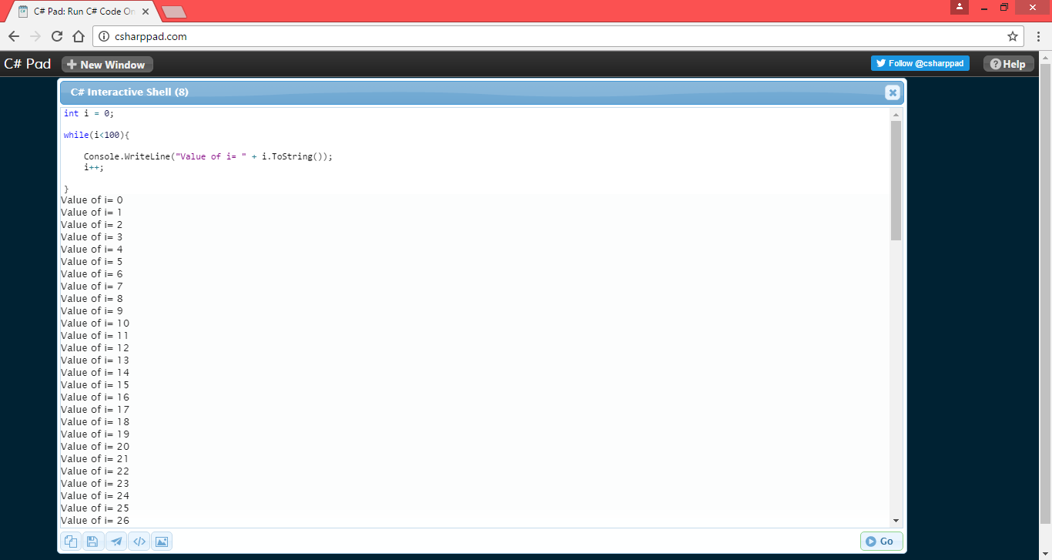

int i = 0;

while(i<100){

Console.WriteLine("Value of i= " + i.ToString());

}

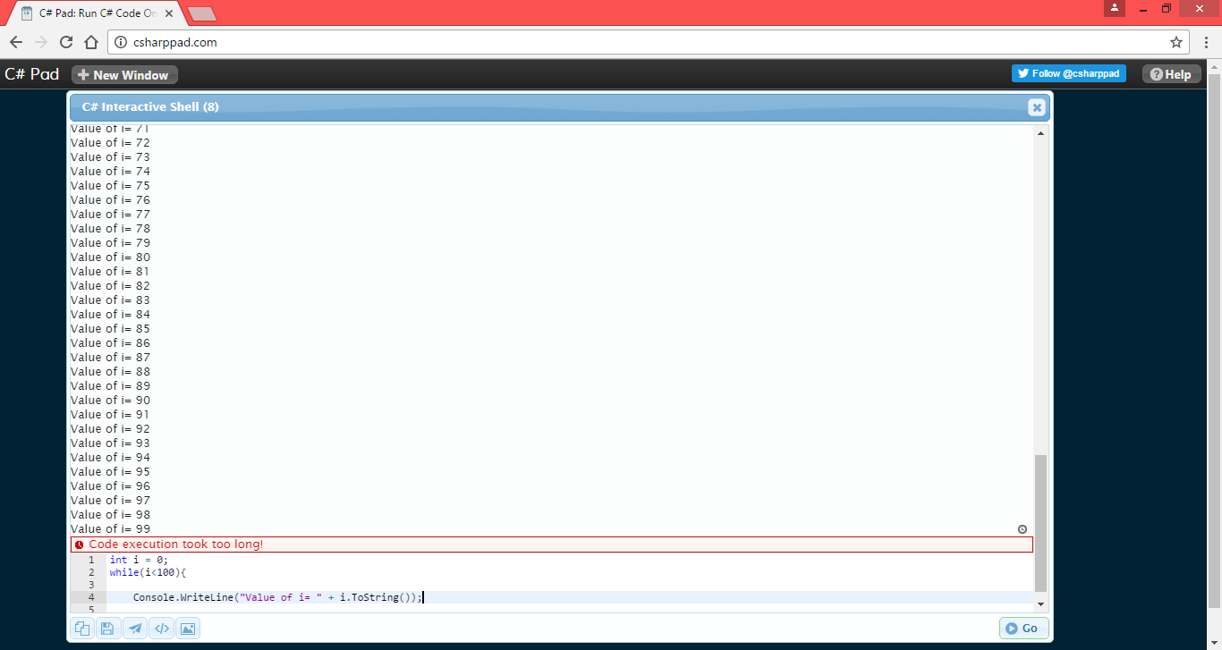

int i = 0;

while(i<100){

Console.WriteLine("Value of i= " + i.ToString());

}

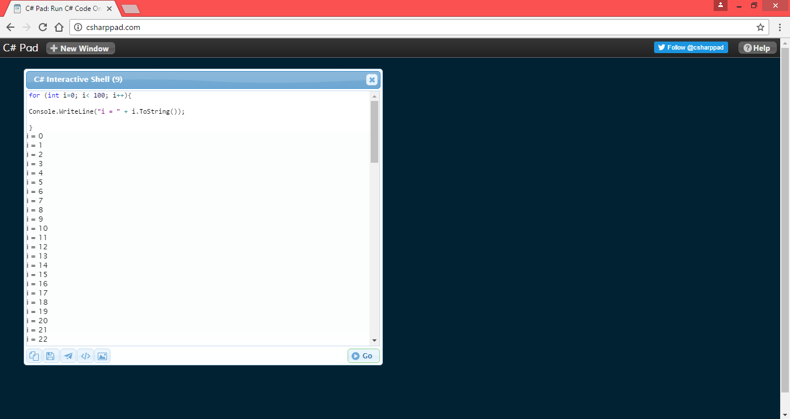

string [] myArray = new string [] {"Learn", "app",

    "development"};

int [] intArray= new int[] { 232, 373, 326161, 8969869};

string word = myArray[1];

Console.WriteLine(word);

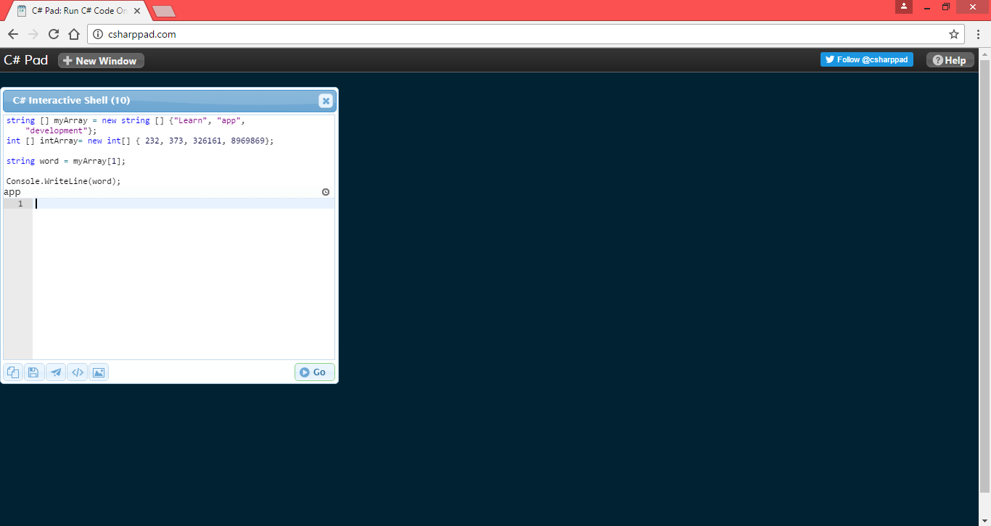

int [] intArray= new int[] { 232, 373, 326161, 8969869};

int arrayLength = intArray.Length;

Console.WriteLine(arrayLength.ToString());

