**C# CODE IN VISUAL STUDIO**

**Code for printing different data types:**

using System;

using System.Collections.Generic;

using System.Linq;

using System.Text;

using System.Threading.Tasks;

namespace ConsoleApp

{

class Program

{

static void Main(string[] args)

{

//numeric data types

sbyte aSignedByte = 127;

byte aByte = 255;

ushort anUnsignedShort = 65535;

short aShort = 32767;

int anInt = 2147483647;

uint anUnsignedInt = 4294967295;

ulong anUnsignedLong = 18446744073709551615;

long aLong = 9223372036854775807;

float aFloat = 105.5678493F;

double aDouble = 105.567849312873245;

decimal aDecimal = 105.84923797593487492387482374982347987293487M;

//character data types

char aChar = 'A';

string aString = "A string of chars";

//Boolean types

bool trueResult = true;

bool falseResult = false;

//Console.Output values, .NET types, size of data type and max value

Console.WriteLine("aByte value is {0},{1}, {2} Byte(s), {3}", aByte, typeof(byte), sizeof(byte), byte.MaxValue);

Console.WriteLine("aInt value is {0},{1}, {2} Byte(s), {3}", anInt, typeof(int), sizeof(byte), byte.MaxValue);

Console.WriteLine("aLong value is {0},{1}, {2} Byte(s), {3}", aLong, typeof(long), sizeof(byte), byte.MaxValue);

Console.WriteLine("aFloat value is {0},{1}, {2} Byte(s), {3}", aFloat, typeof(float), sizeof(byte), byte.MaxValue);

Console.WriteLine("aDouble value is {0},{1}, {2} Byte(s), {3}", aDouble, typeof(double), sizeof(byte), byte.MaxValue);

Console.WriteLine("aDecimal value is {0},{1}, {2} Byte(s), {3}", aDecimal, typeof(decimal), sizeof(byte), byte.MaxValue);

}

}

}

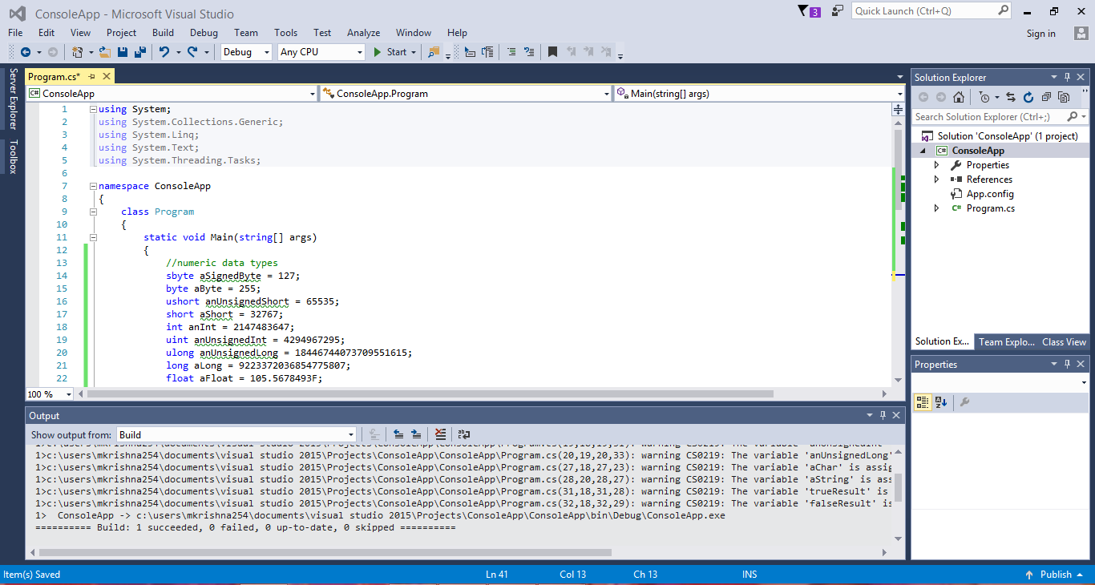

**Output Console:**

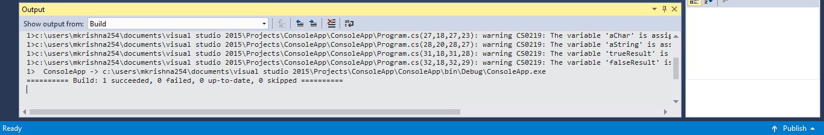

**Result: Command Prompt Window:**

