**JAVA**

**String:**

**package** Exam;

**public** **class** StringR {

**public** **static** **void** main(String[] args){

String str = "Neelima Reddy Daggula";

StringBuilder sb = **new** StringBuilder(str);

str = sb.reverse().toString();

System.***out***.println("ReverseString : "+str);

}

}

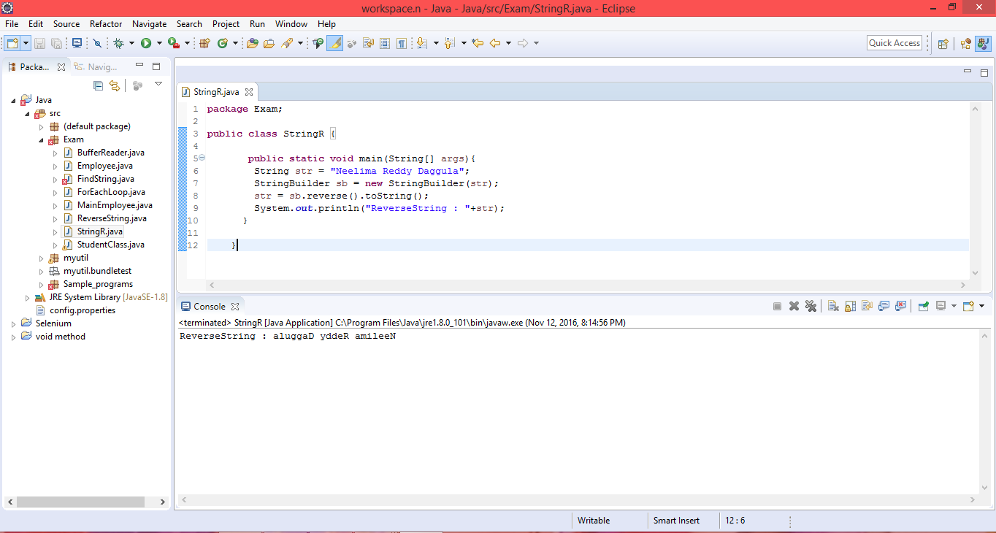

**StringDemo:**

**public** **class** StringDemo

{

**static** **int** *i*,*c*=0,*res*;

**static** **int** wordcount(String s)

{

**char** ch[]= **new** **char**[s.length()];

**for**(*i*=0;*i*<s.length();*i*++)

{

ch[*i*]= s.charAt(*i*);

**if**( ((*i*>0)&&(ch[*i*]!=' ')&&(ch[*i*-1]==' ')) || ((ch[0]!=' ')&&(*i*==0)) )

*c*++;

}

**return** *c*;

}

**public** **static** **void** main (String args[])

{

*res*=StringDemo.*wordcount*(" manchester united is also known as red devil ");

System.***out***.println("The number of words in the String are : "+*res*);

}

}

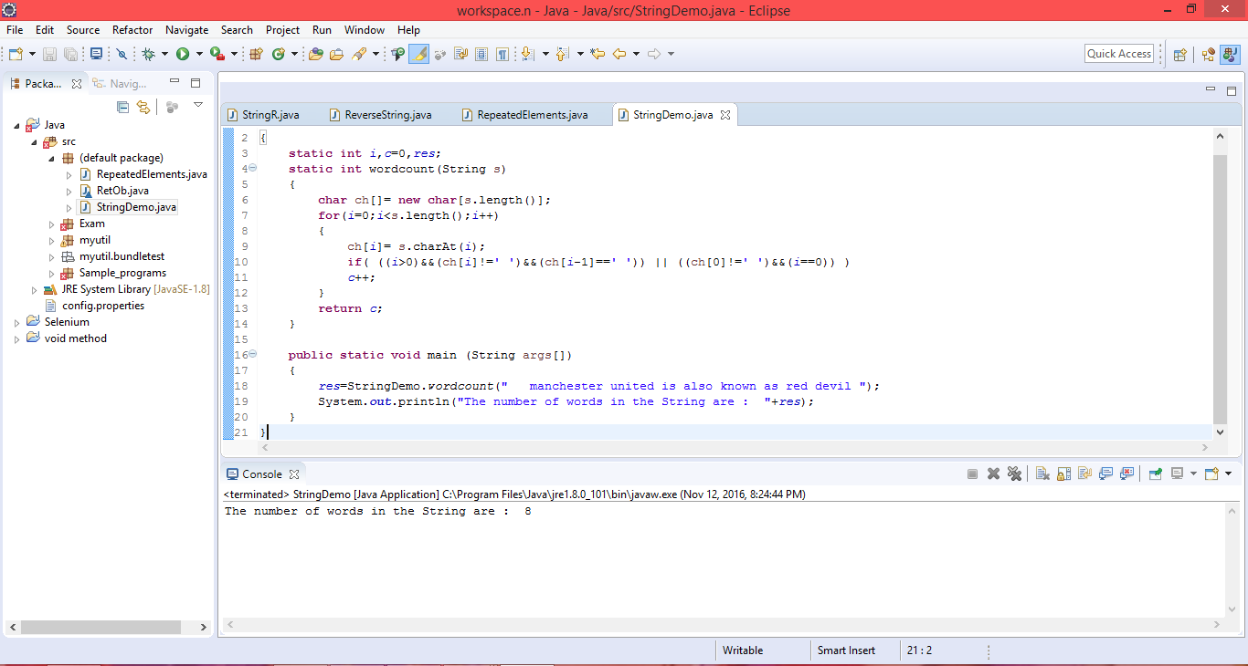

**ReverseString:**

**package** Exam;

**public** **class** ReverseString

{

**static** **int** *i*,*a*=0;

**static** **void** stringreverse(String s)

{

**char** ch[]=**new** **char**[s.length()];

**for**(*i*=0;*i* < s.length();*i*++)

ch[*i*]=s.charAt(*i*);

**for**(*i*=s.length()-1;*i*>=0;*i*--)

System.***out***.print(ch[*i*]);

}

**public** **static** **void** main (String args[])

{

System.***out***.println("Original String is : ");

System.***out***.println("I am seeking job in Quality Assurance ");

System.***out***.println("Reverse String is: ");

ReverseString.*stringreverse*("I am seeking job in Quality Assurance");

}

}

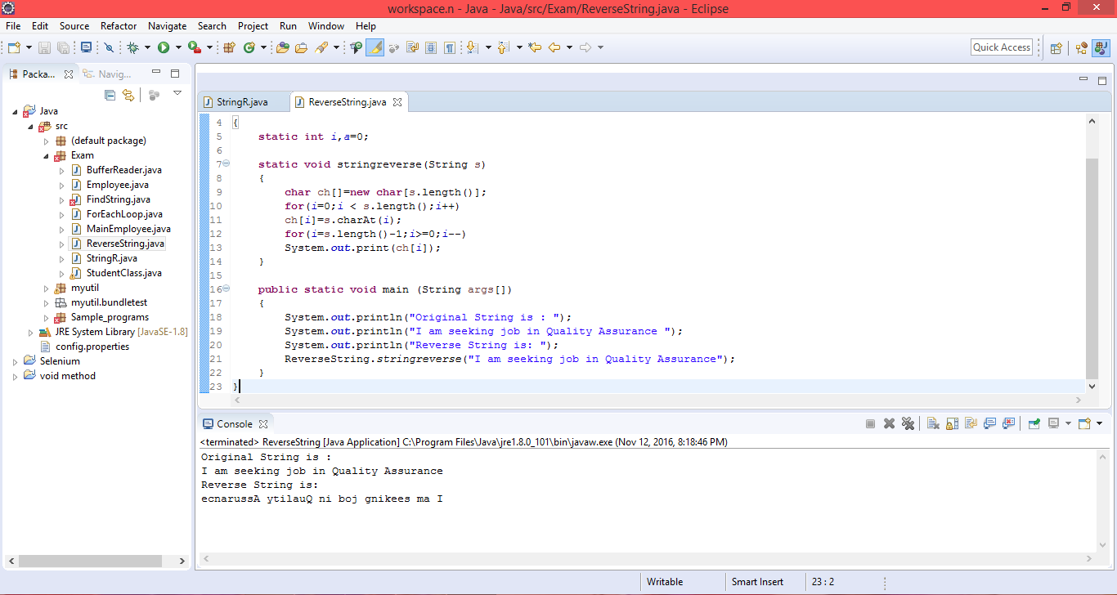

**Sort:**

**package** Sample_programs;

**class** sort{

**public** **static** **void** main(String args[])

{

**int** numbers[] = {6,3,37,12,46,5,64,21};

**int** highest = 0;

**int** second_highest = 0;

**for**(**int** n:numbers){

**if**(highest < n){

second_highest = highest;

highest =n;

} **else** **if**(second_highest < n){

second_highest = n;

}

}

System.***out***.println("First Max Number: "+highest);

System.***out***.println("Second Max Number: "+second_highest);

}

}

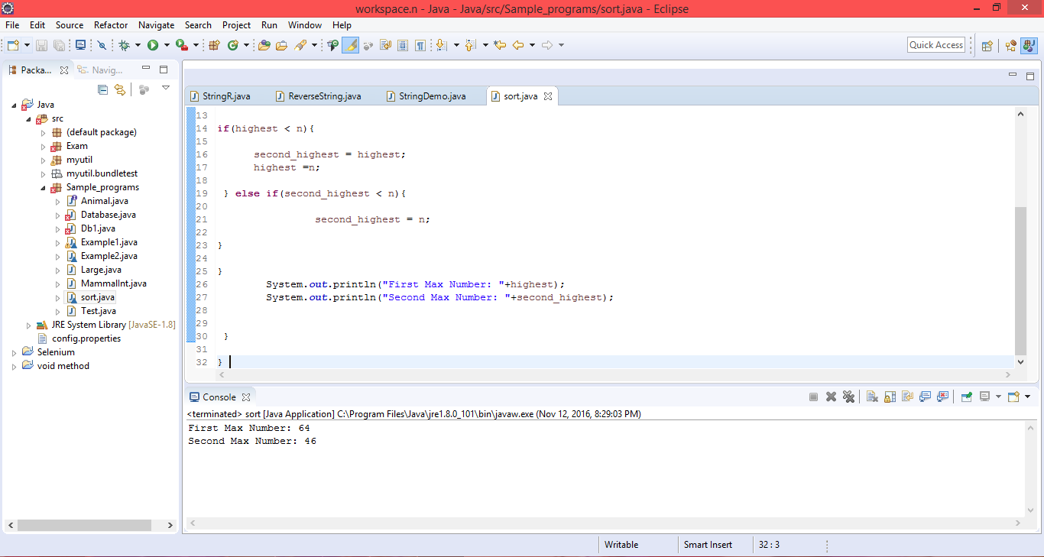

**RepeatElement:**

package myutil;

import java.util.ArrayList;

import java.util.Arrays;

import java.util.HashMap;

import java.util.HashSet;

import java.util.List;

import java.util.Map;

import java.util.Set;

public class RepeatElement {

public static void main(String[] args) {

String para = "Where are you are";

List <String> paraList = new ArrayList <String>();

paraList = Arrays.asList(para.split(" "));

System.out.println(paraList);

int size = paraList.size();

int i = 0;

Map <String, Integer> duplicateCountMap = new HashMap <

String, Integer>();

for (int j = 0; size > j; j++) {

int count = 0;

for (i = 0; size > i; i++) {

if (paraList.get(j).equals(paraList.get(i))) {

count++;

duplicateCountMap.put(paraList.get(j), count);

}

}

}

System.out.println(duplicateCountMap);

List <Integer> myCountList = new ArrayList < Integer>();

Set <String> myValueSet = new HashSet <String> ();

for (Map.Entry <String, Integer> entry:

duplicateCountMap.entrySet()) {

myCountList.add(entry.getValue());

myValueSet.add(entry.getKey());

}

System.out.println(myCountList);

System.out.println(myValueSet);

}

}

