1. Sample code for demonstrating IndexOutOfRange exception

using System;

using System.Collections.Generic;

using System.Linq;

using System.Text;

namespace difference

{

class arrayoutofindex

{

public void calculatedifference()

{

int difference = 0;

int[] number = new int[5] { 1, 2, 3, 4, 5 };

try

{

for (int init = 1; init <= 5; init++)

{

difference = difference - number[init];

}

Console.WriteLine("The difference of the array is:" + difference);

}

catch (IndexOutOfRangeException e)

{

Console.WriteLine(e.Message);

}

}

}

class classmain

{

static void Main(string[] args)

{

arrayoutofindex obj = new arrayoutofindex();

obj.calculatedifference();

Console.ReadLine();

}

}

}

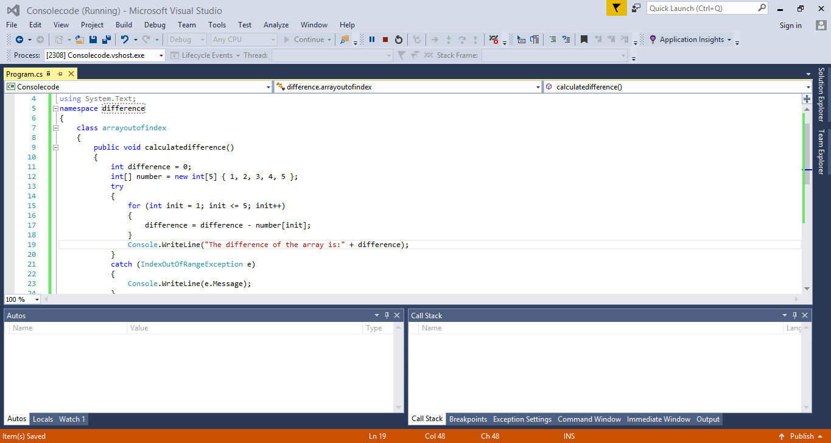

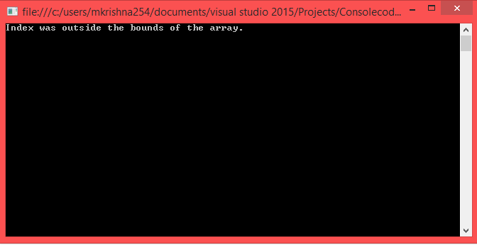

1. Java sample code for method overloading

**package** Sample;

**public** **class** MethodOverloading {

**class** DisplayOverloading

{

**public** **void** disp(**char** c)

{

System.***out***.println(c);

}

**public** **void** disp(**char** c, **int** num)

{

System.***out***.println(c + " "+num);

}

}

**class** Sample

{

**public** **void** main(String args[])

{

DisplayOverloading obj = **new** DisplayOverloading();

obj.disp('a');

obj.disp('a',10);

}

}

}