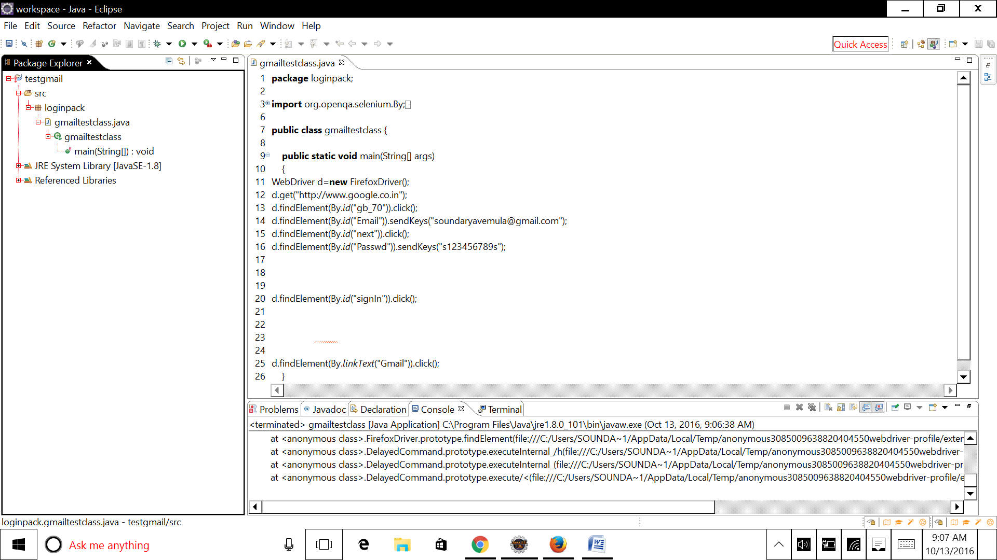

Result:

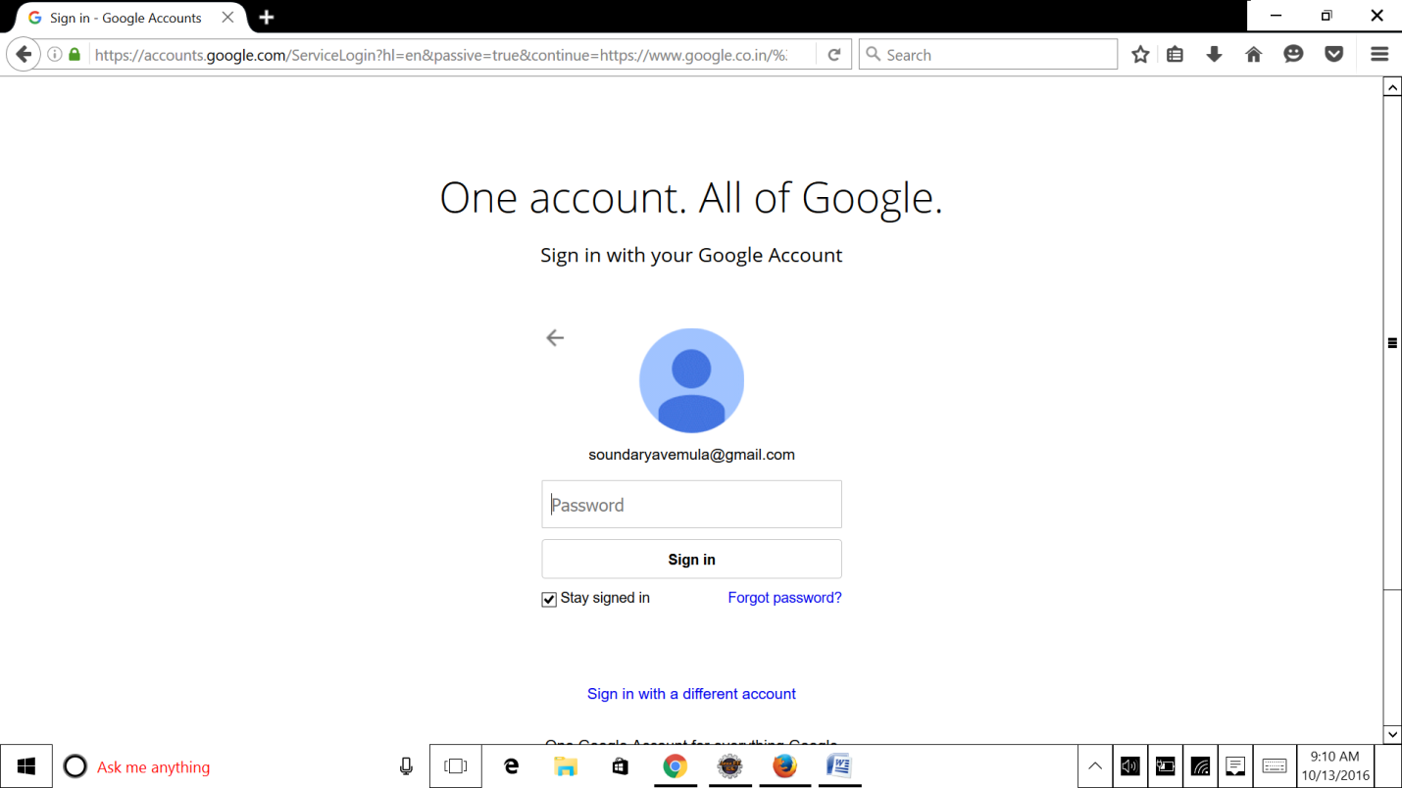

Code:

package loginpack;

import org.openqa.selenium.By;

import org.openqa.selenium.WebDriver;

import org.openqa.selenium.firefox.FirefoxDriver;

public class gmailtestclass {

public static void main(String[] args)

{

WebDriver d=new FirefoxDriver();

d.get("http://www.google.co.in");

d.findElement(By.id("gb_70")).click();

d.findElement(By.id("Email")).sendKeys("soundaryavemula@gmail.com");

d.findElement(By.id("next")).click();

d.findElement(By.id("Passwd")).sendKeys("s123456789s");

// click on sign in

d.findElement(By.id("signIn")).click();

// click on gmail

d.findElement(By.linkText("Gmail")).click();

}

}