creating method with void:

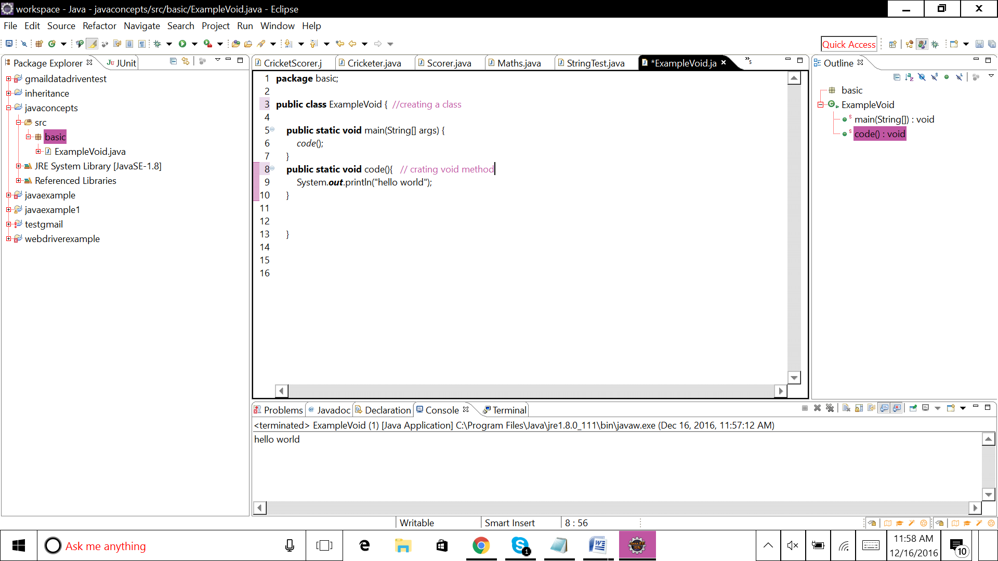

**package** basic;

**public** **class** ExampleVoid { //creating a class

**public** **static** **void** main(String[] args) {

*code*();

}

**public** **static** **void** code(){ // crating void method

System.***out***.println("hello world");

}

}

creating method with void and parameter :

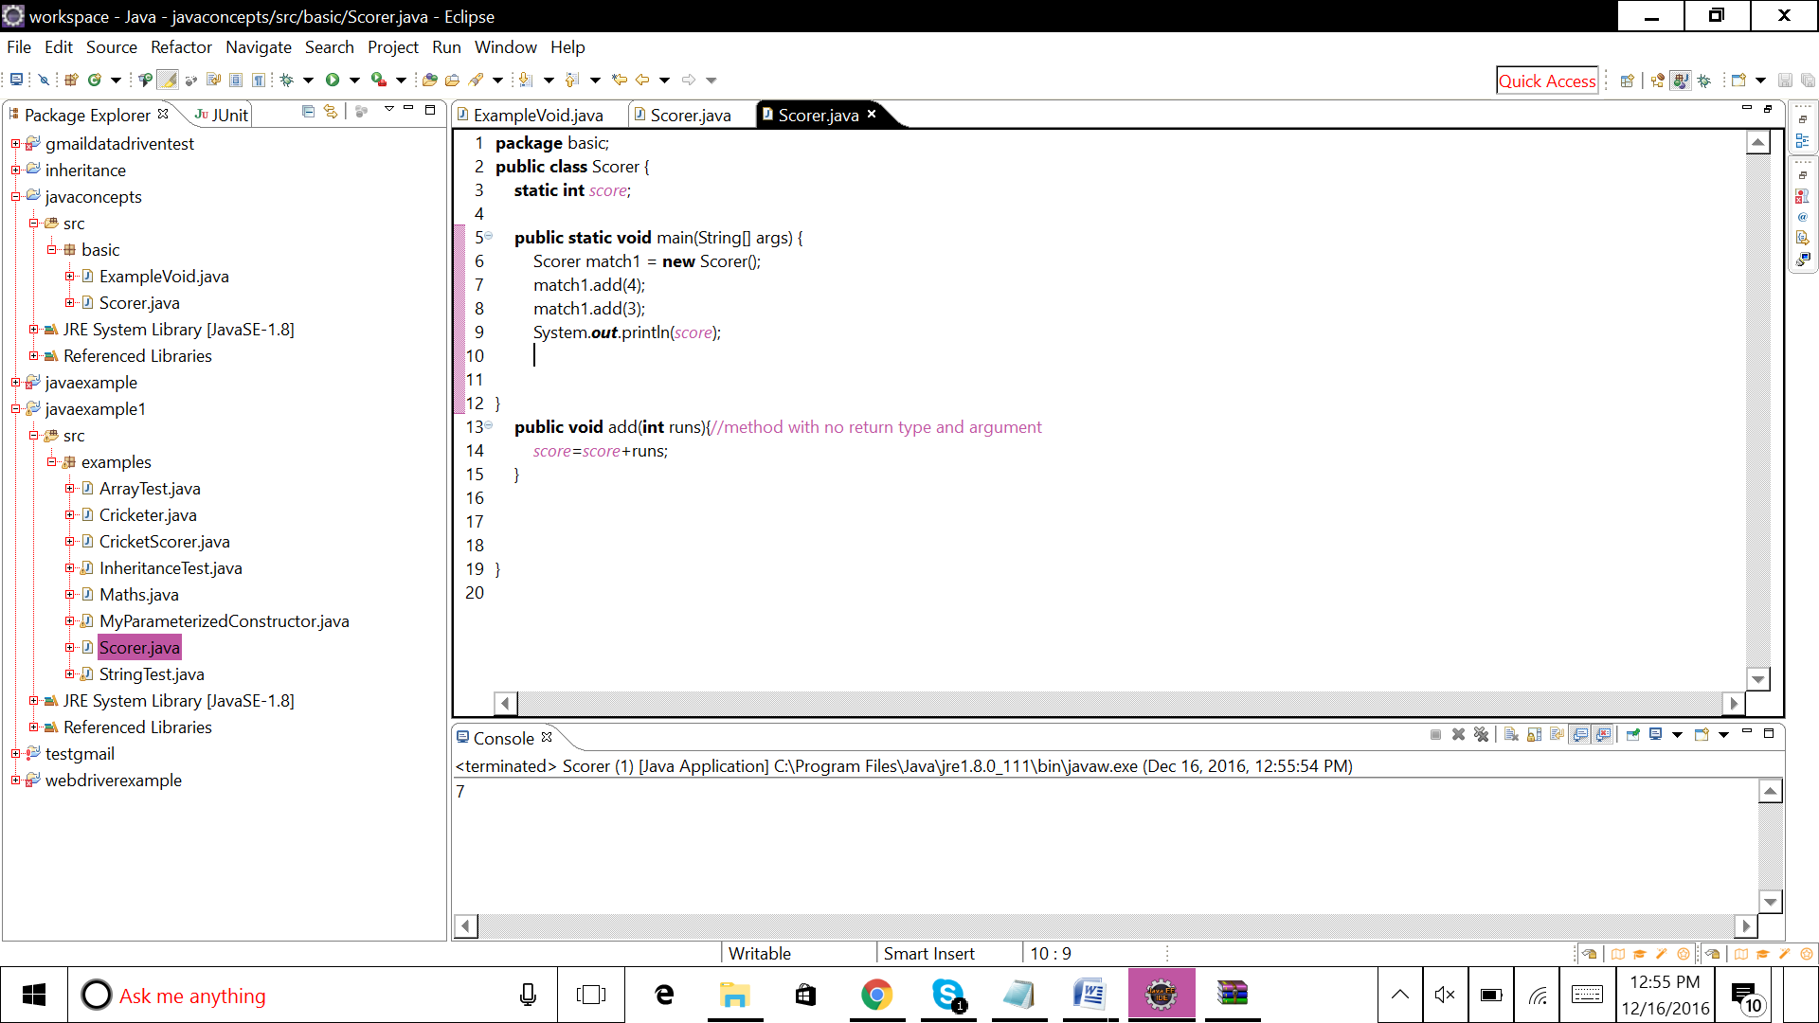

**package** basic;

**public** **class** Scorer {

**static** **int** *score*;

**public** **static** **void** main(String[] args) {

Scorer match1 = **new** Scorer();

match1.add(4);

match1.add(3);

System.***out***.println(*score*);

}

**public** **void** add(**int** runs){//method with void and parameter

*score*=*score*+runs;

}

}

creating method with return data type

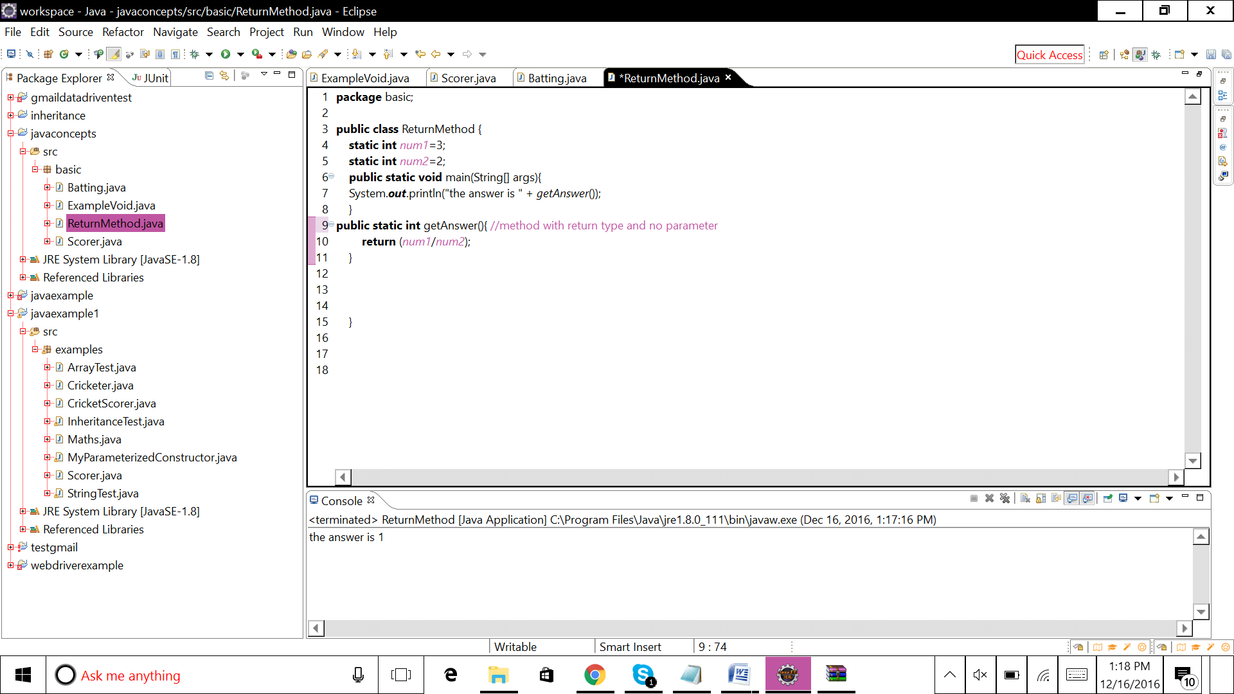

**package** basic;

**public** **class** ReturnMethod {

**static** **int** *num1*=3;

**static** **int** *num2*=2;

**public** **static** **void** main(String[] args){

System.***out***.println("the answer is " + *getAnswer*());

}

**public** **static** **int** getAnswer(){ //method with return type and no parameter

**return** (*num1*/*num2*);

}

}

creating method with return data type and parameter:

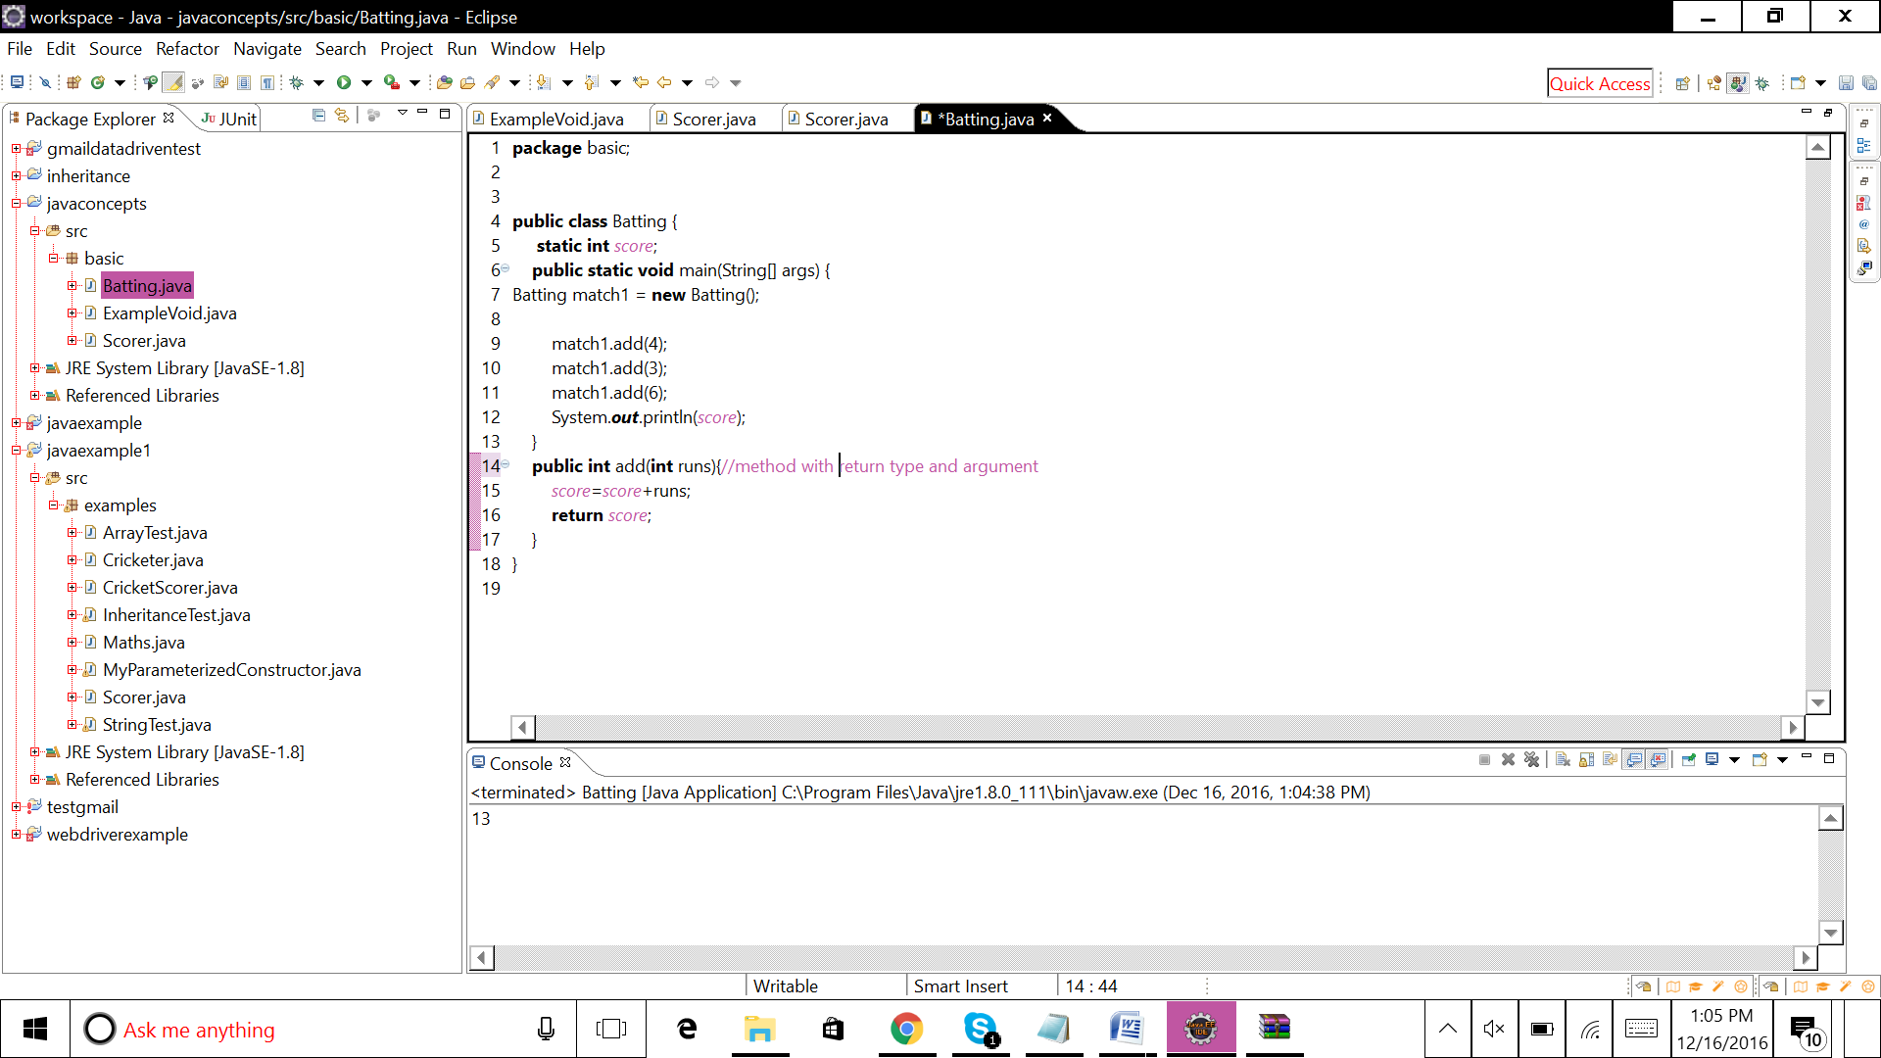

**package** basic;

**public** **class** Batting {

**static** **int** *score*;

**public** **static** **void** main(String[] args) {

Batting match1 = **new** Batting();

match1.add(4);

match1.add(3);

match1.add(6);

System.***out***.println(*score*);

}

**public** **int** add(**int** runs){//method with return type and argument

*score*=*score*+runs;

**return** *score*;

creating variable

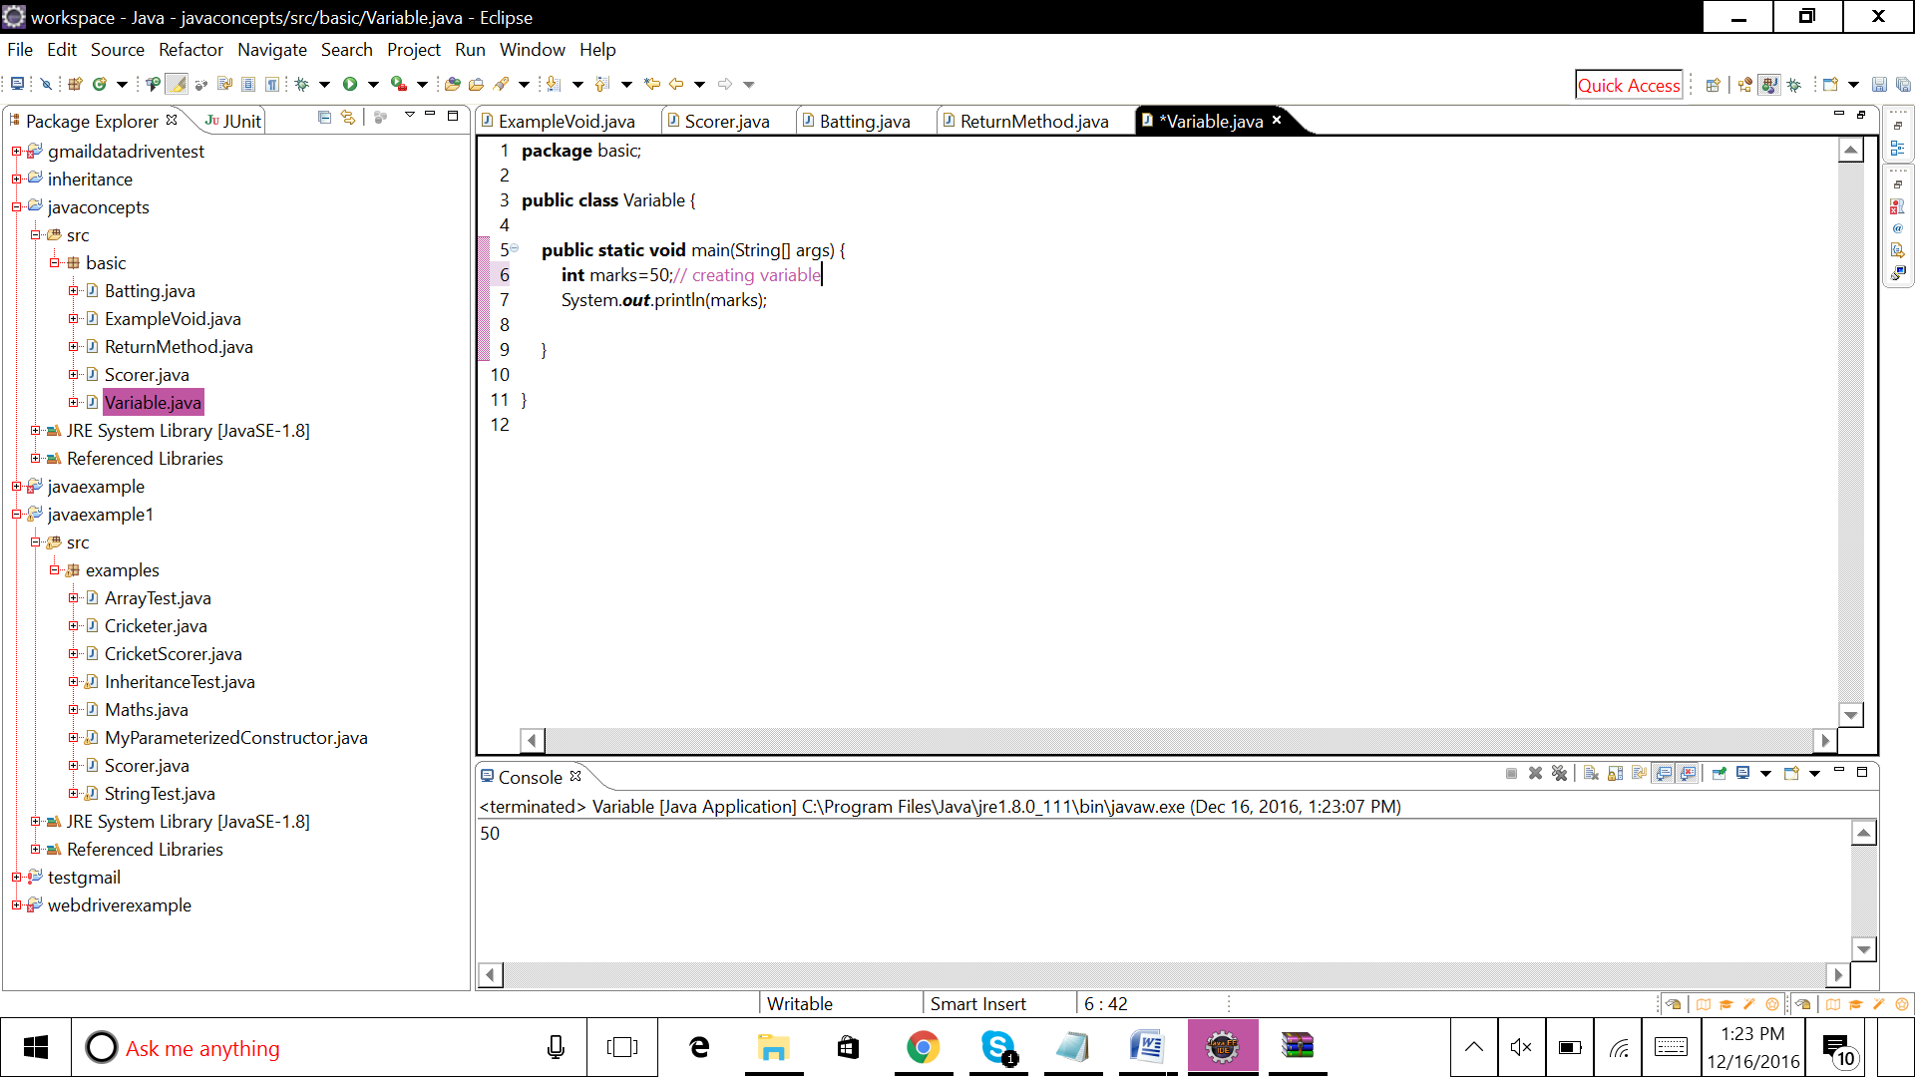

**package** basic;

**public** **class** Variable {

**public** **static** **void** main(String[] args) {

**int** marks=50;// creating variable

System.***out***.println(marks);

}

}

creating static method

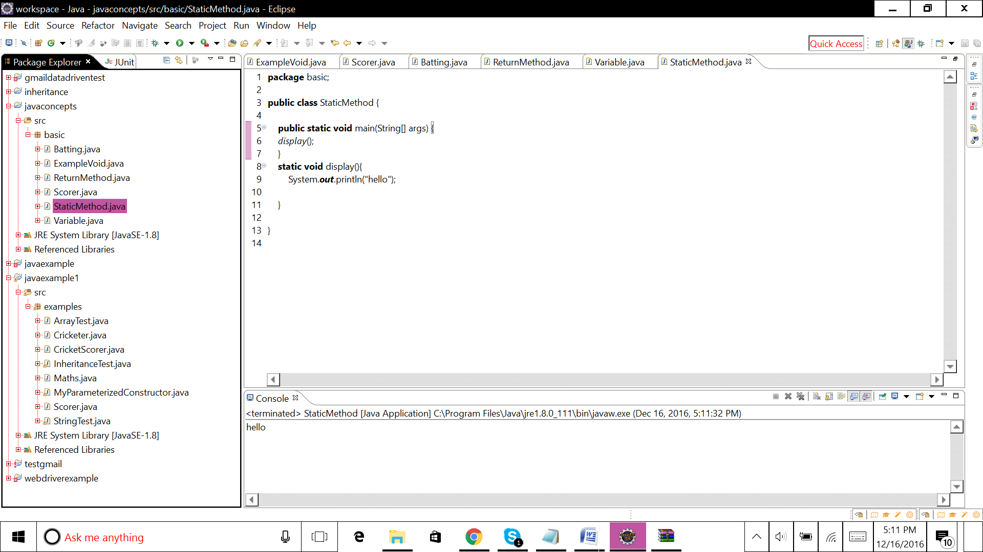

**package** basic;

**public** **class** StaticMethod {

**public** **static** **void** main(String[] args) {

*display*();

}

**static** **void** display(){

System.***out***.println("hello");

}

}

write code to handle exceptions with try/catch/finally

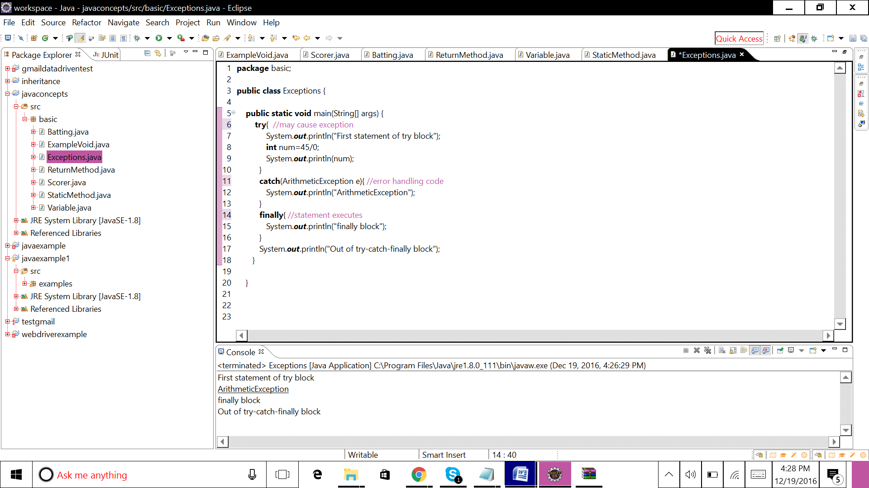

**package** basic;

**public** **class** Exceptions {

**public** **static** **void** main(String[] args) {

**try**{ //may cause exception

System.***out***.println("First statement of try block");

**int** num=45/0;

System.***out***.println(num);

}

**catch**(ArithmeticException e){ //error handling code

System.***out***.println("ArithmeticException");

}

**finally**{ //statement executes

System.***out***.println("finally block");

}

System.***out***.println("Out of try-catch-finally block");

}

}

write code for interface and create class to implement that interface

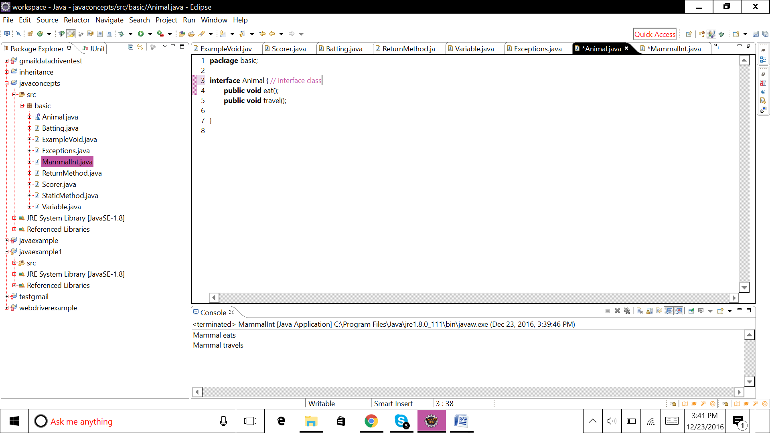

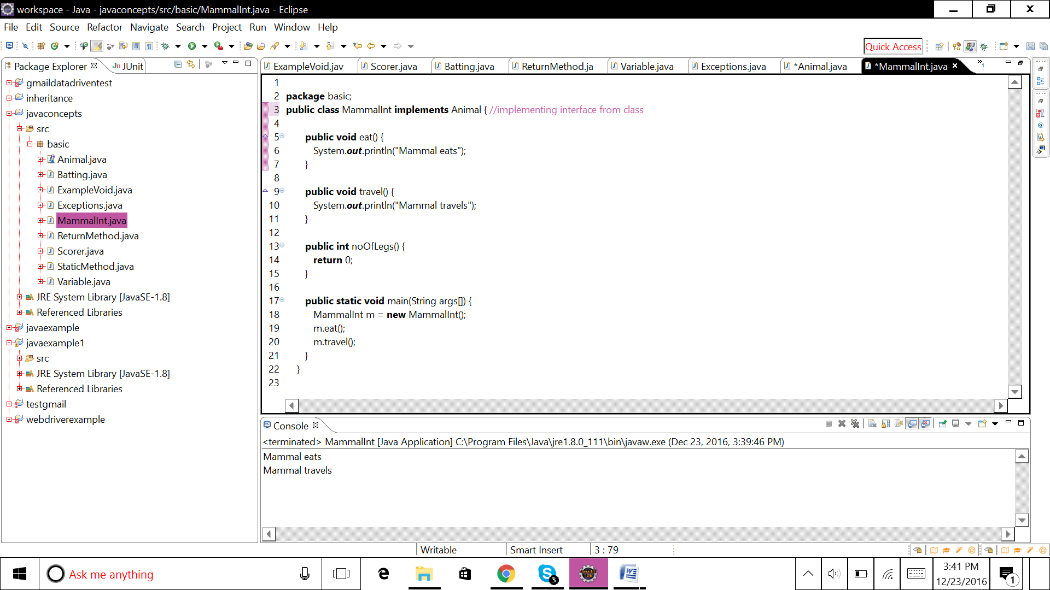

**package** basic;

**interface** Animal { // interface class

**public** **void** eat();

**public** **void** travel();

}

**package** basic;

**public** **class** MammalInt **implements** Animal { //implementing interface from class

**public** **void** eat() {

System.***out***.println("Mammal eats");

}

**public** **void** travel() {

System.***out***.println("Mammal travels");

}

**public** **int** noOfLegs() {

**return** 0;

}

**public** **static** **void** main(String args[]) {

MammalInt m = **new** MammalInt();

m.eat();

m.travel();

}

}

implement method overloading

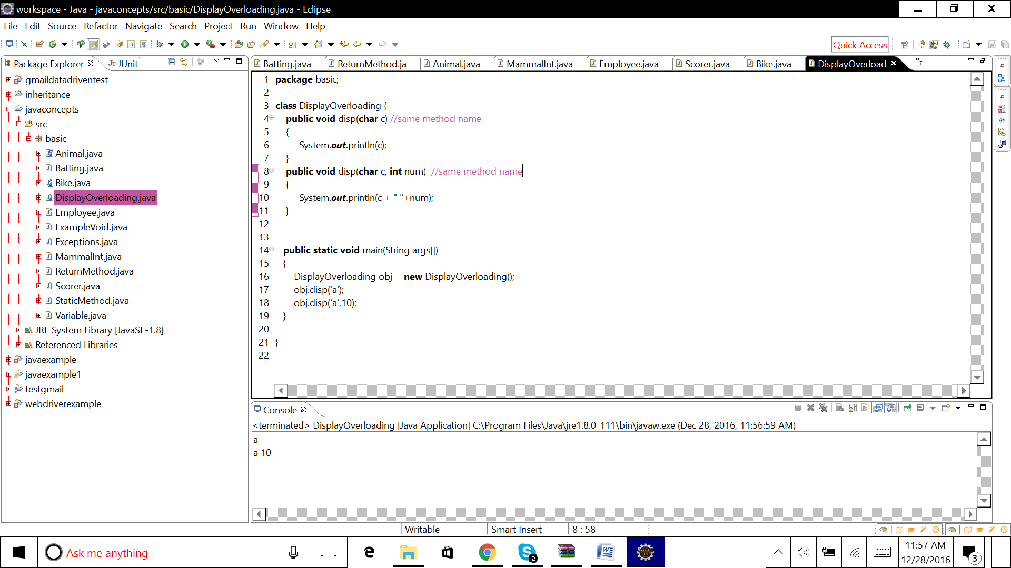

**package** basic;

**class** DisplayOverloading {

**public** **void** disp(**char** c) //same method name

{

System.***out***.println(c);

}

**public** **void** disp(**char** c, **int** num) //same method name

{

System.***out***.println(c + " "+num);

}

**public** **static** **void** main(String args[])

{

DisplayOverloading obj = **new** DisplayOverloading();

obj.disp('a');

obj.disp('a',10);

}

}

implement method overriding

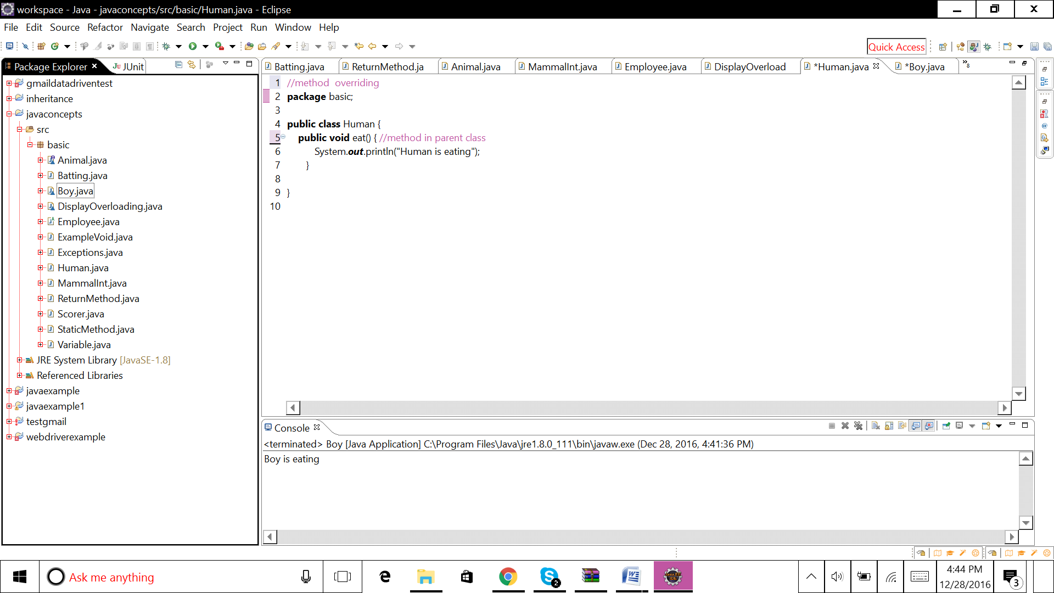

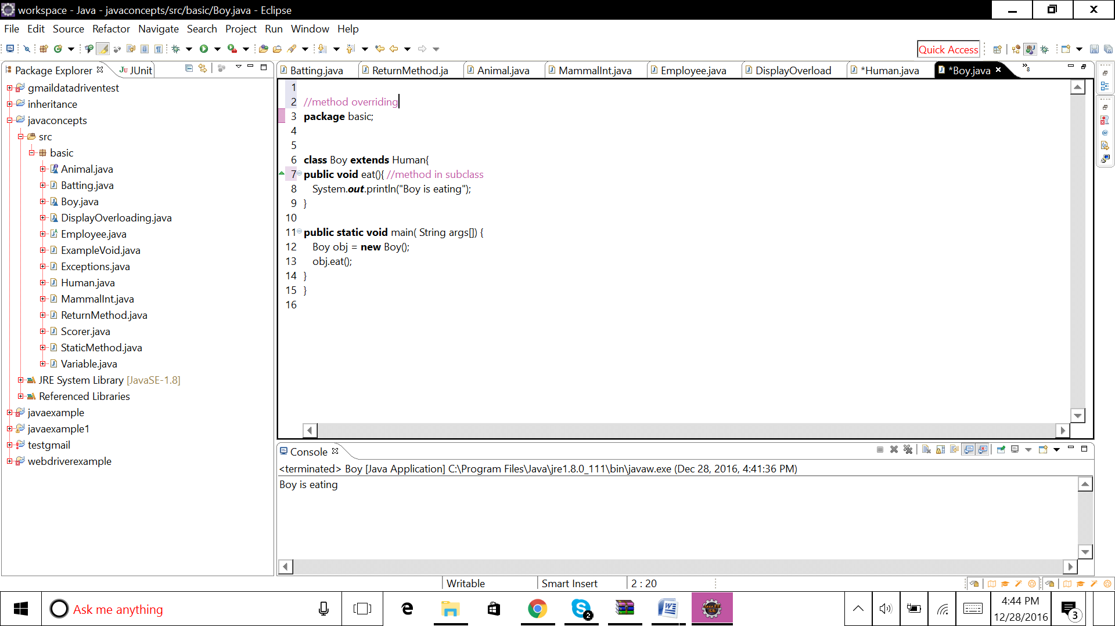

//method overriding

**package** basic;

**public** **class** Human {

**public** **void** eat() { //method in parent class

System.***out***.println("Human is eating");

}

}

//method overriding

**package** basic;

**class** Boy **extends** Human{

**public** **void** eat(){ //method in subclass

System.***out***.println("Boy is eating");

}

**public** **static** **void** main( String args[]) {

Boy obj = **new** Boy();

obj.eat();

}

}