Function invocation:

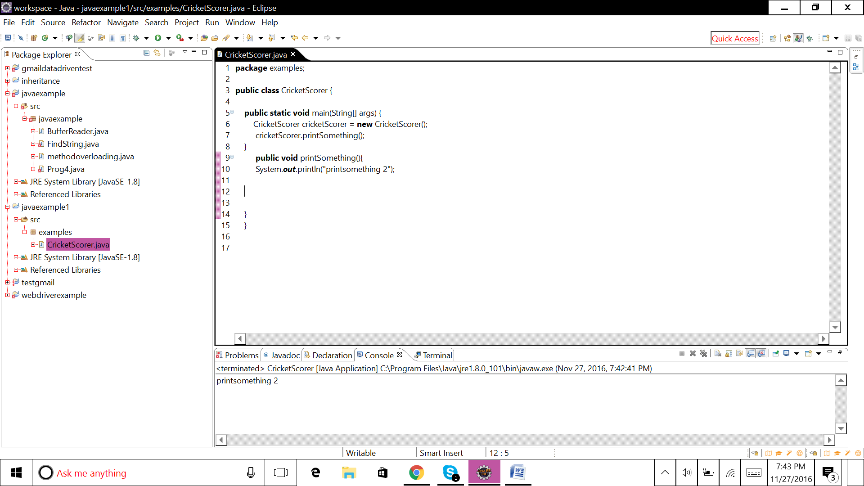

**package** examples;

**public** **class** CricketScorer {

**public** **static** **void** main(String[] args) {

CricketScorer cricketScorer = **new** CricketScorer();

cricketScorer.printSomething();

}

**public** **void** printSomething(){

System.***out***.println("printsomething 2");

}

}

Class instance and object:

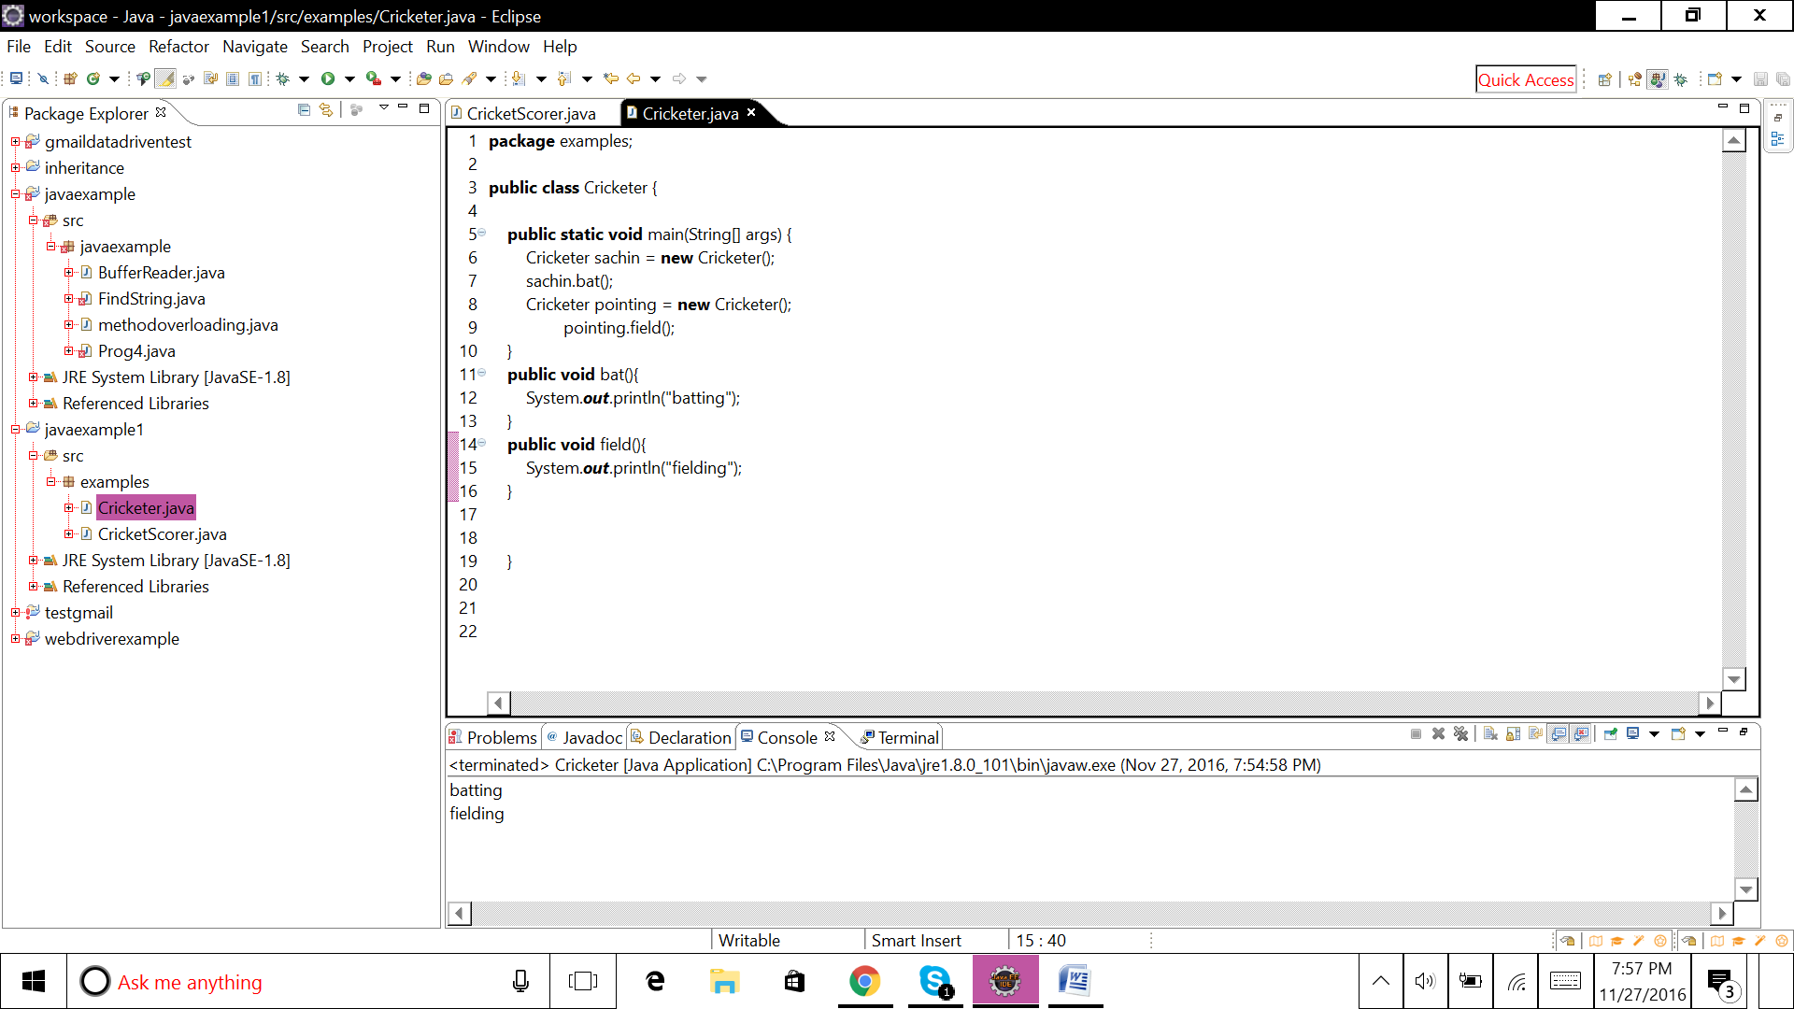

**package** examples;

**public** **class** Cricketer {

**public** **static** **void** main(String[] args) {

Cricketer sachin = **new** Cricketer();

sachin.bat();

Cricketer pointing = **new** Cricketer();

pointing.field();

}

**public** **void** bat(){

System.***out***.println("batting");

}

**public** **void** field(){

System.***out***.println("fielding");

}

}

Method Parameters:

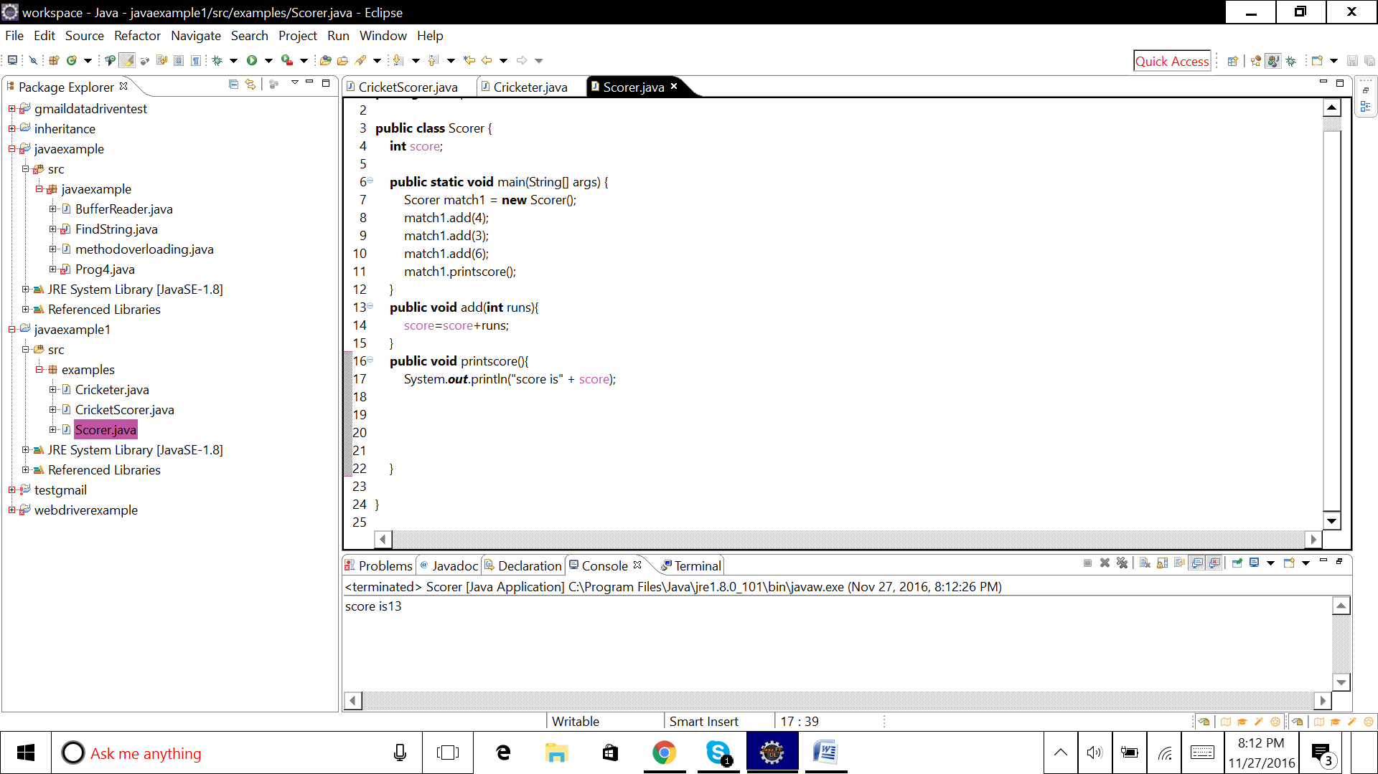

**package** examples;

**public** **class** Scorer {

**int** score;

**public** **static** **void** main(String[] args) {

Scorer match1 = **new** Scorer();

match1.add(4);

match1.add(3);

match1.add(6);

match1.printscore();

}

**public** **void** add(**int** runs){

score=score+runs;

}

**public** **void** printscore(){

System.***out***.println("score is" + score);

}

}

Return value from function:

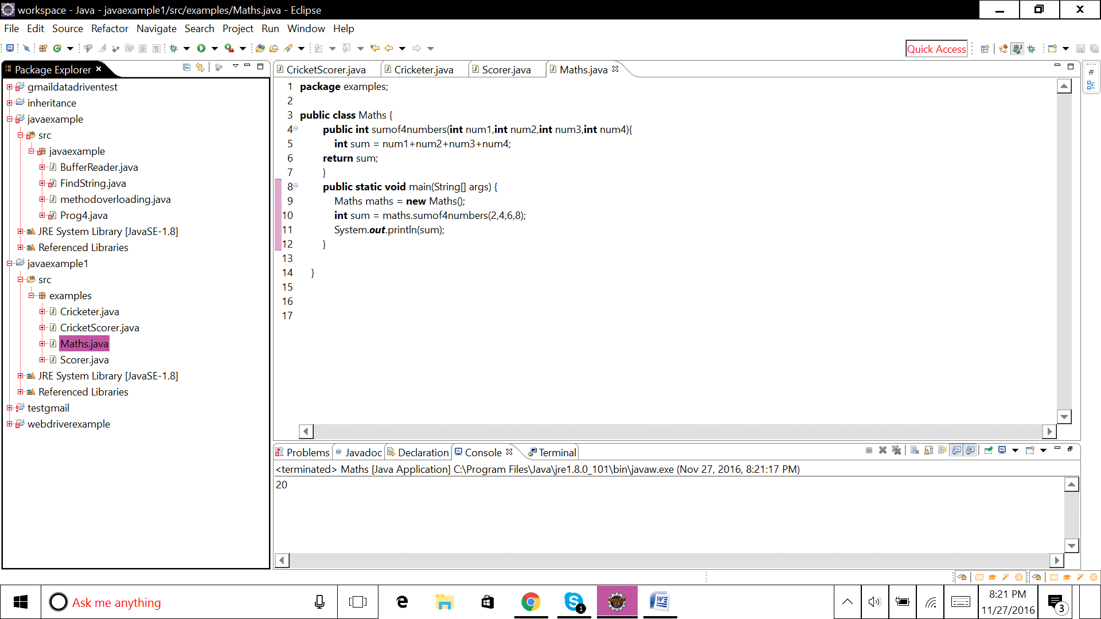

**package** examples;

**public** **class** Maths {

**public** **int** sumof4numbers(**int** num1,**int** num2,**int** num3,**int** num4){

**int** sum = num1+num2+num3+num4;

**return** sum;

}

**public** **static** **void** main(String[] args) {

Maths maths = **new** Maths();

**int** sum = maths.sumof4numbers(2,4,6,8);

System.***out***.println(sum);

}

}