Strings:

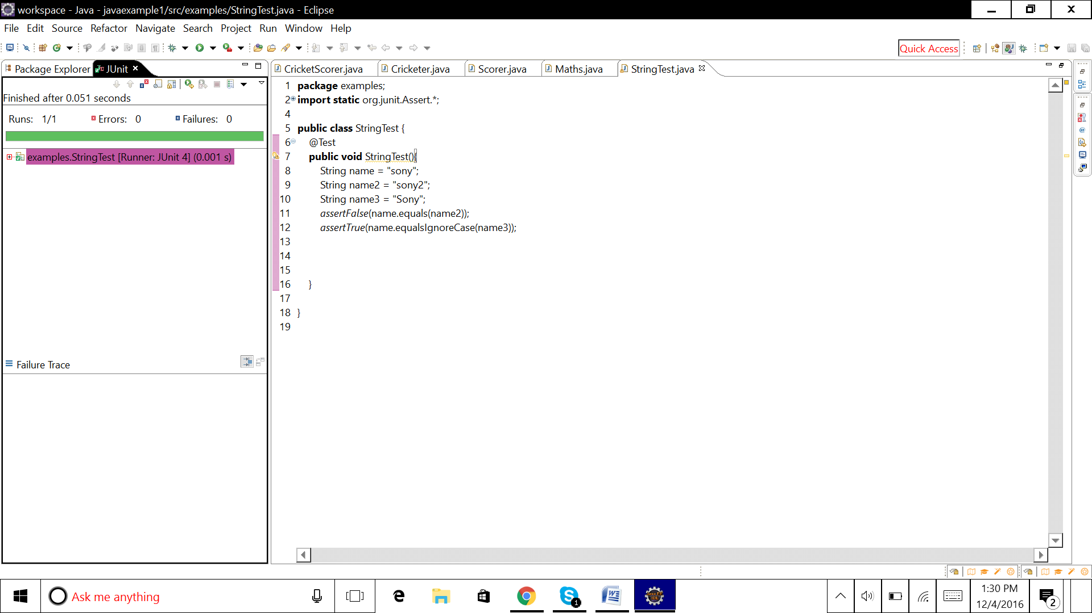

package examples;

import static org.junit.Assert.*;

import org.junit.Test;

public class StringTest {

@Test

public void StringTest(){

String name = "sony";

String name2 = "sony2";

String name3 = "Sony";

assertFalse(name.equals(name2));

assertTrue(name.equalsIgnoreCase(name3));

}

}

Arrays :

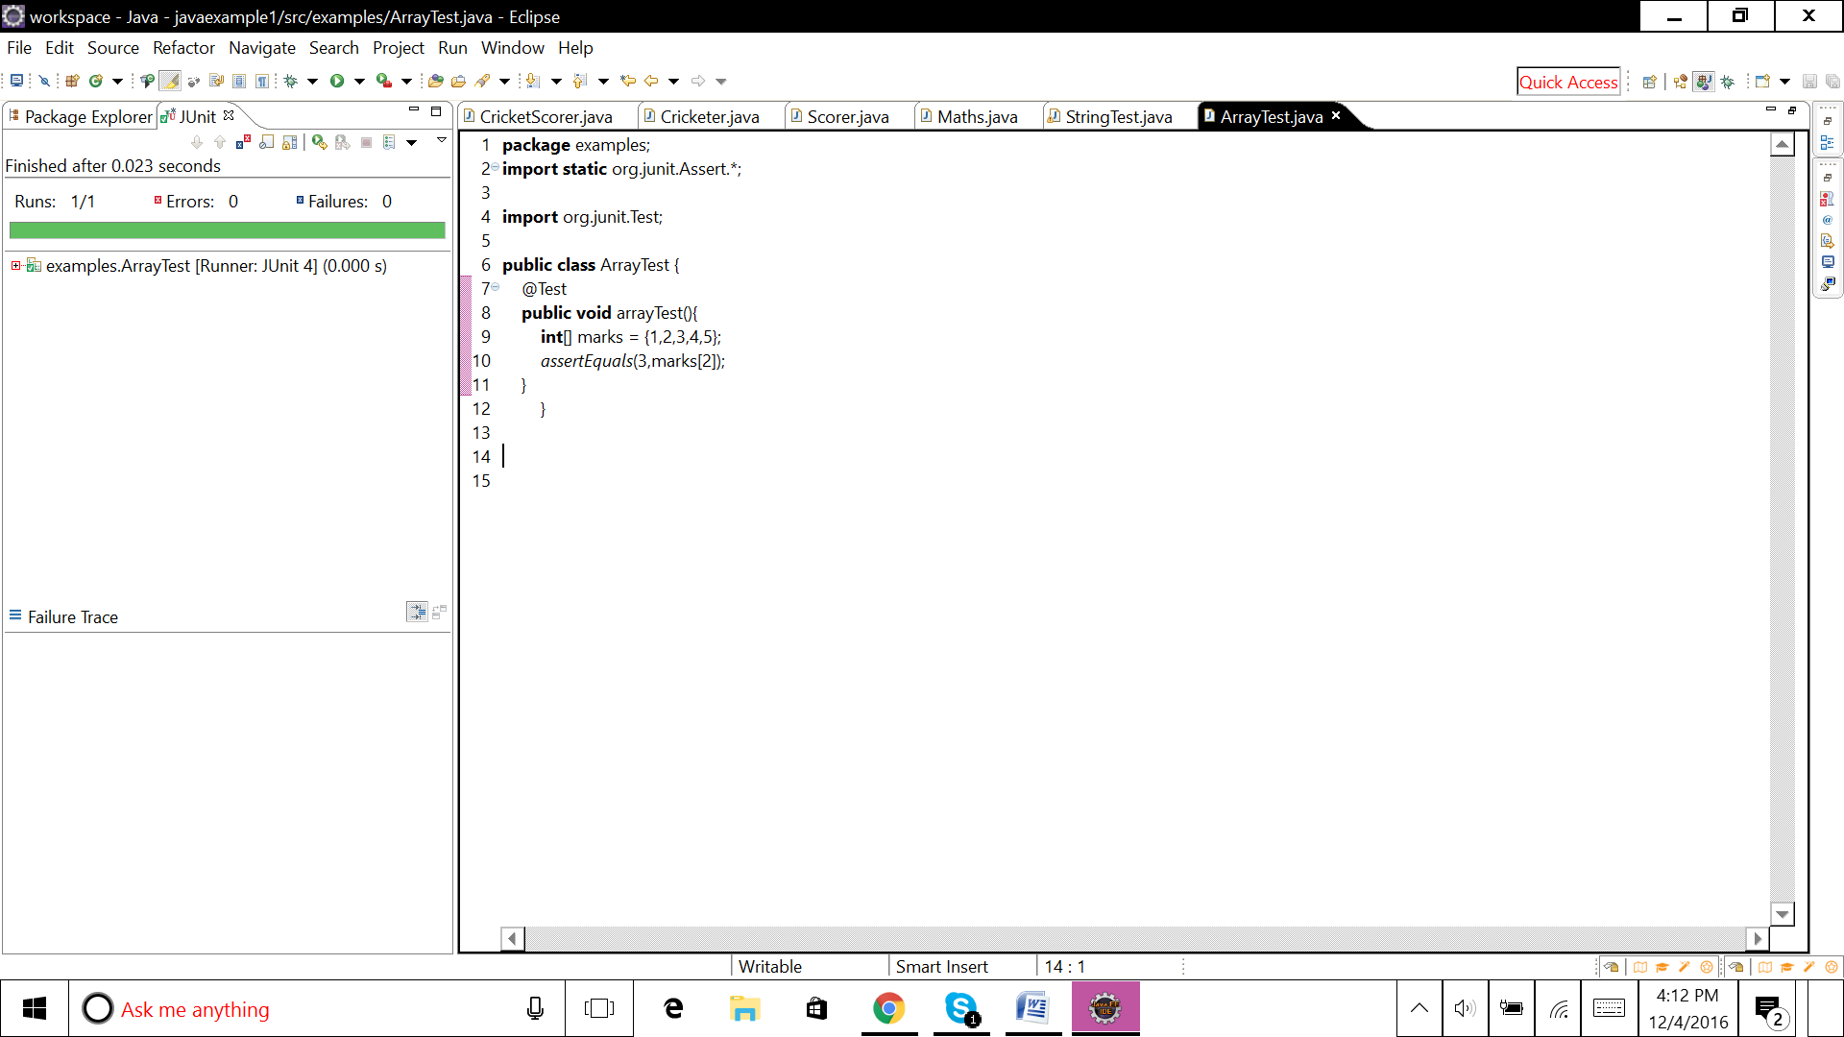

**package** examples;

**import** **static** org.junit.Assert.*;

**import** org.junit.Test;

**public** **class** ArrayTest {

@Test

**public** **void** arrayTest(){

**int**[] marks = {1,2,3,4,5};

*assertEquals*(3,marks[2]);

}

}

Inheritance :

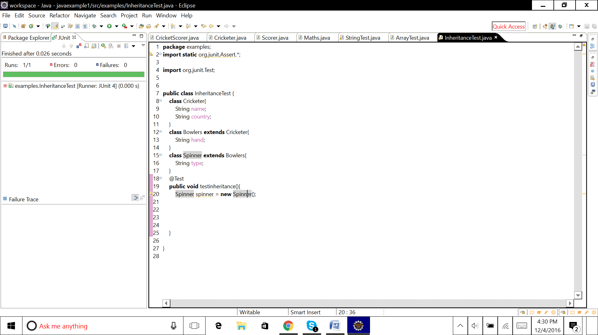

**package** examples;

**import** **static** org.junit.Assert.*;

**import** org.junit.Test;

**public** **class** InheritanceTest {

**class** Cricketer{

String name;

String country;

}

**class** Bowlers **extends** Cricketer{

String hand;

}

**class** Spinner **extends** Bowlers{

String type;

}

@Test

**public** **void** testinheritance(){

Spinner spinner = **new** Spinner();

}

}