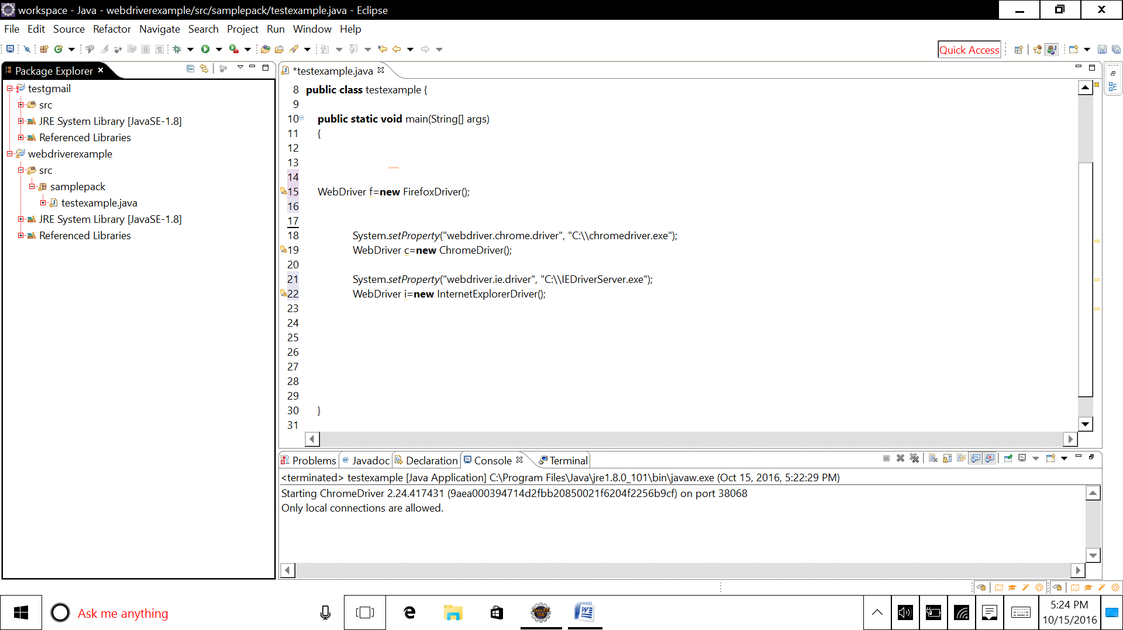

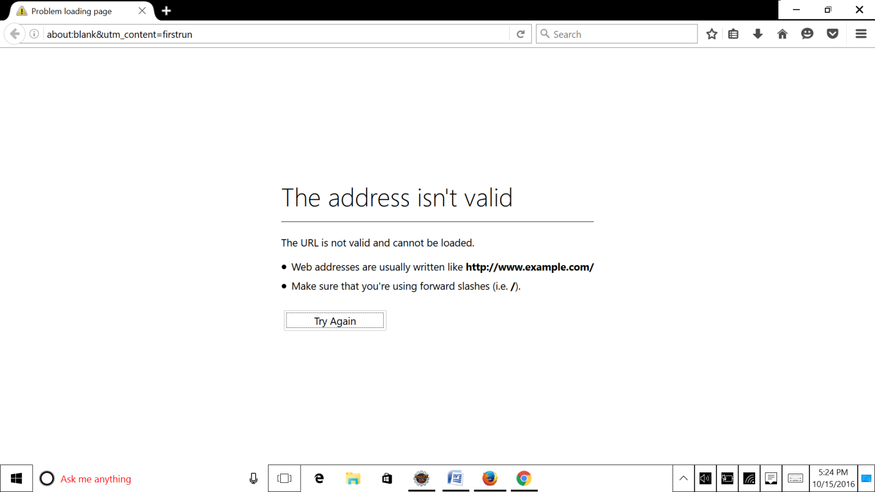

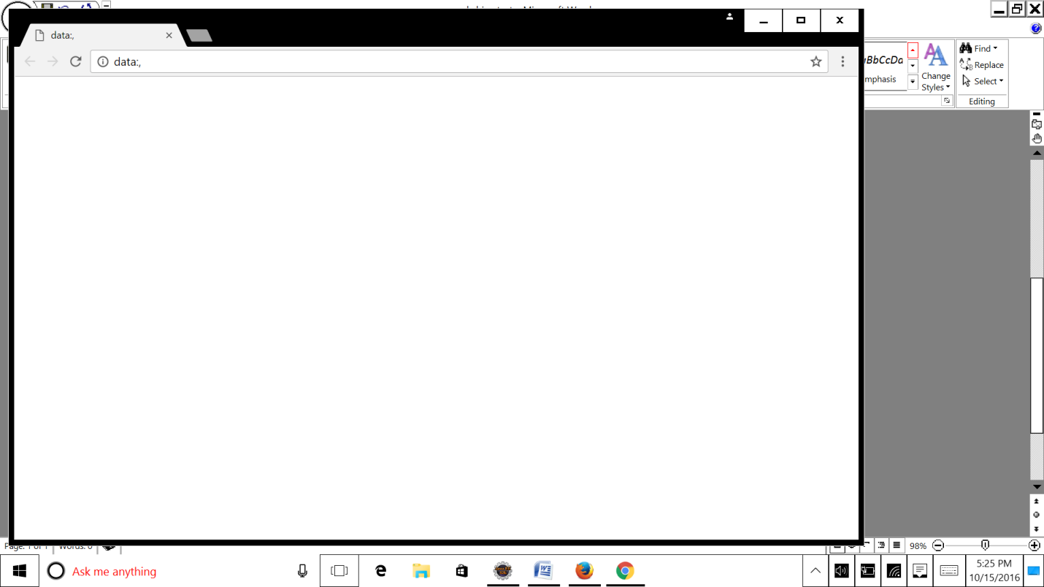

package examplePack;

import org.openqa.selenium.WebDriver;

import org.openqa.selenium.chrome.ChromeDriver;

import org.openqa.selenium.firefox.FirefoxDriver;

import org.openqa.selenium.ie.InternetExplorerDriver;

public class sample

{

public static void main(String[] args)

{

// FireFox WebDriver

WebDriver f=new FirefoxDriver();

// Chrome WebDriver

System.setProperty("webdriver.chrome.driver", "C:\\chromedriver.exe");

WebDriver c=new ChromeDriver();

// IE WebDriver

System.setProperty("webdriver.ie.driver", "C:\\IEDriverServer.exe");

WebDriver i=new InternetExplorerDriver();

}

}