A Realistic Image Generation of Face From Text Description Using the Fully Trained Generative Adversarial Networks

In this paper author is using fully trained GAN (generative adversarial networks) algorithm to convert TEXT to Face. GAN algorithms is a deep learning algorithm which was introduced to generate Fake images by getting trained on sample images. GAN can be used to train on sample images and after training it can predict related fake images from given input images.

Later GAN was used to convert TEXT to FACES but this existing GAN model was training separately with images and pre-trained TEXT encoder and due to separate training, face generated from pre-trained TEXT model was not accurate and to overcome from this problem, author of this paper is simultaneously training TEXT encoder and image decoder.

GAN algorithm was used to decode images and BI-LSTM (Bidirectional-Long Short Term Memory) was used to encode TEXT. Both models will be combine to decode image based on input text sentences. BI-LSTM will map each input sentence to related image and then get trained to generate image decoding model. Input TEXT will be converted into VECTOR and this vector will be input to BI-LSTM model to encode vector and this vector will be input to GAN to decode image.

In this paper author propose a fully trained generative adversarial network to generate realistic and natural images. The proposed work trained the text encoder as well as the image decoder at the same time to generate more accurate and efficient results.

To trained GAN and BI-LSTM model author has used CELEBA dataset which consists of DESCRIPTION and IMAGES. GAN get trained on IMAGES and BI-LSTM get trained on DESCRIPTION.

Below screen showing description file which is available in JSON format

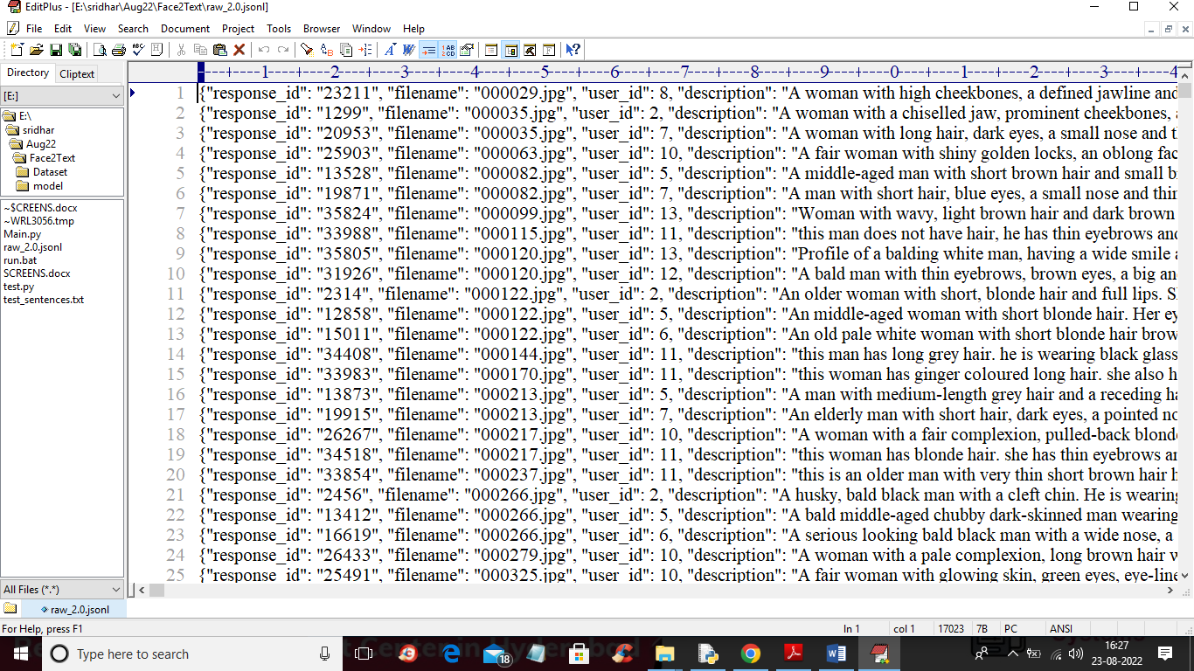

In above JSON file we can see IMAGE NAME and Description and this images we can find inside ‘Dataset/img_align_celeba’ folder and I am showing those images in below screen.

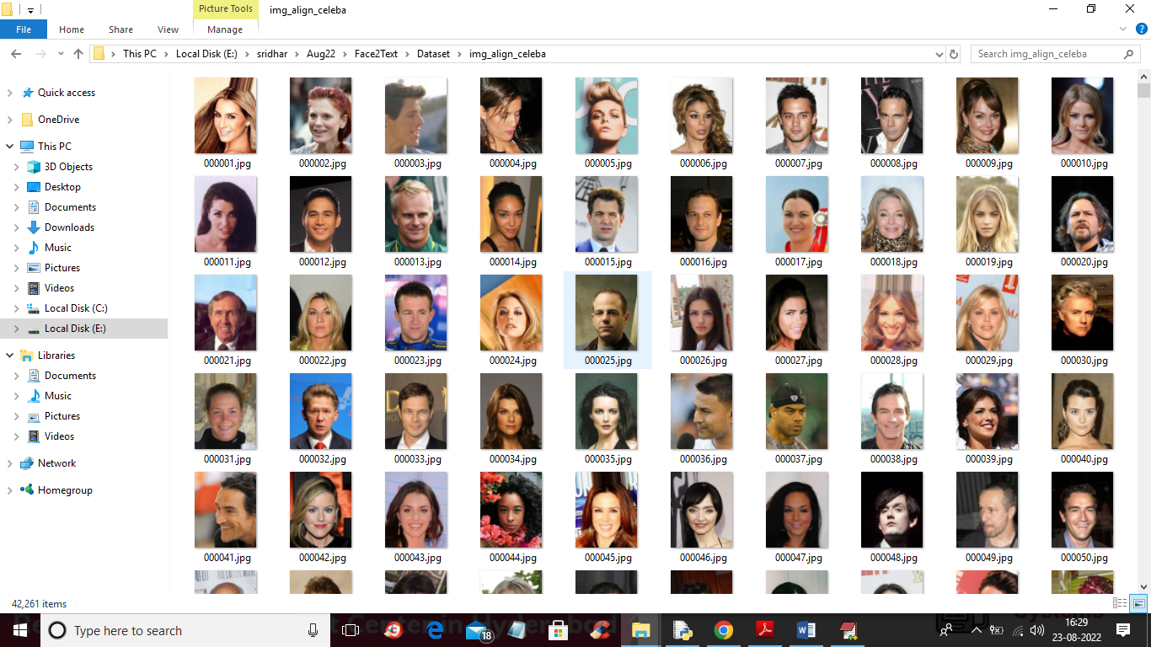

So by using above description and images we will train GAN and BI-LSTM model. GAN model consists of Discriminator which will take REAL dataset images and Generator will generate fake or alternate images by taking trained features from Discriminator.

In below screen I am showing code with comments for Generator and discriminator

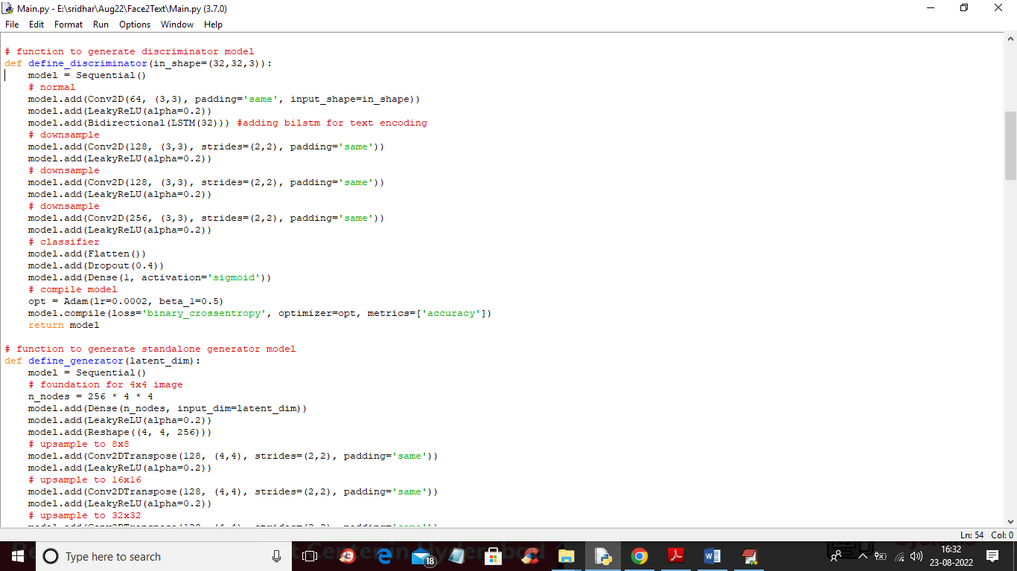

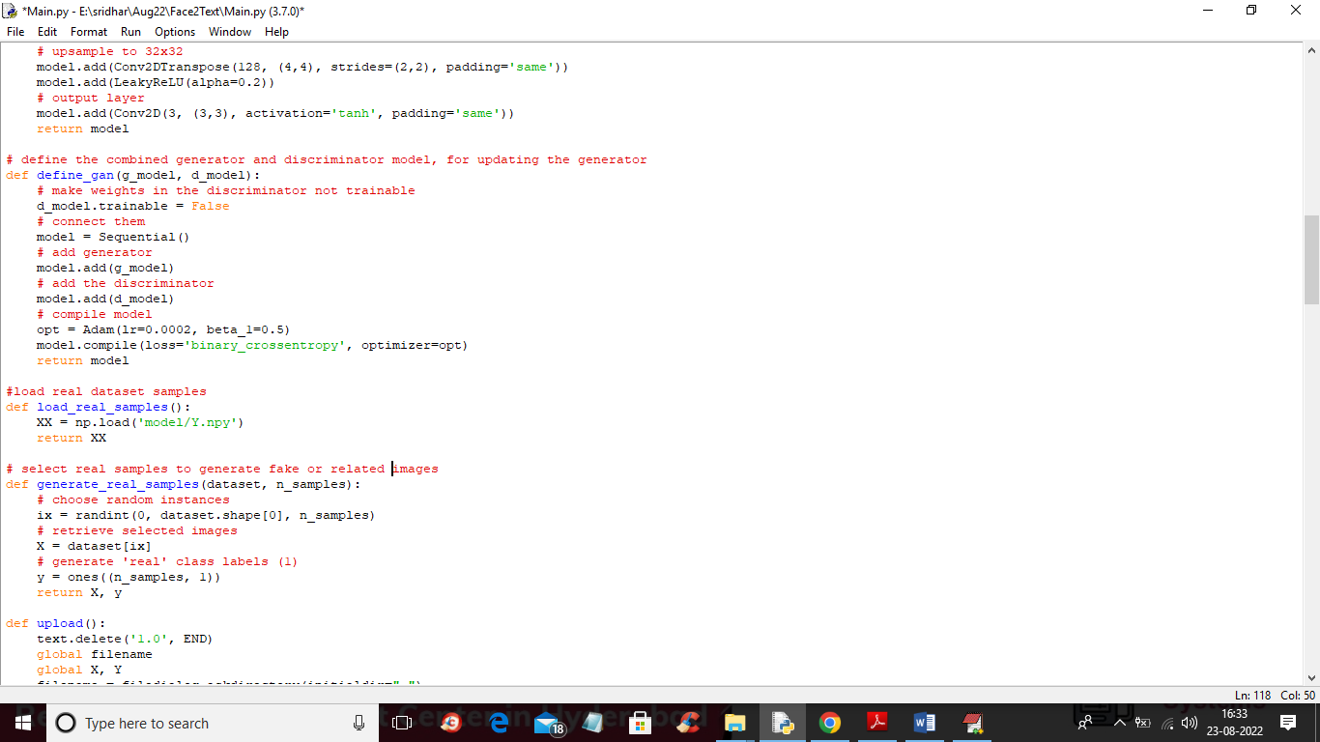

In above screen read red colour comments to know about GAN training with Discriminator, Generator and BI-LSTM.

To implement this project we have designed following modules

1. Upload CelebA Dataset: using this module we will upload dataset images to application and this module we will read all images and description and then saved it as array
2. Generate Fully Trained GAN Model: images and description array will be input to Proposed Fully Trained GAN to generate TEXT to Face conversion model. This model will differentiate gender using MALE and FEMALE and age will be differentiate using YOUNG and OLD words.
3. Generate Face from Text: this module will take sentences as TEXT and then input to GAN model which will covert TEXT into vector and then input this vector to GAN to decode vector to faces.

SCREEN SHOTS

To run project double click on ‘run.bat’ file to get below screen

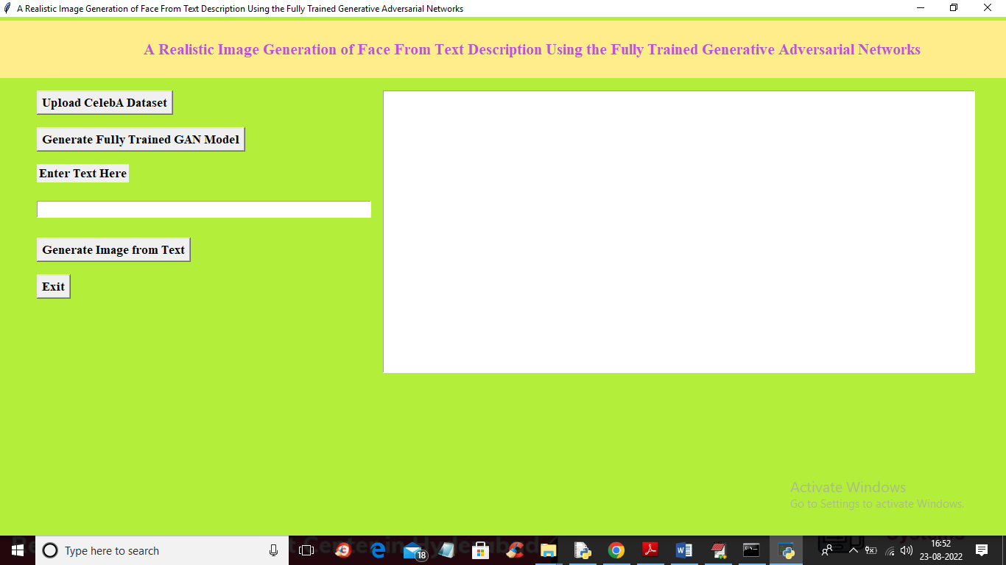

In above screen click on ‘Upload CelebA Dataset’ button to upload dataset and get below screen

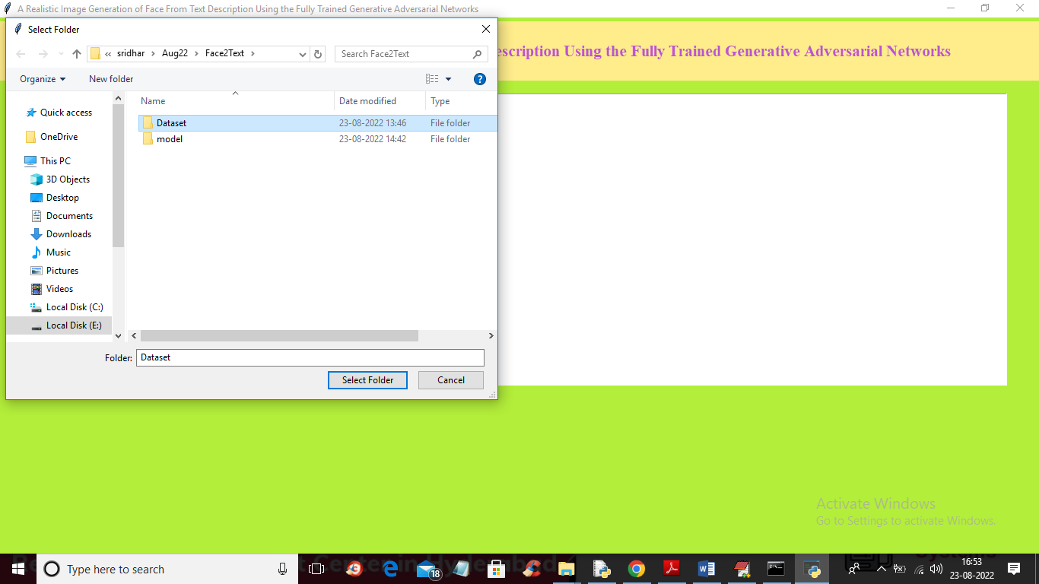

In above screen selecting and uploading ‘Dataset’ folder and then click on ‘Select Folder’ button to load dataset and get below output

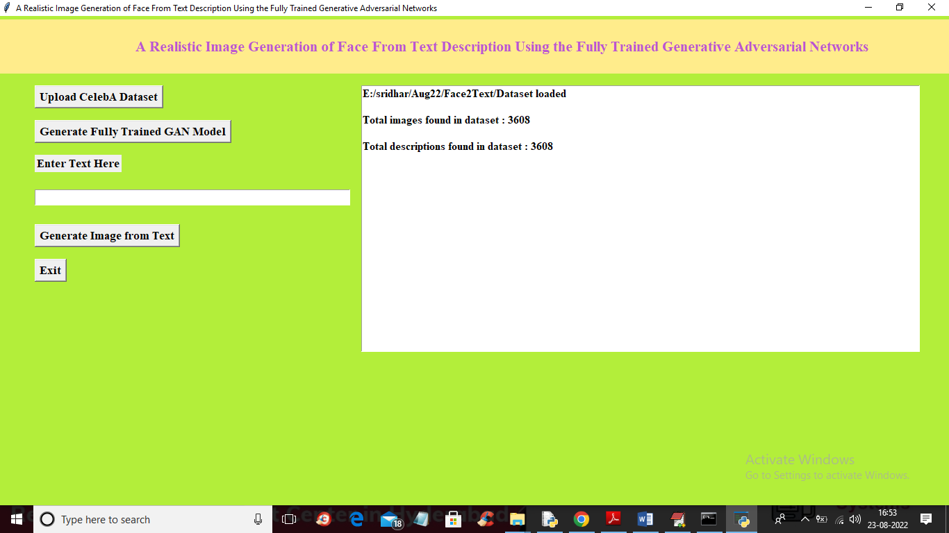

In above screen dataset loaded and application read 3608 images and description from dataset and now click on ‘Generate Fully Trained GAN Model’ button to train GAN with above images and description to get below output

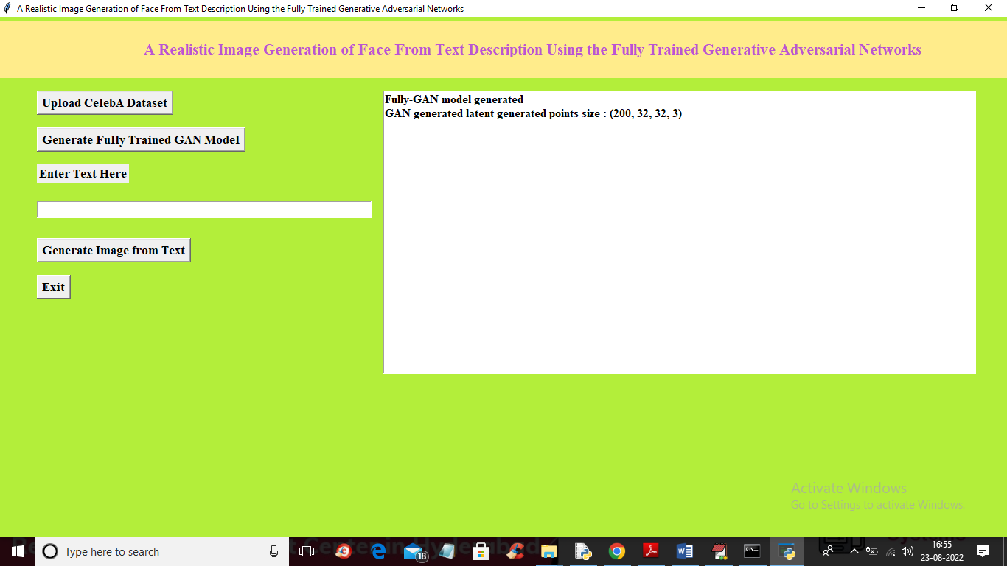

In above screen GAN model generated and this model can generated 200 faces with 32 X 32 dimension with 3 as RGB colour images from TEXT sentences and then extract face with maximum similarity from input encoded text. Now enter some TEXT inside text box and then click on ‘Generate Image from Text’ button to get below output

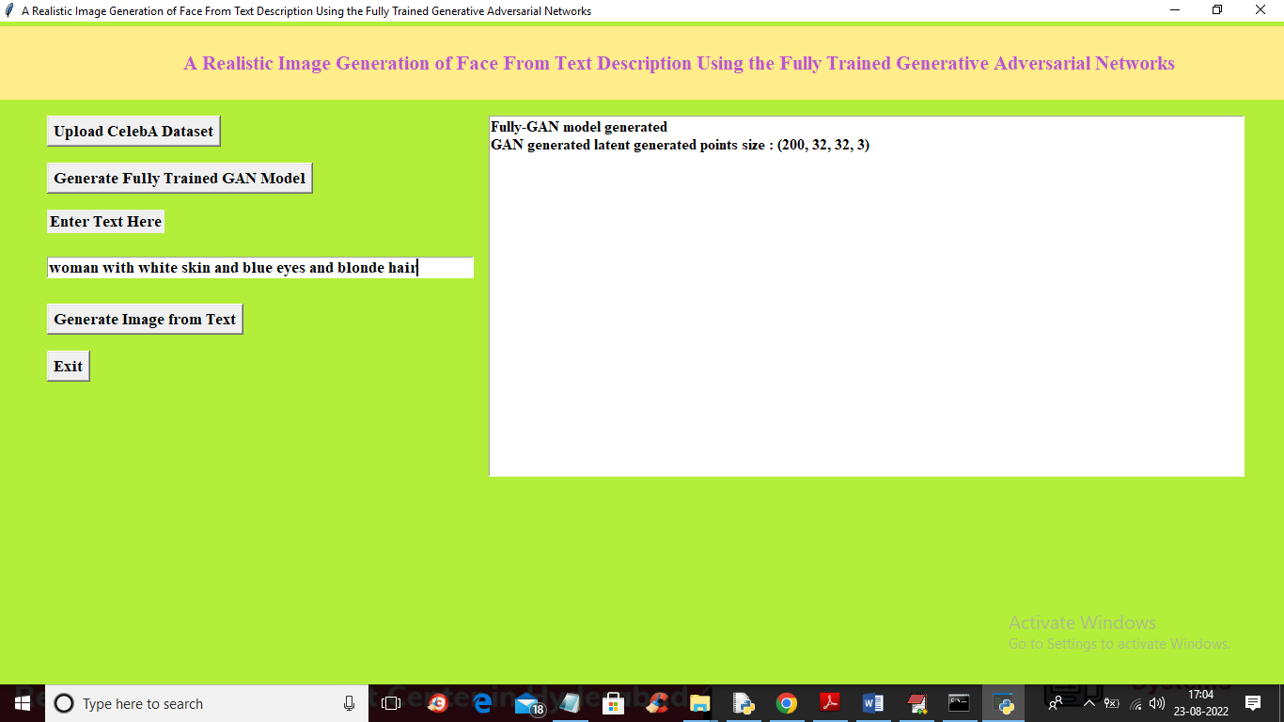

In above screen I entered some message in the TEXT BOX and then click on ‘Generate Image from Text’ button to get below output

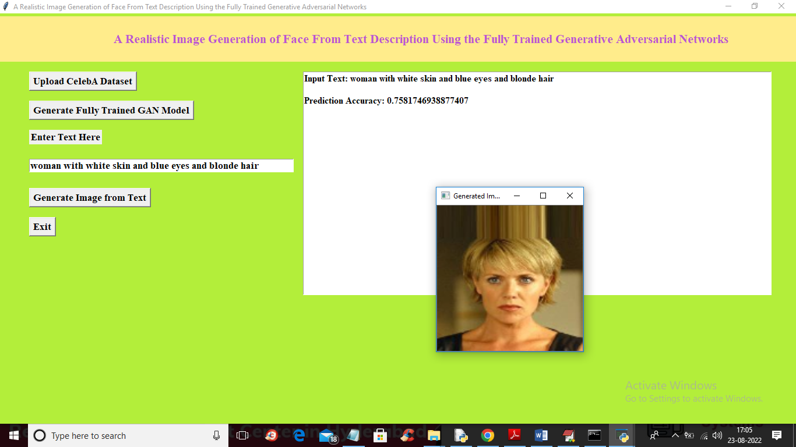

In above screen we can see face generated from given text and now try another TEXT sentences

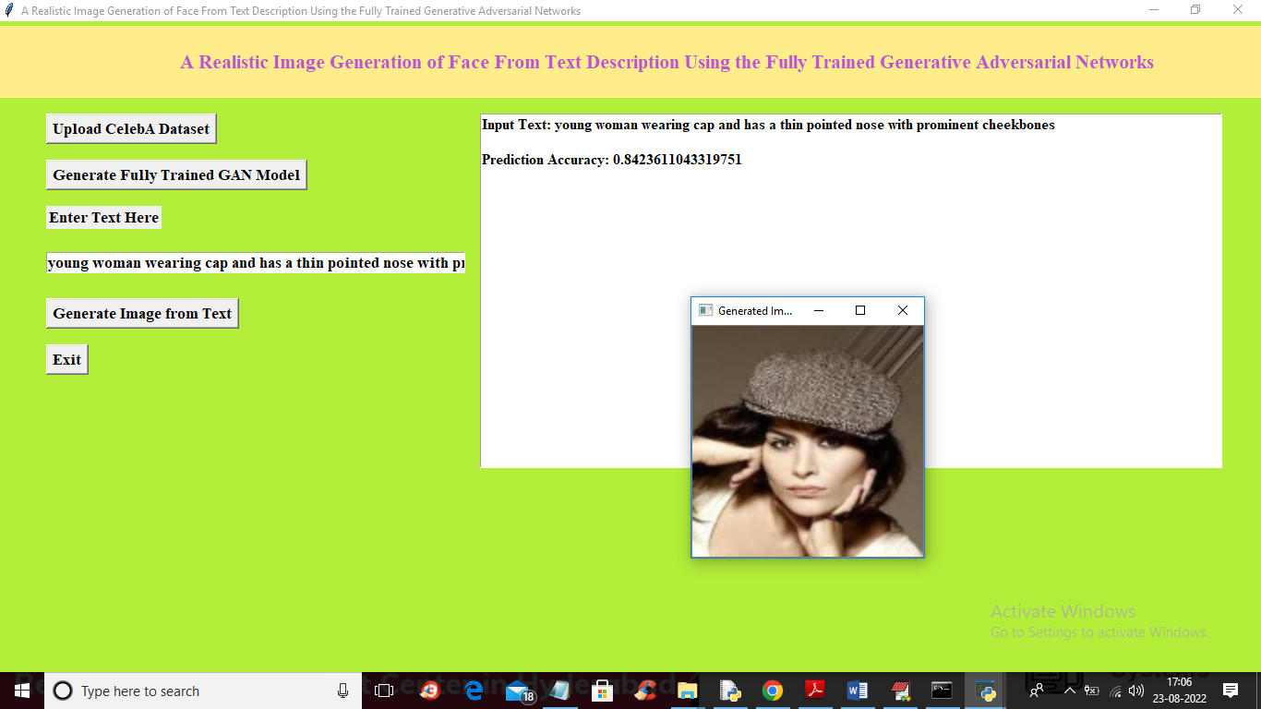

In above screen you can read sentence from TEXT AREA and then can see generated image

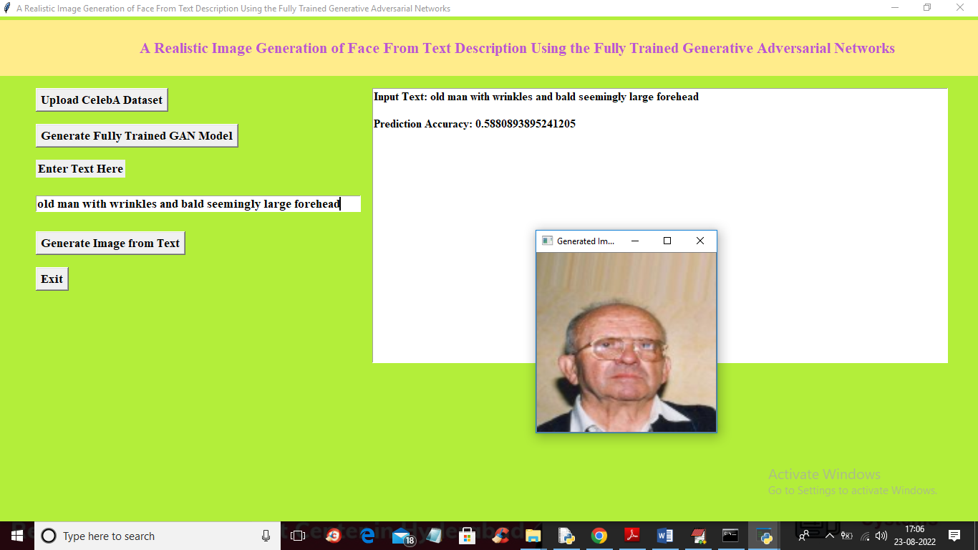

In above screen you can see given TEXT sentence and generated image and we can see prediction accuracy also. This accuracy refers to MAX matching similarity between GAN predicted image and input TEXT sentence vector.

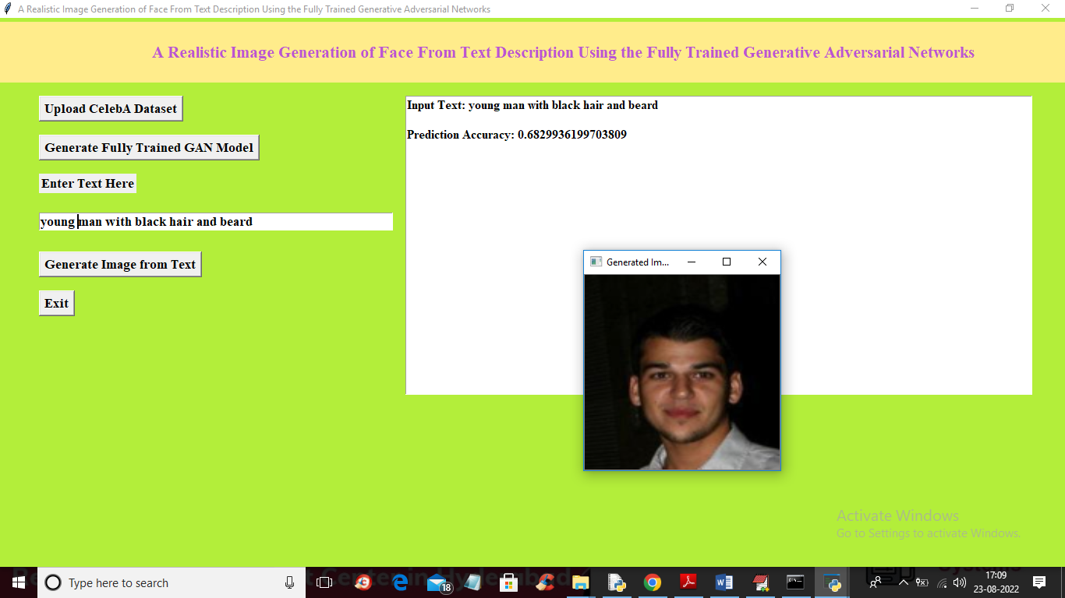

Similarly you can input any text to generate faces