TASK - 1
SALES FORECASTING PROJECT REPORT

- Introduction
Sales forecasting is the process of predicting future sales based on historical data. It helps businesses make informed decisions related to inventory, staffing, and financial planning. In this project, a machine learning approach is used to analyze past sales data and predict future demand.
- Objective
The main objective of this project is:
- To predict future sales using historical data
- To analyze trends and patterns in sales
- To help businesses plan inventory and resources efficiently

- Dataset Description

The dataset used is the Superstore Sales Dataset
The dataset used in this project contains the following attributes:

Order Information
- Row ID – Unique identifier for each row
- Order ID – Unique ID for each order
- Order Date – Date when the order was placed
- Ship Date – Date when the order was shipped
- Ship Mode – Shipping method used

Customer Information
- Customer ID – Unique ID for each customer
- Customer Name – Name of the customer
- Segment – Type of customer (Consumer, Corporate, etc.)

Location Information
- Country – Country of the customer
- City – City of the customer
- State – State of the customer
- Postal Code – Postal code
- Region – Region (East, West, etc.)

Product Information
- Product ID – Unique product identifier
- Category – Product category (Furniture, Office Supplies, etc.)
- Sub-Category – Subdivision of category
- Product Name – Name of the product

Sales Information (Important for Task)
- Sales – Revenue generated from the order
- Quantity – Number of items sold
- Discount – Discount applied
- Profit – Profit earned

Important Note:

For the purpose of sales forecasting, the most important attributes used are:
- Order Date : to analyze time-based patterns
- Sales : to predict future demand

4. Data Preprocessing

The dataset was prepared using the following steps:
- Missing values were checked and removed
- The "Order Date" column was converted into datetime format
- The data was sorted based on date
- New features like Year, Month, and Day were created
This step ensures the data is clean and suitable for analysis.

5. Data Visualization

A line graph was plotted to understand sales trends over time.
Observations:
- Sales show variation over time
- Some periods have higher sales (peak demand)
- Trends help identify seasonal patterns

6. Model Used

A Linear Regression model was used for forecasting.
- The model takes time (date) as input
- It predicts sales based on historical patterns
This is a simple and effective approach for basic forecasting.

7. Forecasting

The model predicts sales for the next 30 days.
- Future dates were generated
- Predictions were made using the trained model
- Results were plotted on a graph
This helps visualize expected future sales.

8. Model Evaluation

The model performance was evaluated using:
- Mean Absolute Error (MAE)
A lower MAE indicates better prediction accuracy.

9. Results
- The model successfully predicted future sales
- The forecast graph shows both actual and predicted values
- Trends indicate possible increase or decrease in demand

10. Business Applications
This system can help businesses in:
- Inventory Management
Stock products based on demand
- Staff Planning
Increase staff during peak periods
- Financial Planning
Manage budget and cash flow
- Risk Reduction
Avoid overstocking or losses

OUTPUT:
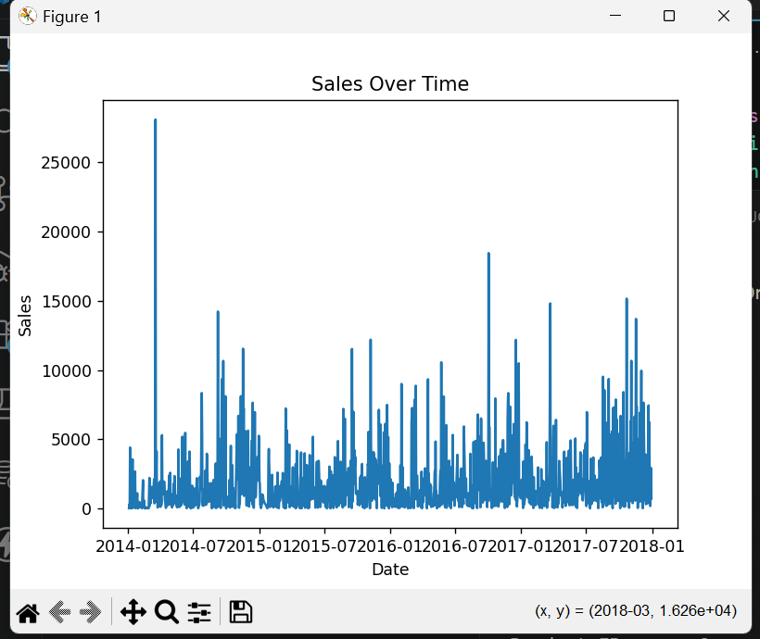

11. Conclusion
Sales forecasting using machine learning provides valuable insights for businesses. It helps in better planning, reduces risks, and improves decision-making. This project demonstrates how historical data can be used to predict future sales effectively.

