**Bazaar –** **Ecommerce Platform**

***22i0879 | 22i0748 __ Section K – Deliverable 2***

**Sprint 2**: **Client Engagement & Order Workflow**

*This sprint focuses on building end-to-end functionality for clients to engage with the platform. It includes browsing available products, viewing featured services, placing orders, tracking recent and detailed order information, and editing and viewing their profile. It also integrates the user’s ability to manage incoming orders, establishing a complete platform for him to sell his products.*

**Sprint Backlog:**

|  |  |  |  |  |  |  |  |  |  |
| --- | --- | --- | --- | --- | --- | --- | --- | --- | --- |
| **#** | **TITLE** | **USER STORY** | **SUB STORIES** | | | **Priority** | | **Status** | |
| **1** | **User Login/Register** | *As a user, I want to log in or register so I can access the platform.* | **1** | 1. As a user, I want to register with my email and password. | **High** | |  | |
| **2** | 2. As a user, I want to log in securely using my credentials. | **Done** | |
| **2** | **Profile Management** | *As a user, I want to manage my profile so I can keep my information up to date.* | **1** | As a user, I want to edit my personal details | **Medium** | |  | |
| **2** | As a user, I want to upload a profile picture | Half-Done | |
| **3** | **View Orders** | *As a user, I want to view my orders so I can track my purchases* | **1** | As a user, I want to see a list of my recent orders | **High** | |  | |
|  | **2** | As a user, I want to view basic details of each order | Done | |
| **4** | **Explore Products** | *As a user, I want to explore products so I can find what I need* | **1** | As a user, I want to browse products by category, price | **High** | |  | |
| **2** | *As a user, I want to search for specific products* | *Done* | |
| **5** | **Add Products** | *As a seller, I want to add products so I can sell them on the platform* | **1** | As a seller, I want to upload product details. | **High** | |  | |
| **2** | As a seller, I want to categorize my products for better visibility | **Done** | |
| **6** | **View Order Logs** | *As a seller, I want to view order logs so I can manage my sales* | **1** | As a seller, I want to see a list of orders placed for my products | **High** | | **Done** | |
| **7** | **Selling Platform** | *As a seller, I want to manage my products and orders so I can run my business effectivley* | **1** | As a seller, I want to update the status or orders | **High** | | **Done** | |
| **2** | As a seller, I want to edit or remove my listed prodcuts |  | |
| **8** | **Edit Profile** | *As a user, I want to edit my information to keep my data updated* | **1** | As a user, I want to update my personal and business information | **Medium** | |  | |

**Sprint 1 - MID**

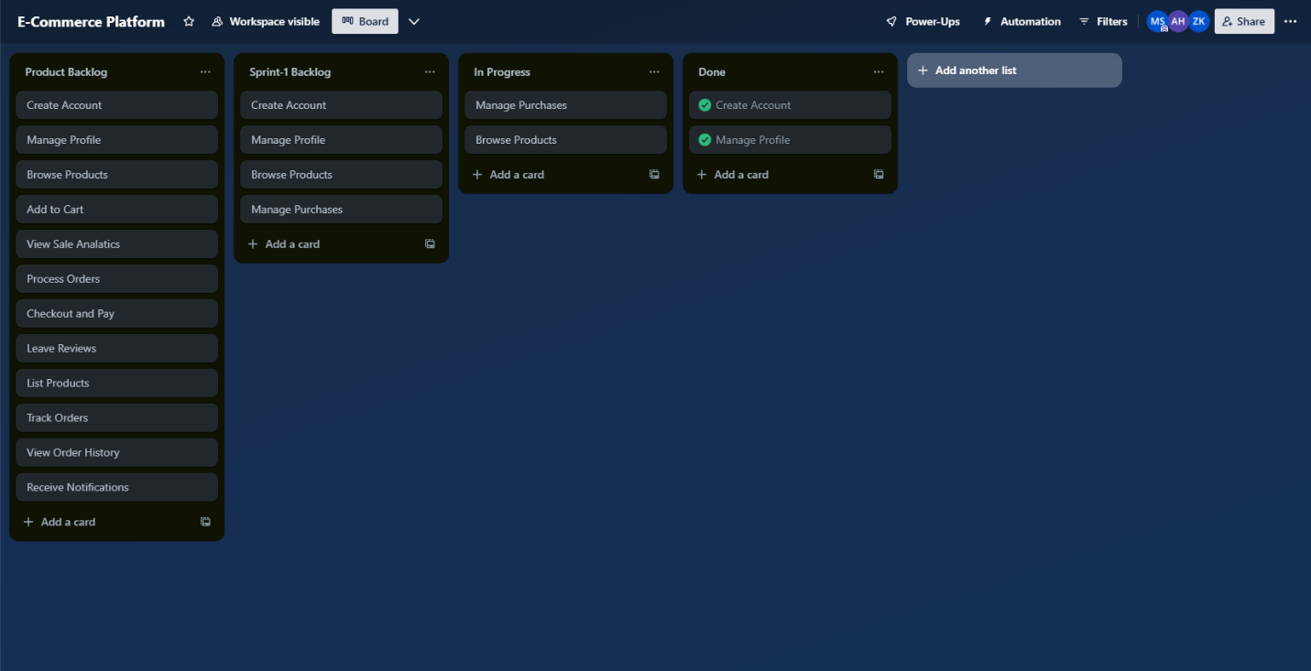

**Sprint 1 - Completed**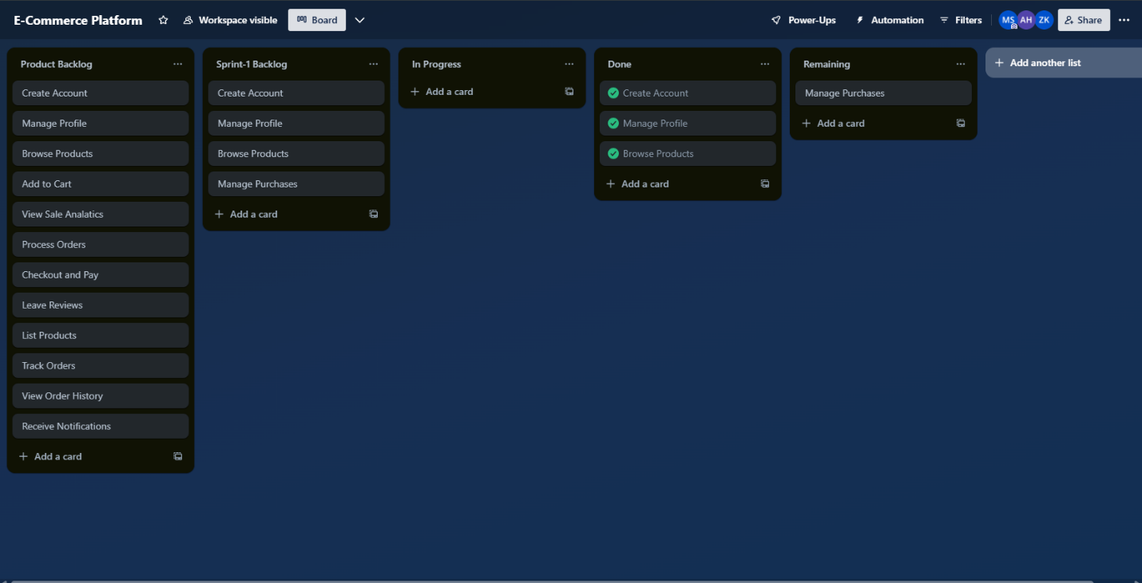

**Sprint 2 - MID**

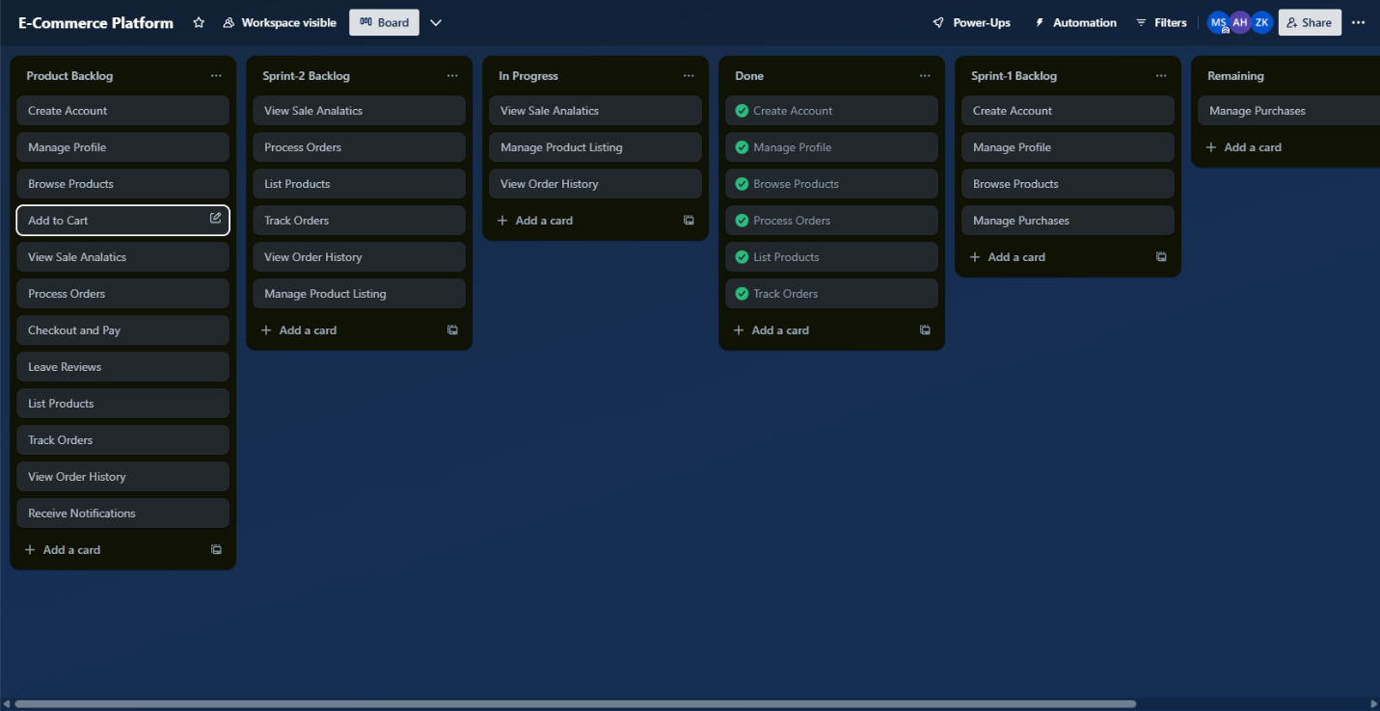

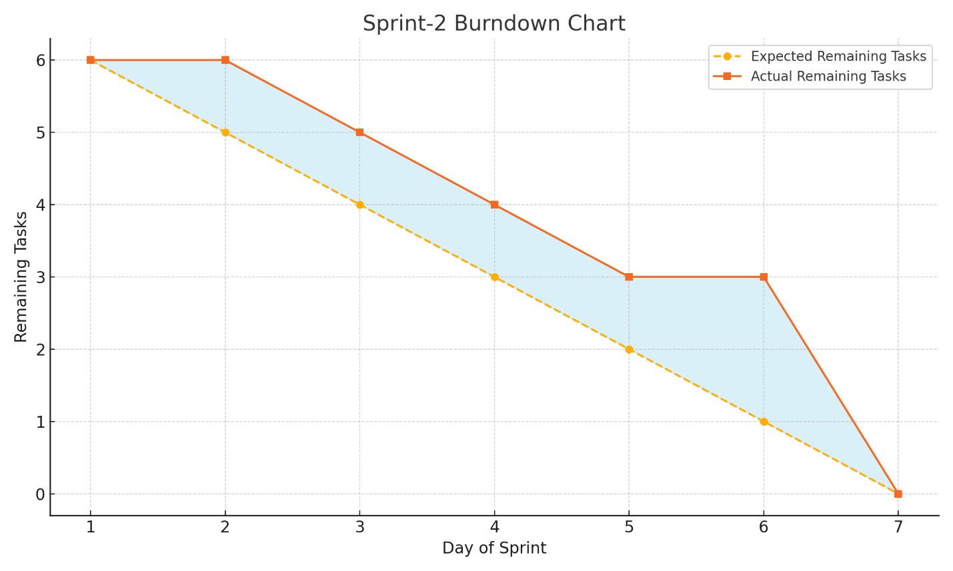

**Sprint 2 - Completed**

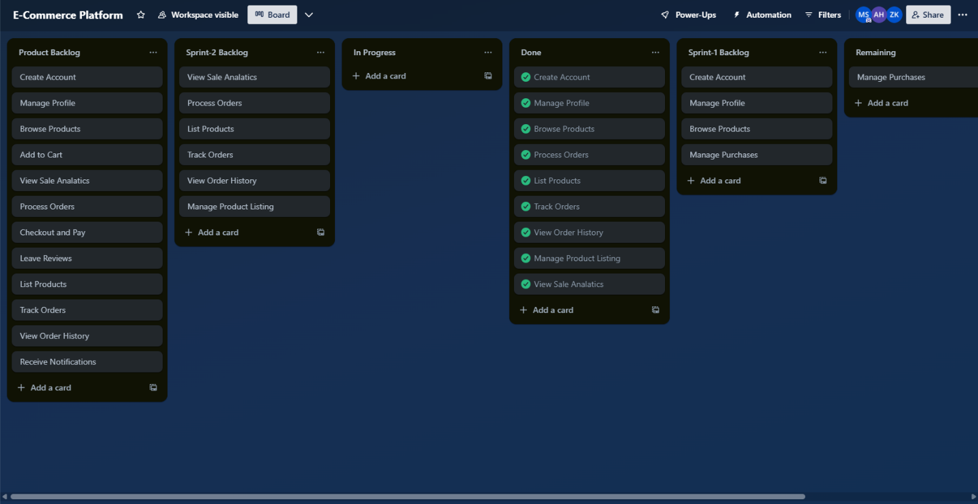

**Version Control:**

**Github Repository:** *https://github.com/Saibi10/Bazaar.git*

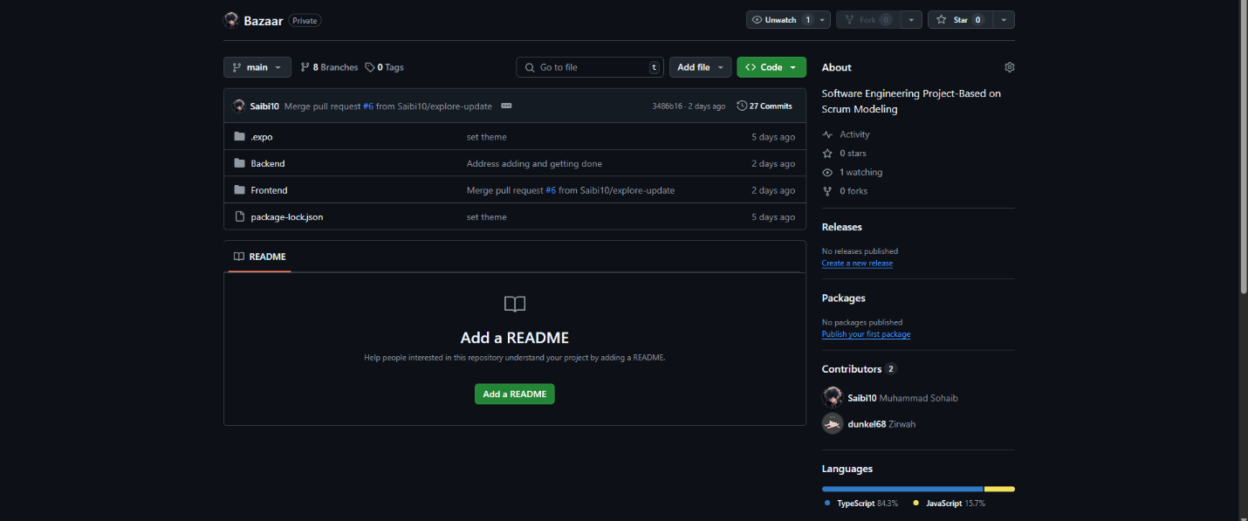

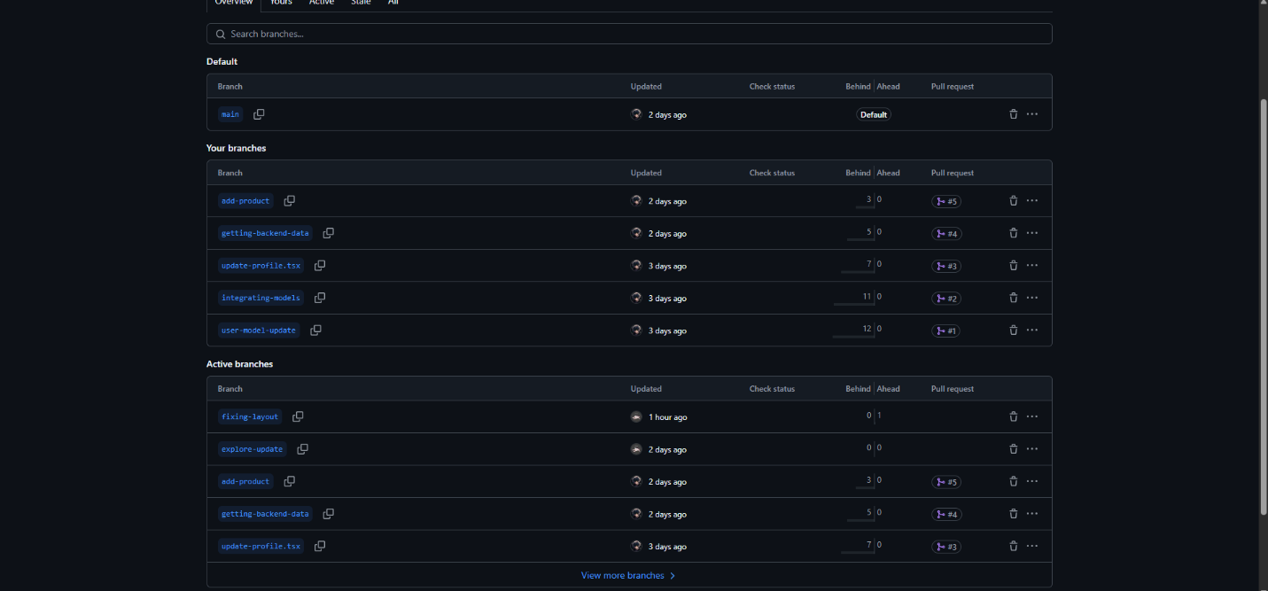

**MOM:**

**Discord Meetings:**