# Software Requirements and Design Document

# for

# Travel Ease

**Prepared by**

1. Hussnain Ul Abidin 22i-1102
2. Hamdan Sajid 22i-0872
3. Muhammad Sohaib 22i-0879

**Organization**

**VALIT**

**26th Sep, 2024**

# Table of Contents

1. Introduction

1.1 Purpose

1.2 Product Scope

1.3 Title

1.4 Objectives

1.5 Problem Statement

2. Overall Description

2.1 Product Perspective

2.2 Product Functions

2.3 List of Use Cases

2.4 Extended Use Cases

2.5 Use Case Diagram

3. Other Nonfunctional Requirements

3.1 Performance Requirements

3.2 Safety Requirements

3.3 Security Requirements

3.4 Software Quality Attributes

3.5 Business Rules

3.6 Operating Environment

3.7 User Interfaces

# 1. Introduction

## 1.1 Purpose

The Tourism Management System provides a platform for booking and managing tourism-related activities. This document specifies the functional and non-functional requirements for the system's design and development.

## 1.2 Product Scope

The software aims to streamline the management of tourism services, offering functionality such as booking tours, generating reports, and providing custom tour packages.

## 1.3 Title

TravelEase

## 1.4 Objectives

To create an integrated platform for tourism services, enabling efficiency and convenience for users through seamless booking, payment, and support functionalities.

## 1.5 Problem Statement

Traditional tourism management systems often lack cohesion and integration, leading to inefficiencies. The Tourism Management System addresses this by providing a unified platform that minimizes manual intervention and enhances user experience.

# 2. Overall Description

## 2.1 Product Perspective

This system is a self-contained solution for managing tourism operations. It integrates with payment gateways, provides real-time updates, and ensures compatibility with existing infrastructure.

## 2.2 Product Functions

Major functionalities include:  
- Booking tours and custom packages  
- Managing user accounts and preferences   
- Generating comprehensive reports for administrators  
- Providing ratings and feedback mechanisms

## 2.3 List of Use Cases

Refer to the attached use case document for detailed descriptions.

1. Register
2. Login
3. View Booking
4. Book a Tour
5. Obtain Customer Support
6. Cancel Booking
7. Give Rating
8. View Available Tours
9. Request a Custom Tour
10. Respond to Queries
11. Manage Transport Providers
12. Manage Tours
13. View Stats

## 2.4 Extended Use Cases

**View Bookings**

|  |  |
| --- | --- |
| **Use Case Name** | View Bookings |
| **Level** | User Goal |
| **Scope** | Tourism Management System |
| **Primary Actor** | Tourist |
| **Stakeholders and Interest** | * Tourist: Wants to view details of their past and upcoming bookings. * System: Must provide accurate booking information. |
| **Preconditions** | The tourist is logged into the system and has existing bookings. |
| **Postconditions** | * Success: Tourist sees a list of all past and future bookings with relevant details. * Failure: Tourist is notified that no bookings are available. |
| **Main Success Scenario** | |
| **Actor Action (Or Intention)** | **System Responsibility** |
| Tourist logs into the system. |  |
| Tourist navigates to the “View Bookings” tab. |  |
|  | The system retrieves and displays a list of all bookings related to the user. |
| Tourist views all the bookings and can choose a certain action he wants to perform. |  |
| **Extensions** | If no bookings exist, the system displays a message saying "No bookings found." |

**Book Tour:**

|  |  |
| --- | --- |
| **Use Case Name** | Book a Tour |
| **Level** | User Goal |
| **Scope** | Tourism Management System |
| **Primary Actor** | Tourist |
| **Stakeholders and Interest** | * Tourist: Wants to book a tour based on their preferences. * System: Must accurately confirm bookings. |
| **Preconditions** | The tourist is logged in and has chosen a tour package. |
| **Postconditions** | * Success: The tour is booked, and confirmation is sent to the tourist. * Failure: The system displays an error message if booking cannot be completed. |
| **Main Success Scenario** | |
| **Actor Action (Or Intention)** | **System Responsibility** |
| Tourist navigates to the all-tour tab. |  |
|  | System retrieves all the tours from the database and show it in the tab view. |
| Tourist view all the tours and choose a specific tour. |  |
|  | System retrieves the description for the tour selected and show on the tab. |
| Tourist view all the description for the tour. |  |
| Tourist proceeds to book the tour. |  |
|  | System shows the payment tab to pay the amount for the booking. |
| Tourist enter card details and select make payment option. |  |
|  | System confirms the payment and add the tour booking in the booking tab. |
| **Extensions** | If the tour is fully booked, the system notifies the tourist and suggests alternative options. |

**Cancel Tour Booking**

|  |  |
| --- | --- |
| **Use Case Name** | Cancel Tour Booking |
| **Level** | User Goal |
| **Scope** | Tourism Management System |
| **Primary Actor** | Tourist |
| **Stakeholders and Interest** | * Tourist: Wants to cancel a previously booked tour. * System: Ensures cancellation is processed and any applicable refunds are issued. |
| **Preconditions** | The tourist has a valid booking. |
| **Postconditions** | * Success: The booking is canceled, and a refund is initiated if applicable. * Failure: The system notifies the tourist if cancellation is not possible. |
| **Main Success Scenario** | |
| **Actor Action (Or Intention)** | **System Responsibility** |
| Tourist navigates to the all booking tab. |  |
|  | System shows all the booking related to the specific Tourist |
| Tourist selects the cancel booking button for a specific booking. |  |
|  | The system processes the cancellation refund the payment to the user. |
|  | The payment is added to the wallet of the tourist. |
| **Extensions** | If the cancellation window has passed, the system informs the tourist that cancellation is not possible. |

**Make Payment**

|  |  |
| --- | --- |
| **Use Case Name** | Make Payment |
| **Level** | User Goal |
| **Scope** | Tourism Management System |
| **Primary Actor** | Tourist |
| **Stakeholders and Interest** | * Tourist: Wants to complete payment for a booked tour. * Payment Processor: Ensures secure handling of the transaction. |
| **Preconditions** | The tourist has a pending booking that requires payment. |
| **Postconditions** | * Success: Payment is processed, and booking is confirmed. * Failure: Payment is not processed, and the tourist is notified. |
| **Main Success Scenario** | |
| **Actor Action (Or Intention)** | **System Responsibility** |
| Tourist selects a payment for a tour. |  |
|  | System shows the form to enter payment details |
| Tourist enters payment details. |  |
| Tourist select the make payment button. |  |
|  | The system processes the payment. |
|  | A confirmation is sent to the tourist, and the booking is finalized. |
| **Extensions** | If payment fails, the system provides an error message and prompts the user to retry. |

**Give Rating**

|  |  |
| --- | --- |
| **Use Case Name** | Give Feedback |
| **Level** | User Goal |
| **Scope** | Tourism Management System |
| **Primary Actor** | Tourist |
| **Stakeholders and Interest** | * Tourist: Wants to provide feedback about a completed tour. * System: Records feedback for future analysis. |
| **Preconditions** | The tourist has completed a tour and is logged in |
| **Postconditions** | * Success: Feedback is recorded successfully. * Failure: Tourist is notified if the feedback submission fails. |
| **Main Success Scenario** | |
| **Actor Action (Or Intention)** | **System Responsibility** |
| Tourist navigates to the All booking tab. |  |
|  | System shows the all booking related to the specific tourist. |
| Tourist view all the booking and select give rating for the tour that is completed. |  |
|  | System shows the form to give rating. |
| Tourist fill the from and proceed to submit the form. |  |
|  | System records the feedback and save it in the database. |
| **Extensions** | If feedback fails to submit, the system displays an error and prompts the user to retry. |

**View Available Tours**

|  |  |
| --- | --- |
| **Use Case Name** | View Available Tours |
| **Level** | User Goal |
| **Scope** | Tourism Management System |
| **Primary Actor** | Tourist |
| **Stakeholders and Interest** | * Tourist: Wants to browse available tours and make decisions. * System: Displays up-to-date tour packages. |
| **Preconditions** | Tours are available in the system. |
| **Postconditions** | * Success: A list of available tours is displayed. * Failure: The system notifies the tourist if no tours are available. |
| **Main Success Scenario** | |
| **Actor Action (Or Intention)** | **System Responsibility** |
| Tourist navigates to the “View Available Tours” section. |  |
|  | The system displays a list of available tours with details. |
| **Extensions** | If no tours are available, the system displays a message saying "No tours available at this time." |

**Refund Payment**

|  |  |
| --- | --- |
| **Use Case Name** | Refund Payment |
| **Level** | User Goal |
| **Scope** | Payment System |
| **Primary Actor** | Tourist |
| **Stakeholders and Interest** | * Tourist: Wants a refund for a canceled booking. * Payment Processor: Ensures secure handling of the refund transaction. |
| **Preconditions** | The tourist has canceled a booking that qualifies for a refund. |
| **Postconditions** | * Success: Refund is processed, and confirmation is sent. * Failure: The system notifies the tourist if the refund cannot be processed. |
| **Main Success Scenario** | |
| **Actor Action (Or Intention)** | **System Responsibility** |
| Tourist select the all booking tab. |  |
|  | System shows the all booking related to the specific tourist. |
| Tourist view all the booking and select cancel booking for a tour. |  |
|  | System confirms the cancel booking and update the wallet of the customer with refunded amount. |
| Extensions | If the refund fails, the system displays an error message and prompts the user to contact support. |

**Generate Reports**

|  |  |
| --- | --- |
| **Use Case Name** | Generate Reports |
| **Level** | Admin Goal |
| **Scope** | Tourism Management System |
| **Primary Actor** | Administrator |
| **Stakeholders and Interest** | * Administrator: Needs insights on bookings, revenue, and performance. * System: Generates accurate and up-to-date reports. |
| **Preconditions** | The system contains data on bookings, payments, and tours |
| **Postconditions** | * Success: Reports are generated and available for review. * Failure: The system notifies the administrator if reports cannot be generated. |
| **Main Success Scenario** | |
| **Actor Action (Or Intention)** | **System Responsibility** |
| Admin selects a dashboard tab |  |
|  | The system generates the requested report. |
| Admin reviews the generated report. |  |
| **Extensions** | If no data is available for the report, the system displays a message indicating no data is found. |

**Manage Transport Provider**

|  |  |
| --- | --- |
| **Use Case Name** | Manage Transport Provider |
| **Level** | Admin Goal |
| **Scope** | Tourism Management System |
| **Primary Actor** | Administrator, Transport Provider |
| **Stakeholders and Interest** | * Administrator: Ensures transport services are available and managed efficiently. * Transport Provider: Provides services as part of the tour package. * System: Tracks and updates transport provider information. |
| **Preconditions** | Transport providers are registered in the system. |
| **Postconditions** | * Success: Transport provider information is updated or maintained. * Failure: The system notifies the administrator of any issues. |
| **Main Success Scenario** | |
| **Actor Action (Or Intention)** | **System Responsibility** |
| Admin open the transport provider tab |  |
|  | System show tab where there are options to Add, Remove, Delete, edit a transport provider. |
| The admin selects the specific task he wants to perform. |  |
|  | The system shows the form/tab to make the change. |
| Admin enter the new data he wants to enter |  |
|  | The system validates the input and checks for completeness. |
|  | System makes the change in the database and proceed to show the changes |
| **Extensions** | If the provider is not found, the system displays an error and prompts for a retry. |

**Request Custom Tour Package**

|  |  |
| --- | --- |
| **Use Case Name** | Request Custom Tour Package |
| **Level** | Customer Goal |
| **Scope** | Tourism Management System |
| **Primary Actor** | Customer |
| **Stakeholders and Interest** | * System Administrator: May need to oversee the system's performance and ensure custom requests are handled properly. * Customer: Wants a personalized travel experience that fits their specific preferences, such as destinations, activities, budget, and dates. |
| **Preconditions** | * The user must be logged into their account. * The system should have a predefined interface for submitting custom requests. |
| **Postconditions** | * The custom tour request is successfully submitted. * The admin operator may follow up with a detailed proposal, and the request is stored in the system for future reference. |
| **Main Success Scenario** | |
| **Actor Action (Or Intention)** | **System Responsibility** |
| The user navigates to the "Request Custom Tour" section from their dashboard or the main menu. |  |
|  | The system presents a form where the user can specify their desired tour details |
| The user fills out the form and submits the request. |  |
|  | System confirm the request and save it in the database for the admin to respond. |
| **Extensions** | If the user provides incomplete or invalid information  1. The system highlights the errors and prompts the user to correct them. |

**Manage Tours**

|  |  |
| --- | --- |
| **Use Case Name** | Manage Tours |
| **Level** | Admin Goal |
| **Scope** | Tourism Management System |
| **Primary Actor** | Admin |
| **Stakeholders and Interest** | * Customer: Wants to view available tours and book them, trusting that the information is accurate and up-to-date. * Transport Provider: Who want to know the location of all next added or existing tour so he can manage transport facility |
| **Preconditions** | * The admin must be logged into the system with the necessary permissions to manage tours. * The system must already have a list of tour packages that the admin can manage. |
| **Postconditions** | * The tour is successfully created, updated, or removed. * Changes are reflected immediately and visible to tourists. |
| **Main Success Scenario** | |
| **Actor Action (Or Intention)** | **System Responsibility** |
| The admin navigates to the "Manage Tours" section from their dashboard. |  |
|  | System show tab where there are options to Add, Remove, Delete, edit tour. |
| The admin selects the specific task he wants to perform. |  |
|  | The System shows the required tab to perform the task. |
| The admin submits the change. |  |
|  | The system validates the input and checks for completeness. |
|  | System makes the change in the database and proceed to show the changes |
| **Extensions** | If the user provides incomplete or invalid information  1. The system highlights the errors and prompts the user to correct them. |

**Obtain Customer Support**

|  |  |
| --- | --- |
| **Use Case Name** | Obtain Customer Support |
| **Level** | User Goal |
| **Scope** | Tourism Management System |
| **Primary Actor** | Tourist |
| **Stakeholders and Interest** | * Tourist: Wants assistance for booking or related issues. * System: Must facilitate efficient communication with the support team. |
| **Preconditions** | The tourist is logged in and has access to customer support. |
| **Postconditions** | * Success: Tourist receives the required support. * Failure: Support is unavailable, and the system notifies the tourist. |
| **Main Success Scenario** | |
| **Actor Action (Or Intention)** | **System Responsibility** |
| Tourist navigates to the “Customer Support” section. |  |
|  | The system presents a contact form to enter the message. |
| Tourist enter the title and description to the query. |  |
| Tourist selects the submit query button to submit the customer support message. |  |
|  | System validates the message and store it in the database for admin to respond to the query. |
| **Extensions** | If no agents are available, the system logs the query and informs the tourist of the expected response time. |

## 2.5 Use Case Diagram

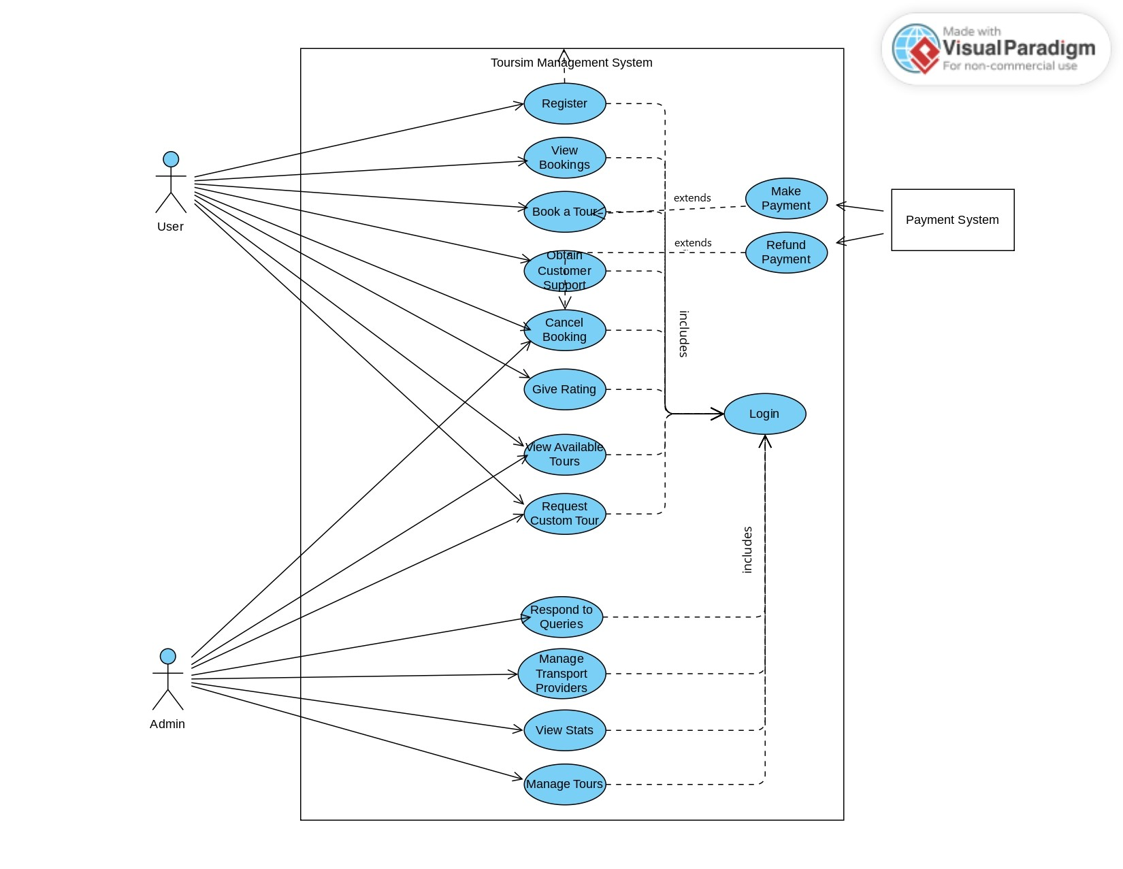

# 3. Other Nonfunctional Requirements

## 3.1 Performance Requirements

The system should handle multiple users with a quick response time for all key operations.

## 3.2 Safety Requirements

The software ensure that all information related to user if safe.

## 3.3 Security Requirements

The system should employ user authentication and role-based access controls to safeguard sensitive information.

## 3.4 Software Quality Attributes

Key attributes include:  
- Reliability: Ensures consistent uptime and error-free operations  
- Maintainability: Easy to update and extend functionality  
- Usability: Intuitive interfaces for all user roles

## 3.5 Business Rules

Administrative users can manage tours, while regular users are restricted to booking and feedback functions.

## 3.6 Operating Environment

The software will operate on local-based servers with a standard Windows OS and compatibility with modern desktops.

## 3.7 User Interfaces

The user interface will feature a responsive design compatible with only desktop devices, adhering to modern UI/UX standards.

# Domain Model

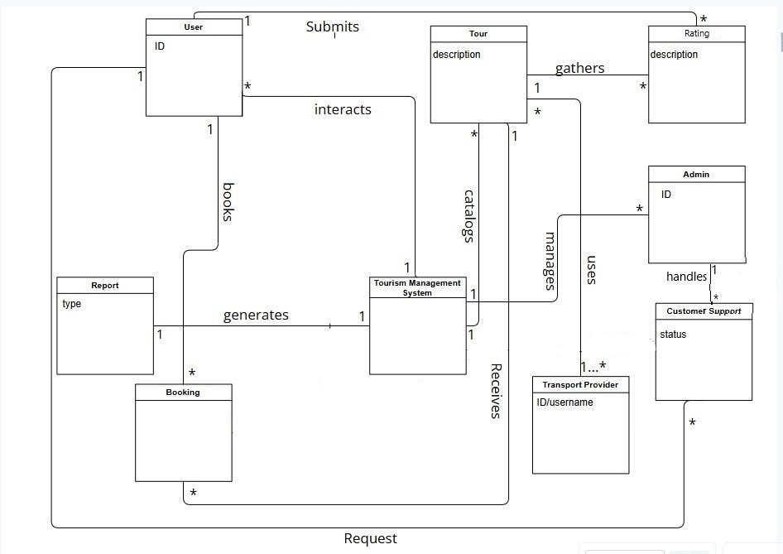

# System Sequence Diagram

**Admin System Sequence Diagrams**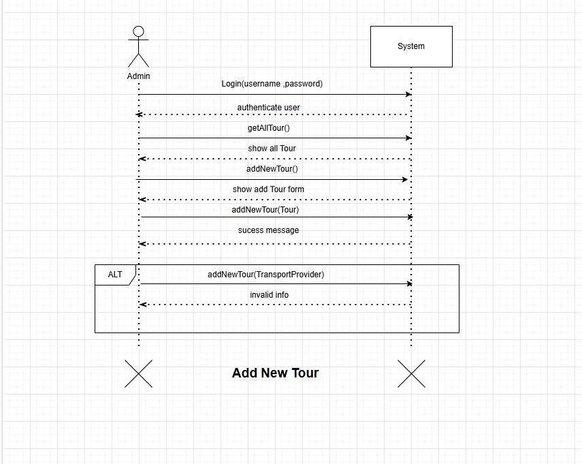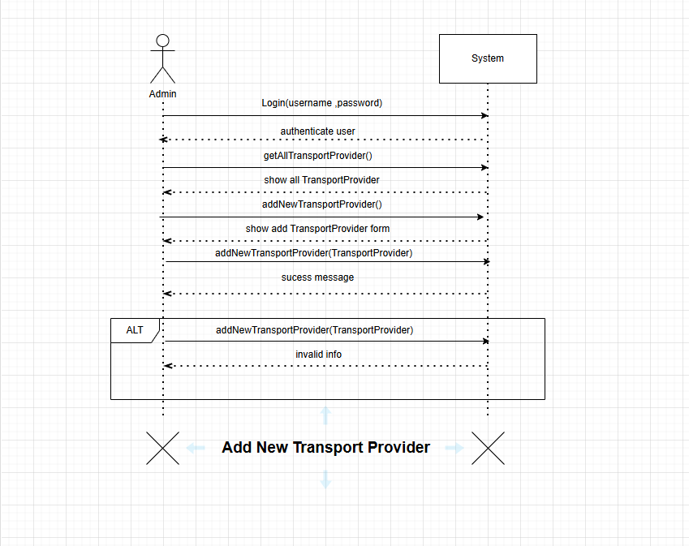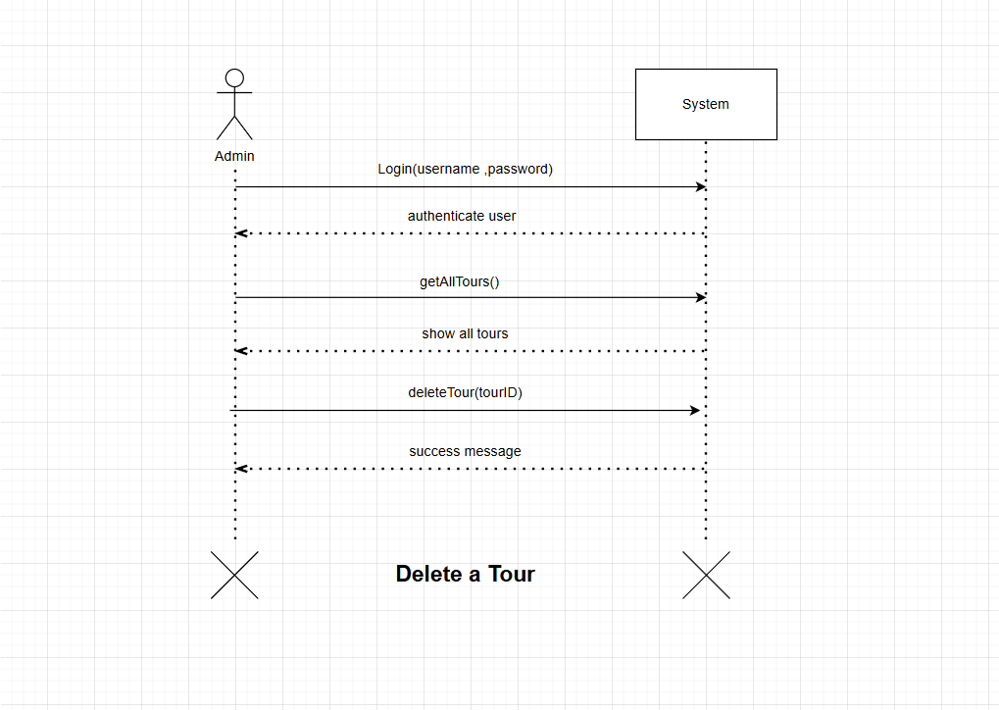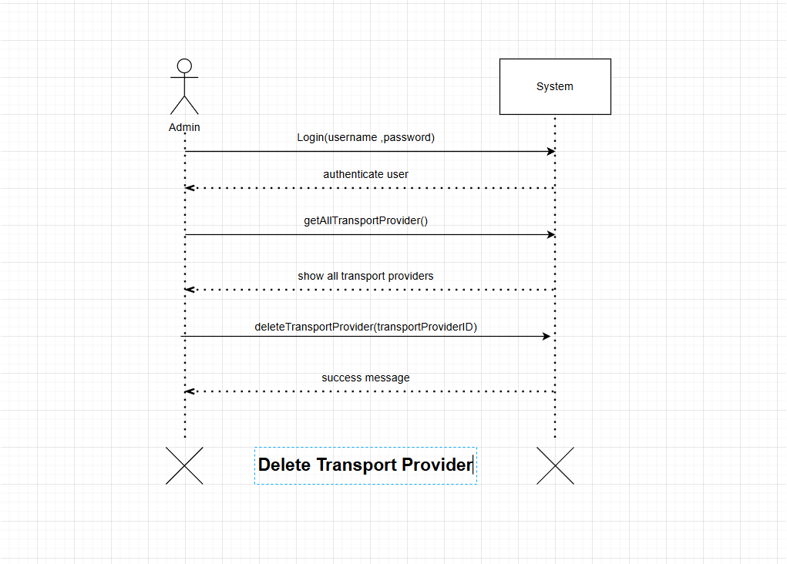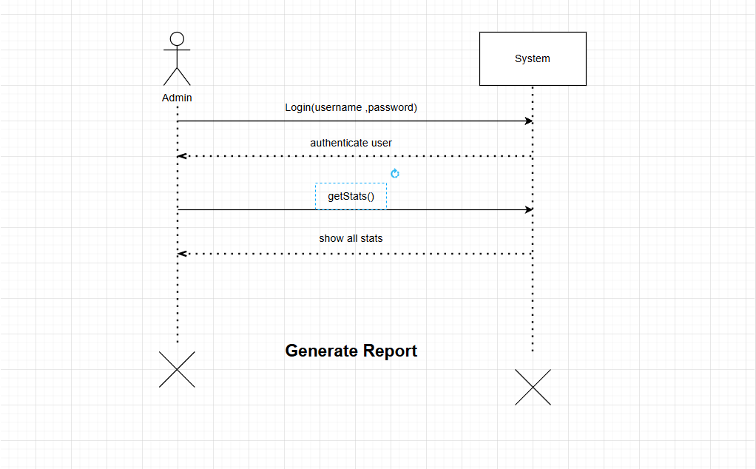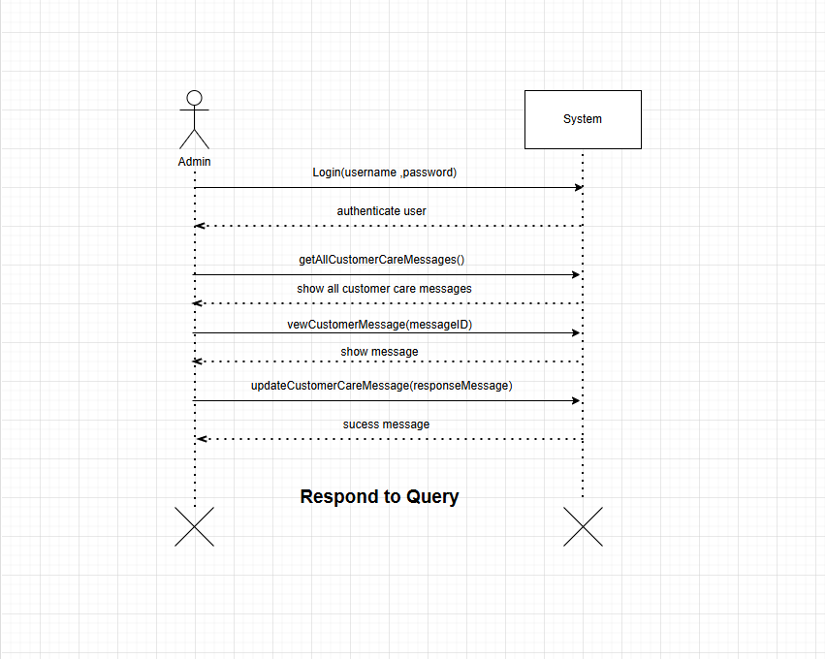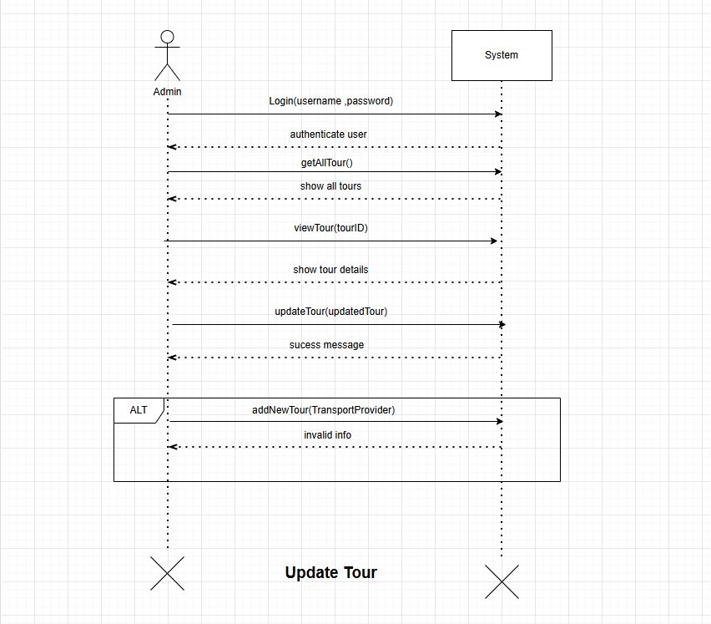

**Tourist System Sequence Diagrams** 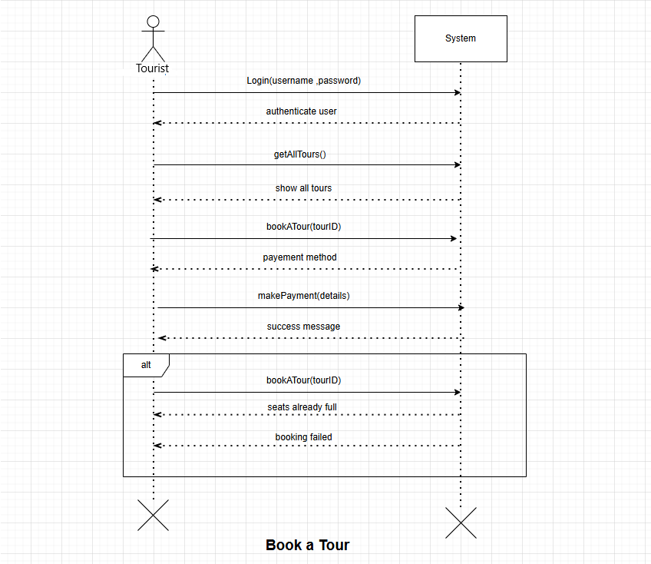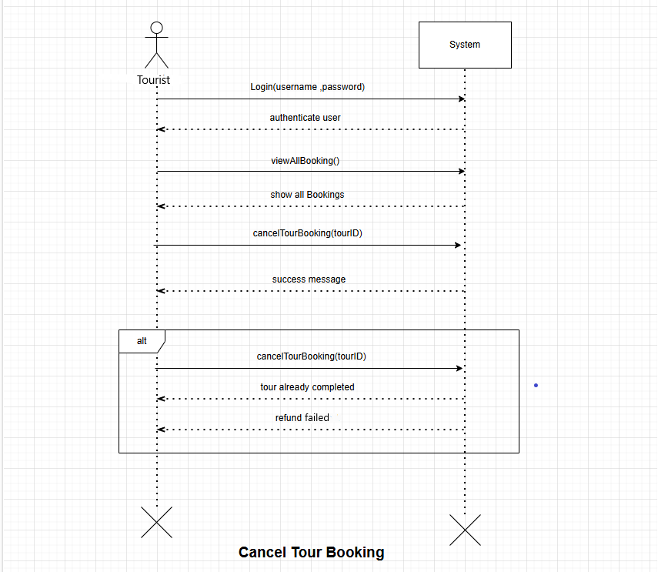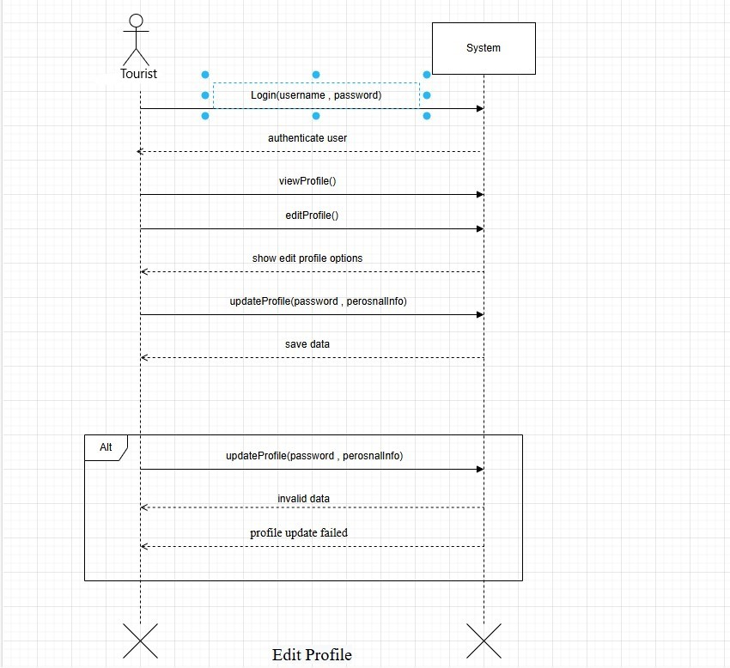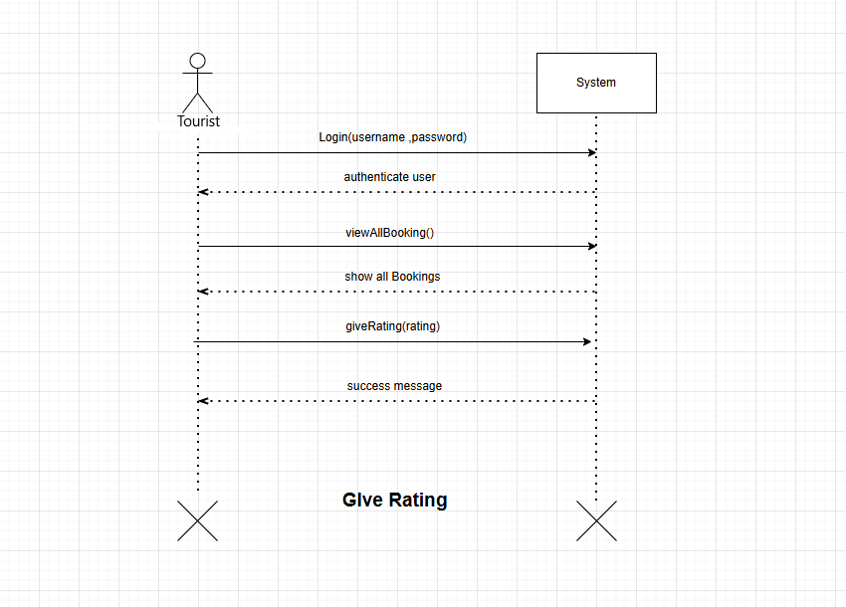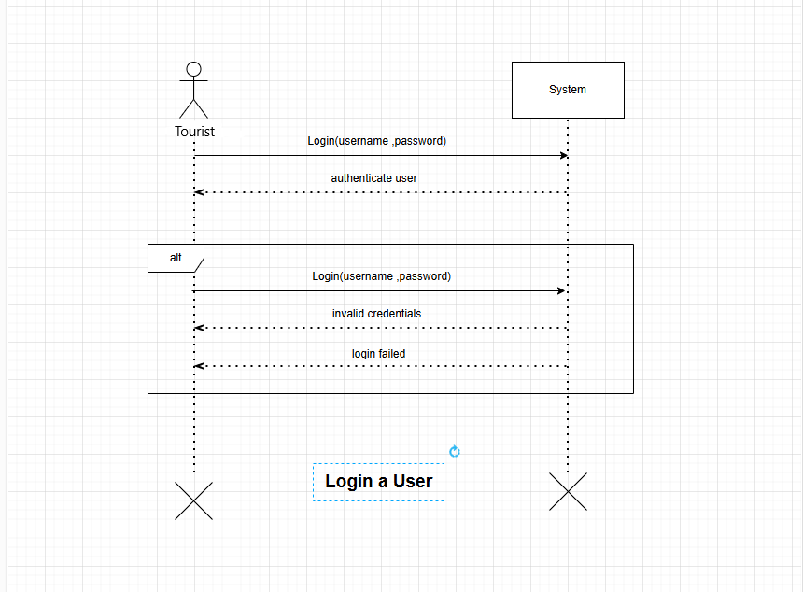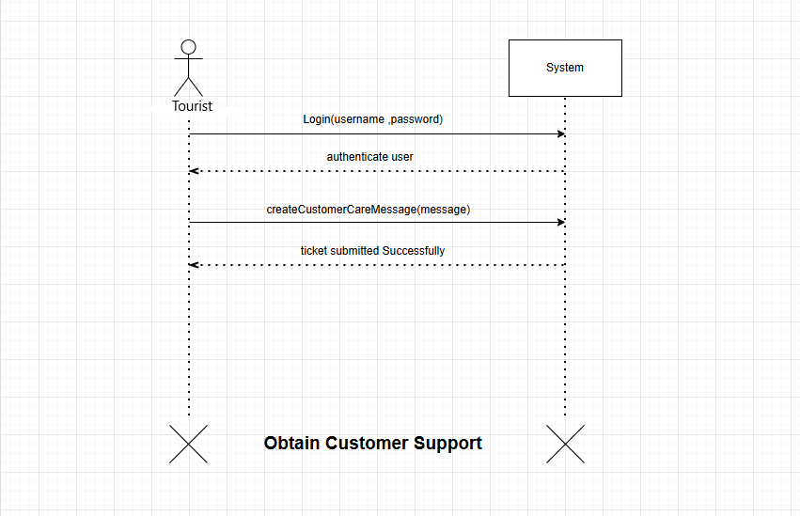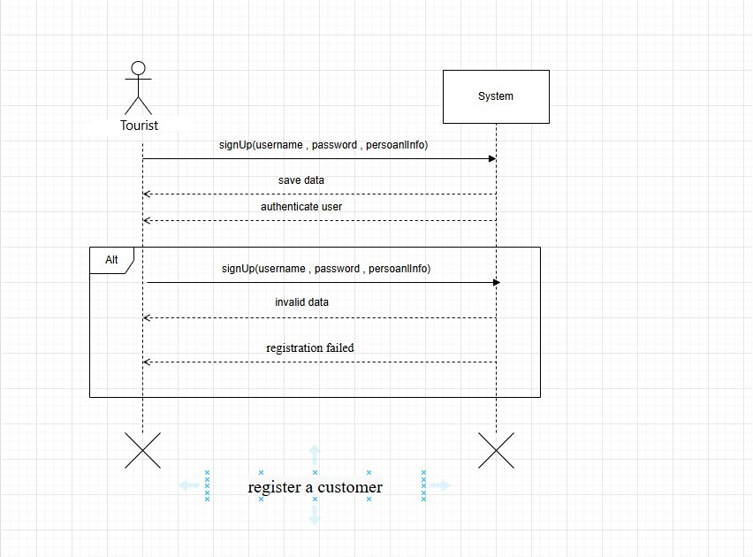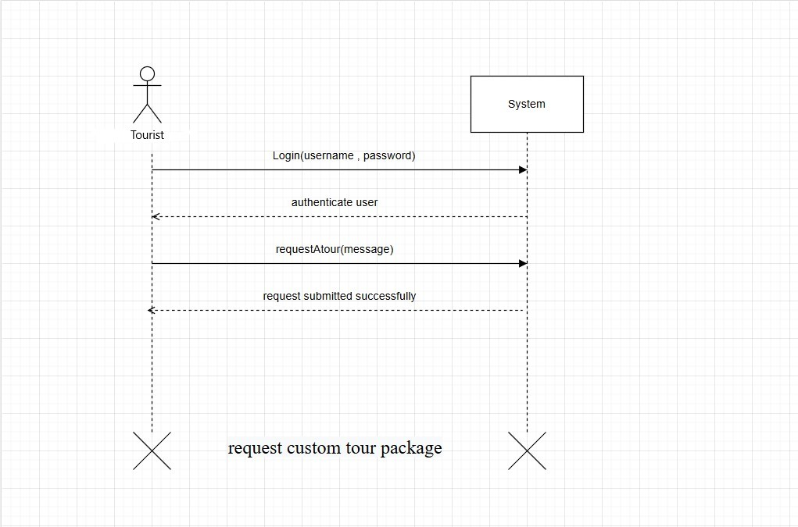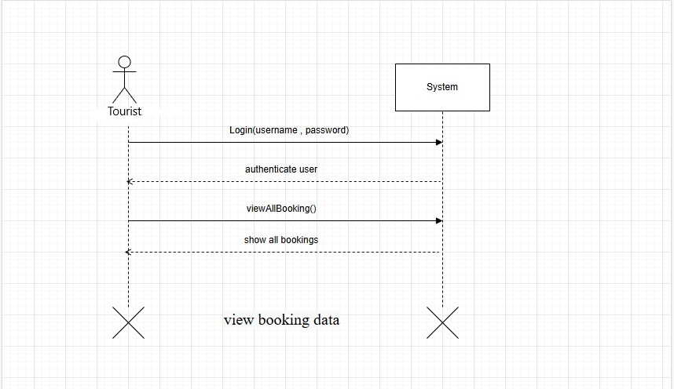

# 6. Sequence Diagrams

**Admin Sequence Diagrams**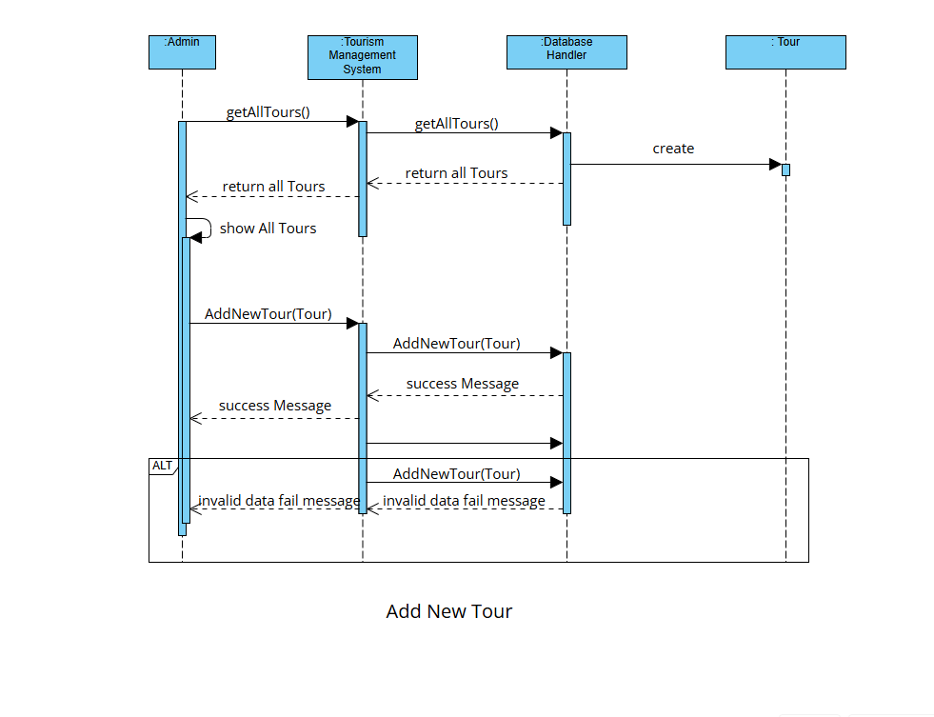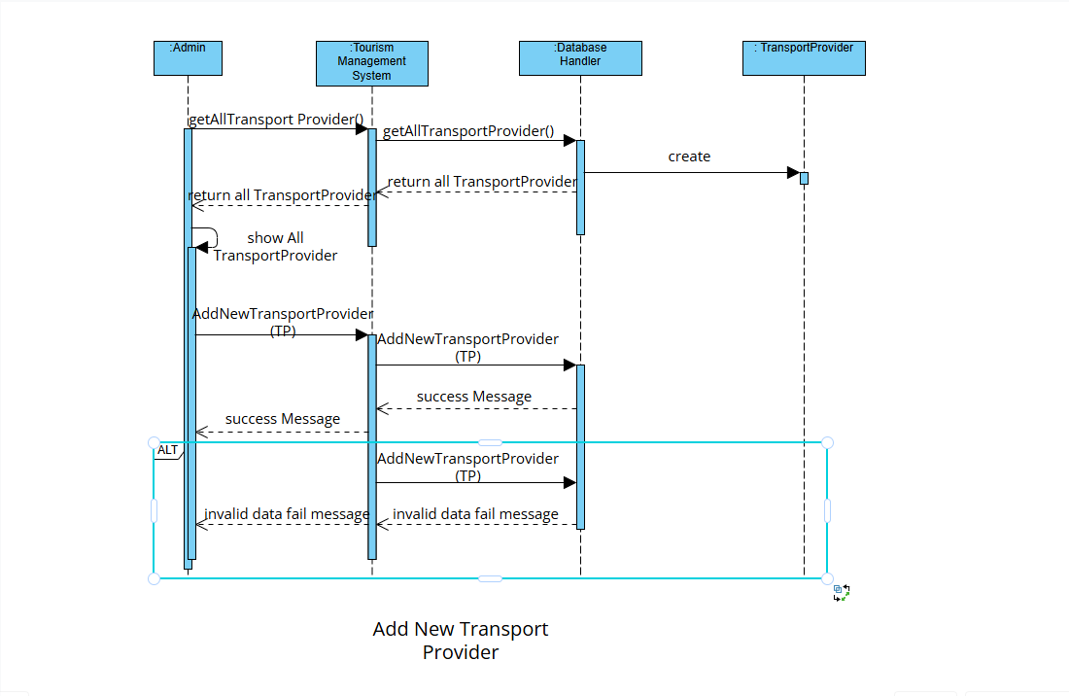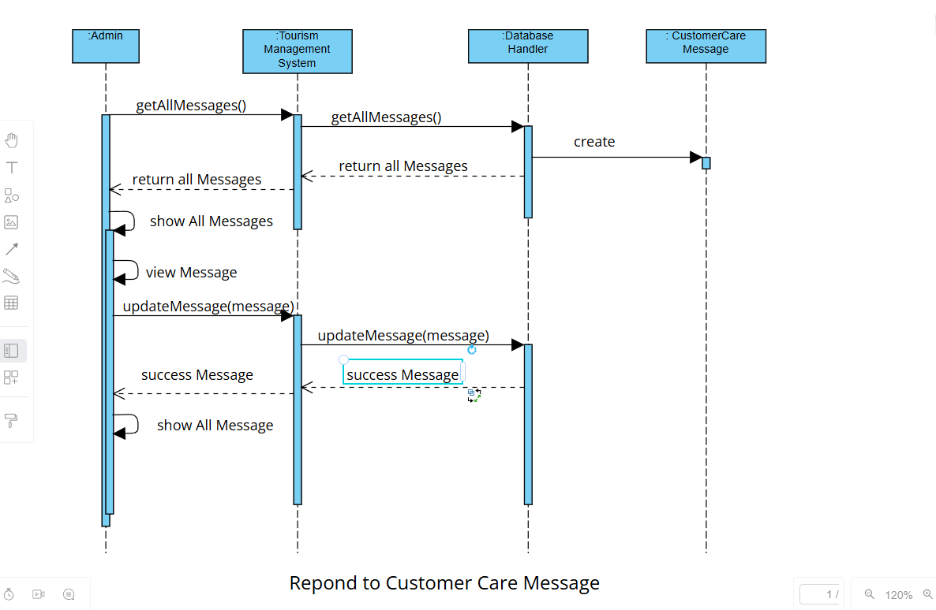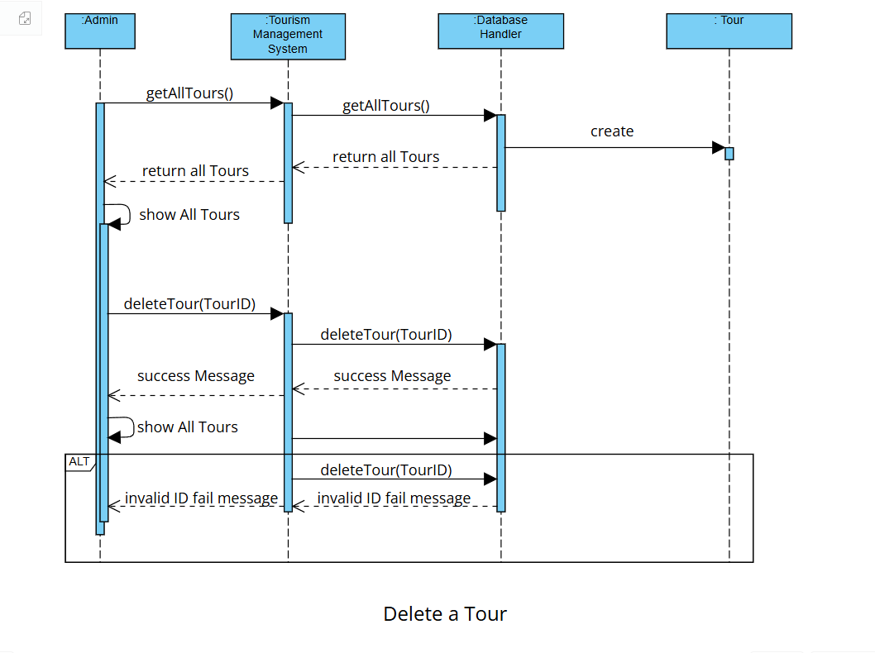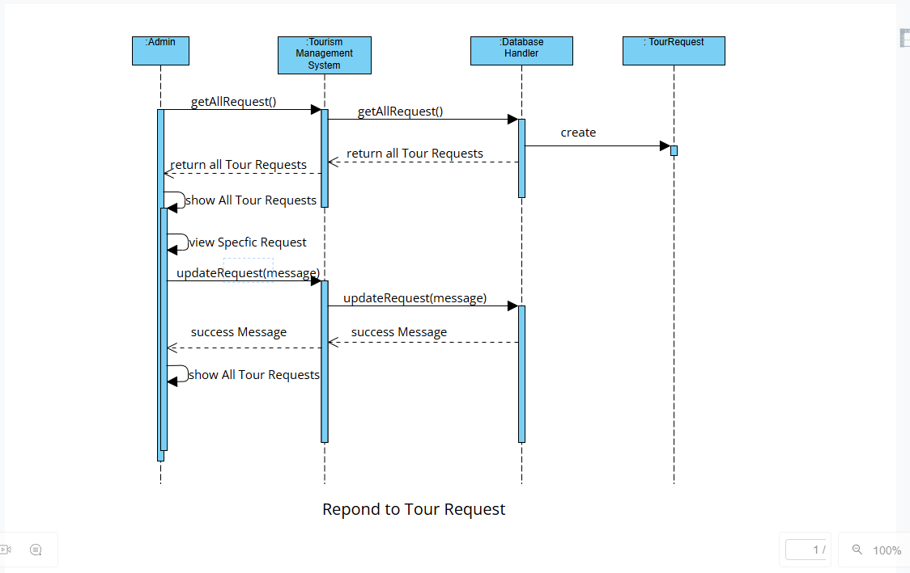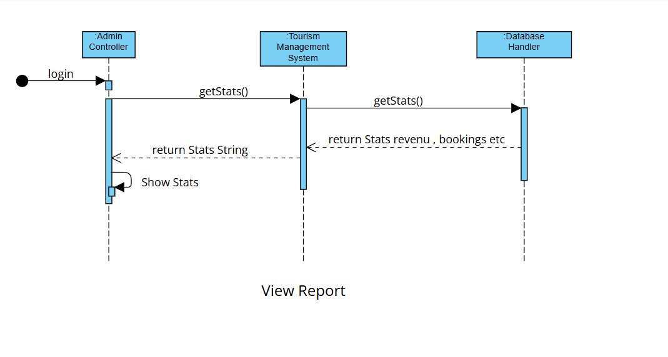

**Tourist Sequence Diagrams**

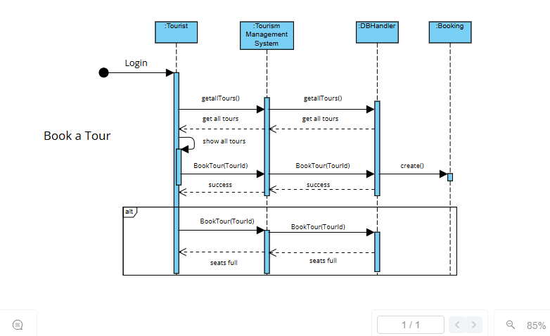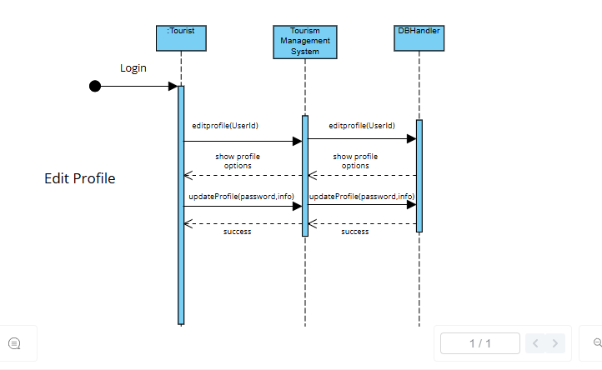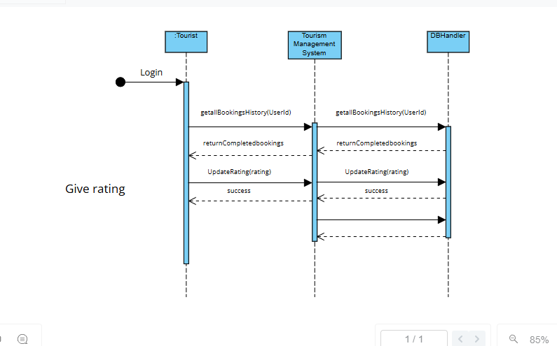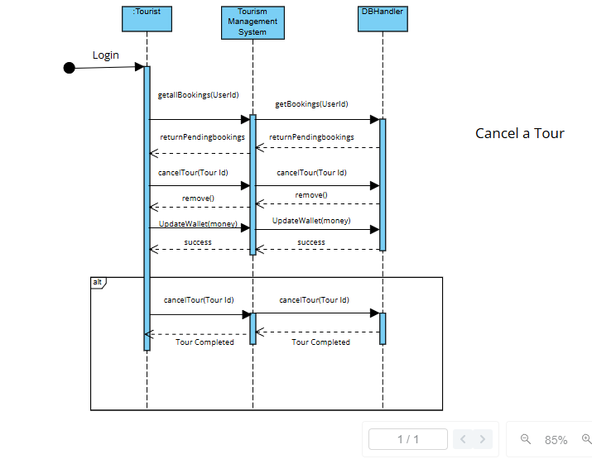

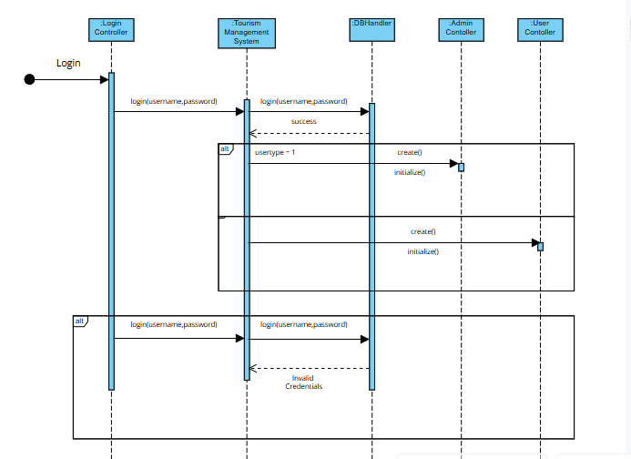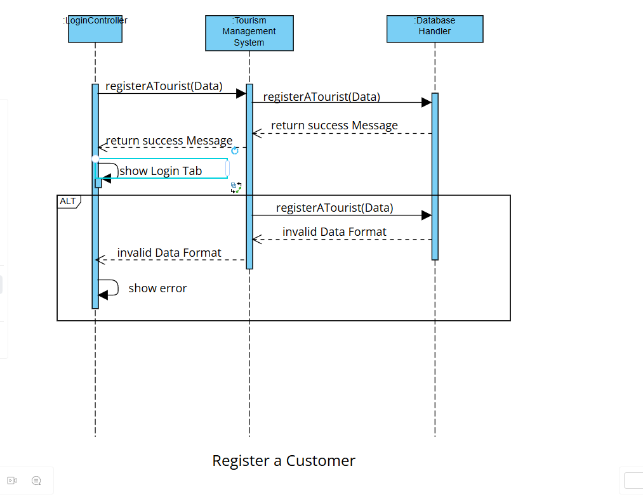

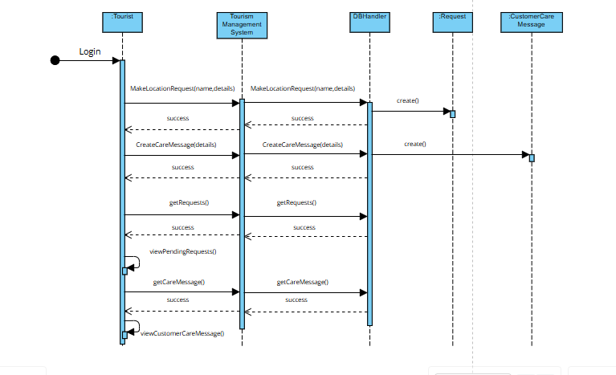

Customer Care Message + New Tour Location Request

1. **Class Diagram**

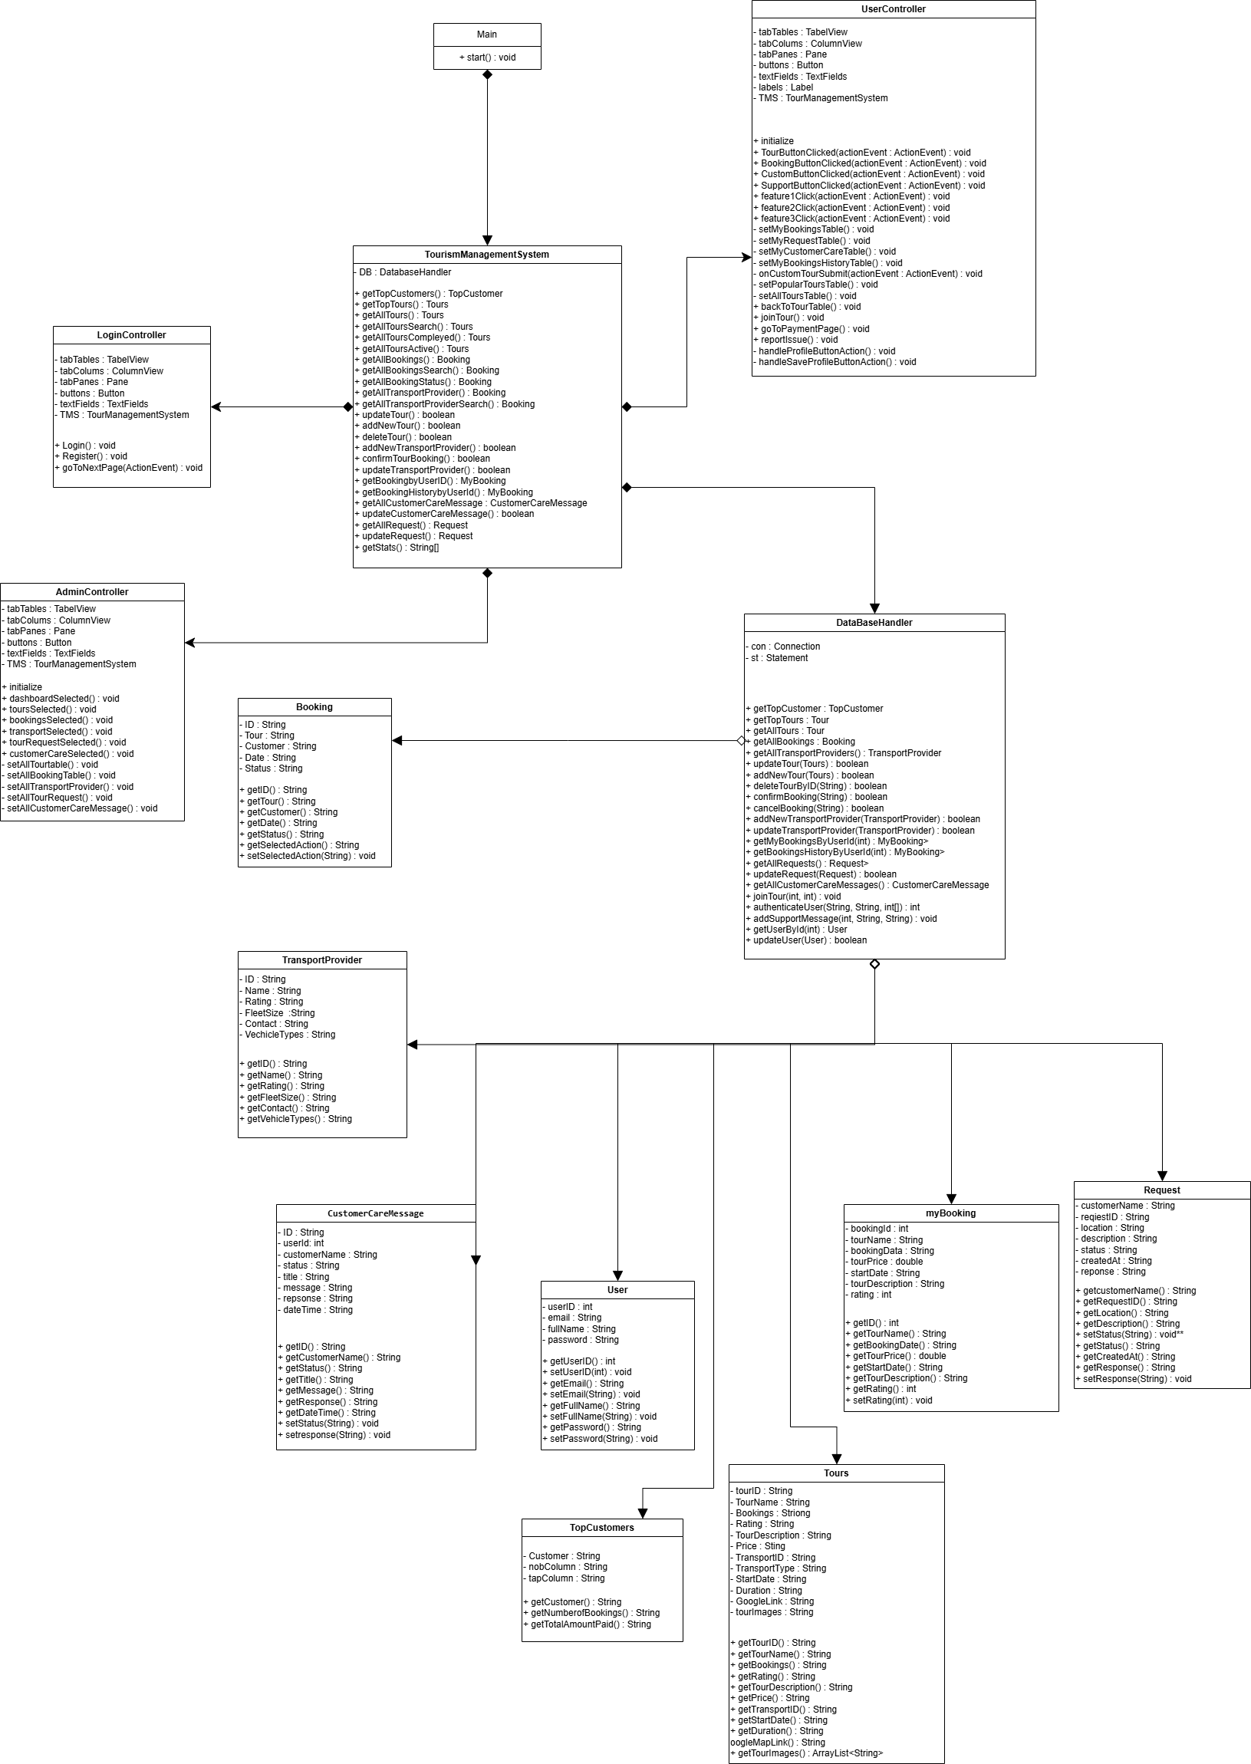

1. **Package Diagram**

1. **Deployment Diagram**

1. **Component Diagram**

