RA23502 – AUTONOMOUS MOBILE ROBOT
DESIGN AND SIMULATION OF INDUSTRY STANDARD AMRs
(AGILEX SCOUT MINI) WITH MOTOR, TORQUE AND
SLIP MODEL (SECOND REVIEW)

Submitted By:
SAILAKSHMI B T (2024511019)
BACHELOR OF ENGINEERING
in
ROBOTICS AND AUTOMATION

DEPARTMENT OF PRODUCTION TECHNOLOGY
MADRAS INSTITUTE OF TECHNOLOGY
ANNA UNIVERSITY - CHENNAI 600044

BONAFIDE CERTIFICATE
Certified that this project report “Design and Simulation of Industry Standard AMRs (AgileX Scout Mini) with Motor, Torque and Slip Model (Second Review)” is the Bonafide work of Sailakshmi B T (2024511019) who carried out the project work under my supervision.
SIGNATURE SIGNATURE
HEAD OF THE DEPARTMENT SUPERVISOR

TABLE OF CONTENTS:
S.No | TOPICS | PAGE
1 | Introduction | 5
2 | First Review in Brief | 5
3 | Work Done Since the First Review | 7
4 | Robot Data and Assumed Parameters | 7
5 | DC Motor, Gearbox and Battery Model | 9
6 | Torque and Force for Driving | 11
7 | Traction Limit and Wheel Slip | 12
8 | Slip Management with the Motor Limit | 12
9 | Software Changes | 14
10 | Test Method | 15
11 | Results | 15
12 | Unit Tests | 21
13 | Problems Solved | 21
14 | Algorithms Used | 21
15 | How to Run | 22
16 | Limitations and Future Enhancements | 23
17 | Conclusion | 24
18 | References | 24

Abstract
This report presents the second review of the design and simulation of an industry-standard autonomous mobile robot (AMR), the AgileX Scout Mini, as a warehouse robot in MATLAB R2025b with Simulink and Simscape Multibody. The first review built the robot from a SolidWorks model (URDF, STL meshes, smimport), turned it into a dynamic plant with a tyre-ground contact model and low-friction patches, added a 3D warehouse with four moving obstacles, and made it autonomous with a LiDAR, an A* planner, pure pursuit, a mission state machine and a wheel-slip management layer. In that work the wheel torque was limited by a constant of 17.5 N·m that was not derived from any motor data, and the torque, current and battery were not calculated. The second review adds the drive: four 150 W brushless hub motors and a 24 V, 15 Ah battery are modelled with a torque-speed limit (peak 15 N·m, rated 5 N·m), and the force, torque, current and power of eight driving cases are calculated by hand, compared with the grip limit μ m g of the three floor types, and compared with the simulation. The same torque-speed limit now acts on every wheel in the controller, and the motor current, battery voltage and charge are calculated from the logged torques and wheel speeds. For the simulated mass of 28.3 kg the cruise torque is 1.59 N·m per wheel (32 % of the rated torque), a 2.5 m/s² start needs 3.24 N·m, and the grip limit on the oily dock is only 0.88 N·m, so the floor, not the motor, limits the acceleration. The hand calculation and the simulation agree to within 0.08 N·m at cruise and in acceleration once the joint damping of the URDF is included. In the reference mission the robot delivered the load in 51.5 s over 32.5 m with 5 route corrections and 0 collisions; the peak wheel torque was 5.90 N·m, the peak motor current 9.2 A and the battery gave 1.06 Wh of 360 Wh. Six unit tests of the drive model pass. All results are from simulation; no test was done on the physical robot.

1. Introduction
The first review presented the Scout Mini as an autonomous warehouse robot in Simulink and Simscape Multibody: a SolidWorks model converted to a URDF, a free-chassis plant with four torque-driven wheels and a tyre-ground friction model, a 3D warehouse with racks, spills and four moving obstacles, and an autonomy stack of LiDAR, occupancy grid, A* planning, pure pursuit and wheel-slip management. In that work the wheels could not run out of torque, because the torque limit was a single constant, and nothing in the model said what the motors and the battery of a real Scout Mini would have to deliver.
A real robot has motors with a limited torque that falls with speed, a battery that sags, and a floor that can only transmit a limited force. The second review therefore asks two questions: what does the drive have to deliver, and what happens when the floor cannot take it? The objectives are:
- to add the real drive of the Scout Mini (four 150 W brushless hub motors, a 24 V battery) as a model with a torque-speed limit, a current limit and a battery with internal resistance;
- to calculate the wheel force, torque, current and power for the driving cases of the warehouse mission (cruise, start, brake, ramp, pivot), by hand and in MATLAB;
- to calculate the traction limit μ m g of the dry, wet and oily floor and to compare it with the force demand, which shows when the wheels must slip;
- to make the motor limit act in the simulation, to calculate the motor current, power, battery voltage and charge of the mission, and to compare the hand calculation with the simulated torque;
- to repeat the mission and the slip-management comparison with the new drive model, to test the drive model with unit tests, and to trace every number to a saved result.
Section 2 summarises the first review and Section 3 lists what changed. Sections 4 to 7 give the robot data and assumptions, the motor and battery model and the calculations of torque, force and traction. Sections 8 and 9 describe how the controller and the software use the model. Sections 10 to 12 give the test method, the results and the unit tests; Sections 13 to 17 the problems solved, the algorithms, how to run, the limitations and the conclusion.

2. First Review in Brief
This section is a short summary of the first review; the details of the CAD model, the URDF, the model structure, the warehouse and the autonomy stack are in that report. The toolchain is shown in Fig. 1: SolidWorks model, URDF with STL meshes, import with importrobot and smimport, a Simscape Multibody plant with the controller as MATLAB Function blocks, and the run script that produces the figures.
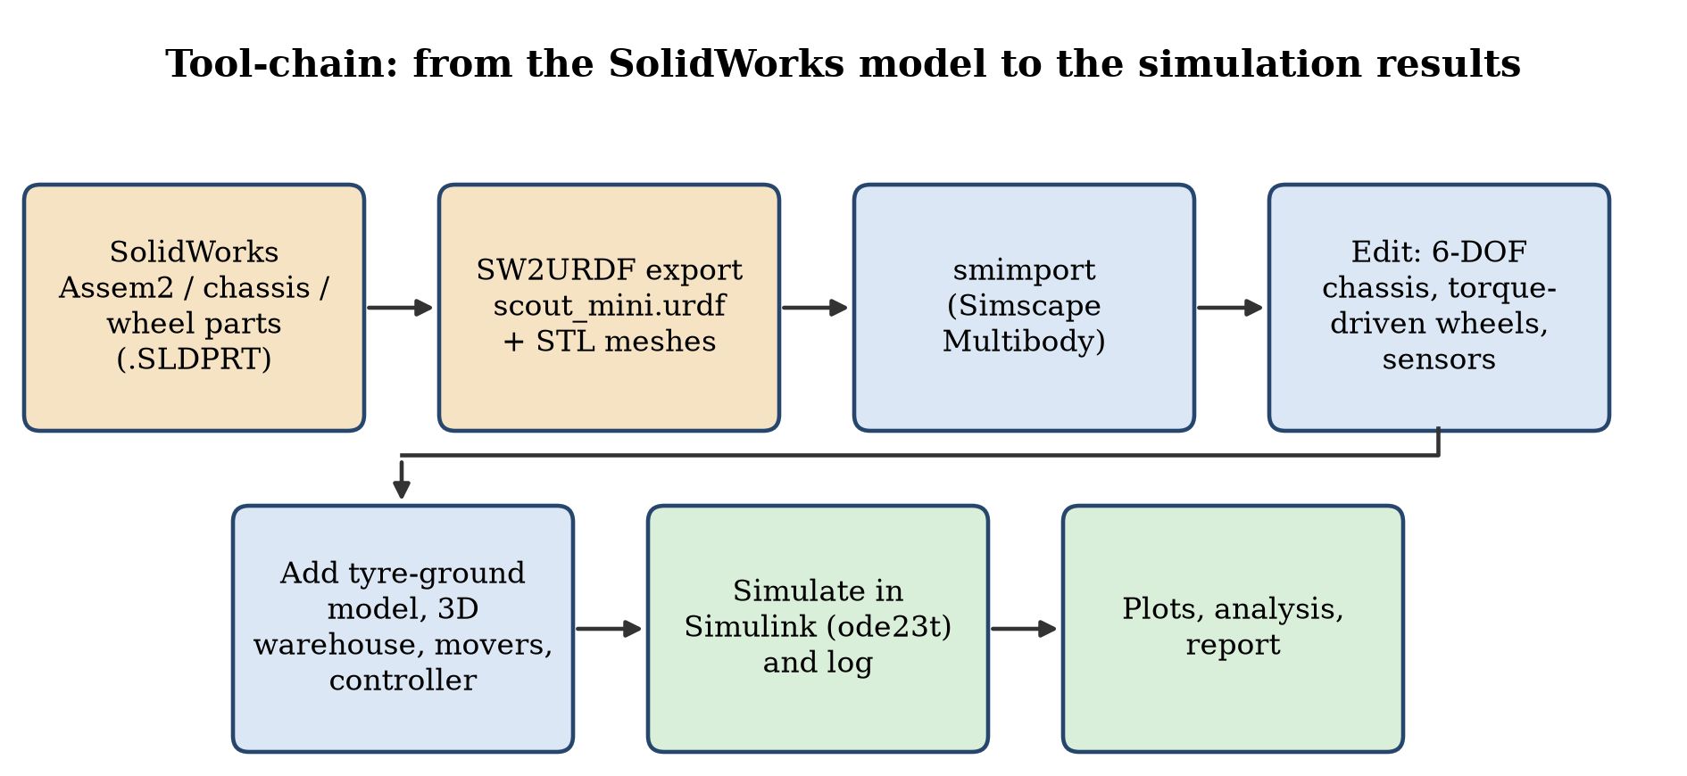
Fig. 1: From the SolidWorks model to the simulation results
Stage | Result of the first review
CAD and URDF | Scout Mini assembly (Assem2: chassis, chassis_top, W, up) in SolidWorks, exported to scout_mini.urdf with STL meshes; four continuous wheel joints; base_link 22.0 kg, wheels 1.5 kg each (28.3 kg in total)
Import | importrobot (rigidBodyTree) for checking, smimport for the Simscape Multibody model; track 0.612 m, wheel radius 0.085 m
Plant | free 6-DOF chassis, four torque-driven revolute wheel joints, tyre-ground contact per wheel (spring-damper normal force, smoothed Coulomb friction, k_c = 12 000 N/m, c_c = 700 N·s/m)
Floor | dry concrete μ = 0.90, an oily loading dock μ = 0.15 at the start and two water spills μ = 0.30
Warehouse | nine racks in three rows, walls, pickup and delivery stations, two floor boxes, four moving obstacles (two workers, a second AMR, a pallet truck), all part of the multibody scene
Autonomy | 72-beam LiDAR (8 m, 10 Hz), occupancy grid, A* with replanning every 0.5 s, pure pursuit, mission state machine (start, pickup, load, delivery, unload)
Slip management | slip-ratio detection (|κ| > 0.12), traction window, torque limiting, friction estimation; wheel torque limited by a constant of 17.5 N·m
Result of the first review | mission 49.6 s, 32 m, 3 route corrections, 0 collisions, minimum clearance 0.22 m, peak slip ratio 0.48 with and 0.64 without slip management, peak wheel torque 6.2 N·m

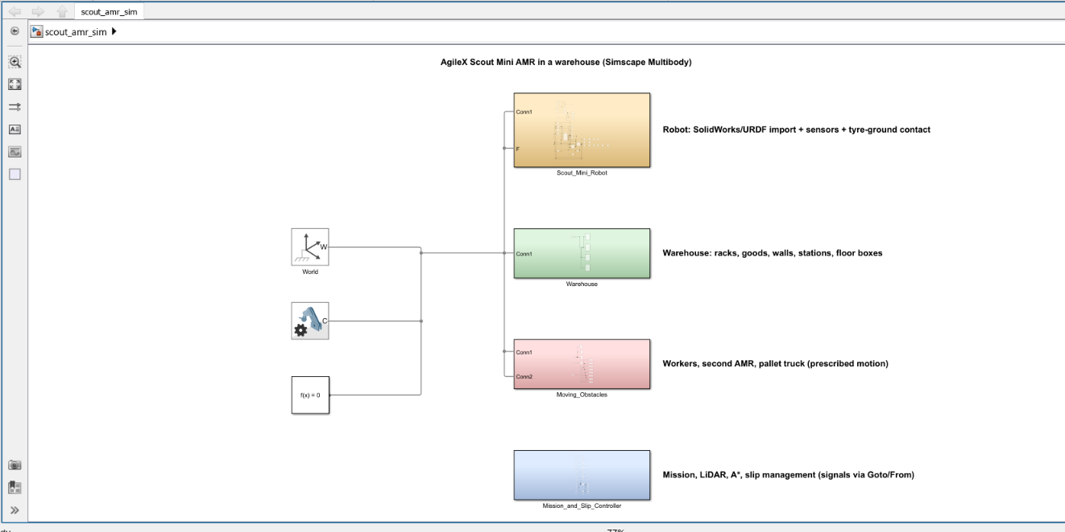
Fig. 2: Top level of scout_amr_sim.slx in Simulink: World, Mechanism Configuration, Solver Configuration and the four subsystems
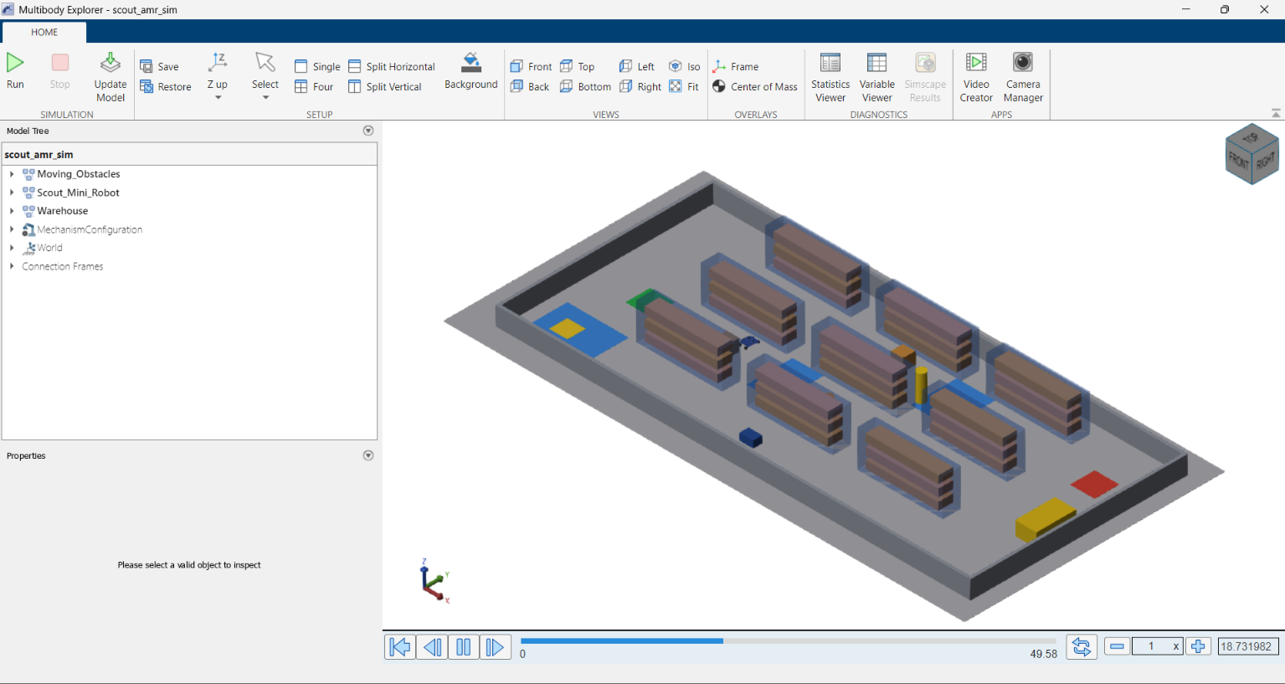
Fig. 3: Multibody Explorer, isometric view at t = 18.7 s of an earlier run (robot in aisle 2); the warehouse is part of the physical simulation
The first review showed that the chain from CAD to an autonomous mission works. Its limits were the ones the second review addresses: the 17.5 N·m torque limit had no source, the acceleration feed-forward used a mass of 30 kg that does not match the URDF, and the torque, current and battery of the drive were not calculated or checked against the grip of the floor.

3. Work Done Since the First Review
The table compares the two reviews. The CAD model, the URDF, the warehouse, the navigation and the slip-detection logic of the first review are unchanged in kind; the drive model, the calculations, the torque limit, the logging of motor quantities, the tests and the re-measured mission are new.
Item | First review | Second review (this report)
Motor | Constant torque limit 17.5 N·m; no motor data | 4 × 150 W brushless hub motors, K_t = 0.64 N·m/A, R = 0.6 Ω; peak 15 N·m (3 × rated 5 N·m); torque-speed limit min(15 N·m, K_t (V − K_e ω) / R)
Battery | None | 24 V (25.2 V full, 21.0 V empty), 15 Ah, internal resistance 0.08 Ω; voltage and charge calculated for the mission
Torque calculation | Acceleration feed-forward only, with m = 30 kg | Hand calculation of eight driving cases (force, torque, current, power) with m = 28.3 kg of the URDF, rolling resistance, ramp, pivot and the joint damping
Traction | Slip ratio threshold only | Grip limit μ m g and the force demand against it for dry, water and oil floors; shows that the floor limits the acceleration
Joint damping | Not known | Found in the Simscape joints (0.1 N·m·s/rad from the URDF) and included in the torque calculation
Slip management | Torque limit τ_lim = 17.5 N·m · max(0.1, 1 − s) | τ_lim = τ_env(ω) · max(0.1, 1 − s), with τ_env the motor torque-speed limit
Logging and figures | Slip, speed, LiDAR and trajectory figures | Adds motor current, power, battery voltage and charge (Fig. 8) and the design cases on the torque-speed limit (Fig. 5)
Tests | Verification checklist on the reference run | Six unit tests of the drive model; hand calculation compared with the simulated torque; repeated run gives identical numbers
Reference run | 49.6 s, 3 route corrections, clearance 0.22 m | 51.5 s, 5 route corrections, clearance 0.12 m, 0 collisions (the mission is sensitive to small changes of the torque limit and mass)

4. Robot Data and Assumed Parameters
The Scout Mini is a four-wheel skid-steer robot. The simulated robot is the SolidWorks-derived URDF, which is heavier than the real 20 kg robot. Table 3 gives the robot model, Table 4 the drive data and the assumptions of the drive model, and Table 5 the sensors. Quantities taken from the URDF or the manual are marked as such; every other value is an assumption.
The AgileX Scout Mini is a four-wheel-drive skid-steer platform for research, education and light transport. The table lists the values of the model that was built and simulated in this project. They come from the author's SolidWorks model, the exported URDF and the controller parameters; they are not measurements of the real robot, and the manufacturer's data sheet figures were not re-checked against them.
Parameter | Value in this project | Source
Type of drive | Four-wheel skid-steer, all wheels driven (hub-motor style torque on every wheel) | URDF, Simulink model
Links / joints | base_link + 4 wheels (w1…w4); 4 continuous wheel joints (j1…j4); fixed mounts for LiDAR, IMU, camera | scout_mini.urdf
Chassis mesh size | 0.672 × 0.580 × 0.225 m (x, y, z in the base_link frame) | base_link.STL bounding box
Wheel mesh | Radius 0.090 m, width 0.124 m (largest extent of w1.STL); radius used for rolling in the controller and tyre model 0.085 m | w1…w4.STL, scout_amr_params.m
Track (left-right wheel distance) | 0.612 m | Gazebo plug-in value in the URDF, controller
Wheel base (front-rear) | 0.391 m | Joint origins in the URDF
Mass | Chassis 22.0 kg + 4 wheels × 1.5 kg + small sensor links ≈ 28.3 kg (URDF), also used in the acceleration feed-forward | URDF, scout_amr_params.m
Wheel joint limits | Effort 40 N·m, velocity 25 rad/s (URDF); the motor model limits the torque to 15 N·m per wheel (3 × the rated 5 N·m, Section 5) | URDF, scout_amr_params.m
Speed limit in the mission | v ≤ 1.2 m/s, acceleration demand ≤ 2.5 m/s², yaw-rate demand slewed at 4 rad/s² | scout_amr_params.m, controller
Tyre-ground contact | Normal stiffness 12 000 N/m and damping 700 N·s/m per wheel; friction μ = 0.9 on dry concrete, 0.15 on oil, 0.30 on water | scout_amr_params.m
Payload (12 kg only in the sizing cases), protection class | Not modelled | –

Applications. In this project the robot is used as a warehouse transport AMR: it drives from a start dock to a pickup station, waits while loading, drives through the aisles to a delivery station and waits while unloading. The same platform is used in research and education for navigation, mapping and control, and for indoor and outdoor patrolling.
The manual of the Scout Mini gives four 150 W DC brushless hub motors, a 24 V battery of 15 Ah and a mass of 20 kg. It does not give the motor constants, the gear ratio or the battery resistance. The mass, the wheel geometry and the joint damping are those of the simulated robot (URDF); every other value is an assumption chosen to be plausible for a 24 V drive, and the reason is listed.
Quantity | Symbol | Value | Source / reason
Mass | m | 28.3 kg | sum of the URDF link masses (the real robot has 20 kg)
Weight, load per wheel | m g, F_z | 277.6 N, 69.4 N | g = 9.81 m/s²; weight shared equally by the four wheels
Wheel radius | r | 0.085 m | wheel mesh and contact model of the Simulink model (the ROS 2 model uses 0.08 m)
Track, wheel base | B, L | 0.612 m, 0.391 m | URDF
Wheel inertia, yaw inertia | J_w, I_z | 0.005 kg·m², 1.4 kg·m² | J_w from the URDF; I_z estimated: chassis 0.65 plus four wheels at 0.363 m from the centre
Joint damping | b | 0.1 N·m·s/rad | URDF <dynamics>; the Simscape import keeps it on every wheel joint (checked in the model)
Rolling resistance, turning friction | c_rr, μ_t | 0.03, 0.35 | assumed (hard rubber on concrete; skid-steer scrub)
Motors | – | 4 × 150 W, brushless hub | manual
Battery | V, Ah | 24 V (25.2 V full, 21.0 V empty), 15 Ah | manual; 6S pack
Battery internal resistance | R_int | 0.08 Ω | assumed for a 6S pack
Torque / back-EMF constant | K_t = K_e | 0.64 N·m/A | 24 V / 37.5 rad/s, so that the no-load speed of the motor is 37.5 rad/s
Winding resistance | R | 0.6 Ω | assumed
Rated torque, rated current | τ_rated, I_rated | 5.0 N·m, 7.8 A | 150 W at 30 rad/s gives 5.0 N·m; I = τ / K_t
Peak torque, peak current | τ_peak, I_peak | 15.0 N·m, 23.4 A | 3 × rated; current limit of the driver
Gear ratio, efficiency | N, η | 1 : 1, 1.0 | direct-drive hub motor; the manual lists no gearbox
Idle electronics power | P_0 | 12 W | assumed (computer, LiDAR, drivers)

Assumptions of the drive model.
- M1: the four wheels share the load equally, and the wheels on one side carry the same torque.
- M2: each wheel is driven by one DC motor with torque τ = K_t I and back-EMF e = K_e ω, with K_t = K_e in SI units.
- M3: the gearbox has ratio N and efficiency η; for the hub motor N = 1 and η = 1, so the wheel torque equals the motor torque.
- M4: the driver limits the current to I_peak, and the battery voltage limits the speed (no-load speed V / K_e).
- M5: the battery has an open-circuit voltage that falls linearly from 25.2 V to 21.0 V with the charge, and the internal resistance R_int.
- M6: each wheel joint has the viscous damping b = 0.1 N·m·s/rad of the URDF, so the motor must also deliver b·ω. The joint Coulomb friction of the URDF (0.1 N·m) is not transferred by the import and is not modelled.
- M7: the wheel torque is applied to the joints of the multibody model (the motor is a limited torque source, not a velocity source), and the tyre model decides how much of it becomes force at the ground. The contact model has friction only: it has no rolling resistance, so c_rr acts in the hand calculation but not in the simulation.
An industrial AMR needs exteroceptive sensors (what is around the robot) and proprioceptive sensors (how the robot itself moves). Three groups of sensors appear in this project, and the table below states for each one whether it is part of the Simulink simulation or only declared in the robot description.
Sensor | Configuration | Reason for use | Status
2D LiDAR (Simulink simulation) | 72 beams over 360° (5° spacing), maximum range 8 m, 10 Hz, exact ray–rectangle and ray–circle intersection with the warehouse geometry (scout_wh_lidar.m); no noise | Detects racks, boxes, workers, the second AMR and the truck; its hits build the dynamic layer of the occupancy grid, trigger re-planning and give the reactive repulsion and stop-before-contact limit | Simulated, used by the navigation
Body-state sensors (Transform Sensor blocks) | World-frame position, rotation matrix, linear and angular velocity of the base_link and of each wheel, sampled by the controller every 5 ms | Provide the robot pose and speed (stand-in for localisation and odometry) and the wheel positions for the tyre model | Simulated, ideal (true pose)
Wheel joint speed (encoder equivalent) | Joint velocity of each of the four wheel joints, 5 ms, no quantisation or noise | Closed-loop wheel-speed control and slip-ratio estimation | Simulated, ideal
Collision monitor | Ground-truth distance from the robot collision circle (r = 0.36 m) to every rack, wall, box, mover; counts overlaps | Measures safety of the run; it is not seen by the controller | Simulated (evaluation only)
2D LiDAR (URDF declaration) | Gazebo gpu_lidar: 720 samples over 360°, range 0.12–16 m, 20 Hz, Gaussian noise σ = 0.01 m | Navigation and SLAM in the earlier ROS 2 / Gazebo project that the URDF comes from | Mount imported as a body; scan model replaced by the analytic LiDAR above
IMU (URDF declaration) | Gazebo imu: 100 Hz, gyro noise σ = 0.0002 rad/s, accelerometer noise σ = 0.017 m/s² | Orientation and yaw-rate feedback for sensor fusion in ROS 2 | Mount imported as a body; no IMU signal is simulated in Simulink
RGB-D camera (URDF declaration) | Gazebo rgbd_camera: 640 × 480 RGB, field of view 80°, depth 0.1–10 m | Forward perception (obstacle classification, depth) | Mount imported as a body; not simulated in Simulink
Wheel odometry (URDF declaration) | Gazebo DiffDrive plug-in: 50 Hz, wheel separation 0.612 m, wheel radius 0.08 m, limits 2.5 m/s and 3.5 rad/s | Dead-reckoning odometry in ROS 2 | Not used in Simulink

By type, the sensors of the project are:
- Exteroceptive (sense the environment): a 2D planar LiDAR (simulated in Simulink, with a 3D-camera mount); an RGB-D camera is declared in the URDF only.
- Proprioceptive (sense the robot itself): wheel joint-speed sensors (encoder equivalent) on all four wheels, Transform Sensors for chassis pose and velocity (stand-in for localisation and odometry), and an IMU (gyroscope and accelerometer; declared in the URDF and simulated in the script simulation).
- Evaluation only: the collision monitor, which measures the ground-truth distance to obstacles and is not available to the controller.
A planar LiDAR is sufficient for the warehouse of this project because every obstacle is a vertical prism (rack, box, wall, worker cylinder, truck) that extends well above the scan plane, so one plane sees everything the robot could hit. The LiDAR in the Simulink model is an analytic model, not a measurement: it has no noise, no dropped returns and no minimum range; its ranges are only rounded to 2 cm. The robot pose used by the navigation is the true simulator pose, so no localisation, SLAM or sensor fusion is implemented in the Simulink project; the EKF, SLAM Toolbox and Nav2 configuration of the ROS 2 repository the URDF comes from were not run in this work.

5. DC Motor, Gearbox and Battery Model
The model is built from the assumptions M1 to M7 of Section 4 (Table 4 gives the values). Each assumption is numbered so that the calculation can be checked against it. Fig. 4 shows the drive train of one wheel and the equations of each block.
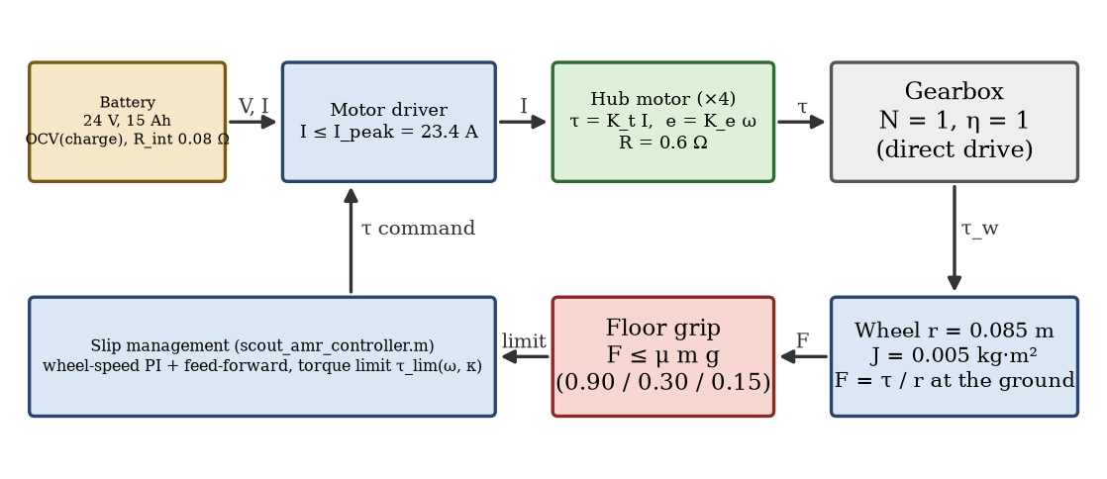
Fig. 4: Drive train of one wheel and the quantities that pass between the blocks
The wheel speed follows from the body speed v and the yaw rate ω (Eq. 1). The force that the four wheels must produce at the ground is the rolling resistance, the slope and the acceleration (Eq. 2); the yaw moment for turning is the scrub of the wheels plus the yaw acceleration (Eq. 3). Each wheel carries a quarter of the force (Eq. 4); the wheel torque adds the wheel inertia and the joint damping (Eq. 5). The motor current and the electrical power follow from M2 and M3 (Eqs. 6 and 7).
(1) w_L,R = (v -/+ B/2 * omega) / r
(2) F = m g c_rr cos(theta) + m g sin(theta) + m a
(3) M = mu_t m g R_c + I_z alpha R_c = sqrt((B/2)^2 + (L/2)^2) = 0.363 m
(4) F_w = F / 4 (pivot: F_w = mu_t F_z (B/2)/R_c + I_z alpha (B/2) / (4 R_c^2))
(5) tau_w = (F_w r + J_w a / r) / (N eta) + b w
(6) I = tau_w / K_t
(7) P_el = tau_w w + R I^2 per motor, P_bat = 4 P_el + P_0
The torque that the motor can deliver at the wheel speed ω_w is limited first by the current and, above the knee, by the voltage that remains after the back-EMF (Eq. 8). The battery current for the power demand follows from the terminal voltage V_t = OCV − R_int I_b (Eq. 9). The largest torque, the force of the four wheels, the no-load speed, the knee and the unlimited stall torque are Eqs. 10 to 13:
(8) tau_avail(w) = min( tau_peak , K_t (V - K_e w) / R )
(9) I_b = ( OCV - sqrt(OCV^2 - 4 R_int P_bat) ) / (2 R_int)
(10) tau_peak = K_t I_peak F_peak = 4 tau_peak / r
(11) w_0 = V / K_e v_0 = w_0 r
(12) w_knee = (V - R I_peak) / K_e
(13) tau_stall = K_t V / R
Calculation (K_t = K_e = 0.64 N·m/A, R = 0.6 Ω, V = 24 V, I_peak = 23.4 A, r = 0.085 m): τ_peak = 0.64 · 23.4 = 15.0 N·m; F_peak = 4 · 15.0 / 0.085 = 706 N; ω_0 = 24 / 0.64 = 37.5 rad/s, i.e. v_0 = 3.19 m/s; ω_knee = (24 − 0.6 · 23.4) / 0.64 = 15.5 rad/s (1.32 m/s); τ_stall = 0.64 · 24 / 0.6 = 25.6 N·m. The current limit therefore decides the torque up to 15.5 rad/s, and above it the back-EMF lowers it along Eq. 8. The fastest wheel that the controller can ask for (v = 1.2 m/s with ω = 1.3 rad/s) turns at (1.2 + 0.306 · 1.3) / 0.085 = 18.8 rad/s; there the motor can still deliver 12.8 N·m. In the mission run the fastest wheel turned at 14.9 rad/s, below the knee, so the voltage limit never became active. With the empty battery (21.0 V) the available torque at 18.8 rad/s is 9.6 N·m, which is also well above what the mission needs.
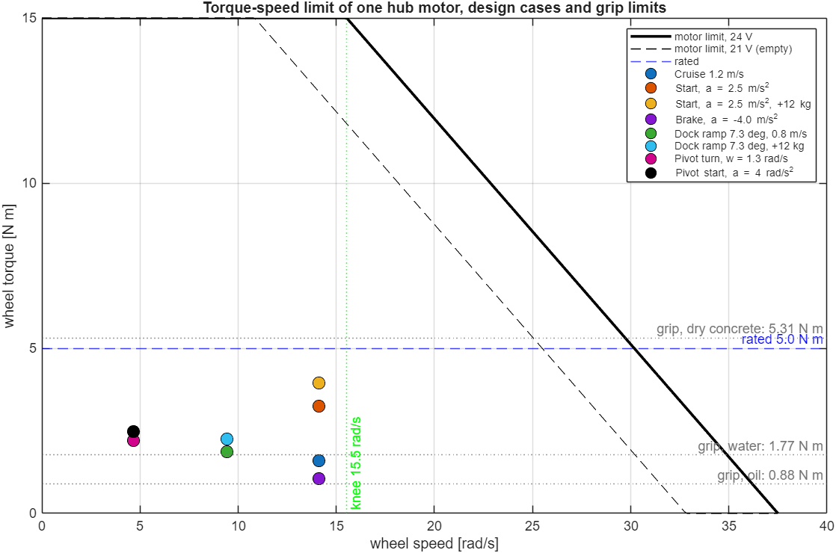
Fig. 5: Torque–speed limit of one hub motor (24 V and empty battery 21 V), the driving cases of Table 6 and the grip limits of the three floors
Fig. 5 shows the limit of Eq. 8. Every driving case of Table 6 lies far below the curve, so the motor can supply it; the horizontal lines are the grip limits of Section 7, which are lower than the motor limit everywhere.

6. Torque and Force for Driving
The mission is driven on a flat floor with one dock ramp in the script simulation, so the driving cases are cruise, starts, braking, the ramp and turns of the skid-steer base. The table gives, per wheel, the torque from Eqs. 2 to 7 for the simulated mass of 28.3 kg. The last three columns are the traction demand: the force demanded divided by the grip limit μ m g of Section 7 (a value above 1 means that the wheels must slip).
Worked example, cruise at 1.2 m/s on the flat floor. With a = 0 and θ = 0, Eq. 2 gives F = 0.03 · 277.6 = 8.3 N. Each wheel carries a quarter, so the ground part of the torque is 8.3 · 0.085 / 4 = 0.18 N·m. The wheel speed is 1.2 / 0.085 = 14.1 rad/s, so the joint damping adds 0.1 · 14.1 = 1.41 N·m and the wheel torque is 1.59 N·m (32 % of the rated 5.0 N·m). Eq. 6 gives I = 1.59 / 0.64 = 2.48 A, and the electrical power of one motor is 1.59 · 14.1 + 0.6 · 2.48² = 26.1 W. The joint damping is the largest part of the cruise torque. The same formulas give the other cases of Table 6.
Case | F [N] | τ ground [N·m] | b·ω [N·m] | τ wheel [N·m] | τ / τ_rated | I [A] | Demand dry | Demand water | Demand oil
Cruise 1.2 m/s | 8.3 | 0.18 | 1.41 | 1.59 | 32 % | 2.5 | 0.03 | 0.10 | 0.20
Start, a = 2.5 m/s^2 | 79.1 | 1.83 | 1.41 | 3.24 | 65 % | 5.1 | 0.32 | 0.95 | 1.90
Start, a = 2.5 m/s^2, +12 kg | 112.6 | 2.54 | 1.41 | 3.95 | 79 % | 6.2 | 0.32 | 0.95 | 1.90
Brake, a = -4.0 m/s^2 | 104.9 (brake) | -2.46 | 1.41 | 1.05 | 21 % | 1.6 | 0.42 | 1.26 | 2.52
Dock ramp 7.3 deg, 0.8 m/s | 43.5 | 0.93 | 0.94 | 1.87 | 37 % | 2.9 | 0.17 | 0.52 | 1.05
Dock ramp 7.3 deg, +12 kg | 62.0 | 1.32 | 0.94 | 2.26 | 45 % | 3.5 | 0.17 | 0.52 | 1.05
Pivot turn, w = 1.3 rad/s | 81.9 (sum) | 1.74 | 0.47 | 2.21 | 44 % | 3.5 | – | – | –
Pivot start, a = 4 rad/s^2 | 94.9 (sum) | 2.02 | 0.47 | 2.48 | 50 % | 3.9 | – | – | –

Demand is the force that the case needs divided by the grip limit μ m g of the floor (Section 7); a value above 1 means that the wheels must slip. The motor current is below the rated 7.8 A in every case, and the largest wheel torque of the table (3.95 N·m, the 2.5 m/s² start with the 12 kg payload) is 26 % of the peak torque of 15 N·m and 79 % of the rated torque. The pivot cases are for the turning of a skid-steer base: the wheels scrub sideways, which needs a yaw moment of μ_t m g R_c = 35.3 N·m in steady turning (the table gives the force along the wheel direction that each wheel has to drive). The braking case is the largest deceleration that the controller allows (1.6 times the acceleration limit); the motors brake with regenerative torque, and the damping of the joints already supplies a part of the braking.

7. Traction Limit and Wheel Slip
Assumptions of the traction model: S1, Coulomb friction between tyre and floor, so that the largest force the four wheels can transmit is F_max = μ m g; S2, the weight is shared equally by the four wheels; S3, slip begins as soon as the force demand exceeds F_max; S4, in the simulation the friction comes from the tyre-ground model of the first review, with μ read from the floor map of Table 8.
The largest force that four wheels can transmit by friction is F_max = μ m g (Coulomb friction, weight shared equally), which gives the best acceleration a_max = μ g and the grip torque per wheel τ_grip = μ m g r / 4:
(14) a_max = mu g (15) tau_grip = mu m g r / 4
Calculation (m g = 277.6 N): dry concrete (μ = 0.90): F_max = 250 N, a_max = 8.8 m/s², τ_grip = 5.31 N·m; water (0.30): 83 N, 2.94 m/s², 1.77 N·m; oil (0.15): 42 N, 1.47 m/s², 0.88 N·m.
Floor | μ | F_max [N] | a_max [m/s²] | τ_grip per wheel [N·m] | Start torque (3.24 N·m, of which 1.83 N·m reaches the ground)
Dry concrete | 0.90 | 250 | 8.83 | 5.31 | grip is enough
Water | 0.30 | 83 | 2.94 | 1.77 | wheels spin (1.0 × the grip)
Oil | 0.15 | 42 | 1.47 | 0.88 | wheels spin (2.1 × the grip)

Only the part of the torque that makes force at the ground has to be held by the floor, because the damping torque is lost inside the joint. The motors are never the limit: the largest case needs 26 % of the peak torque, and the largest torque of the mission run (5.90 N·m) is 39 % of it. The floor is the limit. On dry concrete the grip torque of 5.31 N·m is more than the ground part of every case of Table 6. On water the grip of 1.77 N·m is just below the ground part of the 2.5 m/s² start (1.83 N·m), and on the oil of the loading dock the grip of only 0.88 N·m is half of it, so an acceleration of more than 1.47 m/s² makes the wheels spin. This is why the start on the dock is slow, and why the controller lowers its acceleration limit to 0.85 μ̂ g (Section 8.2): the torque that the motors could give is far above what the floor can take, so the slip management has to limit the torque, not the motor.

8. Slip Management with the Motor Limit

8.1 Detection and management (from the first review)
The floor of the warehouse is not uniform, so the wheels can lose grip, and a skid-steer robot also scrubs its wheels sideways in every turn. The controller therefore monitors the slip of every wheel and manages it. This logic is unchanged from the first review; what changed is the torque limit it acts on (Section 8.2).
The slip ratio of each wheel is calculated from the wheel speed and the ground speed at the wheel:
κ = (r·ω − v_k) / max(|r·ω|, |v_k|, 0.8 m/s)
Here ω is the wheel speed, r the wheel radius and v_k the ground speed at the wheel's lateral position (chassis speed minus yaw rate times the wheel offset). The 0.8 m/s floor in the denominator avoids division by zero at standstill. The slip is detected and managed as follows:
- Detection: a wheel slips when |κ| > 0.12; a slip timer records how long this lasts.
- Traction-control window: the wheel-speed target is limited to the speed that matches the ground ± a tolerance (anti-spin on acceleration, anti-lock on braking). The allowed slip is regulated to about 0.08.
- Torque limiting: above the threshold the available torque is reduced linearly, down to 10 % of the motor torque limit τ_env at κ = 0.40 (Section 8.2).
- Friction estimation: while slip is detected the friction estimate μ̂ decreases by 0.5 per second (not below 0.10); when there is no slip it recovers at 0.15 per second up to 0.9.
- Friction-aware acceleration: the acceleration demand is limited to 0.85·μ̂·g, so the robot accelerates gently on a slippery floor.
- Wheel-speed control: a PI controller (Kp = 0.3, Ki = 8) with an acceleration feed-forward term (28.3 kg · a · r / 4) drives each wheel to its target; the integrator is clamped to the current torque limit.
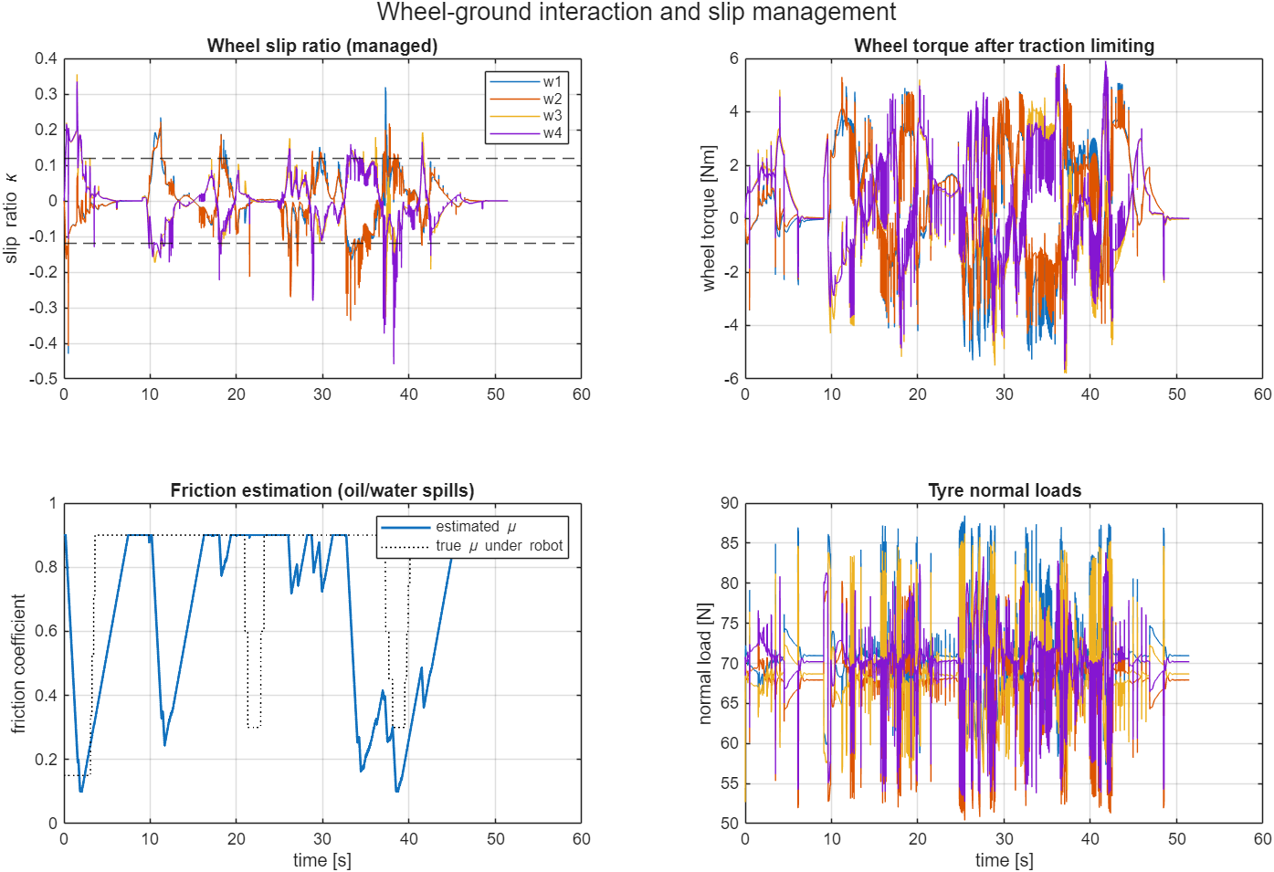
Fig. 6: Wheel slip ratios with the ±0.12 threshold, wheel torques after limiting, friction estimate against the true friction under the robot, and tyre normal loads
The friction estimate falls as low as 0.10 in the low-friction zones and recovers on dry floor, following the true friction with a lag of several seconds (Fig. 6, bottom left). The slip ratio stays mostly within ±0.2 with short spikes during sharp turns, reversing and in the spills. The torque and normal-load traces are noisy because the contact model is stiff and the controller works at 5 ms; this chatter was not tuned away.

8.2 The motor torque limit in the controller
In the first review the torque of every wheel was clipped to a constant. In the second review the clip is the torque that the motor can deliver at the present wheel speed (Eq. 8 of Section 5), and the slip management reduces that envelope further:
tau_env,k = min( 15 , 0.64 * (24 - 0.64 * |w_k|) / 0.6 ) (scout_amr_motor_limit.m, Eq. 8)
s = (|kappa_k| - 0.12) / (0.40 - 0.12)
tau_lim,k = tau_env,k * max(0.1, 1 - s) if s > 0, else tau_env,k
tau_k = clip( tau_ff + K_p e + I , -tau_lim,k , +tau_lim,k )
The acceleration feed-forward τ_ff = m a r / 4 now uses the mass of the URDF, 28.3 kg (it was 30 kg). In the mission the fastest wheel turned at 14.9 rad/s, below the knee of the motor limit at 15.5 rad/s, so the envelope was the constant 15 N·m and only the slip factor reduced the limit. The envelope matters for faster wheels: at the fastest speed that the controller can request (18.8 rad/s) it is 12.8 N·m.

8.3 The floor of the warehouse
Zone | x range [m] | y range [m] | μ | Grip torque per wheel [N·m] | Max. acceleration [m/s²]
Oily loading dock at the start | −1.5 … 2.5 | −1.5 … 1.5 | 0.15 | 0.88 | 1.47
Water spill, aisle 2 | 9.0 … 11.0 | 2.7 … 5.7 | 0.30 | 1.77 | 2.94
Water spill, aisle 3 | 15.5 … 18.0 | 6.9 … 9.9 | 0.30 | 1.77 | 2.94
Dry concrete (everywhere else) | – | – | 0.90 | 5.31 | 8.8

The robot starts on the oily dock, where the grip torque is 0.88 N·m, so the acceleration limit of the slip management (0.85 μ̂ g) is what lets it leave the dock without spinning; the two water spills are crossed in aisles 2 and 3. The friction coefficient is read for the contact point of each wheel in scout_amr_tires.m.

9. Software Changes
The structure of the simulation did not change: the Simulink model scout_amr_sim.slx calls the controller and the tyre model as MATLAB Function blocks every 5 ms (Fig. 7). The second review changed the parameter file and the controller, and added the drive calculation, the post-processing and the tests (Table 10). The Simulink model itself was not edited: the torque limit lives in the controller file that the block calls.
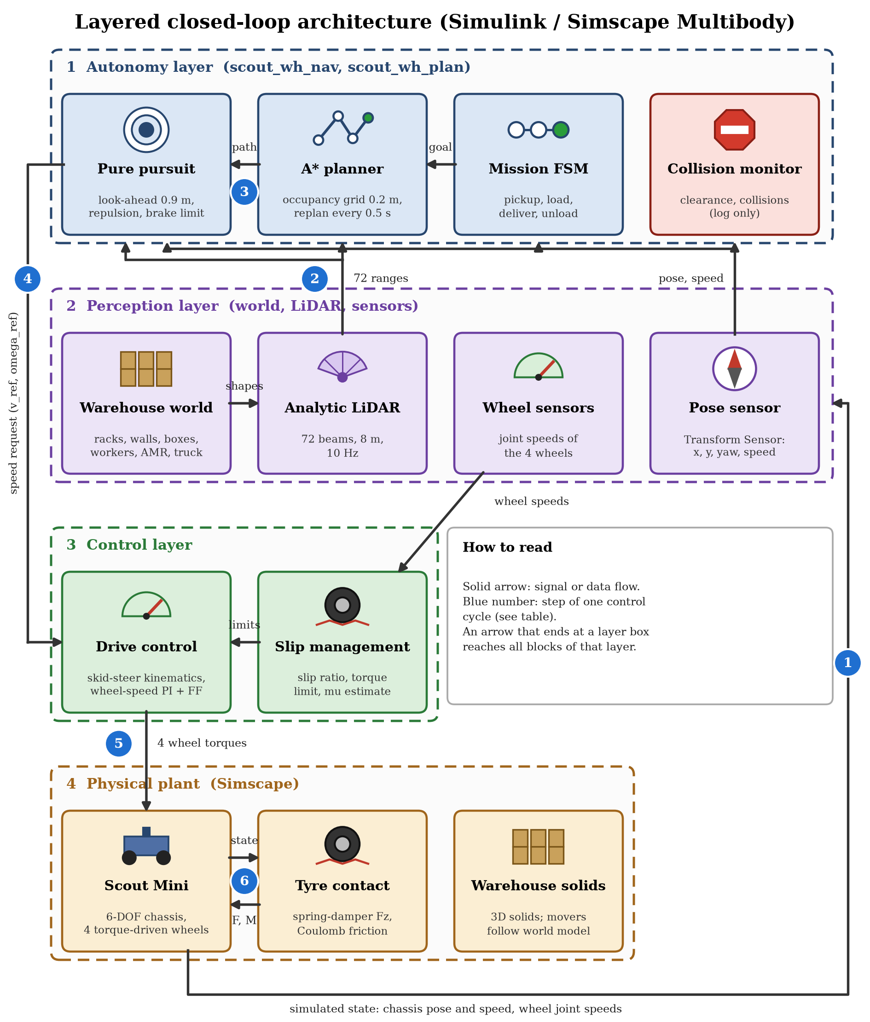
Fig. 7: Closed-loop architecture of the Simulink / Simscape Multibody simulation; the numbered arrows are the steps of one 5 ms control cycle (Table 9)
No. | Step | What happens
1 | Robot to sensors | The Transform Sensors and the wheel joints give the chassis pose and speed and the four wheel speeds (every 5 ms)
2 | Sensors to LiDAR | The pose, together with the obstacle geometry of the world model, goes to the analytic LiDAR, which scans it (72 ranges, 10 Hz)
3 | LiDAR to navigation | The ranges and the pose go to the navigation: the occupancy grid is updated, the mission state machine sets the goal, A* plans the path (every 0.5 s or when blocked) and pure pursuit follows it with LiDAR repulsion and the stop-before-contact limit
4 | Navigation to drive control | The speed and yaw-rate request (v_ref, omega_ref) goes to the drive control, which converts it into wheel-speed targets with the skid-steer kinematics; the wheel-speed PI and the acceleration feed-forward give the torques
5 | Drive control to slip management | The slip management compares the wheel speeds with the ground speed, limits the targets and the torque when a wheel slips, and lowers the acceleration limit on a slippery floor
6 | Slip management to robot | The four limited wheel torques (at most 15 N·m) drive the wheel joints of the Scout Mini; the tyre-ground model returns the forces F and M, the chassis moves and the new state is sampled in the next 5 ms step (back to step 1)

File | Status | Role
scout_amr_params.m | changed | Adds the motor, battery and load data of Table 4 (kt, Rm, Ipk, trated, tmax, Vbus, Rint, Ah, bJoint, Crr, muT, P0) and the mass 28.3 kg
scout_amr_motor_limit.m | new | Eq. 8: the largest wheel torque at a wheel speed; called by the controller and by the unit tests
scout_amr_controller.m | changed | Torque envelope τ_env(ω) in place of the constant; slip factor acts on it; feed-forward with 28.3 kg
scout_amr_drive_sizing.m | new | Hand calculation of the driving cases and the grip limits (Tables 6 and 7), prints the tables
scout_amr_drive_post.m | new | Motor current, power, battery current, terminal voltage and charge from the logged torques and wheel speeds (Eqs. 6, 7, 9)
run_scout_warehouse_simulation.m | changed | Draws the motor and battery figure (Fig. 8) and the design-case figure (Fig. 5)
report/report_numbers.m | changed | Writes the numbers of the report (drive, hand-against-simulation check, events) into numbers.json
test_scout_amr_drive.m | new | Six unit tests of the drive model (Section 12)

The log vector of the controller (44 values) did not change, because the motor current and the battery are calculated from the logged torques (columns 21 to 24) and wheel speeds (columns 13 to 16) after the run.

10. Test Method
Mission. The warehouse mission was simulated twice with the same world, with slip management on (tc_on = 1) and off (tc_on = 0), headless, with run_scout_warehouse_simulation(false, true). The run stops when the mission state machine reaches the state done. A repeated run was compared sample by sample with the first one.
Hand calculation. The eight driving cases of Table 6 were calculated with scout_amr_drive_sizing.m from the equations of Section 5 and the data of Table 4.
Comparison with the simulation. Two situations in which the robot drives straight on dry concrete were selected from the log: steady cruise (|a| < 0.05 m/s², |ω| < 0.05 rad/s, v > 1 m/s) and acceleration (a > 1.5 m/s²). The hand torque was calculated at the mean speed and acceleration of the selected samples and compared with the mean of the four logged wheel torques.
Motor and battery quantities. The motor current, power, battery current, terminal voltage and charge were calculated with scout_amr_drive_post.m from the logged torques and wheel speeds of the whole mission.
Unit tests. Six function-based tests of the drive model (matlab.unittest) check the torque limit, the hand calculation and the battery model without running the simulation.

11. Results

11.1 Motor model: calculated against simulated
Situation | Samples | Speed / acceleration | Hand with c_rr [N·m] | Hand without c_rr [N·m] | Simulation [N·m]
Steady cruise | 267 | 1.08 m/s (12.7 rad/s) | 1.44 | 1.27 | 1.27
Acceleration | 46 | 2.35 m/s² (8.6 rad/s) | 2.59 | 2.41 | 2.49

At cruise the simulation needs 1.27 N·m against 1.27 N·m calculated without rolling resistance, and in acceleration 2.49 N·m against 2.41 N·m: the two agree within a few per cent. The hand value without rolling resistance is the one that the simulation should reproduce, because the contact model has friction only and no rolling resistance (assumption M7); with c_rr = 0.03 the hand value is higher by 0.18 N·m, which is what a real floor would add. The first draft of the calculation did not contain the joint damping and gave 0.18 N·m at cruise against 1.27 N·m in the simulation; the damping of 0.1 N·m·s/rad of the URDF, which the Simscape import keeps, explains the difference (Section 13, problem 3). The largest torque of the run (5.90 N·m) is larger than the quasi-static start of Table 6 (3.24 N·m) because the quasi-static cases do not contain the proportional and integral terms of the speed controller, the changing normal load of the wheels, simultaneous turning on the wet floor or the chatter of the stiff contact; it is a short peak and not a design value.
Quantity | Slip management on | Slip management off | Reference value
Peak wheel torque | 5.90 N·m | 6.06 N·m | peak 15.0 N·m; rated 5.0 N·m
RMS wheel torque | 1.98 N·m | 1.94 N·m | rated 5.0 N·m (thermal limit)
Share of samples above the rated torque | 0.5 % | – | –
Peak motor current | 9.2 A | 9.5 A | peak 23.4 A; rated 7.8 A
RMS motor current | 3.09 A | 3.04 A | rated 7.8 A
Peak battery power (4 motors + 12 W) | 254 W | 252 W | 4 × 150 W = 600 W rated
Mean battery power | 74 W | 77 W | –
Copper loss in the windings | 0.33 Wh | 0.28 Wh | –
Energy taken from the battery | 1.06 Wh (0.29 % of 360 Wh) | 0.98 Wh | 360 Wh (24 V × 15 Ah)
Lowest battery terminal voltage | 24.36 V | 24.37 V | 21.0 V empty
Charge at the end of the mission | 99.72 % | 99.74 % | 100 % at the start

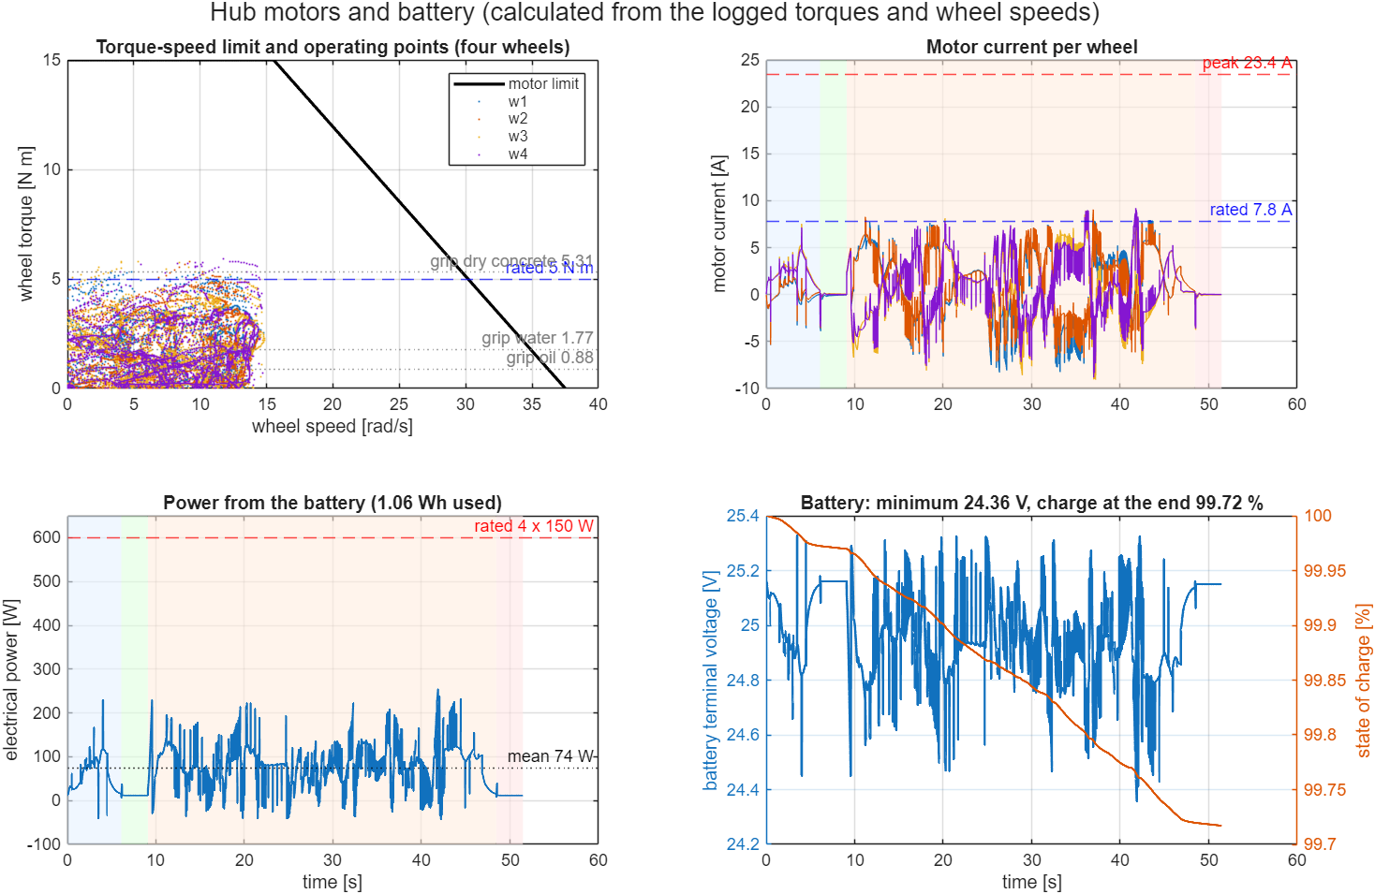
Fig. 8: Motor limit with the operating points of the mission run, motor current, battery power and battery voltage / charge
The wheel torque stays inside the motor limit in the whole run (Fig. 8, top left): the largest value is 5.90 N·m, only 0.5 % of the samples are above the rated torque, and the RMS torque of 1.98 N·m is 40 % of the rated torque, so the continuous rating is not exceeded. The peak current of 9.2 A is 39 % of the current limit. The wheel torque is above the grip torque of the dry floor (5.31 N·m at the static load) only for short moments; the normal load of a wheel varies between 50 N and 88 N in the run (static 69 N), and at the largest load the grip torque is 6.8 N·m. The battery supplies 1.06 Wh in the mission (0.29 % of the pack), of which 0.33 Wh is copper loss and about 0.17 Wh is the idle power of 12 W; the terminal voltage stays above 24.36 V.

11.2 The warehouse mission
The mission has five states: drive to the pickup station, load for 3 s, drive to the delivery station, unload for 3 s, done. The robot reached the pickup station at 6.1 s, left it at 9.1 s and stopped at the delivery station at 48.5 s. The run ended at 51.5 s. The simulation was repeated with the same settings and gave the same numbers (the world, the workers and the controller are deterministic, there is no sensor noise).
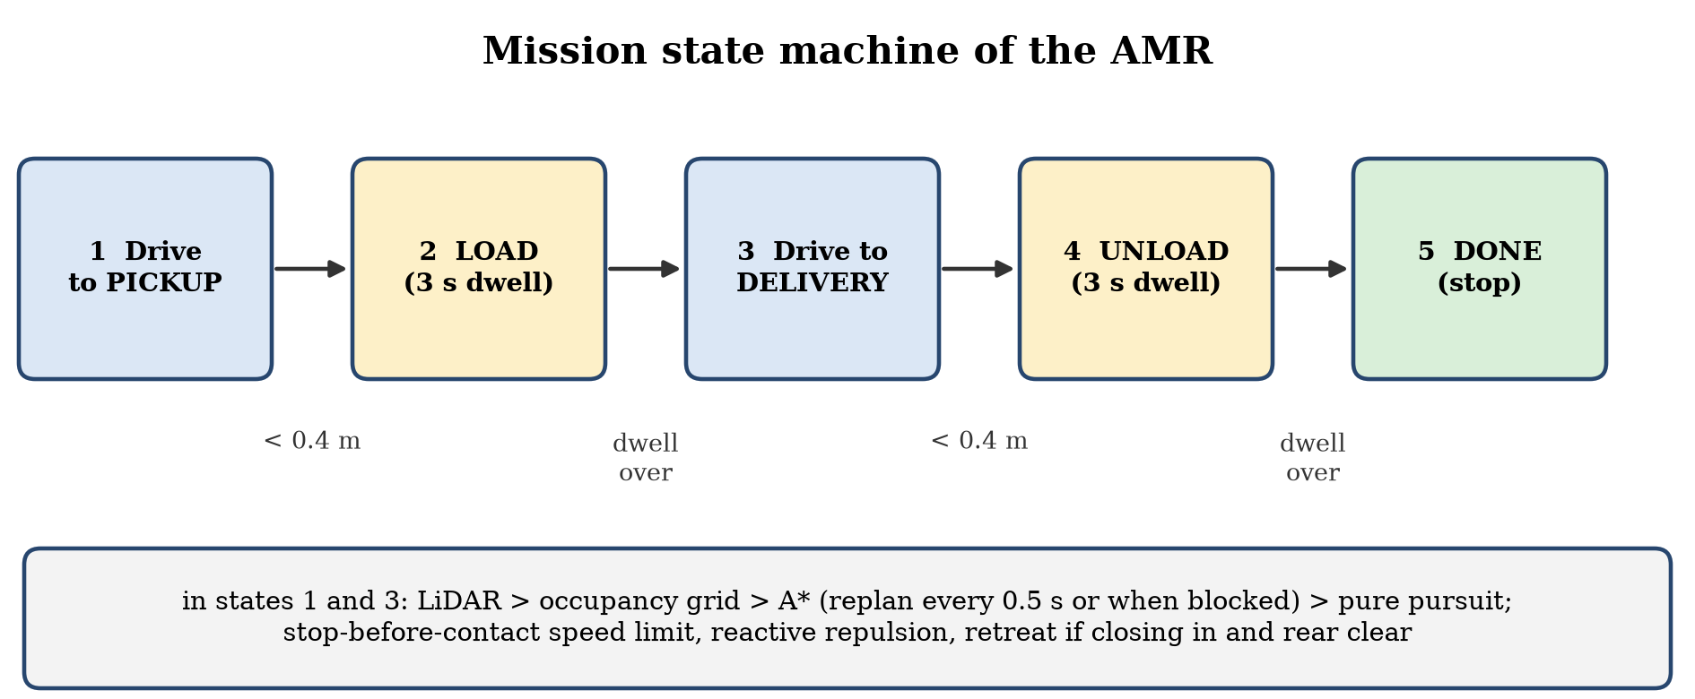
Fig. 9: Mission state machine
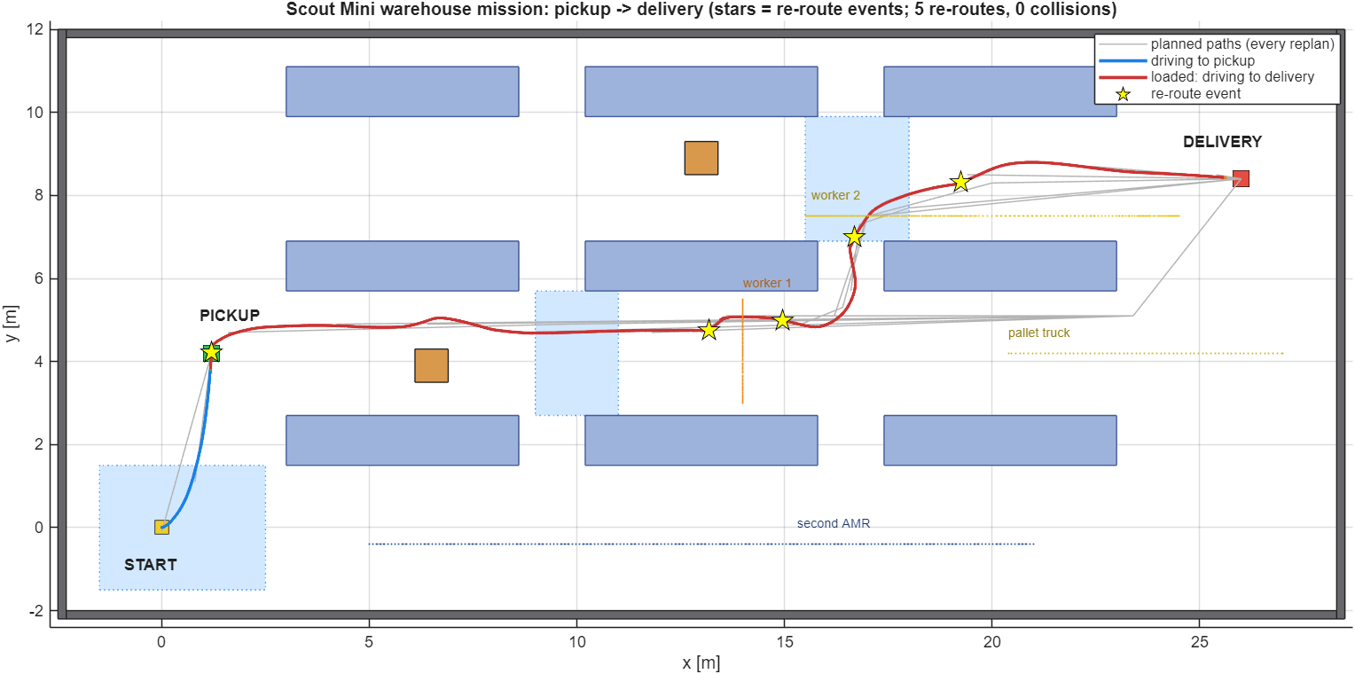
Fig. 10: Warehouse map with the driven trajectory (blue: to pickup, red: to delivery), all planned paths (grey) and the re-route events (stars); dotted lines are the paths of the moving obstacles
The six demonstration scenarios happen in one mission. The table below gives the time of each one in the reference run.
No. | Scenario | Time in the run | What happens
1 | Aisle traversal | 9.1–48.5 s | The robot drives along aisle 2 and then aisle 3 between the racks; the clearance to the nearest obstacle falls to 0.12 m once (worker 1, at 30.8 s)
2 | Navigating around shelves | 36–37 s | The robot leaves aisle 2 through the cross-aisle at x ≈ 16.5 m and continues in aisle 3
3 | Avoiding a floor box | 9.7 s (closest at 17.4 s) | The LiDAR sees the box in aisle 2 about 6 m ahead as soon as the robot leaves the pickup station; the planner adds it to the map and the path bends around it
4 | Avoiding a moving human | 25–32 s | Worker 1 crosses aisle 2; two route corrections happen with the worker about 1 m away, and the closest approach is 0.78 m between the centres at 30.8 s
5 | Pickup to delivery | 9.1–48.5 s | Loaded drive from the pickup station to the delivery station
6 | Alternative path when blocked | 25.2, 32.2, 37.7, 41.7 s | The pallet truck is released when the robot passes x = 12 m (at 24.0 s), drives into aisle 2 and stops at x = 20.4 m at 30.6 s, closing the aisle; the planner then routes the robot through the cross-aisle at x ≈ 16.5 m into aisle 3. The 5 route corrections of the run are at 9.7, 25.2, 32.2, 37.7, 41.7 s: the first is the floor box, the second and third are caused by worker 1 within about 1 m in aisle 2, the fourth is at the entry of aisle 3 and the fifth is caused by worker 2 at 0.91 m. The robot backs away when something closes in

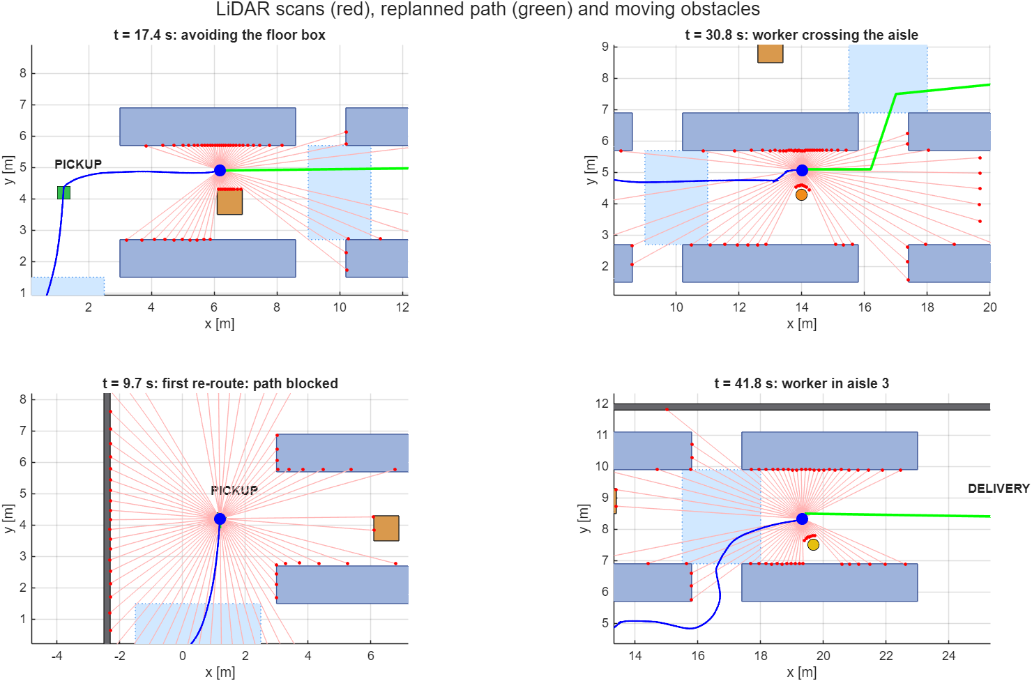
Fig. 11: LiDAR scans (red), re-planned path (green), driven path (blue) and moving obstacles at four moments of the mission
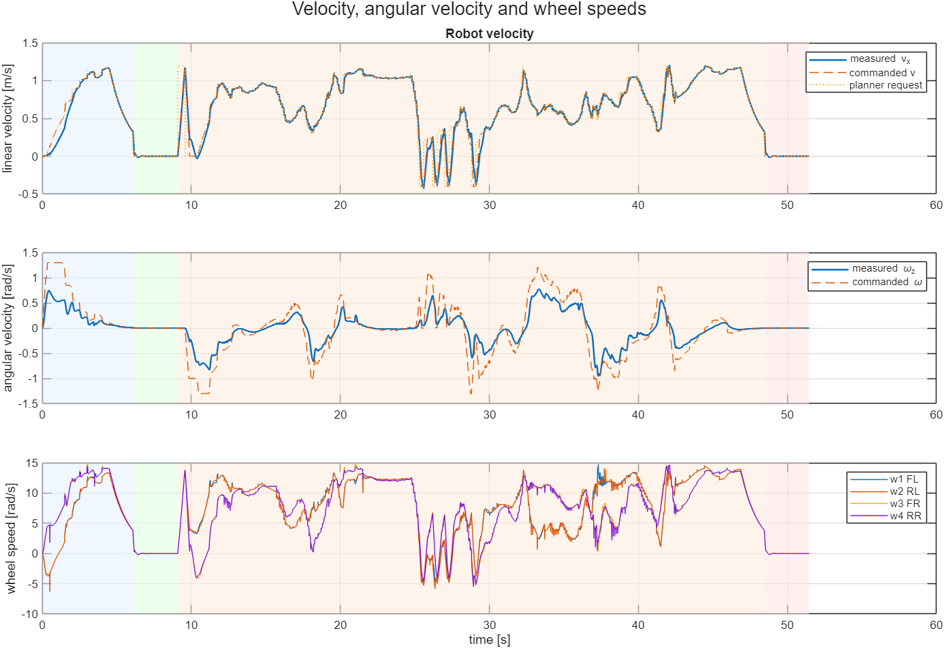
Fig. 12: Linear and angular velocity (commanded and measured) and the four wheel speeds
Quantity | Value
Mission completed | yes
Mission time | 51.5 s
Distance driven | 32.5 m
Mean / top speed | 0.63 m/s / 1.20 m/s
Route corrections (replans around a blockage) | 5
Collisions (collision circle r = 0.36 m overlaps an obstacle) | 0
Minimum clearance to any obstacle | 0.12 m
Closest LiDAR return | 0.48 m
Peak wheel slip ratio / RMS slip ratio | 0.46 / 0.06
Peak yaw rate | 0.95 rad/s
Wheel mechanical work (Σ|τ·ω|) | 2717 J
RMS wheel torque / peak wheel torque | 1.98 N·m / 5.90 N·m
Wall-clock time of the simulation run | about 2 to 3 minutes for the slip-management-on run and 1 to 2 minutes for the off run on the author's computer (R2025b, headless); this depends on the computer and its load

Time [s] | Event
0 | Start on the oily dock (μ = 0.15); the slip management limits the acceleration and the wheel speeds
6.1 | Arrival at the pickup station (distance to goal below 0.40 m); loading starts
9.1 | Loading finished after the 3 s dwell; the robot starts towards the delivery station
9.7 | First route correction: the LiDAR returns from the floor box in aisle 2 (about 6 m ahead) enter the obstacle layer; the path is re-planned and passes 0.54 m from the box
17.4 | Closest approach to the floor box
24.0 | The robot passes x = 12 m; the pallet truck is released and drives towards aisle 2
25.2 | Second route correction: worker 1 is about 1 m away in aisle 2 and blocks the current path
30.6 | The pallet truck stops at x = 20.4 m and closes aisle 2
30.8 | Smallest clearance of the run, 0.12 m, to worker 1 (centres 0.78 m apart)
32.2 | Third route correction: the path is blocked again by worker 1 (about 1 m); the truck is 5.5 m away
36.0–37.4 | The robot passes through the cross-aisle (x ≈ 16.5 m) into aisle 3
37.7 | Fourth route correction at the entry of aisle 3
41.7 | Fifth route correction: worker 2 walks in aisle 3 and is 0.91 m away at 41.8 s
48.5 | Arrival at the delivery station; unloading starts
51.5 | Unloading finished; mission state done; the simulation stops

Navigation. The robot covered 32.5 m in 51.5 s, of which 6 s were spent standing during loading and unloading. The 5 route corrections show that the dynamic layer, the 0.5 s planning period and the retreat behaviour work together. The closest approach between the collision circle and any obstacle was 0.12 m and the front sector of the LiDAR never came closer than 0.64 m, above the 0.55 m safety-stop distance; the closest return (0.48 m) came from the side, from worker 1. The clearance is small and smaller than in the first review (0.22 m): the mission is sensitive to small changes of the torque limit and the mass, which changed when and where the paths were blocked. The result is reported as it came out; the controller was not tuned to restore the earlier numbers.

11.3 Slip management on and off
The mission was simulated twice with the same world: with the slip management of Section 8.1 (tc_on = 1) and with a plain wheel-speed controller (tc_on = 0), which has no traction window, no torque limiting and no friction-aware acceleration limit.
Quantity | Slip management ON | Slip management OFF
Mission completed | yes | yes
Mission time [s] | 51.5 | 45.5
Distance driven [m] | 32.5 | 31.5
Peak slip ratio (worst wheel) | 0.46 | 0.63
RMS slip ratio (all wheels) | 0.064 | 0.069
Share of time with worst-wheel |κ| > 0.2 | 2.0 % | 5.3 %
Wheel mechanical work [J] | 2717 | 2627
Collisions | 0 | 0
Minimum clearance [m] | 0.12 | 0.19

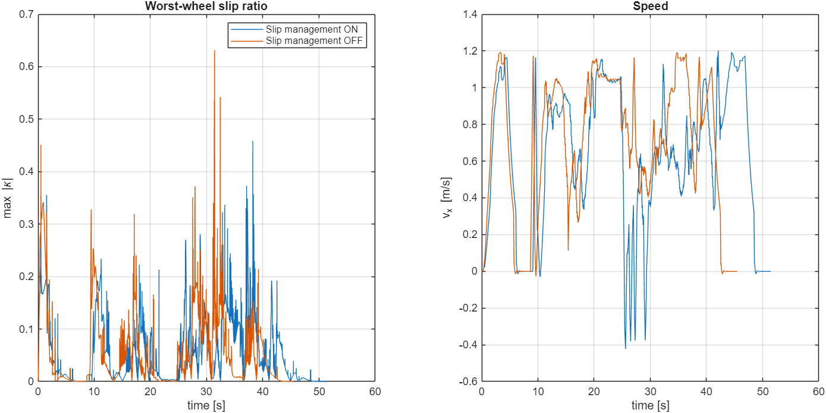
Fig. 13: Worst-wheel slip ratio and forward speed with slip management on (blue) and off (orange)
With slip management the peak slip ratio is lower (0.46 against 0.63) and the worst wheel spends less time above a slip ratio of 0.2 (2.0 % against 5.3 % of the time). The price is time: the friction-aware acceleration limit and the torque limiting make the robot slower, so the mission takes 51.5 s instead of 45.5 s. The energy and the RMS slip ratio are almost the same. In this layout the plain controller also finished the mission without a collision, so the benefit of the slip management is smoother, more controlled wheel-ground behaviour, not the difference between success and failure. A single run per case on one layout does not allow a stronger statement.
Without slip management the controller still has the motor torque-speed limit of Eq. 8, because that is the motor and not the traction control; the comparison therefore shows the effect of the traction window, the slip-dependent torque limiting and the friction-aware acceleration limit only.

11.4 Verification checklist
No. | Check | Expected | Observed | Result
1 | URDF imports without error | base_link, four wheel bodies, four revolute wheel joints and the sensor mounts | Imported (first review) | Pass
2 | Chassis rests on the floor without sinking or floating | Height constant after the first second | Settles about 0.5 mm below its starting height (range 1.2 mm afterwards); tilt within 0.6° | Pass
3 | Repeatability | Same inputs give the same numbers | A repeated run gave identical logs (difference 0) | Pass
4 | Mission completes | State done reached before 120 s | Done at 51.5 s | Pass
5 | No collision | Collision circle (r = 0.36 m) never overlaps an obstacle | 0 collisions; minimum clearance 0.12 m | Pass
6 | Speed limit respected | v ≤ 1.2 m/s | Top speed 1.20 m/s | Pass
7 | Torque within the motor limit | |τ| ≤ 15 N·m (Eq. 8) | Peak wheel torque 5.90 N·m; 0.5 % of the samples above the rated 5 N·m | Pass
8 | Motor current within the limit | I ≤ 23.4 A; RMS below 7.8 A | Peak 9.2 A, RMS 3.09 A | Pass
9 | Battery within its limits | Terminal voltage above 21 V | Lowest 24.36 V; charge at the end 99.72 % | Pass
10 | Hand calculation agrees with the simulation | Same torque at the same speed and acceleration (Table 11) | Cruise 1.27 against 1.27 N·m, acceleration 2.49 against 2.41 N·m | Pass
11 | Slip is limited by the management | Peak slip lower than without management | 0.46 against 0.63 | Pass
12 | Friction estimate follows the floor | Falls on the oil and water, recovers on dry concrete | Minimum 0.10; maximum 0.90 | Pass
13 | Re-planning around blockages | Route corrections when the planned path is blocked | 5 corrections at 9.7, 25.2, 32.2, 37.7, 41.7 s | Pass
14 | Comparison with the real robot | Model agrees with measurements | Not done (no hardware test) | Not checked

12. Unit Tests
The drive model has six unit tests (matlab.unittest, no simulation needed): runtests('test_scout_amr_drive'). All six pass. They check that the torque limit, the hand calculation and the battery model give the values used in this report.
Test | What it checks | Expected
testStallTorqueMatchesCurrentLimit | Torque limit at standstill = K_t I_peak | 15.0 N·m
testNoLoadSpeedIsVoltageLimited | Available torque at V / K_e = 37.5 rad/s, and above it | 0 N·m
testTorqueFallsAboveTheKnee | Flat below the knee at 15.5 rad/s, strictly falling above it, same in both directions | monotone decrease
testCruiseAndStartTorqueMatchTable | Cruise 1.2 m/s (ground part 0.18, total 1.59 N·m); start 2.5 m/s² (3.24 N·m); I = τ / K_t | within 0.01 N·m
testGripLimitsAreBelowMotorTorque | τ_grip = 5.31 / 1.77 / 0.88 N·m; the start demands more than the grip on oil, less on dry concrete | grip below 15 N·m
testBatterySagAndChargeBalance | P_el from Eq. 7; V_t = OCV − R_int I_b; I_b V_t = P; charge falls; energy = P t | relative error below 1e-6

13. Problems Solved
The problems of the first review (model import, contact stiffness, controller stability) are in that report. The table lists the problems met while adding the drive model.
# | Problem | Root cause | Fix
1 | The torque limit of 17.5 N·m had no source | A constant chosen without motor data | Replaced by the torque-speed limit of Eq. 8 with 15 N·m peak (3 × the rated 5 N·m)
2 | After adding the motor data the model stopped compiling: “unable to determine sizes and/or types of the outputs” in a tyre block | Code generation does not allow new fields in a struct after the struct has been read (P.Irated = P.trated / P.kt) | Derived values are computed from local variables before the struct fields are set; found by compiling the tyre function with codegen
3 | Hand cruise torque 0.18 N·m against 1.27 N·m in the simulation | The Simscape wheel joints keep the damping of 0.1 N·m·s/rad of the URDF; the first draft assumed no joint friction (M6) | b ω added to Eq. 5 (1.41 N·m at 14.1 rad/s); assumption M6 corrected; agreement within a few per cent
4 | The run without slip management was reported as not completed | The Stop Simulation block ends the run before the last log sample shows the done flag | report_numbers.m treats a stop before the final time as completed
5 | The acceleration feed-forward used 30 kg | A rounded value from the first review | Set to the 28.3 kg of the URDF
6 | Same mission, different result: 5 route corrections and 0.12 m clearance instead of 3 and 0.22 m | The re-planning is sensitive to small changes of the torque limit and the mass; a test with 30 kg and the new limit also gave a different result (4 corrections) | Reported as it is; both reviews' numbers are given in Table 2
7 | Unit tests could not call the torque limit | The formula was written inline in the controller | Moved to scout_amr_motor_limit.m; the simulation gave identical logs afterwards

14. Algorithms Used
Algorithm | Where | Purpose
Motor torque-speed limit (Eq. 8) | scout_amr_motor_limit.m | Largest torque of a hub motor at a wheel speed: current limit, then back-EMF limit
Driving-case calculation (Eqs. 1–7) | scout_amr_drive_sizing.m | Force, torque, current and power of cruise, start, brake, ramp and pivot
Traction (grip) comparison (Eqs. 14–15) | scout_amr_drive_sizing.m | Flags force demand above μ m g
Battery model (Eqs. 7, 9) | scout_amr_drive_post.m | Battery current, terminal voltage and charge for the logged power
Slip ratio, traction window, torque limiting, friction estimate | scout_amr_controller.m | Slip management (first review); torque limit now τ_env · max(0.1, 1 − s)
LiDAR ray cast, occupancy grid, A*, pure pursuit, mission state machine | scout_wh_*.m | Unchanged from the first review

Algorithm 1. Drive calculation for the logged run (scout_amr_drive_post.m).
for each log sample (t, w_k, tau_k, k = 1..4):
I_k <- tau_k / K_t # Eq. 6
P_k <- tau_k w_k + R I_k^2 # Eq. 7, per motor; negative while braking
P_bat <- sum(P_k) + P_0
OCV <- V_empty + (V_full - V_empty) soc
I_bat <- (OCV - sqrt(OCV^2 - 4 R_int P_bat)) / (2 R_int) # Eq. 9
V_t <- OCV - R_int I_bat
soc <- soc - I_bat dt / (15 Ah)
energy <- integral of max(P_bat, 0) dt / 3600 # Wh, no credit for regeneration
Algorithm 2. Wheel torque in the controller (scout_amr_controller.m, every 5 ms).
tau_env_k <- min(tau_peak, K_t (V - K_e |w_k|) / R) # Eq. 8
kappa_k <- (r w_k - v_k) / max(|r w_k|, |v_k|, 0.8) # slip ratio
if slip management on: s <- (|kappa_k| - 0.12) / (0.40 - 0.12)
tau_lim_k <- tau_env_k max(0.1, 1 - s) if s > 0 else tau_env_k
e_k <- w_target_k - w_k; I_k <- clip(I_k + K_i e_k dt, -tau_lim_k, tau_lim_k)
tau_k <- clip(m a_cmd r / 4 + K_p e_k + I_k, -tau_lim_k, tau_lim_k)

15. How to Run
Software. The product dependency analysis of scout_amr_sim.slx lists MATLAB, Simulink, Simscape and Simscape Multibody. Table 21 lists everything that was used and what it is needed for.
Product | Used for | Needed to run the mission and the drive calculation?
MATLAB | All scripts, the drive calculation, the unit tests (matlab.unittest), the plots and videos (exportgraphics, VideoWriter) | Yes
Simulink | The model scout_amr_sim.slx, the MATLAB Function blocks of the controller and the tyre model, the Stop Simulation block | Yes
Simscape and Simscape Multibody | The multibody plant, smimport of the URDF, the 3D Mechanics Explorer, the wheel joints with their damping | Yes
Stateflow (programming interface only) | build_scout_amr_model.m uses sfroot to write the code of the MATLAB Function blocks; the product analysis of the scripts reports it. Not tested without it | Only to rebuild the model
Robotics System Toolbox | importrobot and show for the URDF figure (live_demo.m, make_report_figures.m) | No
SolidWorks and the SolidWorks-to-URDF exporter | Only to change the CAD model | No
Python 3 (matplotlib, PyMuPDF, python-docx) and Microsoft Edge | Only to build this report (build_review2.py) and its block diagrams | No
Not used | Simscape Electrical and Simscape Driveline (listed as future work), Control System Toolbox, Optimization Toolbox, MATLAB Coder: the motor and battery are calculated in MATLAB code, the controller is a hand-written PI | –

All commands are typed in the MATLAB Command Window in the folder simulink_amr of the project.
cd('D:\academic_shit\SEM5-III\AMR ROS\simulink_amr')
run_scout_warehouse_simulation(false, true) % mission with slip management on and off, all figures in results/ (2 to 5 minutes)
run_scout_warehouse_simulation('replot') % redraw the figures from the saved results
scout_amr_drive_sizing % print the hand calculation: driving cases, grip limits, motor limits
runtests('test_scout_amr_drive') % six unit tests of the drive model
cd report; report_numbers % write the numbers of the report to numbers.json
python build_review2.py % build the second-review report (PDF and DOCX)

15.1 Live graphs while the simulation runs
run_scout_warehouse_simulation draws its figures after the mission has ended. For a demonstration in which the graphs move together with the robot, the script live_graphs.m runs the same mission and updates one figure about every 0.1 s of wall time. It reads the output ports of the Controller block (the 44-value log vector, the mover positions, the LiDAR ranges and the planned path) while the simulation is running, so the model itself is not changed. Besides the map, speed, slip and clearance, the figure shows the motor current, the battery terminal voltage and the electrical power, calculated with the formulas of scout_amr_drive_post.m at every update. Fig. 14 is a screenshot at the end of the mission (t = 51.4 s).
cd('D:\academic_shit\SEM5-III\AMR ROS\simulink_amr')
live_graphs % Multibody Explorer (3D) and the live figure, slip management on
live_graphs(false) % live figure only, without the 3D window
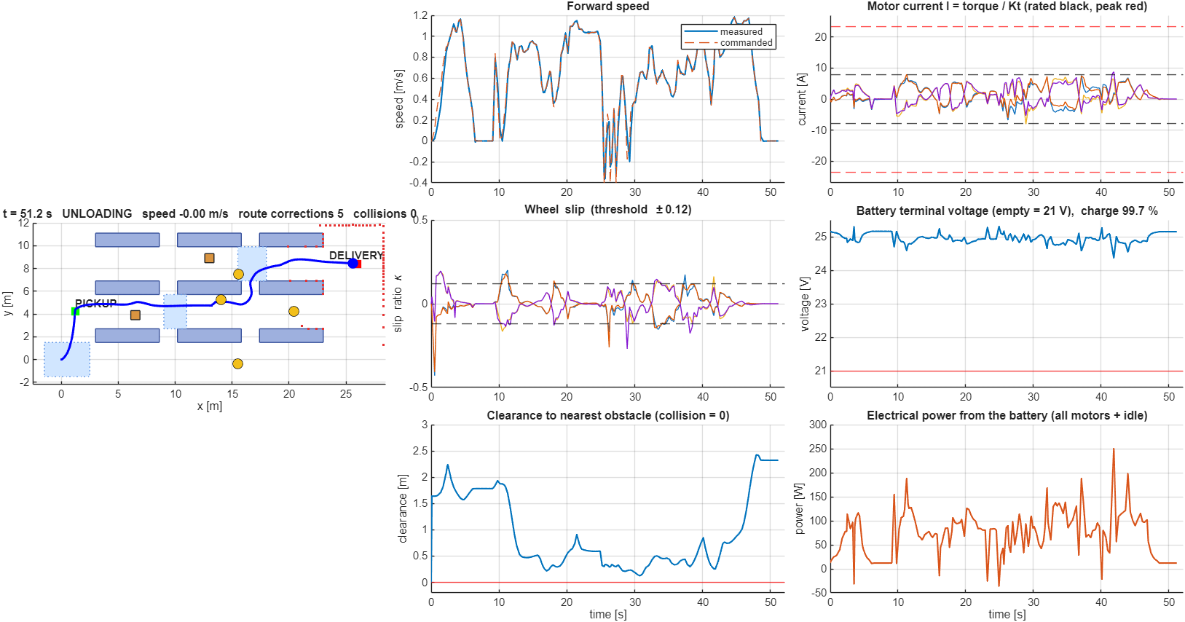
Fig. 14: Live figure of live_graphs.m at the end of the mission (t = 51.4 s): map with the driven path, forward speed, wheel slip ratios and clearance (left and middle); motor current, battery voltage and electrical power (right)
- Map (left): racks, floor boxes, low-friction patches and the two stations; the title shows the time, the mission state, the speed, the number of route corrections and the number of collisions.
- Forward speed: measured against commanded.
- Wheel slip: the slip ratio of the four wheels with the ±0.12 detection lines.
- Clearance: the distance from the robot to the nearest obstacle against the collision line at zero.
- Motor current (right, top): the current of the four motors with the rated 7.8 A (black) and the peak 23.4 A (red) lines. Battery voltage: stays above the 21 V empty line, and the title shows the remaining charge. Power: the electrical power of all motors plus the idle power.
The live figure is a viewing tool: the saved results and all numbers of this report come from run_scout_warehouse_simulation. The motor current, voltage and power are the same quantities as in Fig. 8, which is drawn from the saved log after the run.

16. Limitations and Future Enhancements

16.1 Limitations
- Simulation only; no run on the physical robot and no comparison with measured motor data. The motor constants, the winding resistance, the battery resistance, the rolling resistance and the turning friction are assumptions (Table 4).
- The motors are torque sources limited by the torque-speed envelope; the motor current, the battery and the copper loss are calculated after the run and do not act on the dynamics, and the motor electrical dynamics are not modelled.
- The contact model has friction only and no rolling resistance, so the simulated torque is lower than the hand value with c_rr = 0.03 by 0.18 N·m. The Coulomb friction of the URDF joints (0.1 N·m) is not transferred by the import.
- The quasi-static hand calculation does not contain the speed controller, the load transfer or the chatter of the stiff contact; the peak torque of the run is larger than the design cases.
- The pose is the true pose of the simulator; LiDAR and collision checks are analytic computations; the movers follow scripted trajectories and are not pushed by the robot.
- One layout and one mission per slip setting; the mission result is sensitive to small parameter changes (Table 19, problem 6), so one run does not allow a strong statement.
- The slip ratio is computed from a track half-width of 0.30 m (P.yWheel), while the half wheel base of the model is 0.306 m (B/2); this makes the kinematic wheel speed and the slip ratio of the turning wheels about 2 % too small or too large. This is small compared with the slip threshold of 0.12, but it was not corrected.
- The separate script simulation simulate_industry_amr_warehouse.m still uses its own motor limit of 17.5 N·m and a torque check that divides by μ; it was not changed.

16.2 Future enhancements
- Model the motors and the battery with Simscape Electrical and the drive line with Simscape Driveline, so that current and voltage act on the dynamics.
- Measure the motor constants and the battery resistance of a real Scout Mini and replace the assumptions of Table 4; add rolling resistance and joint friction to the contact and joint models.
- Add noisy LiDAR, IMU and wheel odometry and replace the true pose by an estimator; add physical contact with obstacles.
- Test more layouts, random obstacle placements and several runs per slip configuration, and study how the mission depends on the torque limit and the controller gains.

17. Conclusion
The second review added the drive to the Scout Mini warehouse simulation: four 150 W hub motors with a torque-speed limit of 15 N·m peak, a 24 V, 15 Ah battery, a hand calculation of the force, torque, current and power of the driving cases, and the comparison with the grip limit of the floor. The calculation shows that the motors are never the limit: the largest case needs 26 % of the peak torque, and the mission run used 5.90 N·m at most and 1.06 Wh of the 360 Wh battery. The floor is the limit: on the oily dock the grip torque of 0.88 N·m is less than half of what a 2.5 m/s² start needs, which is why the slip management has to limit the torque. The hand calculation and the simulation agree within a few per cent once the joint damping of the URDF is included, and the six unit tests pass. With the new torque limit and the mass of the URDF the mission was delivered in 51.5 s with 5 route corrections and 0 collisions, and the slip management lowered the peak slip ratio from 0.63 to 0.46 at the cost of 6.0 s of mission time.
These results come from simulation with the true pose, analytic sensing, scripted moving obstacles and assumed motor constants on a single invented layout, so they show that the drive model and the calculations are consistent with each other and with the simulation, not that the physical robot would behave the same. The next steps are measured motor data, motor and battery blocks that act on the dynamics, localisation with noisy sensors and hardware tests.

18. References
- The MathWorks, Inc. MATLAB, Simulink, Simscape Multibody and Robotics System Toolbox documentation, release R2025b (functions smimport, importrobot, rigidBodyTree, ode23t).
- Open Robotics. URDF specification (Unified Robot Description Format), ROS documentation.
- AgileX Robotics. SCOUT MINI user manual and product data sheet.
- P. E. Hart, N. J. Nilsson and B. Raphael, “A formal basis for the heuristic determination of minimum cost paths,” IEEE Transactions on Systems Science and Cybernetics, vol. 4, no. 2, pp. 100–107, 1968.
- R. C. Coulter, “Implementation of the pure pursuit path tracking algorithm,” Technical Report CMU-RI-TR-92-01, Carnegie Mellon University Robotics Institute, 1992.
- H. Pacejka, Tyre and Vehicle Dynamics, 3rd ed., Butterworth-Heinemann, 2012 (slip ratio definition and friction models).
- R. Siegwart, I. R. Nourbakhsh and D. Scaramuzza, Introduction to Autonomous Mobile Robots, 2nd ed., MIT Press, 2011.
- S. Thrun, W. Burgard and D. Fox, Probabilistic Robotics, MIT Press, 2005 (occupancy grids, range sensing).
- International Organization for Standardization. ISO 3691-4: Industrial trucks – Safety requirements and verification – Part 4: Driverless industrial trucks and their systems.
- SolidWorks documentation, URDF export of assemblies (Assem2: chassis, chassis_top, W, up).

