Project Explanation and MATLAB File Guide
Design and Simulation of an Industry Standard AMR (AgileX Scout Mini) in a Warehouse
Sailakshmi B T (2024511019) | RA23502 Autonomous Mobile Robot
This document explains the project report in simple words and lists every MATLAB file, what it does and what output it gives. Use it to understand the work and to prepare for questions. The folder is D:\academic_shit\SEM5-III\AMR ROS\simulink_amr unless another path is given.

0. Explain it simply (start here)
The two-minute story for your professor:
- The idea. A warehouse robot has to carry goods from a pickup point to a delivery point without a driver and without hitting anything. Testing that on a real floor is slow and risky, so I built the robot and the warehouse inside the computer and let the robot do the job by itself.
- The robot. It is the AgileX Scout Mini, a small four-wheel robot. I drew it in SolidWorks, exported it as a URDF file (a text file that lists the robot's parts, joints and masses) plus 3D shape files, and loaded it into MATLAB Simulink / Simscape Multibody.
- The physics. Simscape Multibody is a physics engine: the robot has real mass, the four wheels get a motor torque, and the floor pushes back with friction. I wrote the wheel-floor friction model myself, with dry concrete, oil and water patches, so wheels can really slip.
- The warehouse. Racks with goods, walls, a pickup and a delivery station, floor boxes, two workers, a second robot and a pallet truck that blocks an aisle.
- The brain. Four steps repeated all the time: (1) LiDAR looks around, (2) the robot updates its map, (3) A* finds the shortest free path and plans again when something blocks it, (4) pure pursuit steers along the path while a safety rule slows or stops the robot near obstacles.
- The wheels. A slip controller watches each wheel. If a wheel spins faster than the ground moves, it reduces the torque, so the robot keeps its grip.
- The result. The robot finished the job in 49.6 s, drove 32.0 m, changed its route 3 times and had 0 collisions (closest it came to anything: 0.22 m). With slip control the worst slip was 0.48, without it 0.64.
The architecture in plain words (Fig. 21 of the report). Think of four layers that form a loop:
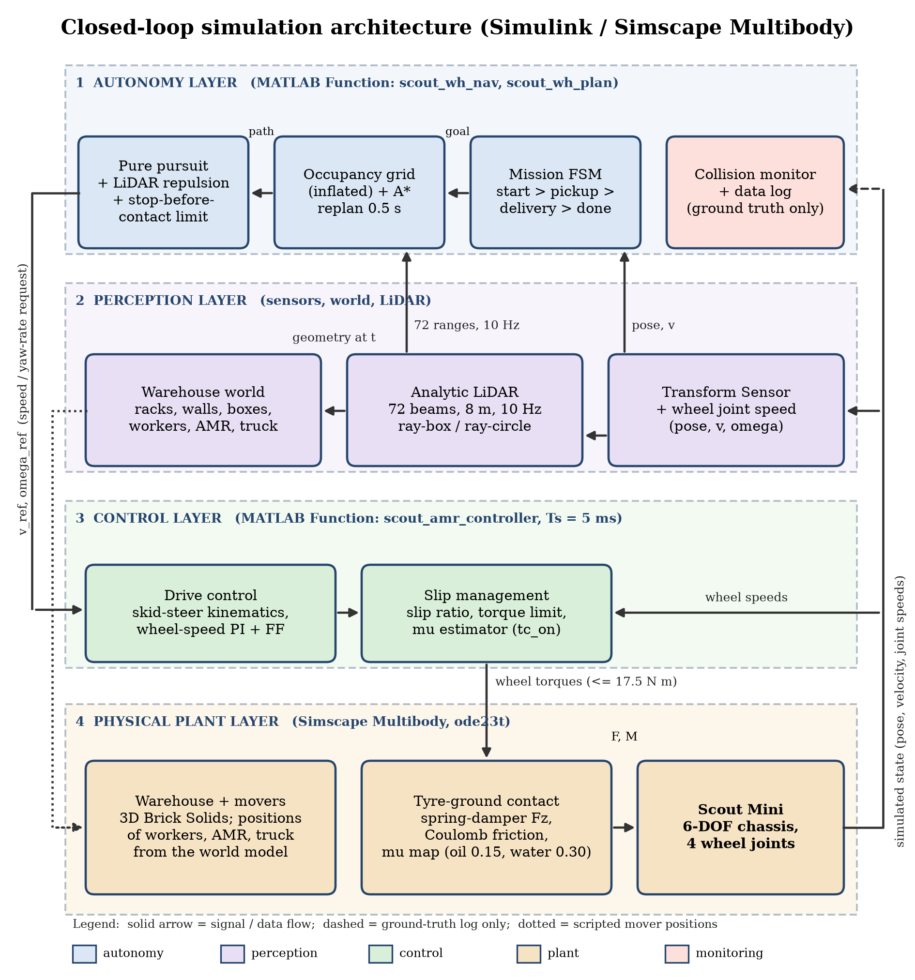
Layer | In plain words | Where it is
4 Physical plant | The 'real world' inside the computer: the robot, its wheels, the floor friction and the warehouse. It obeys physics. | scout_amr_sim.slx (Simscape Multibody), scout_amr_tires.m
2 Perception | The robot's eyes: where am I and how fast am I going, what is around me. The LiDAR sends 72 rays and measures the distance to the first thing each ray hits. | Transform Sensor blocks, scout_wh_world.m, scout_wh_lidar.m
1 Autonomy | The decision maker: mission steps (pickup, load, deliver, unload), the map, the A* route, and the steering with obstacle avoidance. Its output is 'drive at this speed and turn at this rate'. | scout_wh_nav.m, scout_wh_plan.m
3 Control | The muscle: converts 'speed and turn rate' into a target speed for each wheel, then into a motor torque, and limits the torque when a wheel slips. | scout_amr_controller.m

The loop: the plant produces the state, perception reads it, autonomy decides, control sends wheel torques, the tyre model turns them into forces, and the plant moves and produces a new state. This repeats every 5 ms. The collision monitor only watches and records; the robot never uses it to steer.
Words you may need:
Term | Simple meaning
AMR | Autonomous mobile robot: it finds its own way, unlike a robot that follows a line on the floor.
URDF / STL | URDF = text description of the robot's parts and joints; STL = the 3D shape of each part.
Skid steer | Left and right wheels turn at different speeds to steer, like a tank. There is no steering wheel.
LiDAR | A spinning distance sensor: it measures how far the nearest object is in each direction.
Occupancy grid | A map made of small squares (20 cm); each square is free or occupied. Obstacles are enlarged by 0.48 m so the robot keeps a safe distance.
A* | A search method that finds the shortest path through the free squares, guided by the straight-line distance to the goal.
Pure pursuit | The robot always steers towards a point 0.9 m ahead on its path.
Slip ratio | How much faster a wheel turns than the ground moves under it. 0 = perfect grip, large = the wheel is spinning.
Traction control | Reduces the wheel torque when slip is too high, so the wheel grips again.
PI controller | A simple feedback rule: torque = gain x speed error + accumulated error. It makes each wheel reach its target speed.

If asked what is NOT real (say it first): it is simulation only; the pose comes straight from the simulator; the LiDAR and the collision check are computed from the geometry; the workers and the truck follow scripts; nothing was tested on the real robot.

1. The project in one page
What was built. A virtual warehouse robot. The robot is your own SolidWorks model of the AgileX Scout Mini (a four-wheel skid-steer robot). It is placed in a 3D warehouse inside MATLAB Simulink / Simscape Multibody, where real physics (mass, wheel torque, tyre friction) moves it. The robot drives by itself from a start dock to a pickup station, waits to load, drives to a delivery station and waits to unload, while avoiding racks, boxes, a worker, a second robot and a pallet truck.
The chain of work, in order:
- SolidWorks CAD model of the robot (your files Assem2, chassis, chassis_top, W, up).
- Export to URDF + STL meshes: a text description of the robot (links, joints, masses) plus the 3D shapes.
- Import into MATLAB: importrobot (for viewing) and smimport (creates the Simscape Multibody / Simulink model).
- Make it a physical robot: free-moving chassis, torque-driven wheels, a tyre-ground friction model written by us.
- Build the warehouse: racks with goods, walls, stations, floor boxes, oil/water patches, and four moving obstacles.
- Add autonomy: LiDAR, occupancy grid, A* path planning, re-planning, path following and a mission state machine.
- Add slip management: detect wheel slip and limit torque so the wheels do not spin or lock.
- Run, log, plot, report: one script runs everything and draws all graphs.
Why it matters. Testing a warehouse robot in simulation is cheaper and safer than on a real floor. The project shows the full path from a CAD model to a robot that senses, plans, moves and handles slippery floors.

2. The report explained section by section
Section | What it tells | Key point to remember
Abstract | One-paragraph summary of the whole project and its results. | Mission 49.6 s, 3 route corrections, 0 collisions, minimum clearance 0.22 m.
1 Introduction | What an AMR is, why simulate, the objectives and the scope. | Simulation only. Real hardware was not tested.
2 Robot Specifications | Numbers of the model: mass, wheel size, track, torque limit, tyre values. | Values come from your CAD/URDF, not from measuring the real robot.
3 Sensors | Every sensor, its configuration, why it is used and whether it is really simulated. | Only the LiDAR (analytic) and the body-state / wheel-speed sensors are used in Simulink. IMU and camera are mounted in the model but give no signals.
4 SolidWorks Design | Your CAD files and screenshots. | SolidWorks files cannot be opened in MATLAB, so STL meshes carry the shape.
5 Conversion to URDF | What URDF is and the values read from it. | Only change made: package:// mesh paths replaced by meshes/.
6 Importing in MATLAB and Simulink | importrobot and smimport. | smimport is slow (minutes), so the result is cached in scout_import_raw.slx. Imported wheel joints have their Z axis along the axle.
7 Building the Simscape Multibody Model | Steps that turn the import into a dynamic robot, the tyre model equations, the subsystem structure (schematic of Scout_Mini_Robot), the Simulink top-level screenshot and the Mission controller diagram. | 6-DOF chassis, torque-driven wheels, spring-damper normal force + smoothed Coulomb friction (kc 12000 N/m, cc 700 N·s/m).
8 Creating the Warehouse | Layout table, moving obstacles, planning map and the three Multibody Explorer screenshots (3D scene). | Racks and walls are known to the planner; boxes, workers, AMR and truck are found only by LiDAR.
9 Autonomous Navigation | One full mission with the state machine, the result figures (trajectory, LiDAR scenarios, velocities, safety, signals) and the limits. | All six demo scenarios happen in one mission (box, worker, blocked aisle, cross-aisle, pickup to delivery, alternative path).
10 Slip and Traction Management | How slip is detected and limited; ON versus OFF comparison. | Peak slip 0.48 (ON) vs 0.64 (OFF), but ON is about 4.1 s slower. Both finished without collision.
11 Algorithms | Table of every algorithm, file and parameters; A* and dynamic-obstacle handling. | Reactive avoidance: moving obstacles are not predicted.
12 System Architecture | Layered closed-loop diagram (autonomy, perception, control, physical plant), the flow of one 5 ms control step and (12.2) how the MATLAB files call each other. | Four layers in a loop: Plant, Perception, Autonomy, Control (Fig. 21). The pose comes from the simulator (no localisation).
13 Additional MATLAB Visual Simulation | The script simulation simulate_industry_amr_warehouse with ISO 3691-4 style safety fields, one screenshot and telemetry graphs. | Kinematic animation, not a multibody solver.
14 How to Set It Up | Requirements, getting the files from GitHub, the 10-step run table, parameter table, SolidWorks to URDF, troubleshooting, code layout. | Run run_scout_warehouse_simulation.
15 Limitations and Future Enhancements | What is not modelled and what to do next. | Analytic LiDAR and collisions, scripted obstacles, true pose, noisy torque.
16 Conclusion | Summary of what was achieved and its limits. | Shows the software chain works; not proof for the physical robot.

3. MATLAB files and the output each one gives
The files are grouped by purpose. 'Output' means what you get when the file is run or called.

3.1 Robot description (inputs, not code)
File / folder | What it is | Output / use
scout_mini.urdf | URDF of the robot: links, joints, masses, inertias, sensor mounts (copied from the ROS 2 repository; mesh paths changed to meshes/). | Read by importrobot and smimport.
meshes/ (base_link.STL, w1.STL ... w4.STL) | 3D shapes exported from your SolidWorks model. | Drawn in the 3D scene and in the report renders.
../scout_mini_sw/ (Assem2.SLDASM, chassis.SLDPRT, chassis_top.SLDPRT, W.SLDPRT, up.SLDPRT) | Your original SolidWorks files (cloned from GitHub). | Source of the STL meshes. Not read by MATLAB.

3.2 Model and physics
File | What it does | Output
scout_amr_params.m | Holds every constant: robot, wheels, tyre contact, friction patches, warehouse layout, LiDAR, planning grid, controller gains. Also computes the wheel rotation signs from the URDF. | Returns the struct P used by all other files. Edit this file to change the warehouse or the gains.
build_scout_amr_model.m | Imports the URDF with smimport (or reuses scout_import_raw.slx), replaces the weld by a 6-DOF joint, makes wheels torque-driven, adds sensors, tyre forces, the 3D warehouse, the four movers, logging blocks, subsystems and the diagram layout. | Creates scout_amr_sim.slx. Run it only to rebuild the model.
scout_import_raw.slx | Raw result of smimport (cache). | Speeds up rebuilds.
scout_amr_sim.slx | The Simulink / Simscape Multibody simulation. Top level: World, Mechanism Configuration, Solver and four subsystems (Scout_Mini_Robot with the nested Tyre_Ground_Contact_Model, Warehouse, Moving_Obstacles, Mission_and_Slip_Controller). | When run it logs ctrl_log, tire_log, lidar_log, path_log and mover_log to the workspace and shows the 3D Mechanics Explorer.
scout_amr_tires.m | Tyre-ground model for one wheel (called four times): normal spring-damper force, smoothed Coulomb friction, floor friction map. | 11 values per wheel: force (3) and torque (3) in the wheel frame, normal load Fz, longitudinal force, lateral force, slip ratio, friction μ.

3.3 Autonomy and control (called every 5 ms from the model)
File | What it does | Output
scout_amr_controller.m | The brain inside the Controller block: gets robot pose and speed, calls the navigation, converts commands to wheel targets, estimates slip, applies slip management, runs the wheel-speed PI controller. | tau_j: four wheel torques. lg: log vector of 44 signals (pose, speeds, slip ratios, torques, friction estimate, mission state, clearance, collisions...). mv: 8 mover positions. rng: 72 LiDAR ranges. pth: planned path.
scout_wh_nav.m | Perception, planning and mission logic: world update, LiDAR, occupancy grid, A* replanning, pure pursuit, reactive repulsion, stop-before-contact limit, retreat, mission state machine, collision monitor. | Speed and yaw-rate reference, mover positions, LiDAR ranges, path and an info vector (state, number of re-routes, clearance, collisions, goal distance).
scout_wh_world.m | Warehouse geometry and moving obstacles at time t (17 rectangles, 2 circles, mover positions). Workers react to the robot; the truck is released at x > 12 m. | Rectangles, circles and the positions that move the 3D bodies.
scout_wh_lidar.m | Casts 72 rays against the rectangles and circles. | 72 range values in metres (8 m means no return).
scout_wh_plan.m | 8-connected A* on the inflated grid with line-of-sight smoothing. | Path of up to 80 waypoints and their count.

3.4 Running and plotting
File | How to run | Output
run_scout_warehouse_simulation.m | run_scout_warehouse_simulation (3D window)  run_scout_warehouse_simulation(false) (headless)  run_scout_warehouse_simulation(false,true) (slip ON and OFF)  run_scout_warehouse_simulation('replot') (redraw from saved data) | Runs the model, saves results/scout_warehouse_results.mat, draws figures 1 to 5 (6 with the comparison) as PNG in results/ and prints the summary (mission time, distance, speeds, re-routes, collisions, clearance, slip, energy).
results/1_warehouse_trajectory.png | (made by the file above) | Map with driven path, planned paths, re-route events and mover trails.
results/2_velocity_wheel_speeds.png |  | Linear and angular velocity (commanded and measured) and the four wheel speeds.
results/3_perception_safety.png |  | Closest LiDAR range, ground-truth clearance, route corrections, collisions, mission state.
results/4_slip_management.png |  | Slip ratio of each wheel, torques after limiting, friction estimate vs true friction, normal loads.
results/5_lidar_scenarios.png |  | Four snapshots: avoiding the box, worker crossing, aisle blocked re-route, worker in aisle 3.
results/6_slip_on_vs_off.png | (only with compareSlip = true) | Worst-wheel slip ratio and speed with slip management on and off.
results/scout_warehouse_results.mat |  | Saved logs of both runs (R) and the parameters (P).
live_graphs.m | live_graphs or live_graphs(false) | Runs the mission and updates one figure (map, speed, slip, clearance) while the simulation runs.

3.5 Report-making files (folder report/)
File | Output
make_report_figures.m | robot_importrobot.png, robot_render.png (robot meshes with joint axes), the Simulink subsystem pictures (hi-res prints of the Mission controller, used split in two halves as simulink_Mission_2col.png) (in report/figs).
report_numbers.m | numbers.json: every number quoted in the report (ON and OFF run metrics, re-route times).
capture_industry_full.m | industry_01..05, industry_final.png (screenshots) and industry_telemetry.mat: runs simulate_industry_amr_warehouse.m unchanged and grabs its window and telemetry.
make_industry_graphs.m | industry_g1_kinematics.png, industry_g2_safety_sensors.png, industry_g3_path.png redrawn from industry_telemetry.mat.
make_diagrams.py | diag_toolchain.png, diag_urdf_tree.png, diag_robot_subsystem.png, diag_mission_fsm.png, diag_architecture.png, diag_control_step.png (Python, matplotlib; drawn at the printed width so the text stays readable).
content.py + build_report.py | Scout_Mini_Warehouse_AMR_Report.pdf and .docx (Python; content.py holds the text, build_report.py the layout).
build_explainer.py | This document.
build_cheatsheet.py | Live_Demo_Cheat_Sheet_final.docx: the command for every figure, a demo plan and an explanation of every graph.

3.6 Earlier visual MATLAB simulation (folder AMR ROS)
File | What it does | Output
simulate_industry_amr_warehouse.m | Script simulation: 26 x 16 m warehouse with racks, pallets, a ramp to a loading dock, the Scout Mini STL meshes, LiDAR, IMU and odometry drift, ISO 3691-4 style warning / braking / stop fields and automatic re-routing. | An animated 3D figure with an occupancy grid, speed / wheel-speed / slip plots and safety telemetry. Not a multibody simulation.
plan_warehouse_roadmap.m | Waypoint roadmap along aisle centre lines, avoiding hazard boxes. | path: list of waypoints from the current position to the goal.
teleop_industry_amr_warehouse.m | Same scene driven by hand (W/A/S/D, arrows, space). | Interactive 3D figure.

4. How the files work together
The call tree (also in section 12.2 of the report). Read it from the top: each indented file is called by the file above it.
run_scout_warehouse_simulation
scout_amr_params ........ all constants (every file reads this)
build_scout_amr_model ... only if scout_amr_sim.slx is missing
smimport(scout_mini.urdf + meshes) -> scout_import_raw.slx
writes scout_amr_sim.slx (MATLAB Function blocks call the two files below)
sim(scout_amr_sim) .......... every 5 ms:
Controller block -> scout_amr_controller
scout_wh_nav
scout_wh_world ... obstacles and movers at time t
scout_wh_lidar ... 72 ranges, 10 Hz
scout_wh_plan .... A* path, every 0.5 s or when blocked
Tire blocks (one per wheel) -> scout_amr_tires -> forces on the wheel
saves results/scout_warehouse_results.mat and draws Fig. 15 to 20

make_example_style_outputs reads the .mat -> trajectory_map.png, signals.png, MP4
In one sentence: the parameters file feeds everyone, the Simulink model calls the controller and the tyre model, the controller calls the navigation, the navigation calls the world, LiDAR and planner, and the run script ties model, parameters and plots together.
Order of events when you run run_scout_warehouse_simulation:
- The runner loads scout_amr_sim.slx (builds it with build_scout_amr_model.m if missing) and sets tc_on (1 = slip management, 0 = off).
- Simulink runs. Every 5 ms the Controller block calls scout_amr_controller.m. That calls scout_wh_nav.m, which calls scout_wh_world.m (obstacle geometry), scout_wh_lidar.m (ranges) and scout_wh_plan.m (A* path).
- The controller returns four wheel torques. Four Tyre blocks call scout_amr_tires.m to turn wheel states into ground forces. Simscape Multibody applies the torques and forces and moves the chassis, wheels and movers.
- The sensors feed pose, velocity and wheel speeds back to the controller. The logs are stored.
- When the mission state reaches 'done' the simulation stops. The runner converts the logs, saves the .mat file, draws the figures and prints the summary.
- scout_amr_params.m is read by all of them, so changing a number there changes the whole simulation.

5. Results to remember
Quantity | Slip management ON | Slip management OFF
Mission time | 49.6 s | 45.5 s
Reached pickup / left / delivered | 6.1 / 9.1 / 46.6 s | 5.7 / 8.7 / 42.5 s
Distance | 32.0 m | 31.5 m
Top speed | 1.20 m/s | 1.19 m/s
Route corrections | 3 | 3
Collisions | 0 | 0
Minimum clearance | 0.22 m | 0.19 m
Peak slip ratio | 0.48 | 0.64
Time with worst-wheel slip above 0.2 | 2.1 % | 5.4 %
Wheel mechanical work | 2670 J | 2633 J

Route corrections in the ON run happened at t = 25.1, 30.2 and 37.6 s, each time the current path became blocked by an obstacle the LiDAR had just seen (worker 1 about 1 m ahead in aisle 2 for the first two, worker 2 and the pallet truck for the third). The pallet truck closes the end of aisle 2 at about 27 s, which is why the robot goes through the cross-aisle into aisle 3.

6. Every graph explained simply
Each entry gives the picture, what it shows, how to read it and a sentence you can say. Coloured bands in the time graphs are the mission phases: blue = driving to the pickup, green = loading, orange = driving to the delivery, red = unloading. All numbers are from the reference run (slip management on).

Fig. 15 Warehouse map with the driven path
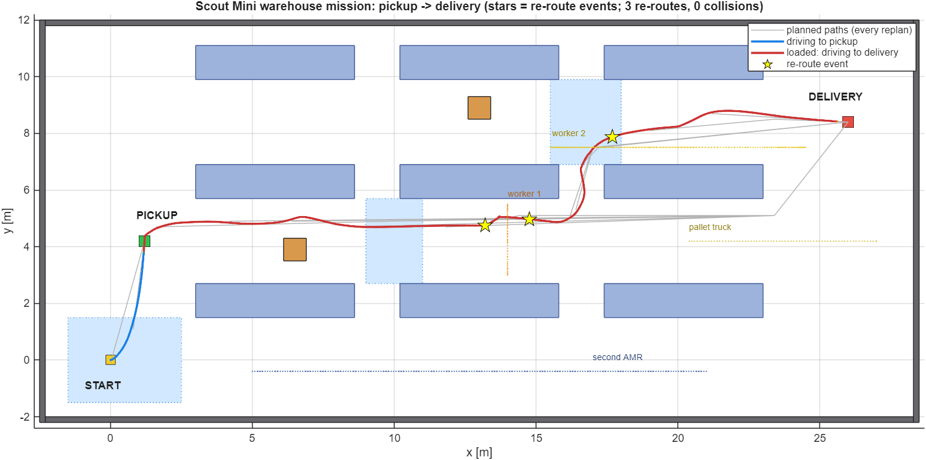
- What it shows: A top view of the whole warehouse. Blue boxes are the racks, light-blue areas are the oil and water patches, brown squares are floor boxes, and the dotted lines are the tracks of the workers, the second robot and the pallet truck.
- How to read it: Blue line = robot driving from START to PICKUP, red line = robot carrying the load from PICKUP to DELIVERY. Grey lines are the older plans that were replaced. Yellow stars are the three moments when the robot changed its route.
- Say this: This is the whole mission on one picture: the robot goes up aisle 2, turns through the cross-aisle at about x = 16.5 m into aisle 3 and reaches the delivery point without touching anything.

Fig. 16 LiDAR snapshots at four moments
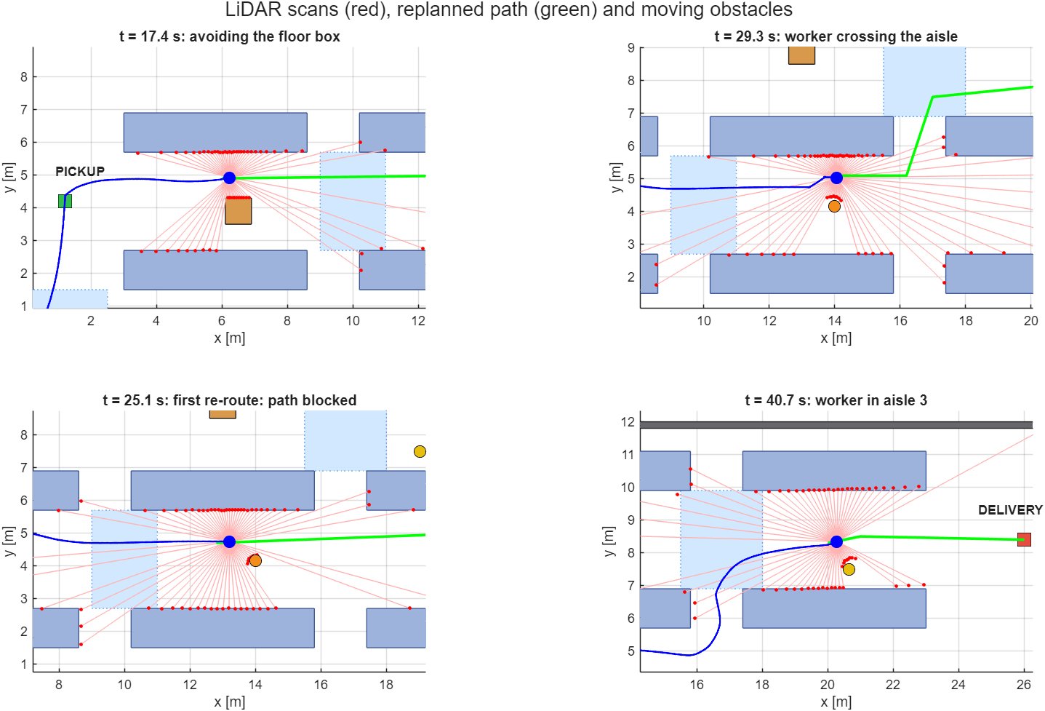
- What it shows: Four zoomed pictures of what the robot sees. Red lines are the LiDAR rays and the red dots are where they hit something. Blue line = path driven so far, green line = the current plan, orange and yellow circles = workers.
- How to read it: Top left (17.4 s): the rays bunch up on the floor box in aisle 2 and the plan bends around it. Top right (29.3 s): worker 1 crosses aisle 2 and the plan now leaves aisle 2 through the cross-aisle. Bottom left (25.1 s): the first route correction, with worker 1 about 1 m ahead. Bottom right (40.7 s): worker 2 in aisle 3 close to the path.
- Say this: The robot does not know about boxes, workers or the truck in advance. It only learns them from the LiDAR and plans again.

Fig. 17 Speeds and wheel speeds
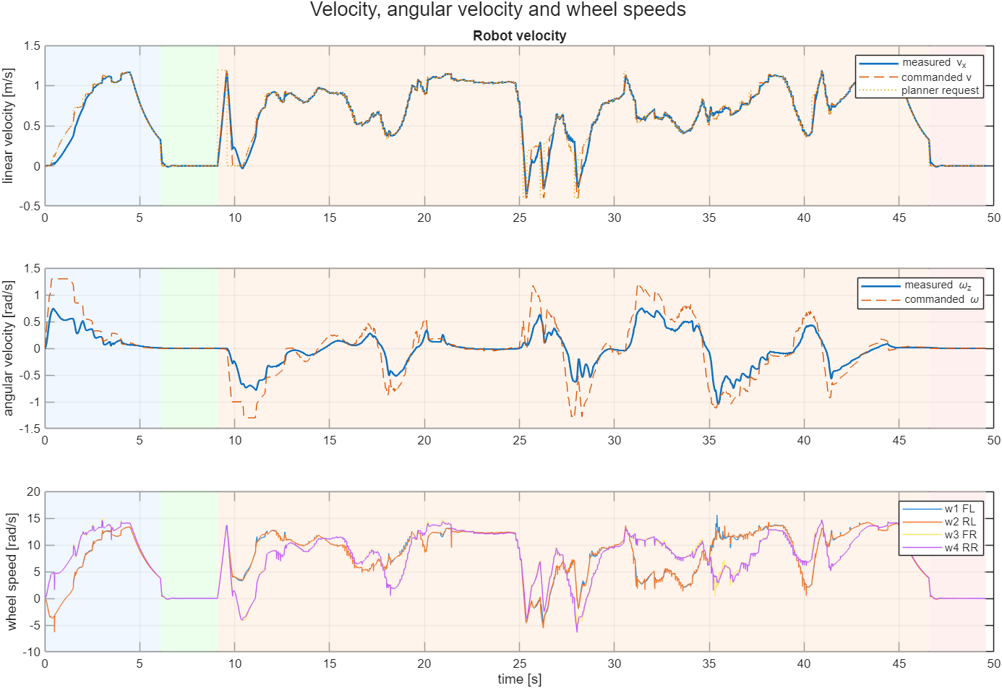
- What it shows: Top: forward speed. Middle: turning speed (yaw rate). Bottom: the speed of the four wheels. Commanded and measured curves are drawn together.
- How to read it: The measured line follows the commanded line closely, so the controller works. Top speed is 1.2 m/s. The dips below zero around 25 to 28 s are the robot backing away from the worker. In the bottom graph the left and right wheels differ whenever the robot turns, because a skid-steer robot steers by running its sides at different speeds.
- Say this: The robot accelerates smoothly, stops for 3 s at the pickup and the delivery, and turns by running its left and right wheels at different speeds.

Fig. 18 Obstacle detection and safety
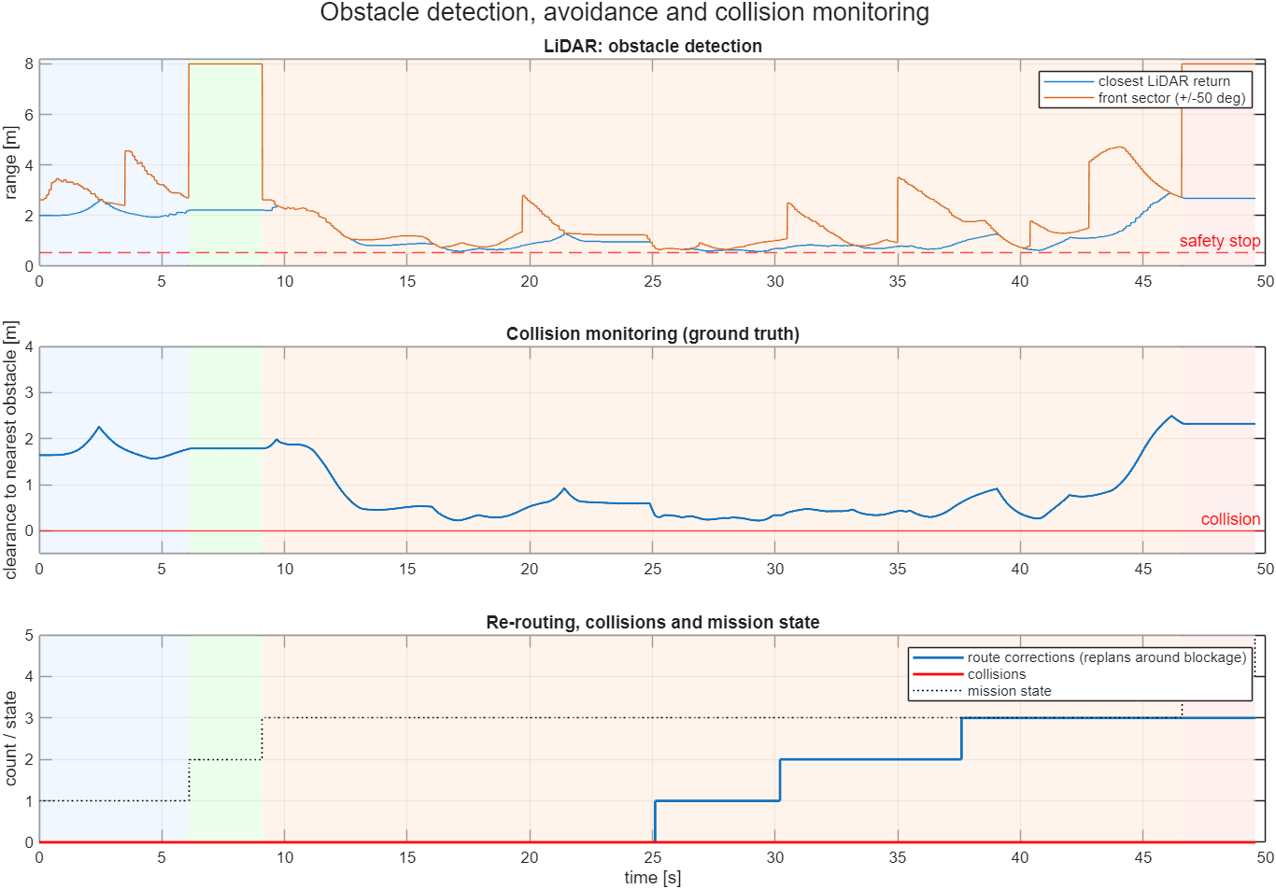
- What it shows: Top: distance to the nearest LiDAR return (blue) and to the nearest return in front (orange), with the 0.55 m safety-stop line. Middle: true clearance between the robot and the nearest obstacle. Bottom: number of route corrections (blue steps), collisions (red) and the mission state (dotted).
- How to read it: The clearance curve never reaches the red line at zero, so no collision happened. Its lowest value is 0.22 m (at about 29 s, passing worker 1). The blue steps at 25.1, 30.2 and 37.6 s are the three route corrections. The dotted line steps from 1 to 5 through the mission states.
- Say this: Zero collisions, closest approach 22 cm. The clearance here is measured from the true geometry; the controller never sees it.

Fig. 19 Wheel slip and traction management
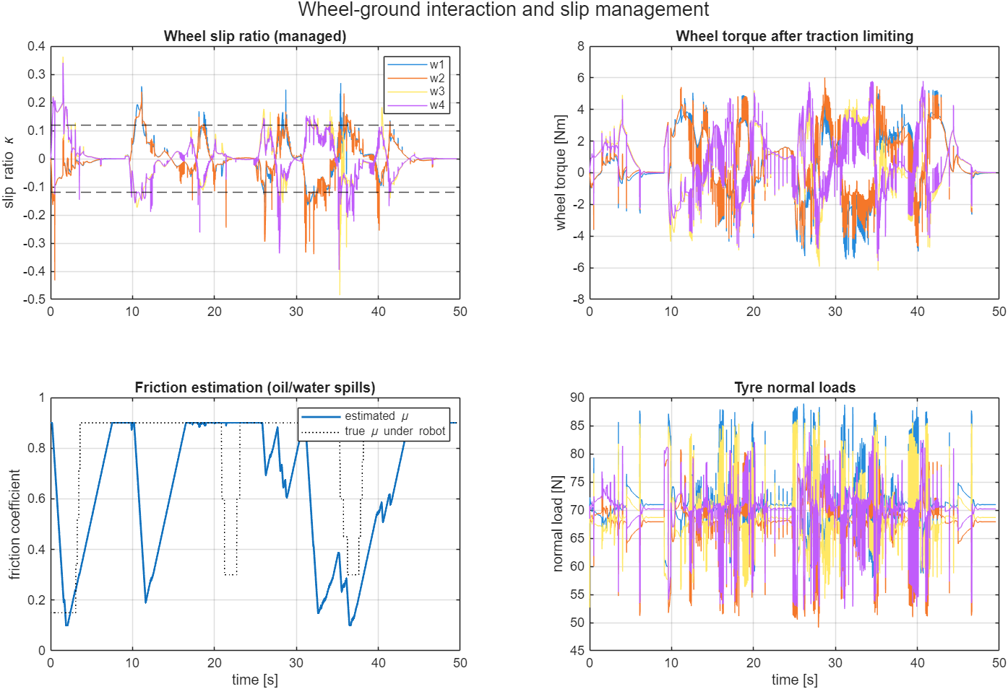
- What it shows: Four panels. Top left: slip ratio of each wheel with the plus and minus 0.12 detection lines. Top right: wheel torques after limiting. Bottom left: the friction the controller estimates (blue) against the true friction under the robot (dotted). Bottom right: the load on each tyre.
- How to read it: Slip stays mostly inside the 0.12 lines and spikes only in sharp turns, reversing and on the spills. In the friction panel the true friction (dotted) drops to 0.15 on the oil at the start and to 0.30 on the water spills near 21 to 23 s and 35 to 38 s. The estimate falls when slip is detected and climbs back at 0.15 per second, so it follows the truth with a delay. Torque stays below about 6 N·m (the limit is 17.5). Tyre load is about 70 N per wheel (30 kg robot, static load about 74 N) and is noisy.
- Say this: The controller notices slip, lowers its friction estimate and gives less torque and acceleration on a slippery floor. The noisy torque and load curves come from the stiff contact model and were not tuned away.

Fig. 20 Slip management on and off
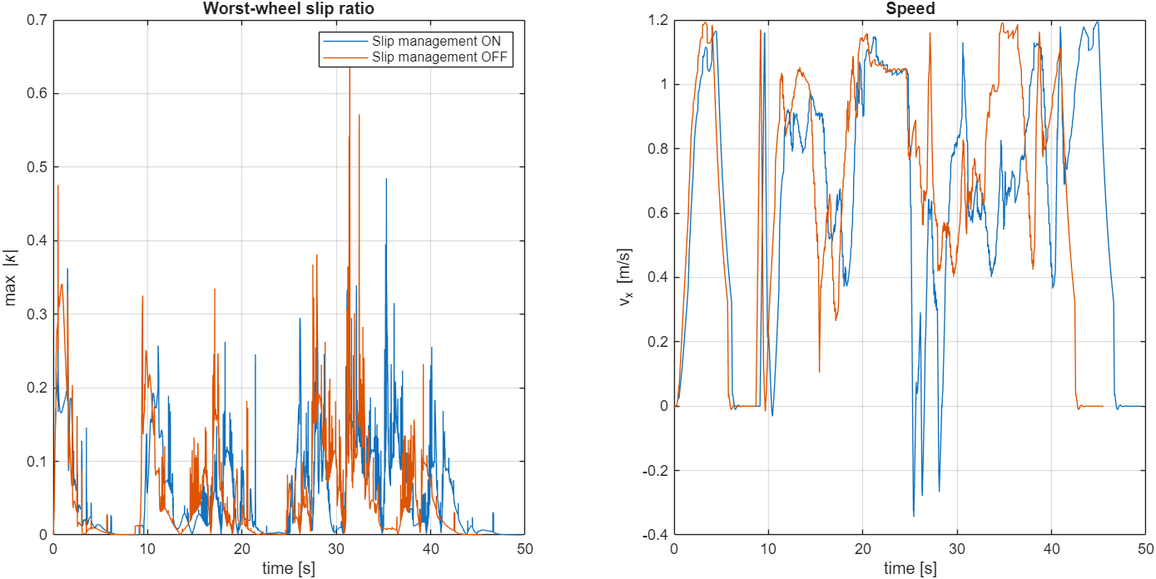
- What it shows: Left: the worst wheel's slip ratio for both runs. Right: forward speed. Blue = slip management on, orange = off. Same world, same mission, only the switch tc_on is different.
- How to read it: Orange (off) has the higher spikes: peak slip 0.64 against 0.48 for blue, and 5.4 % of the time above 0.2 against 2.1 %. Blue is slower: 49.6 s against 45.5 s.
- Say this: Slip management lowers the worst slip and makes the wheels behave better, and it costs about 4 s. Both runs finished without a collision, so it is not the difference between success and failure.

Fig. 14 Mission state machine
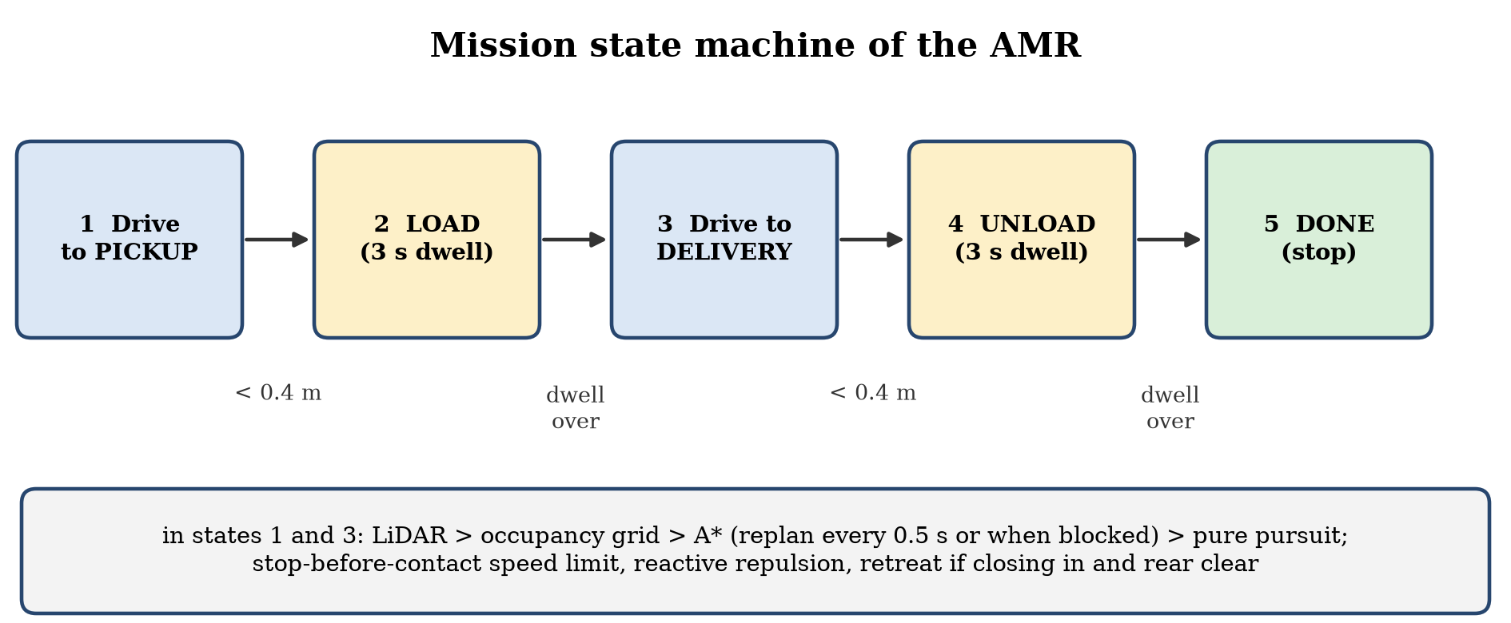
- What it shows: The five steps of the job: drive to pickup, load, drive to delivery, unload, done.
- How to read it: A drive step ends when the robot is within 0.4 m of the goal. A load or unload step ends after 3 s.
- Say this: The mission logic is a simple state machine. Inside the drive steps the robot senses, plans and steers.

Fig. 22 One control step (every 5 ms)
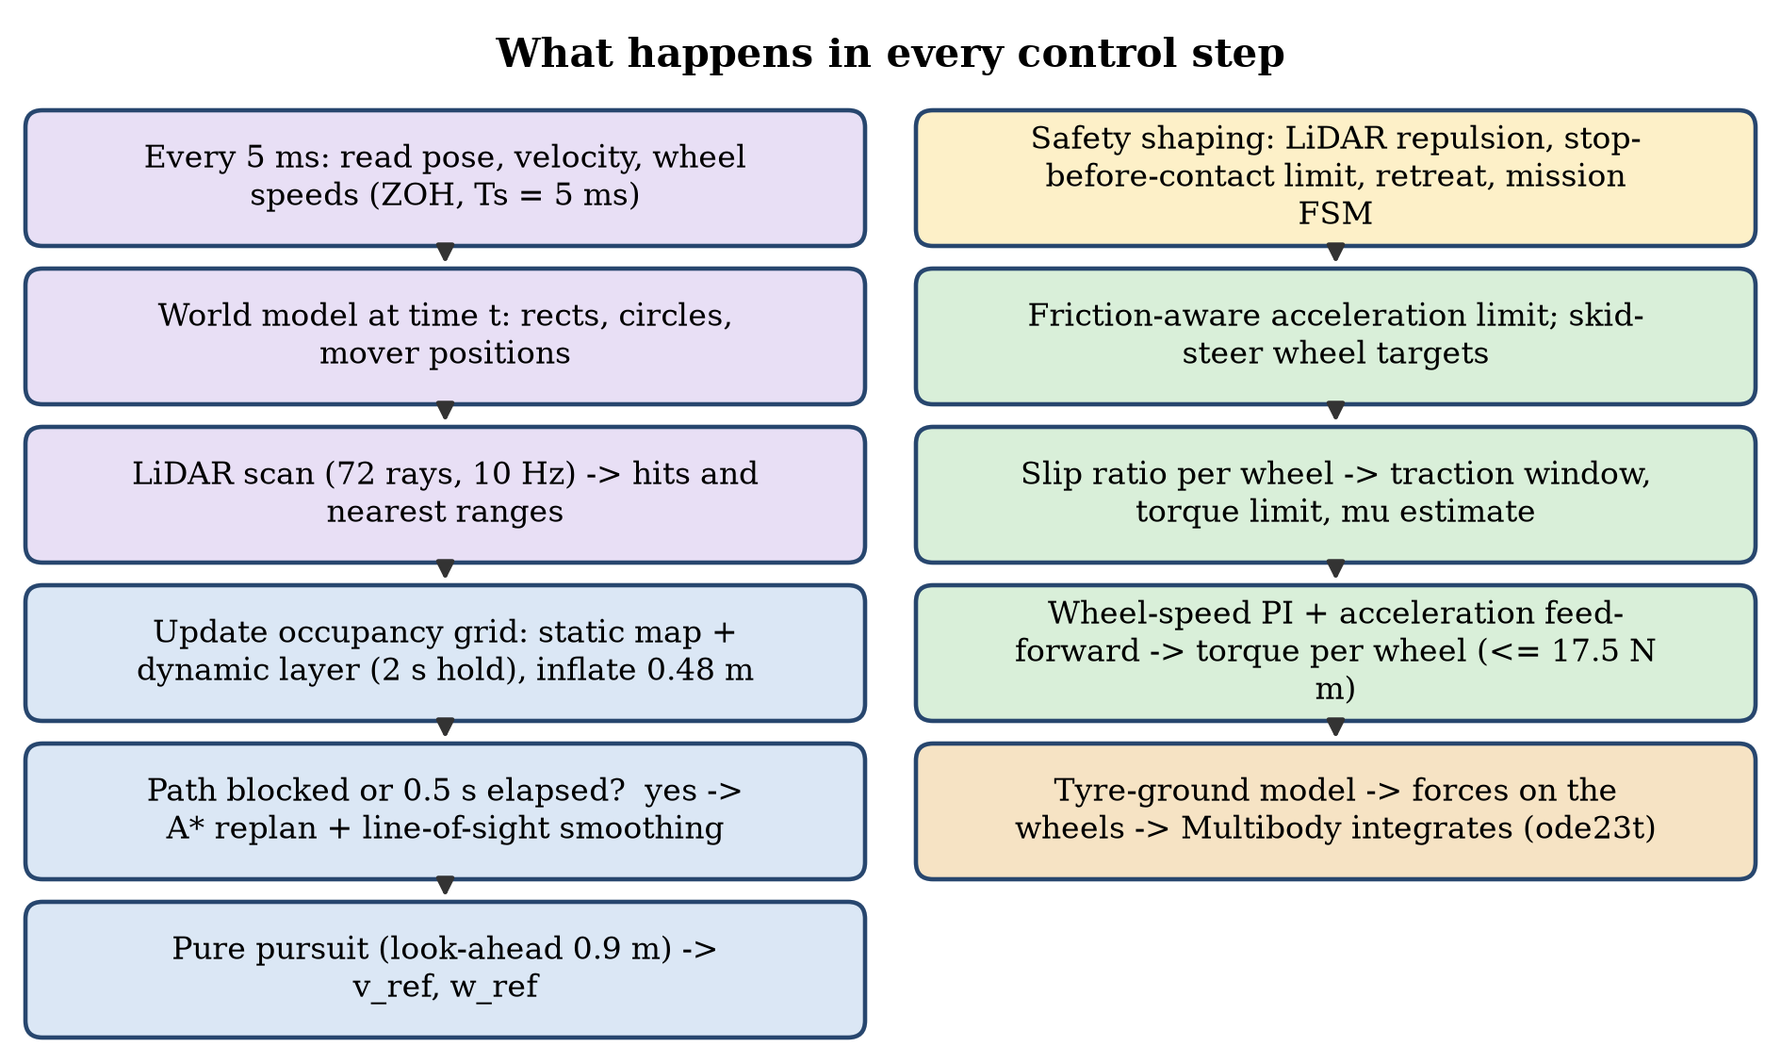
- What it shows: What the controller does 200 times per second, from reading the sensors to giving the wheel torques.
- How to read it: Read the boxes from the top of the left column down, then the right column. Purple = sensing, blue = planning, yellow = safety rules, green = wheel control, orange = physics.
- Say this: Perception, planning, safety shaping, slip control and torque all happen inside every 5 ms step. A* is only run again every 0.5 s or when the path is blocked.
Graphs of the earlier script simulation (simulate_industry_amr_warehouse.m, a kinematic model, not a multibody simulation):

Fig. 24 Speed, yaw rate, motor speed and slip (script)
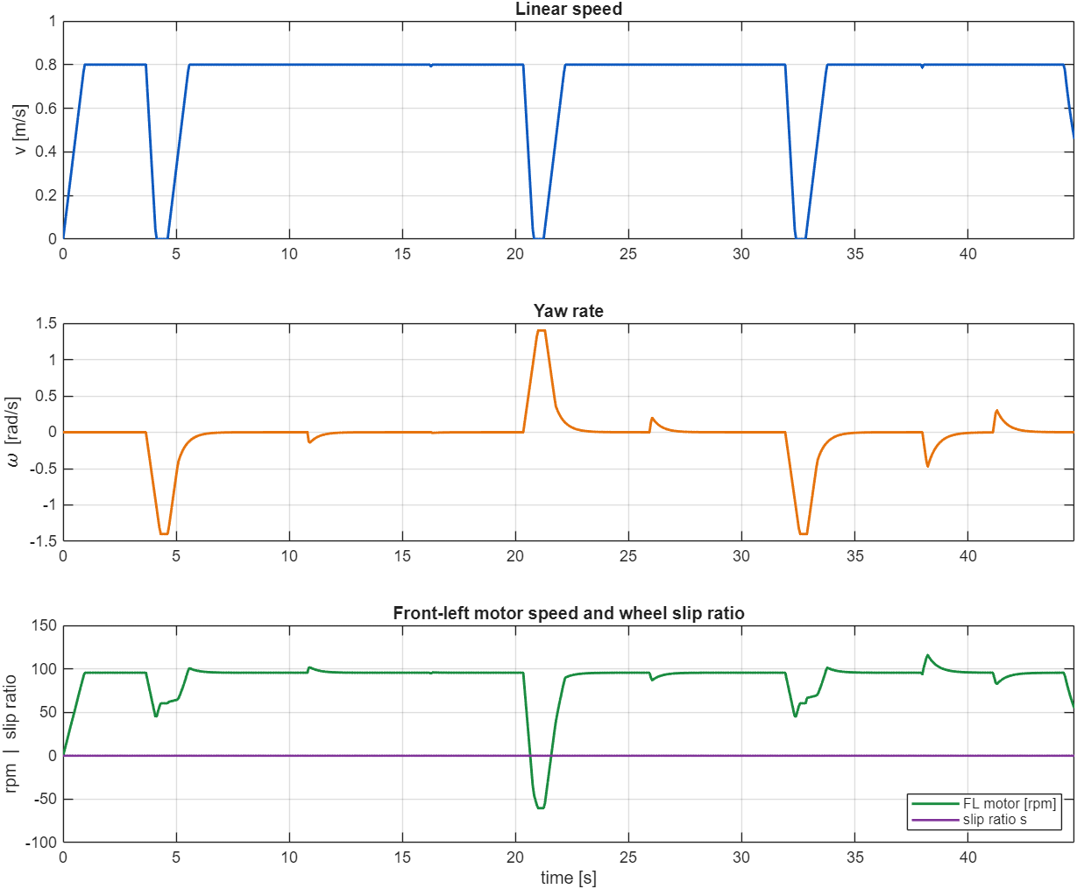
- What it shows: Linear speed (limit 0.8 m/s), yaw rate (limit 1.4 rad/s), front-left motor speed and the slip ratio of the script robot.
- How to read it: The speed drops to zero at the three corners of the route, where the robot pivots on the spot. The slip ratio is flat at zero.
- Say this: The slip is zero here only because this script has a simple drift model and no tyre contact. The Simscape model of Fig. 19 is the one that really simulates slip.

Fig. 25 Path driven by the script
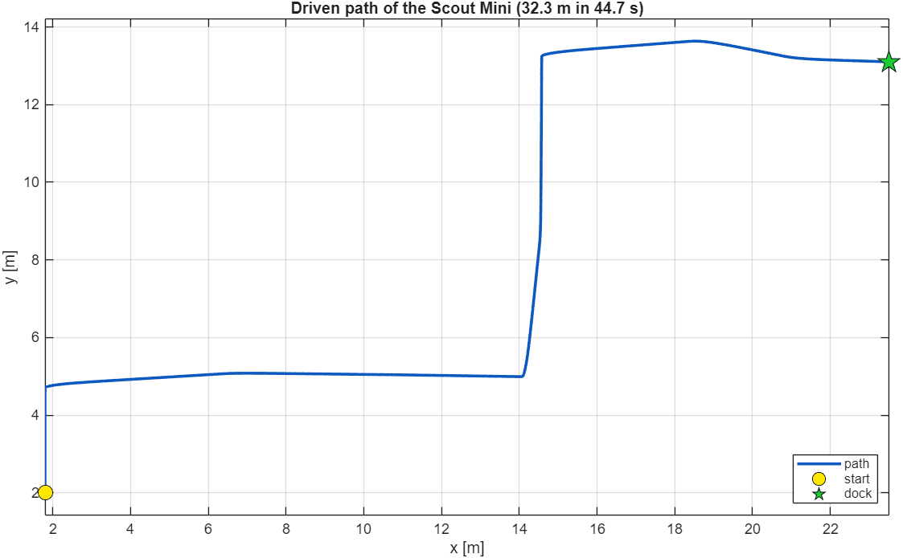
- What it shows: The route from the inbound depot to the shipping dock.
- How to read it: It follows the aisle centre lines of the waypoint roadmap and turns at three corners.
- Say this: The route comes from plan_warehouse_roadmap.m: a fixed roadmap along the aisles, not a grid search like the A* of the main model.

Fig. 26 Clearance with the ISO 3691-4 fields, drift and IMU (script)
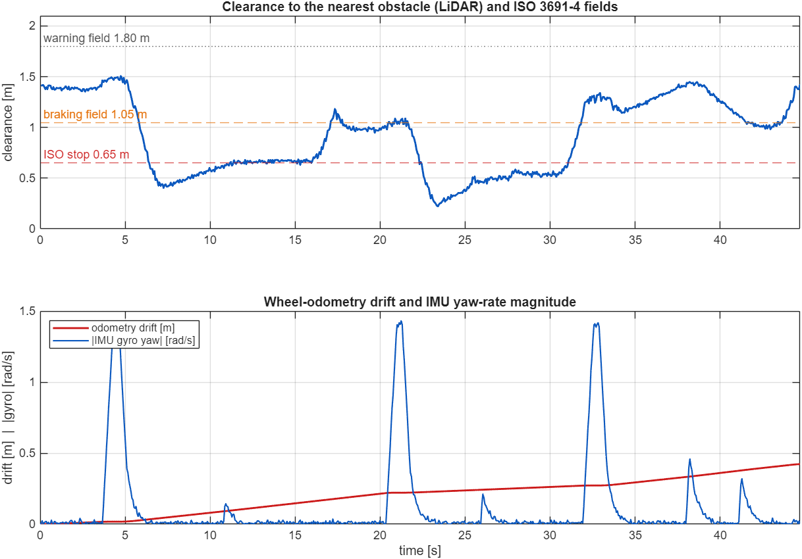
- What it shows: Top: LiDAR clearance with the warning (1.80 m), braking (1.05 m) and protective-stop (0.65 m) fields. Bottom: wheel-odometry drift (red) and the IMU yaw-rate magnitude (blue).
- How to read it: The clearance dips below the braking field between the racks and has its lowest value of 0.22 m at about 23 s. The three tall blue peaks are the corner turns. The red line shows odometry drift growing to 0.42 m.
- Say this: This shows how safety fields slow the robot down, and why wheel odometry alone drifts and a real robot needs LiDAR-based localisation.

Fig. 27 Live figure while the simulation runs
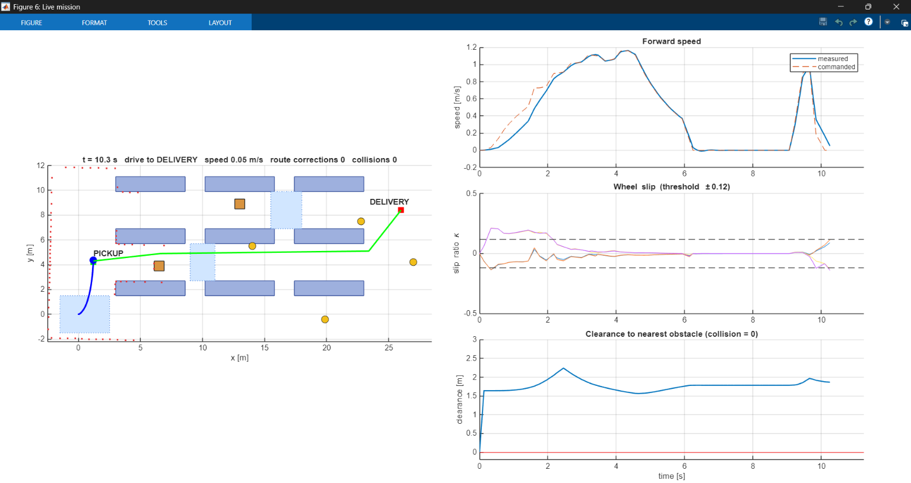
- What it shows: A screenshot of live_graphs at t = 10.3 s. The map on the left shows the robot, its driven path (blue), the planned path (green), the LiDAR hits (red dots) and the moving obstacles. On the right: forward speed, wheel slip and clearance against time.
- How to read it: Everything updates about every 0.1 s while the robot drives. Here the robot has finished loading (the speed is zero from 6 to 9 s) and starts towards the delivery. The slip is largest in the first 2 s, on the oil patch at the start. The clearance stays well above the collision line at zero.
- Say this: Command: live_graphs. This is the same data as the other graphs, but seen live. The report numbers come from run_scout_warehouse_simulation.

7. Likely questions and short answers
Q: Why Simscape Multibody and not just a MATLAB animation?
A: Because the wheels, chassis and tyre forces are simulated with real physics: torque on the wheels, friction at the ground, mass and inertia. The motion (and the slip) comes out of the physics, not from a drawn path.
Q: How did the SolidWorks model get into MATLAB?
A: SolidWorks to URDF + STL meshes with the exporter, then importrobot (Robotics System Toolbox) and smimport (Simscape Multibody) read the URDF.
Q: What changed after the import?
A: The weld between the footprint and the chassis was replaced by a 6-DOF joint so the robot can move; the wheel joints were set to accept torque; sensors, tyre forces, the warehouse and the controller were added.
Q: How is wheel-ground friction modelled?
A: Per wheel: a spring-damper normal force and a smoothed Coulomb friction force with μ from a floor map (0.9 concrete, 0.15 oil, 0.30 water). Written in scout_amr_tires.m.
Q: What is slip ratio and how is it handled?
A: Slip ratio = (wheel speed x radius - ground speed) / reference speed. Above 0.12 the controller limits the wheel-speed target to the ground speed window, cuts torque as slip grows and lowers its friction estimate, which also lowers the acceleration limit.
Q: Did slip management help?
A: It reduced the peak slip (0.48 vs 0.64) and the time with high slip, but made the mission about 4.1 s slower. The robot also finished without collision with it off, so the benefit is smoother wheel behaviour, not success versus failure.
Q: How does the robot see obstacles?
A: A 72-beam, 8 m, 10 Hz LiDAR modelled by ray casting against the warehouse geometry. Racks and walls are known in advance; boxes, workers, the second AMR and the truck appear only when the LiDAR hits them.
Q: How does it plan and avoid?
A: A* on a 0.2 m occupancy grid inflated by 0.48 m, re-planned every 0.5 s or when the path is blocked, then pure pursuit with reactive repulsion and a stop-before-contact speed limit. If an obstacle closes in and the rear is free it backs away.
Q: What does the mission state machine do?
A: Five states: drive to pickup, load 3 s, drive to delivery, unload 3 s, done.
Q: Is the pose estimated?
A: No. The pose is the true simulator pose from the Transform Sensor blocks. There is no localisation or SLAM in the Simulink model.
Q: Are collisions physical?
A: No. Collisions are checked analytically with a 0.36 m robot circle against the geometry. There is no Simscape contact between the robot and obstacles, and the movers follow scripted paths.
Q: Is the IMU or camera used?
A: They are mounted on the robot (from the URDF) but give no signals in Simulink. Their specifications are listed in the report as part of the robot description; the IMU, odometry drift and LiDAR noise are modelled only in the earlier script simulation.
Q: How do I change the warehouse or the gains?
A: Edit scout_amr_params.m. If you change the racks, walls or movers, rebuild the model with build_scout_amr_model.m so the 3D scene matches.

8. Honest limits (say these before you are asked)
- Simulation only. Nothing was tested on the physical Scout Mini.
- LiDAR and collision detection are analytic; there is no physical contact with obstacles.
- The moving obstacles follow scripts, and the workers pause when the robot is close.
- The pose is the true simulator pose (no localisation, no sensor noise in Simulink).
- The tyre model is a simple point-contact model; the motors are ideal torque sources limited to 17.5 N·m.
- The 3D scene of the Simscape model is shown by the Multibody Explorer screenshots (Fig. 11-13); the live view appears when the model runs.
- The slip comparison is one run per case on one layout.

