Project Explanation and MATLAB File Guide
Design and Simulation of an Industry Standard AMR (AgileX Scout Mini) in a Warehouse
Sailakshmi B T (2024511019) | RA23502 Autonomous Mobile Robot
This document explains the project report in simple words and lists every MATLAB file, what it does and what output it gives. Use it to understand the work and to prepare for questions. The folder is D:\academic_shit\SEM5-III\AMR ROS\simulink_amr unless another path is given.

0. Explain it simply (start here)
The two-minute story for your professor:
- The idea. A warehouse robot has to carry goods from a pickup point to a delivery point without a driver and without hitting anything. Testing that on a real floor is slow and risky, so I built the robot and the warehouse inside the computer and let the robot do the job by itself.
- The robot. It is the AgileX Scout Mini, a small four-wheel robot. I drew it in SolidWorks, exported it as a URDF file (a text file that lists the robot's parts, joints and masses) plus 3D shape files, and loaded it into MATLAB Simulink / Simscape Multibody.
- The physics. Simscape Multibody is a physics engine: the robot has real mass, the four wheels get a motor torque, and the floor pushes back with friction. I wrote the wheel-floor friction model myself, with dry concrete, oil and water patches, so wheels can really slip.
- The warehouse. Racks with goods, walls, a pickup and a delivery station, floor boxes, two workers, a second robot and a pallet truck that blocks an aisle.
- The brain. Four steps repeated all the time: (1) LiDAR looks around, (2) the robot updates its map, (3) A* finds the shortest free path and plans again when something blocks it, (4) pure pursuit steers along the path while a safety rule slows or stops the robot near obstacles.
- The wheels. A slip controller watches each wheel. If a wheel spins faster than the ground moves, it reduces the torque, so the robot keeps its grip.
- The result. The robot finished the job in 49.6 s, drove 32.0 m, changed its route 3 times and had 0 collisions (closest it came to anything: 0.22 m). With slip control the worst slip was 0.48, without it 0.64.
The architecture in plain words (Fig. 22 of the report). Think of four layers that form a loop:
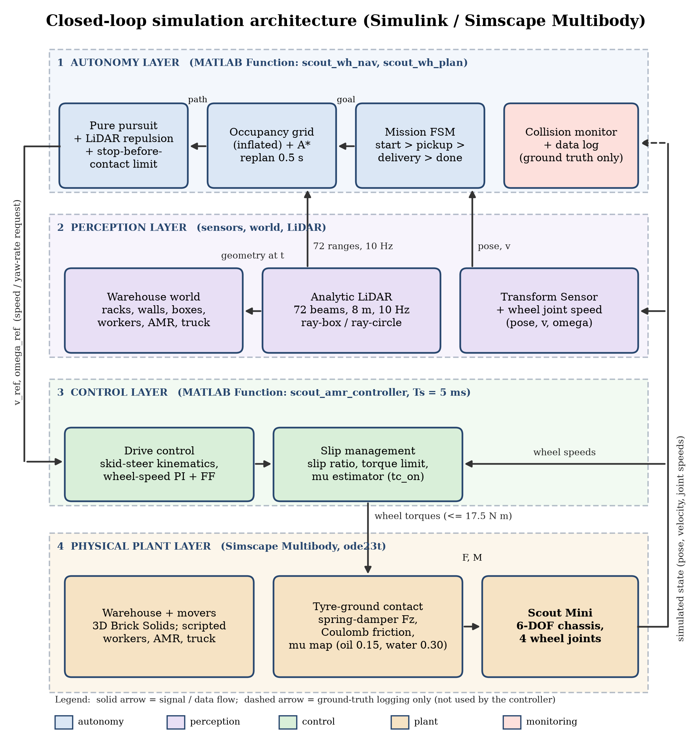
Layer | In plain words | Where it is
4 Physical plant | The 'real world' inside the computer: the robot, its wheels, the floor friction and the warehouse. It obeys physics. | scout_amr_sim.slx (Simscape Multibody), scout_amr_tires.m
2 Perception | The robot's eyes: where am I and how fast am I going, what is around me. The LiDAR sends 72 rays and measures the distance to the first thing each ray hits. | Transform Sensor blocks, scout_wh_world.m, scout_wh_lidar.m
1 Autonomy | The decision maker: mission steps (pickup, load, deliver, unload), the map, the A* route, and the steering with obstacle avoidance. Its output is 'drive at this speed and turn at this rate'. | scout_wh_nav.m, scout_wh_plan.m
3 Control | The muscle: converts 'speed and turn rate' into a target speed for each wheel, then into a motor torque, and limits the torque when a wheel slips. | scout_amr_controller.m

The loop: the plant produces the state, perception reads it, autonomy decides, control sends wheel torques, the tyre model turns them into forces, and the plant moves and produces a new state. This repeats every 5 ms. The collision monitor only watches and records; the robot never uses it to steer.
Words you may need:
Term | Simple meaning
AMR | Autonomous mobile robot: it finds its own way, unlike a robot that follows a line on the floor.
URDF / STL | URDF = text description of the robot's parts and joints; STL = the 3D shape of each part.
Skid steer | Left and right wheels turn at different speeds to steer, like a tank. There is no steering wheel.
LiDAR | A spinning distance sensor: it measures how far the nearest object is in each direction.
Occupancy grid | A map made of small squares (20 cm); each square is free or occupied. Obstacles are enlarged by 0.48 m so the robot keeps a safe distance.
A* | A search method that finds the shortest path through the free squares, guided by the straight-line distance to the goal.
Pure pursuit | The robot always steers towards a point 0.9 m ahead on its path.
Slip ratio | How much faster a wheel turns than the ground moves under it. 0 = perfect grip, large = the wheel is spinning.
Traction control | Reduces the wheel torque when slip is too high, so the wheel grips again.
PI controller | A simple feedback rule: torque = gain x speed error + accumulated error. It makes each wheel reach its target speed.

If asked what is NOT real (say it first): it is simulation only; the pose comes straight from the simulator; the LiDAR and the collision check are computed from the geometry; the workers and the truck follow scripts; nothing was tested on the real robot.

1. The project in one page
What was built. A virtual warehouse robot. The robot is your own SolidWorks model of the AgileX Scout Mini (a four-wheel skid-steer robot). It is placed in a 3D warehouse inside MATLAB Simulink / Simscape Multibody, where real physics (mass, wheel torque, tyre friction) moves it. The robot drives by itself from a start dock to a pickup station, waits to load, drives to a delivery station and waits to unload, while avoiding racks, boxes, a worker, a second robot and a pallet truck.
The chain of work, in order:
- SolidWorks CAD model of the robot (your files Assem2, chassis, chassis_top, W, up).
- Export to URDF + STL meshes: a text description of the robot (links, joints, masses) plus the 3D shapes.
- Import into MATLAB: importrobot (for viewing) and smimport (creates the Simscape Multibody / Simulink model).
- Make it a physical robot: free-moving chassis, torque-driven wheels, a tyre-ground friction model written by us.
- Build the warehouse: racks with goods, walls, stations, floor boxes, oil/water patches, and four moving obstacles.
- Add autonomy: LiDAR, occupancy grid, A* path planning, re-planning, path following and a mission state machine.
- Add slip management: detect wheel slip and limit torque so the wheels do not spin or lock.
- Run, log, plot, report: one script runs everything and draws all graphs.
Why it matters. Testing a warehouse robot in simulation is cheaper and safer than on a real floor. The project shows the full path from a CAD model to a robot that senses, plans, moves and handles slippery floors.

2. The report explained section by section
Section | What it tells | Key point to remember
Abstract | One-paragraph summary of the whole project and its results. | Mission 49.6 s, 3 route corrections, 0 collisions, minimum clearance 0.22 m.
1 Introduction | What an AMR is, why simulate, the objectives and the scope. | Simulation only. Real hardware was not tested.
2 Robot Specifications | Numbers of the model: mass, wheel size, track, torque limit, tyre values. | Values come from your CAD/URDF, not from measuring the real robot.
3 Sensors | Every sensor, its configuration, why it is used and whether it is really simulated. | Only the LiDAR (analytic) and the body-state / wheel-speed sensors are used in Simulink. IMU and camera are mounted in the model but give no signals.
4 SolidWorks Design | Your CAD files and screenshots. | SolidWorks files cannot be opened in MATLAB, so STL meshes carry the shape.
5 Conversion to URDF | What URDF is and the values read from it. | Only change made: package:// mesh paths replaced by meshes/.
6 Importing in MATLAB and Simulink | importrobot and smimport. | smimport is slow (minutes), so the result is cached in scout_import_raw.slx. Imported wheel joints have their Z axis along the axle.
7 Building the Simscape Multibody Model | Steps that turn the import into a dynamic robot, the tyre model equations, the subsystem structure (schematic of Scout_Mini_Robot), the Simulink top-level screenshot and the Mission controller diagram. | 6-DOF chassis, torque-driven wheels, spring-damper normal force + smoothed Coulomb friction (kc 12000 N/m, cc 700 N·s/m).
8 Creating the Warehouse | Layout table, moving obstacles, planning map and the three Multibody Explorer screenshots (3D scene). | Racks and walls are known to the planner; boxes, workers, AMR and truck are found only by LiDAR.
9 Autonomous Navigation | One full mission with the state machine, the result figures (trajectory, LiDAR scenarios, velocities, safety, signals) and the limits. | All six demo scenarios happen in one mission (box, worker, blocked aisle, cross-aisle, pickup to delivery, alternative path).
10 Slip and Traction Management | How slip is detected and limited; ON versus OFF comparison. | Peak slip 0.48 (ON) vs 0.64 (OFF), but ON is about 4.1 s slower. Both finished without collision.
11 Algorithms | Table of every algorithm, file and parameters; A* and dynamic-obstacle handling. | Reactive avoidance: moving obstacles are not predicted.
12 System Architecture | Layered closed-loop diagram (autonomy, perception, control, physical plant) and the flow of one 5 ms control step. | Four layers in a loop: Plant, Perception, Autonomy, Control (Fig. 22). The pose comes from the simulator (no localisation).
13 Additional MATLAB Visual Simulation | The script simulation simulate_industry_amr_warehouse with ISO 3691-4 style safety fields, one screenshot and telemetry graphs. | Kinematic animation, not a multibody solver.
14 How to Set It Up | Requirements, getting the files from GitHub, the 10-step run table, parameter table, SolidWorks to URDF, troubleshooting, code layout. | Run run_scout_warehouse_simulation.
15 Limitations and Future Enhancements | What is not modelled and what to do next. | Analytic LiDAR and collisions, scripted obstacles, true pose, noisy torque.
16 Conclusion | Summary of what was achieved and its limits. | Shows the software chain works; not proof for the physical robot.

3. MATLAB files and the output each one gives
The files are grouped by purpose. 'Output' means what you get when the file is run or called.

3.1 Robot description (inputs, not code)
File / folder | What it is | Output / use
scout_mini.urdf | URDF of the robot: links, joints, masses, inertias, sensor mounts (copied from the ROS 2 repository; mesh paths changed to meshes/). | Read by importrobot and smimport.
meshes/ (base_link.STL, w1.STL ... w4.STL) | 3D shapes exported from your SolidWorks model. | Drawn in the 3D scene and in the report renders.
../scout_mini_sw/ (Assem2.SLDASM, chassis.SLDPRT, chassis_top.SLDPRT, W.SLDPRT, up.SLDPRT) | Your original SolidWorks files (cloned from GitHub). | Source of the STL meshes. Not read by MATLAB.

3.2 Model and physics
File | What it does | Output
scout_amr_params.m | Holds every constant: robot, wheels, tyre contact, friction patches, warehouse layout, LiDAR, planning grid, controller gains. Also computes the wheel rotation signs from the URDF. | Returns the struct P used by all other files. Edit this file to change the warehouse or the gains.
build_scout_amr_model.m | Imports the URDF with smimport (or reuses scout_import_raw.slx), replaces the weld by a 6-DOF joint, makes wheels torque-driven, adds sensors, tyre forces, the 3D warehouse, the four movers, logging blocks, subsystems and the diagram layout. | Creates scout_amr_sim.slx. Run it only to rebuild the model.
scout_import_raw.slx | Raw result of smimport (cache). | Speeds up rebuilds.
scout_amr_sim.slx | The Simulink / Simscape Multibody simulation. Top level: World, Mechanism Configuration, Solver and four subsystems (Scout_Mini_Robot with the nested Tyre_Ground_Contact_Model, Warehouse, Moving_Obstacles, Mission_and_Slip_Controller). | When run it logs ctrl_log, tire_log, lidar_log, path_log and mover_log to the workspace and shows the 3D Mechanics Explorer.
scout_amr_tires.m | Tyre-ground model for one wheel (called four times): normal spring-damper force, smoothed Coulomb friction, floor friction map. | 11 values per wheel: force (3) and torque (3) in the wheel frame, normal load Fz, longitudinal force, lateral force, slip ratio, friction μ.

3.3 Autonomy and control (called every 5 ms from the model)
File | What it does | Output
scout_amr_controller.m | The brain inside the Controller block: gets robot pose and speed, calls the navigation, converts commands to wheel targets, estimates slip, applies slip management, runs the wheel-speed PI controller. | tau_j: four wheel torques. lg: log vector of 44 signals (pose, speeds, slip ratios, torques, friction estimate, mission state, clearance, collisions...). mv: 8 mover positions. rng: 72 LiDAR ranges. pth: planned path.
scout_wh_nav.m | Perception, planning and mission logic: world update, LiDAR, occupancy grid, A* replanning, pure pursuit, reactive repulsion, stop-before-contact limit, retreat, mission state machine, collision monitor. | Speed and yaw-rate reference, mover positions, LiDAR ranges, path and an info vector (state, number of re-routes, clearance, collisions, goal distance).
scout_wh_world.m | Warehouse geometry and moving obstacles at time t (17 rectangles, 2 circles, mover positions). Workers react to the robot; the truck is released at x > 12 m. | Rectangles, circles and the positions that move the 3D bodies.
scout_wh_lidar.m | Casts 72 rays against the rectangles and circles. | 72 range values in metres (8 m means no return).
scout_wh_plan.m | 8-connected A* on the inflated grid with line-of-sight smoothing. | Path of up to 80 waypoints and their count.

3.4 Running and plotting
File | How to run | Output
run_scout_warehouse_simulation.m | run_scout_warehouse_simulation (3D window)  run_scout_warehouse_simulation(false) (headless)  run_scout_warehouse_simulation(false,true) (slip ON and OFF)  run_scout_warehouse_simulation('replot') (redraw from saved data) | Runs the model, saves results/scout_warehouse_results.mat, draws figures 1 to 5 (6 with the comparison) as PNG in results/ and prints the summary (mission time, distance, speeds, re-routes, collisions, clearance, slip, energy).
results/1_warehouse_trajectory.png | (made by the file above) | Map with driven path, planned paths, re-route events and mover trails.
results/2_velocity_wheel_speeds.png |  | Linear and angular velocity (commanded and measured) and the four wheel speeds.
results/3_perception_safety.png |  | Closest LiDAR range, ground-truth clearance, route corrections, collisions, mission state.
results/4_slip_management.png |  | Slip ratio of each wheel, torques after limiting, friction estimate vs true friction, normal loads.
results/5_lidar_scenarios.png |  | Four snapshots: avoiding the box, worker crossing, aisle blocked re-route, worker in aisle 3.
results/6_slip_on_vs_off.png | (only with compareSlip = true) | Worst-wheel slip ratio and speed with slip management on and off.
results/scout_warehouse_results.mat |  | Saved logs of both runs (R) and the parameters (P).

3.5 Report-making files (folder report/)
File | Output
make_report_figures.m | robot_importrobot.png, robot_render.png (robot meshes with joint axes), the Simulink subsystem pictures (hi-res prints of the Mission controller, used split in two halves as simulink_Mission_2col.png) (in report/figs).
report_numbers.m | numbers.json: every number quoted in the report (ON and OFF run metrics, re-route times).
capture_industry_full.m | industry_01..05, industry_final.png (screenshots) and industry_telemetry.mat: runs simulate_industry_amr_warehouse.m unchanged and grabs its window and telemetry.
make_industry_graphs.m | industry_g1_kinematics.png, industry_g2_safety_sensors.png, industry_g3_path.png redrawn from industry_telemetry.mat.
make_diagrams.py | diag_toolchain.png, diag_urdf_tree.png, diag_robot_subsystem.png, diag_mission_fsm.png, diag_architecture.png, diag_control_step.png (Python, matplotlib; drawn at the printed width so the text stays readable).
content.py + build_report.py | Scout_Mini_Warehouse_AMR_Report.pdf and .docx (Python; content.py holds the text, build_report.py the layout).
build_explainer.py | This document.
build_cheatsheet.py | Live_Demo_Cheat_Sheet_final.docx: the command for every figure, a demo plan and an explanation of every graph.

3.6 Earlier visual MATLAB simulation (folder AMR ROS)
File | What it does | Output
simulate_industry_amr_warehouse.m | Script simulation: 26 x 16 m warehouse with racks, pallets, a ramp to a loading dock, the Scout Mini STL meshes, LiDAR, IMU and odometry drift, ISO 3691-4 style warning / braking / stop fields and automatic re-routing. | An animated 3D figure with an occupancy grid, speed / wheel-speed / slip plots and safety telemetry. Not a multibody simulation.
plan_warehouse_roadmap.m | Waypoint roadmap along aisle centre lines, avoiding hazard boxes. | path: list of waypoints from the current position to the goal.
teleop_industry_amr_warehouse.m | Same scene driven by hand (W/A/S/D, arrows, space). | Interactive 3D figure.

4. How the files work together
Order of events when you run run_scout_warehouse_simulation:
- The runner loads scout_amr_sim.slx (builds it with build_scout_amr_model.m if missing) and sets tc_on (1 = slip management, 0 = off).
- Simulink runs. Every 5 ms the Controller block calls scout_amr_controller.m. That calls scout_wh_nav.m, which calls scout_wh_world.m (obstacle geometry), scout_wh_lidar.m (ranges) and scout_wh_plan.m (A* path).
- The controller returns four wheel torques. Four Tyre blocks call scout_amr_tires.m to turn wheel states into ground forces. Simscape Multibody applies the torques and forces and moves the chassis, wheels and movers.
- The sensors feed pose, velocity and wheel speeds back to the controller. The logs are stored.
- When the mission state reaches 'done' the simulation stops. The runner converts the logs, saves the .mat file, draws the figures and prints the summary.
- scout_amr_params.m is read by all of them, so changing a number there changes the whole simulation.

5. Results to remember
Quantity | Slip management ON | Slip management OFF
Mission time | 49.6 s | 45.5 s
Reached pickup / left / delivered | 6.1 / 9.1 / 46.6 s | 5.7 / 8.7 / 42.5 s
Distance | 32.0 m | 31.5 m
Top speed | 1.20 m/s | 1.19 m/s
Route corrections | 3 | 3
Collisions | 0 | 0
Minimum clearance | 0.22 m | 0.19 m
Peak slip ratio | 0.48 | 0.64
Time with worst-wheel slip above 0.2 | 2.1 % | 5.4 %
Wheel mechanical work | 2670 J | 2633 J

Route corrections in the ON run happened at t = 25.1, 30.2 and 37.6 s, when the pallet truck blocked aisle 2 and the robot re-planned.

6. Likely questions and short answers
Q: Why Simscape Multibody and not just a MATLAB animation?
A: Because the wheels, chassis and tyre forces are simulated with real physics: torque on the wheels, friction at the ground, mass and inertia. The motion (and the slip) comes out of the physics, not from a drawn path.
Q: How did the SolidWorks model get into MATLAB?
A: SolidWorks to URDF + STL meshes with the exporter, then importrobot (Robotics System Toolbox) and smimport (Simscape Multibody) read the URDF.
Q: What changed after the import?
A: The weld between the footprint and the chassis was replaced by a 6-DOF joint so the robot can move; the wheel joints were set to accept torque; sensors, tyre forces, the warehouse and the controller were added.
Q: How is wheel-ground friction modelled?
A: Per wheel: a spring-damper normal force and a smoothed Coulomb friction force with μ from a floor map (0.9 concrete, 0.15 oil, 0.30 water). Written in scout_amr_tires.m.
Q: What is slip ratio and how is it handled?
A: Slip ratio = (wheel speed x radius - ground speed) / reference speed. Above 0.12 the controller limits the wheel-speed target to the ground speed window, cuts torque as slip grows and lowers its friction estimate, which also lowers the acceleration limit.
Q: Did slip management help?
A: It reduced the peak slip (0.48 vs 0.64) and the time with high slip, but made the mission about 4.1 s slower. The robot also finished without collision with it off, so the benefit is smoother wheel behaviour, not success versus failure.
Q: How does the robot see obstacles?
A: A 72-beam, 8 m, 10 Hz LiDAR modelled by ray casting against the warehouse geometry. Racks and walls are known in advance; boxes, workers, the second AMR and the truck appear only when the LiDAR hits them.
Q: How does it plan and avoid?
A: A* on a 0.2 m occupancy grid inflated by 0.48 m, re-planned every 0.5 s or when the path is blocked, then pure pursuit with reactive repulsion and a stop-before-contact speed limit. If an obstacle closes in and the rear is free it backs away.
Q: What does the mission state machine do?
A: Five states: drive to pickup, load 3 s, drive to delivery, unload 3 s, done.
Q: Is the pose estimated?
A: No. The pose is the true simulator pose from the Transform Sensor blocks. There is no localisation or SLAM in the Simulink model.
Q: Are collisions physical?
A: No. Collisions are checked analytically with a 0.36 m robot circle against the geometry. There is no Simscape contact between the robot and obstacles, and the movers follow scripted paths.
Q: Is the IMU or camera used?
A: They are mounted on the robot (from the URDF) but give no signals in Simulink. Their specifications are listed in the report as part of the robot description; the IMU, odometry drift and LiDAR noise are modelled only in the earlier script simulation.
Q: How do I change the warehouse or the gains?
A: Edit scout_amr_params.m. If you change the racks, walls or movers, rebuild the model with build_scout_amr_model.m so the 3D scene matches.

7. Honest limits (say these before you are asked)
- Simulation only. Nothing was tested on the physical Scout Mini.
- LiDAR and collision detection are analytic; there is no physical contact with obstacles.
- The moving obstacles follow scripts, and the workers pause when the robot is close.
- The pose is the true simulator pose (no localisation, no sensor noise in Simulink).
- The tyre model is a simple point-contact model; the motors are ideal torque sources limited to 17.5 N·m.
- The 3D scene of the Simscape model is shown by the Multibody Explorer screenshots (Fig. 11-13); the live view appears when the model runs.
- The slip comparison is one run per case on one layout.

