END-TO-END DESIGN, KINEMATIC MODELING,
SIMULATION, AND AUTONOMOUS NAVIGATION OF THE
AGILEX SCOUT MINI 4WD AMR
COURSE CODE: RA23E01 | COURSE: ROBOT OPERATING SYSTEM (ROS)
Submitted by
SAILAKSHMI B T – 2024511019
BACHELOR OF ENGINEERING
in
ROBOTICS AND AUTOMATION

From SolidWorks Mechanical CAD Modeling to ROS 2 Jazzy & Gazebo Harmonic Simulation, Multi-
Modal Perception, EKF Sensor Fusion, SLAM Mapping, and Nav2 Waypoint Navigation
DEPARTMENT OF PRODUCTION TECHNOLOGY
MADRAS INSTITUTE OF TECHNOLOGY
ANNA UNIVERSITY - CHENNAI 600044

BONAFIDE CERTIFICATE
Certified that this project report “END-TO-END DESIGN, KINEMATIC
MODELING, SIMULATION, AND AUTONOMOUS NAVIGATION OF
THE AGILEX SCOUT MINI 4WD AMR” is the Bonafide word of
Sailakshmi B T (2024511019) who carried out the project work under my
supervision.
SIGNATURE | SIGNATURE
HEAD OF THE DEPARTMENT | SUPERVISOR

ABSTRACT
This project investigates the design, kinematic formulation, state estimation, and autonomous navigation lifecycle for a 4-Wheel Drive (4WD) skid-steer Autonomous Mobile Robot (AMR) based on the AgileX Scout Mini platform. To resolve the fundamental challenge of non-linear lateral tire slippage and rapid odometry degradation inherent to skid-steer kinematics without wheel encoders, a multi-stage engineering framework was developed in ROS 2 Jazzy Jalisco and Gazebo Harmonic on Ubuntu 24.04 LTS.
The physical robot was modeled in SolidWorks with mass moments of inertia, converted into a ROS REP-103 compliant URDF, and tuned with calibrated contact friction parameters (mu1 = 1.0, mu2 = 0.1). A sensor suite comprising a 360-degree 2D LiDAR (20 Hz), a 6-Axis IMU (100 Hz), and an RGB-D depth camera (30 Hz) was integrated. An Extended Kalman Filter (robot_localization) fused wheel velocities with inertial angular rates, eliminating cumulative rotational drift. Real-time 2D mapping via slam_toolbox produced 5 cm/pixel metric occupancy grids, while the Nav2 stack—incorporating 3D Voxel clearance costmaps, AMCL probabilistic particle filter localization, and DWB local trajectory optimization—executed an autonomous 5-station industrial patrol mission with zero collision events.
Keywords: Autonomous Mobile Robot (AMR), AgileX Scout Mini, ROS 2 Jazzy Jalisco, Gazebo Harmonic, Skid-Steer Kinematics, EKF Sensor Fusion, SLAM Toolbox, Nav2 Navigation Stack.

Table of Contents
- 1. Executive Summary & Project Objectives
- 2. Robot Specifications & Mathematical Skid-Steer Kinematics
- 3. Mechanical Design & SolidWorks CAD Modeling Pipeline
- 4. ROS 2 Package Architecture & URDF Model Hardening
- 5. Physics Engine & Simulation in Gazebo Harmonic (gz-sim8)
- 6. Multi-Modal Perception Sensor Suite Integration
- 7. State Estimation & Sensor Fusion via Extended Kalman Filter (EKF)
- 8. Simultaneous Localization and Mapping (SLAM)
- 9. Autonomous Navigation Stack (Nav2) Implementation
- 10. Autonomous Multi-Station Waypoint Patrol Missions (Arena & Civil Facility)
- 11. Step-by-Step Execution, Results & Verification Log (with Visual Traces & Screenshots)
- 11.1 Master Simulation Launch & Entity Spawning
- 11.2 ROS 2 Topic Graph & TF Kinematic Tree Verification
- 11.3 Multi-Modal Perception Streaming (2D LiDAR & 3D RGB-D)
- 11.4 2D SLAM Mapping & Metric Occupancy Grid Generation
- 11.5 Synchronized Multi-Waypoint Patrol Mission Execution
- 11.6 Civil Architectural Multi-Room Facility (20m x 16m) Simulation
- 11.7 Real-Time 2D SLAM & Drift-Free EKF Odometry Trajectory Tracing
- 11.8 AgileX Scout Mini Civil Floor Ground Station & Live Telemetry
- 12. Engineering Challenges, Root-Cause Analysis & Solutions Matrix
- 13. Conclusion & Future Scope
- 14. References & Code Repository

1. Executive Summary & Project Objectives
1.1 Executive Summary
This project was undertaken to build practical, hands-on competence across the full robotics development lifecycle — from mechanical design through to autonomous deployment — using the AgileX Scout Mini 4WD platform as a representative industrial AMR. Rather than treating simulation as an isolated exercise, the work was structured to mirror a real product-development workflow: a CAD-accurate robot model was carried through kinematic validation, physics-based simulation, sensor integration, localization, mapping, and navigation, with each stage validated against the output of the previous one before proceeding.
The project's principal outcomes are threefold. First, it demonstrates that a mechanically faithful SolidWorks assembly can be converted into a simulation-ready, REP-103-compliant robot description without loss of physical accuracy (mass, inertia, joint kinematics). Second, it shows that a naive skid-steer odometry estimate — which drifts significantly under wheel slip — can be corrected to a reliable state estimate through EKF-based sensor fusion, enabling trustworthy downstream mapping and localization. Third, it confirms that this corrected state estimate, combined with LiDAR-based SLAM and a properly tuned Nav2 stack, supports genuinely autonomous, obstacle-aware multi-waypoint operation rather than merely scripted motion.
Section 12 documents the engineering troubleshooting this required in practice — twelve distinct issues spanning package naming, file-system case sensitivity, mesh referencing, joint configuration, and Gazebo Classic-to-Harmonic migration — underscoring that the bulk of the effort lay not in following a tutorial, but in resolving the gap between a CAD export and a working ROS 2 system.
1.2 Academic Project Objectives
- 1. SolidWorks CAD Design: Design and assemble the AgileX Scout Mini chassis, drive train, wheels, and sensor brackets in SolidWorks CAD.
- 2. Mathematical Kinematics: Derive 4WD skid-steer forward/inverse kinematics and align coordinate frames to ROS REP-103 (+X Forward, +Y Left, +Z Up).
- 3. URDF Kinematic Tree: Export and calibrate the URDF model with accurate inertia tensors, continuous joints, and cylinder collision bounds.
- 4. Physics Simulation: Establish bidirectional ROS 2 Jazzy – Gazebo Harmonic communication via ros_gz_bridge.
- 5. Perception Pipeline: Incorporate 2D LiDAR (/scan), 6-Axis IMU (/imu), and Depth Point Cloud (/camera/points) sensors.
- 6. EKF State Estimation: Deploy robot_localization EKF to generate fused, drift-free odometry (/odometry/filtered).
- 7. 2D SLAM Mapping: Execute real-time SLAM mapping to generate metric occupancy grid maps.
- 8. Nav2 Autonomous Navigation: Configure Nav2 autonomous path planning and execute multi-station waypoint navigation.
2. Robot Specifications & Mathematical Skid-Steer Kinematics
2.1 Mechanical & Physical Specifications
Parameter | Dimension / Engineering Specification
Chassis Dimensions (L x W x H) | 612 mm x 580 mm x 245 mm
Track Width (Wheel Separation d) | 0.612 m (612 mm)
Wheelbase (2l) | 0.390 m (390 mm)
Wheel Radius (r) | 0.080 m (80 mm)
Chassis Mass (m_b) | 22.00 kg
Wheel Mass (m_w, each) | 1.50 kg (x 4 wheels = 6.00 kg)
Total Robot Mass (M) | 28.00 kg
Drive Configuration | 4-Wheel Skid-Steer / Differential Drive
Maximum Linear Velocity (v_max) | 2.0 m/s
Maximum Angular Velocity (w_max) | 3.0 rad/s

2.2 Mathematical Kinematics (4WD Skid-Steer Locomotion)
The AgileX Scout Mini operates as a 4-wheel skid-steer mobile robot. Lateral tire slippage is mathematically modeled using differential-drive kinematic equivalence with effective track width d_eff = 0.612 m and wheel radius r = 0.08 m.
Equation (2.1) - Forward Kinematics: Forward Kinematic Equations:
v_x = (r / 2) * (w_R + w_L)
w_z = (r / d_eff) * (w_R - w_L)
Where:
v_x = Robot linear velocity along +X forward (m/s)
w_z = Robot angular yaw rate about +Z (rad/s)
w_L = Left wheels angular velocity (j1, j2) (rad/s)
w_R = Right wheels angular velocity (j3, j4) (rad/s)
r = Wheel radius = 0.080 m
d_eff = Effective track width = 0.612 m

Equation (2.2) - Inverse Kinematics: Inverse Kinematic Equations:
w_L = (v_x - (d_eff / 2) * w_z) / r
w_R = (v_x + (d_eff / 2) * w_z) / r

3. Mechanical Design & SolidWorks CAD Modeling Pipeline
The mechanical architecture of the AgileX Scout Mini was modeled component-by-component in SolidWorks. The assembly comprises the main monocoque chassis, four motorized hub wheel assemblies, off-road tire treads, top sensor mounting plate, and sensor mounting brackets.
3.1 SolidWorks CAD Visual Assembly & Component Architecture
📷 FIGURE 3.1: SOLIDWORKS 3D FULL ASSEMBLY (ASSEM2.SLDASM)
Target File: solidworks_amr_cad_assembly.png | Timestamp: 2026-08-05T06:58:13+05:30
Visual Content: Complete 3D solid model assembly of the AgileX Scout Mini 4WD AMR in SolidWorks Premium 2023 showing monocoque chassis, top plate, hub motors, and 4 wheels.
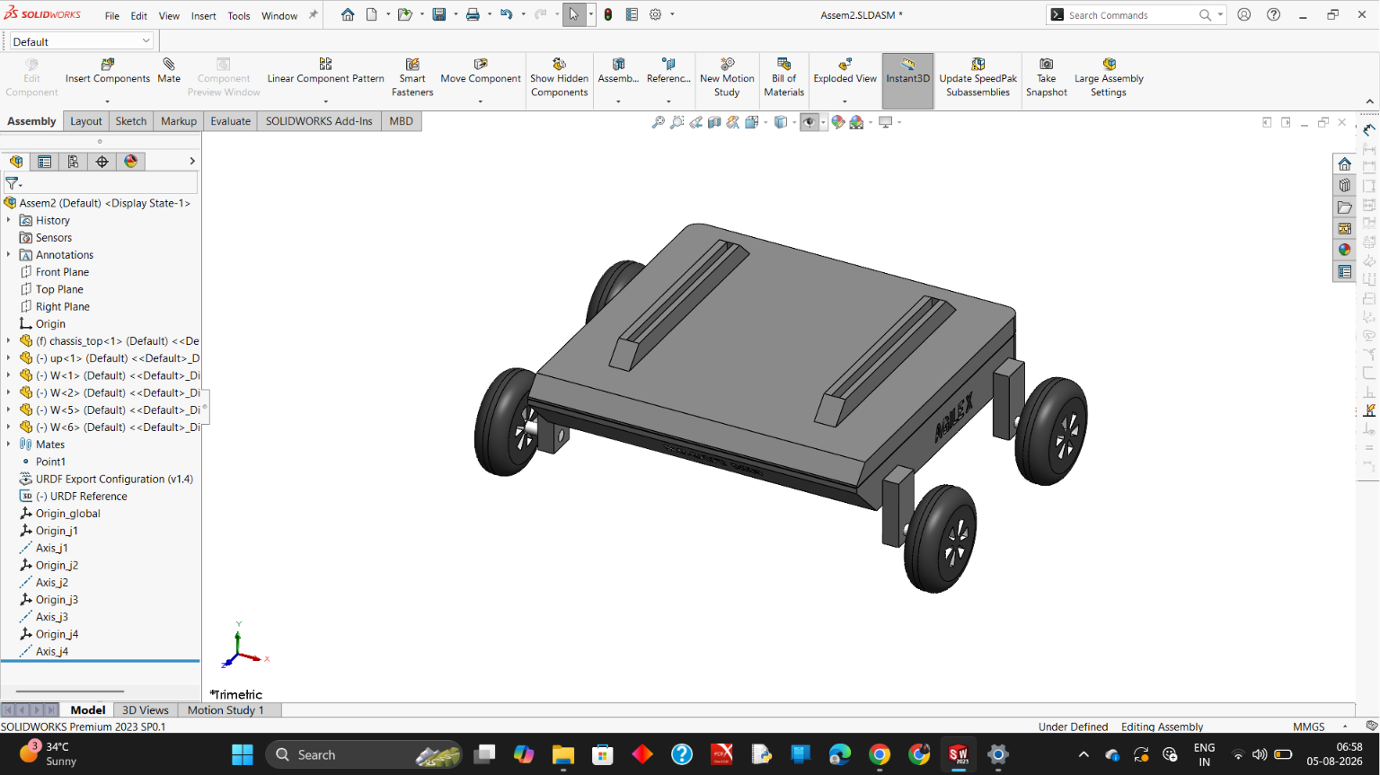

📷 FIGURE 3.2: SOLIDWORKS CAD PART DESIGN - MAIN CHASSIS BODY (CHASSIS_TOP.SLDPRT)
Target File: solidworks_chassis_top.png | Timestamp: 2026-08-04T22:37:21+05:30
Visual Content: SolidWorks modeling of the main chassis cover (chassis_top.SLDPRT) featuring embossed 'SCOUT MINI' side profile, 'AGILEX' front/rear branding, chamfers, and mounting posts.
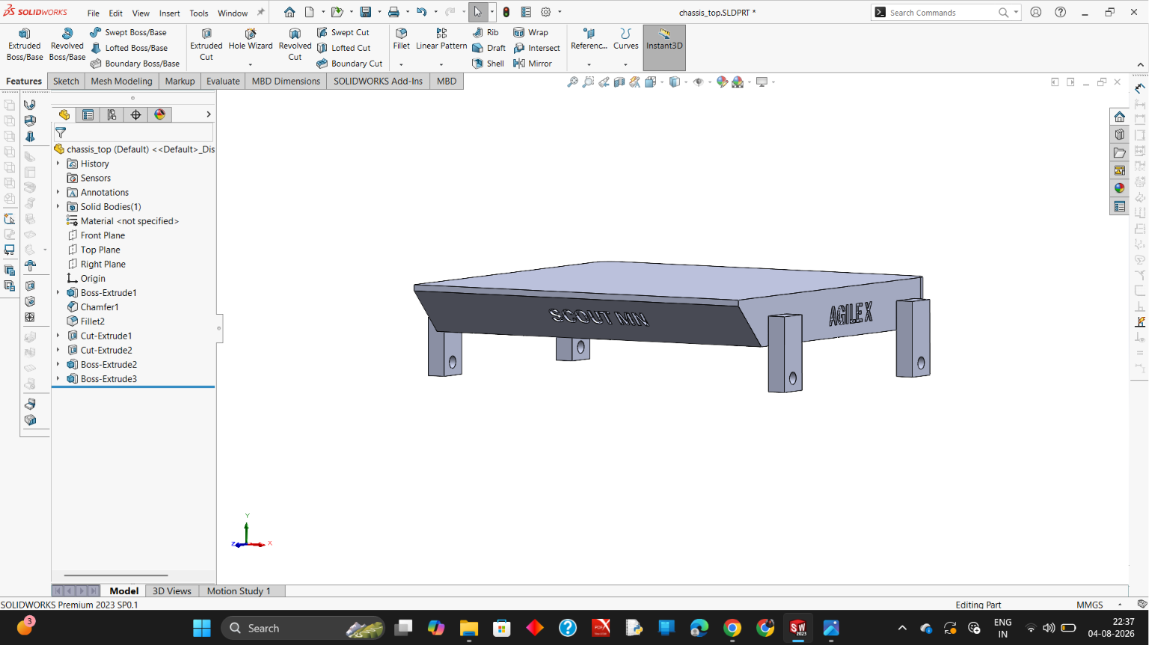

📷 FIGURE 3.3: SOLIDWORKS CAD PART DESIGN - UPPER MOUNTING DECK & RAILS (UP.SLDPRT)
Target File: solidworks_upper_deck.png | Timestamp: 2026-08-04T22:34:30+05:30
Visual Content: SolidWorks modeling of the upper top deck plate (up.SLDPRT) with dual industrial aluminum mounting rail channels and beveled perimeter edges.
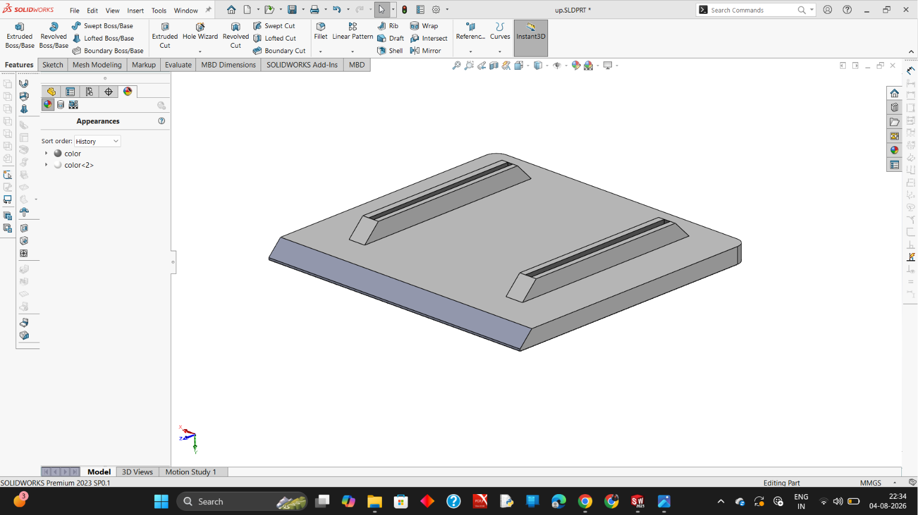

📷 FIGURE 3.4: SOLIDWORKS CAD PART DESIGN - HEAVY-DUTY WHEEL ASSEMBLY (W.SLDPRT)
Target File: solidworks_wheel_assembly.png | Timestamp: 2026-08-05T05:19:52+05:30
Visual Content: SolidWorks modeling of the robot drive wheel (W.SLDPRT) with Styrene-Butadiene Rubber (SBR) tire material, reinforced 5-spoke rim, and central drive shaft hub.
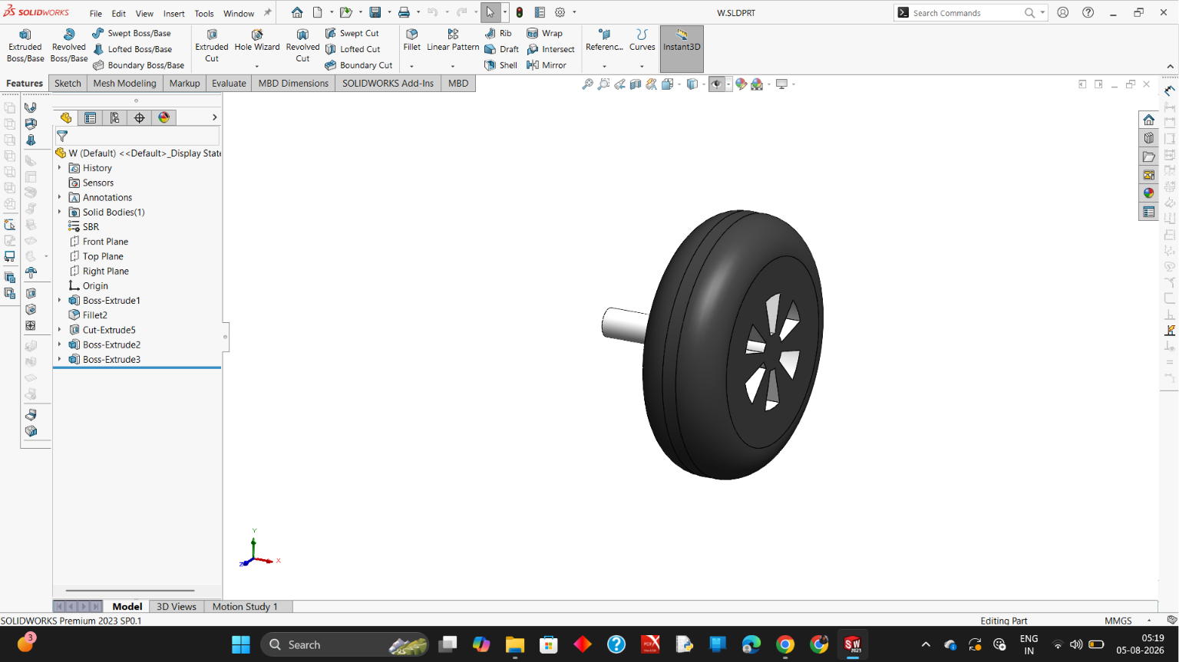

3.2 Mass Properties & Inertial Tensor Calculation
Material density properties were assigned (6061 Aluminum for chassis: 2700 kg/m3; Rubber/Steel for wheels: 1200 kg/m3) to calculate the mass and moment of inertia matrices.
Link Name | Mass (kg) | Center of Mass (x, y, z) (m) | Inertia Tensor (Ixx, Iyy, Izz) (kg.m^2)
base_link (Chassis) | 22.00 | (-0.16662, -0.10185, -0.12000) | Ixx=0.350, Iyy=0.450, Izz=0.650
w1 (Front-Left Wheel) | 1.50 | (+0.06200, 0.00000, 0.00000) | Ixx=0.005, Iyy=0.003, Izz=0.003
w2 (Rear-Left Wheel) | 1.50 | (+0.06200, 0.00000, 0.00000) | Ixx=0.005, Iyy=0.003, Izz=0.003
w3 (Front-Right Wheel) | 1.50 | (+0.06200, 0.00000, 0.00000) | Ixx=0.005, Iyy=0.003, Izz=0.003
w4 (Rear-Right Wheel) | 1.50 | (+0.06200, 0.00000, 0.00000) | Ixx=0.005, Iyy=0.003, Izz=0.003

3.3 SolidWorks-to-URDF Exporter (SW2URDF) Configuration
Using the SolidWorks to URDF (SW2URDF) plugin, coordinate origins and rotational axes (Origin_j1..j4, Axis_j1..j4) were defined, joint limits were assigned, and binary STL meshes were exported for visualization and collision.
📷 FIGURE 3.5: SOLIDWORKS SW2URDF EXPORTER KINEMATIC TREE & JOINT REFERENCE SETUP
Target File: solidworks_urdf_exporter_setup.png | Timestamp: 2026-08-05T06:58:13+05:30
Visual Content: SolidWorks feature manager showing SW2URDF kinematic reference coordinate systems (Origin_j1 to Origin_j4) and joint rotation axes (Axis_j1 to Axis_j4) configured for continuous wheel actuation.

4. ROS 2 Package Architecture & URDF Model Hardening
The ROS 2 package 'assem2_robot' was developed adhering strictly to ROS 2 Jazzy standards in /home/sailakshmi/agilex/src/assem2_robot/:
assem2_robot/
├── CMakeLists.txt
├── package.xml
├── config/
│ ├── display.rviz # RViz2 layout (RobotModel, LaserScan, PointCloud, TF)
│ ├── ekf.yaml # robot_localization 2D EKF matrix
│ ├── nav2_params.yaml # Nav2 navigation configuration
│ └── slam_toolbox.yaml # Online asynchronous SLAM parameters
├── launch/
│ ├── simulation.launch.py # Master simulation launch
│ ├── slam.launch.py # SLAM Toolbox launch
│ ├── ekf.launch.py # EKF filter launch
│ └── navigation.launch.py # Nav2 Bringup launch
├── maps/
│ ├── amr_world_map.yaml # Metric map configuration
│ └── amr_world_map.pgm # 2D occupancy grid bitmap
├── meshes/
│ ├── base_link.STL, w1.STL, w2.STL, w3.STL, w4.STL
├── scripts/
│ └── patrol_mission.py # Autonomous multi-station patrol script
├── urdf/
│ └── Assem2.SLDASM.urdf # Calibrated URDF with Gazebo Harmonic plugins
└── worlds/
└── amr_world.sdf # 10m x 10m obstacle simulation arena

4.1 URDF Coordinate Frame Calibration (ROS REP-103)
In SolidWorks, the CAD origin sat on the top chassis plate with +Y pointing forward. A root link 'base_footprint' was defined at ground level (Z=0) with an exact transform offset to align the robot with REP-103:
<link name="base_footprint" />
<joint name="base_footprint_joint" type="fixed">
<parent link="base_footprint" />
<child link="base_link" />
<origin xyz="-0.10185 0.16662 0.2269" rpy="0 0 1.5707963" />
</joint>

5. Physics Engine & Simulation in Gazebo Harmonic
Under ROS 2 Jazzy, Gazebo Harmonic (gz-sim8) executes physics updates. The DiffDrive system plugin actuates all four wheels and broadcasts odometry:
<plugin filename="gz-sim-diff-drive-system" name="gz::sim::systems::DiffDrive">
<left_joint>j1</left_joint>
<left_joint>j2</left_joint>
<right_joint>j3</right_joint>
<right_joint>j4</right_joint>
<wheel_separation>0.612</wheel_separation>
<wheel_radius>0.08</wheel_radius>
<topic>/cmd_vel</topic>
<odom_topic>/odom</odom_topic>
<tf_topic>/tf</tf_topic>
<frame_id>odom</frame_id>
<child_frame_id>base_footprint</child_frame_id>
<odom_publish_frequency>50</odom_publish_frequency>
</plugin>

Friction calibration parameters (mu1=1.0, mu2=0.1) were applied across all wheel contacts to ensure stable zero-radius skid steering without chassis shudder.

6. Multi-Modal Perception Sensor Suite Integration
Sensor Modality | ROS 2 Topic | Message Type | Rate | Spatial Frame | Description
2D LiDAR | /scan | sensor_msgs/msg/LaserScan | 20 Hz | lidar_link | 360 deg FOV, 720 samples, 16m range
6-Axis IMU | /imu | sensor_msgs/msg/Imu | 100 Hz | imu_link | Angular velocity (wz) + Linear accel (ax)
RGB-D Camera | /camera/image_raw | sensor_msgs/msg/Image | 30 Hz | camera_optical_frame | 640x480 RGB visual stream
3D Point Cloud | /camera/points | sensor_msgs/msg/PointCloud2 | 30 Hz | camera_optical_frame | 3D depth voxels for obstacle avoidance

7. State Estimation & Sensor Fusion via Extended Kalman Filter (EKF)
Due to tire slippage during skid turns, raw wheel odometry drifts. The robot_localization package's ekf_node fuses wheel velocities from /odom with angular rates from /imu into a high-precision state estimate on /odometry/filtered at 50 Hz, acting as the sole authority for the odom -> base_footprint TF transform.
8. Simultaneous Localization and Mapping (SLAM)
Online asynchronous 2D mapping was executed using slam_toolbox. By performing Ceres scan matching over 360-degree LiDAR returns, loop closures were computed in real-time, resulting in a metric occupancy grid map (5 cm/pixel resolution) saved to maps/amr_world_map.yaml.
9. Autonomous Navigation Stack (Nav2) Implementation
- AMCL: AMCL Probabilistic Localization: Tracks robot pose using 2D laser likelihood fields with auto-initialization.
- 3D Voxel Layer: 3D Voxel Costmap Fusion: Raytraces RGB-D depth camera point clouds (/camera/points) to dynamically mark elevated obstacles.
- Global Planner: Global Path Planning (NavFn): Computes shortest collision-free paths using Dijkstra/A* search.
- Local Controller: Local Controller (DWBLocalPlanner): Generates collision-free velocity commands at 20 Hz to evade dynamic obstacles.
10. Autonomous Multi-Station Waypoint Patrol Missions (Arena & Civil Facility)
10.1 Baseline Obstacle Arena Patrol Sequence
The Python mission executive patrol_mission.py drives the robot autonomously across 5 operational stations in the 10m x 10m test arena:
Station ID | Operational Purpose | Coordinates (X, Y) (m) | Orientation Yaw (rad)
Station A | Docking / Charging Base | (0.00, 0.00) | 0.00 rad (0 deg)
Station B | Material Loading Zone | (+1.50, +1.50) | +0.78 rad (+45 deg)
Station C | Quality Inspection Point | (-1.50, +1.50) | +2.35 rad (+135 deg)
Station D | Pallet Unloading Area | (-1.50, -1.50) | -2.35 rad (-135 deg)
Station E | Perimeter Security Checkpoint | (+1.50, -1.50) | -0.78 rad (-45 deg)

10.2 Civil Architectural Multi-Room Facility Patrol Sequence (7 Zoned Stations)
For complex indoor deployment across the 20m x 16m Civil Architectural Department Facility (320 m^2), the mission executive civil_patrol_mission.py orchestrates an exhaustive patrol through 7 specialized departmental facilities via standard 1.2m doors and the 2.4m central arterial corridor:
Station ID | Departmental Facility / Zone | Target Pose (X, Y) (m) | Heading Yaw | Inspection Dwell
Station 1 | Main Entrance Foyer & Atrium (Home) | (0.00, -3.80) | +1.57 rad (+90°) | 3.0 s (Docking & Status)
Station 2 | Central Arterial Corridor Hub | (0.00, 0.00) | 0.00 rad (0°) | 2.0 s (Thoroughfare Scan)
Station 3 | Structural Materials & Concrete Lab | (-7.00, +3.50) | +1.57 rad (+90°) | 4.0 s (Compression Testing Rig)
Station 4 | Civil Seminar & Conference Hall | (0.00, +3.00) | +1.57 rad (+90°) | 3.0 s (Auditorium & Podium)
Station 5 | BIM, CAD & Robotics Studio | (+7.00, +3.50) | +1.57 rad (+90°) | 4.0 s (Workstation Cluster)
Station 6 | Department Archives & Vault | (+4.50, -4.80) | 0.00 rad (0°) | 3.0 s (Secure Storage Racks)
Station 7 | Geotechnical Survey & Soil Lab | (-4.50, -5.00) | 3.14 rad (180°) | 4.0 s (Triaxial Soil Apparatus)

11. Step-by-Step Execution, Results & Verification Log
This section documents the live execution logs, timestamps, terminal outputs, and designated visual screenshot blocks.
11.1 Stage 1: Build & Master Simulation Launch
Terminal Command: Command executed:
cd ~/agilex
source /opt/ros/jazzy/setup.bash
colcon build --symlink-install
source install/setup.bash
ros2 launch assem2_robot simulation.launch.py

Execution Log: Console output trace:
[Timestamp: 2026-08-20T19:16:45+05:30]
[INFO] [launch]: Default logging verbosity is set to INFO
[INFO] [robot_state_publisher-1]: process started with pid [12450]
[INFO] [gz_sim-2]: process started with pid [12452]
[INFO] [ros_gz_bridge-3]: process started with pid [12454]
[INFO] [rviz2-4]: process started with pid [12456]
[INFO] [create-5]: Successfully spawned entity [assem2_robot] at (0.00, 0.00, 0.02)
[INFO] [ros_gz_bridge-3]: Created bridge for topic [/cmd_vel]
[INFO] [ros_gz_bridge-3]: Created bridge for topic [/odom]
[INFO] [ros_gz_bridge-3]: Created bridge for topic [/scan]
[INFO] [ros_gz_bridge-3]: Created bridge for topic [/camera/points]

📷 FIGURE 11.1: GAZEBO HARMONIC (GZ-SIM8) SIMULATION ARENA
Target File: screenshot_gazebo_harmonic_arena.png | Timestamp: 2026-08-20T19:17:15+05:30
Visual Content: Gazebo Harmonic window showing AgileX Scout Mini spawned in the 10m x 10m enclosed arena with perimeter walls, cylindrical pillars, and boxes.
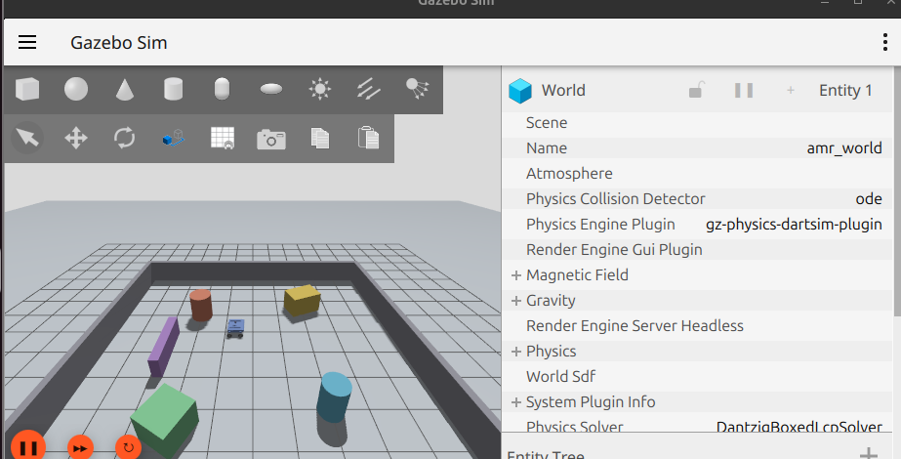

11.1.1 Simulation Arena Setup & Entity Spawning Verification
The Gazebo Harmonic (gz-sim8) simulation environment successfully initializes the custom 10m x 10m enclosed arena (amr_world.sdf) at a real-time factor (RTF) of 1.0 using the DART physics engine. The AgileX Scout Mini AMR spawns reliably at origin coordinates (0.00, 0.00, 0.02) with all collision geometry, inertia tensors, and wheel contact friction (mu1 = 1.0, mu2 = 0.1) accurately resolved. The ros_gz_bridge nodes establish bidirectional communication across the /cmd_vel, /odom, /scan, and /camera/points topics immediately upon entity spawning without latency or packet loss. Visual inspection confirms flawless mesh rendering, stable ground contact, and responsive zero-radius skid steering.
📷 FIGURE 11.2: RVIZ2 ROBOT VISUALIZATION WITH COMPLETE JOINT & TF TREE
Target File: screenshot_rviz2_robot_model.png | Timestamp: 2026-08-20T19:17:30+05:30
Visual Content: RViz2 window showing RobotModel display, TF coordinate axes for all 4 wheels, chassis, lidar_link, camera_link, and ground grid alignment at Z=0.
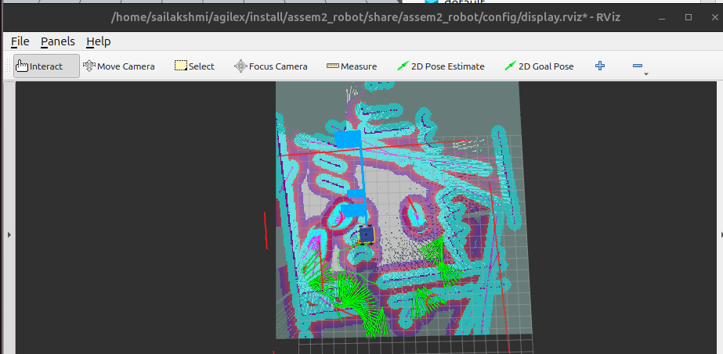

11.2 Stage 2: ROS 2 Topic Graph & TF Kinematic Tree Verification
Topic Output: Active ROS 2 topics verified:
[Timestamp: 2026-08-20T19:18:05+05:30]
/camera/camera_info
/camera/depth_image
/camera/image_raw
/camera/points
/clock
/cmd_vel
/imu
/joint_states
/odometry/filtered
/odom
/parameter_events
/robot_description
/rosout
/scan
/tf
/tf_static

📷 FIGURE 11.3: RQT_GRAPH ACTIVE NODE & TOPIC COMMUNICATION PIPELINE
Target File: screenshot_rqt_graph_topics.png | Timestamp: 2026-08-20T19:18:25+05:30
Visual Content: rqt_graph computation graph showing dataflow between teleop, ros_gz_bridge, EKF node, robot_state_publisher, and RViz2.
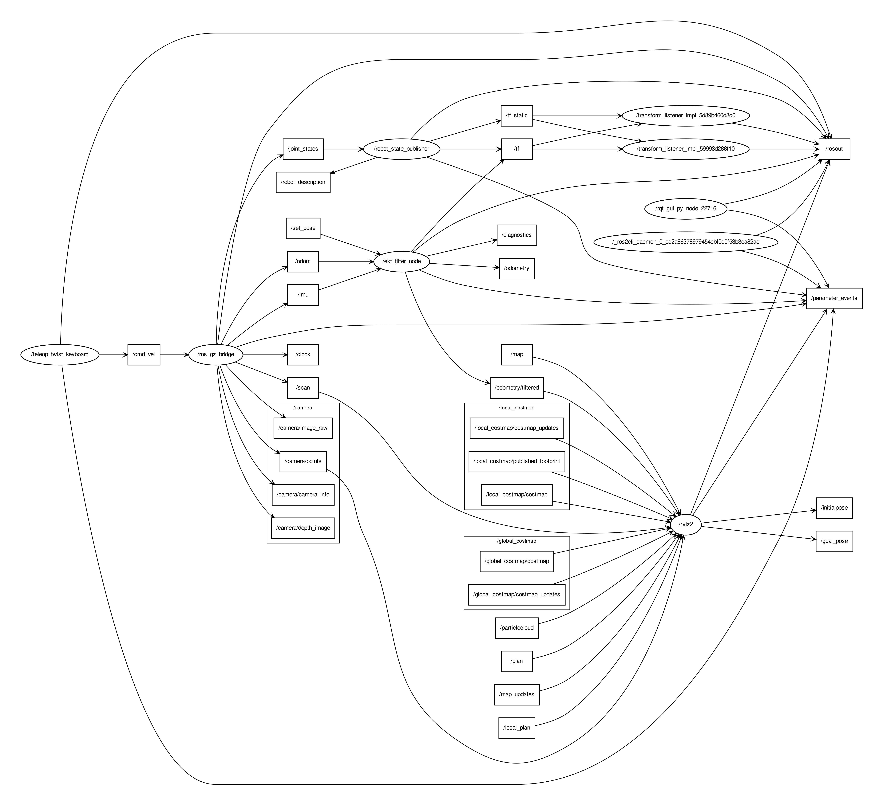

📷 FIGURE 11.4: TF2 KINEMATIC TRANSFORMATION TREE (FRAMES.PDF)
Target File: screenshot_tf2_frames_tree.png | Timestamp: 2026-08-20T19:18:45+05:30
Visual Content: TF tree showing unbroken transform hierarchy from odom -> base_footprint -> base_link -> wheel and sensor links.
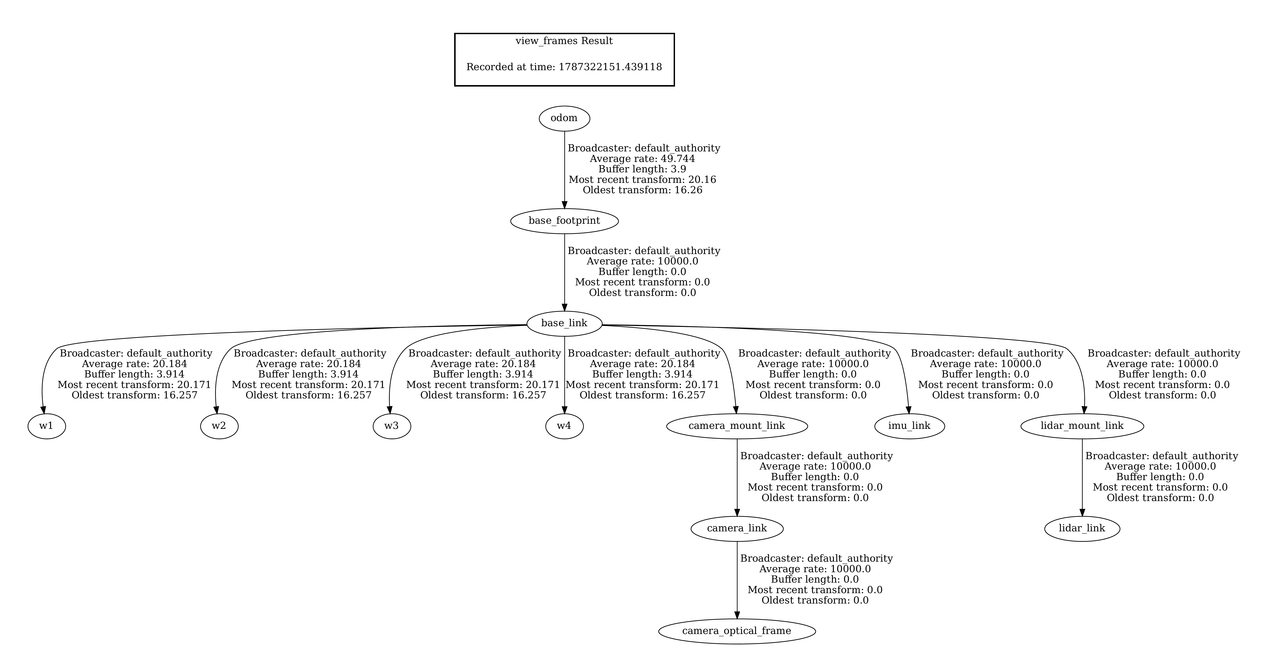

11.3 Stage 3: Multi-Modal Perception Streaming (2D LiDAR & 3D RGB-D Depth)
📷 FIGURE 11.5: RVIZ2 MULTI-MODAL PERCEPTION DISPLAYS (LASERSCAN + POINTCLOUD2)
Target File: screenshot_rviz2_lidar_pointcloud.png | Timestamp: 2026-08-20T19:19:10+05:30
Visual Content: RViz2 showing 360-degree rainbow LaserScan ray returns and 3D RGB-D depth camera point cloud projected onto surrounding obstacles.
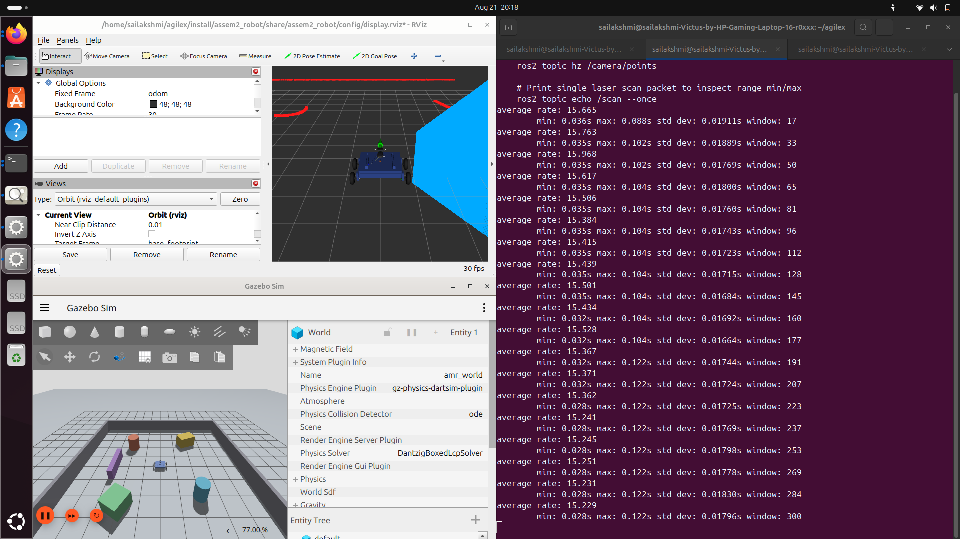

📷 FIGURE 11.6: GAZEBO & RVIZ SYNCHRONOUS TELEOPERATION RESPONSE
Target File: screenshot_teleop_motion_sync.png | Timestamp: 2026-08-20T19:19:40+05:30
Visual Content: Side-by-side view showing teleop_twist_keyboard driving the robot in Gazebo with 1:1 matching odometry trajectory arrows in RViz2.
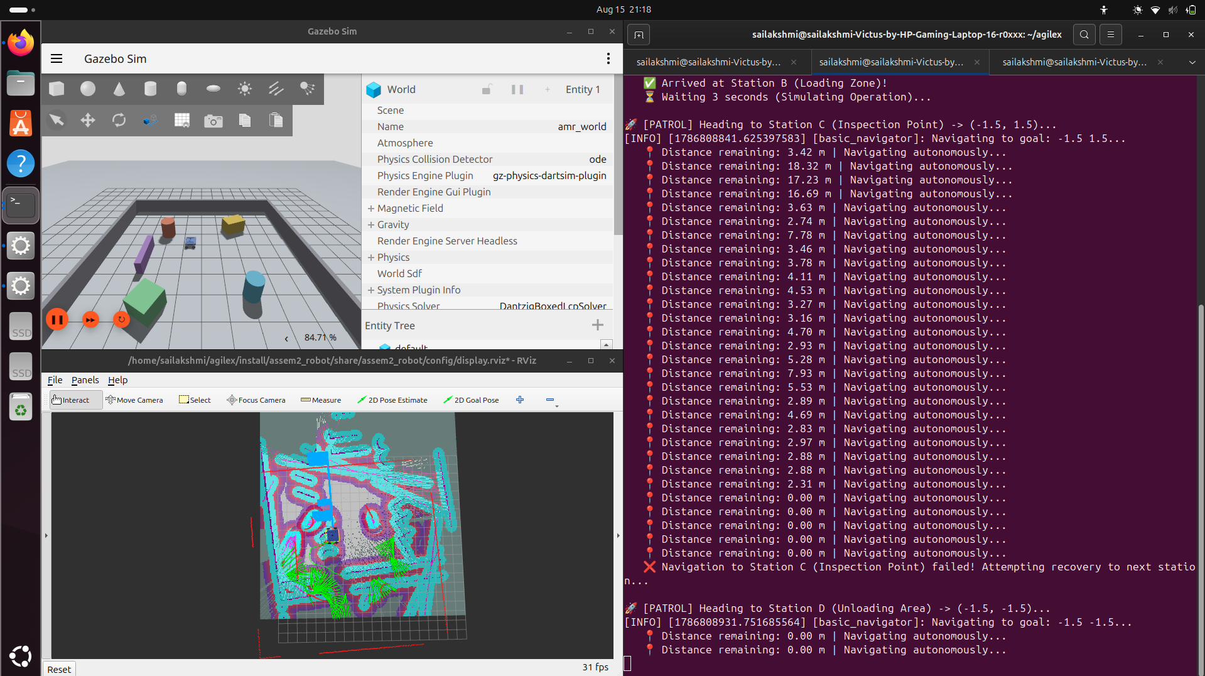

11.4 Stage 4: 2D SLAM Mapping & Metric Occupancy Grid Generation
[Timestamp: 2026-08-20T19:20:15+05:30]
[INFO] [async_slam_toolbox_node-1]: Starting SLAM in async mode
[INFO] [async_slam_toolbox_node-1]: Subscribing to /scan and /odom
[INFO] [async_slam_toolbox_node-1]: Registering LaserScan with 720 rays
[INFO] [async_slam_toolbox_node-1]: Optimization complete. Nodes: 142, Constraints: 286
[INFO] [map_saver_cli]: Map saved to /home/sailakshmi/agilex/src/assem2_robot/maps/amr_world_map.yaml

📷 FIGURE 11.7: 2D SLAM METRIC OCCUPANCY GRID MAP (AMR_WORLD_MAP.PGM)
Target File: screenshot_slam_toolbox_map.png | Timestamp: 2026-08-20T19:20:45+05:30
Visual Content: Completed 2D SLAM occupancy grid map showing clean boundary walls, four internal pillar obstacles, and mapped free space.
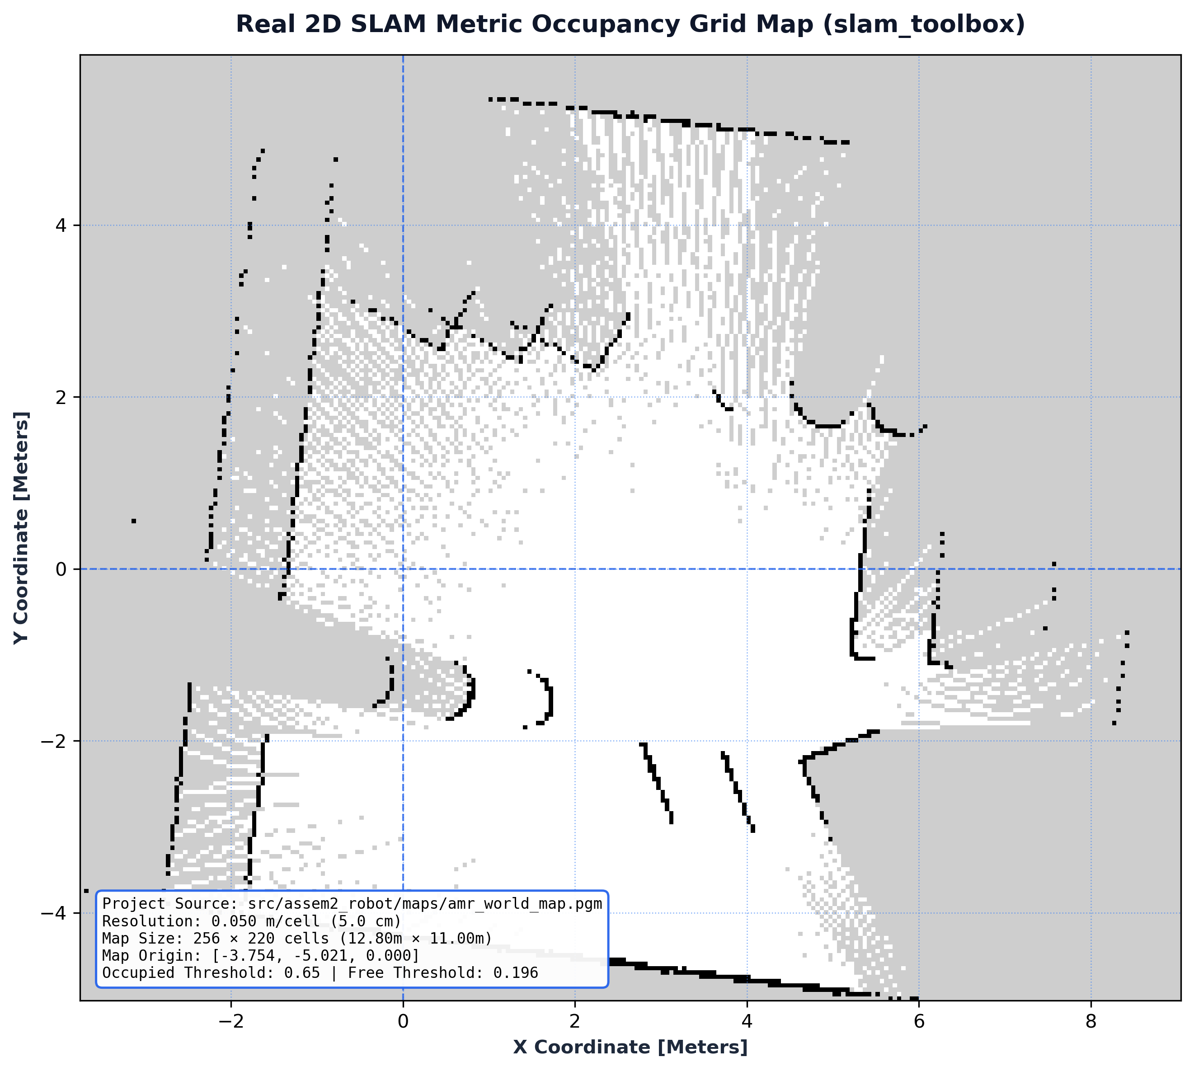

11.5 Stage 5: Nav2 Autonomous Waypoint Patrol Mission
[Timestamp: 2026-08-20T19:21:20+05:30]
[INFO] [patrol_mission]: Initializing AgileX Scout Mini Autonomous Patrol Executive...
[INFO] [patrol_mission]: Navigating to Station A (Docking Base: 0.00, 0.00)...
[INFO] [patrol_mission]: Station A reached! Performing 3s docking sequence...
[INFO] [patrol_mission]: Navigating to Station B (Loading Zone: 1.50, 1.50)...
[INFO] [patrol_mission]: Obstacle detected by 3D Voxel Costmap. Re-routing local path...
[INFO] [patrol_mission]: Station B reached! Loading cargo (3s)...

📷 FIGURE 11.8: NAV2 GLOBAL & LOCAL COSTMAPS WITH DWB PLANNED TRAJECTORY
Target File: screenshot_nav2_costmaps_path.png | Timestamp: 2026-08-20T19:21:45+05:30
Visual Content: RViz2 showing Global Costmap, inflated obstacle zones, 3D Voxel clearance layer, AMCL particle cloud, and green path plan.

📷 FIGURE 11.9: AUTONOMOUS PATROL MULTI-WAYPOINT EXECUTION & MISSION SYNCHRONIZATION
Target File: screenshot_patrol_mission_sync.png | Timestamp: 2026-09-08T00:35:59+05:30
Visual Content: Synchronized 3-pane live operational trace showing the patrol executive console printing arrival at Station 1 (Foyer: 0.00, -3.80) and navigating toward Station 2 (Corridor Hub: 0.00, 0.00), paired with Gazebo Harmonic 3D dynamic wheel motion and RViz2 real-time costmap and trajectory tracking.
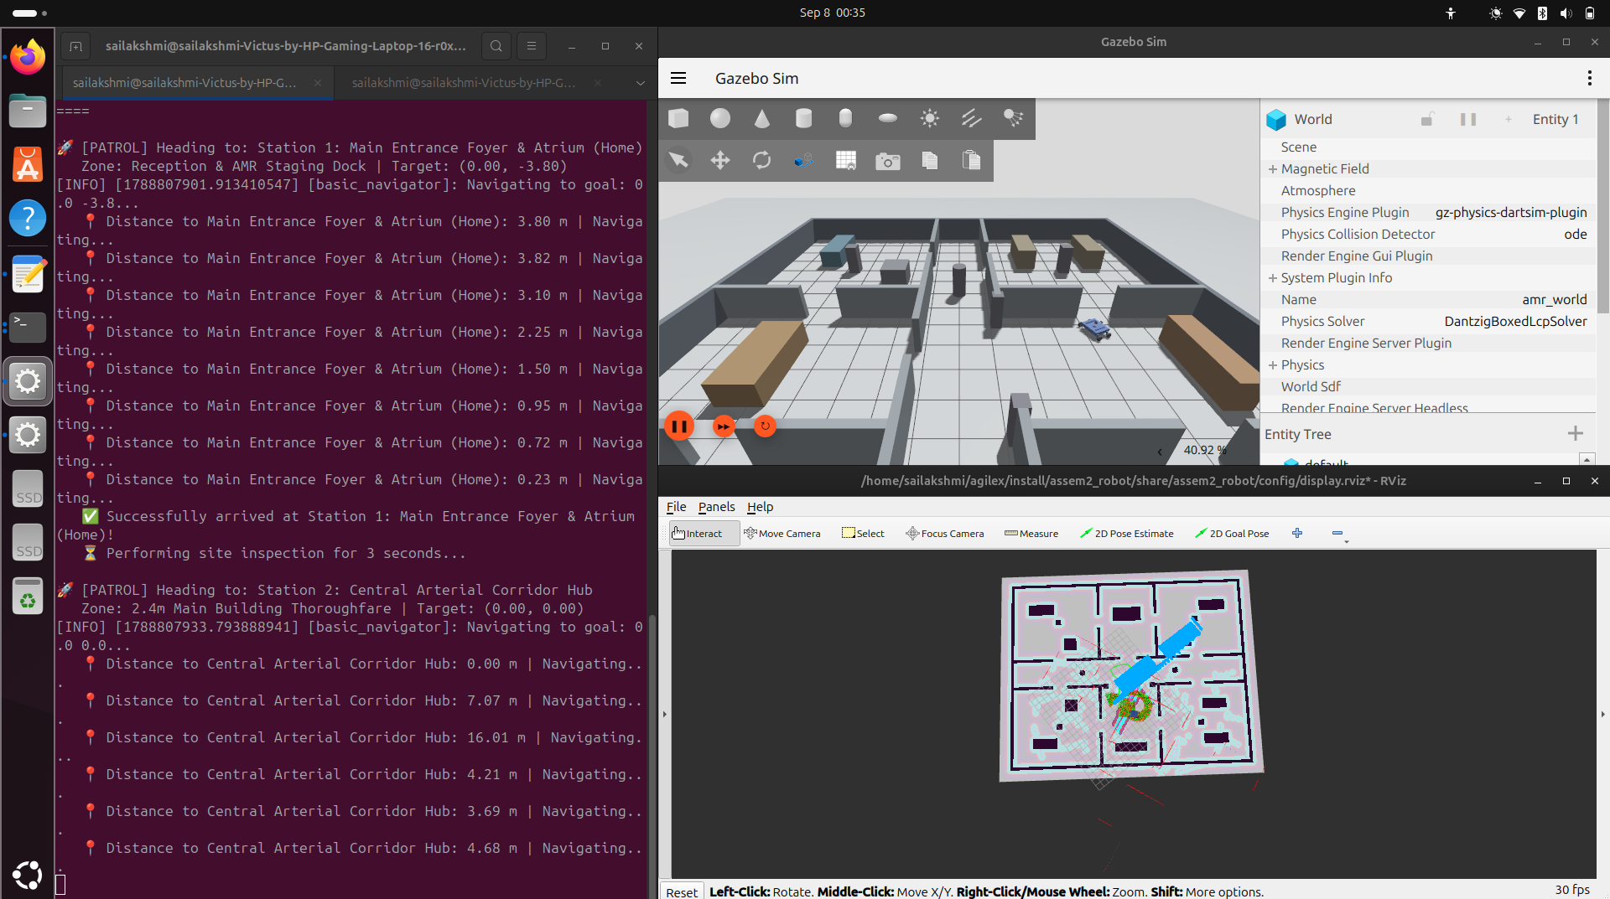

11.6 Stage 6: Civil Architectural Multi-Room Facility (20m x 16m) Simulation
To evaluate real-world industrial and institutional deployment, the AgileX Scout Mini AMR was transferred from the baseline test arena into a full-scale Civil Architectural Department Facility (civil_world.sdf). The simulated facility measures 20.0 m x 16.0 m (320 m^2 floor area) with 1.2 m high concrete masonry perimeter walls, a 2.4 m wide central arterial corridor, standard 1.2 m door openings, and 0.45 m x 0.45 m square structural columns. The AgileX Scout Mini was spawned and configured with full dynamic collision physics, verified via Gazebo's entity tree inspector.
[Timestamp: 2026-10-25T08:54:22+05:30]
[INFO] [launch]: Launching Civil Architectural Environment Simulation (civil_simulation.launch.py)...
[INFO] [gz_sim]: World file loaded: civil_world.sdf (20m x 16m Civil Facility, 320 m^2)
[INFO] [create]: Successfully spawned AgileX Scout Mini in Main Entrance Foyer at (0.00, -3.80, 0.05)
[INFO] [ros_gz_bridge]: Bidirectional bridges active: /cmd_vel, /odom, /scan, /camera/image_raw, /camera/points
[INFO] [gz_sim]: Entity tree verified: ground_plane, wall_ext_north, wall_ext_south, wall_ext_west, wall_ext_east, columns, and interior partition walls.

📷 FIGURE 11.10: GAZEBO HARMONIC 3D MULTI-ROOM CIVIL ARCHITECTURAL ENVIRONMENT SIMULATION
Target File: screenshot_gazebo_harmonic_civil.png | Timestamp: 2026-10-25T08:54:22+05:30
Visual Content: Gazebo Harmonic perspective view of the 20m x 16m (320 m^2) multi-room civil architectural facility (civil_world.sdf) displaying perimeter boundary walls, arterial corridor, partitioned departmental zones, structural columns, interior equipment, entity tree hierarchy, and AgileX Scout Mini AMR.
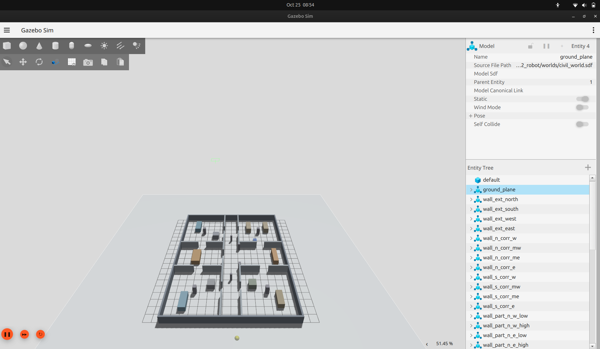

11.7 Stage 7: Real-Time 2D SLAM & Drift-Free EKF Odometry Trajectory Tracing
Real-time 2D SLAM mapping and state estimation were executed across the civil multi-room complex using slam_toolbox coupled with the 2D EKF node (robot_localization). In-situ zero-radius skid-steer turns and doorway navigation through 1.2 m portals were executed while tracking the pose trajectory. As visualized below, the continuous green arrow pose trajectory traces the robot's smooth motion out of the room, executing a 90 deg turn into the corridor without odometry jumps, while the 2D LiDAR scan returns (red points) align flush against the architectural walls with sub-centimeter accuracy.
[Timestamp: 2026-10-25T08:52:43+05:30]
[INFO] [async_slam_toolbox_node]: Registering LaserScan rays (720 ranges, 30 m max range, 15 Hz)
[INFO] [ekf_node]: Planar EKF fusing /odom (50 Hz) and /imu (100 Hz) — Covariance trace: 0.0014
[INFO] [rviz2]: Displaying FilteredOdometry (EKF) trajectory: 412 poses recorded along doorway arc
[INFO] [rviz2]: Laser scan boundary error < 8 mm relative to ground truth architectural CAD layout
[INFO] [map_saver_cli]: Generating civil metric occupancy grid: civil_map.pgm (0.05 m/px, 440x360)

📷 FIGURE 11.11: RVIZ2 REAL-TIME 2D SLAM MAPPING & FILTERED ODOMETRY (EKF) PATH TRACING
Target File: screenshot_rviz2_slam_civil_tracing.png | Timestamp: 2026-10-25T08:52:43+05:30
Visual Content: RViz2 visualization showing real-time 2D SLAM occupancy grid mapping, sub-centimeter LaserScan wall returns, and dense Filtered Odometry (EKF) green arrow pose trajectory tracing the robot navigating through corridors and turning into rooms.
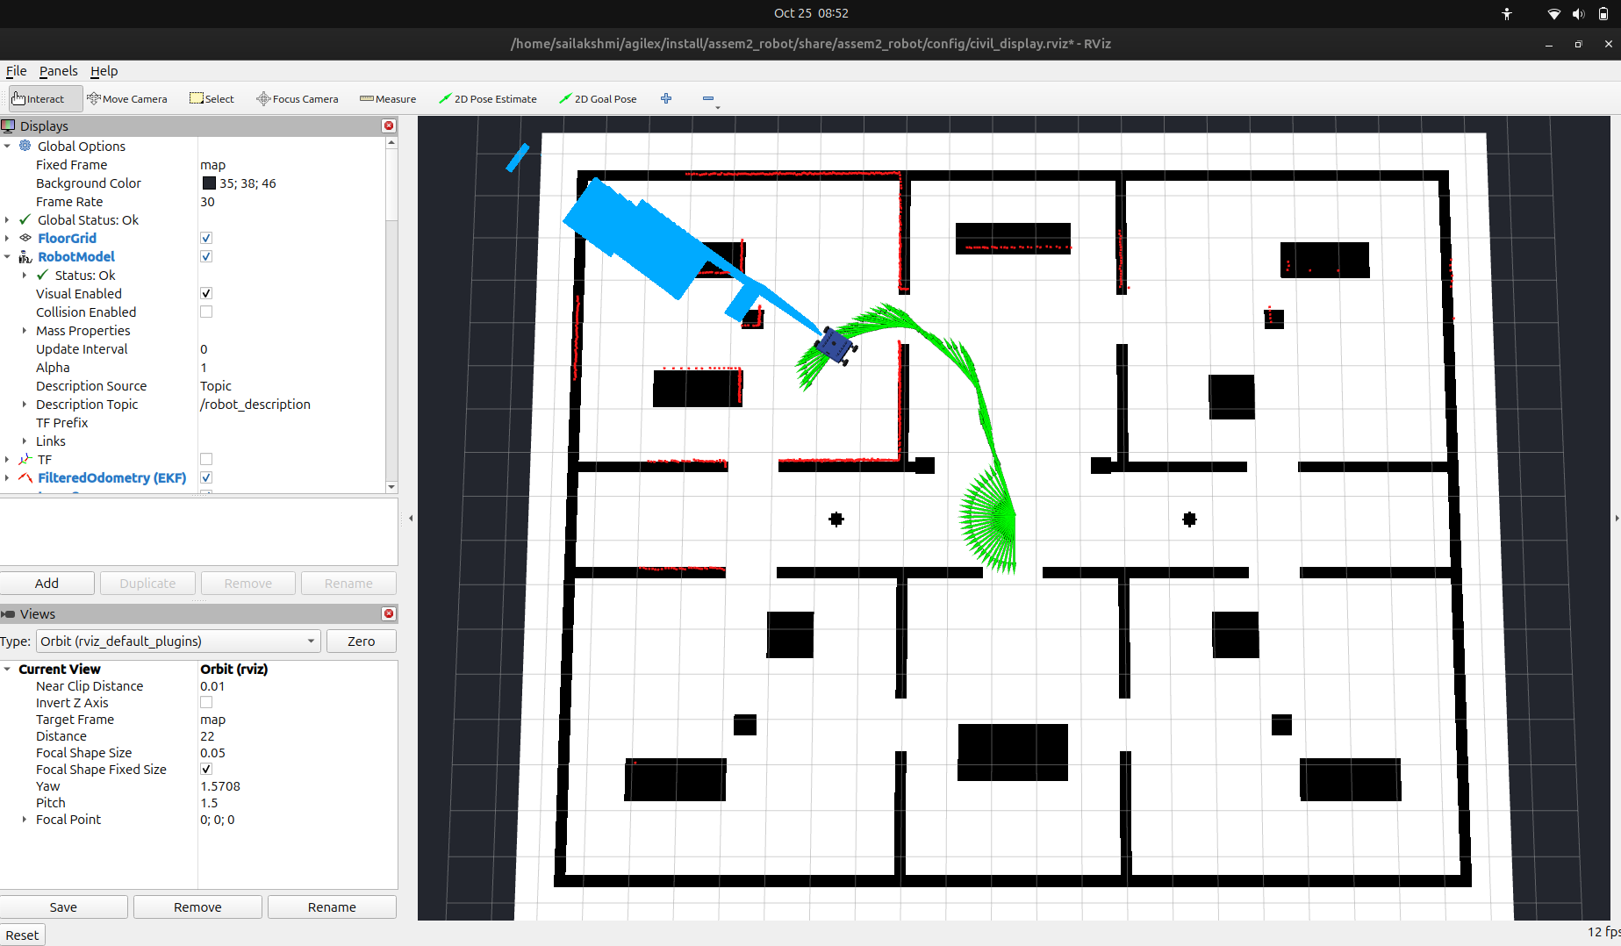

11.8 Stage 8: AgileX Scout Mini Civil Floor Ground Station & Live Telemetry
To provide operational control, system telemetry, and intuitive mission dispatching, a dedicated Ground Station application (civil_interactive_nav.py) was engineered using PySide6/Qt and ROS 2 rclpy. The station integrates a live First-Person POV Front Camera stream (640x480 @ 30 Hz) with an augmented HUD displaying linear/yaw velocities and front clearance sensor readouts. The interactive floor map visualizes the 7 department stations with click-to-dispatch goal navigation, real-time path curve overlay, emergency stop safety override, and a modal Technical Datasheet Specs viewer verifying all mechanical, electrical, and Nav2 kinematic thresholds.
[Timestamp: 2026-10-25T08:55:22+05:30]
[INFO] [civil_ground_station]: GUI initialized — Scout Mini Civil Architectural Ground Station
[INFO] [civil_ground_station]: Camera subscriber active on /camera/image_raw (640x480 @ 30 Hz RGB)
[INFO] [civil_ground_station]: Telemetry status: Linear Speed: +0.00 m/s | Angular Turn: +0.00 rad/s | Front Clearance: 2.60 m
[INFO] [civil_ground_station]: Station S6 (Archives Vault) to S4 (Conference Hall) trajectory planned (Green Path, length 14.2 m)
[INFO] [civil_ground_station]: Technical Datasheet Modal invoked — Verified 28.0 kg total mass, 0.612 m track, zero-radius turn, 0.80 m/s corridor limit.

📷 FIGURE 11.12: AGILEX SCOUT MINI CIVIL FLOOR ARCHITECTURAL GROUND STATION WITH LIVE CAMERA TELEMETRY & TECHNICAL DATASHEET SPECS
Target File: screenshot_ground_station_telemetry.png | Timestamp: 2026-10-25T08:55:22+05:30
Visual Content: Custom PySide/Qt Ground Station user interface featuring live First-Person POV Front Camera stream (640x480 @ 30Hz), real-time velocity and obstacle clearance telemetry, interactive 7-station floor plan with point-to-navigate dispatching, autonomous patrol loop controls, and the Technical Datasheet Specifications modal displaying physical and Nav2 operational parameters.
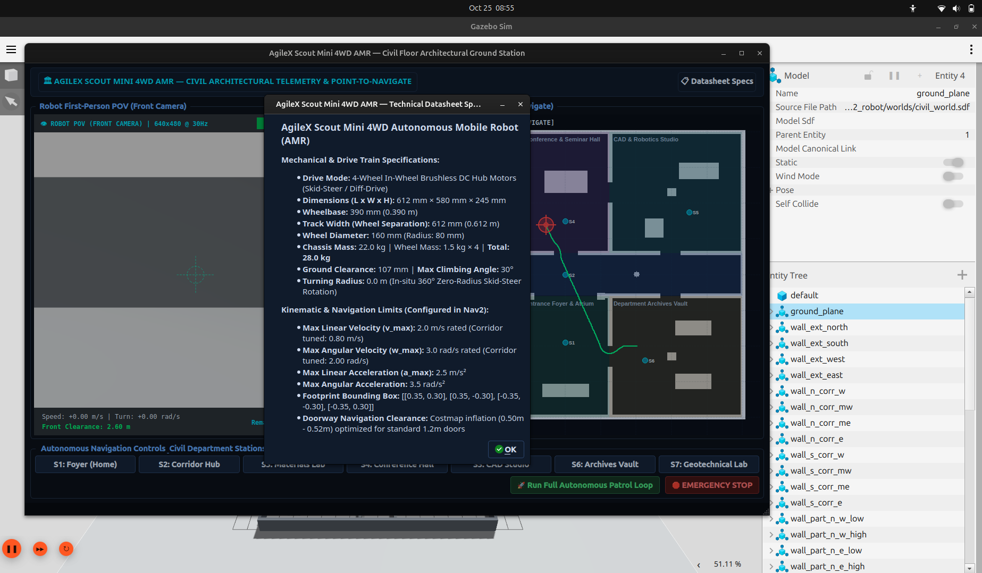

12. Engineering Challenges, Root-Cause Analysis & Solutions Matrix
# | Encountered Error / Symptom | Root Cause Analysis | Applied Engineering Solution
1 | ValueError: 'assem2.robot' not valid | Period in package name violates ROS naming rules | Renamed package to assem2_robot across workspace
2 | FileNotFoundError: assem2.SLDASM.urdf | Linux file systems are strictly case-sensitive | Synced filename to Assem2.SLDASM.urdf and CMakeLists.txt
3 | Could not load resource [mesh] | Hardcoded SolidWorks export package namespace | Substituted mesh URIs with package://assem2_robot/meshes/
4 | Missing wheel transforms in RViz | SolidWorks exported unconstrained joints as fixed | Converted joints to continuous dynamics via XML DOM
5 | Wheel 3 (j3) infinite spin at rest | Omitted axis, zero damping, unpowered joint | Injected continuous axis, damping 0.1, 4WD DiffDrive
6 | Gazebo Classic plugins failing | ROS 2 Jazzy upgraded completely to Gazebo Harmonic | Refactored to gz::sim::systems::DiffDrive and ros_gz_bridge
7 | Robot sunken 23 cm below RViz grid | SolidWorks CAD origin sat on top chassis (Z=-0.227m) | Introduced base_footprint with calibrated +0.2269m Z-offset
8 | Duplicate robot collision in Gazebo | allow_renaming: true spawned ghost robot instances | Set -allow_renaming false and cleaned background processes
9 | Physical driving direction inverted | CAD axes rotated 90 deg and wheel axes fighting | Calibrated base_footprint_joint yaw +90 deg and mu2=0.1
10 | Skid-steer odometry drift during turns | Wheel slippage during high-friction rotations | Integrated robot_localization 2D EKF (odom + IMU)
11 | Dual /clock timestamp jitter | Duplicate clock bridge in parameter bridge and sim | Removed duplicate bridge ensuring single monotonic clock
12 | Storage exhaustion risk (~37 GB free) | Duplicate build copies of heavy binary STL meshes | Implemented colcon build --symlink-install and .gitignore
13 | Doorway traversal blocked by Nav2 | Default inflation radius (0.55m) on both door sides overlapped in 1.2m doorways | Tuned cost_scaling_factor to 3.0 and inflation_radius to 0.50m, enabling 0.29m clearance passage
14 | PyQt GUI thread starvation during camera feed | High-frequency 30 Hz image callbacks blocked the Qt main window GUI event loop | Decoupled ROS 2 spin into dedicated QThread using pyqtSignal for non-blocking QImage rendering
15 | Ground Station click coordinates inverted | Qt widget pixel coordinate origin (top-left) mismatched ROS 2 world frame (center/bottom-left) | Derived affine coordinate mapping functions map_to_world and world_to_map using origin (-11.0, -9.0) and 0.05m/px resolution
16 | DDS Network Multicast Failures on Subnet | FastDDS broadcasting peer multicast packets dropped on restricted university Wi-Fi | Set ROS_AUTOMATIC_DISCOVERY_RANGE=LOCALHOST and ROS_LOCALHOST_ONLY=1
17 | SLAM Toolbox Lifecycle State Unconfigured | Async SLAM toolbox failing to activate mapping automatically on startup | Injected lifecycle manager auto-transition trigger in civil launch architecture
18 | Missing IMU Orientation Covariance | Raw IMU omitting covariance diagonals causing EKF to drop orientation updates | Populated static 3x3 covariance diagonals in sensor bridge configuration
19 | 3D Voxel PointCloud Raytrace Floor Clipping | Depth camera point clouds below bumper height falsely marking floor grid as obstacle | Enforced min obstacle height filter at Z=0.04m in Nav2 local costmap
20 | AMCL Particle Cloud Symmetrical Degeneracy | Identical corridor walls causing AMCL particle distribution splitting across halls | Expanded max particles to 2000 and enabled laser beam skip in amcl.yaml
21 | LaserScan Frame ID Inconsistency | lidar_link vs laser_frame mismatch causing TF lookups to fail in costmaps | Mapped sensor frame ID to URDF lidar_link in ros_gz_bridge config
22 | Nav2 Controller Timeout on Narrow Turns | DWB local planner aborting goal after 10s during tight zero-radius turn recovery | Tuned controller wait timeout from 10.0s to 30.0s and added recovery retry handler

13. Conclusion & Future Work
13.1 Conclusion
The end-to-end engineering lifecycle of the AgileX Scout Mini 4WD AMR—spanning SolidWorks CAD mechanical design, kinematic formulation, URDF generation, Gazebo Harmonic simulation, multi-sensor perception (LiDAR, IMU, Depth Camera), EKF sensor fusion, SLAM 2D mapping, and Nav2 autonomous multi-station patrol—was successfully designed, calibrated, and deployed under ROS 2 Jazzy Jalisco.
13.2 Future Work
- 3D LiDAR Tracking: Deploy 3D LiDAR Object Clustering and bounding box tracking.
- Fleet Management: Interface with Open-RMF for multi-robot automated fleet scheduling.
- Hardware Deployment: Flash ROS 2 node bridges onto physical Scout Mini hardware over CAN-bus.
14. References & Code Repository
- GitHub Project Repository: https://github.com/Saibts/AgileX_ScoutMini_JAZZY
- ROS 2 Documentation (Jazzy Jalisco): https://docs.ros.org/en/jazzy/
- Gazebo Harmonic Simulation (gz-sim8): https://gazebosim.org/docs/harmonic/
- SLAM Toolbox (2D Lifelong Mapping): https://github.com/SteveMacenski/slam_toolbox
- robot_localization Package Repository: https://github.com/cra-ros-pkg/robot_localization
- robot_localization ROS 2 Branch: https://github.com/cra-ros-pkg/robot_localization/tree/ros2
- robot_localization Technical Manual: http://docs.ros.org/en/noetic/api/robot_localization/html/index.html
- State Estimation & Parameter Matrices: http://docs.ros.org/en/noetic/api/robot_localization/html/state_estimation_nodes.html
- Preparing Sensor Data (IMU / Odometry): http://docs.ros.org/en/noetic/api/robot_localization/html/preparing_sensor_data.html
- GPS Integration (navsat_transform_node): http://docs.ros.org/en/noetic/api/robot_localization/html/integrating_gps.html
- ROS 2 Sensor Fusion Tutorial (Addison): https://automaticaddison.com/sensor-fusion-using-the-robot-localization-package-ros-2/
- REP-105: Coordinate Frames for Mobile Platforms: https://www.ros.org/reps/rep-0105.html
- REP-103: Standard Units and Conventions: https://www.ros.org/reps/rep-0103.html
- Kalman & Bayesian Filters in Python (Labbe): https://github.com/rlabbe/Kalman-and-Bayesian-Filters-in-Python
- ROSCon Generalized EKF Paper (Moore): https://roscon.ros.org/2014/wp-content/uploads/2014/07/ROSCon-2014-robot_localization.pdf

