Mason Walls

CPRE 489

Lab 4: GENI

What I learned:

Prior to the lab, I had never used GENI before. After working through the lab, I have learned what GENI can do, and how it could be useful for running tests on a sample network before deployment. The first thing I learned was how to view the logs of an apache server. This allowed me to look at any connections that had been made, and how much data has been sent, and what the bandwidth of the connect was.

A second thing I learned was more about internet connection and network adapters. One of the questions required for lab was what connections can be made for each interface. Using traceroute and ping helped me understand better how to determine what IP addresses were doing what. This helped me understand the importance of why server admin access needs to be on a private address instead of a public internet address. This provides better security for the server when an admin needs to connect and make changes.

Exercises:

1. 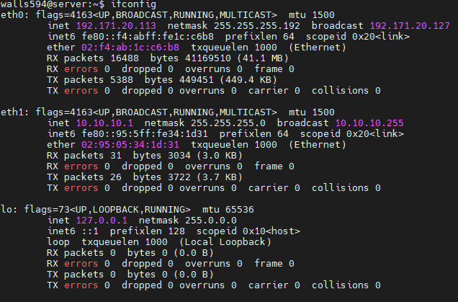

Shown here is the screenshot of my connection to the given GENI server. You can see there is 2 ethernet devices and the default loop back address.

1. 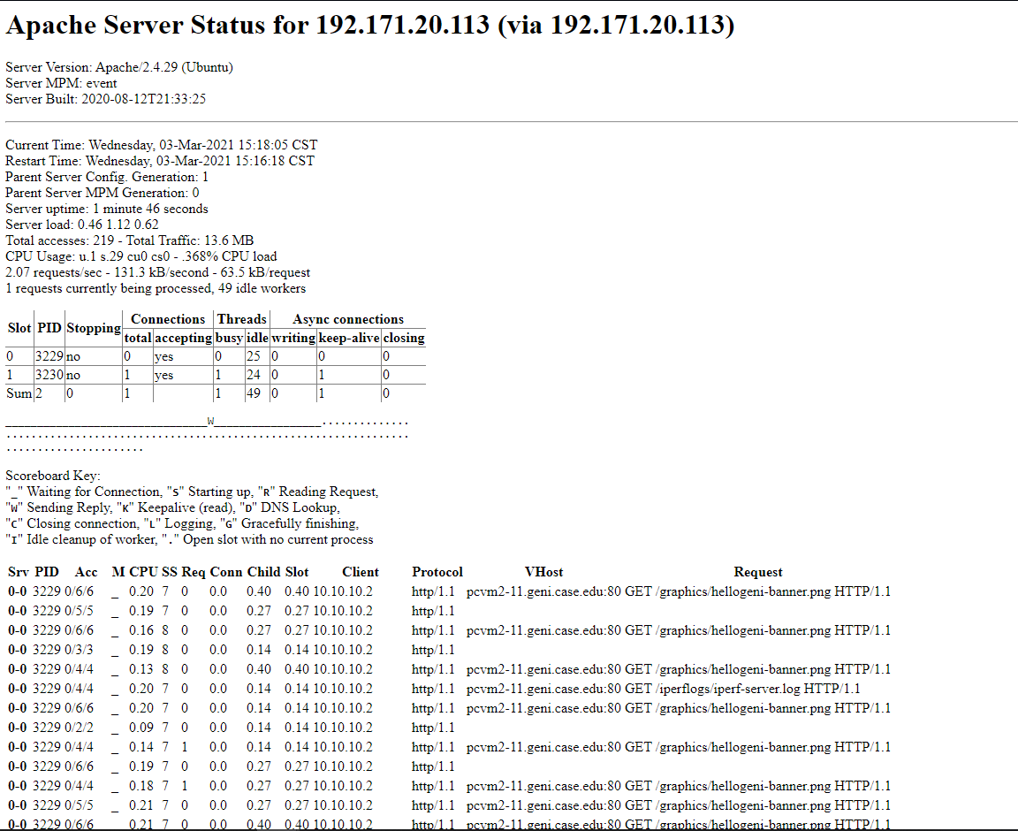

Here is my screenshot of the web statistics from the created apache server. Each time I refreshed, I was able to see the total accesses increase, and after a while the total traffic would increase as well.

1. 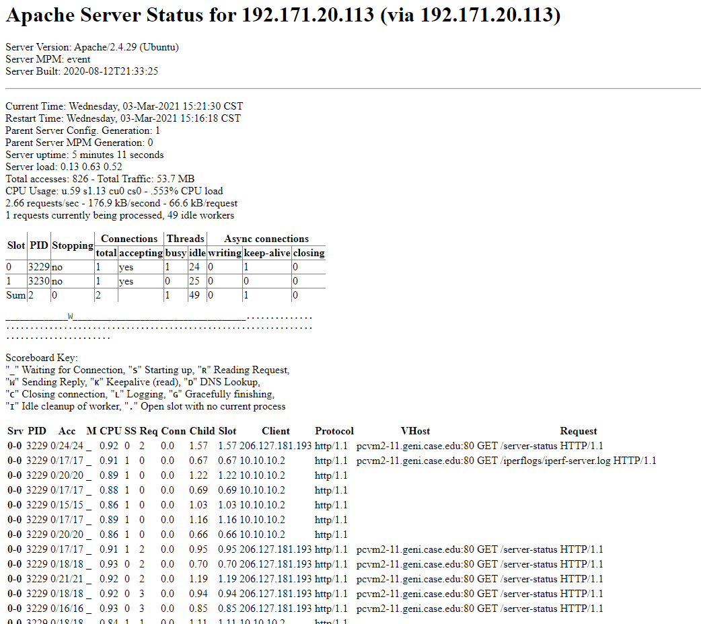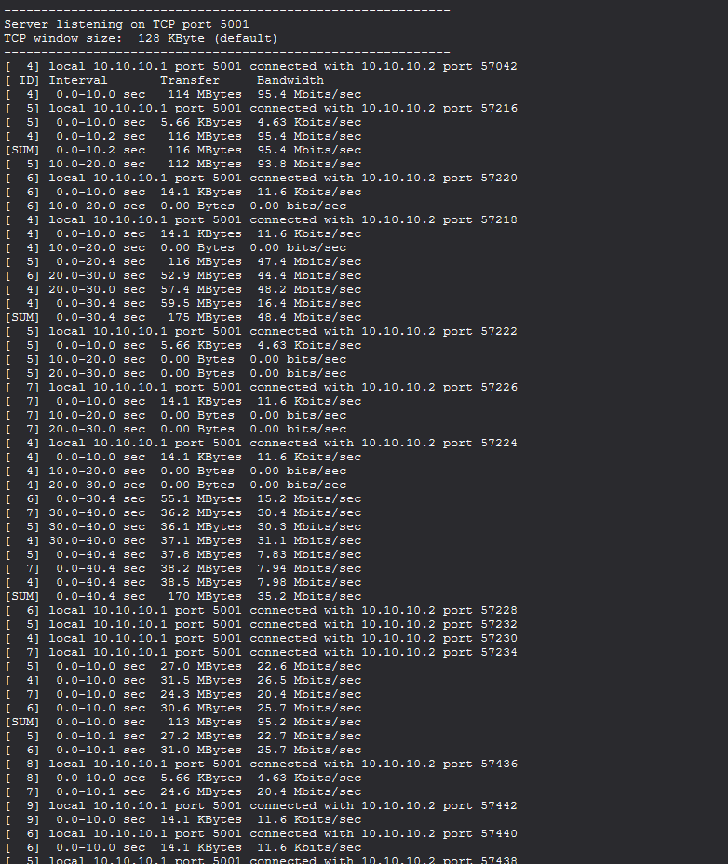

These two screenshots show the iperf logs and web details from running iperf on the client. As shown, many different connections are made, and some data gets transferred. The number of total accesses increases rapidly when using iperf with a large value.

1. 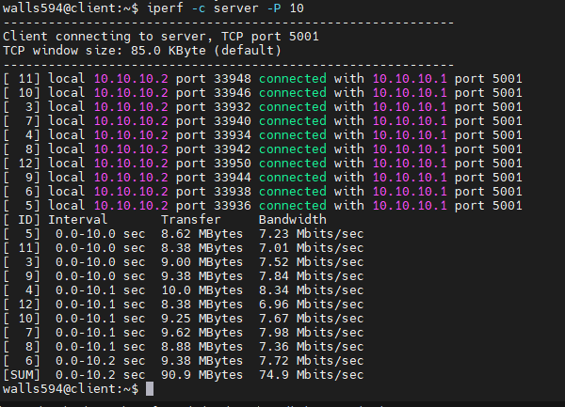

This is a screenshot of running iperf with a larger value onto the server. As shown in the screenshots from part 3, many connections are made and data gets transferred to each connection.

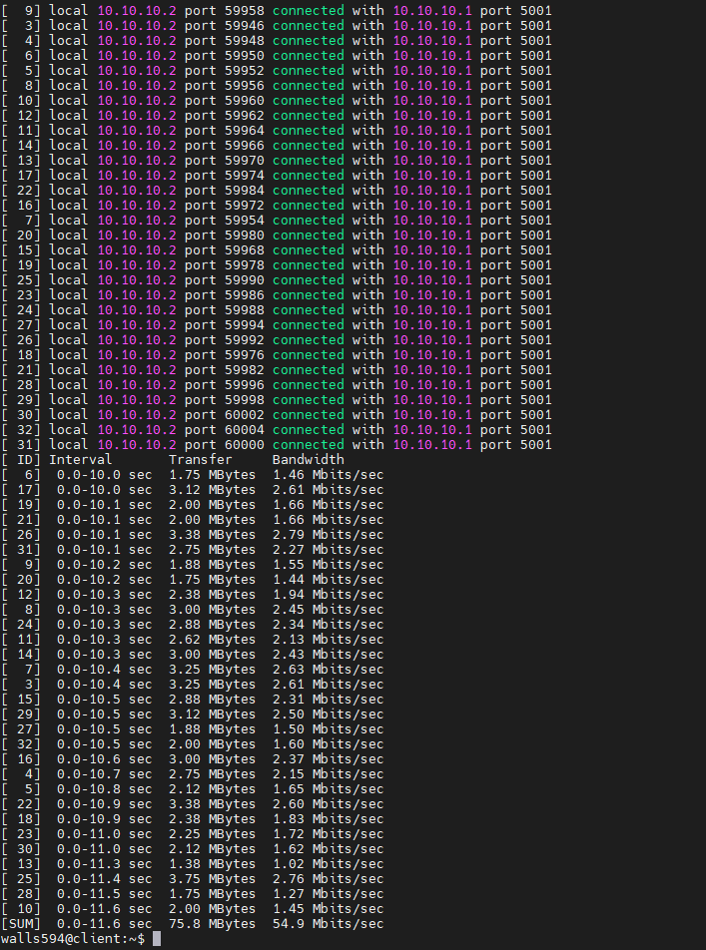

This screenshot shows if there are many different connections, the bandwidth decreases per client to accommodate for everyone.

1. 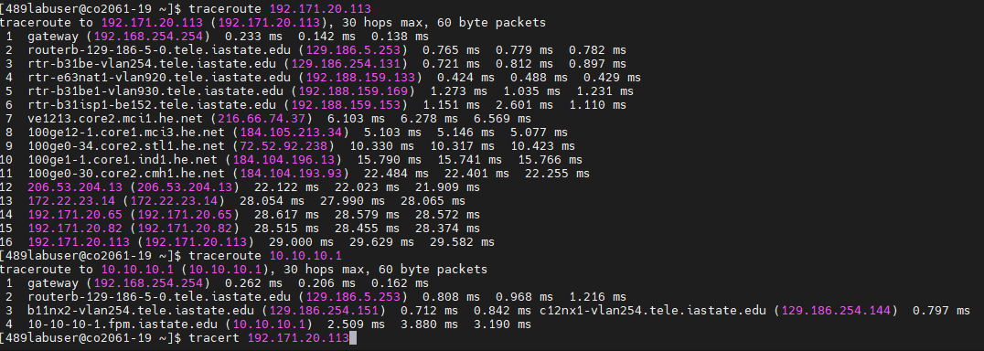

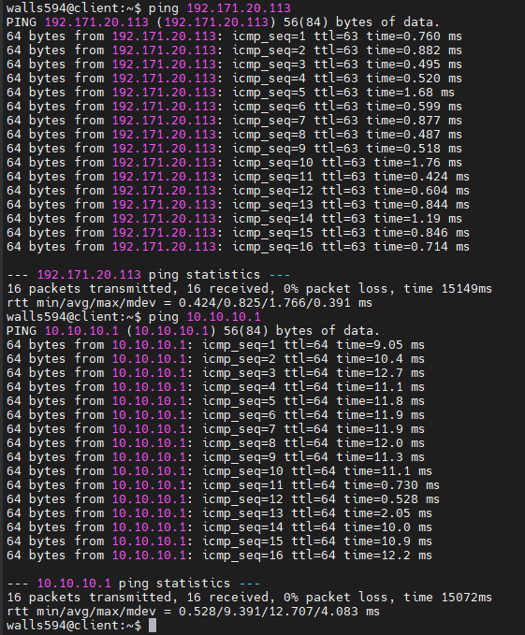

These last two screenshots show me trying to determine which interfaces have access to the client. This, along with the iperf told me which interfaces can connect with what.

For interface:

* Eth0
  + This interface can access the world wide web
  + This interface can access the client
  + This interface is what connect to the web. That is why I am able to go to the site using the ip address on the web browser. This address is also what the client connects to when using iperf or other functions.
* Eth1
  + This interface cannot access the web
  + This interface can directly access the client.
  + This interface has a private network ip, so that it can only connect to devices within the same network. This means that if the client and server are on the same network (which they are), then they can connect. If they are on separate networks, they cannot connect.
* Lo
  + This interface cannot access the web
  + This interface cannot access the client
  + The loopback address interface is specific to each computer. You do not even need a network card installed to have a loopback address. It is impossible to access a loopback address of a different device, so client cannot connect to server loopback.