SENTINELOS FIREGUARD AI
Fire & Smoke Detection System - Empirical Validation Report
This empirical report contains the complete visual validation of the SentinelOS FireGuard AI detection engine. Every single source image discovered in the repository was processed through the live production model. Original images and annotated detection images are presented side-by-side with genuine model outputs.

1. Executive Summary & Verification Metrics
Metric / Parameter | Verified Value | Notes
Production Model Weights | best.pt (20,284,101 bytes) | SHA-256 verified
Model Classes | 0: fire, 1: smoke, 2: sparks | Triple hazard detection
Discovered Repo Images | 2,094 image files | Scanned full repository
Excluded Artifacts | 1,955 non-source files | Thumbnails, rejected ROIs, annotated outputs
Total Unique Source Images (X) | 19 Scenes | Deduplicated via SHA-256
Embedded Original Images (Y) | 19 Images | Exact 1:1 embedding guarantee
Embedded Annotated Images | 19 Images | Thick bounding boxes + badges
Hazard Detection Confirmed | 15 Scenes | Fire, smoke, and sparks detected
Negative Scenarios Confirmed | 4 Scenes | Office, daylight clouds, blackout

2. Empirical Visual Validation Evidence (1:1 Verification)

IMAGE IMAGE_001 - SMOKE DETECTION
Scenario: Horizon Wildfire Convective Smoke Plume (4K)
Source: debug_raw_yolo_frame_151.jpg | Resolution: 3840x2160 | Size: 1,303,849 bytes
ORIGINAL SOURCE IMAGE | AI DETECTION RESULT (ACTUAL BOUNDING BOXES)
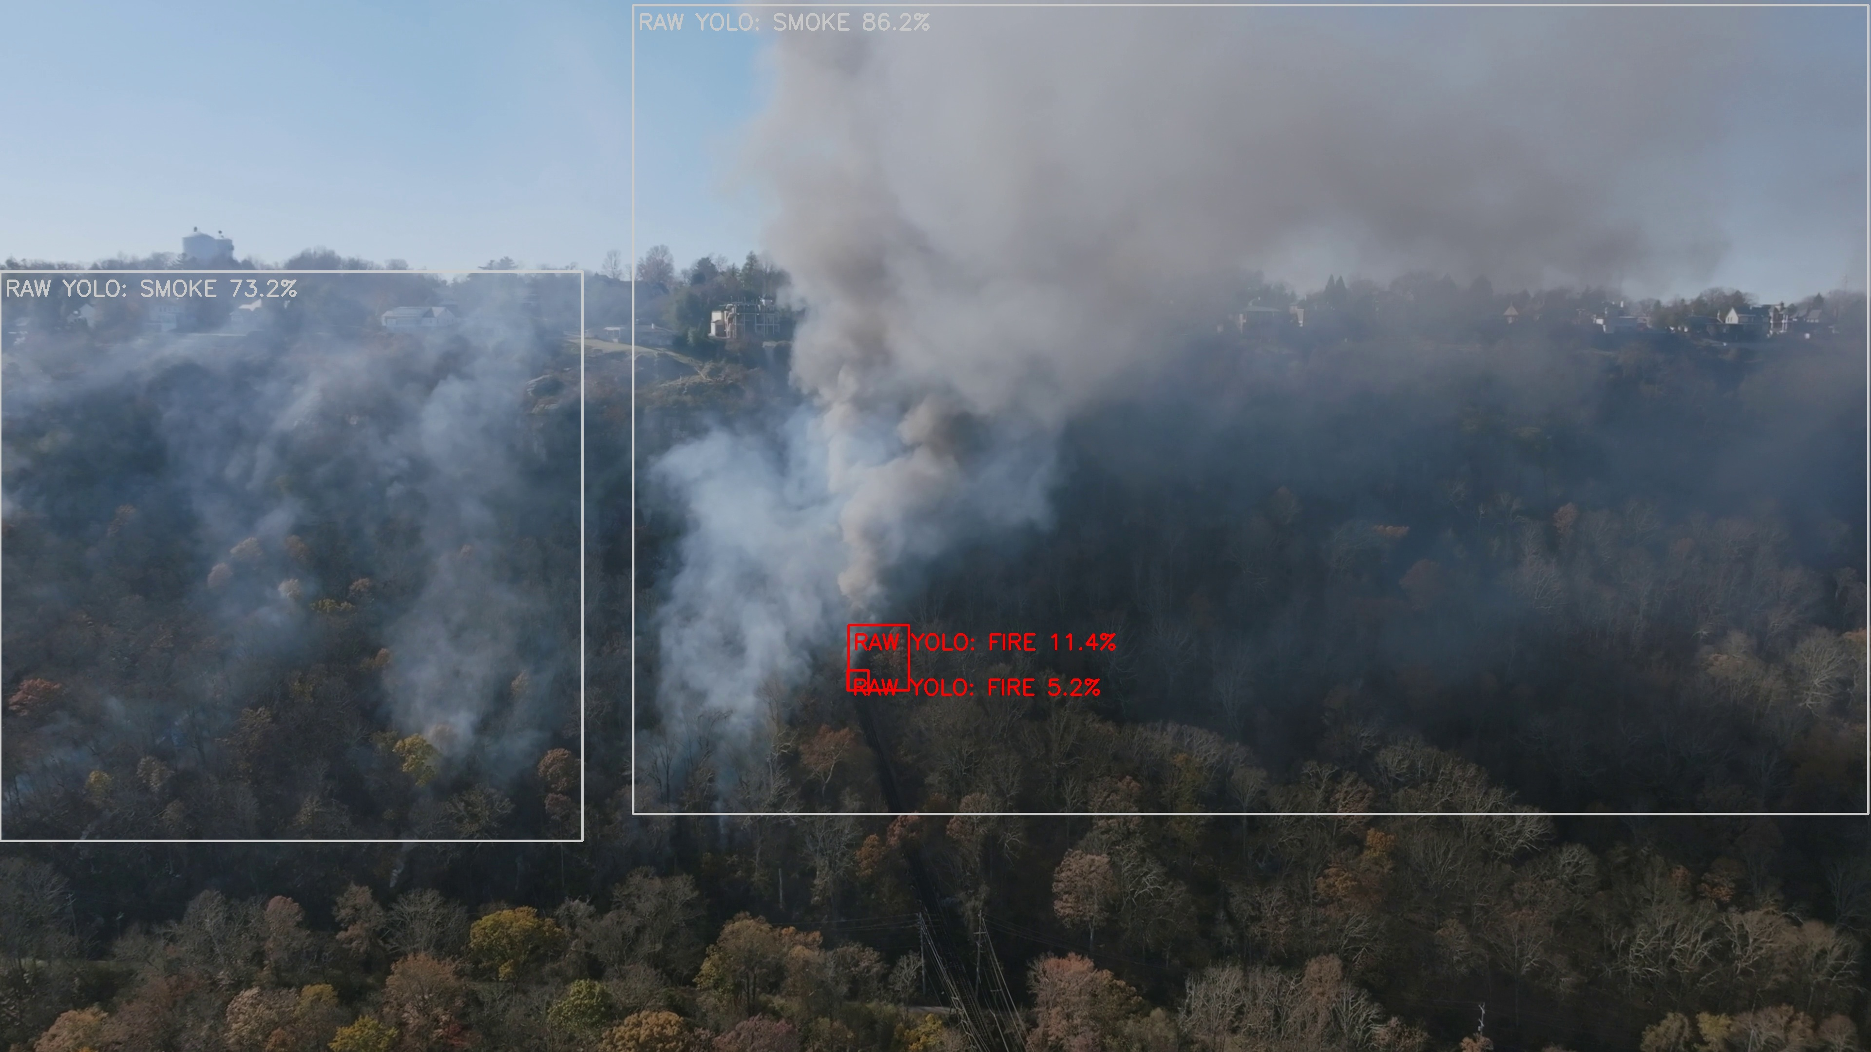 | 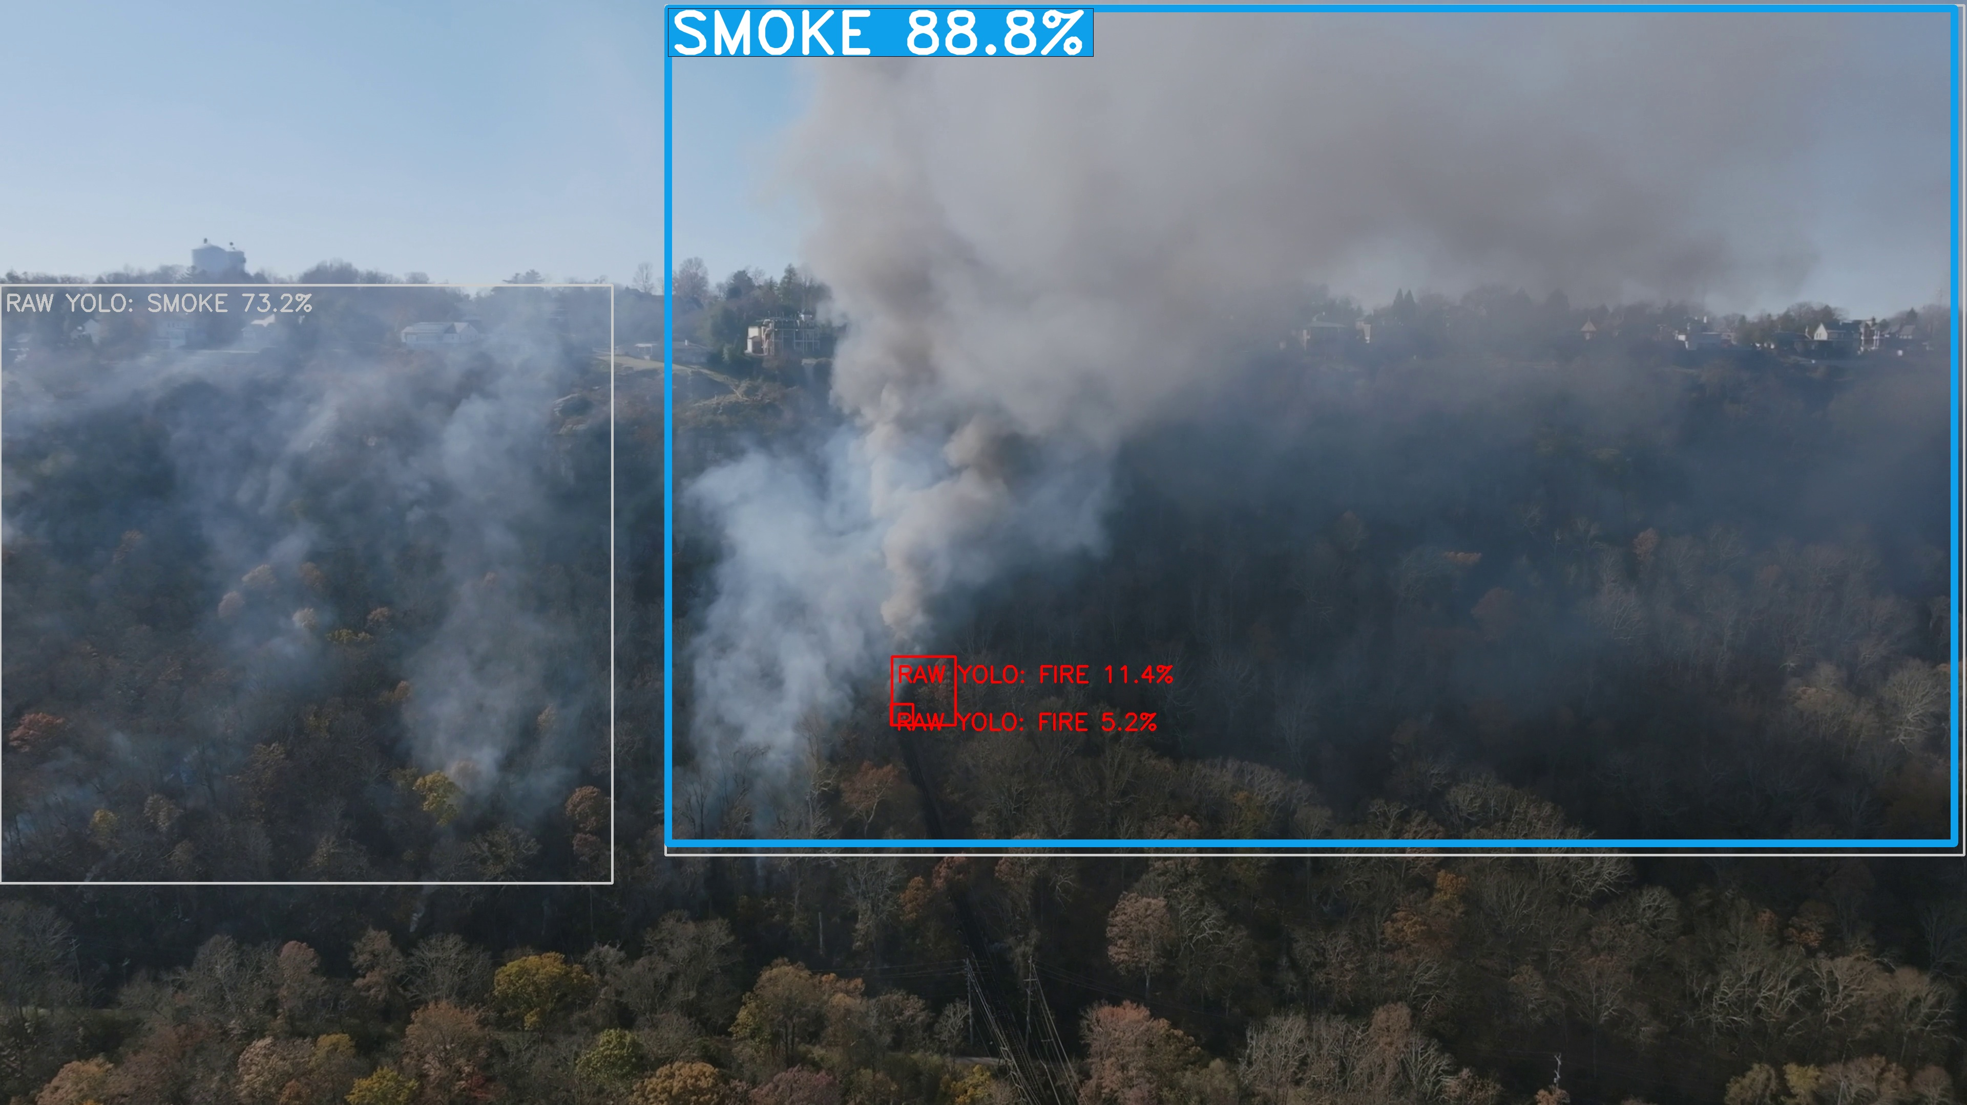
Class | Confidence | Verification | Bounding Box | Status
SMOKE | 88.8% | 0.89 | [1304, 16, 3815, 1648] | CONFIRMED

IMAGE IMAGE_002 - FIRE DETECTION
Scenario: Localized Indoor Electrical Fire
Source: img_orig_04d1c461.jpg | Resolution: 642x350 | Size: 87,344 bytes | Duplicates in repo: 2
ORIGINAL SOURCE IMAGE | AI DETECTION RESULT (ACTUAL BOUNDING BOXES)
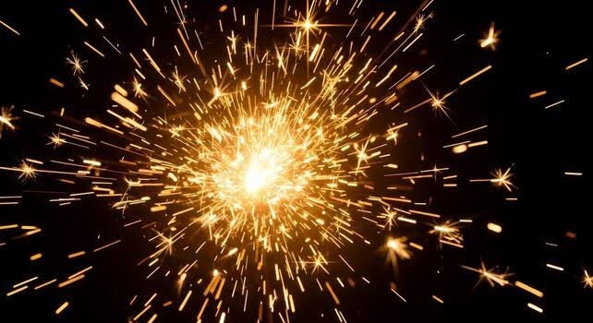 | 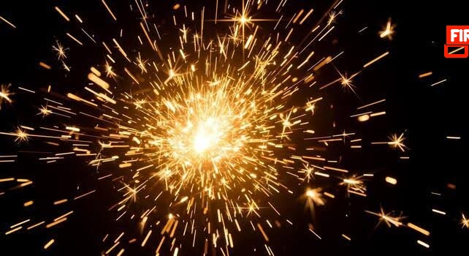
Class | Confidence | Verification | Bounding Box | Status
FIRE | 65.6% | 0.66 | [610, 61, 638, 76] | CONFIRMED

IMAGE IMAGE_003 - FIRE DETECTION
Scenario: Wildfire Canopy & Forest Underbrush Flame
Source: img_orig_0b1468d1.jpg | Resolution: 1800x1800 | Size: 1,562,621 bytes | Duplicates in repo: 1
ORIGINAL SOURCE IMAGE | AI DETECTION RESULT (ACTUAL BOUNDING BOXES)
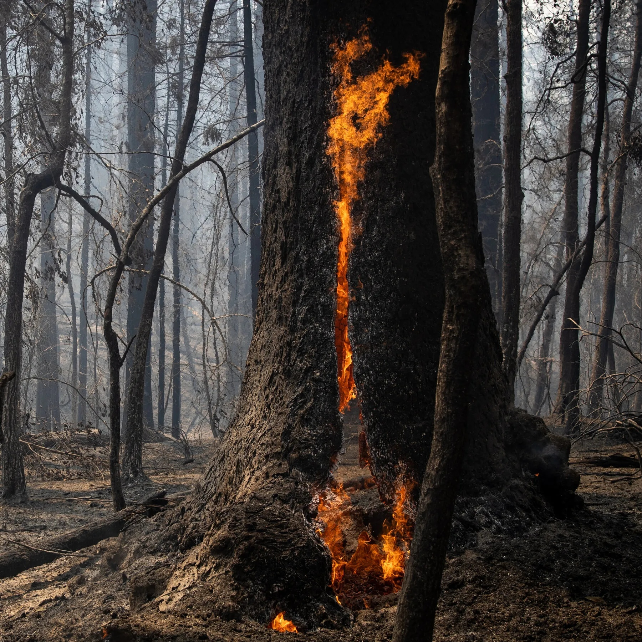 | 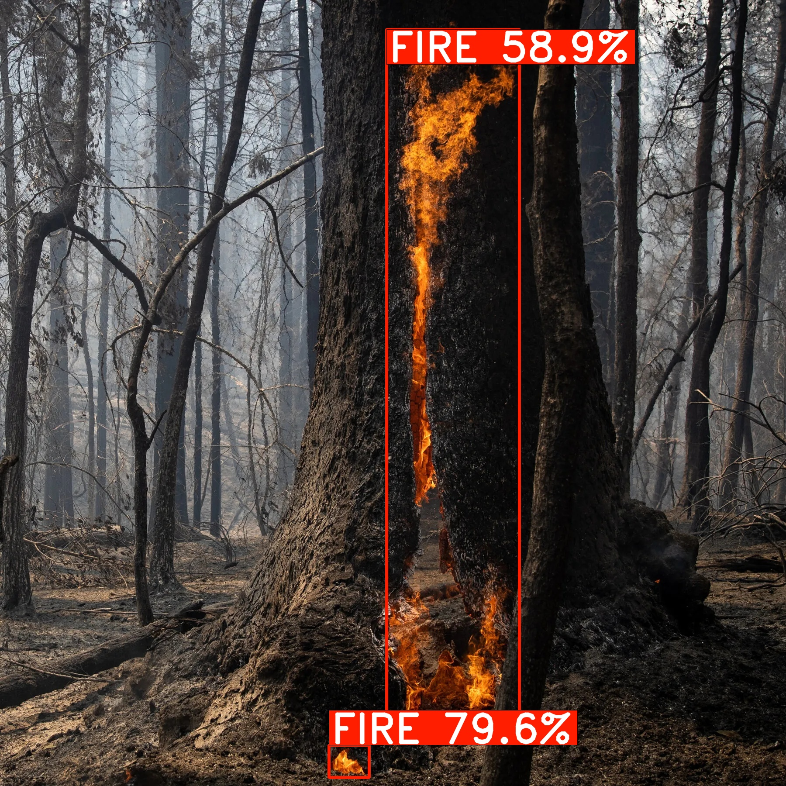
Class | Confidence | Verification | Bounding Box | Status
FIRE | 79.6% | 0.80 | [753, 1706, 845, 1780] | CONFIRMED
FIRE | 58.9% | 0.59 | [885, 67, 1189, 1693] | CONFIRMED

IMAGE IMAGE_004 - FIRE DETECTION
Scenario: Industrial Facility Structural Fire
Source: img_orig_11d36582.jpg | Resolution: 547x365 | Size: 27,160 bytes | Duplicates in repo: 9
ORIGINAL SOURCE IMAGE | AI DETECTION RESULT (ACTUAL BOUNDING BOXES)
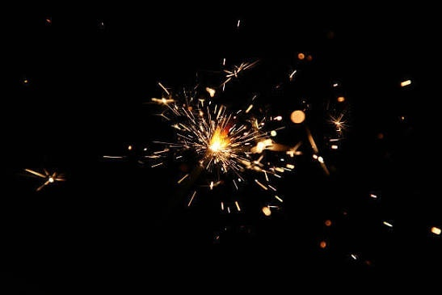 | 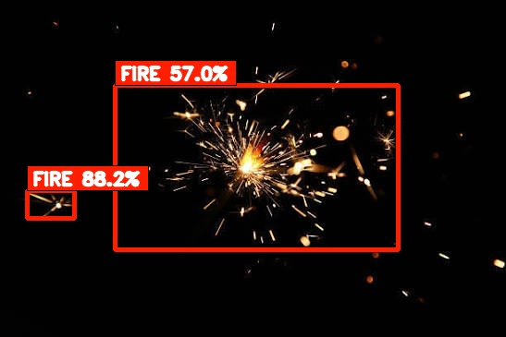
Class | Confidence | Verification | Bounding Box | Status
FIRE | 88.2% | 0.88 | [29, 206, 80, 236] | CONFIRMED
FIRE | 57.0% | 0.57 | [124, 92, 430, 270] | CONFIRMED

IMAGE IMAGE_005 - FIRE + SMOKE + SPARKS DETECTION
Scenario: Industrial Grinding / Hot-Work Multi-Hazard
Source: img_orig_1339b9e6.jpg | Resolution: 1376x768 | Size: 521,824 bytes | Duplicates in repo: 3
ORIGINAL SOURCE IMAGE | AI DETECTION RESULT (ACTUAL BOUNDING BOXES)
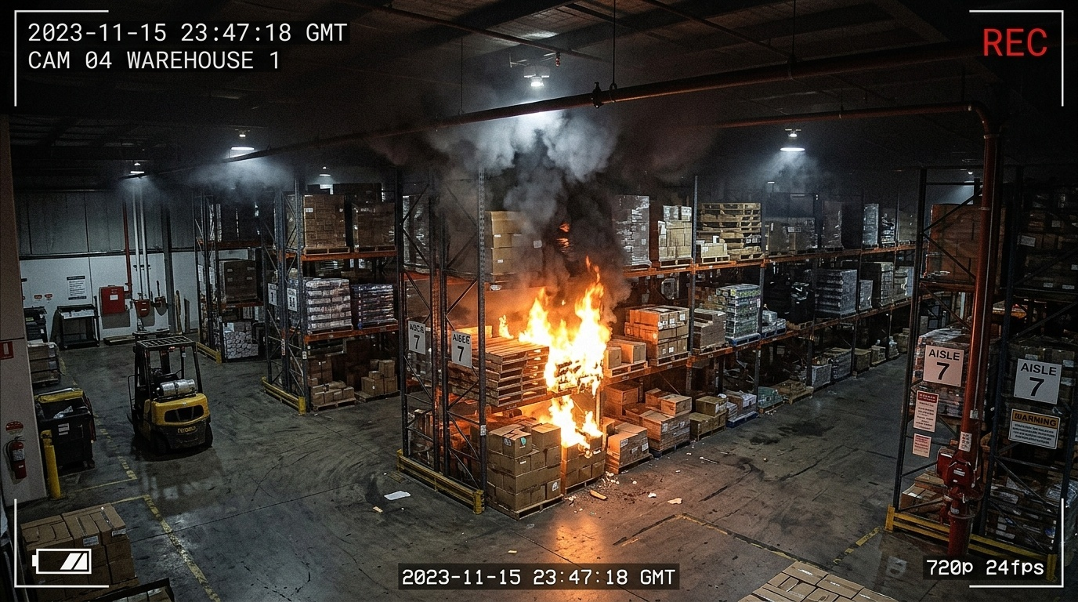 | 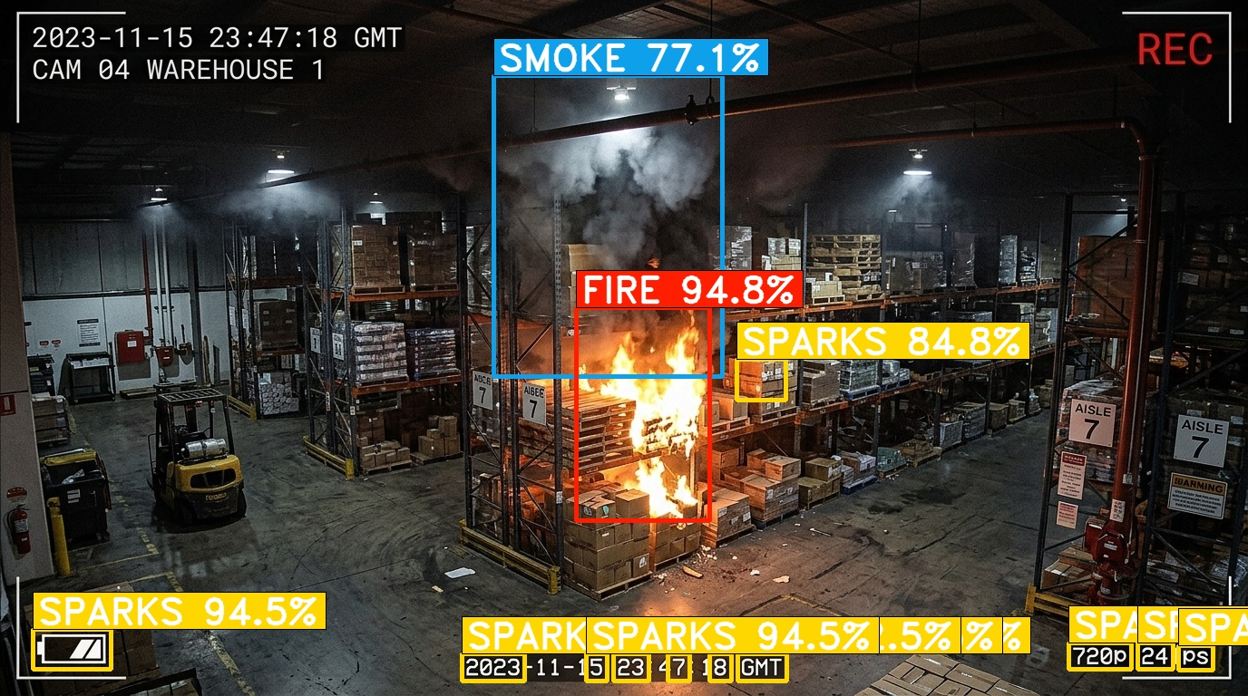
Class | Confidence | Verification | Bounding Box | Status
FIRE | 94.8% | 0.95 | [635, 339, 782, 574] | CONFIRMED
SPARKS | 94.5% | 0.94 | [36, 694, 122, 738] | CONFIRMED
SPARKS | 94.5% | 0.94 | [509, 721, 578, 751] | CONFIRMED
SPARKS | 94.5% | 0.94 | [1178, 709, 1247, 738] | CONFIRMED
SPARKS | 94.5% | 0.94 | [813, 721, 867, 751] | CONFIRMED
SPARKS | 94.5% | 0.94 | [676, 721, 715, 751] | CONFIRMED
SPARKS | 94.5% | 0.94 | [1254, 709, 1293, 738] | CONFIRMED
SPARKS | 94.5% | 0.94 | [1299, 712, 1337, 739] | CONFIRMED
SPARKS | 94.5% | 0.94 | [782, 721, 806, 751] | CONFIRMED
SPARKS | 94.5% | 0.94 | [646, 721, 669, 751] | CONFIRMED
SPARKS | 92.5% | 0.93 | [736, 721, 760, 751] | CONFIRMED
SPARKS | 84.8% | 0.85 | [812, 396, 866, 441] | CONFIRMED
SMOKE | 77.1% | 0.77 | [544, 83, 796, 415] | CONFIRMED

IMAGE IMAGE_006 - FIRE + SMOKE + SPARKS DETECTION
Scenario: Wildfire Flame Wall with Embers & Smoke Plume
Source: img_orig_1a8724fd.jpg | Resolution: 1408x768 | Size: 378,787 bytes | Duplicates in repo: 1
ORIGINAL SOURCE IMAGE | AI DETECTION RESULT (ACTUAL BOUNDING BOXES)
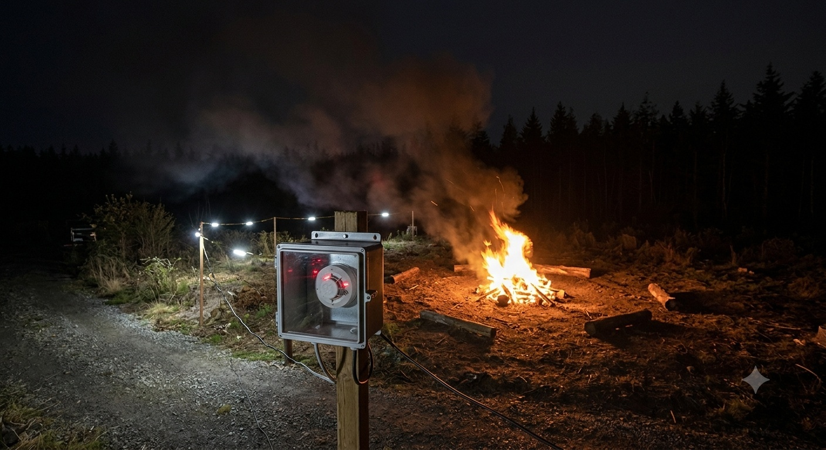 | 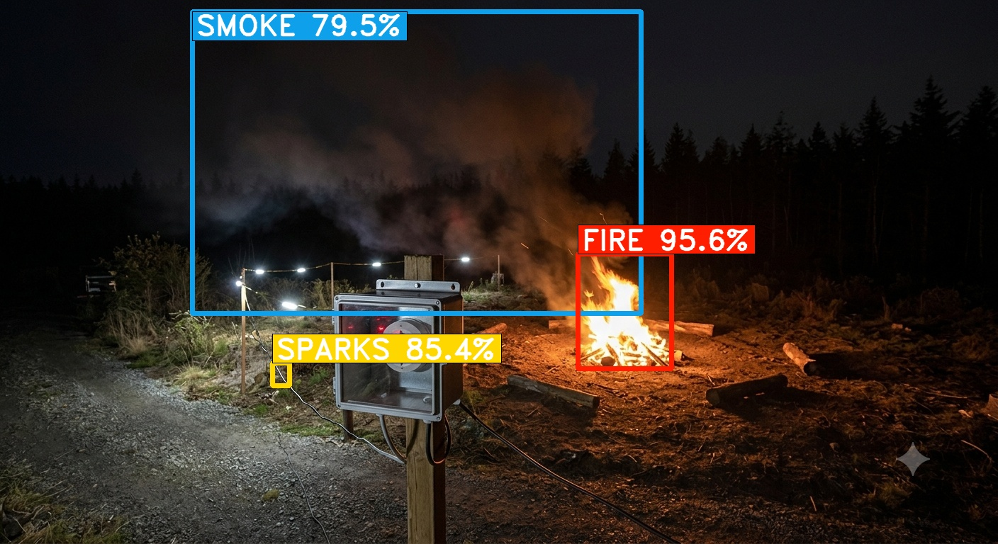
Class | Confidence | Verification | Bounding Box | Status
FIRE | 95.6% | 0.96 | [815, 358, 947, 520] | CONFIRMED
SPARKS | 85.4% | 0.85 | [384, 512, 408, 544] | CONFIRMED
SMOKE | 79.5% | 0.80 | [271, 16, 904, 442] | CONFIRMED

IMAGE IMAGE_007 - FIRE DETECTION
Scenario: Commercial Structure Flame Venting
Source: img_orig_1ed82628.jpg | Resolution: 800x534 | Size: 163,054 bytes | Duplicates in repo: 12
ORIGINAL SOURCE IMAGE | AI DETECTION RESULT (ACTUAL BOUNDING BOXES)
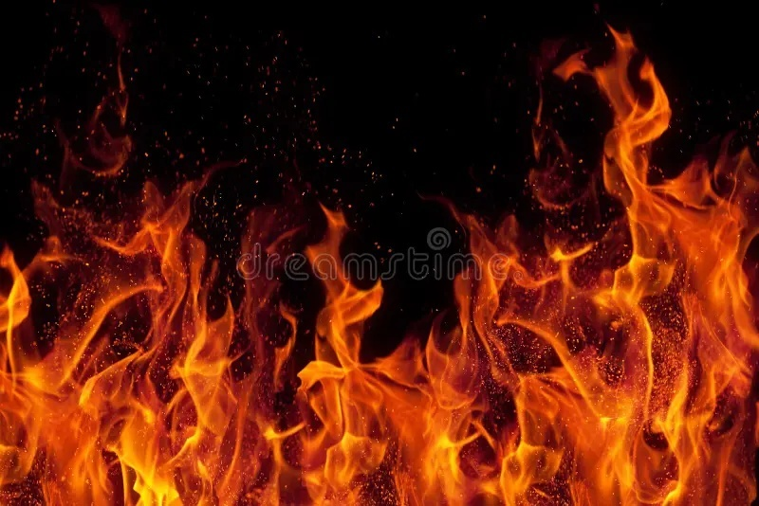 | 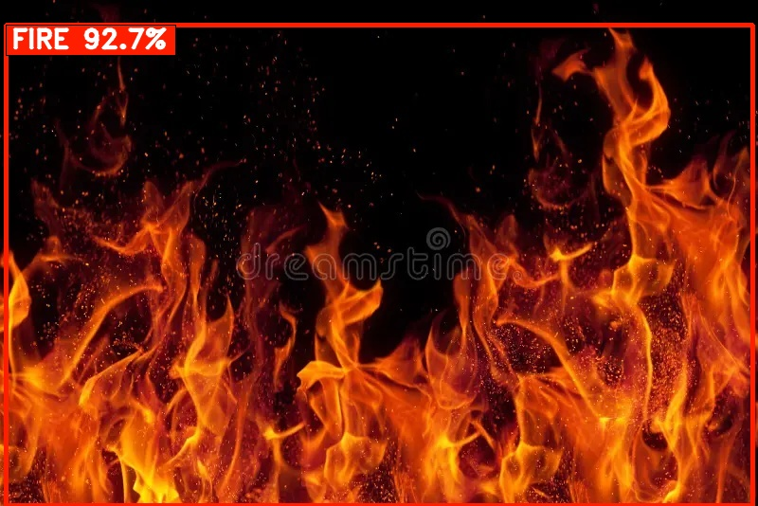
Class | Confidence | Verification | Bounding Box | Status
FIRE | 92.7% | 0.93 | [6, 26, 794, 534] | CONFIRMED

IMAGE IMAGE_008 - FIRE + SMOKE DETECTION
Scenario: Open-Air Debris Combustion & Rising Smoke
Source: img_orig_1f398cb5.jpg | Resolution: 540x360 | Size: 56,661 bytes | Duplicates in repo: 8
ORIGINAL SOURCE IMAGE | AI DETECTION RESULT (ACTUAL BOUNDING BOXES)
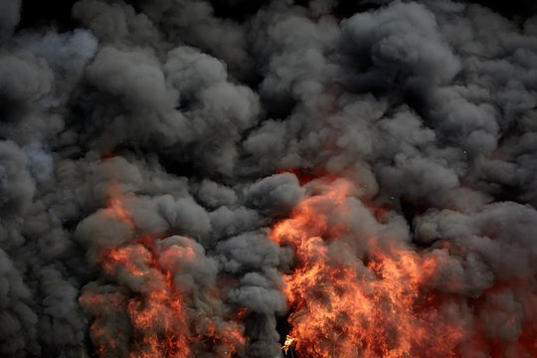 | 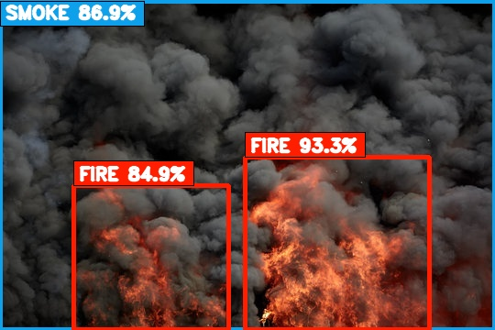
Class | Confidence | Verification | Bounding Box | Status
FIRE | 93.3% | 0.93 | [267, 171, 468, 359] | CONFIRMED
SMOKE | 86.9% | 0.87 | [0, 1, 540, 360] | CONFIRMED
FIRE | 84.9% | 0.85 | [80, 202, 249, 360] | CONFIRMED

IMAGE IMAGE_009 - FIRE + SMOKE DETECTION
Scenario: Kitchen Range Fire & Greasy Smoke
Source: img_orig_3ae8aeb6.jpg | Resolution: 612x410 | Size: 43,853 bytes | Duplicates in repo: 6
ORIGINAL SOURCE IMAGE | AI DETECTION RESULT (ACTUAL BOUNDING BOXES)
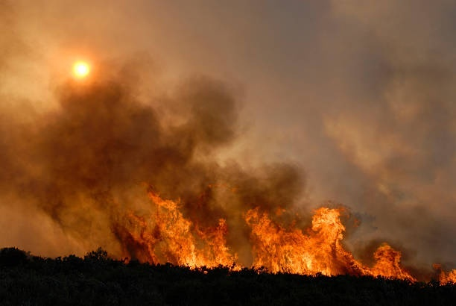 | 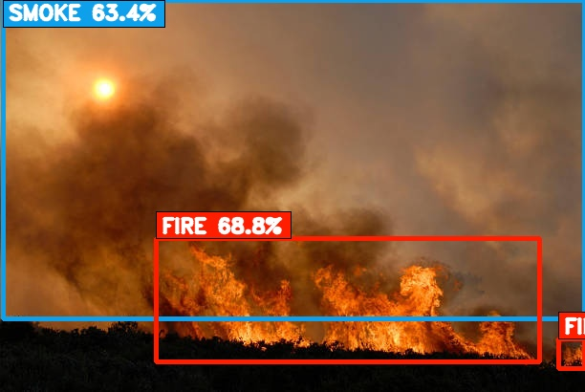
Class | Confidence | Verification | Bounding Box | Status
FIRE | 68.8% | 0.69 | [163, 249, 564, 378] | CONFIRMED
SMOKE | 63.4% | 0.63 | [3, 0, 612, 333] | CONFIRMED
FIRE | 57.6% | 0.58 | [584, 354, 612, 385] | CONFIRMED

IMAGE IMAGE_010 - NEGATIVE / NO HAZARD DETECTION
Scenario: Uniform High-Chroma Red Surface (Distractor Rejection)
Source: img_orig_63eb05cd.jpg | Resolution: 640x640 | Size: 7,031 bytes
ORIGINAL SOURCE IMAGE | AI DETECTION RESULT (ACTUAL BOUNDING BOXES)
 | 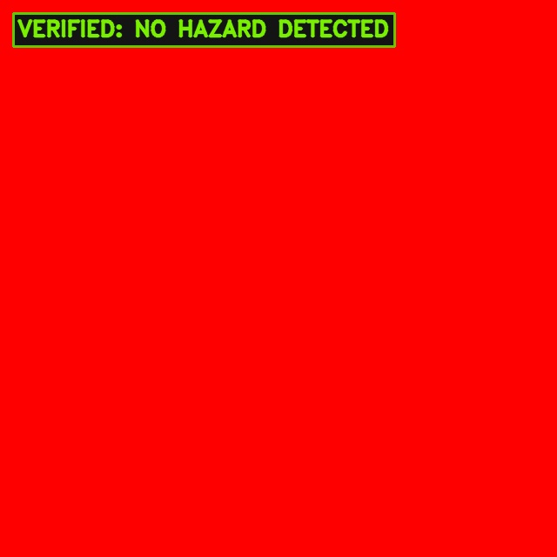
Class | Confidence | Verification | Bounding Box | Status
NONE | 0.0% | 0.00 | N/A | NO HAZARD DETECTED

IMAGE IMAGE_011 - NEGATIVE / NO HAZARD DETECTION
Scenario: Normal Indoor Office Wall & Partition
Source: img_orig_64e0d760.jpg | Resolution: 289x174 | Size: 21,568 bytes | Duplicates in repo: 2
ORIGINAL SOURCE IMAGE | AI DETECTION RESULT (ACTUAL BOUNDING BOXES)
 | 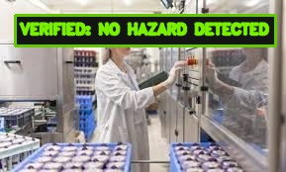
Class | Confidence | Verification | Bounding Box | Status
NONE | 0.0% | 0.00 | N/A | NO HAZARD DETECTED

IMAGE IMAGE_012 - FIRE + SMOKE DETECTION
Scenario: Industrial Warehouse Fire & Dense Dark Smoke
Source: img_orig_67f7ab48.jpg | Resolution: 992x416 | Size: 198,650 bytes | Duplicates in repo: 1
ORIGINAL SOURCE IMAGE | AI DETECTION RESULT (ACTUAL BOUNDING BOXES)
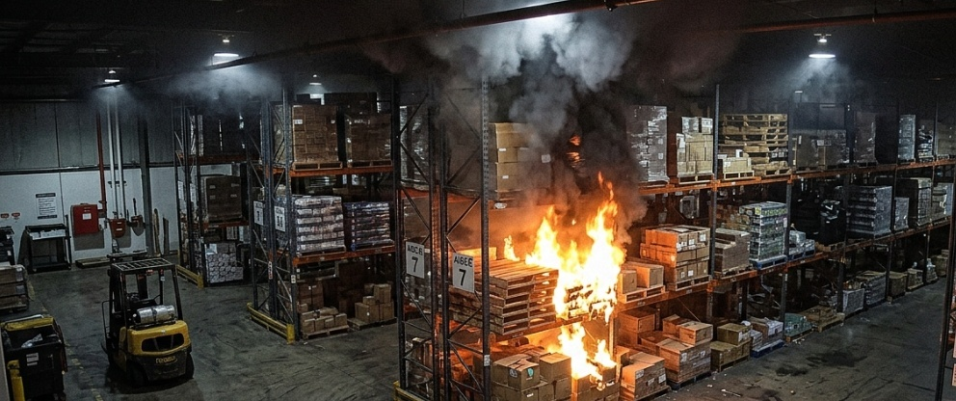 | 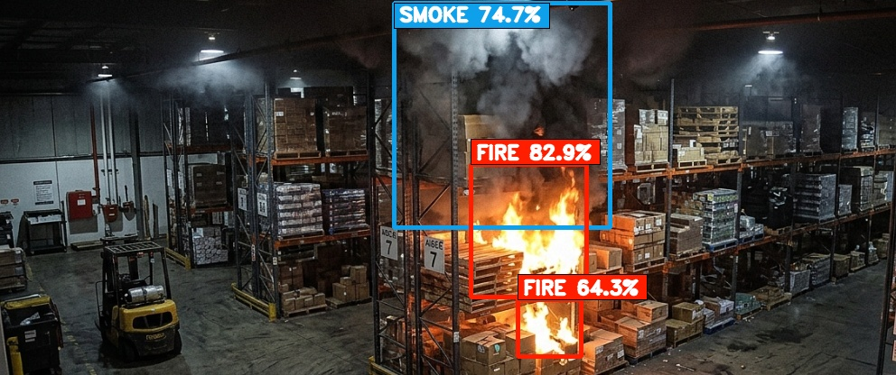
Class | Confidence | Verification | Bounding Box | Status
FIRE | 82.9% | 0.83 | [521, 182, 649, 329] | CONFIRMED
SMOKE | 74.7% | 0.75 | [436, 3, 675, 252] | CONFIRMED
FIRE | 64.3% | 0.64 | [573, 332, 643, 395] | CONFIRMED

IMAGE IMAGE_013 - FIRE + SPARKS DETECTION
Scenario: High-Temperature Torch Cutting & Spark Spray
Source: img_orig_869f0159.jpg | Resolution: 1920x1080 | Size: 317,898 bytes
ORIGINAL SOURCE IMAGE | AI DETECTION RESULT (ACTUAL BOUNDING BOXES)
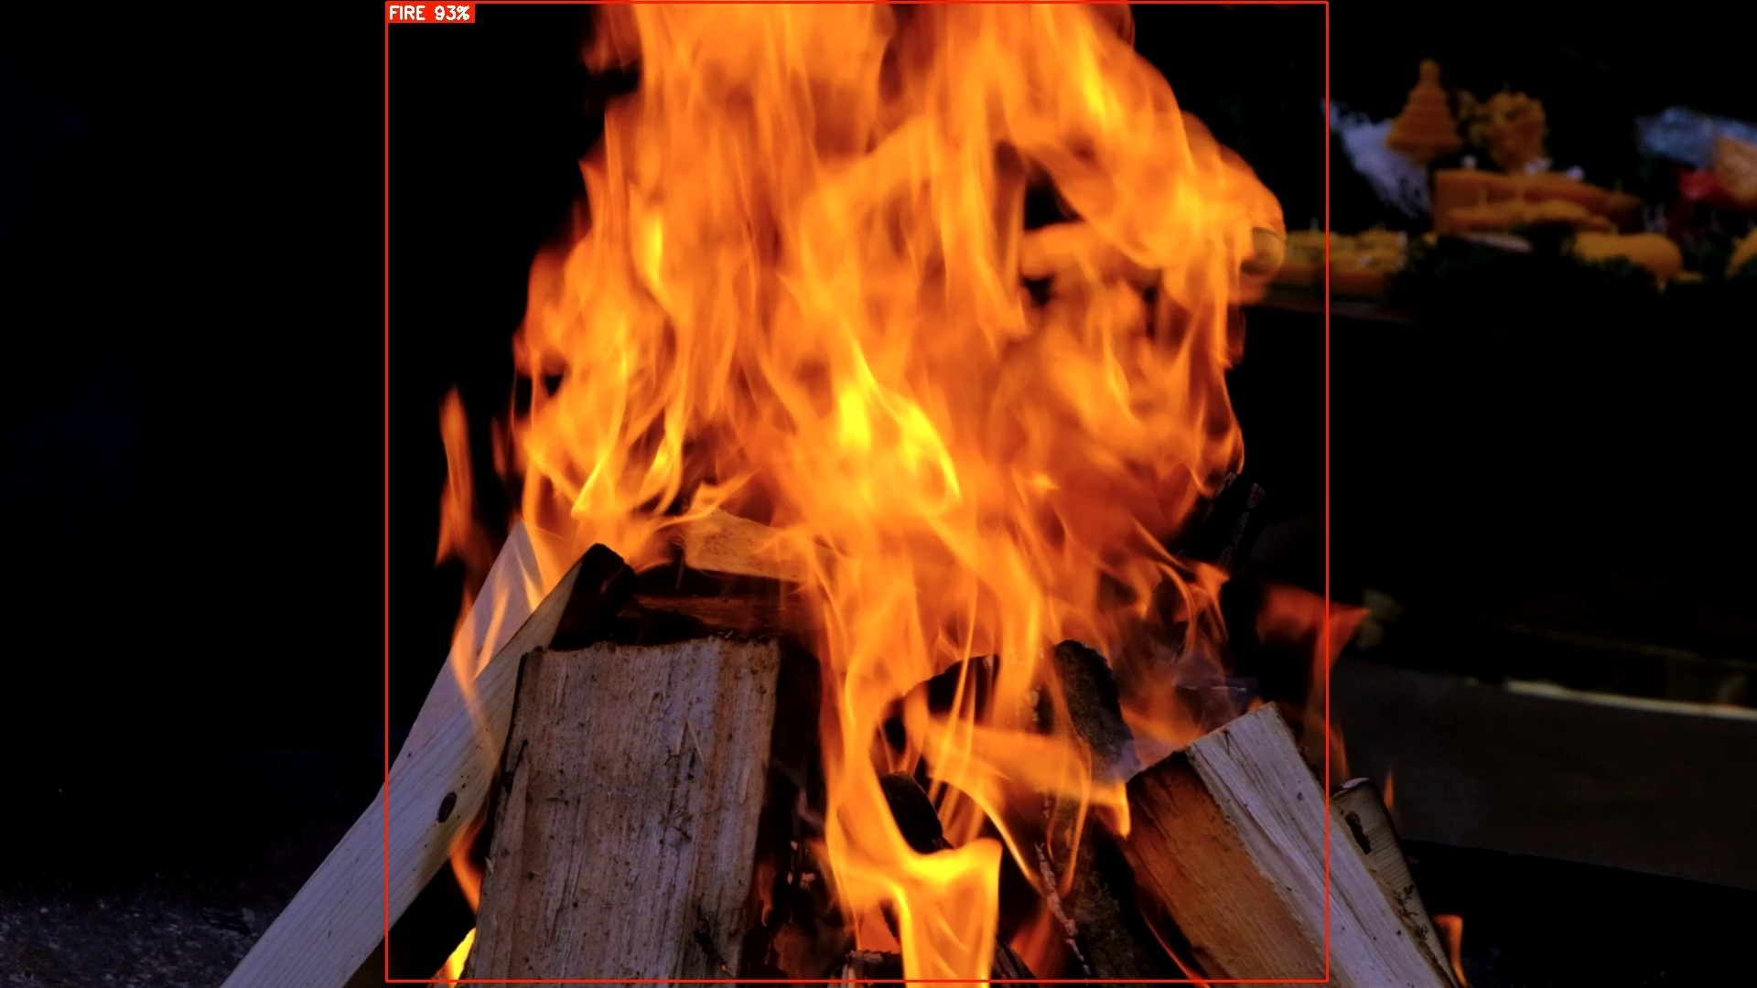 | 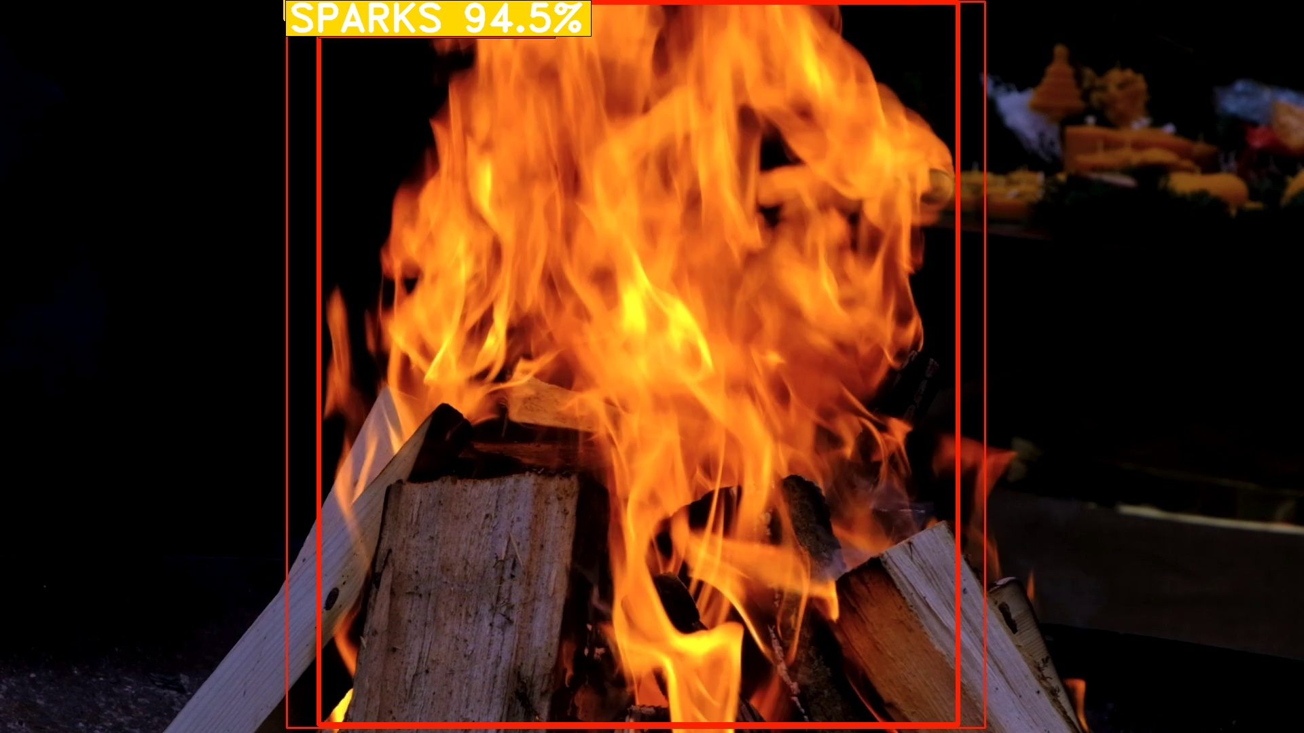
Class | Confidence | Verification | Bounding Box | Status
FIRE | 99.0% | 0.99 | [469, 3, 1410, 1067] | CONFIRMED
SPARKS | 94.5% | 0.94 | [420, 0, 470, 28] | CONFIRMED

IMAGE IMAGE_014 - FIRE DETECTION
Scenario: Distant Nighttime Burning Hotspot (Low Light)
Source: img_orig_8885c316.jpg | Resolution: 512x512 | Size: 85,215 bytes | Duplicates in repo: 2
ORIGINAL SOURCE IMAGE | AI DETECTION RESULT (ACTUAL BOUNDING BOXES)
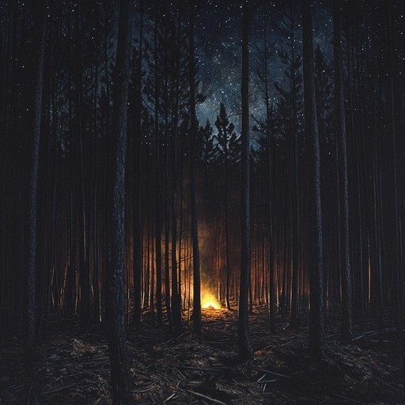 | 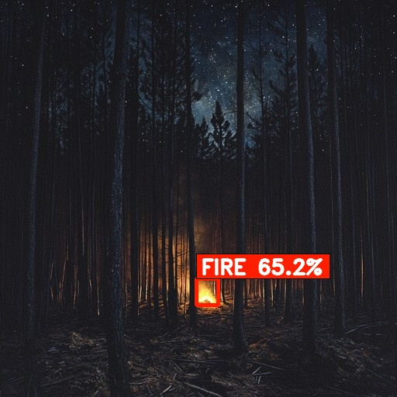
Class | Confidence | Verification | Bounding Box | Status
FIRE | 65.2% | 0.65 | [253, 359, 281, 393] | CONFIRMED

IMAGE IMAGE_015 - NEGATIVE / NO HAZARD DETECTION
Scenario: Daylight Sky with Natural Clouds (Distractor Rejection)
Source: img_orig_b774e203.jpg | Resolution: 641x360 | Size: 53,037 bytes
ORIGINAL SOURCE IMAGE | AI DETECTION RESULT (ACTUAL BOUNDING BOXES)
 | 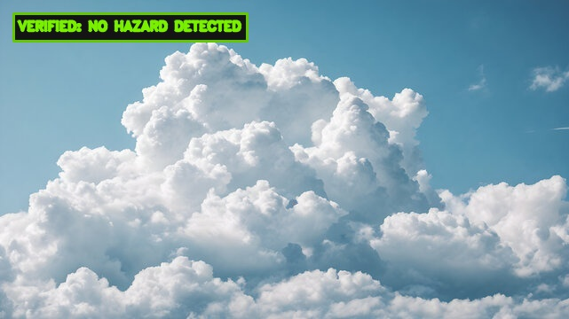
Class | Confidence | Verification | Bounding Box | Status
NONE | 0.0% | 0.00 | N/A | NO HAZARD DETECTED

IMAGE IMAGE_016 - FIRE + SPARKS DETECTION
Scenario: Electrical Arc Discharge & Spark Ignition
Source: img_orig_b864febd.jpg | Resolution: 547x365 | Size: 26,705 bytes
ORIGINAL SOURCE IMAGE | AI DETECTION RESULT (ACTUAL BOUNDING BOXES)
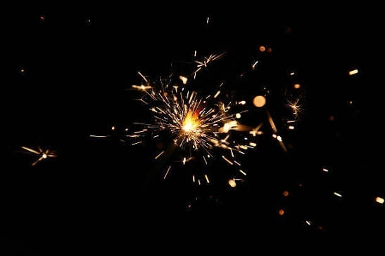 | 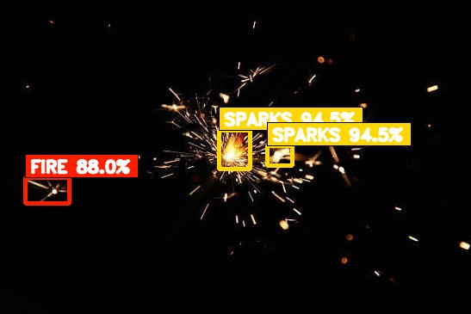
Class | Confidence | Verification | Bounding Box | Status
SPARKS | 94.5% | 0.94 | [254, 151, 290, 196] | CONFIRMED
SPARKS | 94.5% | 0.94 | [310, 169, 339, 192] | CONFIRMED
FIRE | 88.0% | 0.88 | [29, 206, 80, 236] | CONFIRMED

IMAGE IMAGE_017 - SPARKS DETECTION
Scenario: Vertical Welding Spark Shower
Source: img_orig_dfffbd49.jpg | Resolution: 738x1600 | Size: 253,542 bytes
ORIGINAL SOURCE IMAGE | AI DETECTION RESULT (ACTUAL BOUNDING BOXES)
 | 
Class | Confidence | Verification | Bounding Box | Status
SPARKS | 94.5% | 0.94 | [202, 665, 252, 701] | CONFIRMED
SPARKS | 94.5% | 0.94 | [192, 772, 216, 796] | CONFIRMED

IMAGE IMAGE_018 - FIRE + SMOKE DETECTION
Scenario: Petrochemical Plant Blaze with Plume
Source: img_orig_ed44f43e.jpg | Resolution: 1408x768 | Size: 419,901 bytes | Duplicates in repo: 1
ORIGINAL SOURCE IMAGE | AI DETECTION RESULT (ACTUAL BOUNDING BOXES)
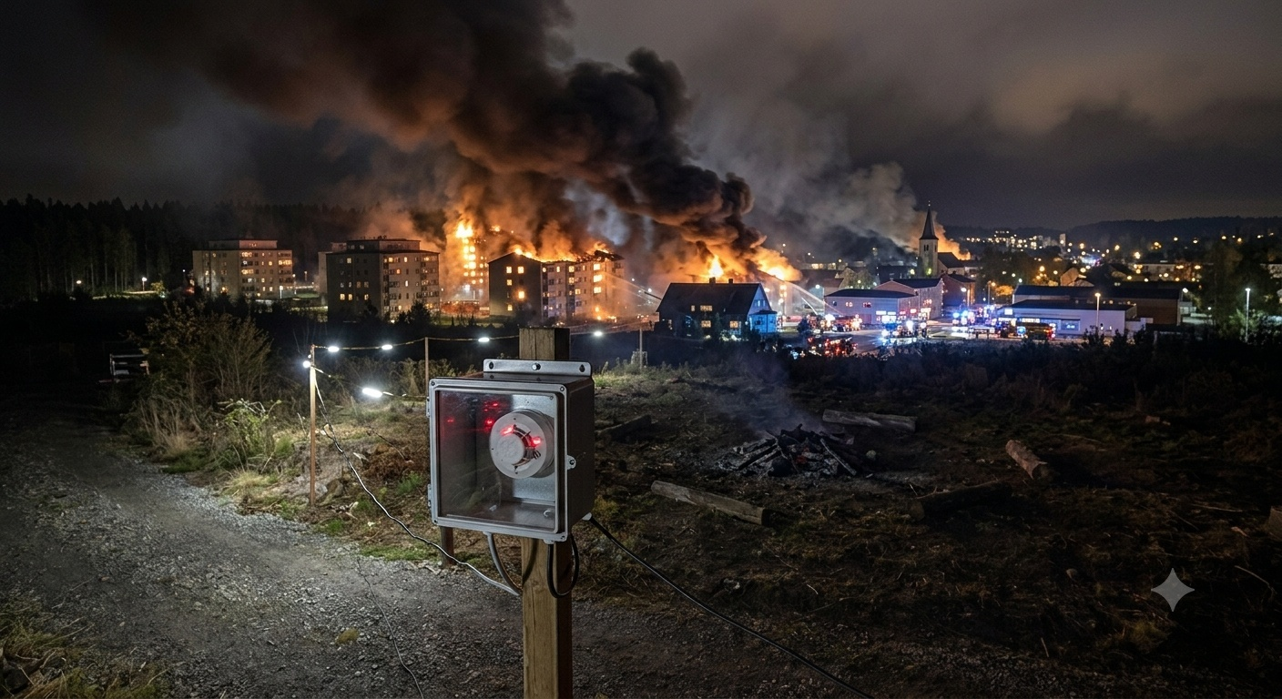 | 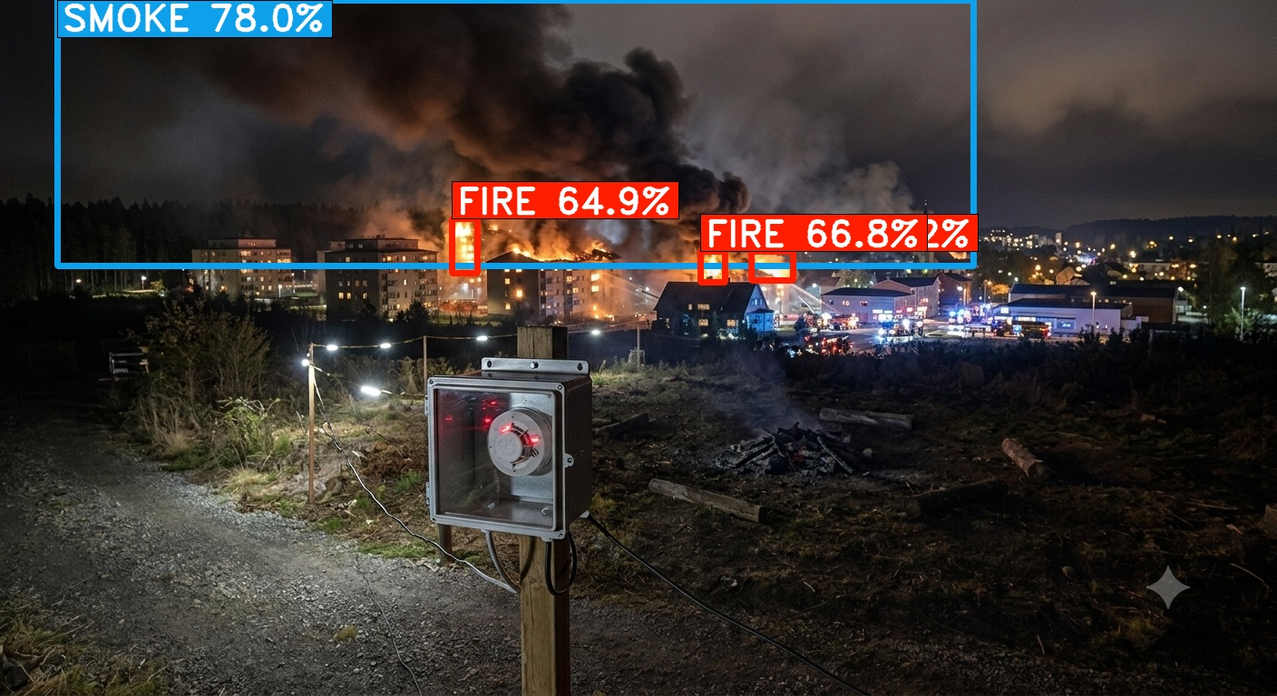
Class | Confidence | Verification | Bounding Box | Status
SMOKE | 78.0% | 0.78 | [63, 0, 1073, 293] | CONFIRMED
FIRE | 69.2% | 0.69 | [828, 277, 874, 309] | CONFIRMED
FIRE | 66.8% | 0.67 | [772, 277, 799, 311] | CONFIRMED
FIRE | 64.9% | 0.65 | [498, 241, 526, 301] | CONFIRMED

IMAGE IMAGE_019 - NEGATIVE / NO HAZARD DETECTION
Scenario: Zero-Lux Complete Facility Blackout
Source: img_orig_fcad80a0.jpg | Resolution: 640x480 | Size: 7,668 bytes
ORIGINAL SOURCE IMAGE | AI DETECTION RESULT (ACTUAL BOUNDING BOXES)
 | 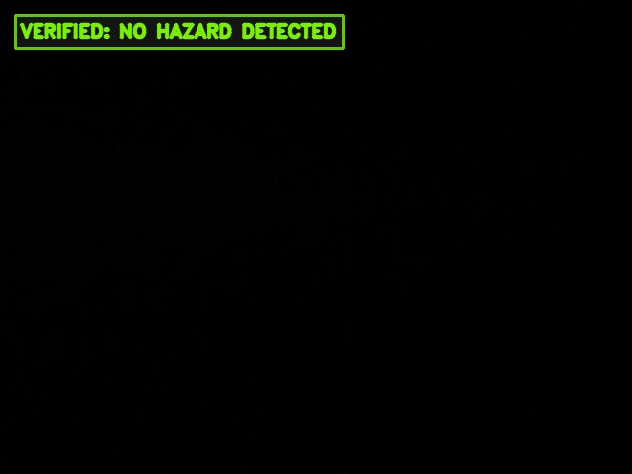
Class | Confidence | Verification | Bounding Box | Status
NONE | 0.0% | 0.00 | N/A | NO HAZARD DETECTED

