What is python

Python is an interpreted, object-oriented, high-level programming language with dynamic semantics. Its high-level built in data structures, combined with dynamic typing and dynamic binding, make it very attractive for Rapid Application Development, as well as for use as a scripting or glue language to connect existing components together. Python's simple, easy to learn syntax emphasizes readability and therefore reduces the cost of program maintenance. Python supports modules and packages, which encourages the code reuse. The Python interpreter and the extensive standard library are available in source or binary form without charge for all major platforms, and can be freely distributed.

Installation of python environment(anaconda).

Installing on Windows
Note
Using Anaconda in a commercial setting? You may need to purchase a license to stay compliant with our Terms of Service. This can be accomplished through Anaconda Commercial Edition, Anaconda Team Edition, or Anaconda Enterprise. If you have already purchased Commercial Edition, please proceed to the Authenticating Commercial Edition section after completing your installation here.
Haven’t purchased Commercial Edition yet? Visit https://anaconda.cloud/register to get started.
- Download the Anaconda installer.
- RECOMMENDED: Verify data integrity with SHA-256. For more information on hashes, see What about cryptographic hash verification?
- Double click the installer to launch.
Note
To prevent permission errors, do not launch the installer from the Favorites folder.
Note
If you encounter issues during installation, temporarily disable your anti-virus software during install, then re-enable it after the installation concludes. If you installed for all users, uninstall Anaconda and re-install it for your user only and try again.
- Click Next.
- Read the licensing terms and click “I Agree”.
- Select an install for “Just Me” unless you’re installing for all users (which requires Windows Administrator privileges) and click Next.
- Select a destination folder to install Anaconda and click the Next button. See FAQ.
Note
Install Anaconda to a directory path that does not contain spaces or unicode characters.
Note
Do not install as Administrator unless admin privileges are required.
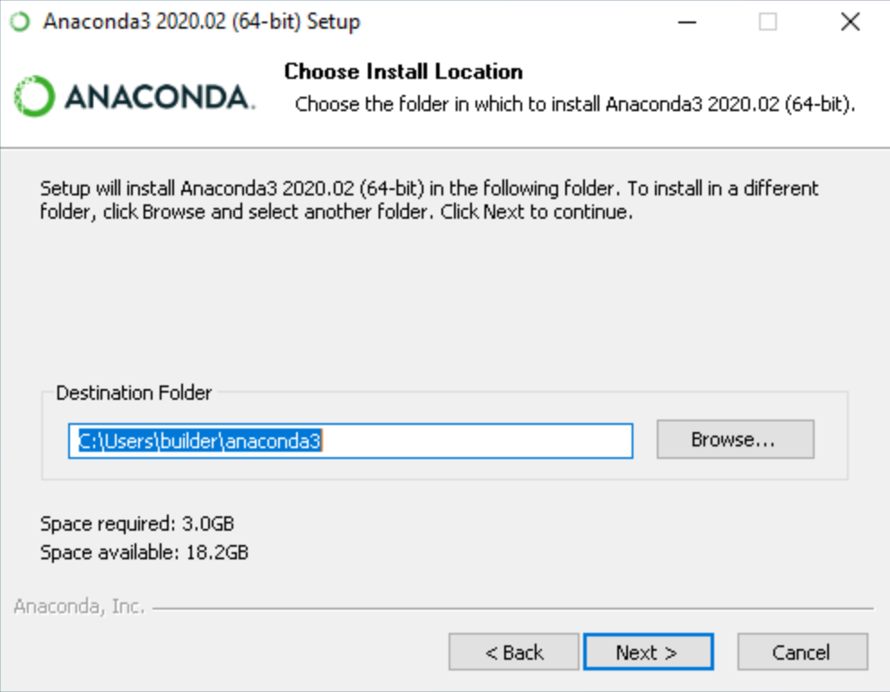

- Choose whether to add Anaconda to your PATH environment variable. We recommend not adding Anaconda to the PATH environment variable, since this can interfere with other software. Instead, use Anaconda software by opening Anaconda Navigator or the Anaconda Prompt from the Start Menu.
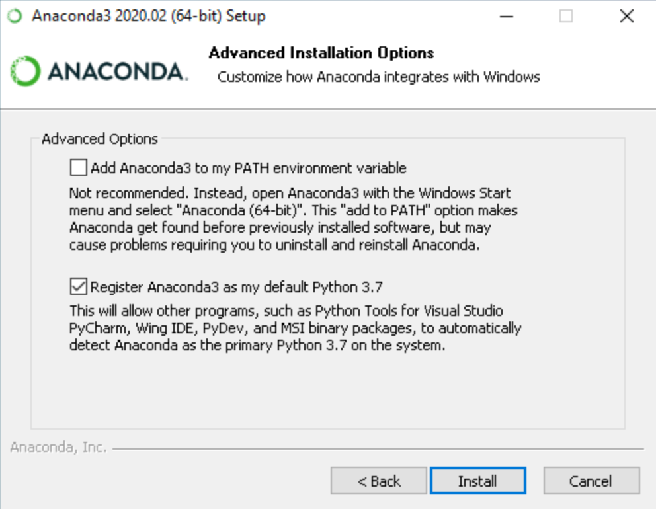

- Choose whether to register Anaconda as your default Python. Unless you plan on installing and running multiple versions of Anaconda or multiple versions of Python, accept the default and leave this box checked.
- Click the Install button. If you want to watch the packages Anaconda is installing, click Show Details.
- Click the Next button.
- Optional: To install PyCharm for Anaconda, click on the link to https://www.anaconda.com/pycharm.
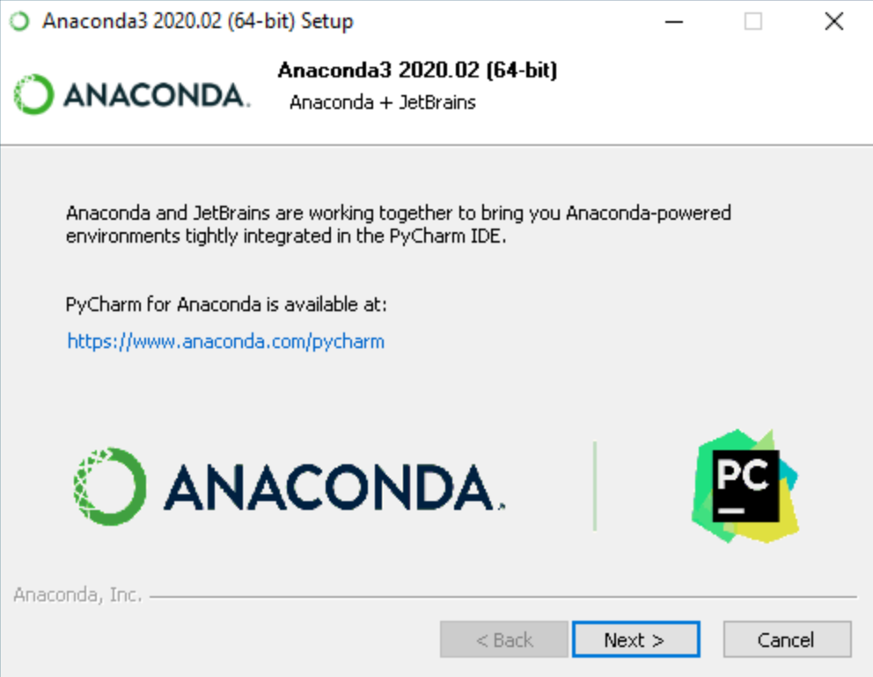

Or to install Anaconda without PyCharm, click the Next button.
- After a successful installation you will see the “Thanks for installing Anaconda” dialog box:
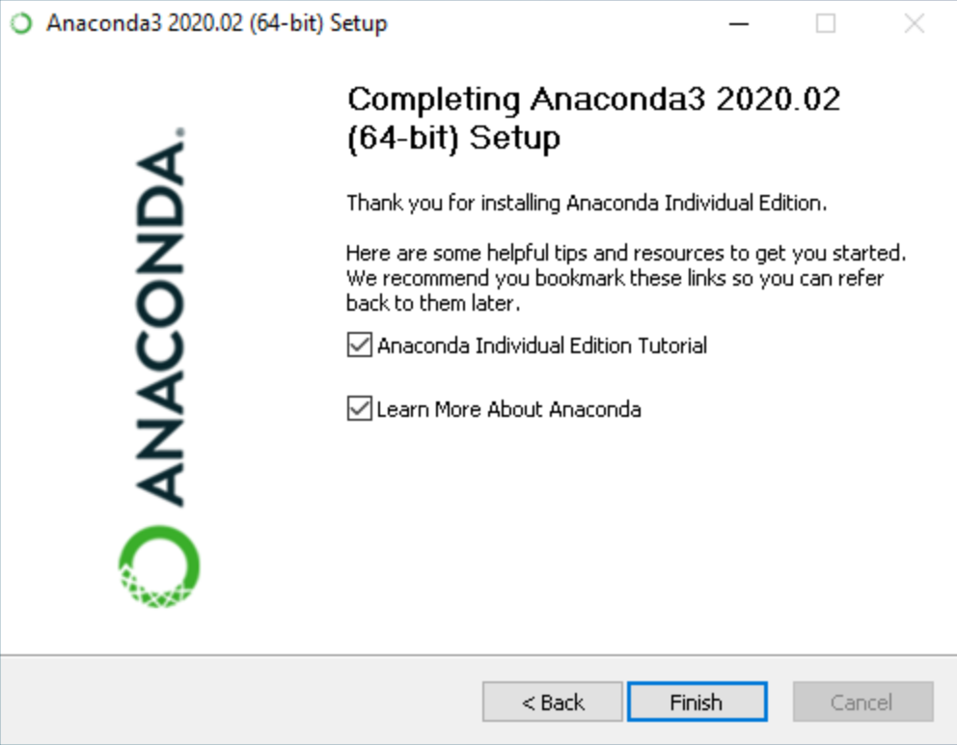

- If you wish to read more about Anaconda.org and how to get started with Anaconda, check the boxes “Anaconda Individual Edition Tutorial” and “Learn more about Anaconda”. Click the Finish button.
- Verify your installation.
Note
If you are behind a company proxy, you may need to do some additional set up. See how to set up your proxy.

Problems?
See troubleshooting.

What’s next?
Get started programming quickly with Anaconda in the Getting started with Anaconda guide.

Getting started with Anaconda
Anaconda Individual Edition contains conda and Anaconda Navigator, as well as Python and hundreds of scientific packages. When you installed Anaconda, you installed all these too.
Conda works on your command line interface such as Anaconda Prompt on Windows and terminal on macOS and Linux.
Navigator is a desktop graphical user interface that allows you to launch applications and easily manage conda packages, environments, and channels without using command-line commands.
You can try both conda and Navigator to see which is right for you to manage your packages and environments. You can even switch between them, and the work you do with one can be viewed in the other.
Try this simple programming exercise, with Navigator and the command line, to help you decide which approach is right for you.
When you’re done, see What’s next?.

Your first Python program: Hello, Anaconda!
Use Anaconda Navigator to launch an application. Then, create and run a simple Python program with Spyder and Jupyter Notebook.

Open Navigator
Choose the instructions for your operating system.
- Windows.
- macOS.
- Linux.
Windows
From the Start menu, click the Anaconda Navigator desktop app.
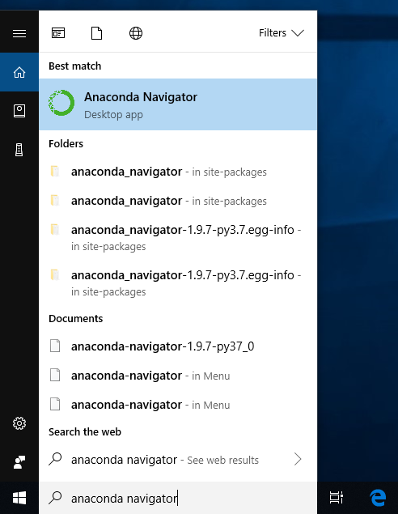
macOS
Open Launchpad, then click the Anaconda Navigator icon.

Linux
Open a terminal window and type anaconda-navigator.

Run Python in Spyder IDE (integrated development environment)
Tip
Navigator’s Home screen displays several applications for you to choose from. For more information, see links at the bottom of this page.
- On Navigator’s Home tab, in the Applications pane on the right, scroll to the Spyder tile and click the Install button to install Spyder.
Note
If you already have Spyder installed, you can jump right to the Launch step.
- Launch Spyder by clicking Spyder’s Launch button.
- In the new file on the left, delete any placeholder text, then type or copy/paste print("Hello Anaconda").
- In the top menu, click File - Save As and name your new program hello.py.
- Run your new program by clicking the triangle Run button.
- You can see your program’s output in the bottom right Console pane.
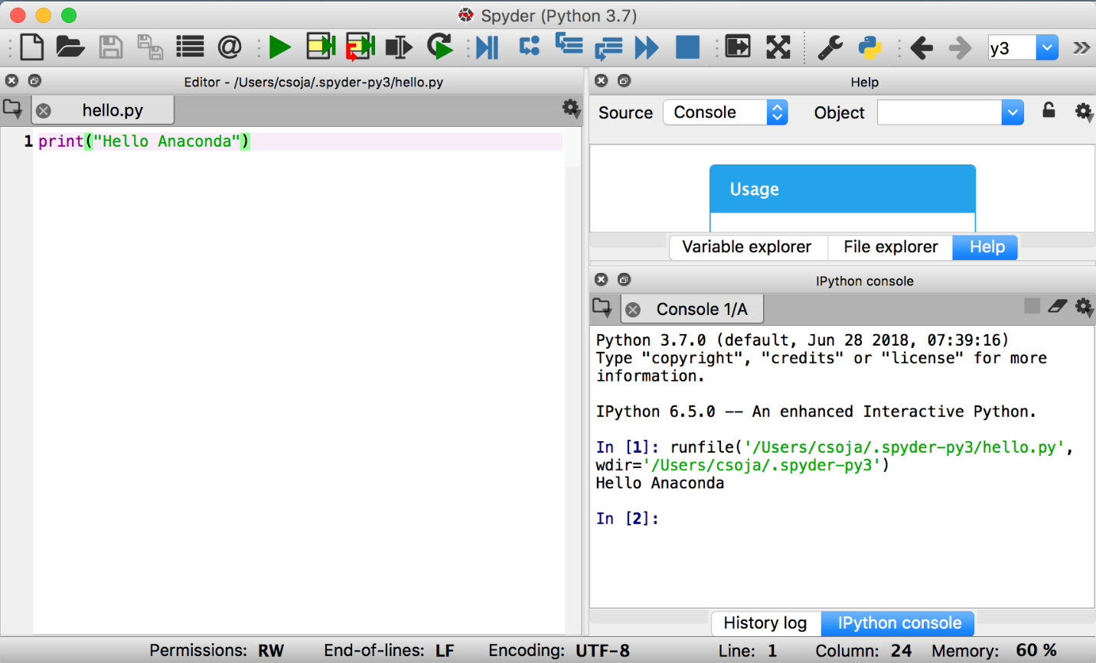

Close Spyder
From Spyder’s top menu bar, select Spyder - Quit Spyder (In macOS, select Python - Quit Spyder).

Run Python in a Jupyter Notebook
- On Navigator’s Home tab, in the Applications pane on the right, scroll to the Jupyter Notebook tile and click the Install button to install Jupyter Notebook.
Note
If you already have Jupyter Notebook installed, you can jump right to the Launch step.
- Launch Jupyter Notebook by clicking Jupyter Notebook’s Launch button.
This will launch a new browser window (or a new tab) showing the Notebook Dashboard.
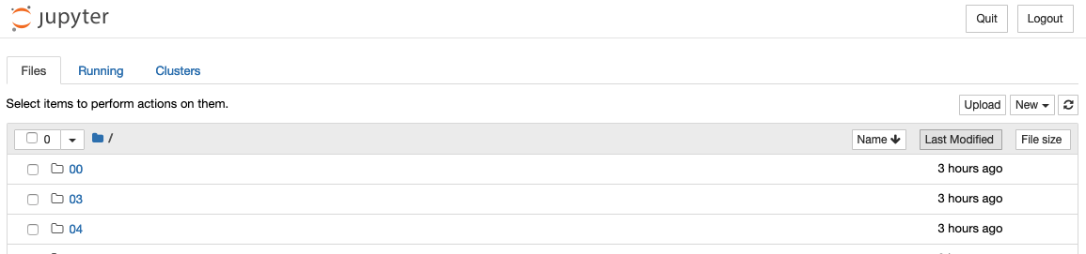
- On the top of the right hand side, there is a dropdown menu labeled “New”. Create a new Notebook with the Python version you installed.
- Rename your Notebook. Either click on the current name and edit it or find rename under File in the top menu bar. You can name it to whatever you’d like, but for this example we’ll use MyFirstAnacondaNotebook.
- In the first line of the Notebook, type or copy/paste print("Hello Anaconda").
- Save your Notebook by either clicking the save and checkpoint icon or select File - Save and Checkpoint in the top menu.
- Run your new program by clicking the Run button or selecting Cell - Run All from the top menu.
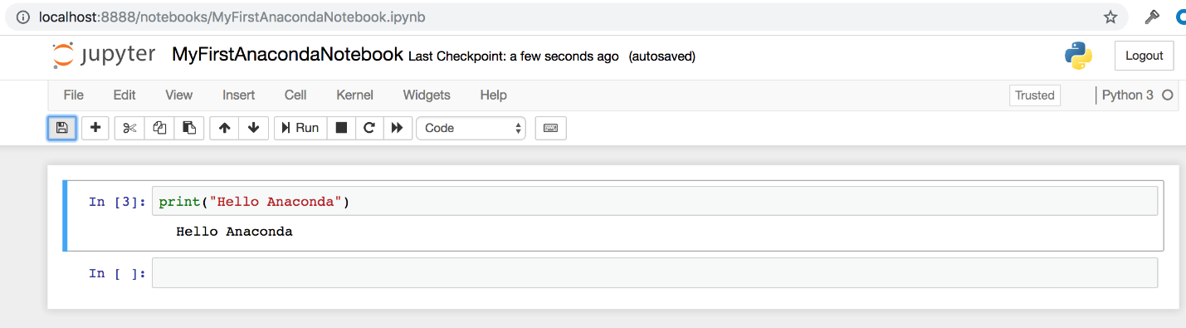

Close Jupyter Notebook
- From Jupyter Notebooks top menu bar, select File - Close and Halt.
- Click the Quit button at the upper right of the Notebook Dashboard and close the window or tab.

Close Navigator
From Navigator’s top menu bar, select Anaconda Navigator - Quit Anaconda-Navigator.

Python keywords

Python Keywords are special reserved words that convey a special meaning to the compiler/interpreter. Each keyword has a special meaning and a specific operation. These keywords can't be used as a variable. Following is the List of Python Keywords.

Code for python keywords

Python program to print the list of all keywords
In this example, we will see a Python program through which we can print the list of all the keywords
For printing the list of all the keywords we will use the "keyword.kwlist" that can be used after importing the "keyword" module. It returns a list of all the keyword available in the current Python version.
Program:

# Python program to print the list of all keywords
# importing the module
import keyword
# printing the keywords
print("Python keywords are...")
print(keyword.kwlist)

Output:
Python keywords are...
False class from or
None continue global pass
True def if raise
and del import return
as elif in try
assert else is while
async except lambda with
await finally nonlocal yield
break for not

