**Racsaanth.B**

**AIE23142 -‘E’**

**ML Volunteering**

import pandas as pd

import matplotlib.pyplot as plt

file_path = "emg gesture.xlsx"  # Update with the correct file path

df = pd.read_excel(file_path, sheet_name="Sheet1")

plt.figure(figsize=(12, 6))

for i in range(1, 9):  # Loop through channel1 to channel8

    plt.plot(df["time"], df[f"channel{i}"], label=f"Channel {i}")

plt.xlabel("Time")

plt.ylabel("EMG Signal Amplitude")

plt.title("EMG Signal Over Time")

plt.legend()

plt.grid()

plt.show()

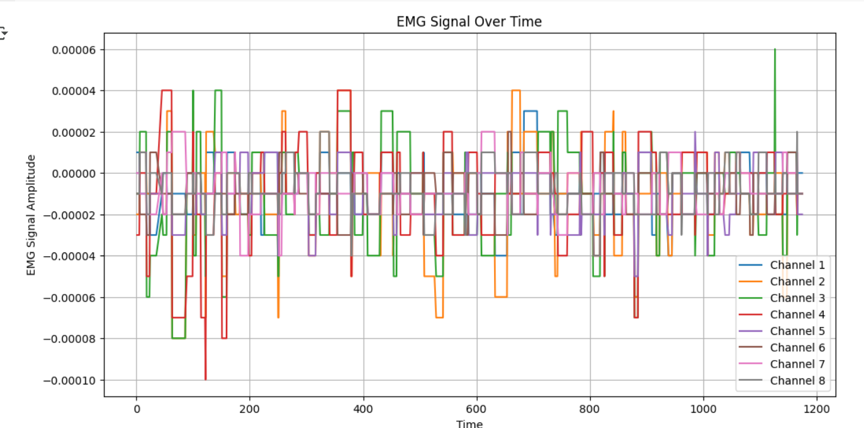

**What the graph tells us:**

**X-axis:** The x-axis represents time. It shows the progression of the recording over a certain time period. You'll notice the values on the x-axis increase as you move from left to right, indicating the passage of time.

**Y-axis:** The y-axis represents the EMG signal amplitude. This indicates the strength or intensity of the electrical activity detected by the EMG sensors (channels 1 through 8). Higher values on the y-axis correspond to stronger muscle contractions or electrical signals.

This graph displays the EMG signals recorded from 8 different channels over a period of time. Each line represents the activity of a specific muscle or muscle group. Overall, the graph visualizes how the electrical activity of these muscles changes over time. This is valuable for analyzing muscle activation patterns, identifying muscle fatigue, and studying movement or gesture control. By observing the amplitude and timing of the signals on different channels, we can gain insights into the coordination and activation of various muscles during a task or movement. For example, you might see increases in amplitude on certain channels during a specific action, indicating which muscles are primarily involved in that movement.

**Channel 1:**

import pandas as pd

import matplotlib.pyplot as plt

file_path = "emg gesture.xlsx"  # Update with the correct file path

df = pd.read_excel(file_path, sheet_name="Sheet1")

plt.figure(figsize=(12, 6))

plt.plot(df["time"], df["channel1"], label="Channel 1")

plt.xlabel("Time")

plt.ylabel("EMG Signal Amplitude")

plt.title("EMG Signal for Channel 1 Over Time")

plt.legend()

plt.grid()

plt.show()

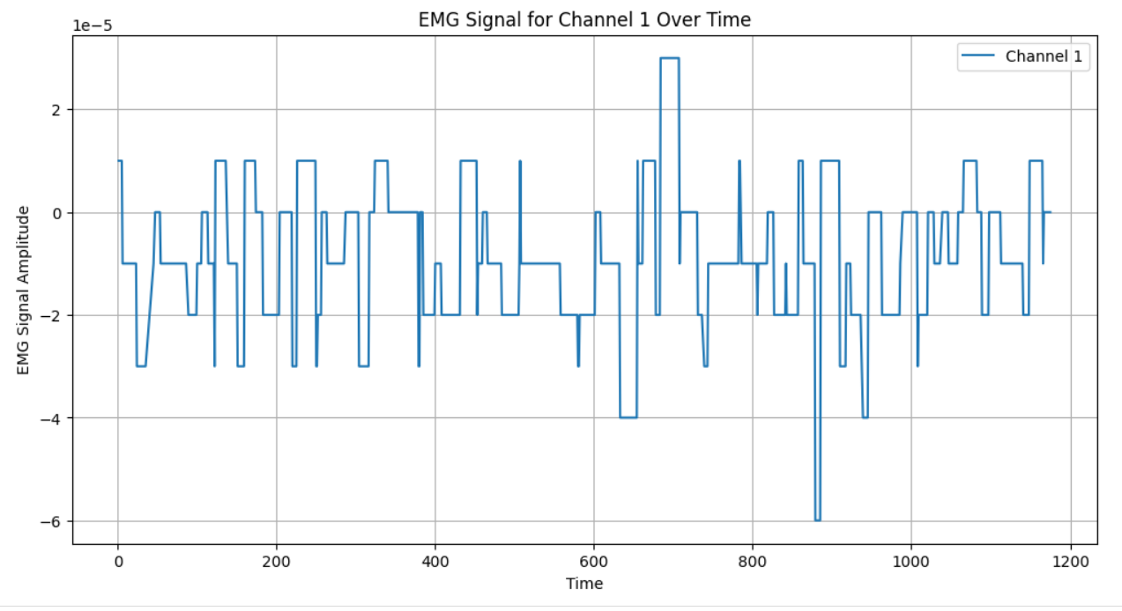

* **X-axis:** Represents time, similar to the overall graph.
* **Y-axis:** Represents the EMG signal amplitude specifically for channel 1.
* **Interpretation:** This graph shows how the electrical activity recorded by channel 1 changes over time. By observing the fluctuations in amplitude, you can assess the activation and relaxation patterns of the muscle or muscle group associated with this channel. This could indicate, for example, periods of muscle contraction and rest.

**Channel 2:**

import pandas as pd

import matplotlib.pyplot as plt

file_path = "emg gesture.xlsx"  # Update with the correct file path

df = pd.read_excel(file_path, sheet_name="Sheet1")

plt.figure(figsize=(12, 6))

plt.plot(df["time"], df["channel2"], label="Channel 2")

plt.xlabel("Time")

plt.ylabel("EMG Signal Amplitude")

plt.title("EMG Signal for Channel 2 Over Time")

plt.legend()

plt.grid()

plt.show()

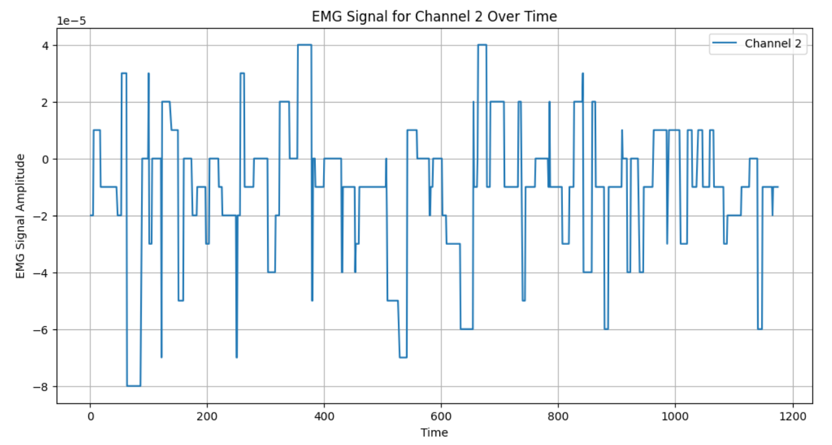

* **X-axis:** Represents time.
* **Y-axis:** Represents the EMG signal amplitude for channel 2.
* **Interpretation:** Similar to channel 1, this graph visualizes the electrical activity of the muscle or muscle group connected to channel 2. Analyze the changes in amplitude to understand its activation patterns over time.

**Channel 3:**

import pandas as pd

import matplotlib.pyplot as plt

file_path = "emg gesture.xlsx"  # Update with the correct file path

df = pd.read_excel(file_path, sheet_name="Sheet1")

plt.figure(figsize=(12, 6))

plt.plot(df["time"], df["channel3"], label="Channel 3")

plt.xlabel("Time")

plt.ylabel("EMG Signal Amplitude")

plt.title("EMG Signal for Channel 3 Over Time")

plt.legend()

plt.grid()

plt.show()

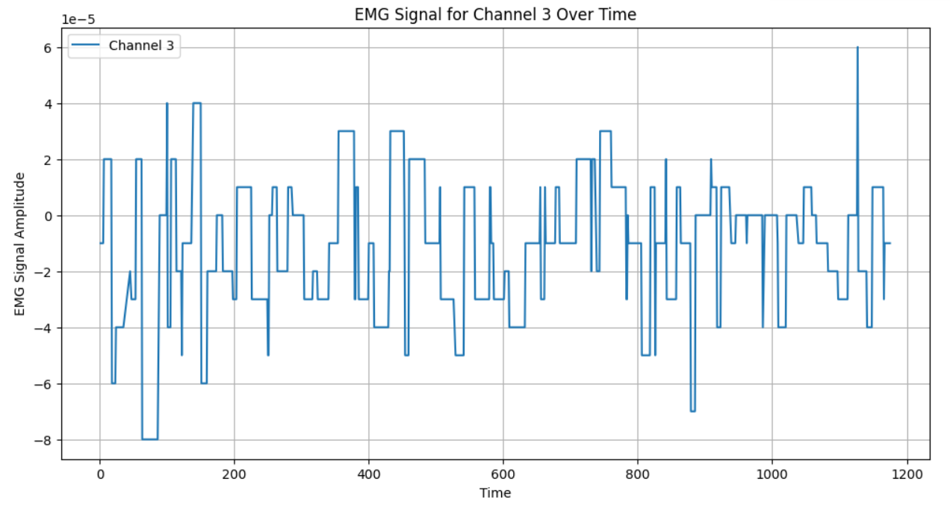

* **X-axis**: Represents time.
* **Y-axis:** Represents the EMG signal amplitude for channel 3.
* **Interpretation:** This graph shows the activity of the muscle or muscle group monitored by channel 3. Analyze the amplitude changes to identify periods of muscle activation and relaxation.

**Channel 4:**

import pandas as pd

import matplotlib.pyplot as plt

file_path = "emg gesture.xlsx"  # Update with the correct file path

df = pd.read_excel(file_path, sheet_name="Sheet1")

plt.figure(figsize=(12, 6))

plt.plot(df["time"], df["channel4"], label="Channel 4")

plt.xlabel("Time")

plt.ylabel("EMG Signal Amplitude")

plt.title("EMG Signal for Channel 4 Over Time")

plt.legend()

plt.grid()

plt.show()

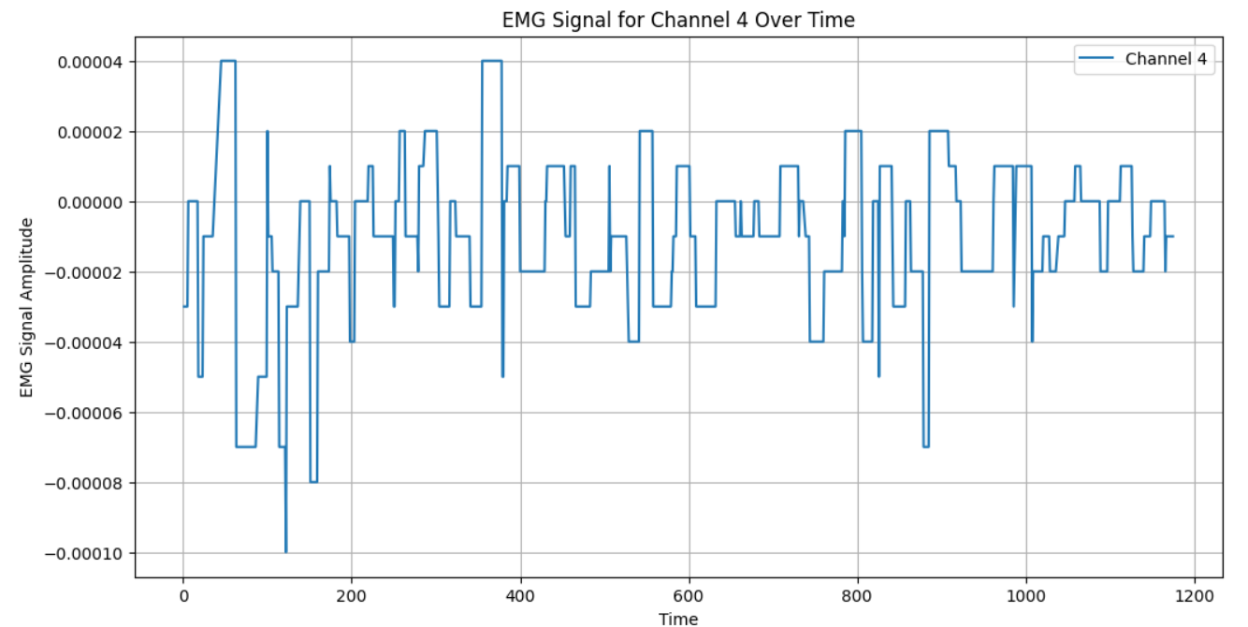

* **X-axis:**Represents time.
* **Y-axis:** Represents the EMG signal amplitude for channel 4.
* **Interpretation:** This graph visualizes the electrical activity of the muscle or muscle group associated with channel 4. Observe the amplitude variations to understand its activation patterns over time.

**Channel 5:**

import pandas as pd

import matplotlib.pyplot as plt

file_path = "emg gesture.xlsx"  # Update with the correct file path

df = pd.read_excel(file_path, sheet_name="Sheet1")

plt.figure(figsize=(12, 6))

plt.plot(df["time"], df["channel5"], label="Channel 5")

plt.xlabel("Time")

plt.ylabel("EMG Signal Amplitude")

plt.title("EMG Signal for Channel 5 Over Time")

plt.legend()

plt.grid()

plt.show()

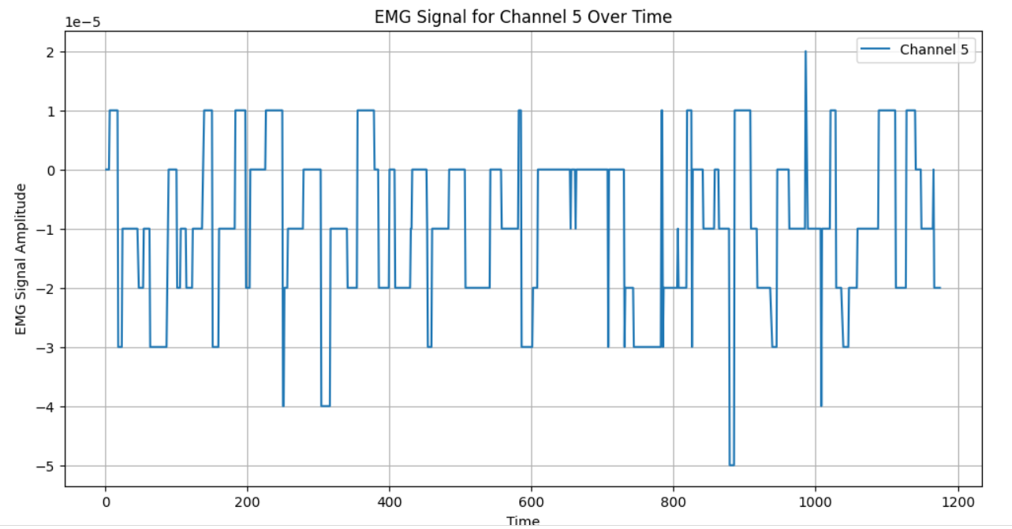

* **X-axis:** Represents time.
* **Y-axis:** Represents the EMG signal amplitude for channel 5.
* **Interpretation:** This graph displays the activity of the muscle or muscle group connected to channel 5. Analyze the amplitude changes to assess its activation and relaxation patterns.