Cloud SQL

SQl connect to cloud shell:

> gcloud sql connect charitha-mysql --user=charitha-user

There are three ways that we can communicate to the browser:
>>UI
>>CLI/Command
>>API

>Cloud SQL:
>>Postgre sql services:
firestore
Datastore
big table
Memory store
Cansendra is like ….which uses sql over nosql called as hybrid model

Accesing the cloud storage via VM:--
> First enable the compute engine API
> Create the VM - go to the compute engine , there create the instance which is a VM instance
Note : to access the storage in vm , we need the instance id
> Create the bucket - go to the cloud storage , create the object instance which is a bucket instance

Note :--In the advanced settings-->provisional model--> spot ( use only when u r creating the sample integration , not everytime)

After creating all the requirements, go to the cloud shell , start integation
>clear
> gcloud compute ssh instance Id --zone=asia-south-a

>clear
> uname -a ( to confirm whether ur on the instance or not )

> gcloud storage ls charithabucket ( reading the file )

>gcloud storage cp gs://charithabucket/gcs-test.txt gsc-test.txt ( here we pull the file into the VM, to test the file we created u filename called gcs-test.txt )

>ls ( to check the file , it shows the filename )

> cat gcs-test.txt ( it prints the file contents )
my name is charitha

>>> After creating all these things, ensure that first go to the billings section --manage billings-- u find the created resources - delete billings
Second go to the manage resources--u find the newly created resoures-- delete the resources

- Created the SQl instance to store and query the database
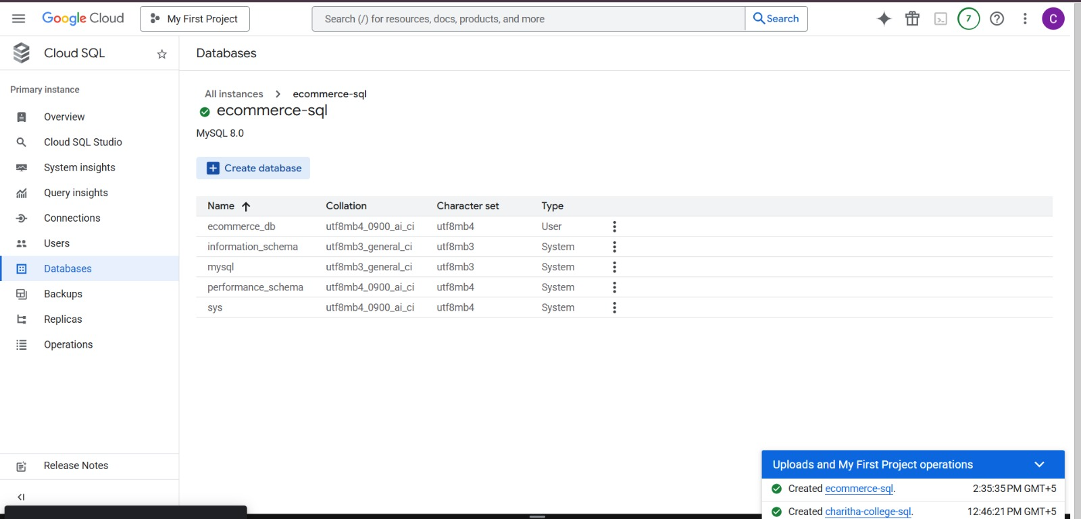
- After creating the sql instance, create the database, and creating the user to access the database

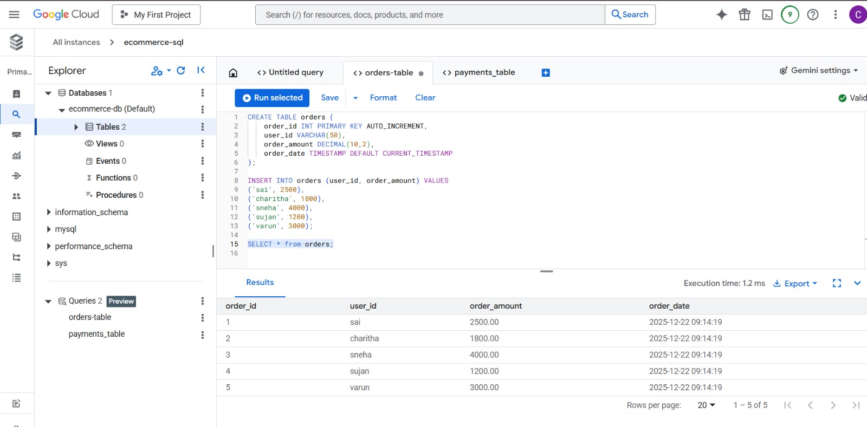

Using the database tables, then we can start doing the querying

