Assignment 1: Resource Governance and Failure Modes
Objective
Validate practical understanding of Requests, Limits, LimitRange, ResourceQuota, OOMKilled behavior, and quota enforcement.
Resources Created
- Namespace: intern-test
- LimitRange: intern-limitrange
- ResourceQuota: intern-quota
- Pod: good-pod
- Pod: oom-pod
Validation
LimitRange
Configured default CPU and memory requests/limits for containers.
ResourceQuota
Configured hard limits for:
- Pods
- requests.cpu
- requests.memory
- limits.cpu
- limits.memory
Successful Pod
good-pod was created successfully and inherited resource values from LimitRange.
OOMKilled Pod
oom-pod was configured with a low memory limit and intentionally exceeded it.
Result:
- Pod entered CrashLoopBackOff state
- Container termination reason: OOMKilled
Screenshots:
LimitRange:
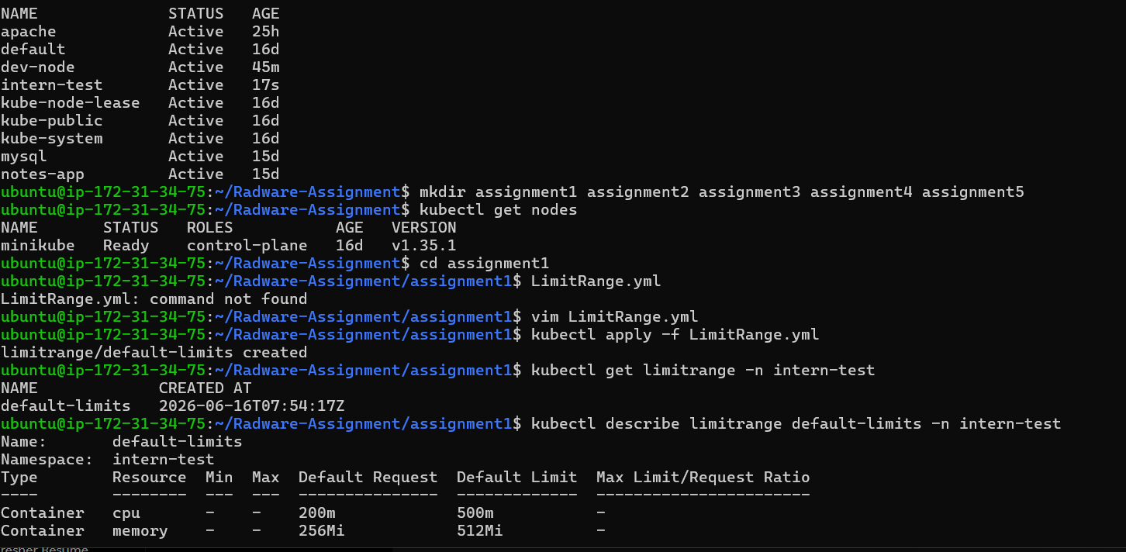
ResourceQuota:
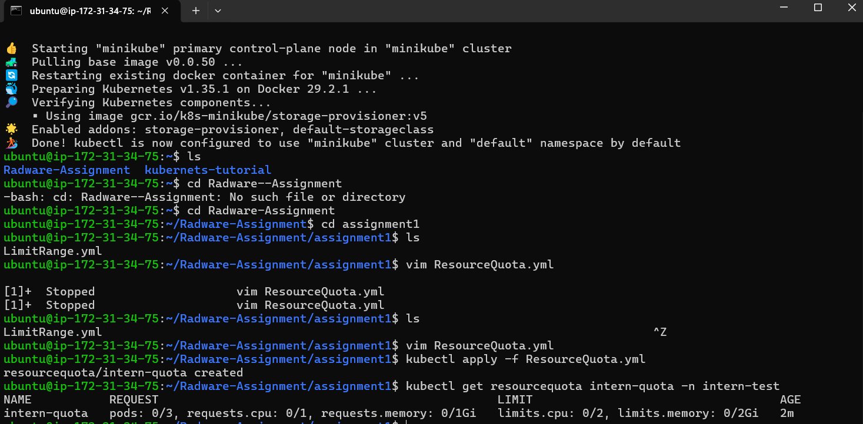

OOMKilled Container:
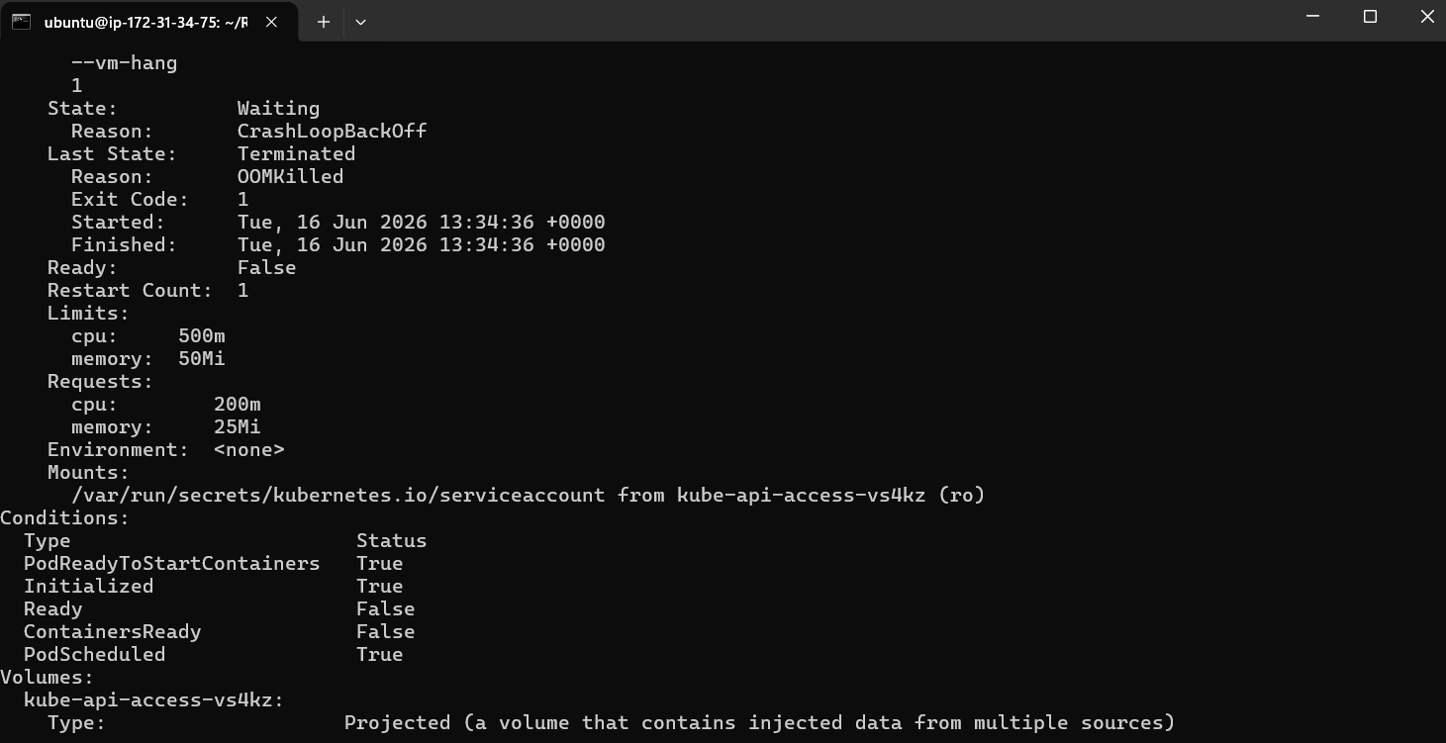
AdmissionError:
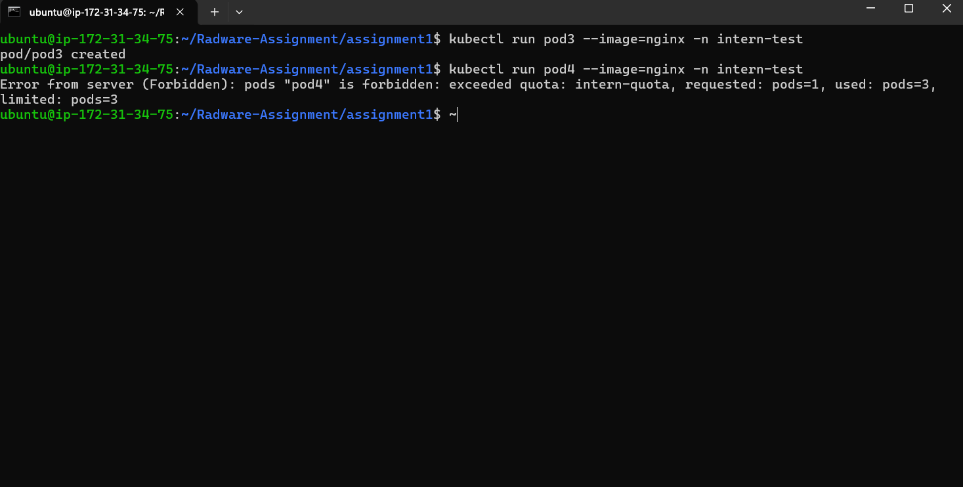

Quota Enforcement
After reaching the pod quota limit, additional pod creation was denied.
Example error:
"exceeded quota: intern-quota"
OOMKill vs Quota Denial
OOMKill occurs when a running container exceeds its memory limit. Kubernetes terminates the container to protect node stability. The pod may restart depending on its restart policy.
Quota denial occurs before a resource is created. The Kubernetes API server rejects the request because the namespace has exceeded configured resource limits.
OOMKill affects running workloads, while quota denial prevents new workloads from being created.

