Git Branching, Merging, Reset & Rebase – Practical Assignment

Student Name: Sai Kukkapalli
GitHub Username: Saichowdary9
Repository Link: https://github.com/Saichowdary9/flask-todo-app

Objective
The objective of this practical assignment is to demonstrate hands-on understanding of Git and GitHub by performing repository setup, SSH authentication, branch creation, merging, conflict resolution, reset, and rebase operations using a Flask-based To-Do application.

Tools & Technologies Used
- Git & GitHub
- Flask (Python)
- MongoDB
- HTML (Frontend)
- Visual Studio Code
- Windows PowerShell

Part 1: SSH Authentication and Repository Setup
In this phase, a new GitHub repository was created and connected securely using SSH authentication. An ED25519 SSH key was generated and added to the GitHub account. The repository was cloned using SSH, and initial Flask project files were added in a separate branch named after the username. The branch was later merged into the main branch.
Screenshots below show SSH authentication success, repository cloning, branch creation, and commits.
Figure 1: SSH setup, cloning, and initial branch operations
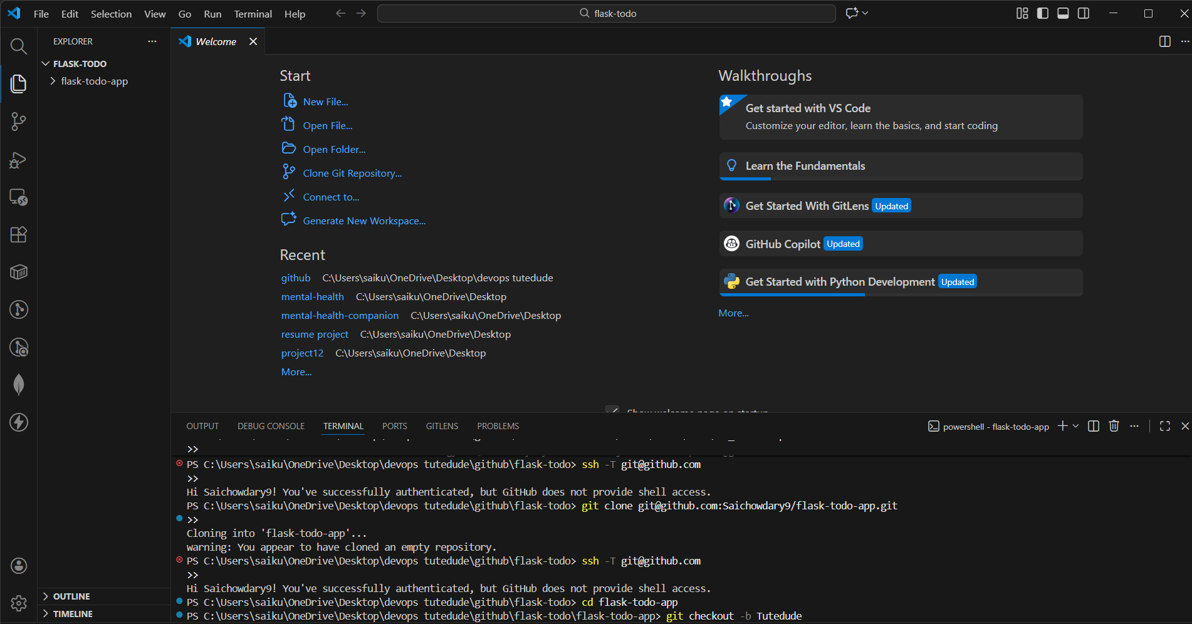
Figure 2: SSH setup, cloning, and initial branch operations
Figure 3: SSH setup, cloning, and initial branch operations
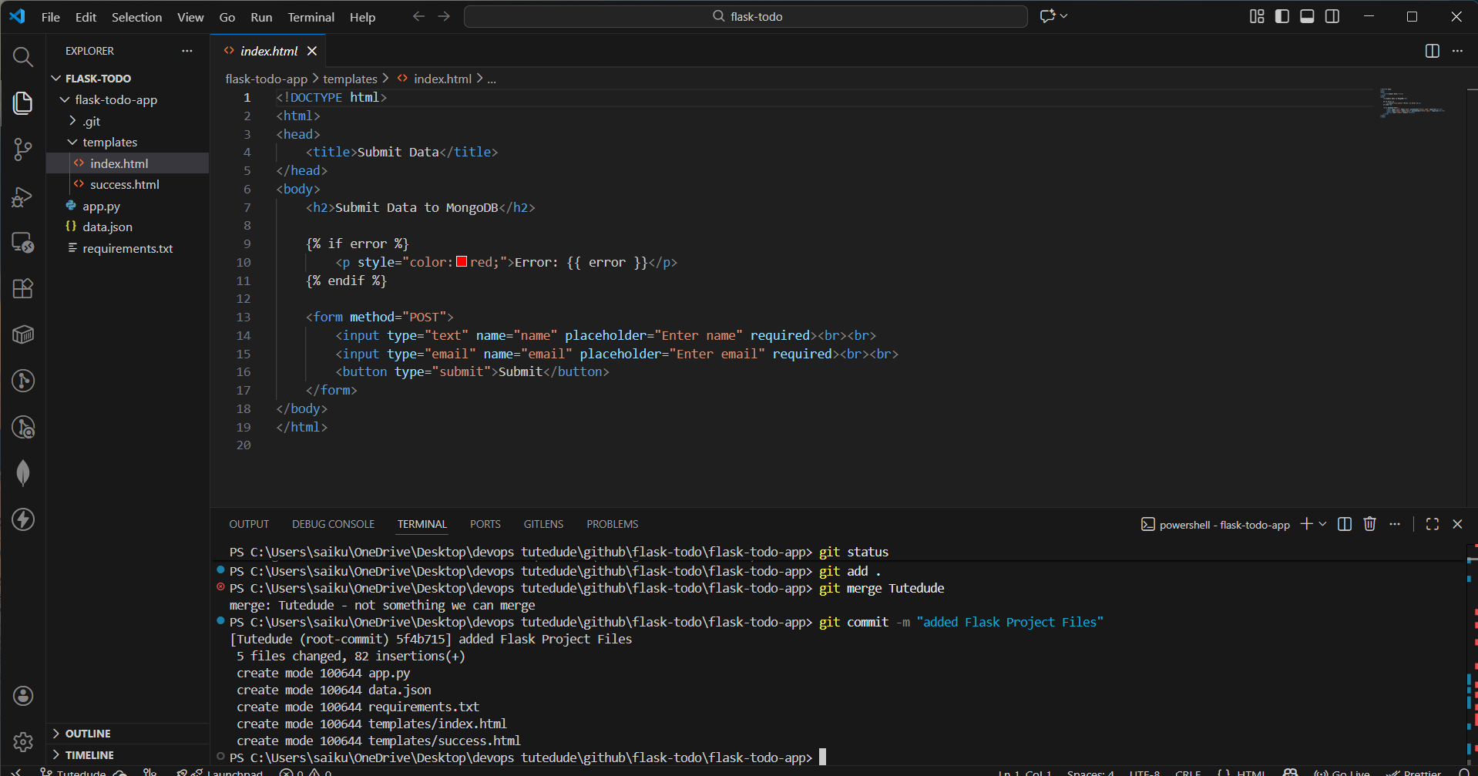
Figure 4: SSH setup, cloning, and initial branch operations
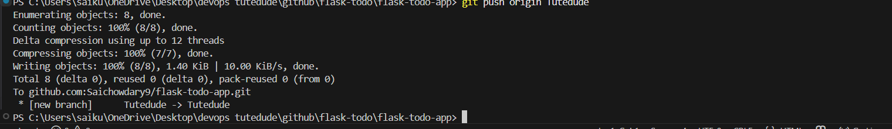
Figure 5: SSH setup, cloning, and initial branch operations
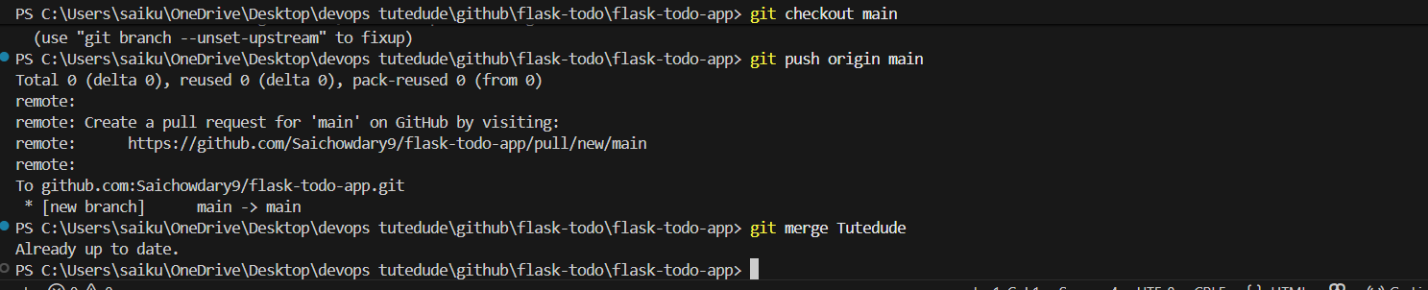

Part 2: JSON Update Using Feature Branch
A new feature branch named Tutedude_new was created from the main branch. In this branch, the JSON file used for the /api route was modified to update API response data. The changes were committed and pushed to GitHub. Finally, the branch was merged back into the main branch.
Figure 6: JSON update, commit, push, and merge to main
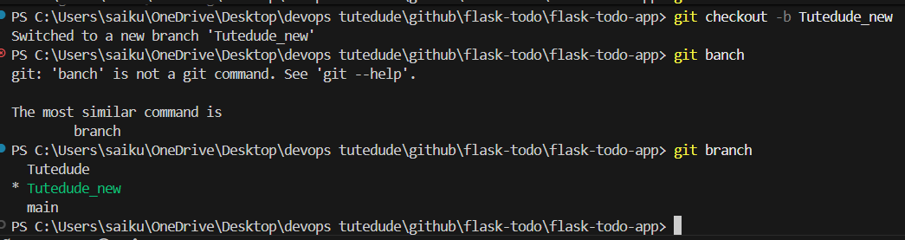
Figure 7: JSON update, commit, push, and merge to main
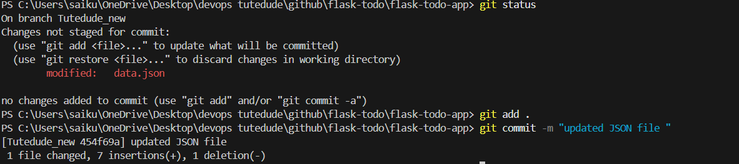
Figure 8: JSON update, commit, push, and merge to main
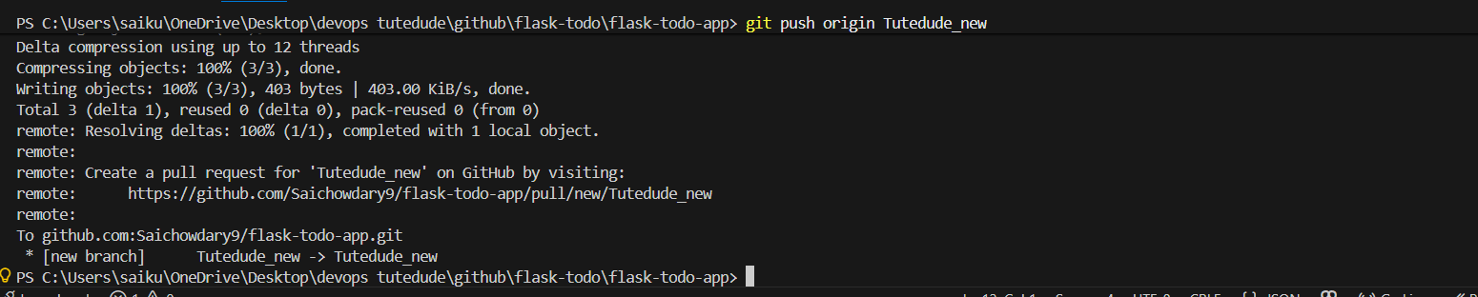
Figure 9: JSON update, commit, push, and merge to main
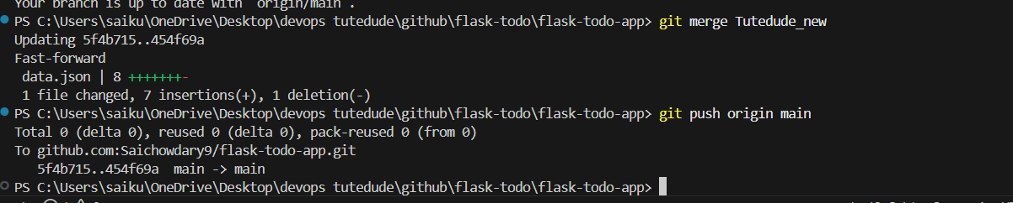

Part 3: Frontend and Backend Development Using Separate Branches
Two branches, master_1 and master_2, were created from the main branch. The master_1 branch was used for frontend development, where a To-Do form was created. The master_2 branch was used for backend development, where a Flask API endpoint (/submittodoitem) was implemented to store data in MongoDB. Both branches were later merged into the main branch.
Figure 10: Branch creation for frontend and backend
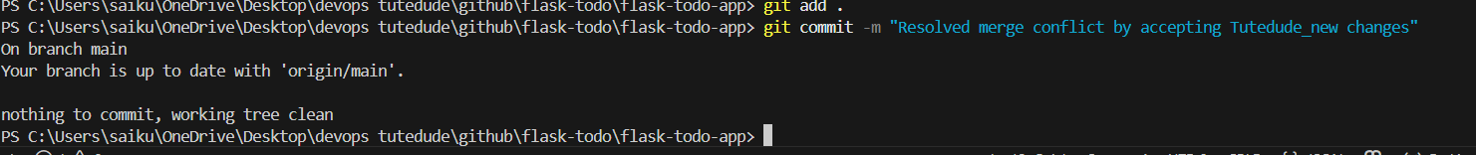
Figure 11: Branch creation for frontend and backend
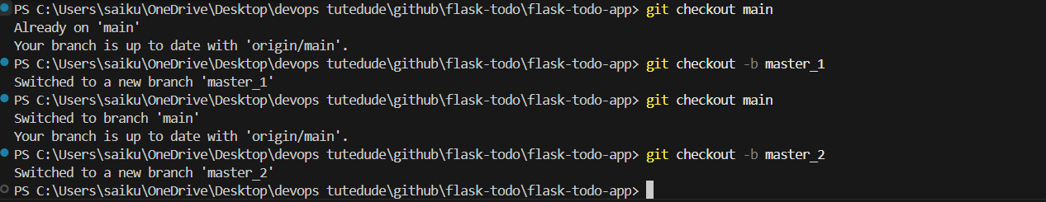

Part 4: Sequential Commits, Git Reset, and Rebase
In this phase, the To-Do form was enhanced by adding Item ID, Item UUID, and Item Hash fields. Each field was committed separately to maintain a clean commit history. The branch was merged into main. A soft reset was performed to roll back to the commit where only the Item ID field existed, while preserving staged changes. Finally, a rebase operation was executed to apply updated main branch history back to the feature branch without squashing commits.
Figure 12: Git reset, force push, and final commit graph
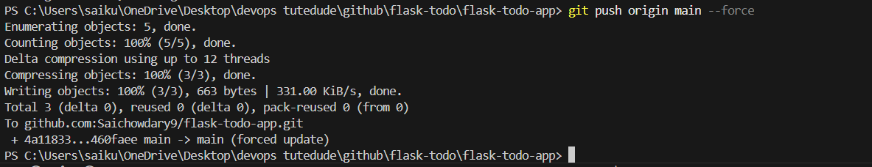
Figure 13: Git reset, force push, and final commit graph
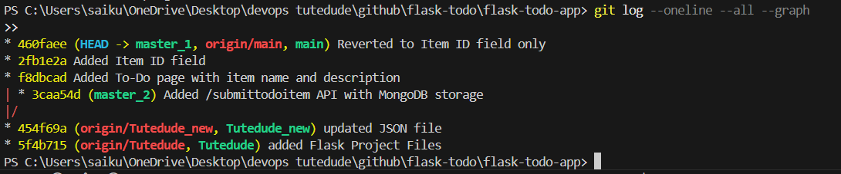

Conclusion
This assignment successfully demonstrated practical Git workflows including branching strategies, feature development, merging, conflict handling, reset, and rebasing. These version control practices are essential for collaborative development and DevOps workflows.

