PROTA CORE BACKEND SPECIFICATION
Complete Backend Architecture & File-by-File Catalog
A clear, exhaustive technical manual of the Prota backend: end-to-end process flow diagrams, security and session architectures, database schema, API contracts, and an itemized reference for every single file.
Release Milestone | Phase 2A: Secure Authentication & Profile Management
Primary Stack | Java 25 / 26, Spring Boot 4.1.1, Spring Security 7.0.9, PostgreSQL 18.4
Security Guarantees | HTTP-Only SameSite=Lax Session Cookie, Double-Submit CSRF, BCrypt $2a$
Test Suite Status | 21 Automated Integration Tests Passing (0 Failures, 0 Skipped, 0 Errors)

1. Overview & Technology Stack
Prota is engineered with an emphasis on rock-solid security, data integrity, and strict domain boundaries. It operates with full schema validation against PostgreSQL 18 with Flyway version control.
Layer / Component | Technology / Specification
Programming Language | Java 25 / 26 (LTS compiler toolchain)
Framework & Engine | Spring Boot 4.1.1 / Spring Framework 7.0.9
Security System | Spring Security 7.0.9 (HTTP-only Session Cookies, CSRF, BCrypt)
Persistence / ORM | Spring Data JPA / Hibernate 7.x (ddl-auto: validate)
Relational Database | PostgreSQL 18.4
Database Versioning | Flyway 11 (via spring-boot-starter-flyway)
JSON Processing | Jackson 2.18 with JavaTimeModule & custom serializers
Build Tooling | Apache Maven (via project Maven Wrapper .\mvnw.cmd)
Health & Telemetry | Spring Boot Actuator (/actuator/health, /actuator/info)

2. Visual Process & Architecture Flow Diagrams
This section contains visual architecture diagrams and process sequence flows illustrating how the Prota backend processes data, enforces security, and isolates user boundaries.
2.1 High-Level Architecture Flow
The diagram below details the client-to-backend infrastructure, showing how client requests pass through the Spring Security boundary, REST controllers, service transactions, and JPA persistence before reaching PostgreSQL:
Figure 1: Prota Multi-Tier System Architecture & Gateway Routing
2.2 Authentication & Session Lifecycle Flow
Prota establishes authenticated sessions using server-managed cookies with session fixation defense and double-submit CSRF tokens:
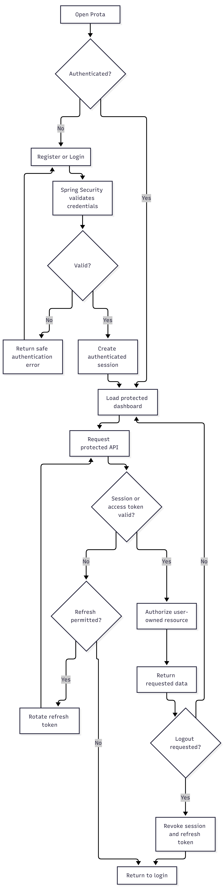
Figure 2: User Registration, Session Fixation Rotation, Cookie Exchange, and Invalidation Flow
2.3 AI Food Logging & Multimodal Estimation Flow
The AI logging pipeline ingests multimodal inputs (voice, text, image), stages estimates in AiFoodEstimate, presents them for user confirmation, and persists entries into the DailyLog snapshot:
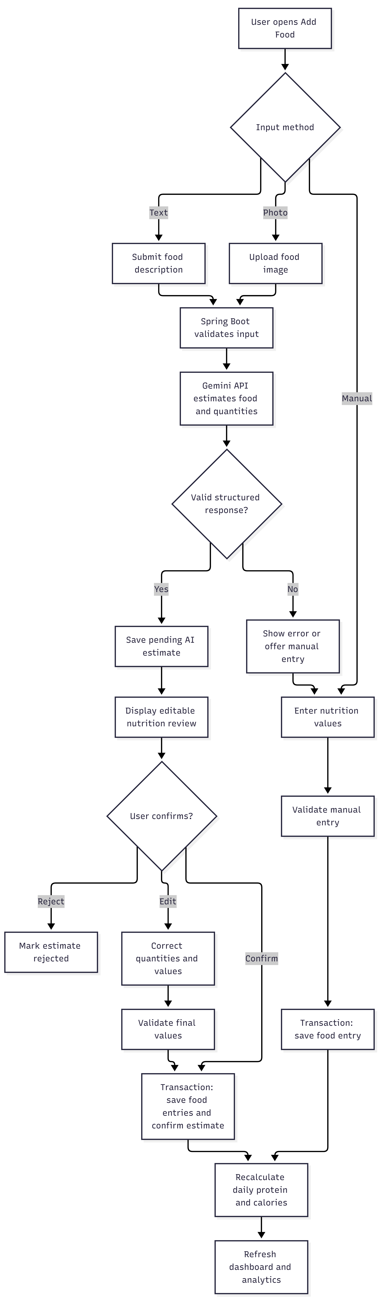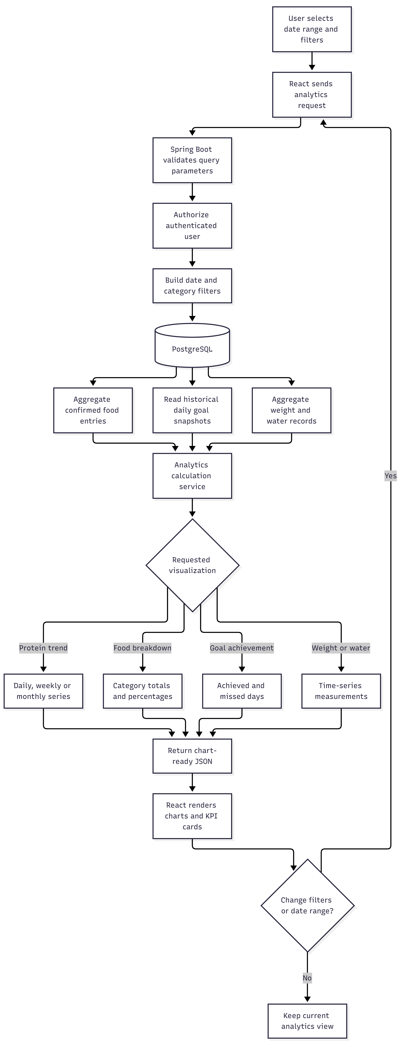
Figure 3: Multimodal Food Parsing, AI Estimation, and Confirmation Flow
2.4 Analytics, Streaks & Historical Rollup Flow
Daily records compute protein and calorie totals dynamically. Updating user settings never alters historical DailyLog goal snapshots, ensuring 100% accurate streaks and analytics:

Figure 4: Daily Log Totals Calculation, Streak Evaluation, and Analytics Rollups
2.5 Reminders & Notification System Flow
The notification engine checks active user reminder preferences, verifies recent intake, and dispatches Web Push notifications with delivery auditing:
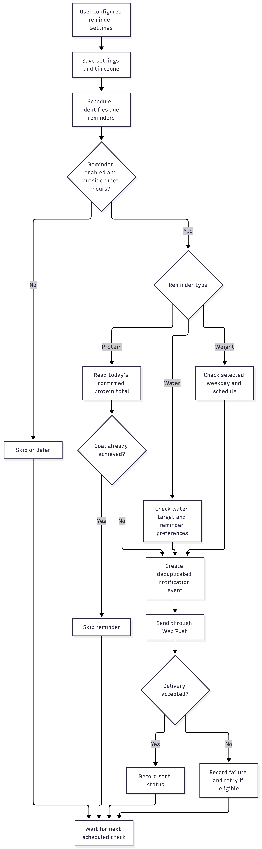
Figure 5: Scheduled Reminders Evaluation and Web Push Notification Dispatch Flow
3. Exhaustive Backend File-by-File Catalog
Every file in the backend repository is documented below with its exact role, key members, and architectural connections.
3.1 Project Root, Build & Environment Files
File Name | Role / Category | Description & Responsibilities
pom.xml | Build Descriptor | Declares all dependencies (Spring Boot, Security, JPA, Flyway, Postgres, Validation, Lombok), compiler release 25, and plugins.
mvnw | Maven Wrapper (POSIX) | Shell script enabling Unix/Linux/macOS developers to run Maven commands identically without a pre-installed Maven binary.
mvnw.cmd | Maven Wrapper (Windows) | Batch script for building and running Maven commands on Windows PowerShell or CMD.
.mvn/wrapper/maven-wrapper.properties | Wrapper Config | Configures wrapper distribution to fetch Apache Maven 3.9.9 automatically.
.env.example | Configuration Template | Documents all required environment variables: PORT, DB_URL, DB_USERNAME, DB_PASSWORD, CORS_ALLOWED_ORIGINS, COOKIE_SECURE.
.gitignore | Version Control | Excludes Maven target directories, IDE settings (.idea, .vscode), temporary scratch scripts, and local .env files.
.gitattributes | Version Control | Normalizes line endings across platforms (forces LF on shell scripts and CRLF/auto on source files).
README.md | Documentation | Provides repository overview, tech stack specifications, local development prerequisites, and build steps.
HELP.md | Reference | Auto-generated Spring Boot reference containing direct links to official documentation.

3.2 Application Entry Point & Configuration
Class Name | Package | Description & Responsibilities
ProtaApplication.java | com.prota | Main application runner. Contains main(String[] args). Initializes Spring context, triggers Flyway, and starts Tomcat.
CorsProperties.java | com.prota.config | Strongly-typed configuration bean bound to app.cors in application.yml. Exposes allowedOrigins, methods, headers, and maxAge.
JacksonConfig.java | com.prota.config | Configures primary ObjectMapper bean. Registers JavaTimeModule, disables timestamp serialization, and enforces UTC timestamps.

3.3 Security Layer (com.prota.security)
Class Name | Role | Description & Responsibilities
SecurityConfig.java | Security Filter Chain | Configures HttpSecurity: session fixation changeSessionId, CookieCsrfTokenRepository (path /), CORS, 401 entry point, and route authorization.
SecurityUtils.java | Identity Helper | Static helper extracting current user UUID (getCurrentUserId()) and email from SecurityContextHolder. Enforces server-side identity.
UserPrincipal.java | UserDetails Adapter | Wraps User entity. Implements Spring Security UserDetails (authorities, enabled status, password hash).
CustomUserDetailsService.java | User Loader | Implements UserDetailsService. Queries UserRepository by normalized email to supply UserPrincipal during authentication.

3.4 REST Controllers (com.prota.controller)
Controller | Routes Handled | Description & Responsibilities
AuthController.java | /api/v1/auth/* | Endpoints: POST /register, POST /login, POST /logout, GET /me, GET /csrf. Coordinates authentication, session cookies, and token exchange.
UserController.java | /api/v1/users/* | Endpoints: GET /me, PATCH /me. Returns profile information and updates user's full name. Enforces email immutability.
SettingsController.java | /api/v1/settings | Endpoints: GET /, PATCH /. Retrieves and updates current user nutrition targets, timezone, unit of weight, and theme.

3.5 Service Layer (com.prota.service)
Service Name | Key Transactions | Description & Responsibilities
AuthService.java | register, login, logout, getCurrentUser | Transactional user creation with default user_settings, BCrypt password hashing, session fixation rotation, and session invalidation.
UserService.java | getProfile, updateProfile | Retrieves authenticated user profile and modifies full name. Rejects email alterations.
SettingsService.java | getSettings, updateSettings | Retrieves and updates goal preferences. Validates timezone with ZoneId.of. Guarantees historical DailyLog records are preserved.
DailyFoodLoggingService.java | getOrCreateDailyLog, addFoodEntry, updateFoodEntry, deleteFoodEntry | Handles daily log creation, meal entry logging, and dynamic recalculation of consumed protein and calories.

3.6 JPA Entities & Enums (com.prota.entity)
Entity / Enum | Database Table | Description & Key Attributes
User.java | users | Core user entity. UUID PK, fullName, email, passwordHash, status, emailVerifiedAt, timestamps.
UserSetting.java | user_settings | 1-to-1 preferences: userId (PK/FK), proteinGoalG, calorieGoalKcal, waterGoalMl, weightUnit, timezone, theme.
DailyLog.java | daily_logs | Per-date record. Captures frozen goal snapshots (proteinGoalG, calorieGoalKcal). Unique (user_id, log_date).
FoodEntry.java | food_entries | Logged meal entry: foodName, mealType, quantity, unit, proteinG, caloriesKcal, consumedAt, user/dailyLog FKs.
SavedFood.java | food_library_items | Reusable food library items: name, brand, servingSize, servingUnit, proteinG, caloriesKcal, isVerified.
AiFoodEstimate.java | ai_usage_logs | Tracks Gemini AI interactions: rawInputText, imageUrl, estimatedProteinG, status, tokenUsage.
WaterEntry.java | daily_logs (ext) | Hydration entries recording volume consumed, dailyLogId, and timestamps.
WeightEntry.java | user_settings (ext) | Bodyweight tracking: weighDate, weightValue, weightUnit, userId.
ReminderSetting.java | notification_preferences | Configures notification reminders: reminderType, scheduleType, scheduledTime, isEnabled, channel.
NotificationEvent.java | security_audit_logs | Audit log of dispatched notifications: recipient, title, body, status, sentAt.
PushSubscription.java | notification_preferences | Web Push subscription: endpoint, p256dhKey, authKey, userAgent.
RefreshToken.java | refresh_tokens | Multi-device session tokens: tokenHash, expiresAt, revokedAt (reserved for future token rotations).

3.7 Spring Data JPA Repositories (com.prota.repo)
Repository Name | Managed Entity | Key Query Methods
UserRepository.java | User | findByEmail(String), existsByEmail(String)
UserSettingRepository.java | UserSetting | findByUserId(UUID)
DailyLogRepository.java | DailyLog | findByUserIdAndLogDate(UUID, LocalDate), existsByUserIdAndLogDate(...)
FoodEntryRepository.java | FoodEntry | findAllByDailyLogId(UUID), findByIdAndUserId(UUID, UUID)
SavedFoodRepository.java | SavedFood | findAllByUserIdOrUserIdIsNull(UUID), searchByName(String)
AiFoodEstimateRepository.java | AiFoodEstimate | findAllByUserIdOrderByCreatedAtDesc(UUID)
WaterEntryRepository.java | WaterEntry | findAllByUserIdAndDate(...)
WeightEntryRepository.java | WeightEntry | findAllByUserIdOrderByWeighDateDesc(UUID)
ReminderSettingRepository.java | ReminderSetting | findAllByUserIdAndIsEnabledTrue(UUID)
NotificationEventRepository.java | NotificationEvent | findAllByUserIdOrderByCreatedAtDesc(UUID)
PushSubscriptionRepository.java | PushSubscription | findAllByUserId(UUID)
RefreshTokenRepository.java | RefreshToken | findByTokenHash(String)

3.8 Data Transfer Objects & Exception Handling
DTO / Exception Class | Category | Description & Payload Attributes
RegisterRequest.java | Request DTO | fullName, email (auto-trimmed), password. Jakarta validation: @NotBlank, @Email, @Size(8..100).
LoginRequest.java | Request DTO | email (auto-trimmed), password. Validates credentials.
UpdateProfileRequest.java | Request DTO | fullName. Validates non-blank and max 100 characters.
UpdateSettingsRequest.java | Request DTO | proteinGoalG (>= 1.00), calorieGoalKcal (> 0), waterGoalMl (> 0), weightUnit, timezone, theme.
CreateFoodEntryRequest.java | Request DTO | foodName, mealType, quantity, quantityUnit, proteinG, caloriesKcal, consumedAt.
UpdateFoodEntryRequest.java | Request DTO | Modifications to existing food entry quantities or nutritional values.
UserResponse.java | Response DTO | id, fullName, email, status, emailVerifiedAt, createdAt. Excludes password hashes.
SettingsResponse.java | Response DTO | userId, proteinGoalG, calorieGoalKcal, waterGoalMl, weightUnit, timezone, theme, updatedAt.
DailyLogResponse.java | Response DTO | id, logDate, goals, consumedProteinG, proteinRemainingG, completion %, foodEntries list.
CsrfResponse.java | Response DTO | token, headerName, parameterName. Used by SPA for CSRF bootstrap.
ErrorResponse.java | Response DTO | Standard RFC 9457 Problem Details envelope (code, message, status, timestamp, fieldErrors).
GlobalExceptionHandler.java | Advice | Translates exceptions (validation, conflicts, missing auth) to uniform RFC 9457 JSON.

3.9 Resources, Migrations & Test Suites
File Path | Category | Description & Highlights
application.yml | Resource | Database settings, context-path (/api/v1), Hikari pool, session cookie (PROTASESSIONID, http-only), CORS.
application-dev.yml | Resource | Dev profile with SQL formatting and DEBUG logging.
V1__create_initial_schema.sql | Flyway Migration | Creates all 12 tables, composite keys, indexes, and constraints.
Phase2AAuthAndProfileTests.java | Integration Test | 10 tests: registration, duplicate email, password hash check, login/logout, CSRF, user isolation, snapshot preservation.
DatabaseSchemaAndConstraintTests.java | Integration Test | 6 tests: verifies all 12 tables, UUID primary keys, composite keys, constraints.
SecurityAndActuatorTests.java | Integration Test | 4 tests: actuator health, sensitive actuators, 401 unauthenticated check, CORS headers.

4. API Contract Reference
All routes reside under context path /api/v1.
4.1 Authentication Endpoints
Route: POST /api/v1/auth/register
Registers a new account with BCrypt password hashing, default settings, and session cookie issuance.
// POST /api/v1/auth/register
{
"fullName": "Jane Doe",
"email": "jane@example.com",
"password": "SecurePassword123!"
}
// 201 Created Response
{
"id": "c0fcf568-338f-43c8-a1d4-ad1ad40a3f9f",
"fullName": "Jane Doe",
"email": "jane@example.com",
"status": "ACTIVE",
"emailVerifiedAt": null,
"createdAt": "2026-10-20T08:22:34.645Z"
}

Route: POST /api/v1/auth/login
Authenticates user credentials, changes session ID (fixation protection), and sets PROTASESSIONID.
// POST /api/v1/auth/login
{
"email": "jane@example.com",
"password": "SecurePassword123!"
}

Route: POST /api/v1/auth/logout
Invalidates session and clears SecurityContextHolder (HTTP 204 No Content).
Route: GET /api/v1/auth/csrf
Retrieves active CSRF token for Single Page Applications.
// 200 OK Response
{
"token": "d7b93198-10b2-4d22-9df7-23456789abcd",
"headerName": "X-XSRF-TOKEN",
"parameterName": "_csrf"
}

4.2 Profile & Settings Endpoints
Route: PATCH /api/v1/users/me
Updates full name (CSRF required). Email is immutable.
// PATCH /api/v1/users/me
{
"fullName": "Jane Smith"
}

Route: PATCH /api/v1/settings
Updates goal targets and preferences. Historical DailyLog records are preserved.
// PATCH /api/v1/settings
{
"proteinGoalG": 180.00,
"calorieGoalKcal": 2400.00,
"waterGoalMl": 3000,
"weightUnit": "KG",
"timezone": "America/New_York",
"theme": "DARK"
}

5. Error Handling & RFC 9457 Specification
Standard error envelope format across all endpoints:
{
"code": "VALIDATION_ERROR",
"message": "Invalid request payload",
"status": 400,
"timestamp": "2026-10-20T08:21:33.427Z",
"fieldErrors": [
{
"field": "proteinGoalG",
"message": "Protein goal must be at least 1 gram",
"rejectedValue": -10.00
}
]
}

6. Developer Setup & Test Verification
All 21 automated integration tests run directly against PostgreSQL with 100% success rate:
# Run all integration tests
.\mvnw.cmd test
# Compile and package production JAR
.\mvnw.cmd package

