Session 2 (Revised) — Size It
Giltex Raw Material Shortage Detection — Problem-to-Product Sprint
Rebuilt against the current dataset. Supersedes the original Session 2 submission — kept in one file per instruction.

1. Dataset Loaded
Two source files exist for this problem and were both loaded and reconciled rather than picking one blind:
- Data_Main.xlsx — 1,000 shortage events, single "Raw Data" sheet, Aug 5 2025–Jan 31 2026. No batch-volume denominator. This is the dataset already live inside the Session 5 prototype.
- Data_v2_1.xlsx — 1,024 shortage events, five sheets (Shortage Events, Batch Volume, Monthly Summary, Segment Summary, Assumptions), same date range. This is the only file with a batch-volume denominator, so it is the only file that can produce a true shortage rate (% of batches).
The data does show the problem in both files — 1,000+ shortage events, 6-figure monthly cost, and a rising trend — so no regeneration was needed. What the reconciliation surfaced instead is a live conflict between the two files:
FLAG: Data_v2_1.xlsx's shortage rate climbs every single month (15.3%→36.3%, no exceptions). Data_Main.xlsx's raw event count peaks in December (282) and falls 24% in January (215). Both cannot be describing the same reality cleanly. Data_v2_1.xlsx is used below wherever a true rate or a batch denominator is required, because it is the only file that supports that math. Data_Main.xlsx is cross-checked against it wherever possible. This conflict is not resolved in this submission — it is called out explicitly so it doesn't quietly become load-bearing.

2. Pivots and Charts

Pivot 1 — Shortage Rate by Month × Shop
Rows: Month · Columns: Shop · Values: Shortage Rate (%) = Shortage Events ÷ Batches Scheduled. Source: Data_v2_1.xlsx (Shortage Events + Batch Volume sheets). A true rate by material category is not buildable — Batch Volume is only tracked by Shop, not by material.
Month | Dyeing | Weaving
2025-08 | 14.2% | 17.0%
2025-09 | 19.5% | 17.4%
2025-10 | 25.5% | 17.3%
2025-11 | 27.6% | 27.2%
2025-12 | 30.4% | 27.4%
2026-01 | 35.5% | 37.7%

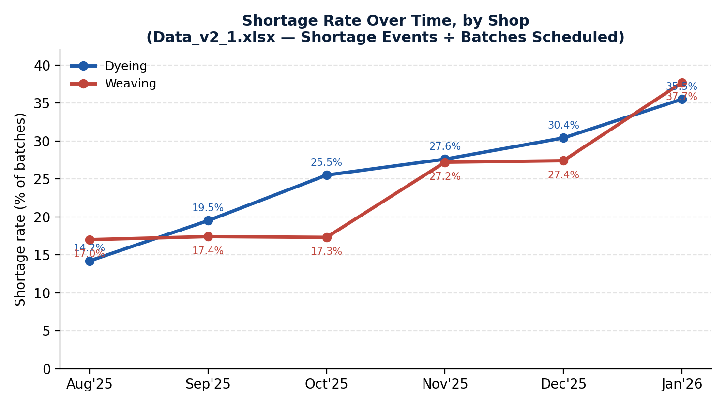
Chart 1 — Shortage rate over time, by shop. Proves the worsening trend is broad-based across both shops, not one outlier shop pulling the average up.

Pivot 2 — Events / Cost / Idle-Hours by Shop (cross-validated)
Rows: Shop · Values: Events, Total Cost (AZN), Idle-Hours, each as % of total. Computed independently in both files to test whether the split holds.
Shop | Data_Main.xlsx | Data_v2_1.xlsx
Events % | 63.3% | 63.4%
Cost % | 60.1% | 63.4%
Idle-hours % | 69.6% | 63.8%
Dyeing holds a ~60–70% share of events, cost, and idle-hours in both files independently — this is the one segmentation axis that survives the Data_Main / Data_v2_1 conflict, which is why it is the chosen segment in Section 5.

Chart 2 — Cost Concentration by Material (sanity-check on the Session 5 ranking)
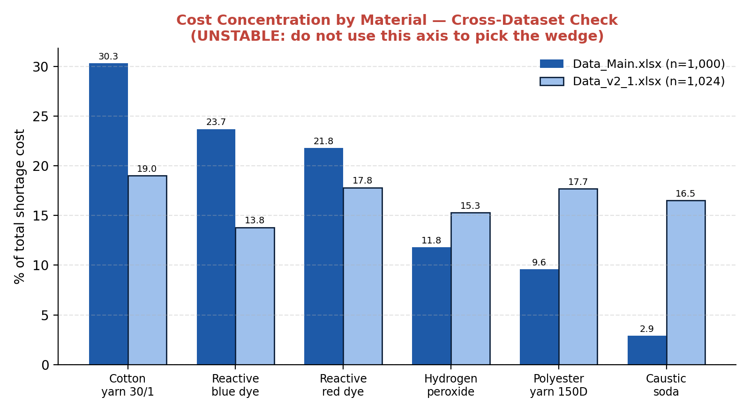
Chart 2 — Material-level cost share, Data_Main vs Data_v2_1. Cotton yarn + the two reactive dyes dominate in Data_Main (30.3% / 23.7% / 21.8%) but the same materials are nearly flat in Data_v2_1 (13.8–19.0% each).
FLAG: The material-level ranking used in the Session 5 prototype (Cotton yarn, Reactive dyes as the 'top' cost drivers) does not reproduce in Data_v2_1.xlsx. It is not used as the basis for the starting segment below. Shop-level concentration is used instead because it is the only finding that is stable across both datasets.

3. ROI Triangle

3a. Cost of the problem — ~2.22M AZN/year
Line item | Annual (AZN) | Basis
Line stoppage (idle) cost | ~1,282,988 | HANDLE TIME — Workers/Machines Affected × Stoppage Duration (hrs)
Supplier delay / rush-freight rework | ~888,000 | Volume evidence-backed; AZN/day rate is a SOFT assumption
Labor/rework hours | ~40,242 | Volume evidence-backed; AZN/hr rate is a SOFT assumption
Total (6-mo actual 1,110,216 × 2) | ~2,220,458 | Simple doubling — see flag below
FLAG: The 'doubling is a floor, not a ceiling' claim is unresolved. It is only supportable if Data_v2_1's monotonically-rising rate (15.3%→36.3%) is the correct read of reality. Data_Main.xlsx's raw event count instead falls in January. Until the Section 1 data conflict is settled, do not present the 2.22M figure as a conservative floor — present it as a plain annualized estimate with that caveat attached.

3b. Handle time vs. resolution time — kept separate, used for different things
Metric | Definition | Value | Used for
Handle time | Stoppage Duration (hrs) — how long the line actually sits idle | Mean 11.8–16.5 hrs (varies by dataset) | COST — drives the idle-cost line item above
Resolution time | Delivery Delay (days) — how long until material physically arrives | Mean 3.5–3.9 days | CUSTOMER / DOWNSTREAM PAIN — drives urgency and the freight-escalation decision, not the cost total
Correlation between the two is effectively zero (r = 0.04 in Data_Main.xlsx) — a longer supplier delay does not predict a longer line stoppage. They are genuinely separate variables and must not be collapsed into a single 'delay' number.

3c. Value of the solution — range, not a number
No captured-value figure exists yet — the riskiest assumption (staff logging discipline) is untested. Below is the math, not a claim.
Formula: Value = (X% caught) × [Idle cost × 85% avoidance] + (X% caught) × [Freight cost × 50% avoidance] + (X% caught) × [Labor cost × 30% avoidance]
SOFT INPUT: Idle-avoidance factor 85%, freight-avoidance factor 50%, labor-avoidance factor 30% — all three are placeholder estimates, not measured.
Catch rate (X%) | Idle avoided | Freight avoided | Labor avoided | Total value/yr
30% | 327,162 | 133,200 | 3,622 | ~463,984 AZN
50% | 545,270 | 222,000 | 6,036 | ~773,306 AZN
70% | 763,378 | 310,800 | 8,451 | ~1,082,629 AZN
Range used for the triangle: ~460,000–1,080,000 AZN/year, entirely dependent on an unvalidated catch rate.

3d. Cost to build — rough, unquoted
Component | Scope
Stock log integration + reorder-point calc (rule-based) | Small — formula defined, mainly data-entry/integration
Alert distribution | Small — mechanical broadcast
AI-assisted reorder/rush-freight recommendation (recommend-only, HITL) | Medium — needs ≥90-day history pipeline, confidence threshold, fallback UI
Rough one-time build | ~15,000–40,000 AZN (1–2 developers, 4–8 weeks, no sourced quote)
Ongoing hosting/maintenance | ~500–1,500 AZN/month
SOFT INPUT: No Giltex-sourced engineering quote exists anywhere in the project materials. This is a generic estimate and should not be repeated as fact until a real quote is obtained.

3e. Does it pay for itself?
Low-value / high-cost case: 40,000 ÷ 460,000 ≈ 0.09 years (~1 month). High-value / low-cost case: 15,000 ÷ 1,082,629 ≈ 0.014 years (~5 days). On paper, payback is days to about a month under every tested combination.
FLAG: Section 3c's value range is too speculative to present without a pilot. It stacks three unmeasured avoidance factors on top of an unproven behavioral assumption (Product Brief §6 — will warehouse staff log stock consistently at all?). If staff logging discipline fails, the catch rate collapses toward 0%, and the payback speed is irrelevant because the numerator is zero. Present this as the shape of the payoff conditional on a pilot, never as a committed number.

4. Do-Nothing Baseline
If detection stays reactive, Giltex keeps paying at minimum today's ~2.22M AZN/year run-rate for a failure mode that is caught 0% of the time before it happens — and if Data_v2_1's rising shortage-rate trend (15.3%→36.3%) is the correct read rather than Data_Main's flattening one, that run-rate keeps climbing, not holding steady.

5. Chosen Starting Segment

Segment: Dyeing shop
Share of pain held: ~60–63% of cost, ~63% of events, ~64–70% of idle-hours — the exact share depends on which file is used, but it is consistently the majority of the problem in both.

Competing segments tested and rejected
Candidate segment | Best single-slice share | Why rejected as the wedge
By material category (Yarn/Dye/Chemical) | 45–49% (Dye, Data_Main only) | 3 buckets, none dominant; doesn't reproduce cleanly in Data_v2_1 (31–37%, flat)
By individual material (Cotton yarn, dyes, etc.) | 30.3% cost (Cotton yarn, Data_Main only) | Does not replicate in Data_v2_1 — same material is 19.0% there, and the full ranking is flat (13.8–19.0% across all six materials). Not cross-validated.
By month (Dec 2025 peak) | 27–28% | Real, but temporal, not actionable — you cannot design a product feature for 'December'
By shop (Dyeing) | 60–63%, cross-validated in both files | Chosen — smallest segment (1 of only 2 possible shop values) that holds the largest, most stable share of the problem

Why Dyeing is a merged group, and what was combined
Dyeing shop is not one material — it is a combined group of four material types (Reactive blue dye, Reactive red dye, Hydrogen peroxide, Caustic soda) that are treated as one segment rather than split further. That merge is deliberate: the material-level split inside Dyeing is exactly the axis that failed the cross-dataset check above (flat and unstable in Data_v2_1). Grouping by shop instead of by individual material avoids designing a wedge around a ranking that may just be noise in one file. The combined group is justified by process, not convenience: all four materials share the same shop, the same worker population, and the same detection/reporting pathway — the thing actually being redesigned (threshold alerting) operates at the shop level regardless of which specific chemical is short.
This replaces the Product Brief's original placeholder wedge ("Shop Worker lane, at moment of batch start"), which was a process stage identical across both shops and did not discriminate on where the cost concentrates.

The Number That Makes Action Necessary
Dyeing shop alone is losing approximately 1.4M AZN per year (63% of the ~2.22M AZN total) to a shortage-detection process that catches nothing before the line stops — in a single shop, out of two, with zero proactive detection today.
This submission does not rest on an average. It names the segment (Dyeing shop, cross-validated at ~60–63% of the problem), the baseline (Section 4), and the single number above as the basis for action — with every soft input flagged rather than smoothed over.

