WaveSafe

(Firearm safety improvement device)

**Süleyman Sertaç Kansız 1804340**

**Said Mustafa Said 1901311**

**Abstract**

Safety is one of the most important things while handling a firearm, if not the most important one. To improve it, engineers worked hard for decades and successfully covered a lot of problems about it but there are still some uncovered areas. Those areas are waiting to be covered and the latest improvements in the defense industry is enabling new approaches to them. using latest technology rather than older mechanical solutions is a new way to enhance safety measures and cover uncovered areas.

“WaveSafe” is a good example of the technology based firearm safety solutions. It is a non-complex, reliable, rugged piece of technology which sits inside a firearm and not allowing trigger pulls if you are not the one holding it, and it gives the user essential information about the firearms current state using a digital display.

There are three main components of the “WafeSafe” system, which are the locking mechanism equipped with a RFID tag, the paired RFID reader formed like a bracelet and the information display. Locking mechanism is placed over the trigger, and it is responsible of not allowing trigger movement before the software enables it to allow trigger pulls. The wearable RFID reader is paired with the locking mechanism and it will communicate with the software to say if it should allow the trigger action or not. The display will be placed on the bracelet, it will display the critical information about the gun such as whether the safety is on or off, or is the weapon ready to fire or not.

Project implementation will start with the flowchart design followed by backend codes and methods, since we are not applying this system to a real firearm the software will mimic all of the RFID and firearm functions, allowing us to demonstrate our device and to test it virtually.

**Literature Review**

**Introduction**

Utilizing a firearm is not a topic that you can have loose safety measures. If an accident happens related to a firearm, it could be an accidental discharge, misfire or another reason, it will result in severe injuries, death, and serious damage to the surroundings. And those accidents generally occur while the gun is held by someone who shouldn't. For example a friend of the owner checking the gun, a young individual found it and playing with it just out of curiosity. Also, it's not just accidental events that cause unwanted harm, sometimes the harm is intentional. In professions that allow people to carry guns while working, for example, law enforcement or military officers, they need to make sure their firearm is safe and only accessible by them. Sometimes people who should not have their hands on a gun, and in professional carry, that means everyone other than the employee that carries the weapon, try to hijack the weapon and use it against people they take the weapon from. There are different safety levels and implementations such as holsters with a button to prevent someone just pulling a gun from a belt, safety switches to prevent accidental discharges, lanyards that tie the gun to holsters but they are not safe enough. There are several accidents reported in which officers end up facing towards their own guns, held by individuals with no good intentions. For example in Los Angeles, an officer in a police building, involved in a fistfight with a civilian which resulted in him falling down, dropping some tactical equipment from his belt including his pistol, and the bad guy grabbing the gun pulling the trigger point-blank [1]. The traditional safety measures are just safe to the point which weapons still in officers' hands or holstered on them, when the weapon is held by the bad guy, it is no longer your weapon.

Our Project is a solution to that with the extra benefit of making firearms more user friendly, we thought of a way that even if someone else has your weapon, the weapon is still yours and will not discharge in someone else's possession. So we think of a system that connects a firearm to a single user. A system to keep the firearm functioning only in the operator's hand and not let it fire under the control of unauthorized or incompetent individuals even if they manage to get their hands on the weapon. There are some studies made to increase gun safety by using controversial methods. For example, there was a trigger system that was made back in the 1970s, it was called the “Magna trigger” which basically is a trigger system that only lets you fire if you have the magnetic ring which interacts with a counter magnet inside the gun[2]. As a more updated and technological approach to gun safety improvement, a teenager named Kai Kloepfer’s solution to gun safety was fingerprint scanners located in the grips of pistols [3]. He first thought that iris scanners could be a good option but later he thought of sunglasses and he moved to the fingerprint scanners, Kai said his system could store up to a thousand different fingerprints and have a success rate of 99.9 percent [4]. These are solutions that could be improved but there are still weak points. to give an example in combat situations operators use gloves, even the environment itself will cause problems while using a scanner that sits outside. Considering war environment, a weapon should be working in snow or dust, hot or cold, and could easily absorb every shockwave that comes with firing, but fingerprint scanners are working with input given from the surface, so when integrating one in a firearm there must be a compromise given from case integrity which will increase the cost of water-dust proofing. Besides, reading fingerprints in wet conditions is not the strongest suit of a scanner. In contrast to that RFID systems can not just perform well in wet conditions, they can work also work underwater[5] Even without all of these problems, user can only hold the gun in a single way to utilize the scanner while firing and this is not user friendly. An operator should be capable of using a weapon with different techniques, depending on the place which can be a room with tight corners or behind a car window. Also, a fully integrated system will be hard to maintain. In a summary, the most common approach for smart gun safety is fingerprint scanning guns, and they have three main weak points. First, they need an input surface so they are not suitable for rough and especially wet terrains. Second, they are not compatible with combat wear like gloves. And finally those systems are fully integrated with all of the needed hardware so maintenance costs are high. Our Project utilizes RFID systems and they will not cause those drawbacks of fingerprint scanning weapons. Our Project will solve the maintenance problem, to maintain a fingerprint scanner a weapon in which the scanner is embedded must be disassembled and disassembly will be required even for the most basic things like battery changes or a simple cleaning. In contrast, RFID systems have two tag types, active tags, and passive tags, passive tags are capable of using the power of readers, therefore they operate without a battery[6]. This means there is no need for frequent changes and this will decrease the maintenance and production cost. RFID systems work with two main parts, a reader and a tag, and the system will function if those are close enough, so whether the operator wears gloves, injured his finger during an operation, or completely soaked the weapon in the dirt, if the reader and the tag are close, all functions will be working. In This Project, the trigger pull will be restricted by a metal pin which can go up and down to block movement in the triggers pull direction. That mechanism will work with an RFID reader and an RFID tag, the tag will be embedded in the trigger guard to not alter the firearms ergonomics, the reader will be in a bracelet shape which also will work as an information screen. When the operator holds his firearm with the bracelet on the wrist, the reader and the tag will be close enough and the system will pull the pin down, therefore enables the trigger to pull and fire. If the bracelet is not on the person who is holding the firearm, the mechanism will block the trigger pull therefore there will be no firing action even if the person tries to pull the trigger. The bracelet will have a screen on it and that screen will feed the operator with critical information. That screen will have three main panels, top one will show if the safety is on or off, below that there will be a bullet counter, and the last one is for error messages that will pop up when the firearm needs a reload or in case of a jam. The screen will get the information from the firearm using 2 sensors, one for trigger to read if the trigger is pulled or not, and one gyro sensor inside the silde to read if the gun is fired or not. With those readings the bullet count and the errors will be displayed on the bracelets screen. This screen is not just for user experience but for safety as well, for example, when the operator pulls the slide, fires the gun and the danger is not present anymore so the operator holsters the gun without pulling the slide and taking that one bullet in the chamber manually, the next gun pull won't require a slide pull because there is a bullet in the chamber, the bracelet will alert the user about the bullet in the chamber. That way the operator will not lose time checking the chamber, will not lose focus trying to remember is there a bullet in the chamber or will not pull the slide when unnecessary and cause a jam in a situation where seconds decide whether there will be casualties or not. To implement these actions and demonstrate them we will make a GUI application using java. The application will have a control panel that will simulate a firearm and an actual screen that shows information which will simulate the bracelet screen. With the implementation of this Project, lots of safety issues mentioned above will be solved without the serious drawbacks of other technology-based safety systems.

**Main advantages over similar projects**

As mentioned in the literature review part WaveSafe’s is more advantageous than the other smart firearm safety implementations. Main approach to make a firearm available to the user only is using a fingerprint scanner, and they are vulnerable to harsh weather condititons and slower. there are RFID based ones but they are not easily applicable and they alter the ergonomics such a way that the user cant feel comfortable anymore. WaveSafe will be a more robust, user friendly solution and it will require less maintenance, therefore being a more reliable option.

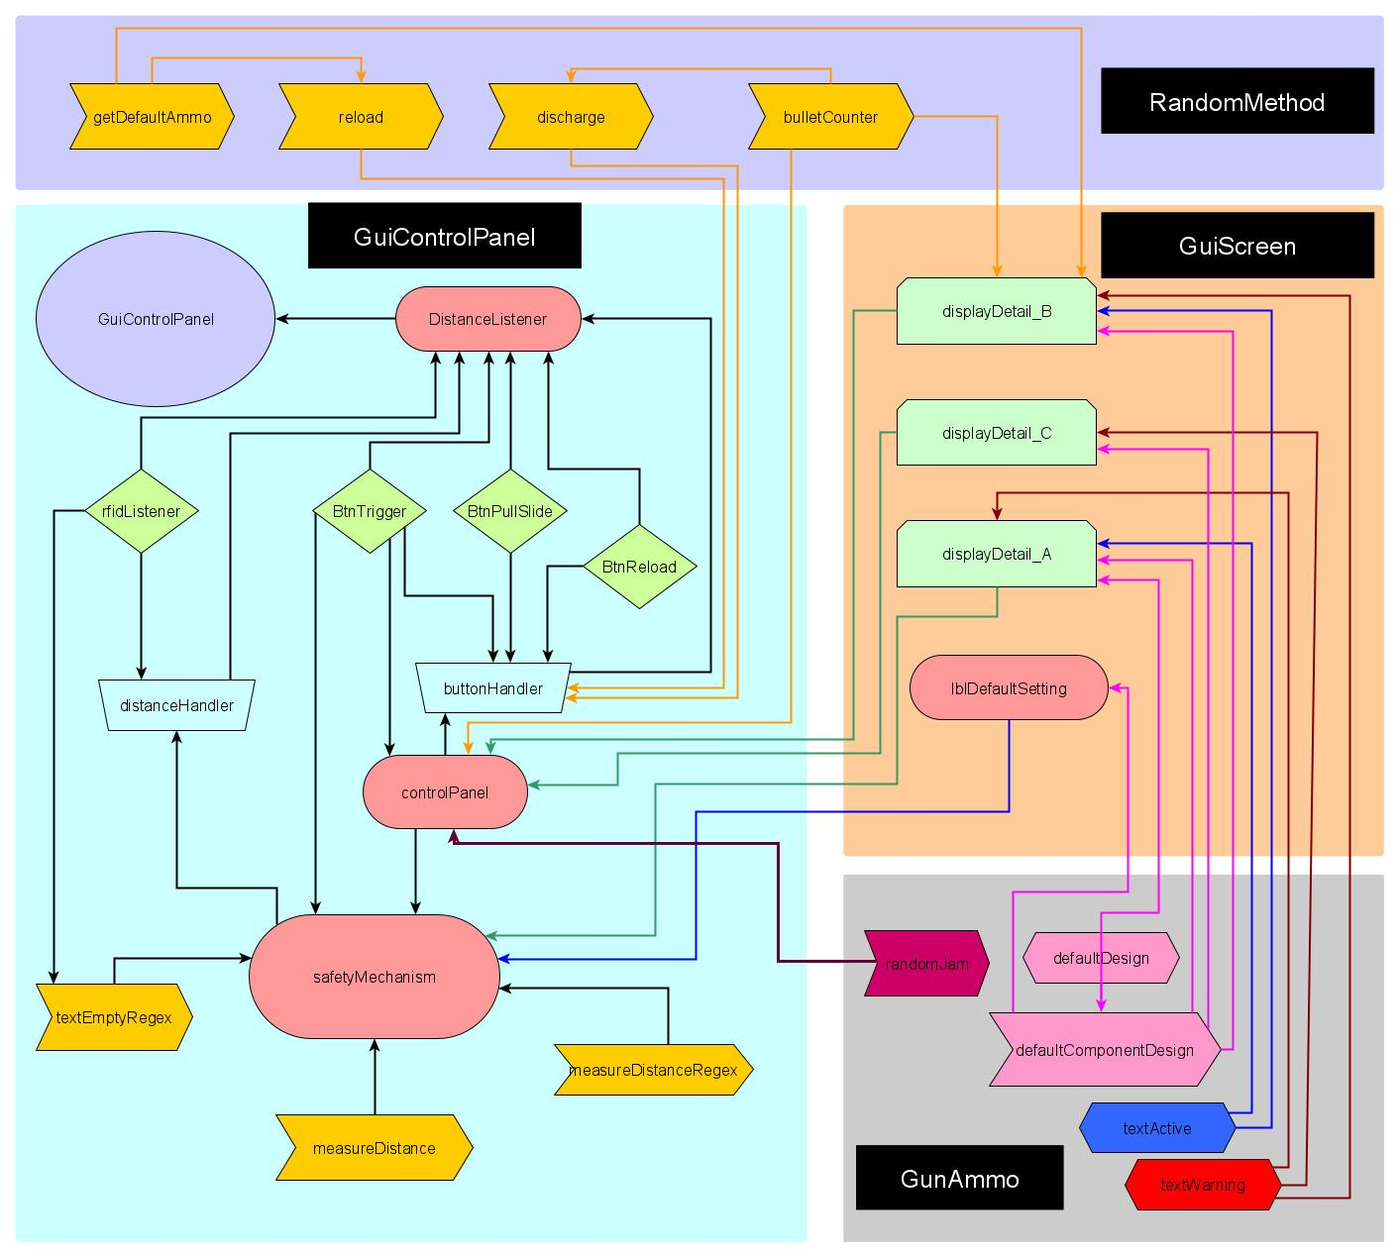**Flowchart of the project**

**Methods and qui components used in the project**

**GUI Components**

we made a GUI using java to simulate the firearm and the information screen. The GUI includes two input components that enabling user to set the wanted distance of RFID tag read, and to set a virtual distance that indicates the distance between RFID tag and reader. There are three buttons included to mimic the firearm functions. The last one is the screen which is the information display. This allows us to see if it works or not without using hardware.

**Components**

**rfidListener:**

Gets an ongoing updating input and sends it to “distanceHandler”.

**BtnTrigger:**

Acts as a trigger, if the safety is off and the mag is loaded it will decrease the number of bullets left in the mag by one. If safety is on this button will be unclickable.

**BtnPullSlide:**

Our aim was to mimic a real firearm so there are jams included, this button will get the firearm in ready to fire state after reloads, and clears any possible jam. Safety will not block this function.

**BtnReload:**

If there are no bullets left, this button will set the number of bullets to the maximum count. Safety will not block this function.

**Methods:**

**displayDetail_A:** Visual output of the safety state, whether it is on or off. Called in “safetyMechanism”.

**displayDetail_B:** Updates constantly, output of the remaining ammo. Called in “controlPanel”.

**displayDetail_C:** If there is a jam this method will send a warning text. Called in “controlPanel”.

**measureDistance:** Compares “distance” to “distancelock” and returns true if “distance” is less than or equal to the “distancelock, false if not. Called in “safetyMechanism”.

**bulletCounter:** Returns the remaining bullet count.

**reload:** Sets the bullet count to default count. Called in “buttonHandler”.

**discharge:** Decreases bullet count by one.

**getDefaultAmmo:** Returns the default number of bullets. Called in “reload” and “displayDetail_B”.

**defaultDesign:** Resets the labels. Called in “displayDetail_A”.

**defaultComponentDesign:** Resets two labels at a time called in all methods of “GuiScreen”.

**textActive:** sets text colour to green.

**textWarning:** sets text colour red.

**controlPanel:** Links the buttons to the displays, decides if the trigger button is enabled or not.

**safetyMechanism:** Main control method, gets the inputs and send necessary instructions such as;

Whether the trigger button is enabled or not.

**Listeners:**

**buttonHandler:** Collects data from all of the buttons using action listeners therefore it checks the firearms current state, then give necessary instructions to “guiScreen**”**  in order to be displayed.

**distanceListener:** Reads the text inputs that mimics the RFID readings, sends them to “safetyMechanism”.

**Methods to improve the realism of the project**

(the methods are separated this way because the project includes two main parts, the functions that will be implemented regardless of it is real or a simulation. And there are methods to improve the realism of the project, and to make demonstration better since it is not hardware based.)

**lblDefaultSetting:** A special method to minimize the GUI errors. Called in “controlPanel”.

**textEmptyRegex:** A special method to minimize the GUI errors. Called in “safetyMechanism”.

**randomJam:** Adds jams randomly to the process in order to be more realistic. Called in “controlPanel”.

**measureDistanceRegex:** Checks if the inputs are integers, and returns a boolean value. Called in “safetyMechanism”.

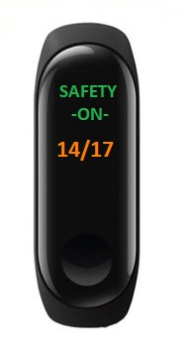

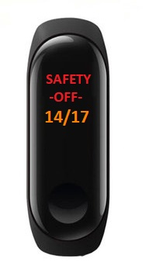**USER INTERFACE**

Safety position will be displayed on the top, above the bullet counter. Bottom part will be off until there is an error, when there is, there will be a error message. If there is not a bullet present in the chamber the bullet counter will be green too.

**-> Safety is on, 14 bullets left, nothing wrong with the firearm**

**-> Safety is off and ready to fire, 14 bullets left, nothing wrong with the firearm**

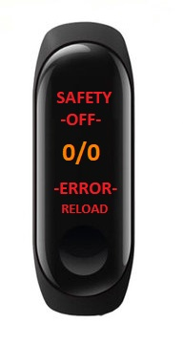

**-> Safety is off and ready to fire, zero bullets left, need a reload as written in the error message**

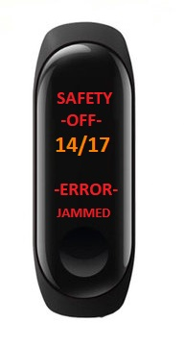

**-> Safety is off, will not fire because there is a jam as written in the error message. After clearing the jam by pulling the slide, the flawed bullet will be discharged and the screen will be shoe 13/17 in the middle section, without an error message.**