* **Framework used: None** (it's a custom implementation of MVC in Vanilla JavaScript).
* **Pattern used:** MVC Design Pattern.
* **How?** I separated your logic into three parts:
* **Model:** Manages the data (tasks) and logic.
* **View:** Handles the UI and shows data to users.
* **Controller:** Connects the View and Model, handling user input and actions.

**Output of the code:**

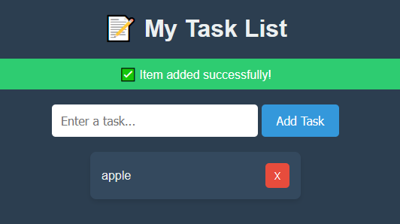

**Architecture style:**

