Estimating Property Prices Automatically
A short summary for the business team, based on 100,775 property listing
Why we looked at this
Right now, people listing a property have to guess the price themselves. This means similar properties often get listed at very different prices, just because one seller guessed higher or lower than another. We wanted to see if we could build something that suggests a fair price automatically, based on the property's own details like size, location, and type.

What we did
We tried three different ways of predicting price and compared them the same way, so it was a fair comparison. The best one turned out to be a method called Random Forest. We then spent time fine-tuning it to squeeze out a bit more accuracy. Finally, we tested it on listings it had never seen before, since that's the only real way to know if it actually works or if it just memorized the training data.
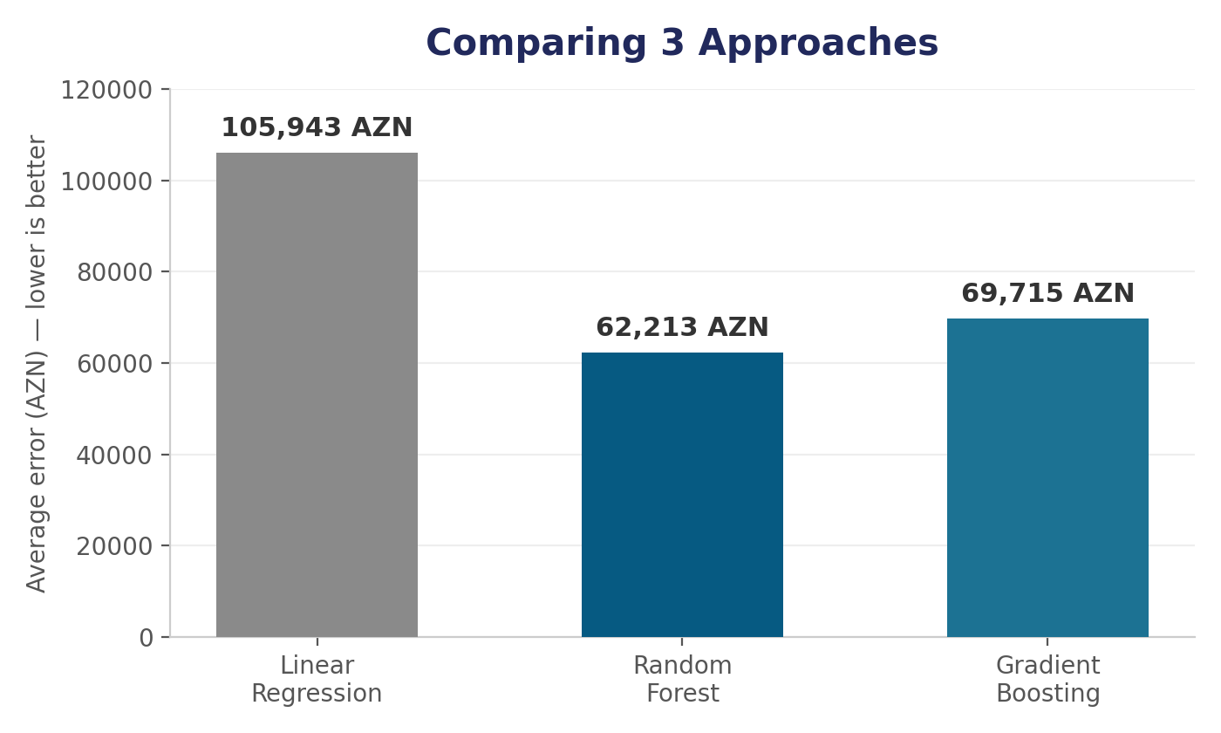
How good is it?
12%  Off by, for a typical listing | 57,000 AZN  Off by, on average (in AZN) | 78%  How much of the price it explains

For a normal, typical listing, our estimate is usually only about 12% off from the real price, which is close to what we were hoping for. On average across everything, we're off by about 57,000 AZN, and the model picks up on about 78% of what actually explains why one property costs more than another.

What it's not so good at
One thing we want to be upfront about: the numbers look worse if you only look at the average across all listings, instead of a typical one. That's because a handful of very cheap listings, mostly land plots and garages, throw the average off. A small mistake in AZN on a cheap listing looks like a huge mistake in percentage terms, even though the model isn't really doing anything wrong. Basically, this tool works well for normal houses and apartments, but land and garages need to be treated more carefully, maybe with a person double-checking.
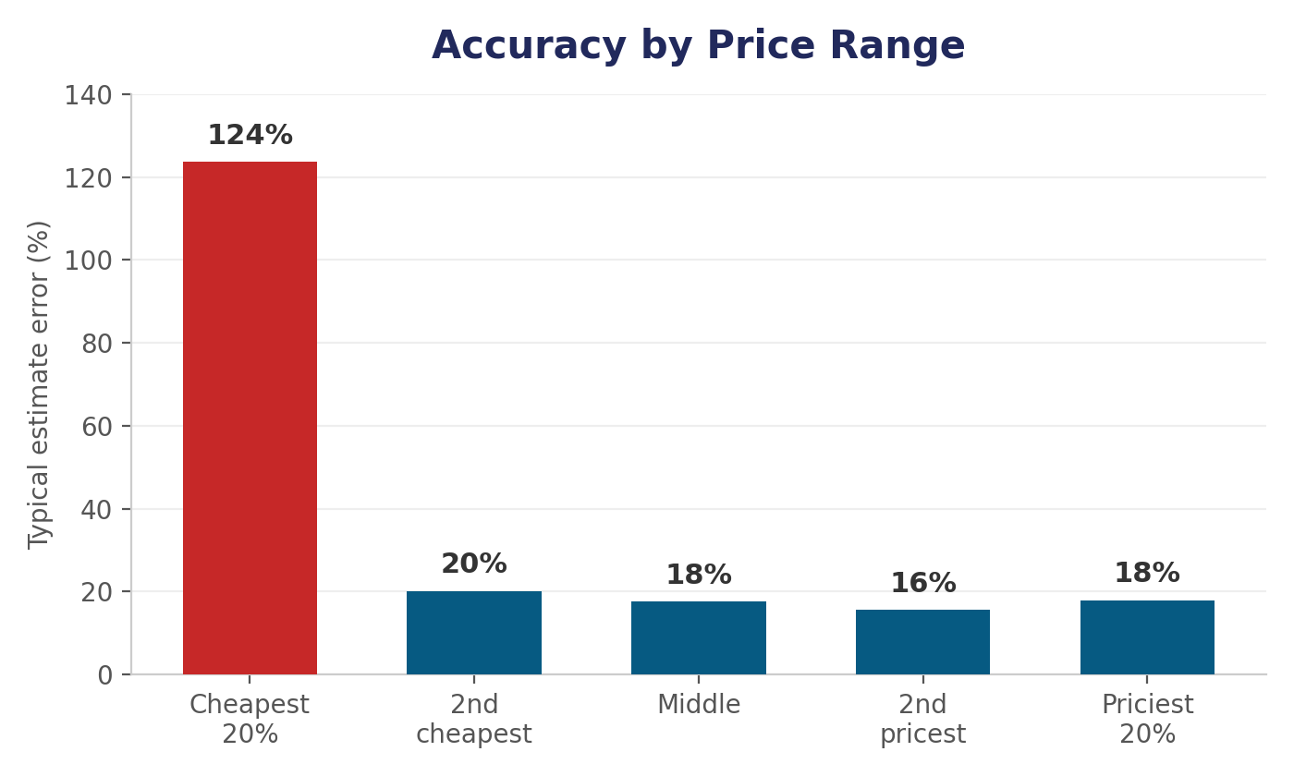
What actually moves the price
We also looked at what the model actually pays attention to when it makes a guess. A couple of things surprised us:
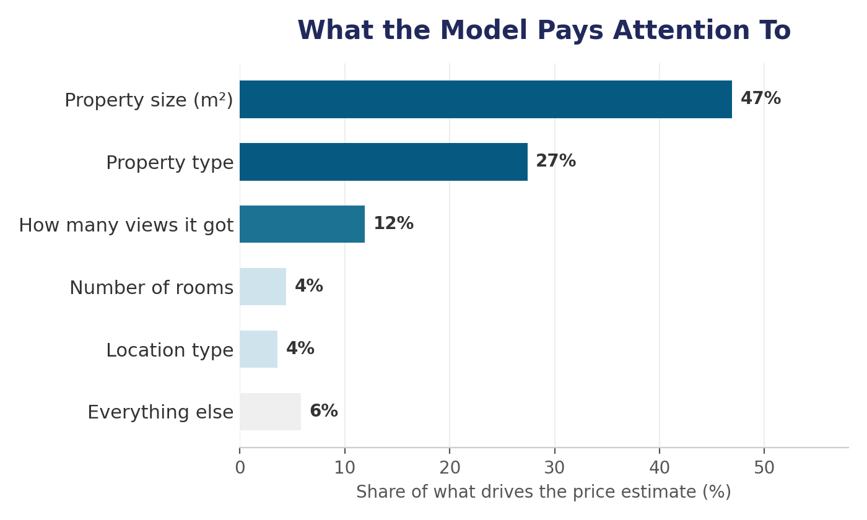
- Size is by far the biggest factor - not surprising.
- What type of property it is the second biggest - also expected.
- How many views a listing got turned out to matter more than we thought - more than room count or location. Possibly because popular listings tend to be priced more "normally" for what they are.
- Room count and location type still matter, just less than we assumed going in.

What we'd suggest doing next
We think this is ready to try out as a "suggested price" shown to sellers when they post a new listing, and maybe to flag listings that look way overpriced or underpriced. Since it's less reliable for land and garages, we'd start with just houses and apartments first, and figure out land/garages separately later.

Next steps
- Try it out on apartment and house listings first, and see what real feedback from sellers looks like.
- Look into a separate approach for land and garages later on.
- Retrain it every so often with newer listings, since prices change over time.

