Hello Javascript

Firstly, we begin JS we need to know some idioms in this JS world.

Let’s begin with a compiler
Compiler is a programm which compiles computer lang(JS,JAVA) into binary machine code like(0,1).

Jit - Just- in- time compilation: This is also compiler java,js and C# uses it. It starts secretly when our program is running.You dont need to command it,it directly starts. It is good for performance.
Chrome,firefox,edge has js engines that has been built in Jit.
For example, let=5+3
After writing this your browser’s jit starts compiling.
First class function

When functions in that language treats like a variable.You can use it as an argument at another function.
So Js is a Jit, dynamic language that has first class function.
Dynamic language which can do multi-functionalities , add update in runtime.
Eval() can return string into code. The argument of eval() is a string.It returns the completion value of the code.

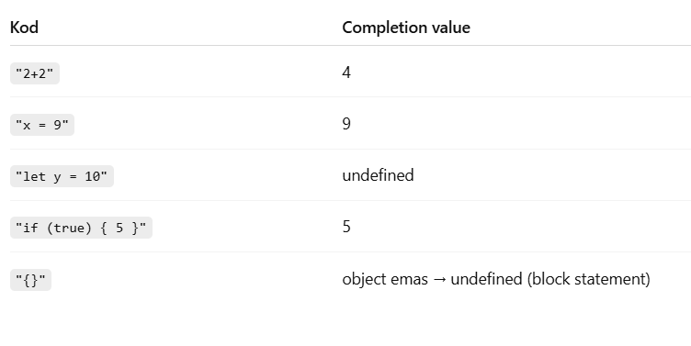
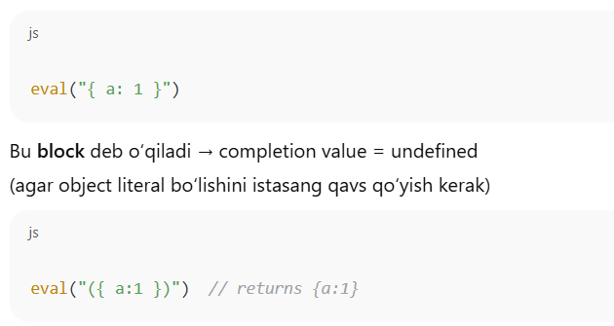
For example:
console.log(eval("2 + 2"));
// Expected output: 4

console.log(eval(new String("2 + 2")));
// Expected output: 2 + 2

console.log(eval("2 + 2") === eval("4"));
// Expected output: true

console.log(eval("2 + 2") === eval(new String("2 + 2")));
// Expected output: false

