Ex 1

Bond with 8 years to maturity, P=110 Coupon rate=8% F=1,000$
YTM?

Solution:

Premium bond P=1,100$ YTM<8%

H1=6%
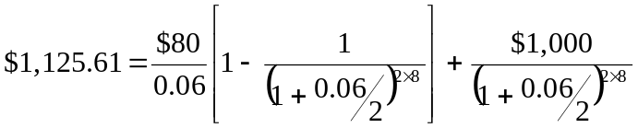

H1=6.5%
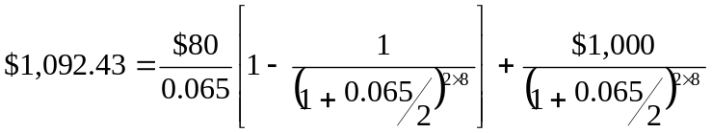

H1=6.3843%
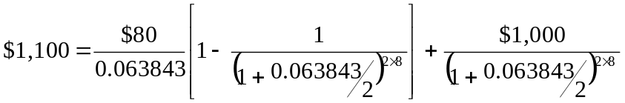

Ex

Bond with 8 years to maturity, P=110 Coupon rate=8% F=1,000$
YTM?

Solution:

Premium bond P=1,100$ YTM<8%

H1=6%

H1=6.5%

H1=6.3843%

Ex 2
You have 3 bonds with coupon rate=10% but different maturities. F=100$
a)T=30years
b)T=10 years
c)T=3 years
Draw the graph of the price-yield curve for the three different bonds

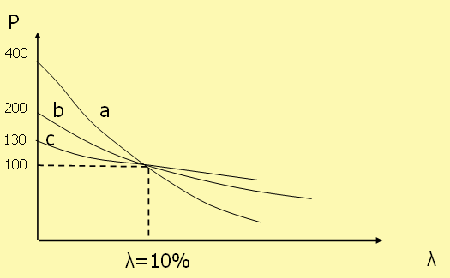

When YTM=10%, all the three curves pass from the same point and all the bonds are at par
At YTM=0 Pa=10x30+100=400$
Pb=10x10+100=200$
Pc=10x3+100=130$

Ex 3

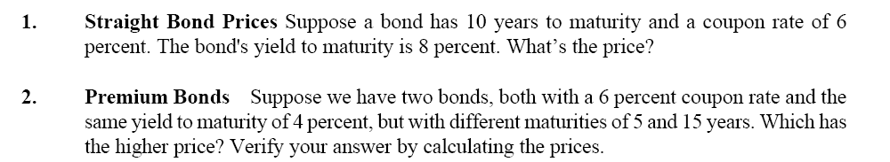

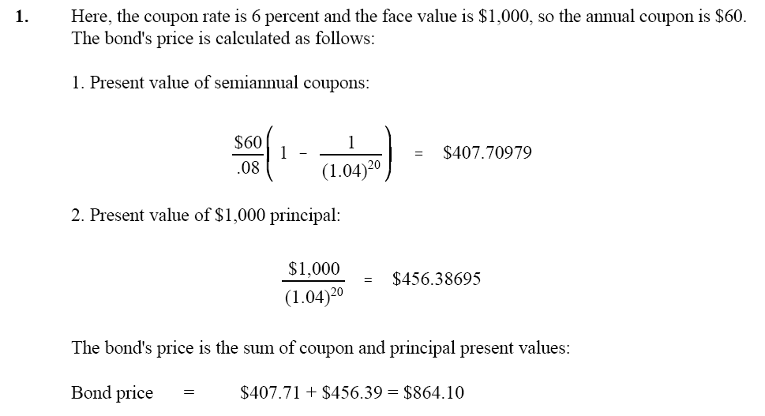

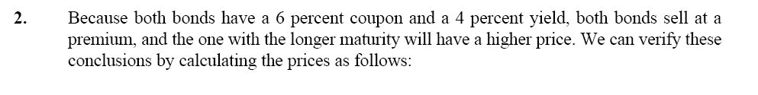
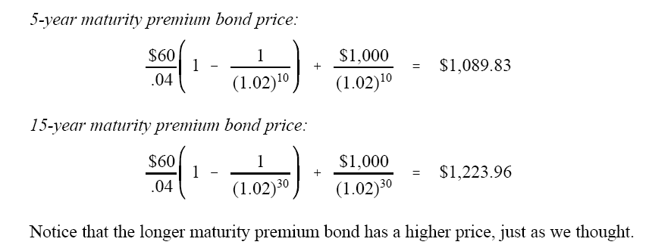

Ex.4

Bond with 3 years until maturity. The bond sells at par. Coupon rate=8% YTM=8%
Interest paid semiannually. F=100 Calculate the duration.
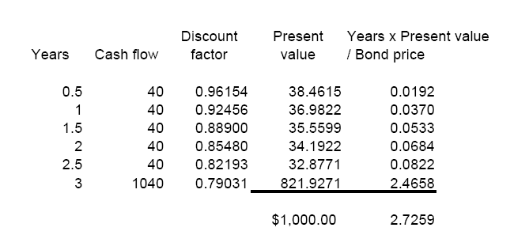

or apply the simplified formula:
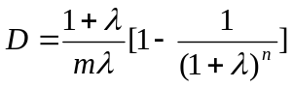

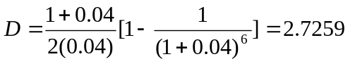

years

Ex.5

Suppose a par value bond has a 6 percent coupon and 10 years to maturity. Interest is paid semi-annually. What is its duration?
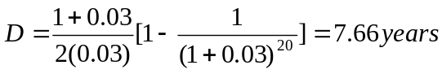

Ex.6
A bond has a yield to maturity of 7 percent. It matures in 12 years. Its coupon rate is 6 percent, paid semi-annually. What is its modified duration?
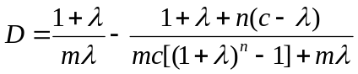
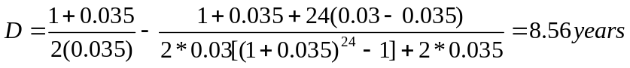

DM=D/1+YTM=8.56/1.035=8.27 years
Ex.7
Bond Prices CIR Inc. has 7 percent coupon bonds on the market that have 11 years left to
maturity. F=1, 000 Coupons paid semi-annually. If the YTM on these bonds is 8.5 percent, what is the current bond price?
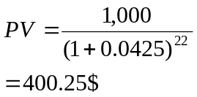

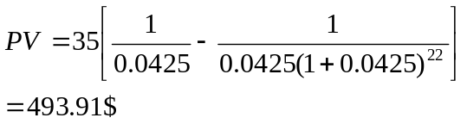

P=400.25+493.91=894.16$

Ex.8
A firm has the opportunity to make two different investments:
A) if it invests 500,000$, after 3 months it will get 503,953$
B) if it invests 500,000$ in a treasury bond with maturity after 6 months. Interest rate for 6 months=3.6%

Spot rates 3 months= 3.10%
Spot rates 6 months=3.35%

Which investment to choose?

B) 500,000 (1+0.036)^{0.5}=508,920$ in 6 months
A) We know that after 3 months we will get 503,953 but what we will get after another 3 months?
We must calculate the forward rate.

(1+s_{0.5})^{0.5}=(1+s_{0.25})^{0.25} (1+f _{0.25, 0.5})^{0.5-0.25}
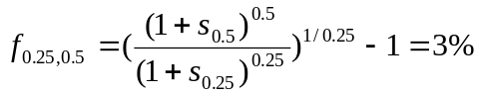

503,953 (1+0.03)^{0.25}=507,690.9$ in 6 months

Choose strategy B

Ex.9

A firm has to pay 3 million $ on 31/12/2012. We are on 01/01/08.
Three types of bonds:
A) ZCB_{A} F=100 Maturity= 31/12/10
B) CB_{B} F=100 coupon rate=5% m=2 Maturity= 31/12/10
C) CB_{c} F=100 coupon rate=8% m=1 Maturity= 31/12/17
Yield=7%

- Create a immunized portfolio
- Calculate the value of the portfolio at 31/12/08

Solution point 1.

Calculate the duration of the bonds to see which enter the portfolio.

Duration ZCB_{A}=3 years

Duration CB_{B}= 2.28 years

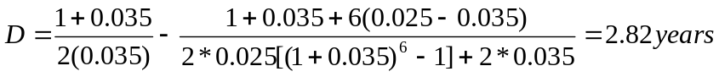

Duration CB_{c}= 7.34years

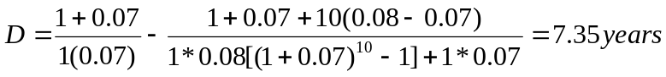

ZCB_{A} and CB_{c} enter the portfolio. Duration of debt is 5 years (from 01/01/08 to 31/12/2012)

Calculate the PV (P) of the two bonds which enter the portfolio:

PV ZCB_{A}=100/(1+0.07)³=81.63$
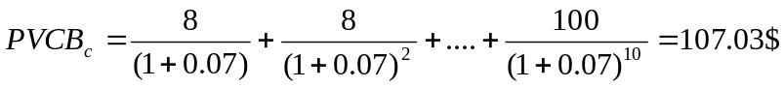

Compute the number of bonds to be purchased to generate the immunized portfolio.
PV portfolio=PV debt
D portfolio=D debt

PV portfolio=PV debt
81.63$*Q ZCB_{A} + 107.03$* Q CB_{c} =3M/(1.07)⁵

D portfolio=D debt
3*81.63$* Q ZCB_{A} +7.35*107.03$* Q CB_{c}=(81.63$*Q ZCB_{A} + 107.03$* Q CB_{c})5

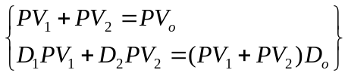

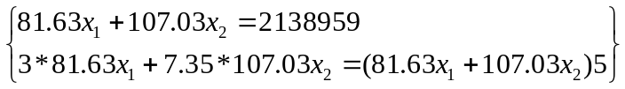
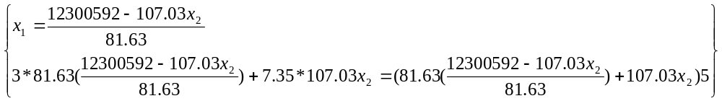

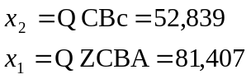

Solution point 2.

The quantities are the same but since one year has gone, prices have changed.

PV ZCB_{A}=100/(1+0.07)²=87.34$
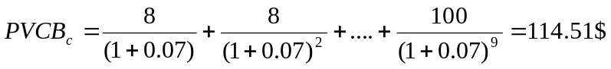

81,407*87.34$+ 52,839*114.51$=13,160,681$ (value of the portfolio at 31/12/08)

Ex.10
Dunbar Corporation has bonds on the market with 10.5 years to maturity, a YTM of 10 percent, and a current price of $860. F=1,000 and coupons are paid semi-annually. What must the coupon rate be on Dunbar’s bonds?
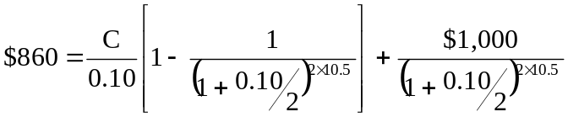

C=78.16$
Coupon rate=7.82%

Ex.11

Jane’s Pizzeria issued 10-year bonds one year ago at a coupon rate of 8.75 percent. If the YTM on these bonds is 7.25 percent, F=1,000 and coupons are paid semi-annually what is the current bond price?

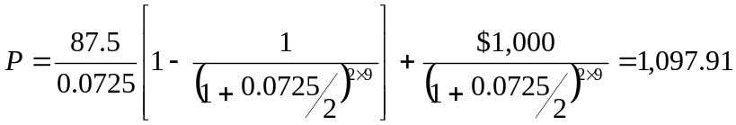

Ex.12

Jerry’s Spaghetti Factory issued 12-year bonds two years ago at a coupon rate of 9.5 percent. If these bonds currently sell for 96 percent of par value (F=1,000), what is the YTM?

P=960$ (discount bond) YTM>9.5%

H1=10%
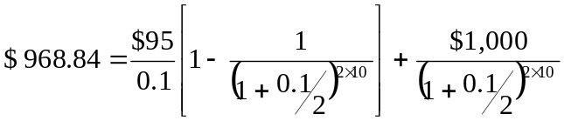

H2=10.15%
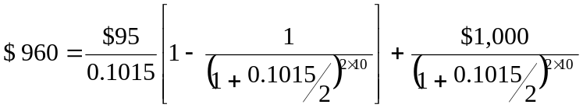

Ex.13

X is a premium bond with a 9 percent coupon, a YTM of 7 percent, and 15 years to maturity, F=1,000. Bond Y is a discount bond with a 6 percent coupon, a YTM of 9 percent, and also 15 years to maturity and F=1,000. Coupon payments are made semi-annually. If interest rates remain unchanged, what do you expect the price of these bonds to be 1 year from now? In 5 years? In 10 years? In 14 years? In 15 years? Explain what happens.

T=0
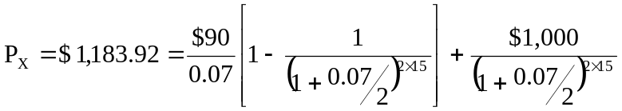

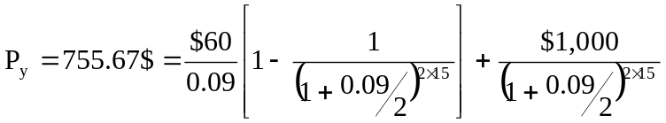

T=1
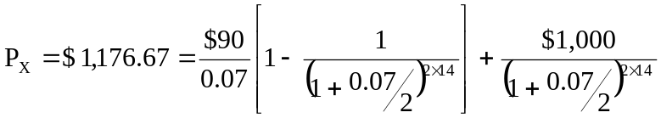

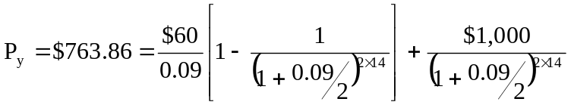

T=10
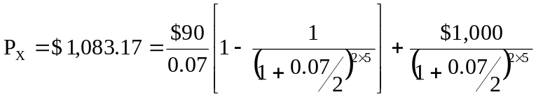

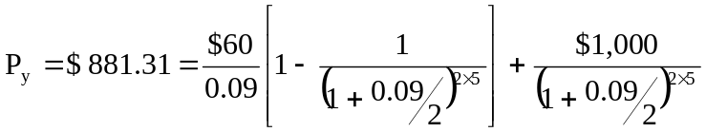

T=14
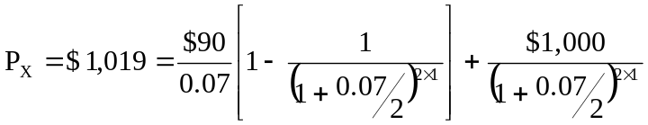

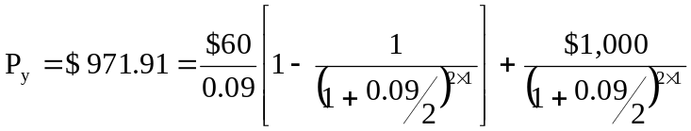

T=15
Px=1,000 $
Py=1,000 $

All else held equal, the premium over par value for a premium bond declines as maturity is
approached, and the discount from par value for a discount bond declines as maturity is
approached.

Ex.14
Both bond A and bond B have 8 percent coupons and are priced at par value 1,000$. Coupon payments are made semiannually. Bond A has 2 years to maturity, while bond B has 15 years to maturity. If interest rates suddenly rise by 2 percent, what is the percentage change in price of bond A? Of bond B? If rates were to suddenly fall by 2 percent instead, what would the percentage change in price of bond A be now? Of bond B? What does this problem tell you about the interest rate risk of longer term bonds?

If both bonds sell at par, the initial YTM on both bonds is the coupon rate, 8 percent.
If the YTM suddenly rises to 10 percent:
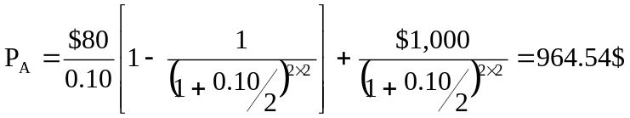

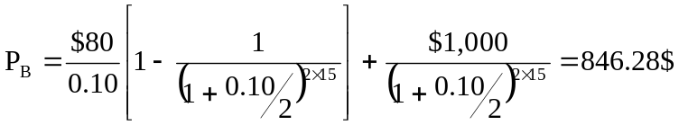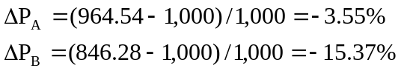

If the YTM suddenly falls to 6 percent:
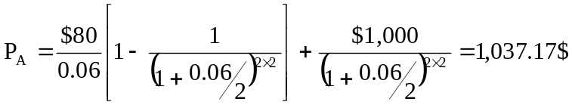
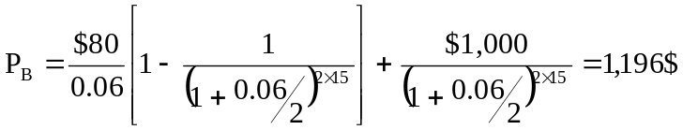

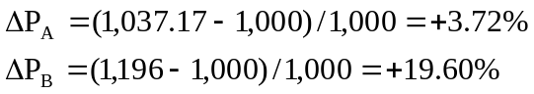

All else the same, the longer the maturity of a bond, the greater is its price sensitivity to
changes in interest rates.

Ex.15
Bond J is a 4 percent coupon bond. Bond K is a 10 percent coupon bond. Both bonds have 10 years to maturity and have a YTM of 9 percent, F=1,000 and coupons are paid semi-annually. If interest rates suddenly rise by 2 percent, what is the percentage price change of these bonds? What if rates suddenly fall by 2 percent instead? What does this problem tell you about the interest rate risk of lower-coupon bonds?

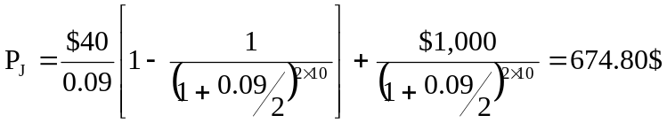Initially, at a YTM of 9 percent, the prices of the two bonds are:

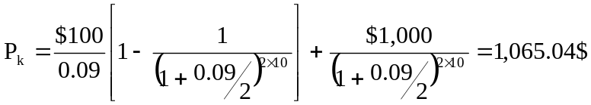

If the YTM rises from 9 percent to 11 percent:
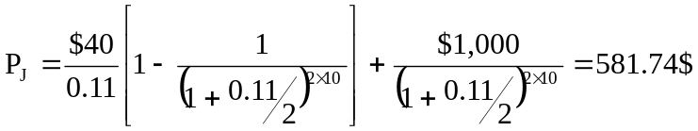
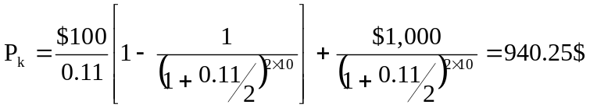

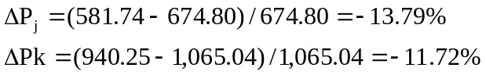

If the YTM declines from 9 percent to 7 percent:
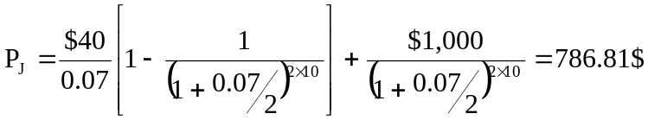

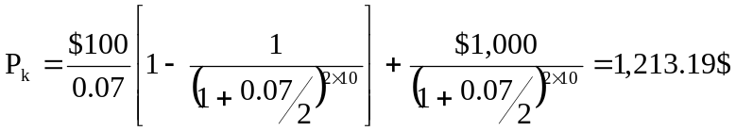

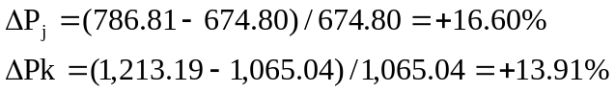

All else the same, the lower the coupon rate on a bond, the greater is its price sensitivity to
changes in interest rates.

Ex.16

ABC Co. has 10 percent coupon bonds with a YTM of 8.5 percent. F=1,000 and coupons are paid semi-annually. The current yield on these bonds is 9.01 percent. How many years do these bonds
have left until they mature?

Current yield=annual coupon/P 0.0901=100/P P=100/0.0901=1,109.88

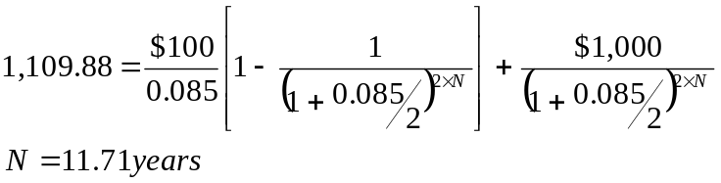

Ex.17
Suppose you buy a 10 percent coupon bond today for $1,100. The bond has 10 years to maturity. F=1,000 and coupons are paid semi-annually. What rate of return do you expect to earn on your investment? Two years from now, the YTM on your bond has declined by 2.5 percent, and you decide to sell. What price will your bond sell for?
P=1,100$ (premium bond) YTM<10%

H1=9%

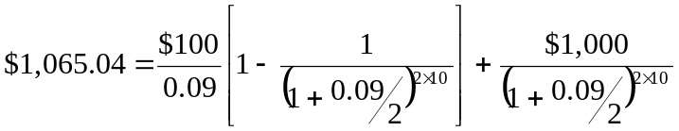

H2=8.5%
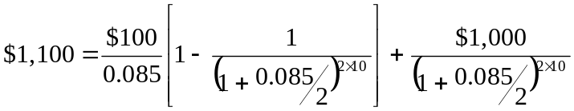

This is the rate of return you expect to earn on your investment when you purchase
the bond.

If YTM declines by 2.5% (from 8.5% to 6%) and M is only 8 years from now, the new bond price will be:
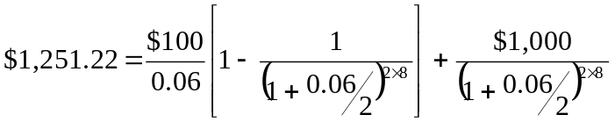

Ex. 18
What is the Macaulay duration of an 8 percent coupon bond with three years to maturity and a current price of $937.10? F=1,000 and coupon payments are made semi-annually. What is the modified duration? Suppose the yield on the bond suddenly decreases by 2 percent. Use duration to estimate the new price of the bond.

First calculate the YTM.
P=937.10$ (discount bond) YTM>8%

H1=9%
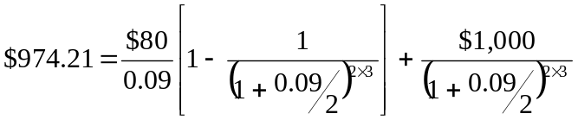

H2=10%
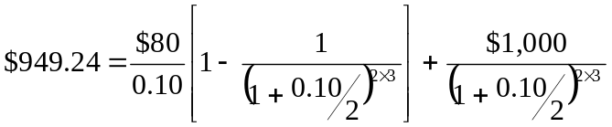

H3=10.498%
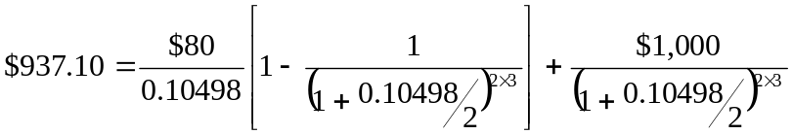

Now calculate the Macaulay duration.

Modified duration = 2.715/(1.05249) = 2.58 years

P1= $937.10+48.35$=985.45$

Ex.19
A firm has to repay an obligation for a total of 4 million $ in 48 months. The company has got enough liquidity today and wants to invest its money today so as to be able to repay the obligation in the future and to be sufficiently protected against the risk of interest rates changes. On the market the following securities are available:

A) ZCB F=1,000 Maturity=5 years
B) CB F=1,000 Maturity=4 years m=1 coupon rate=12%

YTM=5%

- Create a immunized portfolio

Duration of debt=4 years (48 months)
PV of debt=4mln/(1+0.05)⁴=3,290,810$
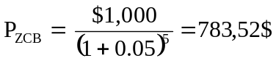

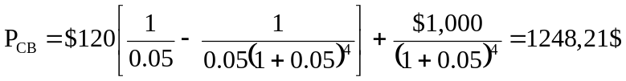

Duration ZCB=5 years
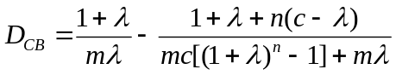

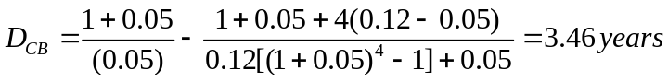

Compute the number of bonds to be purchased to generate the immunized portfolio.

PV portfolio=PV debt
783.52$*Q ZCB + 1248.21$* QCB =3,290,810

D portfolio=D debt
5*783.52$* Q ZCB +3.46*1248.21$* Q CB_{c}=(783.52$*Q ZCB + 1248.21$* Q CB_{c})4

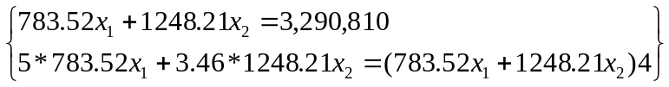
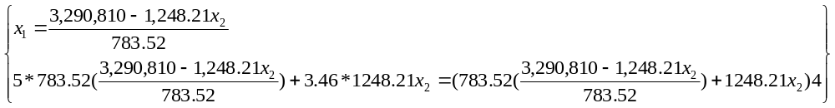
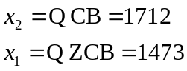

Ex.20

Consider two ZCB with F=1,000. ZCB_{A} has a maturity of 1 year and has a P=952.38$. ZCB_{B} has a maturity of 2 years and has a P=873.44$. Calculate the one-year and two-year spot rates and the forward rate. Suppose that the three-year spot rate is 11%. Which is the price of ZCB_{C} with maturity in 3 years and F=1,000? Which is the forward rate on year 3?

S₁ can be calculated from ZCB_{A.}
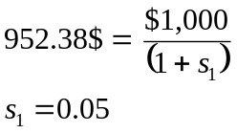

S₂ can be calculated from ZCB_{B.}
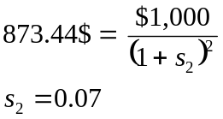

The forward rate can be calculated using both spot rates. If you invest today in ZCB_{A}, receive the face amount 1,000$ next year and reinvest it in a new ZCB with maturity of one year and assuming no arbitrage opportunities, it would give the same return as investing in ZCB_{B.}
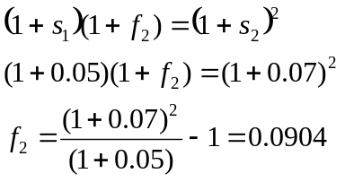

The price of ZCB_{C} is:
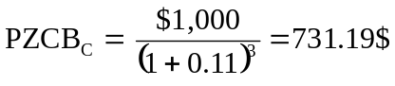

Investing in the ZCB_{C} for three years must give you the same return as investing in the ZCB_{B} for two years and in another ZCB of one-year during the third year.
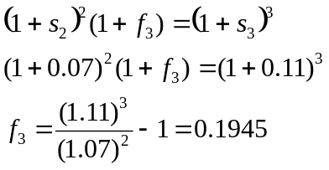

Ex.21

You have the following spot rates: S₁=12% S₂=13% S₃=14%. Calculate the price and YTM of a coupon bond with coupon rate 10%, maturity 3 years and face value 1,000$.
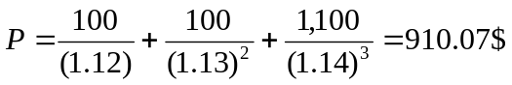

To find the YTM, the trial and error procedure leads to the following result:
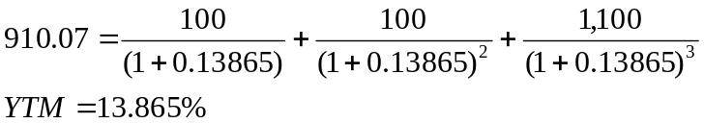

Ex.22
On the market you have the following types of bonds:
A) ZCB with M=1.5 years P=90.349 F=100
B) CB with M=1.5 years coupon rate=5% m=1 P=99.723 F=100

- Calculate the price and YTM of a coupon bond C with M=6 months, coupon rate=5.5% and m=1
- Given the information on current bond prices of bonds A,B and C, which is the market expectation of the future evolution of interest rates?

S_{1.5} can be calculated from ZCB_{A.}
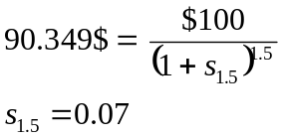

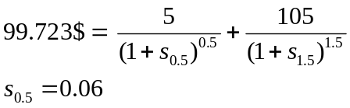S_{0.5} can be calculated from CB_{B}

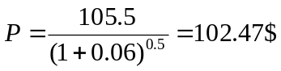Price of CB_{C}:

To see what is the market implying about the future rate, calculate the forward rate:
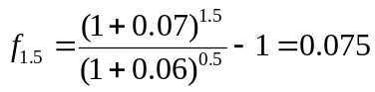

The market expects an interest rate in the near future to be 7.5%.

