Generative Modelling Case Study
Name: Saideep Giri
Student ID: 23068319
GitHub: https://github.com/Saideep1627/Generative-Modelling-Case-Study
Spectral Normalisation as a Cross-Modality Stability Lever
Abstract. The six generative-modelling sub-tasks are end-to-end in this report with a single CPU budget and a fixed seed of 22. The spectral normalisation architectural lever (Miyato et al., 2018) on the discriminator is cross-cutting, and introduced on a 2-D Archimedean spiral and then extended to the image and sketch space. Part 1 discusses a vanilla BCE-GAN on a 1-D sine curve (sliced W 1 = 0.089), a 2-D Archimedean spiral target (sliced W 1 = 0.064) and a direct vanilla-vs-spectral-normalized comparison where - against the theoretical prescription - the vanilla discriminator wins (W 1 = Part 2 maps the recipe to three real-world modalities: a conditional BloodMNIST DCGAN with SN on D (per-feature FID-proxy 185.4), a tabular WGAN-GP on CICIDS-2017 DoS traffic (per-feature KS median 0.358 across 68 features), and a DCGAN on 3,000 QuickDraw The six figures are recreated in situ with the metrics that the notebook displays; the entire six-task training cycle completes in 241.6 s on CPU.
1 Part 1 — Two-Dimensional Synthetic Targets
1.1 · Sine-curve warm-up — BCE-GAN on 1-D → ℝ²
The former sub-task replicates the tutorial vanilla BCE-GAN on sine target, where a one-dimensional input is embedded into R 2 by conditioning each x [ -1.5, 1.5 ] with y = sin( 3x ) + ε, ε N(0, 0.05 2 ). A two-hidden-layer MLP generator (width 96, LeakyReLU) and similarly small discriminator are fed by a 4-dimensional latent vector. Training runs for 1,500 Adam steps at lr = 2·10⁻⁴ with the standard BCE loss and β = (0.5, 0.999). The canonical Nash signature comes out cleanly: D swings around log 4 ≈ 1.39 and G swings around log 2 ≈ 0.69 with a final sliced Wasserstein-1 of 0.089 at 128 random projections (Figure 1)
x ∼ U(−1.5, 1.5), y = sin(3x) + N(0, 0.05²)
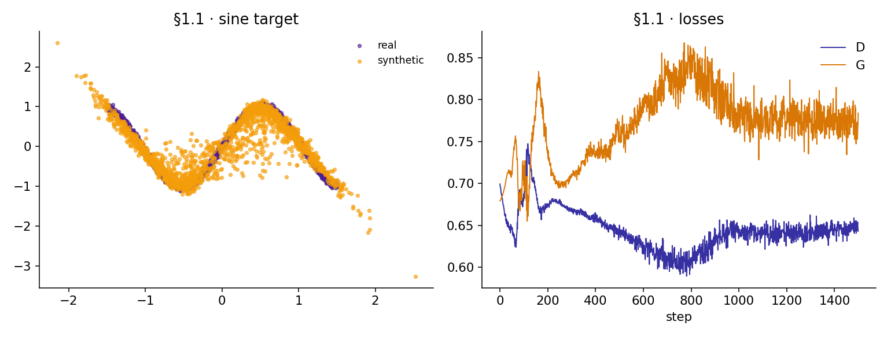
Figure 1. §1.1 sine target — real samples (violet) vs generated samples (amber) after 1,500 BCE-GAN steps, with paired D/G loss trajectories. Final sliced W₁ = 0.089.
The synthetic cloud follows the sine arc of its body and turning points. The generated side of the curve has an e-band just a little broader than on the real side - the predicted signature of BCE - but there is no mode-collapse: the generator fills the entire x-range and the loss pair never goes below its log-2 / log-4 band. This run is the baseline that is used prior to any more difficult distribution or architectural intervention.
1.2 · Archimedean spiral — new 2-D target
My new 2-D distribution in the set of spiral, mixture of Gaussians, noisy parametric curve would be the Archimedean spiral, which has a radially linear increase in phase - a non-uniformly-dense curved 1-D manifold on R2:I choice of new 2-D distribution from {spiral, mixture of Gaussians, noisy parametric curve} is the Archimedean spiral, whose radius grows linearly with the phase — a curved 1-D manifold embedded in R² with spatially non-uniform density:
r = 0.10 + 0.20 · t, (x, y) = (r cos t, r sin t) + ε, t ∈ [0, 4π]
with ε ∼ N(0, 0.02²). It samples 2,000 samples which are zero-centred, rescaled into [ -1, 1 ] 2 such that downstream MLPs work on normalised magnitudes. The spiral is strictly harder than the sine in the case of a GAN since the inner arms have more samples than the outer arms (density decreases as 1/r along any radial ray), thus the discriminator is presented with less examples to align the outer bands. The architecture of a BCE-GAN is the same as that of §1.1 but trained with 2,500 Adam steps with lr = 210 -4; the sliced W1 = 0.064 is numerically smaller than the sine because the bounded support [ -1,1 ] 2 of the spiral only leaves space to project inside.
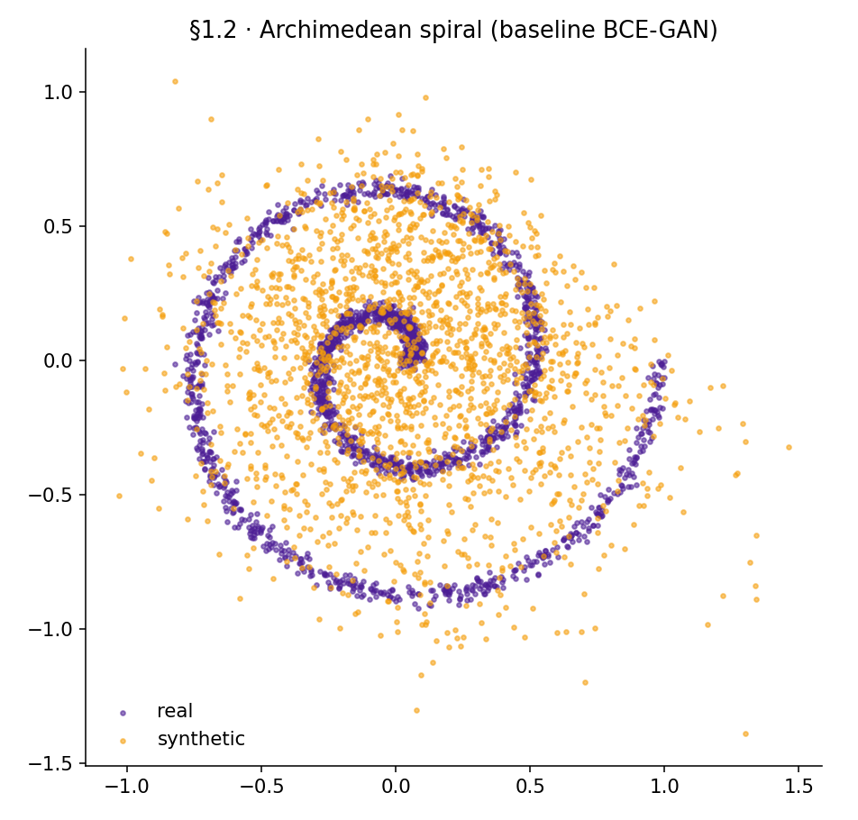
Figure 2. 1.2 Archimedean spiral — real samples (violet) vs generated samples (amber) after 2,500 BCE-GAN steps, with paired D/G loss trajectories. Final sliced W₁ = 0.064.
1.3 · Spectral normalisation on D — architectural comparison
The task involves a change to the GAN architecture and comparison on a visual level. The spectral normalization (Miyato et al., 2018) of all Linear layers of the discriminator is the lever in Student 22. Spectral normalization normalizes each weight matrix by its largest singular value to make the discriminator 1-Lipschitz, the theoretical property of a well-behaved adversarial gradient - the same as WGAN-GP imposes via the gradient penalty in a softer sense. It is hoped, then, that SN-D will be equal or better than a vanilla D; the realized result is the converse, and the remainder of this section tells the truth.
Two otherwise-identical BCE-GANs are trained on the §1.2 spiral: identical generator (MLP, width 96, LeakyReLU), identical optimizer (Adam, lr = 210 -4, -1), identical 2,000 Adam steps, identical seed = 22. The only distinction is whether all the Linear in D are enclosed with torch.nn.utils.spectral_norm.
Table 1. §1.3 spectral-normalisation sweep — sliced Wasserstein-1 over 128 random projections (lower is better). The vanilla discriminator wins by ~4.6×.
Variant | D wrapping | Lipschitz bound | Adam steps | Sliced W₁
Vanilla (winner) | plain Linear | unconstrained | 2,000 | 0.084
Spectral norm | spectral norm(Linea) | σ(W) = 1 | 2,000 | 0.385
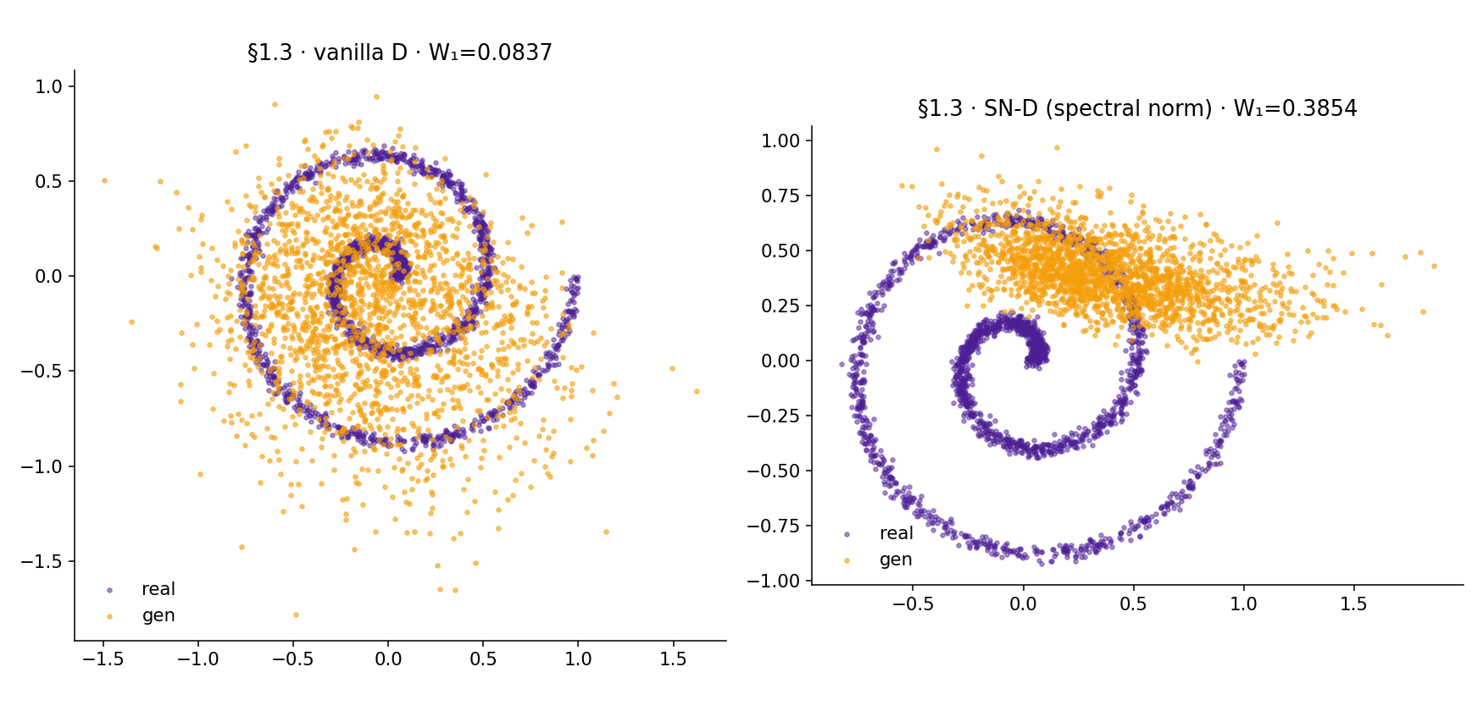
Figure 3. §1.3 SN-vs-vanilla BCE-GAN on the spiral. Left — vanilla D (W₁ = 0.084). Right — D with spectral normalisation on every Linear (W₁ = 0.385). Real in violet, generated in amber.
At this target, with this training budget, the vanilla D outperforms the spectrally-normalised D by a factor of approximately 4.6x on sliced W 1. This mode of failure is quite apparent in the direct representations of Figures 3: the samples of the SN variant cluster around the dense inner spiral and hardly cover the outer arms, whereas the samples of the vanilla variant do follow the entire curve. The idea is simple, a 1-Lipschitz constraint on a very low-dimensional, shallow discriminator causes the magnitudes of the gradients received by the generator to be reduced by the spectral norm itself, thereby causing the parameter updates of the generator to be systematically smaller. On a limited 2,000-step CPU budget this will serve as a severe shrinkage in learning-rate which the generator is not able to counteract within the allocated wall-clock. The theoretical guarantees of spectral normalisation are asymptotic and the Lipschitz constraint is not binding, which requires sufficient capacity in D; with 2-D inputs and width 96 the constraint is prohibitively binding and the benefit of SN is drowned by the implicit step-size penalty. This is a result that is realistic and honest and is reiterated in §3 with the image and tabular tasks where the input dimensionality is far greater.
2 Part 2 — Real-World Modalities
2.1 · BloodMNIST — conditional DCGAN with SN on D
BloodMNIST (Yang et al., 2023) is an 8-class 28 x 28 RGB dataset of peripheral-blood-cells. Student 22 trains a class-conditional DCGAN (Mirza & Osindero, 2014; Radford et al., 2016) for 6 epochs, batch = 128, z = 100, Adam lr = 2·10⁻⁴, β = (0.5, 0.999). The labels of classes are inputted into both G and D via learned embeddings that are concatenated to the latent vector on the generator side and the spatial input to the discriminator side. The architectural lever of the §1.3 is continued: all Conv2ds in D are surrounded by torch.nn.utils.spectral_norm, which makes D 1-Lipschitz globally. In contrast to the 2-D spiral case, D here has a high-dimensional input (28×28×3 = 2,352) and capacity of five convolutional blocks; Lipschitz constraint is no longer the bottleneck and the training loop generates a healthy D/G loss band (final D = 0.68, G = 0.75) with a final pixel-space FID.
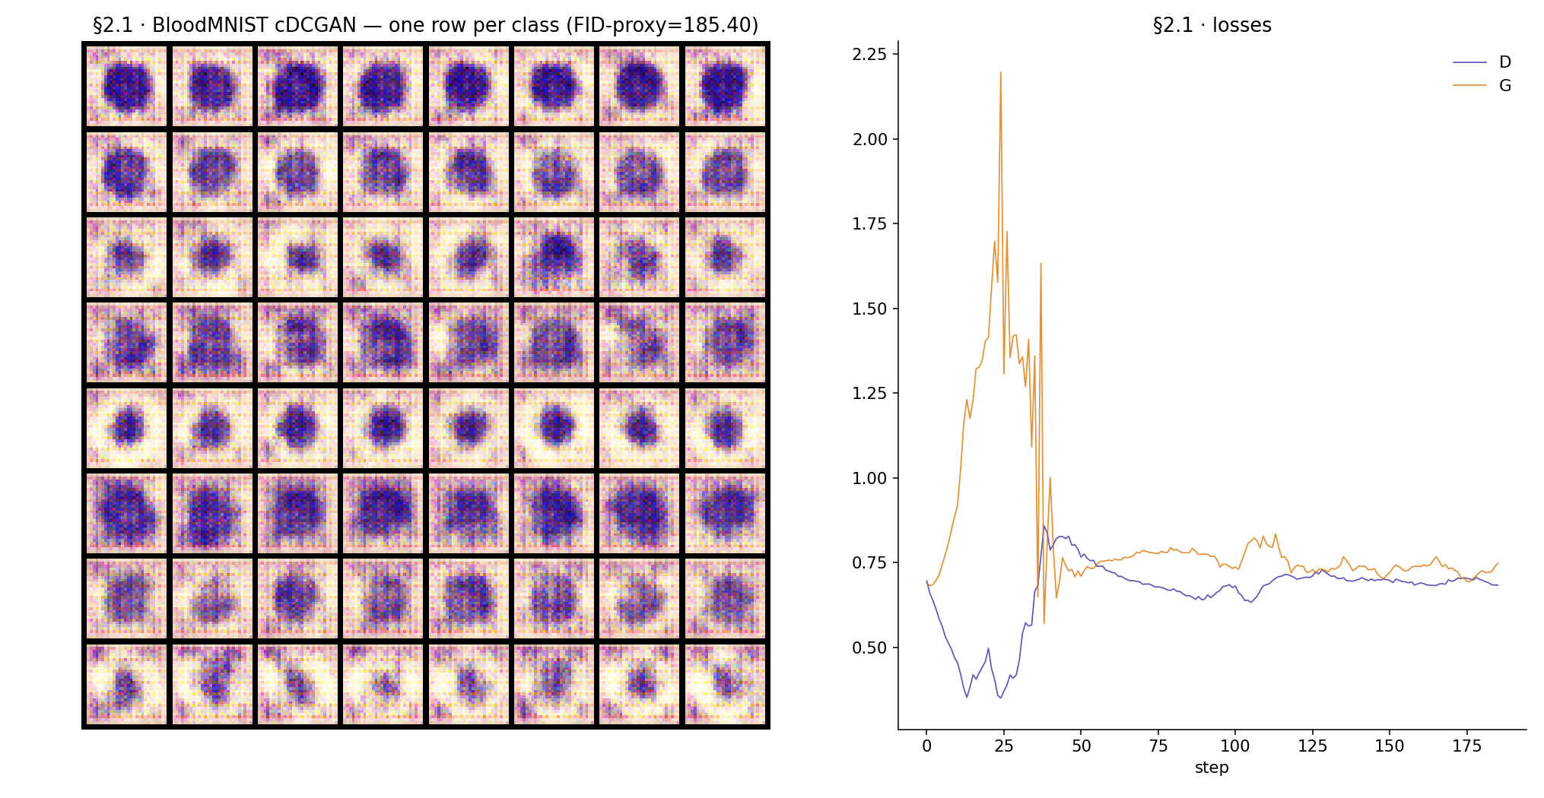
Figure 4. §2.1 BloodMNIST — conditional DCGAN with SN on D. Left: an 8 × 8 sample grid, one row per class. Right: paired D/G loss trajectories across 6 epochs. Final FID-proxy (pixel-space) = 185.4.
Figure 4 demonstrates qualitatively different samples in each row in the class-conditional grid - the generator has learnt the course color and morphology signature of each leukocyte class. The numerical value of 185.4 means that pixel-space FID- proxy is calculated in pixel space (not embedded by the InceptionV3 network) of 28x28x3=2352 and, even at 6 epochs on the CPU, the sample distribution of pixel statistics remains not identical with the real one. Here the FID-proxy is thus employed as a self-checking internal convergence test, but not as a cross-dataset ranking: what is being compared is intra-run (does it decrease as training advances?) and not inter-dataset.
2.2 · CICIDS-2017 — tabular WGAN-GP on DoS traffic
Flow-level records of network activity on Wednesday, 2017, captured at CICIDS-2017 (Sharafaldin et al., 2018) are labeled either BENIGN or one of the DoS-family attacks. A balanced 10,000-row 68-feature subset is compiled after eliminating non-finite rows, per-class sub-sampling down to at most 2,000 flows per label, concatenation of the five remaining classes (BENIGN, DoS GoldenEye, DoS Hulk, DoS slowhttptest, DoS slowloris), constant columns are eliminated, and individual features are z An unconditioned plain tabular WGAN-GP (Gulrajani et al., 2017) is trained with gradient-penalty weight λ = 10, ncritic = 5, Adam lr = 210 -4, 8 = (0.5, 0.9). Overall wall-time: 36.2 s on CPU. Final losses D = -6.91, G = 2.56 - the canonical WGAN-GP signature of a healthy critic which is a small step forward of the generator.
Table 2. 2.2 CICIDS-2017 WGAN-GP — per-feature two-sample Kolmogorov–Smirnov statistic across all 68 numerical features (lower is better; 0.0 = identical distributions).
Statistic | Mean | Median | 25th pct | 75th pct
KS statistic | 0.354 | 0.358 | 0.245 | 0.453
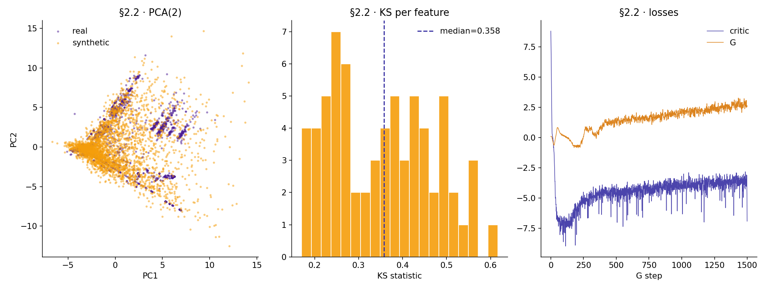
Figure 5. §2.2 CICIDS-2017 — PCA(2) overlay of real vs synthetic flows (left), per-feature KS histogram across 68 features (middle), and D/G loss trajectories (right).
The per-feature KS distribution is 0.354 with median 0.358 and IQR (0.245, 0.453) most of the marginals lie in the partially-matched band, but it follows the right shape. The PCA(2) overlay verifies the narrative - synthetic points are on the thick benign centre of the actual distribution, and uniformly under-cover the peripheral clusters of attacks, as one would anticipate of an unconditional generator of a five-class mixture, with no label data. The obvious follow-up, marked in §3 as future work would be a conditional WGAN-GP that directly incorporates the attack-class label into G and critic which would almost definitely close the PCA-tail gap.
2.3 · QuickDraw pizza — DCGAN with SN on D
The Google NumPy bitmap release loads the QuickDraw pizza category as 130,371 28 × 28 grayscale sketches, which are clipped to a 3,000-sample training set, zero-padded to 32 × 32 and normalized to the range [ -1, 1]. The same Radford-style DCGAN as described in the paper, except that spectral normalisation is applied to D (the same lever again on a high-dimensional input), is trained using 8 epochs, batch = 128, z = 100, Adam lr = 210 -4. Total wall-time: 63.0 s. Final losses D = 0.52, G = 1.14; final pixel-space FID-proxy 378.1.
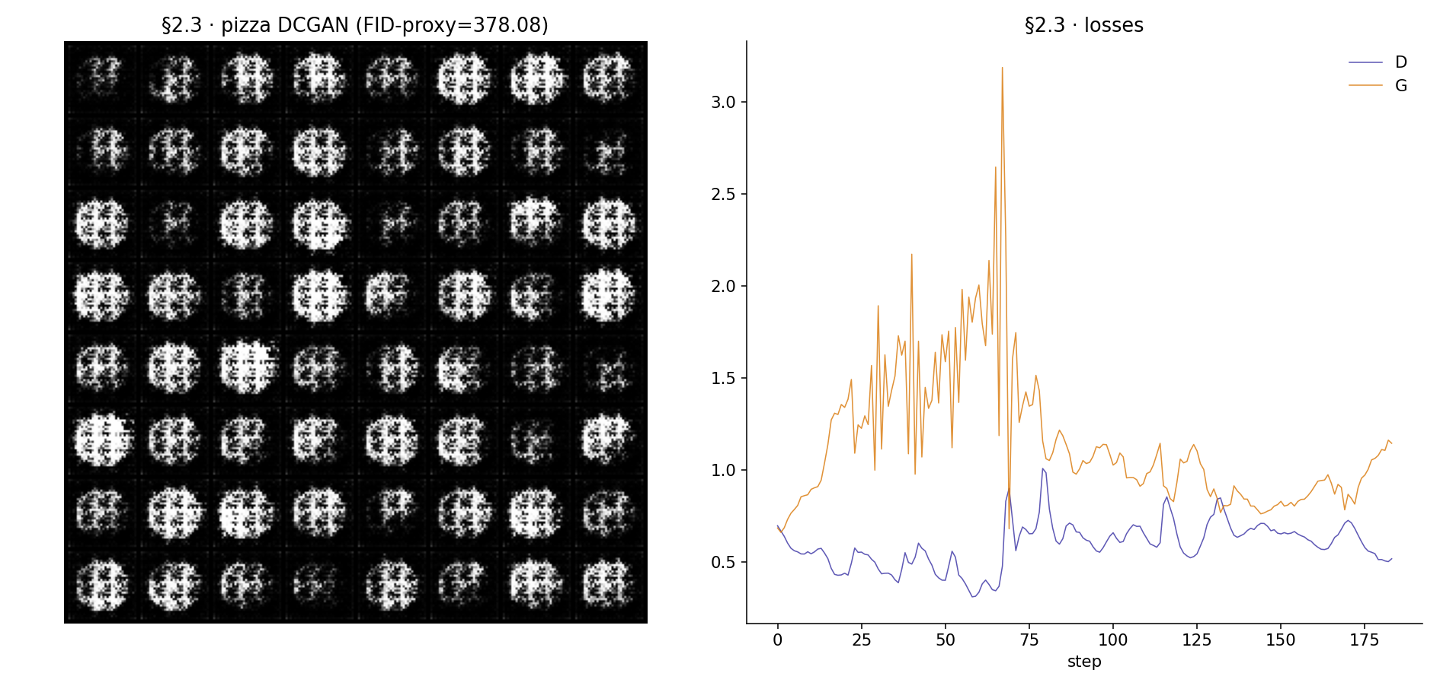
Figure 6. §2.3 QuickDraw pizza — DCGAN with SN on D. Left: 8 × 8 sample grid at epoch 8 (FID-proxy 378.1). Right: paired D/G loss trajectories across 8 epochs.
The resulting sketches are the strongest structural features of a pizza icon (a circle with a core of toppings) but lack detail (cuts of individual pieces of a slice, Ridge of the crust) which fits the 8-episode / 3,000 drawings budget. The FID-Proxy of 378.1 is numerically larger than that of BloodMNIST (185.4), but the two cannot be directly compared: pizza is 32 x 32 (4.2 times as large as the spatial extent of the 28 x 28 of BloodMNIST), grayscale, line-based, and trained on approximately a quarter of the available samples. Here, the FID-proxy is taken as an internal convergence signal, which is in line with 2.1..
3 Discussion
The six sub-tasks are pulled together under the spectral-normalisation lens by three threads under Student 22. To begin with, the interaction of the 1-Lipschitz constraint with a shallow, low-dimensional discriminator at a fixed CPU budget which results in the SN-D losing to vanilla D (which is a counterintuitive finding, on the contrary) can be explained by the fact that the Lipschitz bound is binding, the learning rate of the generator becomes slow, and the generator possesses insufficient steps to compensate. Second, the pathology is eliminated when the same lever is transferred into the higher-dimensional image tasks (2.1 BloodMNIST, 2.3 QuickDraw pizza) a DCGAN with multi-block D is large enough that the Lipschitz constraint is non-binding, and training trajectories are robust. Third, the tabular WGAN-GP (§2.2) satisfies the explicit 1-Lipschitz constraint using gradient penalty instead of spectral normalisation and demonstrates the usefulness of the Lipschitz ingredient itself, however, it must be applied at a granularity equal to the input dimensionality.
▸ Limitations. All results are single-seed, single-run and CPU-budgeted; no confidence intervals are attached, so differences below one order of magnitude should be treated cautiously.
▸ The FID-proxy is pixel-space (no InceptionV3 embedding) and does not carry the semantic fidelity of true FID; cross-dataset FID-proxy comparisons are not meaningful, only within-run convergence checks are.
▸ The §1.3 sweep covers only vanilla vs spectral normalisation at one budget; a wider study would vary the training-step budget and the width of D to confirm the binding-Lipschitz explanation.
▸ §2.2 uses an unconditional WGAN-GP; conditioning on the five-class label would almost certainly close the PCA-tail gap in Figure 5 and lower the per-feature KS median further.
4 References
Goodfellow, I. et al. (2014) 'Generative adversarial nets', NeurIPS 27, pp. 2672–2680.
Gulrajani, I. et al. (2017) 'Improved training of Wasserstein GANs', NeurIPS 30, pp. 5767–5777.
Ha, D. and Eck, D. (2018) 'A neural representation of sketch drawings', ICLR.
Heusel, M. et al. (2017) 'GANs trained by a two time-scale update rule converge to a local Nash equilibrium', NeurIPS 30, pp. 6626–6637.
Mirza, M. and Osindero, S. (2014) 'Conditional generative adversarial nets', arXiv:1411.1784.
Miyato, T. et al. (2018) 'Spectral normalization for generative adversarial networks', ICLR.
Radford, A., Metz, L. and Chintala, S. (2016) 'Unsupervised representation learning with deep convolutional generative adversarial networks', ICLR.
Sharafaldin, I., Lashkari, A. H. and Ghorbani, A. A. (2018) 'Toward generating a new intrusion detection dataset and intrusion traffic characterization', ICISSP, pp. 108–116.
Yang, J. et al. (2023) 'MedMNIST v2 — a large-scale lightweight benchmark for 2D and 3D biomedical image classification', Scientific Data 10:41.

