NAME : Saideep Taddi
Regd no : 11711010
Roll no : 007
Github Link: https://github.com/SaideepTaddi/Multilevel-Queue-Scheduling
MULTI LEVEL QUEUE SCHEDULING:
QUESTION :
*Write a C program to simulate multi-level queue scheduling algorithm considering the following scenario. All the processes in the system are divided into two categories – system processes and user processes. System processes are to be given higher priority than user processes. The priority of each process ranges from 1 to 3. Use fixed priority scheduling for all the processes.

Description:

Multi-level queue scheduling algorithm is used in scenarios where the processes can be classified into groups based on property like process type, CPU time, IO access, memory size, etc. In a multi-level queue scheduling algorithm, there will be 'n' number of queues, where 'n' is the number of groups the processes are classified into. Each queue will be assigned a priority and will have its own scheduling algorithm like round-robin scheduling or FCFS. For the process in a queue to execute, all the queues of priority higher than it should be empty, meaning the process in those high priority queues should have completed its execution. In this scheduling algorithm, once assigned to a queue, the process will not move to any other queues.

Code:
#include<stdio.h>
#include<conio.h>
int main()
{
int p[20],bt[20], su[20], wt[20],tat[20],i, k, n, temp;
float wtavg, tatavg;
printf("Enter the number of processes --- ");
scanf("%d",&n);
for(i=0;i<n;i++)
{
p[i] = i;
printf("Enter the Burst Time of Process %d --- ", i);
scanf("%d",&bt[i]);
printf("System/User Process (0/1) ? --- ");
scanf("%d", &su[i]);
}
for(i=0;i<n;i++)
for(k=i+1;k<n;k++)
if(su[i] > su[k])
{
temp=p[i];
p[i]=p[k];
p[k]=temp;
temp=bt[i];
bt[i]=bt[k];
bt[k]=temp;
temp=su[i];
su[i]=su[k];
su[k]=temp;
}
wtavg = wt[0] = 0;
tatavg = tat[0] = bt[0];
for(i=1;i<n;i++)
{
wt[i] = wt[i-1] + + bt[i-1];
tat[i] = tat[i-1] + bt[i];
wtavg = wtavg + wt[i];
tatavg = tatavg + tat[i];
}
printf("\nPROCESS\t\t SYSTEM/USER PROCESS \tBURST TIME\tWAITING TIME\tTURNAROUND TIME");
for(i=0;i<n;i++)
printf("\n%d \t\t %d \t\t %d \t\t %d \t\t %d ",p[i],su[i],bt[i],wt[i],tat[i]);
printf("\nAverage Waiting Time is --- %f",wtavg/n);
printf("\nAverage Turnaround Time is --- %f",tatavg/n);
getch();
}

Output:

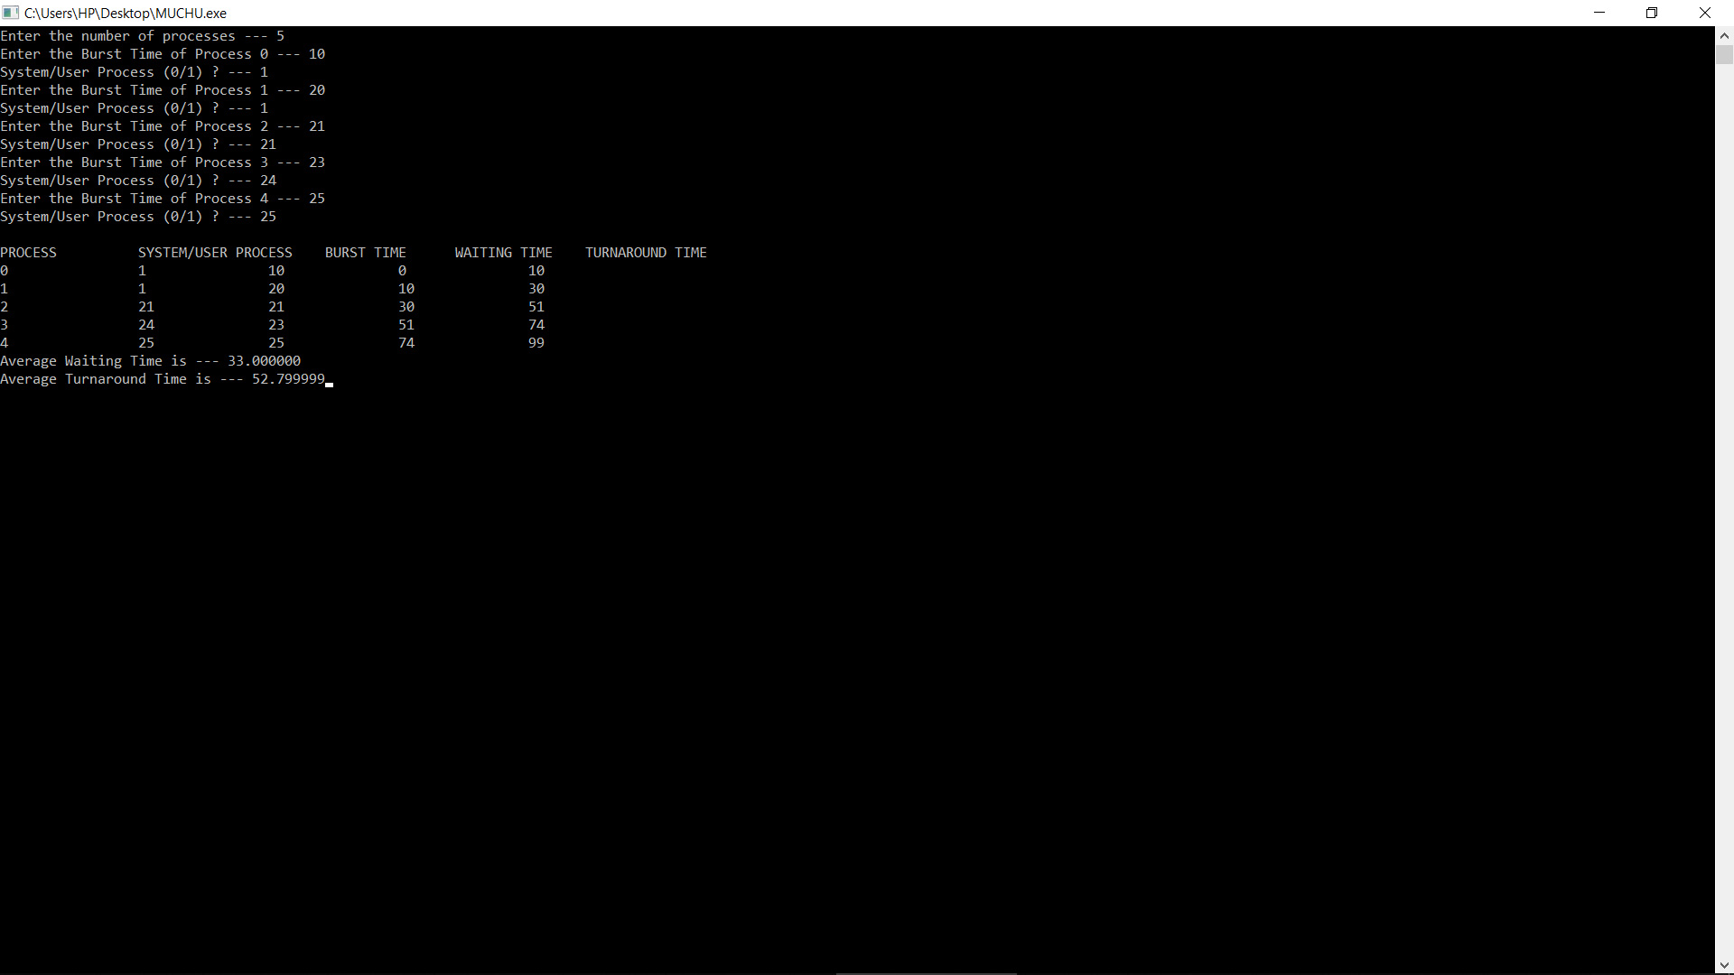
INPUT Enter the number of processes --- 4
Enter the Burst Time of Process 0 --- 3
System/User Process (0/1) ? --- 1
Enter the Burst Time of Process 1 --- 2
System/User Process (0/1) ? --- 0
Enter the Burst Time of Process 2 --- 5
System/User Process (0/1) ? --- 1
Enter the Burst Time of Process 3 --- 1
System/User Process (0/1) ? --- 0

PROCESS SYSTEM/USERPROCESS BURST TIME WAITING TIME TURNAROUND TIME
1 0 2 0 2
3 0 1 2 3
2 1 5 3 8
0 1 3 8 11
Average Waiting Time is --- 3.250000
Average Turnaround Time is --- 6.000000

……………………………………………………………….THE END……………………………………………………………………………..

