
Fall 2025
DAMG7374- GenAI and LLM Applications in Data Engineering

LOCALEATS AI
A Multi-Agent, Data-Driven Restaurant Recommendation System

Instructor: Dr. Kishore Aradhya

Team 4:
Vaibhavi Shinde (002050738)
Saideepak Reddy Kasireddy (002338763)
Ganesh Paparaju (002300719)

December 2025
College of Engineering, Northeastern University
Boston, MA 02115

- INTRODUCTION
BACKGROUND
Recommender systems are a core component of modern digital platforms, helping users navigate with the rapid growth of food delivery platforms and online restaurant discovery tools, users are increasingly overwhelmed by generic recommendations that fail to consider personal preferences, safety concerns, and contextual factors such as location and accessibility. Most existing systems rely heavily on keyword matching or static ratings, offering limited transparency and personalization. At the same time, large language models (LLMs) have shown strong capabilities in natural language understanding and reasoning, but their use in real-world recommendation systems introduces challenges such as hallucinations, lack of grounding, and trustworthiness.
To address these gaps, we designed LocalEats AI, a multi-agent, data-driven restaurant recommendation system built on Snowflake that combines structured analytics with LLM-based reasoning while enforcing strict grounding in trusted data sources.
MOTIVATION
The primary motivation for this project is to explore how multi-agent LLM systems combined with structured analytics platforms can produce trustworthy, personalized restaurant recommendations at scale. Traditional recommendation systems rely heavily on static filters or ratings and often fail to account for contextual factors such as safety, accessibility, dietary needs, and location awareness. On the other hand, purely LLM-driven systems risk hallucinations and lack grounding in real data.
Through this project, we aim to:
- Understand how multi-agent architectures improve reliability and reasoning in complex recommendation workflows.
- Evaluate how LLMs grounded in structured Snowflake data can reduce hallucinations and improve trust.
- Learn how real-world AI systems can integrate ETL pipelines, analytics layers, and generative models end-to-end.
- Gain practical insights into building scalable, explainable, and user-centric AI systems relevant to modern data and AI-driven applications.
GOAL
The primary goal of this project is to design and implement a scalable, trustworthy restaurant recommendation system that combines structured analytics with generative AI. While traditional recommendation systems rely on static filters or ratings, they often fail to capture contextual user needs such as safety, dietary preferences, accessibility, and location awareness. At the same time, purely LLM-driven systems risk hallucinations and lack grounding in real-world data.
To address these challenges, our work focuses on building a multi-agent architecture that orchestrates retrieval, reasoning, generation, and evaluation in a controlled and explainable manner. By grounding all recommendations in Snowflake Gold-layer analytics tables, we ensure that generated outputs remain factual, consistent, and aligned with the underlying data.
A key component of this effort involves integrating an LLM-as-a-Judge evaluation framework, which systematically scores recommendation quality, relevance, and groundedness using the database as the source of truth. Through structured experiments and real user queries, our objective is to assess how different models and configurations impact recommendation quality, latency, and reliability.
Ultimately, this project aims to demonstrate how modern data engineering pipelines, multi-agent AI systems, and rigorous evaluation frameworks can be combined to build production-ready, user-centric recommendation systems that balance personalization, transparency, and scalability.

- METHODOLOGY

1. Data Preprocessing
Data preprocessing in the LocalEats AI system follows a Medallion Architecture (Bronze–Silver–Gold) implemented within Snowflake, enabling scalable ingestion, transformation, and analytics-ready data preparation. This layered design ensures data reliability, traceability, and modular transformation, which are critical for downstream recommendation and evaluation tasks.

1.1 Data Sources and Ingestion
The system integrates multiple heterogeneous external data sources, each contributing a unique dimension to the recommendation pipeline:
- Yelp API
  - Restaurant metadata (name, cuisine type, price level, ratings)
  - Business location details (address, neighborhood, coordinates)
  - Popularity indicators (Yelp rating counts, reviews count)
- Google Places API
  - Enriched attributes such as operating hours
  - Business categories and place-level metadata
  - Supplementary validation for restaurant location and status
- Boston Health Inspections Open Data
  - Historical inspection results and violation records
  - Risk levels and compliance indicators
  - Used to compute normalized restaurant safety scores
- MBTA Transit API
  - Station locations and route information
  - Accessibility indicators (elevators, wheelchair access)
  - Used to compute transit proximity and accessibility features
All data sources are ingested programmatically through scheduled extraction pipelines and stored without modification in the bronze layer to preserve raw fidelity.

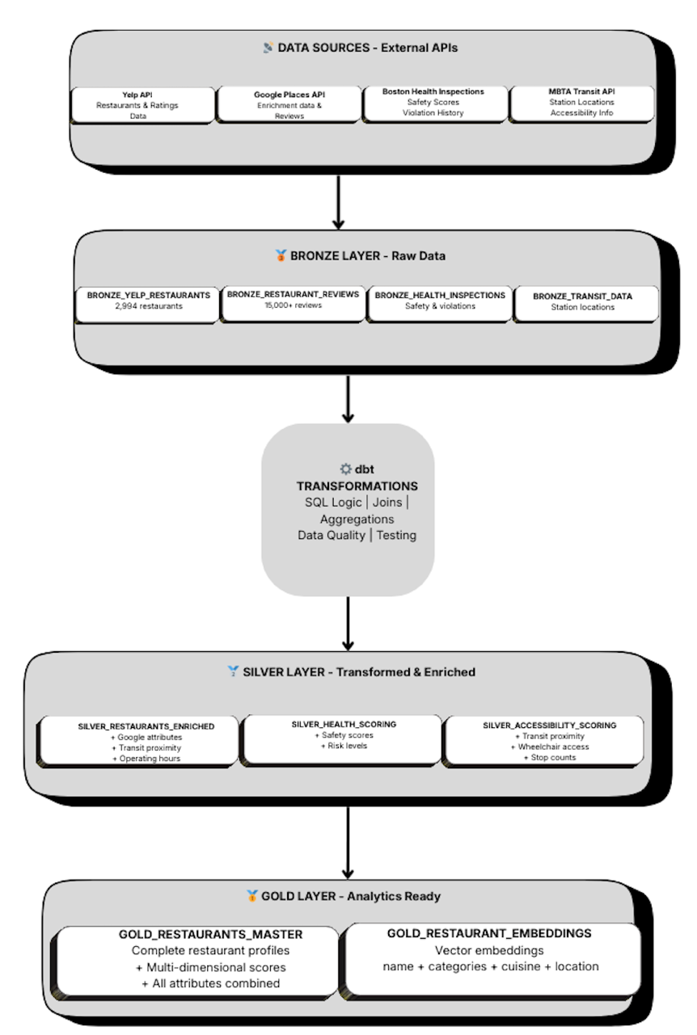

1.2 Bronze Layer – Raw Data Storage
The Bronze layer serves as the system’s immutable raw data repository. It captures source data in its original structure to enable traceability and debugging.
Key Bronze tables include:
- BRONZE_YELP_RESTAURANTS
Stores raw restaurant profiles and ratings from Yelp.
- BRONZE_HEALTH_INSPECTIONS
Contains inspection scores, violations, and timestamps from the city dataset.
- BRONZE_TRANSIT_DATA
Stores MBTA station locations and accessibility attributes.
At this stage:
- No business logic is applied
- Minimal schema enforcement is performed
- All records are preserved, including incomplete or inconsistent entries
This design ensures that downstream transformations can always be traced back to the original source.

1.3 Data Cleaning and Normalization
Before enrichment, extensive cleaning is applied using dbt transformations:
- Missing Value Handling
  - Restaurants with critical missing identifiers are excluded
  - Optional attributes (phone numbers, hours) are safely nullable
- Identifier Standardization
  - Yelp business IDs are normalized and used as primary keys
  - Cross-source joins rely on spatial proximity and name similarity
- Price Level Normalization
  - Price indicators from different sources are mapped to a unified scale ($–$$$$)
- Record Deduplication
  - Duplicate restaurants arising from multiple APIs are consolidated
dbt tests enforce:
- Schema consistency
- Uniqueness of primary keys
- Referential integrity across layers

1.4 Silver Layer – Transformed and Enriched Data
The Silver layer introduces business logic and feature engineering to produce enriched, analysis-ready datasets.
Key transformations include:
a) Restaurant Enrichment
SILVER_RESTAURANTS_ENRICHED
- Combines Yelp and Google attributes
- Adds computed distance from user-specified locations
- Includes operating hours and neighborhood labels
b) Safety Scoring
SILVER_HEALTH_SCORING
- Aggregates inspection violations over time
- Normalizes scores into a 0–100 safety index
- Categorizes restaurants into low, medium, and high risk
c) Accessibility and Transit Scoring
SILVER_ACCESSIBILITY_SCORING
- Computes distance to nearest MBTA station
- Flags wheelchair-accessible routes
- Counts nearby transit stops for convenience scoring
These enriched tables provide a factual, structured context used by downstream agents.

1.5 Gold Layer – Analytics-Ready Tables
The Gold layer consolidates all relevant attributes into optimized tables designed for fast retrieval and ranking.
Key Gold tables include:
- GOLD_RESTAURANTS_MASTER
  - Complete restaurant profiles
  - Multi-dimensional scores (overall, safety, accessibility)
  - Cuisine, neighborhood, and pricing attributes
  - Primary source of truth for recommendations
- GOLD_RESTAURANT_EMBEDDINGS
  - Vector embeddings derived from restaurant metadata
  - Encodes name, cuisine, category, and location semantics
  - Supports semantic retrieval and similarity matching
These tables are optimized for:
- Low-latency queries
- Deterministic ranking
- Integration with LLM-based reasoning agents

MODEL ARCHITECTURE

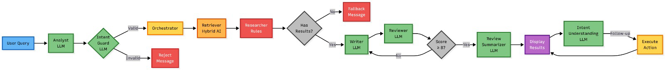

Multi-Agent System Design
LocalEats AI follows a multi-agent architecture, where each agent is responsible for a specific task in the recommendation pipeline. This separation of responsibilities improves accuracy, reliability, and explainability, while reducing hallucinations and uncontrolled LLM behavior.
Analyst Agent: The Analyst Agent is the first component that processes the user’s natural language query. Its primary role is to extract high-level intent, constraints, and contextual information such as cuisine type, price range, or location preference. This agent converts free-form user input into a structured representation that downstream agents can interpret reliably.
Intent Guard: The Intent Guard Agent validates the interpreted query before it enters the system. It checks for ambiguity, unsupported requests, or unsafe inputs. If the query is invalid or outside the system’s scope, the agent triggers a rejection or fallback message. This early validation step prevents noisy or irrelevant queries from propagating through the pipeline.
Orchestrator Agent: The Orchestrator Agent acts as the central control unit of the system.
It coordinates the execution order of all agents, manages fallback logic, tracks iteration counts, and records latency metrics. By enforcing a deterministic workflow, the orchestrator ensures consistent execution while allowing flexible agent interaction.

Retriever Agent (Hybrid Semantic RAG): The Retriever Agent fetches candidate restaurants from Snowflake Gold tables.
It uses a hybrid approach that combines:
- Structured SQL filtering for hard constraints (cuisine, price, neighborhood)
- Semantic matching for flexible intent interpretation
This agent retrieves a top K set of candidates that are factually grounded and ready for further refinement.
Researcher Agent: The Researcher Agent applies rule-based filtering and ranking to the retrieved candidates. It enforces user constraints such as safety thresholds, accessibility needs, and dietary requirements. The output of this agent forms a trusted factual context, ensuring that only valid restaurants are passed to the generative stage.
Writer Agent: The Writer Agent generates the natural-language recommendation.
Unlike generic LLM responses, this agent is strictly grounded in the researcher-approved dataset. It does not introduce new restaurants or unsupported facts, ensuring that the generated explanation remains faithful to the underlying data.
Reviewer Agent: The Reviewer Agent evaluates the generated recommendation and assigns a quality score based on relevance, clarity, and correctness.
If the output does not meet a predefined quality threshold, feedback is provided and the recommendation is sent back to the Writer Agent for refinement. This iterative loop improves output quality and consistency.
Review Summarizer Agent: The Review Summarizer Agent condenses the approved recommendation into a concise, user-friendly format.
This step improves readability and ensures that users receive clear and actionable recommendations without unnecessary verbosity.
Intent Understanding Agent (Follow-up Queries): The Intent Understanding Agent handles follow-up questions such as “Which is cheapest?” or “Closest option?”.
It interprets conversational context and maps the query to an executable action using previously retrieved results, enabling a seamless chat-based user experience.

Guardrails and Safety Mechanisms Implemented
To ensure reliability, safety, and trustworthy recommendations, we implemented multiple guardrails across the system pipeline, preventing invalid inputs, hallucinated outputs, and unsafe recommendations.
Input Validation and Intent Guardrails
The system includes an Input Validator / Intent Guard agent that inspects user queries before they enter the core pipeline. This agent cleans malformed inputs, rejects ambiguous or unsupported requests, and ensures the query aligns with the system’s capabilities (e.g., restaurant recommendations only). Invalid or unclear queries are intercepted early, preventing downstream agents from producing misleading or irrelevant outputs.
Retrieval Grounding Guardrails
All recommendations are strictly grounded in Snowflake Gold tables, which act as the single source of truth. The Retriever Agent only fetches top K candidates from curated analytics-ready data, ensuring that no external or fabricated restaurant information enters the system. If retrieval yields zero results, the system halts generation and triggers a fallback response rather than hallucinating recommendations.
Hallucination Detection and Logging
The evaluation framework explicitly flags hallucinations when the generated response mentions unsupported restaurants or facts. All evaluation outcomes including scores, feedback, and hallucination flags are logged to Snowflake for auditing, analysis, and future improvements.

Challenges Faced:
Integrating Heterogeneous Data Sources
Challenge:
The system relies on multiple external data sources—Yelp, Google Places, Boston Health Inspections, and MBTA Transit APIs—which differ significantly in schema, granularity, update frequency, and data quality. Joining these sources reliably was challenging due to inconsistent restaurant identifiers, missing fields, and duplicate records.
Solution:
To address this, we adopted a Medallion Architecture (Bronze–Silver–Gold) in Snowflake. Raw data was first ingested into the Bronze layer without modification, preserving traceability. In the Silver layer, dbt transformations were used to standardize identifiers, normalize price levels, resolve duplicates, and enrich records using spatial joins and name similarity. Strict dbt tests were implemented to ensure schema consistency and data quality before promoting data to the Gold layer.
Managing Multi-Agent Coordination
Challenge:
Coordinating multiple agents (Analyst, Intent Guard, Retriever, Researcher, Writer, Reviewer, etc.) introduced complexity in execution flow, error handling, and fallback logic. Without careful orchestration, the system risked becoming non-deterministic and difficult to debug.
Solution:
An Orchestrator Agent was implemented as a centralized control layer. It enforces execution order, tracks intermediate outputs, manages retry and fallback logic, and records latency metrics. This design ensured predictable behavior while preserving modularity and extensibility.
Preventing Hallucinations in LLM-Generated Recommendations
Challenge:
Early experiments with direct LLM-based recommendations resulted in hallucinated restaurant names, incorrect attributes, and fabricated details. This posed a significant risk to trustworthiness, especially in a real-world recommendation setting.
Solution:
We addressed this by strictly grounding all generative steps in structured Snowflake Gold tables. The Writer Agent only receives researcher-approved datasets and is not allowed to introduce new entities. Additionally, an LLM-as-a-Judge framework was introduced to explicitly detect hallucinations by comparing generated text against database records treated as the source of truth.
Challenge: Handling Location-Based Queries and Spatial Interpretation
One significant challenge we encountered involved location-based queries, specifically when users searched for restaurants near a given neighborhood versus within that neighborhood. For example, when users entered queries such as “restaurants in Fenway”, the system successfully returned relevant results. However, queries like “restaurants near Fenway” initially failed to produce accurate or expected recommendations.
This issue arose because the system treated neighborhood names (e.g., Fenway) as categorical location labels rather than geographic reference points. Queries containing phrases like “in Fenway” matched directly against the NEIGHBORHOOD field in the database, whereas “near Fenway” implied a proximity-based spatial search, which required latitude–longitude coordinates and distance calculations. Since the initial query-processing logic did not distinguish between these semantic intents, proximity-based queries were not handled correctly.
To address this challenge, we enhanced the query understanding and geocoding pipeline. We introduced logic to detect spatial intent keywords such as “near”, “close to”, and “around”. When such terms were present, the system dynamically geocoded the referenced location (e.g., Fenway Park coordinates) and switched from a categorical filter to a distance-based retrieval strategy using haversine calculations. This allowed the Retriever and Researcher agents to rank restaurants based on geographic proximity rather than strict neighborhood membership.
By explicitly separating location containment (“in”) from location proximity (“near”), the system became more robust and intuitive from a user perspective. This improvement significantly enhanced the system’s ability to handle real-world natural language queries and improved user satisfaction when searching by landmarks or neighborhoods.

Evaluation Framework & Results
LocalEats AI is evaluated using an LLM-as-a-Judge framework grounded in Snowflake Gold tables, which serve as the authoritative source of truth. Each generated recommendation is assessed on Answer Relevance, Context Relevance, and Groundedness, along with hallucination detection and detailed latency measurements across the multi-agent pipeline.
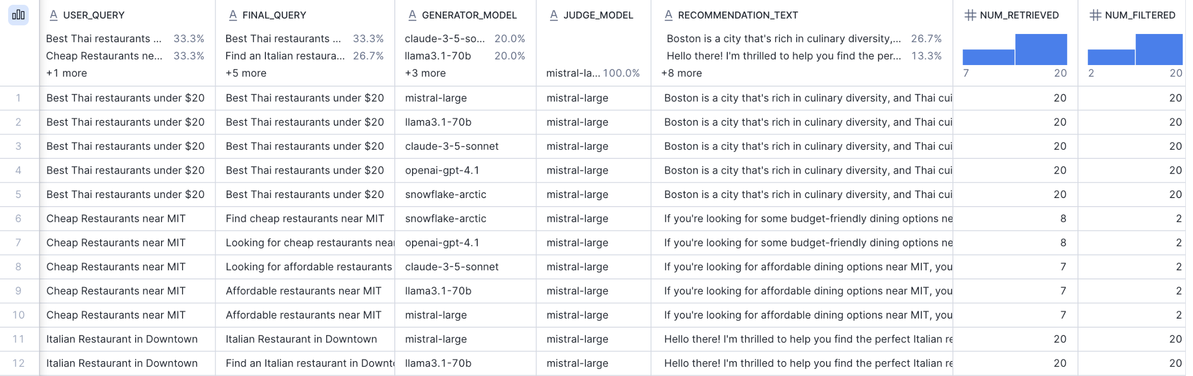

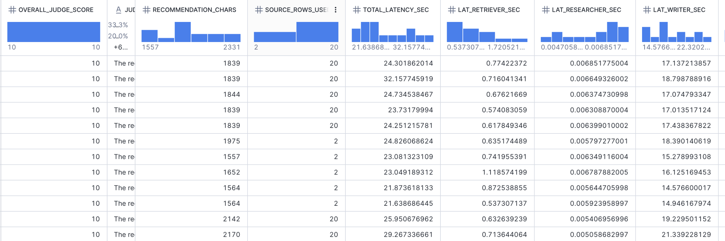
Observations from the Evaluation Results:
- Across multiple user queries and different generator models (Mistral, LLaMA-3.1-70B, Claude-3.5 Snowflake arctic, and GPT-4.1), the system consistently achieved high quality scores (9–10) when recommendations adhered to user intent and database constraints.
- In cases where the system violated constraints such as recommending restaurants outside the specified neighborhood or adding unnecessary transit and distance details the judge model appropriately reduced relevance and groundedness scores and flagged hallucinations.
- Latency analysis revealed that the Writer Agent dominates end-to-end runtime, while retrieval and filtering stages remain highly efficient due to optimized Snowflake queries.
- Despite switching between different LLMs, the generated recommendations remained largely consistent in content, highlighting the effectiveness of the data grounding and agent orchestration strategy.

Interpretation:
These results suggest that system architecture and grounding mechanisms play a more critical role in recommendation quality than the choice of LLM alone. The evaluation framework successfully captures both semantic quality and factual correctness, enabling reliable comparison across models and providing confidence in the system’s real-world usability.

Conclusion:
In this project, we designed and implemented LocalEats AI, a scalable, multi-agent restaurant recommendation system that combines structured data engineering with modern large language models. By leveraging a Medallion Architecture (Bronze–Silver–Gold) in Snowflake and a carefully orchestrated multi-agent pipeline, the system delivers personalized, context-aware, and safety-conscious restaurant recommendations using natural language queries.
A key strength of our approach is the strict grounding of all recommendations in curated database records, ensuring factual correctness and preventing hallucinations. The modular agent design spanning input validation, retrieval, constraint-based reasoning, generation, and review allows the system to be both extensible and robust, closely resembling real-world production AI architectures. Additionally, integrating LLM-as-a-Judge evaluation enabled us to quantitatively assess recommendation quality, relevance, and groundedness across different language models.
Our experimental results show that multiple state-of-the-art LLMs can produce high-quality recommendations when constrained by strong data guardrails, highlighting that system design and grounding matter more than the choice of model alone. The evaluation framework also provides a reusable foundation for continuous monitoring, comparison, and improvement of generative AI systems. Overall, this project demonstrates how data engineering, agentic AI design, and evaluation frameworks can be combined to build trustworthy, scalable AI applications. The lessons learned from handling location ambiguity to enforcing guardrails—offer valuable insights for deploying LLM-powered systems in real-world settings where accuracy, safety, and explainability are critical.

Future Work
While LocalEats AI successfully delivers personalized and grounded restaurant recommendations, we were planning to implement several meaningful extensions thhat can further enhance its real-world applicability and user experience.
1. Group Consensus Based Recommendations
A key future enhancement involves supporting group dining scenarios, where multiple users wish to select a restaurant together. Each user would be able to enter individual preferences such as cuisine, budget, dietary restrictions, safety concerns, or location constraints. The system would then aggregate these preferences and apply a consensus or voting mechanism (e.g., weighted voting, preference ranking, or fairness-aware optimization) to generate recommendations that best satisfy the group as a whole. This feature would make the system especially useful for social planning, team outings, and family dining decisions, where balancing competing preferences is critical.
2. Long-Term User Memory and Personalization
Another important direction is the introduction of long-term user memory. Instead of treating each query independently, the system could store and learn from historical user interactions—such as past restaurant selections, feedback, and repeated preferences. This memory could be leveraged to refine future recommendations, adapt ranking strategies over time, and reduce the need for users to repeatedly specify preferences. Implementing long-term memory would enable a more adaptive, personalized, and intelligent recommendation experience.
3. Adaptive Preference Weighting
Building on memory and group consensus, future versions could dynamically adjust preference weights based on user behavior. For example, if a user consistently prioritizes safety or vegetarian options, the system could automatically emphasize these constraints in future searches without explicit input.

