MBTA ROUTES

The table contains records of transportation routes. Each record represents a single route and includes details about its characteristics and attributes.
Dataset Statistics:
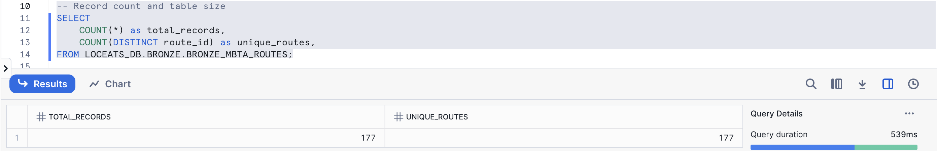
- Total Records: 177
- Unique Routes: 177 (no duplicates)
The MBTA Routes table contains exactly 177 unique transit routes with no duplicate entries. This is a clean reference table representing all MBTA routes including subway lines (Red, Orange, Blue, Green), bus routes, commuter rail, and ferry services. The one-to-one relationship between records and unique routes indicates this is a well-maintained dimension table suitable for joining with other transit-related datasets.
MBTA Routes Column-Level Analysis:
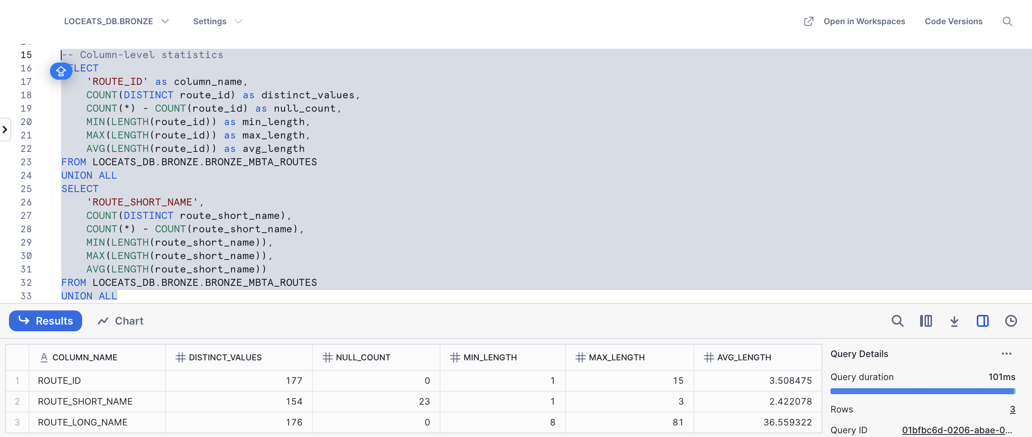

ROUTE_ID: Complete with no NULLs. Length varies from 1 to 15 characters, suggesting mixed formats (single digit for main lines like "1" for Red Line, longer codes for bus routes).
ROUTE_SHORT_NAME: 23 NULL values (13% missing). Contains short codes (1-3 characters) used for display purposes. The 154 distinct values vs 177 routes indicate some routes share the same short name.
ROUTE_LONG_NAME: Complete with no NULLs. Contains full descriptive names ranging from 8 to 81 characters.
Data Quality Assessment: The routes table is well-structured with minimal data quality issues. The 23 NULL values in ROUTE_SHORT_NAME likely represent routes that don't have abbreviated codes (possibly commuter rail or special services). No transformations required for this reference table.

MBTA Routes NULL/Empty Value Analysis:
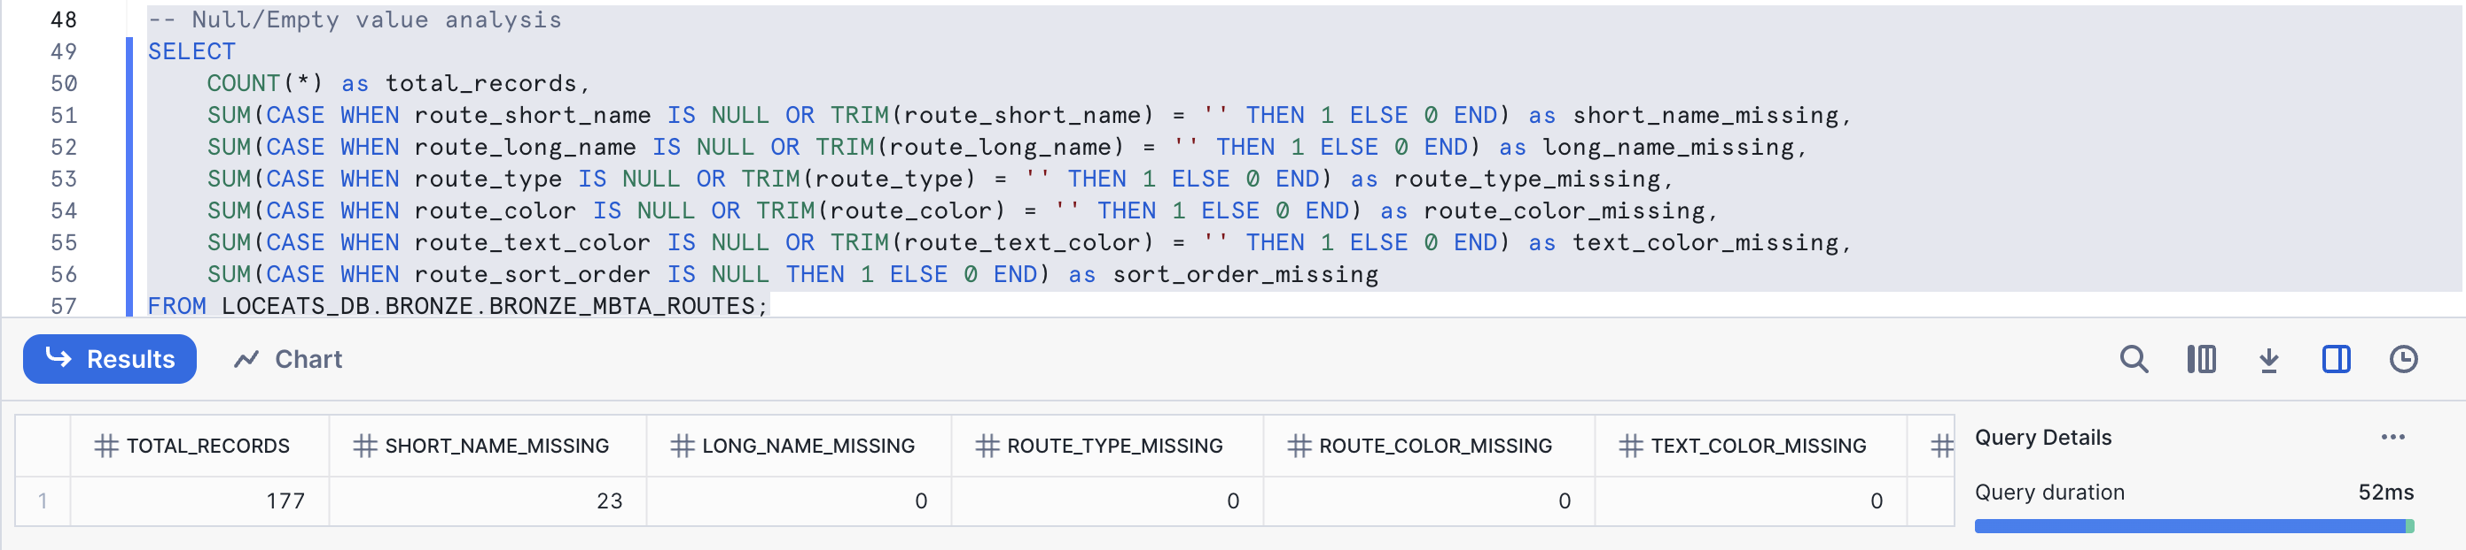
Completeness Summary:
Field | Total Records | Missing | Count Missing %
ROUTE_SHORT_NAME | 177 | 23 | 13.0%
ROUTE_LONG_NAME | 177 | 0 | 0.0%
ROUTE_TYPE | 177 | 0 | 0.0%
ROUTE_COLOR | 177 | 0 | 0.0%
ROUTE_TEXT_COLOR | 177 | 0 | 0.0%
ROUTE_SORT_ORDER | 177 | 0 | 0.0%

Only ROUTE_SHORT_NAME has missing values (23 records). All other fields are 100% complete.

MBTA STOPS
The table contains records of public transportation stops, specifically MBTA stops. Each record includes details about the stop's location, accessibility, and relationship to other stops.
MBTA Stops Dataset Overview:
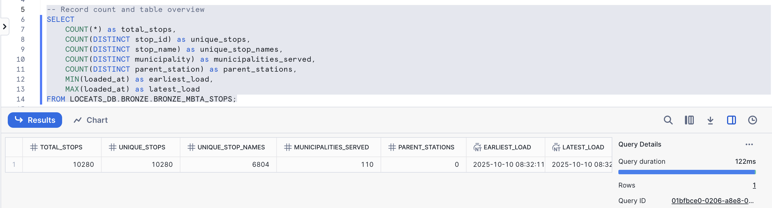

Dataset Statistics:
- Total Stops: 10,280
- Unique Stops: 10,280 (no duplicates)
- Unique Stop Names: 8,804 (some stops share names)
- Municipalities Served: 110
The difference between unique stops (10,280) and unique stop names (8,804) indicates multiple platforms or entrances for the same station (e.g., "Park Street - Inbound" vs "Park Street - Outbound"). The presence of 0 parent stations suggests this table contains the most granular level of stop data, with each platform and bus stop represented individually. Ready for geographic distance calculations with restaurant locations.
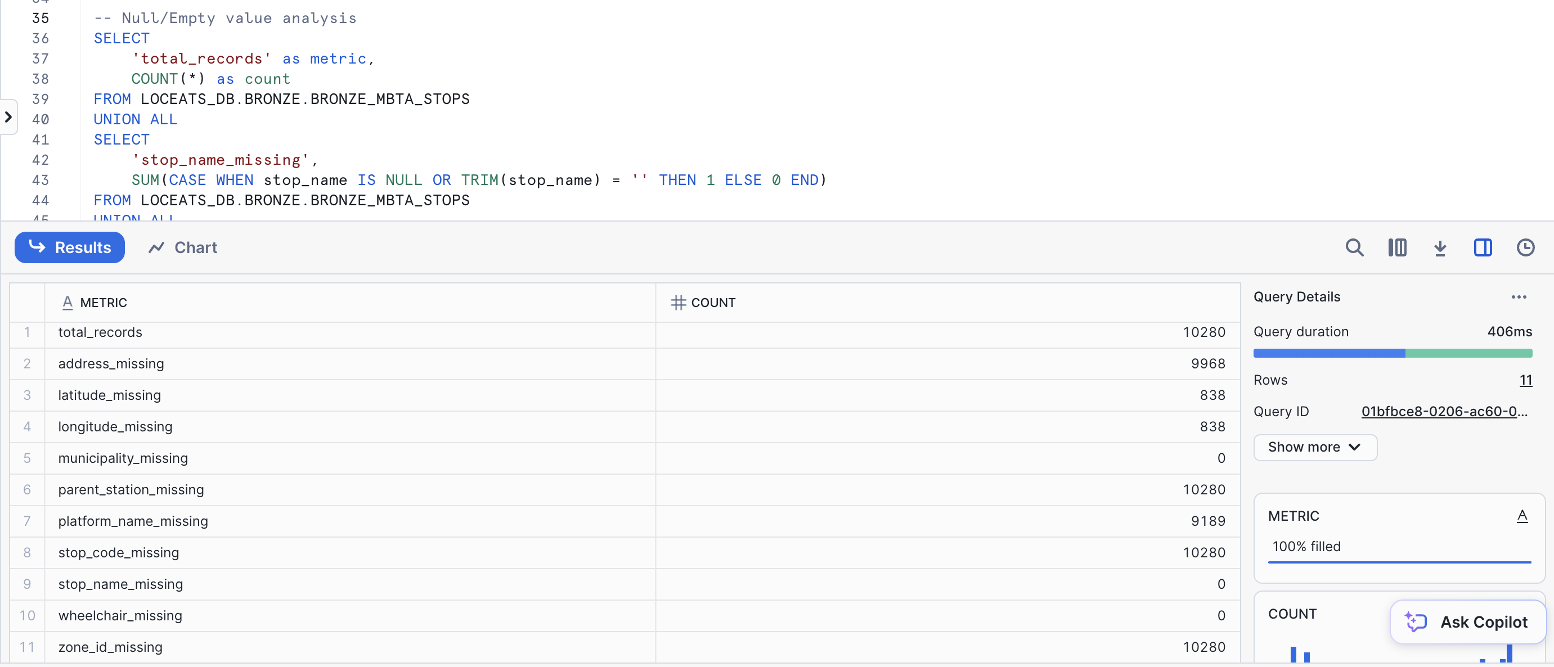
Field | Total Records | Missing Count | Missing %
stop_name | 10,280 | 0 | 0.0%
stop_code | 10,280 | 10,280 | 100.0%
latitude | 10,280 | 838 | 8.2%
longitude | 10,280 | 838 | 8.2%
address | 10,280 | 9,968 | 97.0%
municipality | 10,280 | 0 | 0.0%
platform_name | 10,280 | 9,189 | 89.4%
parent_station | 10,280 | 10,280 | 100.0%
wheelchair_boarding | 10,280 | 0 | 0.0%
zone_id | 10,280 | 10,280 | 100.0%

1. Missing Coordinates: 838 stops (8.2%) lack latitude/longitude data, preventing geographic distance calculations with restaurants.
2. Address Data: 9,968 stops (97%) missing street addresses - not critical since coordinates are more important for distance calculations.
3. Unused Fields: stop_code, parent_station, and zone_id are 100% NULL - these fields can be excluded from transformations.
4. Platform Names: 89% missing - likely only populated for major stations with multiple platforms.

MBTA Stops Coordinate Validation:
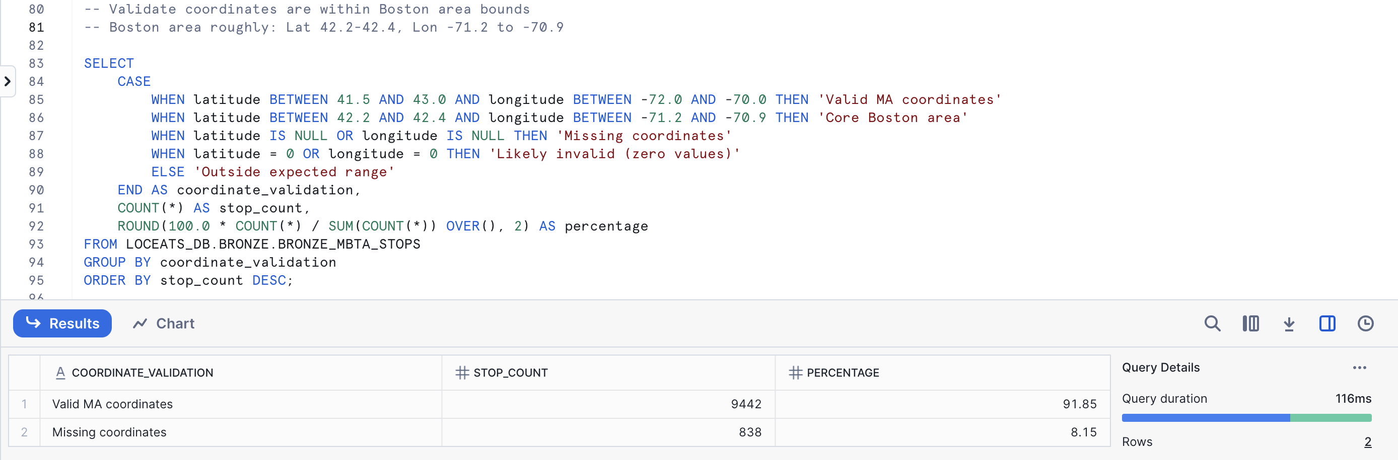
Valid Coordinates: 9,442 stops (91.85%) have valid latitude/longitude values within Massachusetts boundaries (Lat: 42.2-42.4, Lon: -71.2 to -70.9).
Missing Coordinates: 838 stops (8.15%) lack coordinate data, consistent with the NULL analysis.
MBTA Stops Duplicate Name Analysis:
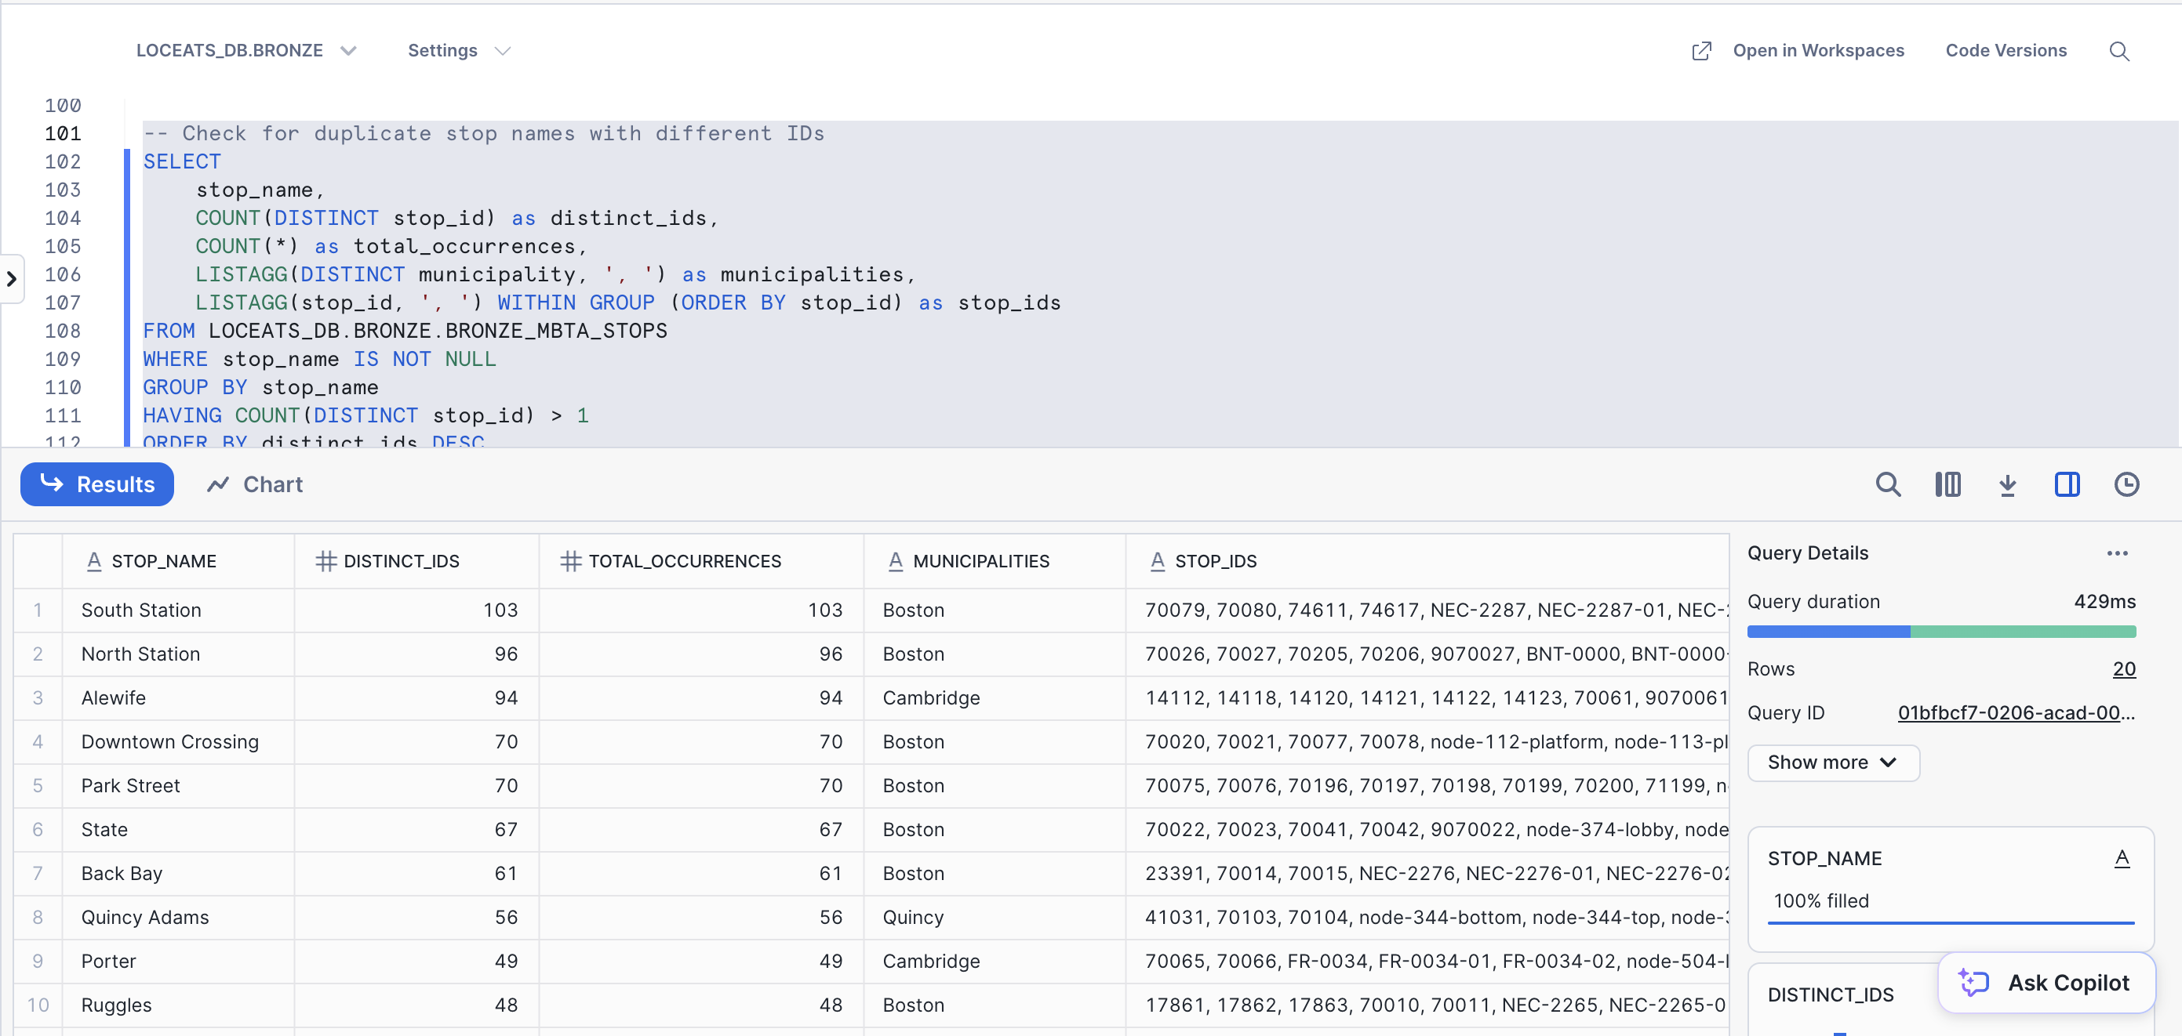

Large stations like South Station (103 IDs) and North Station (96 IDs) have numerous stop IDs representing, Different platforms (Red Line, Silver Line, Commuter Rail), Multiple bus stops around the station, Separate entries/exits and Different service directions (inbound/outbound).

