**Git&GitHub**

**Introduction:**

* Git is an open source distributed version control system or source code management system which is used to manage the different versions of source code while creating.
* We are having two types of version control systems
  + Centralized version control system
  + Distributed version control system
* In Centralized version control system you will be having a centralized system repository where all the users’ changes will be committed when they had made any changes in the code or file.
* If there are any connectivity issues or if the centralized system repository has crashed suddenly, then no user can access the repository to know the changes of the source code.

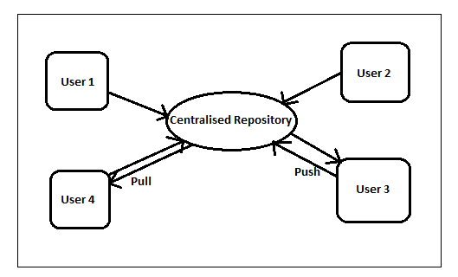

* To overcome the above issue they had come up with ‘Subversion’ and later ‘Distributed version system’.
* In Distributed version system you will be having a Centralized Repository System as well as Local Repository, where your code will be stored in the local repository as well.
* By the use of Local repository you can track the changes of the source code which is in sync with centralized repository. 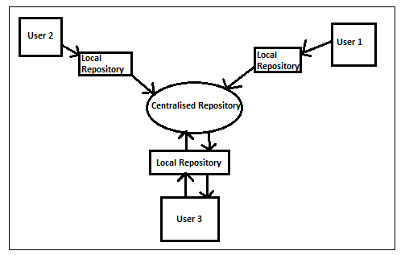

**Features of Git:-**

* Track changes in a file
* Manage source
* Versioning and branching
* Compare code
* Merge branch
* Compare branches

**Git Installation:**

* Download Git from any of the browser based on the operating system you are using, after downloading ‘git’ run the .exe file and install.
* Before going to install git in your local machine you can check git installed on your local machine or not by using the command ‘git –version’ so that it will let you know the version of git using and whether it is installed or not.
* After installation you can run git through our windows local command prompt or from git bash directory based upon the requirement.
* Later from the root directory launch command prompt and execute command ‘git init’ so that it will create a .git file in the directory.
* Execute the below commands in git bash to configure your username and mail-id to git hub account.
  + git config –global user.email “email-id”
  + git config –global user.name “username”
* You can add or update any changes in the directory through the git bash commands.
  + git status (To know the changes of any file when uploaded or committed)
  + git add . (Adds the file to the repository)
  + git add <file name> (Which adds the specific file based on name)
  + git commit –m “Message to be displayed” (Commits the file to repository and changes the status from untracked)

**Git & Git Hub Integration:**

* Go to browser and create git hub account using valid mail id, later create a repository with public type and get the URL of the repository.
* Link your git local and git hub cloud repository by using the commands ‘git remote add origin <git hub cloud repository path>’
* Once the cloud source URL is configured we can push the local data to the cloud repository using the below commands ‘git push –u origin master’ so that all your local files will be moved to cloud repository.