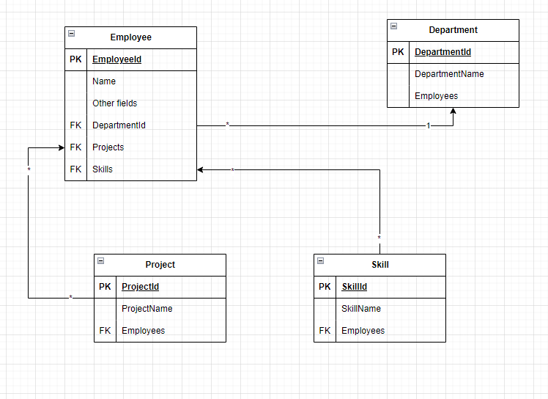

ER Diagram: As you can see< database consist of 4 tables where the main table is employee, it has fk from 3 other tables and used 2 types of relationship model, one to many and many to many. Connections type is revealed on diagram

WebApi: Web api application has crud functionality for all entities without extra operational functions. Used repository pattern and migration for auto generating database tables.