CHAPTER – 1
ABSTRACT

FlowBoard is an intelligent project dashboard designed to enhance team collaboration, task tracking, and workflow management in modern development environments. In today’s fast-paced digital workspace, teams often struggle with fragmented communication, unclear task ownership, and inefficient progress monitoring. FlowBoard addresses these challenges by providing a centralized, interactive platform where team members can plan, assign, and monitor project activities in real time.
The system integrates role-based access, enabling administrators, team leads, and members to view customized dashboards based on their responsibilities. It supports task assignment, status updates, deadline tracking, and visual progress indicators to ensure transparency across all project stages. Additionally, FlowBoard incorporates notification alerts and progress analytics to help teams identify bottlenecks and improve productivity.
Built with a user-friendly interface and scalable architecture, FlowBoard ensures seamless collaboration across distributed teams. By combining intuitive design with intelligent tracking features, it simplifies project management and enhances coordination. Ultimately, FlowBoard aims to improve efficiency, accountability, and teamwork, making it a comprehensive solution for academic projects, software development teams, and organizational workflows.

CHAPTER – 2

INTRODUCTION

2.1 Background and Motivation
In today’s academic and industrial environments, teamwork and collaboration are essential for successfully completing projects. Most projects involve multiple members working on different modules, which requires proper coordination, clear task allocation, and continuous progress tracking. However, many teams still rely on traditional methods such as WhatsApp messages, spreadsheets, or basic to-do lists to manage their work. These methods often lead to confusion, missed deadlines, duplicated work, and lack of transparency among team members.
With the increasing complexity of projects, there is a strong need for a centralized and intelligent system that can bring all project-related activities into a single platform. FlowBoard is designed to address this need by providing a smart project dashboard that improves communication, organization, and productivity. The motivation behind this project is to simplify teamwork by offering real-time updates, structured task management, and visual progress tracking. It helps teams stay aligned with project goals and reduces manual coordination efforts. By integrating all essential project management features into one system, FlowBoard enhances efficiency and ensures smoother collaboration among team members in academic as well as real-world project environments.

2.2 Problem Statement
In many educational institutions and small development teams, managing projects effectively remains a major challenge. Existing tools and methods used for project tracking are often fragmented, non-intuitive, or lack real-time collaboration features. Teams usually depend on separate applications for communication, task management, and file sharing, which creates inconsistency and confusion. As a result, project updates are not properly synchronized, leading to delays, miscommunication, and reduced productivity.
There is also a lack of centralized systems that provide a clear overview of project progress, task ownership, and deadlines in a simple and visual format. Many existing project management tools are either too complex for beginners or too limited in features for proper collaboration. This creates a gap between user requirements and available solutions.
Therefore, the problem is to design and develop an intelligent project dashboard system that integrates task assignment, progress tracking, and team collaboration into a single platform. The system should be user-friendly, support role-based access, and provide real-time updates so that all team members can stay informed and aligned with project objectives effectively.

2.3 Objectives
The primary objective of the FlowBoard project is to develop an intelligent and user-friendly project dashboard that enhances team collaboration and improves project management efficiency. The system aims to provide a centralized platform where all project activities can be managed effectively. One of the key objectives is to enable easy task creation, assignment, and tracking so that every team member clearly understands their responsibilities.
Another important objective is to provide real-time progress updates, allowing team leads and members to monitor the status of tasks without delay. FlowBoard also aims to implement role-based access control, ensuring that different users such as administrators, team leads, and members have appropriate permissions based on their roles.
Additionally, the system focuses on improving communication within teams by reducing dependency on external tools. It also aims to provide visual dashboards that represent project progress in an intuitive manner. Another objective is to increase productivity by reducing confusion, avoiding duplication of work, and ensuring better coordination. Ultimately, FlowBoard is designed to make project management simpler, faster, and more organized for academic and professional teams.

2.4 Scope (Current and Future)
The current scope of the FlowBoard project includes the development of a functional project management dashboard that supports essential features such as user authentication, task creation, task assignment, status updates, and progress tracking. The system allows team members to log in based on their roles and view relevant project information. It also provides a structured interface for monitoring ongoing tasks and overall project progress in a simplified manner.
At present, FlowBoard focuses on improving collaboration within small to medium-sized teams, especially for academic projects and basic software development workflows. The interface is designed to be simple, responsive, and easy to use for all users.
In terms of future scope, FlowBoard can be expanded with advanced features such as AI-based task prioritization, automated deadline reminders, real-time chat integration, file sharing systems, and detailed analytics dashboards. It can also be enhanced to support mobile applications for better accessibility. Furthermore, integration with cloud storage and third-party tools like GitHub or Google Drive can significantly improve its functionality. In the long term, FlowBoard has the potential to evolve into a full-scale enterprise project management system capable of handling large distributed teams and complex workflows efficiently.

CHAPTER – 3
REQUIREMENT ANALYSIS
FlowBoard is designed as an intelligent project dashboard that supports team collaboration, task management, and real-time progress tracking. The system aims to centralize all project activities into a single platform, ensuring smooth communication, better organization, and improved productivity among team members.

3.1 Functional Requirements (Major User-Level Features)
The functional requirements define what the system should do:
- User registration and login (Admin, Team Lead, Member roles)
- Role-based dashboard access for different users
- Create, assign, update, and delete tasks
- View task status (To Do, In Progress, Completed)
- Real-time project progress tracking
- Display team-wise and project-wise dashboards
- Notifications for task assignment and deadline updates
- View overall project summary and progress analytics
- Allow team leads to monitor and manage team performance
- Enable members to update their task status

3.2 Non-Functional Requirements
These define the quality and performance aspects of the system:
- Performance: The system should respond quickly with minimal delay while loading dashboards and updating tasks.
- Scalability: It should support multiple projects and increasing number of users without performance degradation.
- Security: Secure authentication and authorization to protect user data and restrict access based on roles.
- Usability: Simple and intuitive interface so users can easily navigate and manage tasks.
- Reliability: System should maintain data consistency and avoid loss of task or project information.
- Availability: The dashboard should be accessible anytime with minimal downtime.
- Maintainability: Easy to update, modify, and extend new features in the future.

3.3 Use Case Diagram / User Stories

Use Case Overview
FlowBoard consists of three main actors:
- Admin
- Team Lead
- Member

Key Use Cases:
- Admin manages users and projects
- Team Lead assigns tasks and monitors progress
- Member views assigned tasks and updates status
- All users can view dashboards and notifications

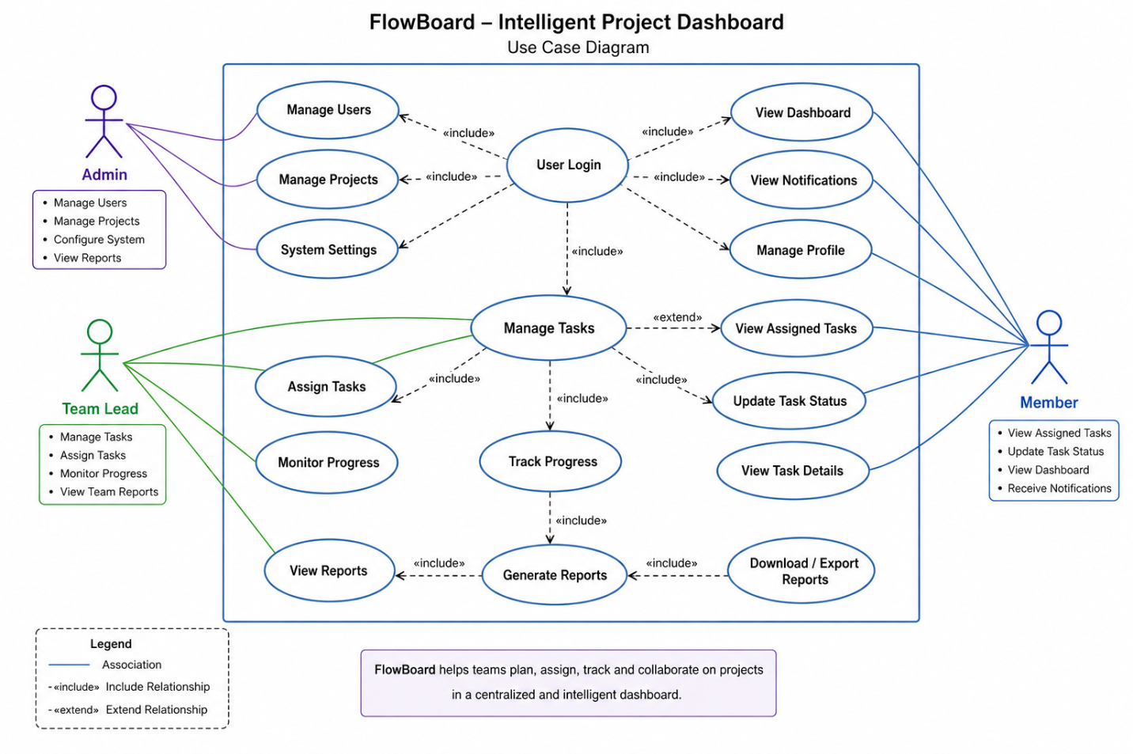

User Stories
- As an Admin, I want to manage users and projects so that the system is organized.
- As a Team Lead, I want to assign tasks to members so that work is distributed properly.
- As a Team Lead, I want to monitor project progress so that I can ensure deadlines are met.
- As a Member, I want to view my assigned tasks so that I know what to work on.
- As a Member, I want to update task status so that progress is visible to the team.
- As a User, I want to receive notifications so that I don’t miss important updates.
- As a User, I want to view dashboards so that I can understand project progress clearly.

CHAPTER – 4
. DESIGN PHASE
4.1 System Architecture
The FlowBoard system follows a client–server architecture where the frontend interacts with the backend through APIs, and the backend manages business logic and database operations.

Explanation
- Frontend (UI Layer):
Built using web technologies (React / HTML / CSS / JS). It provides dashboards for Admin, Team Lead, and Members.
- Backend (Application Layer):
Handles authentication, task management, role-based access, notifications, and business logic.
- Database Layer:
Stores user data, tasks, projects, progress status, and reports.
- Interaction Flow:
User → Frontend → API Calls → Backend → Database → Response → Frontend UI Update
This architecture ensures scalability, modularity, and easy maintenance.

4.2 Module Description
FlowBoard is divided into several key modules:

1. User Management Module
- Handles registration, login, and role-based access
- Roles: Admin, Team Lead, Member
- Status: Completed / In Progress (based on your implementation)

2. Project Management Module
- Create and manage projects
- Assign team members to projects
- Status: In Progress

3. Task Management Module
- Create, assign, update, and delete tasks
- Track task status (To Do, In Progress, Completed)
- Status: In Progress

4. Dashboard Module
- Displays project overview and progress analytics
- Role-based dashboards
- Status: Completed (UI phase)

5. Notification Module
- Sends alerts for task assignment and deadlines
- Status: Not Started / Planned

6. Reporting Module
- Generates progress reports and performance insights
- Status: Not Started

4.3 Database / Data Design

Key Entities
- User
  - user_id, name, email, password, role
- Project
  - project_id, project_name, description, deadline
- Task
  - task_id, title, description, status, assigned_to
- Team
  - team_id, project_id, members

Relationships
- One Admin manages multiple Projects
- One Project has multiple Tasks
- One Team Lead assigns tasks to Members
- Each Member can have multiple tasks
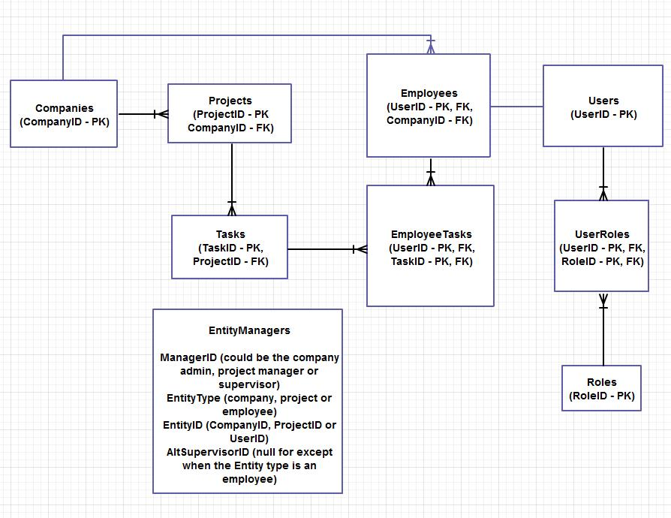
.

4.4 UI/UX Design
FlowBoard UI is designed to be simple, responsive, and user-friendly, focusing on ease of navigation and clarity.

Key UI Features
- Clean dashboard with cards for projects and tasks
- Sidebar navigation (Dashboard, Tasks, Projects, Reports)
- Role-based UI visibility
- Color-coded task status indicators
- Progress bars for project completion
- Responsive design for desktop and mobile

UX Highlights
- Easy navigation with minimal clicks
- Clear task visibility for each user role
- Real-time updates for better collaboration
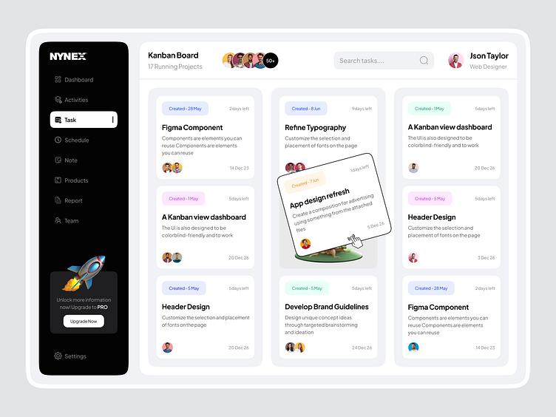
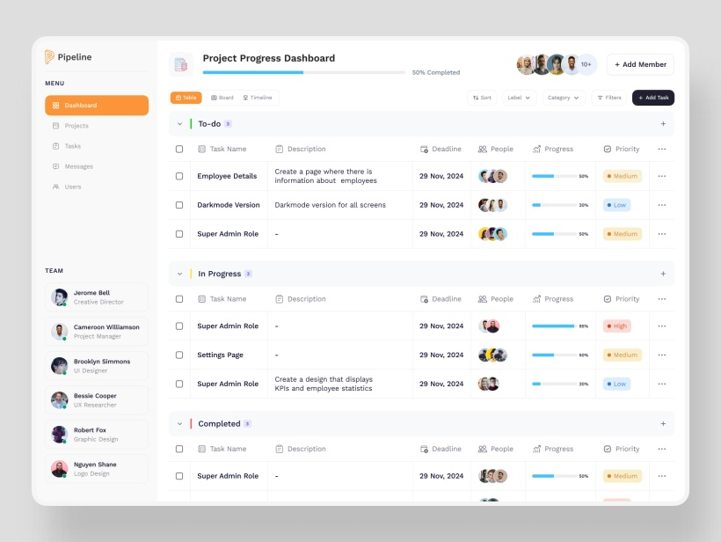
- Simple layout to reduce complexity for users
CHAPTER – 5
DESIGN PHASE

The implementation of the FlowBoard – Intelligent Project Dashboard for Team Collaboration has reached a significant mid-point stage, with several core components successfully developed and integrated. The project development began with the selection and setup of appropriate technologies that align with scalability, performance, and ease of collaboration. The chosen technology stack includes Django for backend development, React/Next.js for the frontend interface, and MongoDB as the database system. Django was selected for its robust backend capabilities and secure authentication system, while React/Next.js provides a dynamic and responsive user interface suitable for real-time dashboard updates. MongoDB was integrated due to its flexibility in handling unstructured project and task-related data. The development environment has been fully configured, and all required dependencies, including REST framework libraries, authentication packages, and UI component libraries, have been installed and tested successfully to ensure smooth development flow.
In terms of version control and repository management, a centralized GitHub repository has been created for the project to ensure structured collaboration among team members. The repository follows a well-defined branching strategy, including main, development, and feature-specific branches, which helps in maintaining code stability and organized workflow. Each module is developed in separate feature branches and later merged after proper review. Frequent commits are maintained with meaningful messages to track progress and changes effectively. This approach ensures transparency, easier debugging, and efficient team coordination during development.
Several core modules of the system have already been implemented at this stage. The User Authentication Module has been completed, allowing secure login and registration functionality for different user roles such as admin and team members. The Project Creation Module has also been developed, enabling administrators to create and manage multiple projects within the system. Additionally, the Task Assignment Interface is partially completed, allowing tasks to be assigned to team members with deadlines and status tracking features. The Member Dashboard interface has been designed and implemented with basic functionality, where users can view their assigned projects and tasks. Although some features are still in development, the foundational structure of all major modules has been successfully established.
On the frontend side, significant progress has been made in designing the user interface and user experience. The dashboard layouts for both admin and team member views have been created using React components. The interface includes structured sections such as project overview cards, task tables, navigation menus, and status indicators. Initial static data has been used to test the layout and responsiveness of the system. The UI is designed to be clean, intuitive, and user-friendly, ensuring smooth navigation and efficient task management for users. Future updates will include dynamic data rendering and real-time updates using API integration.
Regarding backend development and integration, initial REST APIs have been successfully developed and connected to the frontend. APIs for user authentication, project creation, task assignment, and task retrieval are functional and tested. These APIs interact with MongoDB to store and retrieve data efficiently. Basic CRUD (Create, Read, Update, Delete) operations have been implemented, allowing smooth handling of project-related data. The backend is designed to support scalability and future enhancements such as notifications, analytics, and real-time collaboration features.
The implementation progress of FlowBoard is on track, with major foundational components completed and integrated. The system is gradually evolving into a fully functional intelligent project management dashboard, with ongoing development focused on enhancing interactivity, real-time collaboration, and advanced analytics features.

CHAPTER – 6
TESTING AND VALIDATION

The testing and validation phase of the FlowBoard project was conducted systematically to ensure that all developed modules function correctly and meet the expected performance requirements. At this mid-point stage, both functional and interface-level testing were performed across the implemented components, including user authentication, project management, task assignment, and dashboard visualization. The primary objective of this phase was to verify system stability, data accuracy, responsiveness, and overall user experience under different usage conditions.
In Feature Tested 1, the User Authentication Module (Login/Signup System) was evaluated. The sub-tasks included user registration, login validation, and role-based access control for admin and team members. The findings showed that authentication was working successfully with proper validation for correct and incorrect credentials. Session handling and access restriction based on user roles were functioning as expected. The system correctly redirected users to their respective dashboards after login. The performance was stable with no major errors observed, and the status of this feature was marked as Completed.
In Feature Tested 2, the Project Creation and Task Assignment Module was tested. The sub-tasks included creating new projects, assigning tasks to team members, setting deadlines, and updating task status. The observations indicated that project creation was smooth and data was being stored correctly in the MongoDB database. Task assignment functionality worked as intended, and updates were reflected in the member dashboard. However, minor delays were noticed when multiple tasks were loaded simultaneously, indicating the need for optimization in data fetching. Despite this, the feature was considered functionally stable and marked as Completed.
During the testing phase, several important findings were identified. The system demonstrated good responsiveness in most scenarios, but certain UI elements showed slight lag when handling large datasets. The dashboard layout performed well on standard screen sizes, but minor alignment issues were observed on smaller screens, indicating the need for improved responsiveness. API responses were generally fast, but optimization is required for bulk data retrieval operations. Overall, the system showed strong functional integrity but requires enhancements in performance tuning and UI responsiveness.
A few critical issues/blockers were identified during validation. The first issue was inconsistent rendering of task updates when multiple users accessed the system simultaneously, suggesting the need for better state management or real-time synchronization. The second issue was related to delayed API response under heavy data load conditions. Additionally, some UI components lacked dynamic updates, requiring page refresh for updated data visibility.
To address these issues, several design adjustments have been proposed. The implementation of real-time data updates using WebSockets or polling mechanisms is recommended to resolve synchronization problems. Backend query optimization and indexing in MongoDB will help improve performance under large data loads. On the frontend side, adopting state management tools such as Redux or Context API will enhance dynamic UI updates. Furthermore, responsive design improvements using flexible grid layouts and media queries will ensure better usability across devices.

6. Work Plan and Timeline
The next phase of development will focus on improving system performance, implementing real-time collaboration features, and enhancing UI responsiveness. In the upcoming weeks, priority will be given to integrating notification systems, refining dashboard analytics, and completing pending task management features. After stabilization, final testing, bug fixing, and deployment preparation will be carried out to ensure a fully functional and optimized version of FlowBoard.

CHAPTER – 7
CHALLENGES AND RISK MANAGEMENT

During the development of FlowBoard, several challenges were encountered across technical, conceptual, and coordination aspects. These challenges are common in full-stack collaborative systems and provided valuable learning opportunities for improving system design, integration, and teamwork efficiency. Identifying these issues early has helped in planning effective mitigation strategies to ensure smooth progress in the remaining development phases.
Challenge 1: Integration of Backend APIs with Frontend Dashboard
One of the primary difficulties faced was integrating the Django REST APIs with the React/Next.js frontend. While individual components were functioning correctly, syncing real-time data between the frontend and backend initially caused inconsistencies in task updates and project rendering. This was mainly due to improper state handling and asynchronous data fetching issues.
Mitigation:
To resolve this, the API structure was reviewed and standardized using RESTful conventions. Axios was used for consistent API calls, and proper error handling mechanisms were introduced. Additionally, frontend state management was improved using structured data flow practices, ensuring smoother synchronization between backend responses and UI updates.
Challenge 2: Database Performance and Data Handling with MongoDB
As the number of projects and tasks increased during testing, performance issues were observed in data retrieval, especially when loading dashboards with multiple collections. Queries became slower, and occasional delays were noticed in rendering large datasets.
Mitigation:
To address this, indexing strategies were introduced in MongoDB for frequently accessed fields such as project ID, user ID, and task status. Query optimization techniques were applied, and unnecessary nested queries were reduced. In future development, pagination and lazy loading will be implemented to further improve performance and scalability.
Challenge 3: UI Responsiveness and Layout Consistency
Another challenge was maintaining consistent UI behavior across different screen sizes and devices. Some dashboard components did not align properly on smaller screens, affecting user experience and readability.
Mitigation:
This issue was addressed by refining the CSS structure using responsive design principles. Flexbox and grid layouts were optimized, and media queries were added to ensure adaptability across screen sizes. Future enhancements will include a fully mobile-first design approach to improve accessibility.
Challenge 4: Team Coordination and Version Control Conflicts
Since multiple developers were working on different modules simultaneously, occasional Git merge conflicts occurred, especially when integrating frontend and backend updates.
Mitigation:
A structured branching strategy (feature-based branching) was strictly enforced. Regular code reviews and scheduled merges were introduced to reduce conflicts. Clear commit messages and documentation practices were also implemented to improve coordination among team members.
The most significant learning from this phase of development is the importance of system integration planning before implementation. While individual modules were successfully developed, ensuring smooth interaction between frontend, backend, and database required careful architectural planning. Additionally, the project highlighted the importance of state management, API standardization, and scalable database design. From a team perspective, adopting disciplined version control practices and clear communication significantly improved collaboration efficiency. Overall, these experiences have strengthened both technical understanding and real-world software development skills, especially in building scalable full-stack applications like FlowBoard.
CHAPTER – 8
REFERENCES

IEEE Format References
[1] Django Software Foundation, Django Documentation, 2026. [Online]. Available: https://docs.djangoproject.com/
[2] Meta Platforms, Inc., React Documentation, 2026. [Online]. Available: https://react.dev/
[3] Next.js Contributors, Next.js Documentation, 2026. [Online]. Available: https://nextjs.org/docs
[4] MongoDB Inc., MongoDB Manual, 2026. [Online]. Available: https://www.mongodb.com/docs/
[5] Axios Team, Axios HTTP Client Documentation, 2026. [Online]. Available: https://axios-http.com/docs/intro
[6] Git SCM, Git Documentation, 2026. [Online]. Available: https://git-scm.com/doc
[7] GitHub Inc., GitHub Docs – Version Control and Collaboration, 2026. [Online]. Available: https://docs.github.com/
[8] Mozilla Foundation, MDN Web Docs (JavaScript, HTML, CSS Reference), 2026. [Online]. Available: https://developer.mozilla.org/

APA Style References
Django Software Foundation. (2026). Django Documentation. Retrieved from https://docs.djangoproject.com/
Meta Platforms, Inc. (2026). React Documentation. Retrieved from https://react.dev/
Vercel Inc. (2026). Next.js Documentation. Retrieved from https://nextjs.org/docs
MongoDB Inc. (2026). MongoDB Manual. Retrieved from https://www.mongodb.com/docs/
Git SCM. (2026). Git Documentation. Retrieved from https://git-scm.com/doc
GitHub Inc. (2026). GitHub Documentation. Retrieved from https://docs.github.com/
Mozilla Foundation. (2026). MDN Web Docs. Retrieved from https://developer.mozilla.org/

CHAPTER – 9
APPENDIX
The appendix section includes supporting materials that complement the main project documentation of FlowBoard. These materials provide additional technical details, design references, and development resources that were used during the implementation phase. They help in understanding the system more deeply and serve as reference for future enhancements and maintenance.

1. Source Code Repository Link
The complete source code of the FlowBoard project is maintained in a Git-based version control system for collaboration and tracking changes. The repository includes backend, frontend, and configuration files.
GitHub Repository:
https://github.com/your-username/flowboard-project (replace with actual link)
The repository is organized into multiple branches:
- main – Stable production-ready code
- development – Ongoing integration of features
- feature/* – Individual module development branches

2. UI/UX Wireframes and Design Mockups
The UI/UX design phase includes wireframes for both Admin and Team Member dashboards. These wireframes represent the layout structure before final implementation.
Key screens designed:
- Login / Signup Page
- Admin Dashboard (Project Overview, Task Assignment Panel)
- Member Dashboard (Assigned Tasks, Status Updates)
- Project Creation Screen
- Task Tracking Interface
Wireframes were created using tools such as Figma / Adobe XD (or manually sketched prototypes). The design focuses on simplicity, clarity, and ease of navigation for users managing multiple projects.

3. Extended System Diagrams
Additional diagrams were prepared to support system understanding:
- System Architecture Diagram (Frontend–Backend–Database flow)
- Use Case Diagram (Admin vs Member interactions)
- Data Flow Diagram (DFD) showing project and task lifecycle
- ER Diagram (MongoDB Schema Representation)
These diagrams illustrate how data moves between modules and how users interact with the system.

4. Raw Data Samples (Testing Data)
For testing purposes, sample datasets were used to validate system functionality:
- Sample user accounts (Admin and Members)
- Sample projects with deadlines and priorities
- Task records with status values (To Do, In Progress, Completed)
This data helped in verifying CRUD operations and dashboard rendering accuracy.

5. API Testing Data (Postman Collection)
API endpoints were tested using Postman with structured requests:
- /api/login – User authentication
- /api/register – New user creation
- /api/projects – Project management
- /api/tasks – Task assignment and updates
Test cases confirmed proper response handling, validation, and database integration.

The appendix provides all supplementary resources required to understand the FlowBoard system in detail. These materials ensure transparency in development, support reproducibility, and assist in future enhancements of the project.

