

TIMER CAPSULE MESSENGER

INTERNSHIP REPORT

Submitted By

SANDHYA M | (2301225)

CENSOWARE TECHNOLOGIES LLP, COIMBATORE

in partial fulfillment for the award of the degree of
BACHELOR OF ENGINEERING
in

COMPUTER SCIENCE AND ENGINEERING

SRI RAMAKRISHNA ENGINEERING COLLEGE
[Educational Service: SNR Sons Charitable Trust]
VATTAMALAIPALAYAM, N.G.G.O. COLONY POST,
COIMBATORE – 641 022.

January 2026

ANNA UNIVERSITY::CHENNAI 600 025

BONAFIDE CERTIFICATE

This is to certify that the Internship Training Report entitled “Timer Capsule Messenger” is a record of SANDHYA M (2301225) who carried out the internship training work under my supervision.

SIGNATURE SIGNATURE
Dr.R. Kingsy Grace, Dr.M.S. Geetha Devasena,
ACADEMIC COORDINATOR, HEAD OF THE DEPARTMENT,
Professor, Professor and Head,
Department of CSE, Department of CSE,
Sri Ramakrishna Engineering College, Sri Ramakrishna Engineering College, Vattamalaipalayam, Vattamalaipalayam,
N.G.G.O.Colony Post, N.G.G.O.Colony Post,
Coimbatore - 641 022. Coimbatore - 641 022.

Faculty In-charge Signature of the Evaluator

Place: Coimbatore Date:

ACKNOWLEDGMENT

We put forth our hearts and souls to thank the almighty for being with us through our achievements and success. We would like to express our unfathomable thanks to our esteemed and Honorable Managing Trustee Dr.R.Sundar and Sri S. Narendran, Joint Managing Trustee for giving us the chance to be a part of this elite team at Sri Ramakrishna Engineering College, Coimbatore.

We would like to express our sincere thanks to our honorable Principal, Dr.A.Soundarrajan for the facilities provided to complete this training.

We take the privilege to thank the Professor and Head of the Department of Computer science and engineering, Dr. M. S. Geetha Devasena for her consistent support and encouragement at every step of our Internship work.

We wish to convey our special thanks to our Academic Coordinator Dr. R. Kingsy Grace, Professor and Internship Coordinator Mr. G. Narendran, Assistant Professor (SL. Grade), Department of Computer Science and Engineering for their consistent support, timely help and valuable suggestions during the entire period of our Internship work.
We would like to express our sincere thanks to Mr.Pushparaj Ranganathan, CEO & founder of Censoware Technologies LLP,Coimbatore for their valuable support for the completion of this Internship work.

We extend our sincere gratitude to all the teaching and non-teaching staff members of our department who helped us during our internship.
 | TABLE OF CONTENTS
CHAPTER NO. | TITLE | PAGE NO.
 | ACKNOWLEDGEMENT | i
 | INTRODUCTION | ii
1 | OVERVIEW OF THE COMPANY
 | 1.1 Company Profile | 2
2 | ABOUT MY PROJECT | 4
 | 2.1 Project Overview | 5
 | 2.2 Purpose | 6
 | 2.3 Tools And Technologies | 7
3 | COMPONENTS
 | 3.1 Home Page Component | 8
 | 3.2 Login And Sign-Up Component | 9
 | 3.3 Dashboard Component | 9
 | 3.4 Template Management Component | 10
 | 3.5 Capsule Detail Component | 10
 | 3.6 Chat Component | 11
 | 3.7 Profile And Settings Component | 12
 | 3.8 Notification & Scheduling Component | 13
4 | CONCLUSION AND FUTURE SCOPE | 14
5 | LESSONS I HAVE LEARNED | 15
6 | INTERACTION WITH CO-WORKERS | 16
7 | DIFFICULTIES ENCOUNTERED | 17
8 | WEB REFERENCES | 18

INTRODUCTION

During my university education, I acquired theoretical knowledge through lectures, textbooks, and academic resources. While this learning was essential, it provided limited exposure to how concepts are applied in real-world scenarios. An internship plays an important role in bridging this gap by offering practical understanding and exposure to professional practices.
I completed my internship at Censoware LLP, where I was given the opportunity to work on a project titled “Time Capsule Messenger.” The project was carried out through regular discussions and interactions with the staff members and the founder of the organization. These interactions helped me understand project requirements, user needs, and practical considerations involved in developing a real-world application.
Based on the guidance and feedback received, I designed and developed the Time Capsule Messenger project, focusing on features such as scheduled message delivery, templates for different occasions, privacy options, and user-friendly interfaces. This experience allowed me to apply my academic knowledge in a practical manner and improve my understanding of software design and implementation.
The internship at Censoware LLP provided valuable learning through mentorship, discussions, and hands-on project development. It helped me gain confidence, practical insight, and a better understanding of how software projects are conceptualized and executed in a professional environment.

OVERVIEW OF THE ORGANIZATION

Censoware LLP is a web design and development company registered in India, specializing in delivering innovative and high-quality digital solutions for businesses of all sizes. The organization focuses on building visually appealing, responsive, and performance-driven websites that help businesses strengthen their online presence. Censoware LLP offers customized web solutions designed to meet the specific requirements of clients across various domains, ensuring usability, scalability, and professional design standards.
The company provides a complete range of digital services, including custom website development, e-commerce solutions, UI/UX design, search engine optimization, digital marketing, and website maintenance. By adopting modern web technologies and SEO-friendly architectures, Censoware LLP ensures that every project contributes to improved visibility, user engagement, and business growth. The organization emphasizes quality delivery, customer satisfaction, and long-term support.

Office | First Floor, Masakalipalayam Rd, above Kovai palamuthir, Peelamedu, Balan Nagar, Coimbatore, Tamil Nadu 641004
Type of the organization | Web Design and Development Company
Years of Experience | Established Organization (Registered in India)

Nature of business | Censoware LLP provides end-to-end web design, development, and digital solutions, enabling businesses to enhance their digital identity and achieve sustainable online growth.
Business motto URL (website) | “To empower businesses with innovative web solutions and reliable digital services.”  https://censoware.com/
Censoware LLP maintains a positive and professional working environment where creativity, innovation, and learning are encouraged. The organization values collaboration and knowledge sharing, enabling interns and team members to gain practical exposure and industry-relevant experience while working on real-world projects.

ABOUT MY PROJECT

2.1 PROJECT OVERVIEW

The project titled “Time Capsule Messenger” is a web-based application designed to enable users to create, store, and schedule messages that are delivered at a future date and time. The core idea of the project is to combine communication with time-based delivery, allowing users to preserve messages, wishes, and memories for meaningful moments in the future.
The application allows users to create message templates for various occasions such as birthdays, weddings, graduations, festivals, and personal milestones. Users can customize the content, attach media files such as images or videos, choose recipients, and select the mode of delivery. Messages can be scheduled as short-term or long-term capsules depending on the delivery timeline.
The project was developed based on continuous discussions and interactions with the staff members and the founder of Censoware LLP. These conversations helped in understanding real-world requirements, user expectations, and practical design considerations. Based on this guidance, the application structure and features were designed to ensure simplicity, usability, and clarity.
The application was developed using modern web technologies such as HTML, CSS, Bootstrap, and React, following a component-based approach. This project provided practical exposure to web application design, modular development, and real-world project planning, making it a valuable learning experience during the internship.

2.2 PURPOSE
The main purpose of the Time Capsule Messenger project is to bridge communication with time-based delivery. The application is designed to help users send meaningful messages in the future without forgetting important dates. It also aims to provide practical exposure to real-world web application development by applying theoretical knowledge gained during academic studies. The project focuses on usability, structured design, and understanding how modern web applications are built and organized.
2.3 TOOLS AND TECHNOLOGIES
The following tools and technologies were used in the development of the project:
- HTML - For structuring the web pages
- CSS - For styling and layout design
- Bootstrap - For responsive design and UI components
- JavaScript - For basic interactivity
- React - For building reusable components and page navigation
- Visual Studio Code - As the development environment
- Web Browser - For testing and debugging

COMPONENTS

Home Page Component

Login and Sign-Up Component

Dashboard Component

Template Management Component

Capsule Details Component

Chat Component

Profile and Settings Component

Notification and Scheduling Module

3.1 HOME PAGE COMPONENT
The Home Page component serves as the entry point of the application. It provides a brief introduction to the Time Capsule Messenger system and explains its purpose. The page highlights the key features of the application and guides users to begin using the system. It also includes navigation options that redirect users to the dashboard after login.
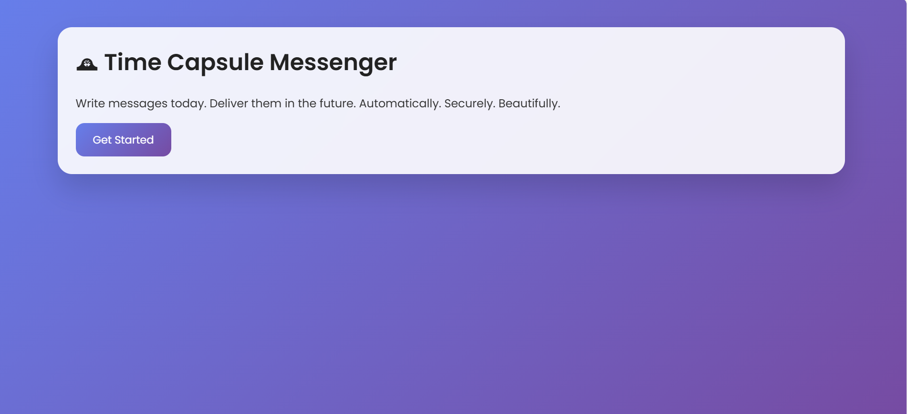
Fig 3.1

3.2 LOGIN AND SIGN-UP COMPONENT
The Login and Sign-Up component allows users to access the application securely. New users can create an account, while existing users can log in using their credentials. This component ensures user authentication and provides controlled access to personal dashboards and capsules.
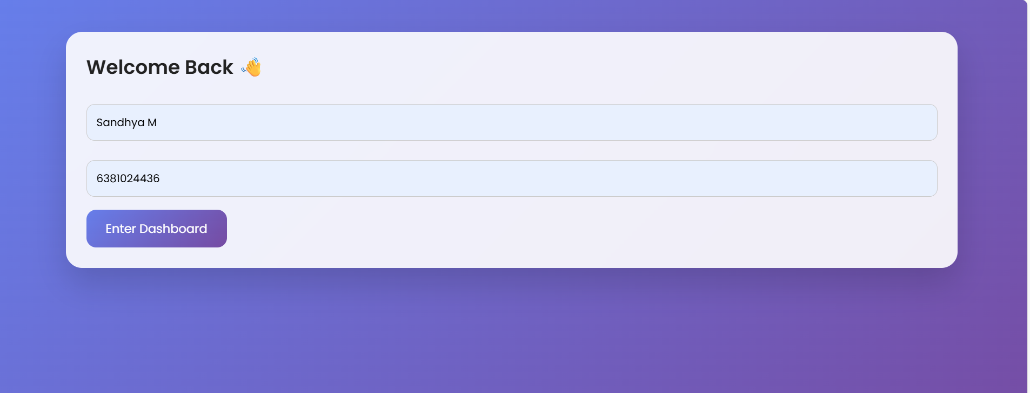
Fig 3.2

3.3 DASHBOARD COMPONENT
The Dashboard component acts as the central hub of the application. It displays available message templates, options to create new templates, and an overview of short-term and long-term capsules. Users can easily navigate to different sections, manage scheduled messages, and access capsule details from this page.
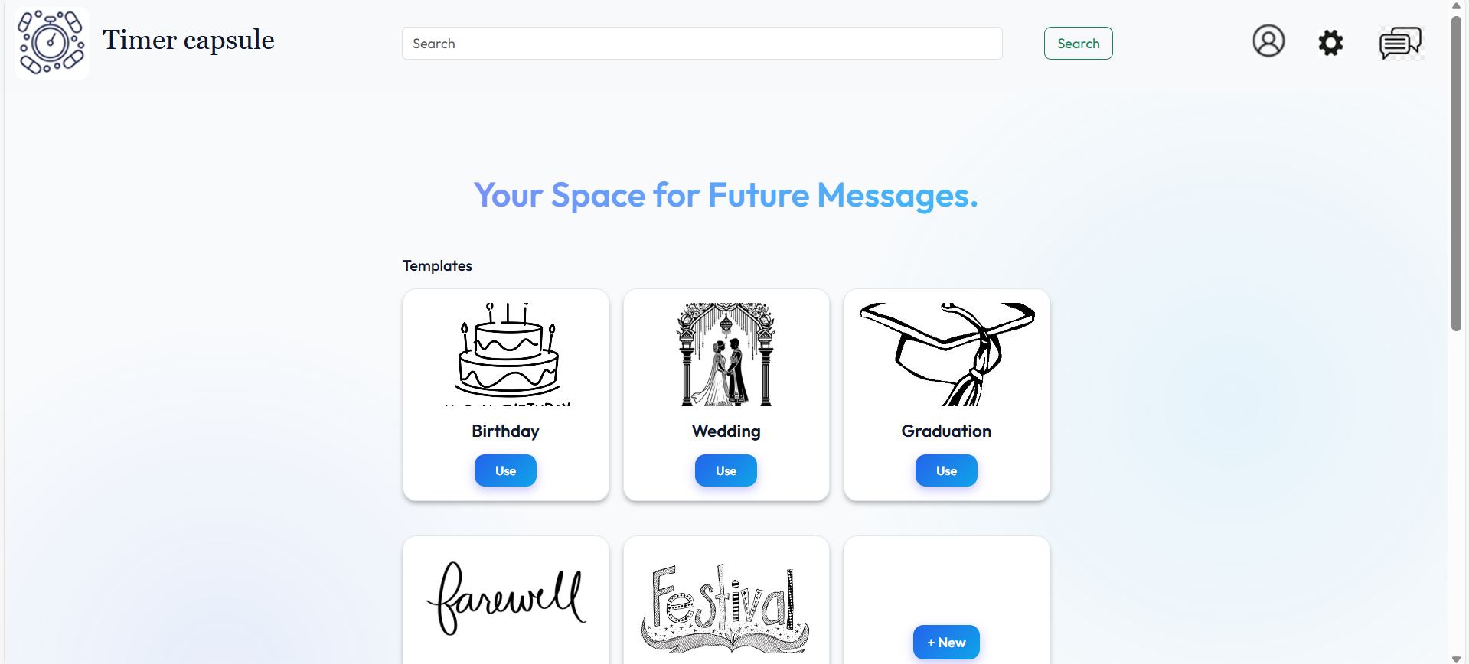
Fig 3.3
3.4 TEMPLATE MANAGEMENT COMPONENT
The Template Management component allows users to create and customize message templates for various occasions such as birthdays, weddings, graduations, and festivals. Users can edit text, attach media files, select delivery methods, and define privacy settings. This component helps streamline the message creation process.
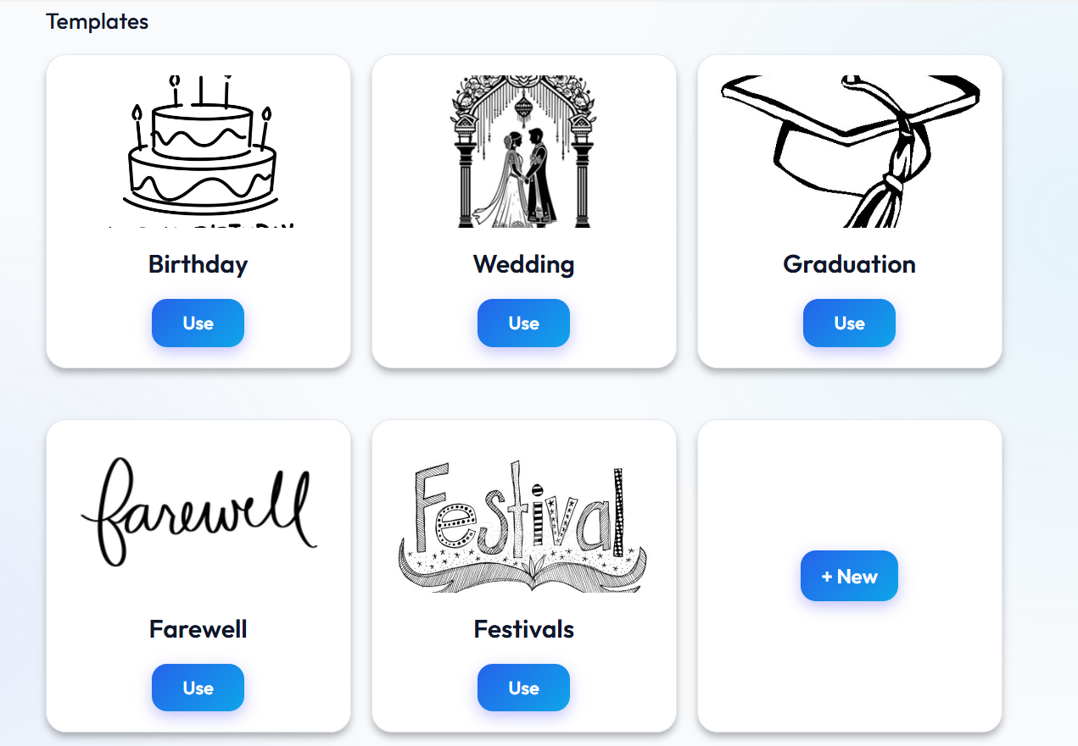
Fig 3.4
3.5 CAPSULE DETAILS COMPONENT
The Capsule Details component displays complete information about a selected capsule. It shows message content, attachments, delivery method, recipients, scheduled time, and current status. Users can view, modify, or cancel capsules from this page, making it an important part of capsule management.
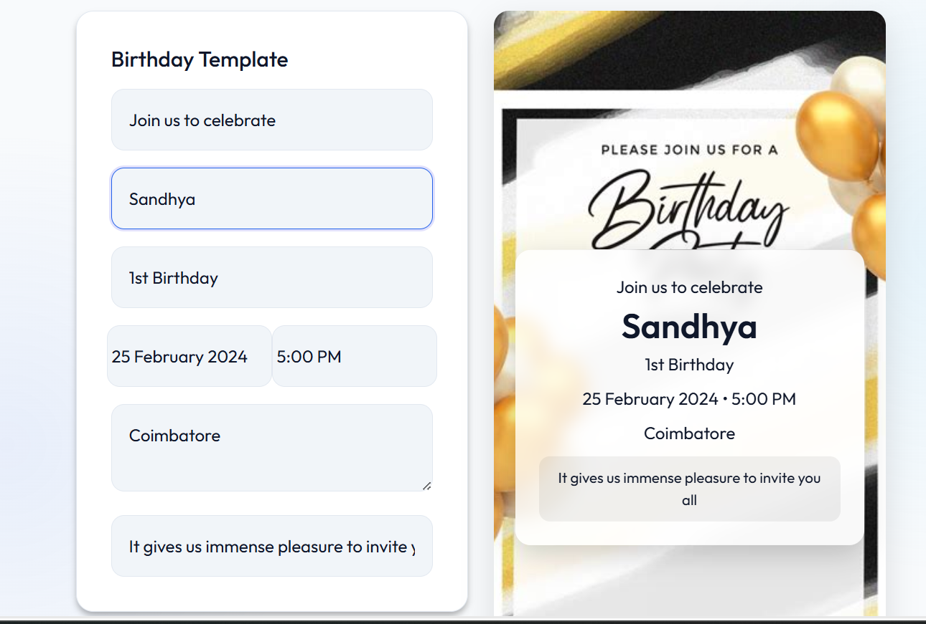
Fig 3.5
3.6 CHAT COMPONENT
The Chat component enables real-time communication between users when both the sender and receiver are registered in the application. It supports text messages and media sharing, allowing capsules to transition into interactive conversations. This component enhances user engagement within the application.
3.7 PROFILE AND SETTINGS COMPONENT
The Profile and Settings component allows users to manage their personal information such as profile picture, bio, contact details, and notification preferences. Users can also configure privacy settings and account-related options, ensuring a personalized and secure experience.
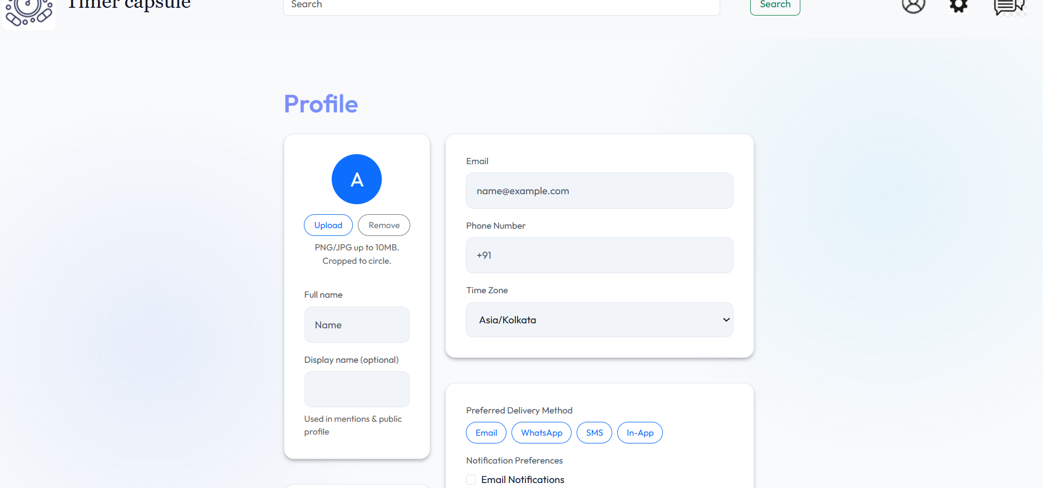
Fig 3.6
3.8 NOTIFICATION AND SCHEDULING COMPONENT
The Notification and Scheduling component handles the timing and frequency of capsule delivery. It allows users to set specific dates, times, and reminders for sending messages. Notifications are triggered before delivery, ensuring users stay informed about upcoming capsule events.

CONCLUSION AND FUTURE SCOPE

The internship project Time Capsule Messenger was a valuable learning experience that helped bridge the gap between academic knowledge and practical application. Through this project, I gained hands-on exposure to designing and developing a web-based application using modern frontend technologies. The project enhanced my understanding of component-based architecture, user interface design, and real-world problem-solving.
The application successfully demonstrates the concept of scheduled communication, allowing users to create and manage future messages efficiently. The guidance received through discussions with the staff and founder of Censoware LLP helped shape the project into a meaningful and user-focused application.
The project can be further enhanced by adding backend integration, database support for storing user data and capsules, authentication using secure methods, and real-time notification services. Additional features such as mobile application support, advanced analytics, and cloud-based deployment can also be incorporated to improve scalability and performance.

LESSONS I HAVE LEARNED

The internship provided me with valuable practical knowledge that could not be gained through classroom learning alone. One of the most important lessons I learned was how to apply theoretical concepts to a real-world project. Working on the Time Capsule Messenger application helped me understand how ideas are transformed into functional software through proper planning and design.
I gained hands-on experience in frontend web development using technologies such as HTML, CSS, Bootstrap, and React. I learned how to structure web pages, create responsive user interfaces, and build reusable components using React. Understanding component-based architecture and routing helped me improve the organization and maintainability of the application.
The internship also enhanced my problem-solving skills. I learned how to debug errors, resolve layout issues, and fix navigation problems by analyzing error messages and experimenting with solutions. This process improved my logical thinking and patience while working on technical challenges.
In addition to technical skills, I developed important professional skills such as communication, self-learning, and time management. Interacting with staff members and receiving feedback helped me understand the importance of clear communication and continuous improvement. Overall, the internship boosted my confidence, strengthened my technical foundation, and prepared me for future opportunities in the software development field.

INTERACTION WITH CO-WORKERS

During my internship at Censoware LLP, I had meaningful interactions with the staff members and the founder of the organization. These interactions mainly took place through discussions related to project ideas, requirements, and design considerations. The guidance provided during these conversations helped me understand real-world expectations and practical approaches to software development.
The staff members were supportive and approachable, which made it easy to clarify doubts and seek feedback on my work. Through regular discussions, I was able to refine the features and structure of the Time Capsule Messenger project based on suggestions and insights shared by them. These interactions played an important role in shaping the project effectively.
Communicating with professionals in the organization helped me improve my communication skills and gain confidence in presenting my ideas. Overall, the interaction with co-workers at Censoware LLP created a positive learning environment and contributed significantly to my professional and personal development.

DIFFICULTIES ENCOUNTERED

During the internship, I faced a few challenges while working on the Time Capsule Messenger project. One of the main difficulties was understanding how to structure a web application using modern frameworks such as React. Concepts like component reuse, routing between pages, and maintaining a clean folder structure were initially challenging.
Another difficulty encountered was handling layout and responsiveness issues while designing the user interface. Aligning elements properly, maintaining consistent spacing, and ensuring responsiveness across different screen sizes required repeated testing and adjustments. Debugging errors and resolving warnings in React also demanded careful attention and patience.
Additionally, since the project was developed based on discussions and feedback from staff members and the founder, translating requirements into a working design required continuous refinement. Understanding user expectations and implementing changes accordingly was sometimes challenging but helped improve the overall quality of the project.
These difficulties were overcome through self-learning, practice, experimentation, and guidance received during discussions. Facing and resolving these challenges enhanced my problem-solving skills and provided valuable practical experience.

WEB REFERENCES

- https://reactjs.org
- https://getbootstrap.com
- https://developer.mozilla.org
- https://www.w3schools.com
- https://nodejs.org

