**Fast:** *ios::sync_with_stdio(false); cin.tie(0);cout.tie(0);*

*vector<int>V;*

*set<int>S;*

*map<int,int>M;*

*vector<int>::iterator it;*

**Max 2 values:**

if(x>=max){ secondMax=max; max=x; }

else if(x>secondMax){secondMax=x; }

**Read(Stream) all integers of a line:**

string line;

getline(cin,line);

istringstream stream(line)

int x;

while(stream>>x){

v.push_back(x);

}

**Lower/Upper_bound:**

it=s.lower_bound(value);

it=upper_bound(v.begin(), v.end(), value);

pos=it-v.begin();

**Priority Queue in ascending order:**

priority_queue<pair<ll,ll>, vector<pair<ll,ll>>, greater<pair<ll,ll>> >pq;

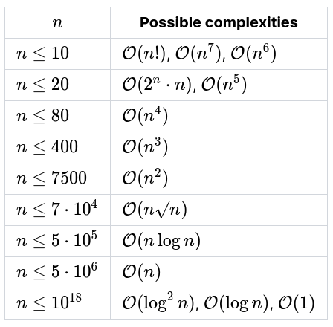

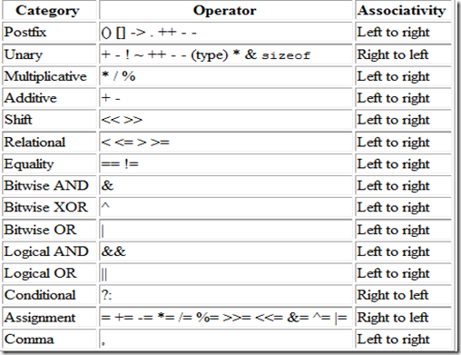

|  |  |
| --- | --- |
| Function | Time Complexity O(#) |
| pow(b, e) | log(e) |
| sqrt(n) | log(n) |
| __gcd(a,b), lcm(a,b) | log(max(a, b)) |
| Vectr:insert(pos,val),erase(pos) | n |
| Set,map:insert,find | logn |
| unordered_[set,map]:insert,find | 1 => n |
| fill(v.begin(),v.end(),val) | n |
| next_permutation(v.begin(),v.end()) | n [save nxt perm to the orgnl vctr] |
| reverse(v.begin(),v.end()) | n |
| Str1.find(substr2)[ind of first occurance] | n*m[n=str1.size, m=str2.size] |
| Str1.compare(str2) | min(n,m)  0: str1==str2  +ve: str1>str2  -ve: str1<str2 |
| __builtin_popcount(x)  __builtin_popcountll(x) | 1 |
| for(i=1; i<=n; i++) {  for(j=i; j<=n; ***j+=i***) {  }  }[pre-calc of divisor-cnt] | ≈n/1+n/2+...+n/n  ≈n(1+1/2+...+1/n)  n(logn)  [Harmonic series] |

**Bitwise Tricks:**

1. x is a power of 2 if(x != 0 && (x&(x-1) == 0))

2. kth bit of x = x&(1<<k)

3. multiply by 2^k: x<<k; divide by 2^k: x>>k;

4. x%(2^k) = x&(2^k-1)

5. swap: x=x^y, y=x^y, x=x^y;

6. a+b = (a^b)+2(a&b) = (a|b)+(a&b)

7. if a^b = c then, a^c = b, b^c = a;

**Debugging:** Edit in a new file if necessary.

## **Wrong Answer**

1. Output format and input constraints(tc)

2. Corner cases(n=0 | n=1, n=1e5), special cases.

3. check all if/else/known cases that implemented

4. Vector/map should it be global? Int overflow?

5. global vectors/variables/maps cleared each tc?

6. uninitialized var? taking input correctly?

7. Floating point/precision problem? MOD=1e9+7?

8. Read the problem again

9. Read the solution again

## **Runtime Error**

1. possible divison by 0? mod 0?

2. Array out of bound?

3. Infinite recursion? Stack overlow?

## **Time Limit Exceeded**

1. possible infinity loop?

2. clear time complexity. O(b^(Power > 20))?

3. unnecessary vector pass by value?