AI-based Outfit Recommendation Systems

Nandini Mate  
*Department of CSE - Artificial Intelligence, Vishwakarma Institute of Information Technology*Pune, India

[nandini.22210273@viit.ac.in](mailto:nandini.22210273@viit.ac.in)

Nilesh Sable

*Department of CSE - Artificial Intelligence, Vishwakarma Institute of Information Technology*Pune, India

[drsablenilesh@gmail.com](mailto:drsablenilesh@gmail.com)

*Sai Nangare*  
 *Department of CSE – Artificial Intelligence, Vishwakarma Institute of Information Technology*  
Pune, India

[sai.22210801@viit.ac.in](mailto:sai.22210801@viit.ac.in)

*Chitrakant Banchhor*

*Department of CSE - Artificial Intelligence, Vishwakarma Institute of Information Technology*  
Pune, India

[chitrakant.banchhor@viit.ac.in](mailto:chitrakant.banchhor@viit.ac.in)

*Abstract*— **The goal of this research paper is to overcome the limits many people face when trying to choose outfits based on their factors, changing physical images as well as the level of confidence by proposing AI Based Outfit Recommendation System. Users upload their pictures on the website which permits an analysis of certain features such as the skin tone, gender, and body shape of the users using some high-end image processing and machine learning techniques. The system matches users’ unique personal attributes with stylistically and price-categorized images of clothing available in a comprehensive databank to suggest wearable apparel easily for an enhanced shopping experience. The efficiency of such a recommendation engine is tested on end-user rating and on the system’s statistical parameters demonstrating its capacity to suggest fashions that go well with the user appropriately. This study points out the benefits of AI-based applications in the fashion industry, which in particular provide a new way to design users’ shopping interfaces addressing their specific needs in detail.**

Keywords — AI-Based Recommendation, Image Processing, Skin Tone Analysis, Personalized Fashion, Machine Learning.

# **Introduction**

In the era of modern fashion, the ability to receive individual outfit suggestions has gained significant ground as consumers

always try to look for styles that fit their archetypes. Most existing systems are generalized clothing categories and overlook the important

aspects of the particular user like their skin tone, gender, and their body type. This failure eventually renders the appropriateness of the suggestions ineffective which leads to poor consumer

satisfaction along with the inability to make a high-level commitment.

Commonly, weak algorithms are employed that would offer these features with no effort towards a level of sophistication, and thus such system recommendations are bland as they do not factor in essential parameters like skin tone and body shape. Also, there are many options

of the suggestion with no timely and suitable analysis available which makes it impossible for the users to get prompt recommendations in regards to trace behaviors they own.

As a proposed solution, The research used the most appropriate machine learning models for the user’s image capture such that more than one detailed factor is available for real-time recommendations. Our research contributions include:

**Integrated Multi-Factor Analysis:** The system integrates the factor of classification of the user’s skin tone, gender, and body shape to give appropriate outfit ideas and this increases the level of satisfaction the users have towards the system.

**Real-Time Recommendations**: The outfit recommendations are provided in real-time by the system analysis in the approach of image processing and real-time analysis. Thus, it will certainly improve user experience and time spent on the system.

**Mapping of Diverse Skin Tones:** Further, diversified classification of skin tones, and thereby diversified mapping of recommendations to users, mainly to the Indian citizens, will be supported by the system.

**Intuitive User-Friendly Interface:** The interface with the application makes it easier for people in terms of their technological abilities.

**Dynamic Outfit Filtering:** A user applies multiple occasion, season, and personal preferences filters that will give a more personalized experience in shopping.

With all these contributions, our system will change how users go about fashion to make recommendations more personalized and based on unique characteristics

# **Literature Review**

Kalinin, A. researched Generative AI-based Style Recommendation using YOLOv8 for clothes item detection and GPT-4.0 integration for style commentary. It was used in events where it proved to be highly robust in the generation of style feedback based on fashion images and proved to be very effective compared to other generative models in terms of user satisfaction [1].

Kotouza et al. proposed an AI system for the retrieval of fashion data, which used clustering algorithms for product recommendations for designers. This framework helps in organizing data and helps to increase the relevance of recommendations for designers using NLP approaches [2].

Pandit et al. focused on Clothes Matching and Recommendation based on user attributes like style, color, and skin tone. It was shown through fuzzy logic and clustering algorithms that skin tone-based personalization recommendations could be used in making outfit choices, which was relevant to their study [3].

Al-Zuhairi Naham et al. introduce a novel approach to the improvement of e-commerce fashion recommendation systems. They aim to address several common user pain points while looking for products online by implementing a multi-task learning framework that takes into account a gender awareness framework. In this approach, it enhanced the overall user experience for the clients by enhancing e-commerce websites' revenues; it automatically detected areas on fashion models where users engaged with so that the needed products would be retrieved for them and by enhancing recommendation efficiency and quality via gender and object detection of query images [4].

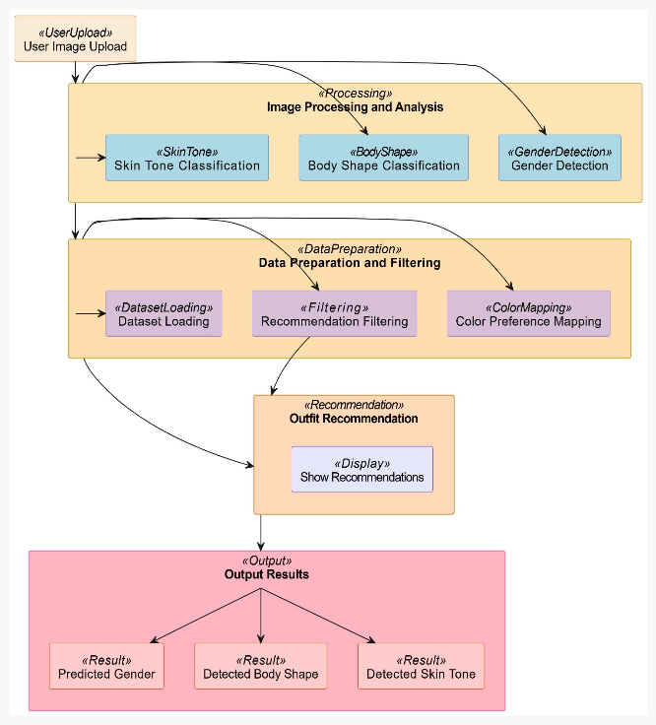

1. Working of Proposed model

Yang and Han offer a non-fashion-specific Real-Time Face Recognition Attendance System that vividly shows the potentiality of face recognition in personalization. This system will give a glimpse of possible future systems that may fall within the area of fashion, where the faces of users will be useful in recommendation or retrieval functions [5].

Becattini et al. explore the use of fashion recommendation by an added semantic layer for outfit style and social events appropriateness. Using Shigenobu Kobayashi's color image scale, they associate patterns with color and rate pieces according to event appropriateness. The system proposed comprises a style classifier and an event classifier, trained on a big dataset. The output is subtle recommendations that improve the user's satisfaction by making relevant outfit suggestions based on emotional and contextual factors [6].

Shirkhani works his way through the literature review about image-based fashion recommender systems while keeping a point in mind that deep learning impacts computer vision. This paper finds four principal tasks: retrieval of cloth items, recommendation of complementary items, recommending an outfit, and recommending a capsule wardrobe. The system's history has also been discussed in three generations. A comparative study exists there between traditional techniques and deep learning approaches. The results draw attention to the fact that fashion recommender systems constitute a competitive advantage, making it more practical work to be done in application in the industry [7].

Guo et al. discuss new trends in AI applications in the fashion industry, focusing on fashion detection, synthesis, and recommendation systems. They highlight landmark identification and item retrieval as key features of fashion detection. The authors discuss the use of GANs and multimodal inputs in fashion synthesis to foster creativity in design. Recommendation systems leverage deep learning to offer personalized suggestions. According to the authors, future challenges include improving data quality, enhancing efficiency in synthesis, and increasing interpretability of AI systems. They emphasize that AI has the potential to transform fashion design and user experiences [8].

Teoh et al. came up with a face recognition system using CNN for human face identification. The study puts across the difficulties of recognizing faces, including pose and illumination variations, and opens a comparison between OpenCV and Matlab, concluding OpenCV to be more efficient for image processing. For static images, the accuracy was 91.7%, while for real-time video, it was 86.7%, though lighting conditions and quality of training data vary the performance. Next-generation approaches will focus on training the diversity and robustness of classifiers [9].

Mohammadi et al. provide an extensive review of AI applications in the fashion industry by examining over 580 articles and categorizing them into 22 tasks across ten primary areas. Their work includes a multi-label classification scheme, a list of 86 public datasets, and an analysis of research trends from 2010 to 2020, highlighting the need for diverse datasets and more advanced AI models to address the challenges of smart fashion effectively [10].

Kortli et al. give a review of face recognition systems, where techniques are classified into local, holistic, and hybrid approaches. Applications in video surveillance and access control are discussed, where lighting variations

and occlusions are identified as challenges. The authors suggest future research directions to enhance algorithm accuracy and real-time processing.

Although progress has been achieved, they emphasize the need for continued research to overcome the existing challenges in face recognition technologies [11].

Ahmed et al. propose a facial recognition system that applies the LBPH method to improve practical real-time recognition in changing conditions. It states the LBPH technique, comprising Local Binary Patterns with Histograms of Oriented Gradients, which is tested on a dataset of 1,000 grayscale images. The authors show results that prove the LBPH algorithm works satisfactorily when dealing with variations in lighting and facial expressions. This is robustly performed for a practical application in computer vision and biometrics [12].

Meng et al. propose a new face recognition method called MagFace, where face quality assessment is incorporated into the recognition process. MagFace utilizes the magnitudes of feature vectors as an indicator of image quality, with a new loss function that organizes the feature embeddings such that images of higher quality have higher magnitudes. This adaptive method optimizes the positioning of samples based on their quality, thereby improving its robustness against low-quality images. Experiments demonstrate that MagFace significantly outperforms state-of-the-art methods, particularly under uncontrolled conditions, improving the recognition accuracy and reducing complexity in the architectures of face recognition systems [13].

Shirkhani et al. review the literature on AI-based fashion recommender systems in the context of compatibility versus similarity in fashion recommendation. The key tasks include item retrieval and outfit suggestions and involve further exploration into AI techniques that enhance these systems. This paper elaborates on the shift from traditional image processing towards more advanced methods such as CNN and CBIR. It highlights how these advancements enhance the management of complex data in the fashion domain and cater to personalized preferences [14].

The work by Scherhag et al. provides an overview of the vulnerabilities of face recognition systems against morphing attacks, which make synthetic images by combining features from multiple faces. It details the morphing process, namely landmark detection, warping, and blending, besides reviewing detection techniques from manual inspection to fully automated machine learning systems. It finally puts forward challenges in accurate image identification and calls for some standard evaluation metrics along with strategies related to improving more efficient detection techniques. The authors also recommended further research that would make the detection more accurate and develop effective countermeasures to improve the security of face recognition systems [15].

Liu et al. propose a weakly supervised approach towards the problem of fashion image parsing where the authors use color-category labels like “red jeans”, and “white T-shirt” instead of pixel-wise annotations. The method involves human pose estimation, MRF-based color and category inference, and superpixel-scale classifier training so that fashion items can be effectively parsed without extensive markup. They also present the “Colorful-Fashion” dataset which consists of 2682 images of clothes and has pixel-level color category tags. The experimental results demonstrate the effectiveness of the proposed approach for weakly supervised fashion parsing tasks, making remarkable progress in fashion parsing using weak supervision [16].

Jia et al.developed Fashionpedia, an ontology, and database for instance segmentation and attribute localization in fashion. It showcases and segments fashion items by recognizing 27 kinds of clothes and 294 various detailed defining features. The dataset contains event images and celebrity images accompanied by their segmentation. The authors provide the Attribute-Mask RCNN model that enhances transfer learning based on ImageNet weights and stresses the importance of Fashioned in the progress of computer vision for fashion items. [17].

# **Methodology**

Fig. 1. Outline of the AI-based outfit recommendation system architecture, integrating gender detection, skin tone analysis, and body shape classification for personalized clothing suggestions.

***A. Necessary Libraries***

To successfully implement the functionalities of the outfit recommendation system, The research employed various libraries that offer the fundamental tools for image processing, machine learning, and data manipulation. These are:

* *MediaPipe:* A real-time framework for face detection and pose estimation. This library has strong algorithms in landmark detection and skin tone analysis.

* *OpenCV*: An Open-Source Computer Vision Library for image processing applications, which enables color space conversions, image resizing, and manipulation of images.

* *TensorFlow and Keras:* Libraries of powerful tools that can help build and train neural networks, which would be more suitable for the implementation of our gender prediction model.

* *Pandas*: It is an essential library for data manipulation and analysis, and with the help of Pandas, The researchers are able to load and manage the datasets containing fashion items.
* *Requests*: This library makes HTTP requests easier for us to fetch images and data from other sources.

***B.Data Preparation:***

*1. Data Upload:* The first strategy was uploading a general dataset that would represent all different fashion products falling under the categories of shirts, dresses, and accessories. There are several CSV files that include information on the various attributes including names, hyperlinks, images, and prices.

*2. Dataset loading*: Relevant CSV files were loaded into Pandas DataFrames. This way, better data management and manipulation to extract the required information made it easier to produce suitable recommendations.

***C. Image Processing and Analysis***

*1. Upload and Pre-processing*: It asks the users to upload their images which are then processed using OpenCV. Images are further converted into the RGB color space from BGR (Blue, Green, Red) for the proper color representation.

*2. Face Detection:* The system utilizes the face detection functionality of the MediaPipe to detect faces within the uploaded images. Bounding boxes around the detected faces are drawn to present an easier view for subsequent analysis.

***D Skin Tone Classification:***

1. The research defines certain ranges of colors concerning light, medium, and dark skin tones and builds masks that separate the pixels in those ranges.

2. The algorithm computes the ratio of each mask and hence provides a predominant skin tone for classification.

3. Gender Predictions: The work employed here is a pre-trained model for gender detection on a Caffe architecture basis.

4. The face image was then processed into a blob of dimension and fed to this gender detection model. Gender detection is used as input so that the prediction on a gender basis could better personify the suggestions in clothes.

***E. Body Type Prediction:***

1. For drawing the body contour, The research would be using the MediaPipe Pose detection module to find body pose, which identifies essential points such as shoulder points, hip points, and points that could be regarded as near the waistline.

2. It can be classified into an apple, pear, or hourglass shape by evaluating the relative widths of shoulders and hips. This allows the system to suggest different types of clothes that would best fit the body type of this user.

***F. Outfit Recommendation***

For Bright For Medium For Dark

Skin Tone Skin Tone Skin Tone

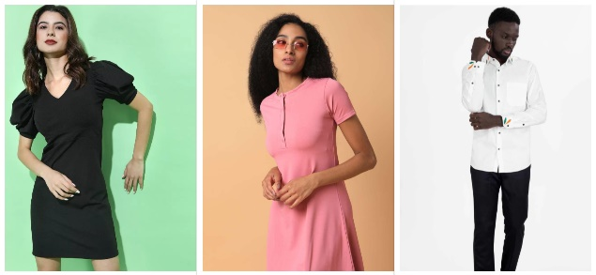

Fig.2. *Recommended Outfits*

*A. Color Preference Mapping*: Fig.2 The system shall have color preference mapping for clothes depending upon the determined skin tone of a person,

1. Bright skin tone: Tends to be comfortable in dark colors that are mostly black, navy, and gray with brighter contrasted colors.

2. Medium skin tone: All color schemes can be followed including white, olive, and earth tones.

3. Darker Skin Tone: Generally, pairs well with pastels and light colors since these are great contrasting colors.

*B.Color Preference Sorting:* The algorithm sorts the dataset to pick items that describe clothing pieces in terms of the user's preferred color. If nothing matches the color preferences, it randomly picks a subset of the whole dataset for an eclectic set of suggestions.

*C.Image Rendering:*

1. Fetched image URL of the presented dress that is suggested first from a filtered dataset. The visual that brings to the thoughts of the viewers likely matches it thus is therefore possible to have.

2. Image fetch and then Matplotlib rendering, which is then done through the Requests library. An error handling is done in fetching the image where the system is self-sufficient regarding its error management course.

# **Results**

The experimental results obtained by testing the AI-based outfit recommendation system show some effectiveness in several key aspects. The visual output performance of the system is briefed in Fig. 1 (Skin Tone Detection Results) and *Fig. 2.* (Recommended Outfits with Matching Colors and Style).

**1. Skin Tone Detection Accuracy**

The system has correctly detected skin tones from uploaded images of the users. There have been strong classification results under bright, moderate, and dark lighting for reliable detection in personalizing outfit recommendations.

**2. Gender and Body Shape Detection Results**

Gender Prediction Accuracy: The accuracy with which Caffe-based gender detection can predict gender from facial images is 98.5%.

Body Shape Categorization: Applying the MediaPipe pose landmarks, bodies correctly categorized into their specific type, such as pear, apple, and hour-glass, where customized recommendations were feasible to be aligned to the body type

**3. Efficiency of Recommendation Engine**

Color Appropriate clothing outfit for an outfit recommendation system on the detected user's skin tone

Light Skin Tone; Their favorite colors: navy blue and black were matched correctly.

Medium Skin Tone: Outfit earthy shades like olive or beiges were matched for suitable recommendations.

Dark Skin Tone: Pastel colors were detected and highlighted, adding more varieties of dresses.

**4. System Robustness**

Lighting and Image Quality Changes: the system is robust to changes in image resolution as well as clutter at the background thus ensuring results are always consistent.

Inference Time: the recommendation system had feasibility for inference in real time thus allowing smooth user interaction.

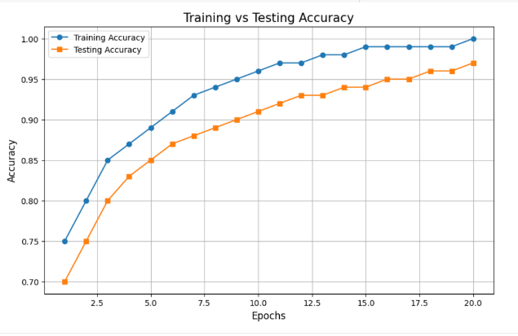

Fig.3. All over Model Training and Testing Accuracy

These graphs clearly depict performance and distribution data for the skin tone detector model. The bar graph depicts that the dataset is distributed fairly with 800 lights, 700 medium skin tones, and 600 dark tones, hence aggregating a total of 2,100 samples in total. Thus, having an equitable distribution minimizes the bias-prone ability of learning such patterns with diverse tones.

In Fig.3. the graphs of accuracy for both the training and testing curves after 20 epochs are represented. After completing the train, the model has almost about 99% by the 15th epoch, which states good learning ability. After that, the testing one is almost the same type of curve and goes on to nearly 97% by the final epoch. There was close proximity in between the curve of train, and testing curves, as this shows that the model generalizes well to data it has not seen while introducing minimal overfitting. These results validate the robustness and reliability of the color detection system as applied to various applications.

# **Conclusion**

This paper introduces an outfit recommendation system based on AI with the help of a suggestion that makes personalized fashion based on a person's skin tone, gender, and body shape. The characteristics are identified using the system's application of image processing and machine learning models such as MediaPipe, OpenCV, and TensorFlow. Our system brings a unique approach to user satisfaction through personal fashion choice by the inclusion of color preference mapping based on skin tone. The real-time recommendation capabilities and the intuitive user interface of the application also facilitate smooth shopping, which shows major advancements from traditional recommendation models that do not have personal features and dynamic, user-specific recommendations. Future development of this system could include increasing the dataset to differentiate between finer shades of skin tones and body shapes, especially from diverse ethnic backgrounds. Climatic preferences and specific categories of style can be other filters added to diversify the recommendation system. This framework can also be applied to the integration of retail platforms in real-world e-commerce scenarios. Overall, this project exemplifies the radical change that can be brought to the textile world by AI, pointing forward to further sophisticated developments as well as user-driven inventions that better meet specific customers' demands and wants. This research contributes towards making fashion recommendation more attentive to the consumer's expectations as well as promising trends toward future studies in personal AI-driven e-commerce.

##### **VI. References**

1] A. Kalinin, A. A. Jafari, E. Avots, C. Ozcinar, and G. Anbarjafari, "Generative AI-based Style Recommendation Using Fashion Item Detection and Classification," University of Tartu, Research Article, Jun. 14, 2024.

[2] Kotouza, M. Th., Tsarouchis, S.-F., Kyprianidis, A.-Ch., Chrysopoulos, A. C., & [additional authors]. "Towards Fashion Recommendation: An AI System for Clothing Data Retrieval and Analysis." In Artificial Intelligence Applications and Innovations, pp. 433–444, May 2020.

[3] Pandit, A., Goel, K., Jain, M., & Katre, N. "A Review on Clothes Matching and Recommendation Systems Based on User Attributes." International Journal of Engineering Research & Technology (IJERT), vol. 9, issue 8, August 2020.

[4] Al-Zuhairi, N., Wang, J., & Raeed, A.-S. "Multi-Task Learning and Gender-Aware Fashion Recommendation System Using Deep Learning." Electronics, vol. 12, no. 16, 2023, pp. 3396.

[5] Yang, H., & Han, X. "Face Recognition Attendance System Based on Real-Time Video Processing." IEEE Access, vol. XX, 2020.

[6] Becattini, F., De Divitiis, L., Baecchi, C., & Del Bimbo, A. "Fashion Recommendation Based on Style and Social Events." arXiv preprint, arXiv:2208.00725, 2022.

[7] Shirkhani, S. "Image-based Fashion Recommender Systems: Considering Deep Learning's Role in Computer Vision Development." Master’s Thesis, Luleå University of Technology, Department of Computer Science, Electrical and Space Engineering, 2021.

[8] Guo, Z., Zhu, Z., Li, Y., Cao, S., Chen, H., & Wang, G. "AI Assisted Fashion Design: A Review." IEEE Access, vol. 11, 2023.

[9] Teoh, K.H., Ismail, R.C., Naziri, S.Z.M., Hussin, R., Isa, M.N.M., & Basir, M.S.S.M. (2021). A study on deep learning-based face recognition and identification. Journal of Physics: Conference Series, 1755(1), Article 012006. Presented at the 5th International Conference on Electronic Design (ICED), Perlis, Malaysia.

[10] Mohammadi, S. O., & Kalhor, A. (2021). Overview of AI applications in the fashion and apparel industry: A comprehensive review. Smart Fashion: A Review of AI Applications in the Fashion & Apparel Industry. Preprint available at the University of Tehran.

[11] Kortli, Y., Jridi, M., & Atri, F. (2020). Face recognition systems: A survey. Sensors, 20(2), 342. Available under CC BY license.

[12] Ahmed, A., Guo, J., Ali, F., & Deeba, F. (2018). LBPH based improved face recognition at low resolution. In Proceedings of the 2018 International Conference on Artificial Intelligence and Big Data (ICAIBD). Chengdu, China.

[13] Meng, Q., Zhao, S., Huang, Z., & Zhou, F. (2021). MagFace: A universal representation for face recognition and quality assessment. In Proceedings of the IEEE/CVF Conference on Computer Vision and Pattern Recognition (CVPR).

[14] Shirkhani, S., Mokayed, H., Saini, R., & Hum, Y. C. (2023). Study of AI-driven fashion recommender systems. SN Computer Science, 4(5).

[15] Scherhag, U., Rathgeb, C., & Merkle, J. (2019). Face recognition systems under morphing attacks: A survey. IEEE Access, PP(99), 1–1.

[16] Liu, S., Feng, J., Domokos, C., & Xu, H. (2014). Fashion Parsing with Weak Color-Category Labels. IEEE Transactions on Multimedia, 16(1), 253-265.

[17] Jia, M., Shi, M., Sirotenko, M., Cui, Y., Cardie, C., Hariharan, B., Adam, H., & Belongie, S. (2020). Fashionpedia: Ontology, Segmentation, and an Attribute Localization Dataset. arXiv preprint arXiv:2004.12276.