*Abstract*

This project focuses on analysis of pneumonia and advancement in medical technology, through with the help of a deep learning model known as CNN. Pneumonia is an inflammatory condition of the lung affecting the alveoli, which are small air sacs where oxygen exchange takes place. Pneumonia was first known to found by Ancient physicist Hippocrates along with Carl Friedländer's who was the first one to identify pneumonia in late 19th century by identifying Streptococcus pneumoniae the specific type of bacteria through microscope. With the development in medical science and technology Doctors are able to identify the presence of pneumonia just by Spectating the x-Ray images of patients and are generally taught to do so until there second year of medical Academics. Though older method had proved there effectiveness there is a need to have an advancement in medical technology through a blend of AI through the implementing the modern stake hold of AI in Accurate identification of Pneumonia through Convulsion Neural Networks popularly Known as Deep Learning Methods. Our project focuses on Making A CNN based model for Pneumonia Classification and support the Medical Science With our Prediction Module and bring it in further use in clinical practice as approved by doctors. Our CNN-based model for pneumonia classification achieved an impressive accuracy of 96%, showcasing its effectiveness in accurate identification and diagnosis.

*Introduction*

Pneumonia is a type of intense respiratory disease caused by microbes, infections, or parasites that influences the lungs. Pneumonia is the driving cause of child mortality around the world, with pneumonia murdering an assessed 920136 children beneath five a long time of age in 2015, bookkeeping for 15% of all passings in children beneath five a long time of age around the world

Despite advances in medical research, pneumonia is still a major worldwide health problem due to its prevalence as a respiratory illness. Pneumonia diagnostic accuracy and promptness are essential for better clinical outcomes and efficient patient care. The accuracy and effectiveness of conventional diagnostic procedures are limited because they frequently depend on the visual interpretation of radiological data. With the development of machine learning (ML) and artificial intelligence (AI), however, the possibility to transform pneumonia diagnosis is becoming more and more apparent. The goal of this research project is to improve the accuracy of pneumonia identification by utilizing Linear Regression models and Convolutional Neural Networks (CNN), a subtype of deep learning. This study uses AI to give a more accurate and efficient way to classify pulmonary abnormalities, specifically differentiating between lung problems that are normal and those that are pneumonia-related.   
  
The diagnosis of pneumonia has traditionally relied largely on subjective and inconsistent manual interpretation of radiological images by healthcare professionals. Although Streptococcus pneumoniae, the bacterial agent that causes pneumonia, was identified as early as the late 1800s, current diagnostic methods still make it difficult to accurately detect and classify cases of pneumonia. This inquiries about addresses the characteristic confinements of conventional symptomatic approaches. The objective of this investigate is to make strides demonstrative exactness and quicken clinical decision-making methods by preparing a CNN-based demonstrate on large-scale information sets.

By utilizing counterfeit insights to recognize miniature designs and characteristics in therapeutic pictures, the determination rate of pneumonia may be expanded. This ponder is imperative for reasons other than the innovation itself. Exact determination of pneumonia with the utilize of manufactured insights might lead to progressed quiet results by encouraging the advancement of personalized treatment plans and opportune mediations. Healthcare professionals can also better manage their workflow and resource allocation by automating certain diagnostic components.

To sum up, this study is a big step in fusing state-of-the-art technology with traditional medical procedures to solve urgent healthcare issues. This research aims to progress medical imaging and contribute to the larger goal of improving patient care and clinical decision-making processes by creating CNN-based models for pneumonia identification.

|  |  |  |
| --- | --- | --- |
| **Paper** | **Abstract summary** | **Outcome measured** |
| Pneumonia detection through Image Classification Using CNN  2022,  Karan Badlani, Shreya Sawal, Mohit Nilkute, Shruti Belekar, Ajinkya Nilawar | The proposed CNN model provides higher accuracy compared to existing CNN models. | The performance of the proposed CNN model is compared with VGG19 and ResNet50-V2. Performance evaluation is done using Precision and Recall |
| Pneumonia Detection using Chest X-ray Images using CNN Algorithm  2023,  Surya Deepta Mazumdar, Ashish Kumar, R. Sethuraman | A proposed model applies a deep learning algorithm to detect the health condition of the patient by analysing their chest X-ray images. | The objective of this research study is to attain the model accuracy as high as possible to provide accurate results to the user. |
| PNEUMONIA DETECTION USING CNN THROUGH CHEST X-RAY  2021,  Mahendra Kumar Gourisaria, S. Rautaray, M. Pandey | A convolutional neural network can serve as a viable tool for physicians and the medicine community to correctly identify and diagnose viral, bacterial, fungal-caused and community-acquired pneumonia given only the chest X-ray of the patient | ability to correctly identify and diagnose viral, bacterial, fungal-caused, and community-acquired pneumonia using chest X-ray images |
| Pneumonia Detection and Classification using CNN and VGG16  2022,  Dr. Sunil L. Bangare, Hrushikesh S. Rajankar, Pavan S. Patil, Karan V. Nakum, Gopal S. Paraskar | The trained version produced a 95% accuracy charge during the total performance training. | Accuracy of the CNN model in detecting and predicting pneumonia based on chest X-ray photographs. |

*Literature survey*

*Methodology*

This section delineates the methodologies integrated into our research, encompassing pivotal steps such as data preprocessing and the construction of our Convolutional Neural Network (CNN) model, succinctly detailed below. The model architecture, depicted in Figure 1, encapsulates the operational framework of our approach, illustrating how our models function cohesively to achieve our research objectives.

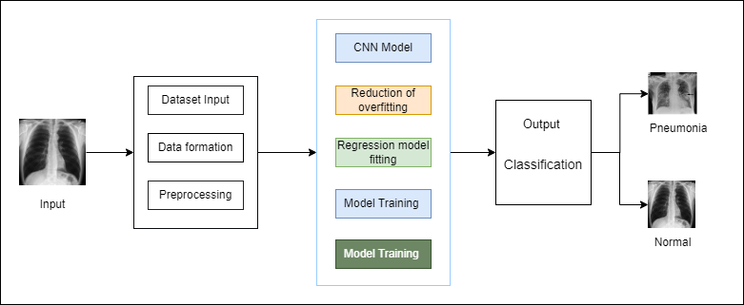

Fig. 1: Model Architecture

* *Dataset Preprocessing*

For dataset preprocessing, we have used total 3617 of Bacterial pneumonia x-ray images and a total of 3620 Normal x-ray images (table I). We convert the images into URLs are they are easy to use and have applied parameters such as dimensional changes. The dataset contains the type of images shown in Fig. 2 and Fig. 3.

Table I: Dataset

|  |  |
| --- | --- |
| **Images** | **Size** |
| Normal images | 3620 |
| Pneumonia images | 3617 |

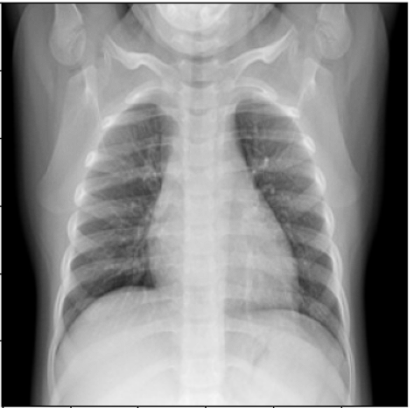 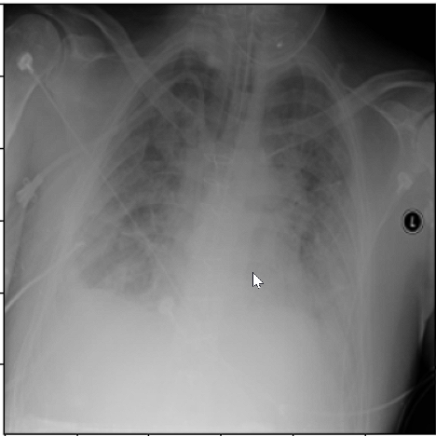

Fig. 2: Normal x-ray Image Fig. 3: Pneumonia x-ray Image

* *CNN Architecture*

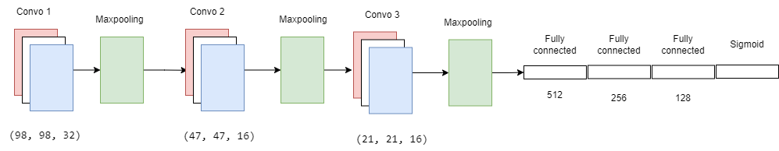Our model was built to assess pictures from X-rays in arrange to analyze pneumonia. Preprocessing was done on the dataset's collection of X-ray pictures to guarantee consistency and quality. The CNN demonstrate comprises of of three parallel convolutional layers and three max pooling layers. The objective of these layers is to play down dimensionality whereas getting vital features from the input pictures. The information is at that point arranged for passage into four thick layers via a flattening layer. The show is able to memorize complex designs and deliver exact figures much obliged to these profound layers, which utilize nonlinear actuation capacities. Refer to Fig. 4.

Fig. 4: CNN Layers

Table II: CNN model architecture

|  |  |
| --- | --- |
| **Type** | **Parameters** |
| Convo2D | 32 |
| Maxpooling2D | (2,2) |
| Convo2D | 16 |
| Maxpooling2D | NA |
| Convo2D | 16 |
| Maxpooling2D | NA |
| Dense | 512 |
| Dense | 256 |
| Dense | 128 |
| Dense | Activation=sigmoid |

The CNN model architecture consists of several key layers, each serving a specific purpose in the feature extraction and classification process:

1. *Convolutional Layers (Conv2D): -*

Features are extracted from input photos using convolutional layers. For the model, we may construct three convo2D layers. These layers blend over the input image, identifying patterns and features like borders and textures with the use of machine-learning filters. Every convolutional layer uses a variety of filters to produce maps that capture various aspects and characteristics of the picture. Refer to table II.

1. *Max Pooling Layers: -*

To assist with highlight choice and dimensionality decrease, three max pooling layers are included after the convolutional layers. Through the evacuation of pointless points of interest and retention of as it were the foremost vital data, max pooling productively downsamples the include maps. Through this approach, the spatial measurements of the highlight maps are diminished, making strides computing proficiency and moderating overfitting.

1. *Flatten Layer: -*

After the convolutional and pooling layers, a smoothing layer reshapes the yield from the past layers into a one-dimensional cluster. This plans the information for input into the ensuing thick (completely associated) layers.

1. *Dense Layers: -*

Four thick layers take after the straightening layer, encouraging high-level include learning and classification. Each thick layer comprises of different neurons interconnected with the neurons of the going before and consequent layers. The joining of nonlinearity into the show utilizing nonlinear actuation capacities, such Corrected Straight Unit (ReLU), permits the demonstrate to recognize perplexing designs inside the information.

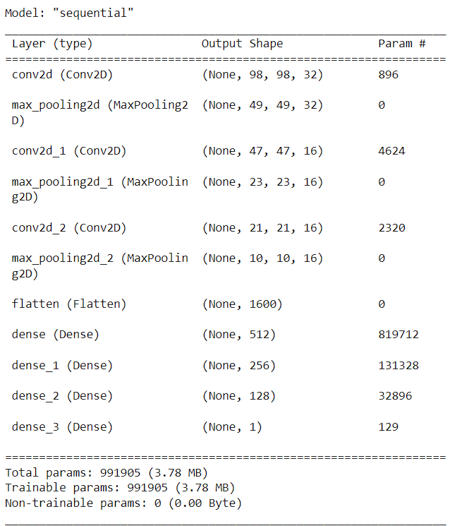

Fig. 5: Model Summary

* *Classification and output*

Utilizing Sklearn and Linear Regression: Utilizing the Scikit-learn toolkit, we considered direct relapse in expansion to the CNN demonstrate. Understanding the connect between the input highlights and the objective variable is made less demanding by this approach. Preparing on the dataset and over and over adjusting parameters to decrease blunder were steps within the demonstrate fitting prepare. The model's execution was surveyed amid the preparing and testing stages, and it accomplished an noteworthy 96 percent exactness on the test set.

Image Classification and Prediction: The prepared demonstration demonstrates proficient classification abilities, differentiating between X-ray images with pneumonia and those without. The demonstrate determines whether an input photo depicts pneumonia or a healthy lung by using learnt highlights. This predictive capacity increases demonstrable productivity and may help medical professionals make accurate and convenient decisions.

These layers collectively enable the CNN model to extract hierarchical features from input images and perform accurate classification tasks, such as distinguishing between pneumonia and normal X-ray images.

*Results and Output*

Pneumonia distinguishing proof utilizing X-ray pictures is an imperative however troublesome work within the field of restorative diagnostics. This ponder points to create a strong arrangement by utilizing the capabilities of direct relapse models and convolutional neural systems (CNNs). Our consider is to convert the exactness of pneumonia discovery by utilizing AI innovation, especially customized CNN engineering and direct relapse approaches. By implies of meticulous examination and confirmation, we need to uncover the viability of our approach in separating between X-ray pictures with pneumonia and those without it. In terms of improving clinical decision-making and understanding results when it comes to pneumonia determination, this investigate may be a basic to begin with step.

This section presents the result of the model training and testing with the dataset of 3620 normal x-ray images and 3617 pneumonia x-ray images. In the evaluation of the results, the two types of patients were taken into account: normal patients and patients with pneumonia. The confusion matrix in Table II shows the error generated by each model. The model was set to use 80% of the dataset for training, for 20 Epochs and 20% for testing propose. We have fitted the model, trained and tested it and have plotted a training Vs testing loss and accuracy graphs. This graphs helps us to analysis that out training loss is decreasing as we training the model more but the testing loss is constant. Visual representation of this will help us understand this better. The Fig. 6 is the graph of training Vs the testing accuracy of our model. The Fig. 7 shows the graph of training Vs testing loss.

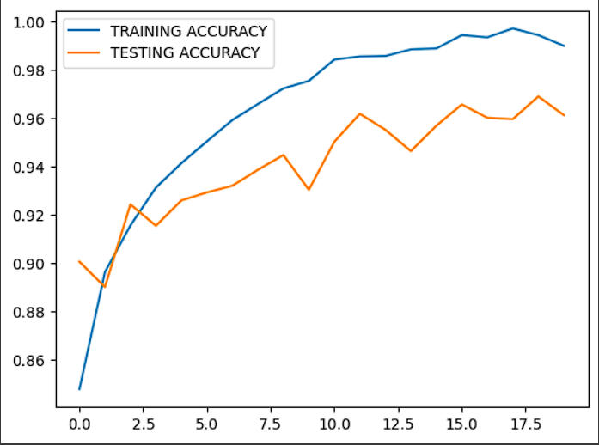

Fig. 5: Training Vs Testing Accuracy plot

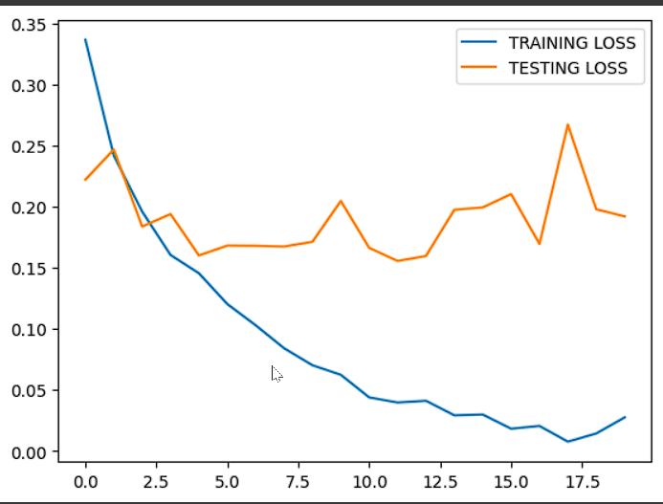

Fig. 6: Training Vs Testing loss plot

The results obtained from the training and validation data are shown in table III. The table contains the data of some epochs to show the loss and accuracy for overall model. As it can be seen in the table that the accuracy is increasing as the model trains i.e. with each epochs and the loss can be seen reducing showing the efficiency of out model and the accuracy that is needed in the medical field.

Table III: Training and Testing accuracy and losses

|  |  |  |  |  |
| --- | --- | --- | --- | --- |
|  | Training | | Testing | |
| Model | Accuracy | Loss | Accuracy | Loss |
| Epoch 1 | 0.8478 | 0.3365 | 0.9006 | 0.2220 |
| Epoch 5 | 0.9414 | 0.1454 | 0.9260 | 0.1600 |
| Epoch 10 | 0.9755 | 0.0623 | 0.9304 | 0.2046 |
| Epoch 15 | 0.9889 | 0.0298 | 0.9569 | 0.1993 |
| Epoch 20 | 0.9900 | 0.0274 | 0.9613 | 0.1919 |

The results of our investigation are interesting and demonstrate that our suggested approach works for identifying pneumonia. The accuracy of our CNN and linear regression models in identifying normal and pneumonia X-ray images was remarkable, reaching 96% Our model demonstrated remarkable economy, speed, and accuracy in picture classification, highlighting its potential for clinical applications. Our model demonstrated remarkable economy, speed, and accuracy in picture classification, highlighting its potential for useful clinical applications. With this accomplishment, pneumonia diagnoses in clinical settings will be more accurate and efficient. It also highlights the need for using cutting edge artificial intelligence techniques to support conventional medical diagnostics. The following figures are a comparative analysis of our model with the proposed work.

Fig. 7: Comparison of Training Time

Table IV: Epochs Vs Time\sec

|  |  |  |  |
| --- | --- | --- | --- |
| MODEL |  | EPOCHES | TIME\SEC |
| GEN-1 |  | 100.00 | 25200 |
| GEN-2 |  | 300.00 | 18000 |
| GEN-3 |  | 500 | 2500 |
| CURRENT | | 2500 | 7500 |
| OUR MODEL | | 20 | 100 |

Fig. 8: Comparison of Accuracy

Fig. 9: Data distribution of our database

Table V: Architecture comparison

|  |  |  |  |  |  |  |
| --- | --- | --- | --- | --- | --- | --- |
| MODEL | ARCITECTURE COMPARISON | | |  |  |  |
| CONV | POOLING | FLATERN | NEURON | DENSE LAYERS | |
| GEN-1 | 5 | 5 | 1 | 37 | 1 | |
| GEN-2 | 12 | 12 | 1 | 46 | 1 | |
| GEN-3 | 23 | 23 | 1 | 63 | 1 | |
| CURRENT | 50 | 50 | 1 | 123 | 3 | |
| OUR MODEL | 3 | 3 | 1 | 200 | 3 | |

Fig. 10: Architecture Comparison

Fig. 11: Comparison of F1 Score

*Conclusion*

In conclusion, our research project has successfully developed and validated a CNN and linear regression-based model for pneumonia diagnosis from X-ray images. With an impressive accuracy of 96%, our model demonstrates robust performance in distinguishing between normal and pneumonia-afflicted lungs. The efficiency and accuracy exhibited by our model underscore its potential as a valuable tool in clinical practice. By automating the diagnostic process and providing rapid, accurate assessments, our model has the capacity to enhance patient care and streamline healthcare workflows. Moving forward, further refinement and validation of the model could lead to its widespread adoption, ultimately contributing to improved pneumonia diagnosis and treatment outcomes.